XXX

软件设计说明

文件修订页

|  |  |  |  |  |  |
| --- | --- | --- | --- | --- | --- |
| 序号 | 修订日期 | 版本/修改单号及修订内容 | 编制 | 审核 | 批准 |
|  |  |  |  |  |  |
|  |  |  |  |  |  |
|  |  |  |  |  |  |
|  |  |  |  |  |  |
|  |  |  |  |  |  |
|  |  |  |  |  |  |
|  |  |  |  |  |  |
|  |  |  |  |  |  |
|  |  |  |  |  |  |

目 录

1 范围 4

1.1 标识 4

1.1.1 系统概述 4

1.2 文档概述 4

2 引用文档 4

# 范围

## 标识

本文档的标识为ZZZ，适用于XXX。

### 系统概述

XXX是。

## 文档概述

本文档描述XXX的软件设计说明，旨在完整地定义XXX的软件架构和低层软件需求，使XXX的系统设计人员与软件开发人员对该项目的软件设计达成共识，为该项目的软件编码和软件测试提供基础，也为该项目的验收提供依据。

# 引用文档

# 架构设计

## 文件列表

[SDD-1]本系统应由以下SCADE Display的图形规格说明文件组成：

(1) D:\Program Files (x86)\Esterel Technologies\SCADE R16.2.1\SCADE Display\KCG66\oglx\examples\pfd\PrimaryFlightDisplay.sgfx

## 图层列表

[SDD-2]文件D:\Program Files (x86)\Esterel Technologies\SCADE R16.2.1\SCADE Display\KCG66\oglx\examples\pfd\PrimaryFlightDisplay.sgfx应包含以下图层：

(1) 1-symbology_layer

## 层次结构

[SDD-3]图层1-symbology_layer应具有图1所示的层次结构：

1-symbology_layer

|- 1-1-PFD

|- 1-1-1-ADI

| |- 1-1-1-1-ADI_masked_parts

| | |- 1-1-1-1-1-SkyEarthAndScales

| | | |- 1-1-1-1-1-1-SKY_EARTH

| | | |- 1-1-1-1-1-2-ScaleAndAlarms

| | | | |- 1-1-1-1-1-2-1-PitchScale

| | | | | |- 1-1-1-1-1-2-1-1-SCALE_DAN_F00

| | | | | |- 1-1-1-1-1-2-1-1-1-begin_moving

| | | | | |- 1-1-1-1-1-2-1-1-1-1-PART_4

| | | | | |- 1-1-1-1-1-2-1-1-1-2-PART_1

| | | | | |- 1-1-1-1-1-2-1-1-1-3-PART_3

| | | | | |- 1-1-1-1-1-2-1-1-1-4-PART_2

| | | | | |- 1-1-1-1-1-2-1-1-1-5-HORIZON_LINE

| | | | |- 1-1-1-1-1-2-2-HighWarning

| | | | | |- 1-1-1-1-1-2-2-1-HIGHWARNING_DAN

| | | | | |- 1-1-1-1-1-2-2-1-1-begin_moving

| | | | |- 1-1-1-1-1-2-3-HighAlarm

| | | | | |- 1-1-1-1-1-2-3-1-HIGHALARM_DAN

| | | | | |- 1-1-1-1-1-2-3-1-1-begin_moving

| | | | |- 1-1-1-1-1-2-4-LowWarning

| | | | | |- 1-1-1-1-1-2-4-1-LOWWARNING_DAN

| | | | | |- 1-1-1-1-1-2-4-1-1-begin_moving

| | | | |- 1-1-1-1-1-2-5-LowAlarm

| | | | |- 1-1-1-1-1-2-5-1-LOWALARM_DAN

| | | | |- 1-1-1-1-1-2-5-1-1-begin_moving

| | | |- 1-1-1-1-1-3-BugReference

| | |- 1-1-1-1-2-lunula

| | |- 1-1-1-1-3-RollIndex

| |- 1-1-1-2-RollFix

| |- 1-1-1-2-1-RollGraduations

| |- 1-1-1-2-1-1-group

| |- 1-1-1-2-1-2-group

| |- 1-1-1-2-1-3-group

| |- 1-1-1-2-1-4-group

| |- 1-1-1-2-1-5-group

| |- 1-1-1-2-1-6-group

| |- 1-1-1-2-1-7-group

| |- 1-1-1-2-1-8-group

|- 1-1-2-Altitude

| |- 1-1-2-1-ClippedBackground

| |- 1-1-2-2-RADALT_Group

| | |- 1-1-2-2-1-RADALT_Analog

| |- 1-1-2-3-AltiScale

| | |- 1-1-2-3-1-lines

| | |- 1-1-2-3-2-texts

| |- 1-1-2-4-Counter

| | |- 1-1-2-4-1-CounterBox

| | |- 1-1-2-4-2-CounterHundreds

| |- 1-1-2-5-Outline

|- 1-1-3-Airspeed

|- 1-1-3-1-ClippedBackground

|- 1-1-3-2-Outline

|- 1-1-3-3-AirspeedScale

| |- 1-1-3-3-1-lines1

| |- 1-1-3-3-2-lines2

| |- 1-1-3-3-3-numbers1

| |- 1-1-3-3-4-numbers2

|- 1-1-3-4-CounterBox

|- 1-1-3-5-ReferenceLine

| |- 1-1-3-5-1-IAS_REF_LINE

|- 1-1-3-6-AirspeedSelectedBug

| |- 1-1-3-6-1-begin_moving

| |- 1-1-3-6-1-1-FULL_SELIASBUG

|- 1-1-3-7-AirspeedTrend

|- 1-1-3-7-1-UpArrow

| |- 1-1-3-7-1-1-translate group

|- 1-1-3-7-2-DownArrow

|- 1-1-3-7-2-1-translate group

图

# 接口设计

## SGFX接口

### 图层1-symbology_layer的接口

#### 输入变量

[SDD-4]变量PN_AIRSPEED应具有表1定义的特性。

表

| Property | Value |
| --- | --- |
| Type | real |
| Representation | n/a |
| Init value | 0.0 |
| Group |  |
| Control |  |

[SDD-5]变量PN_ALTI应具有表2定义的特性。

表

| Property | Value |
| --- | --- |
| Type | real |
| Representation | n/a |
| Init value | 0.0 |
| Group |  |
| Control |  |

[SDD-6]变量PN_PITCH_ANGLE应具有表3定义的特性。

表

| Property | Value |
| --- | --- |
| Type | real |
| Representation | n/a |
| Init value | 0.0 |
| Group |  |
| Control |  |

[SDD-7]变量PN_ROLL_ANGLE应具有表4定义的特性。

表

| Property | Value |
| --- | --- |
| Type | real |
| Representation | n/a |
| Init value | 0.0 |
| Group |  |
| Control |  |

# 详细设计

## SGFX详细设计

### 图层1-symbology_layer

#### 图层1-symbology_layer

[SDD-8]应按表5定义的规格设计图层1-symbology_layer。

表

| Type: layer | | |
| --- | --- | --- |
| Property | Value | Plugs expression |
| Visibility | true |  |
| Origin.x | 0.0 |  |
| Origin.y | 0.0 |  |
| ID | 1 |  |
| Ratio.x | 1 |  |
| Ratio.y | 1 |  |

[注释]图2是1-symbology_layer的参考图像。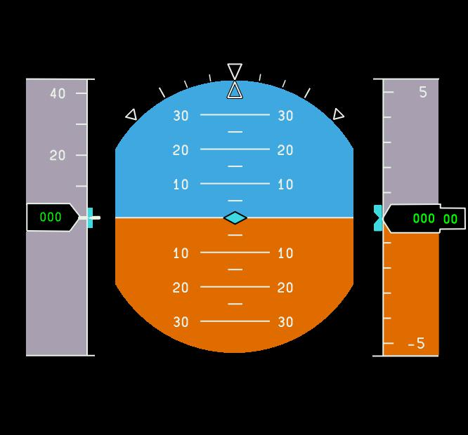

图

#### 图件1-1-PFD

[SDD-9]应按表6定义的规格设计图件1-1-PFD。

表

| Type: container | | |
| --- | --- | --- |
| Property | Value | Plugs expression |
| Visibility | true |  |
| Origin.x | 1.0 |  |
| Origin.y | 0.0 |  |
| Priority | -1 |  |
| Horizontal scale | 1.0 |  |
| Vertical scale | 1.0 |  |
| Rotate angle | 0.0 |  |
| Orientation | Counter Clockwise |  |
| Static properties | editorLinked="true" generateStaticSequence="true" maxX="381.953" maxY="1352.798" minX="-381.953" minY="-398.361" |  |
| Static init | false |  |

[注释]图3是1-1-PFD的参考图像。

图

[注释]图件1-1-PFD包含下列子辈图件/图元:

(1) 1-1-1-ADI

(2) 1-1-2-Altitude

(3) 1-1-3-Airspeed

[注释]图件1-1-PFD的别名是: symbology_layer/PFD

#### 图件1-1-1-ADI

[SDD-10]应按表7定义的规格设计图件1-1-1-ADI。

表

| Type: container | | |
| --- | --- | --- |
| Property | Value | Plugs expression |
| Visibility | true |  |
| Origin.x | 30.123 |  |
| Origin.y | -242.425 |  |
| Priority | -1 |  |
| Horizontal scale | 1.0 |  |
| Vertical scale | 1.0 |  |
| Rotate angle | 0.0 |  |
| Orientation | Counter Clockwise |  |
| Static properties | editorLinked="true" generateStaticSequence="true" maxX="381.953" maxY="467.02402" minX="-381.953" minY="-398.361" |  |
| Static init | false |  |

[注释]图4是1-1-1-ADI的参考图像。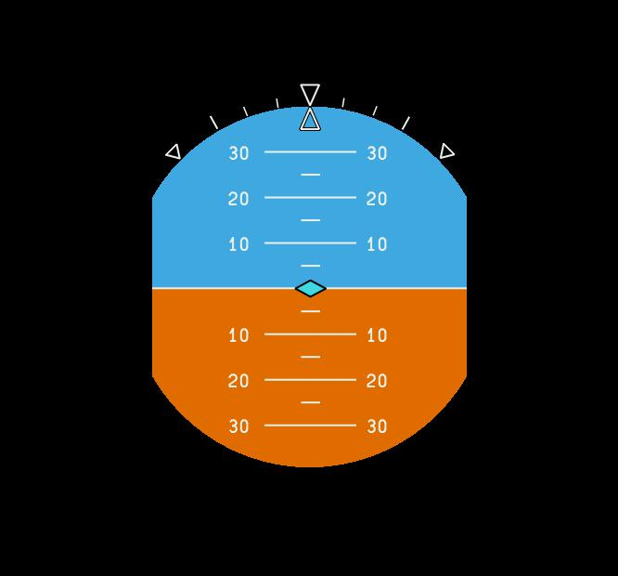

图

[注释]图件1-1-1-ADI包含下列子辈图件/图元:

(1) 1-1-1-1-ADI_masked_parts

(2) 1-1-1-2-RollFix

[注释]图件1-1-1-ADI的别名是: symbology_layer/PFD/ADI

#### 图件1-1-1-1-ADI_masked_parts

[SDD-11]应按表8定义的规格设计图件1-1-1-1-ADI_masked_parts。

表

| Type: container | | |
| --- | --- | --- |
| Property | Value | Plugs expression |
| Visibility | true |  |
| Origin.x | -29.403 |  |
| Origin.y | 241.792 |  |
| Priority | -1 |  |
| Horizontal scale | 1.0 |  |
| Vertical scale | 1.0 |  |
| Rotate angle | 0.0 |  |
| Orientation | Counter Clockwise |  |
| Static properties | editorLinked="true" generateStaticSequence="true" maxX="381.953" maxY="398.361" minX="-381.953" minY="-398.361" |  |
| Static init | false |  |

[注释]图5是1-1-1-1-ADI_masked_parts的参考图像。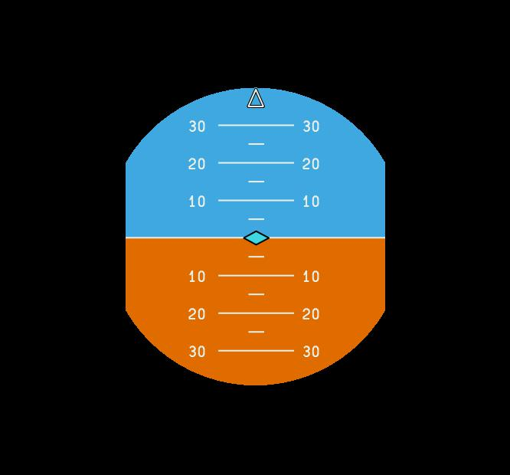

图

[注释]图件1-1-1-1-ADI_masked_parts包含下列子辈图件/图元:

(1) 1-1-1-1-a-_MaskOutlinerADI_001

(2) 1-1-1-1-1-SkyEarthAndScales

(3) 1-1-1-1-2-lunula

(4) 1-1-1-1-3-RollIndex

[注释]图件1-1-1-1-ADI_masked_parts的别名是: symbology_layer/PFD/ADI/ADI_masked_parts

#### 图元1-1-1-1-a-_MaskOutlinerADI_001

[SDD-12]应按表9定义的规格设计图元1-1-1-1-a-_MaskOutlinerADI_001。

表

| Type: stencil | | |
| --- | --- | --- |
| Property | Value | Plugs expression |
| Mask activity | true |  |
| Point1.x | -170.538 |  |
| Point1.y | 98.384 |  |
| Arc segment1.angle | 120.002 |  |
| Arc segment1.orientation | Clockwise |  |
| Point2.x | 168.362 |  |
| Point2.y | 98.384 |  |
| Point3.x | 168.362 |  |
| Point3.y | -94.716 |  |
| Arc segment3.angle | 120.002 |  |
| Arc segment3.orientation | Clockwise |  |
| Point4.x | -170.538 |  |
| Point4.y | -94.716 |  |

[注释]图元1-1-1-1-a-_MaskOutlinerADI_001的别名是: symbology_layer/PFD/ADI/ADI_masked_parts/_MaskOutlinerADI_001

#### 图件1-1-1-1-1-SkyEarthAndScales

[SDD-13]应按表10定义的规格设计图件1-1-1-1-1-SkyEarthAndScales。

表

| Type: container | | |
| --- | --- | --- |
| Property | Value | Plugs expression |
| Visibility | true |  |
| Origin.x | 0.0 |  |
| Origin.y | 0.0 |  |
| Priority | -1 |  |
| Horizontal scale | 1.0 |  |
| Vertical scale | 1.0 |  |
| Rotate angle | 0.0 | PN_ROLL_ANGLE |
| Orientation | Counter Clockwise |  |
| Static properties | editorLinked="true" generateStaticSequence="true" maxX="381.953" maxY="398.361" minX="-381.953" minY="-398.361" |  |
| Static init | false |  |

[注释]图6是1-1-1-1-1-SkyEarthAndScales的参考图像。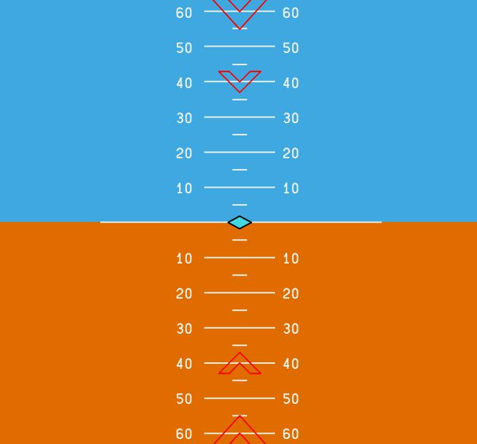

图

[注释]图件1-1-1-1-1-SkyEarthAndScales包含下列子辈图件/图元:

(1) 1-1-1-1-1-1-SKY_EARTH

(2) 1-1-1-1-1-2-ScaleAndAlarms

(3) 1-1-1-1-1-3-BugReference

[注释]图件1-1-1-1-1-SkyEarthAndScales的别名是: symbology_layer/PFD/ADI/ADI_masked_parts/SkyEarthAndScales

#### 图件1-1-1-1-1-1-SKY_EARTH

[SDD-14]应按表11定义的规格设计图件1-1-1-1-1-1-SKY_EARTH。

表

| Type: container | | |
| --- | --- | --- |
| Property | Value | Plugs expression |
| Visibility | true |  |
| Origin.x | 0.0 |  |
| Origin.y | 0.0 | PN_PITCH_ANGLE |
| Priority | -1 |  |
| Horizontal scale | 1.0 |  |
| Vertical scale | 1.0 |  |
| Rotate angle | 0.0 |  |
| Orientation | Counter Clockwise |  |
| Static properties | editorLinked="true" generateStaticSequence="true" maxX="381.953" maxY="398.361" minX="-381.953" minY="-398.361" |  |
| Static init | false |  |

[注释]图7是1-1-1-1-1-1-SKY_EARTH的参考图像。

图

[注释]图件1-1-1-1-1-1-SKY_EARTH包含下列子辈图件/图元:

(1) 1-1-1-1-1-1-a-SkyRect

(2) 1-1-1-1-1-1-b-EarthRect

[注释]图件1-1-1-1-1-1-SKY_EARTH的别名是: symbology_layer/PFD/ADI/ADI_masked_parts/SkyEarthAndScales/SKY_EARTH

#### 图元1-1-1-1-1-1-a-SkyRect

[SDD-15]应按表12定义的规格设计图元1-1-1-1-1-1-a-SkyRect。

表

| Type: rectangle | | |
| --- | --- | --- |
| Property | Value | Plugs expression |
| Visibility | true |  |
| First point.x | -375.953 |  |
| First point.y | 0.0 |  |
| Third point.x | 375.953 |  |
| Third point.y | 392.361 |  |
| Line width | {2.4, 1.5, 3.5} [#0] |  |
| Line stipple | 0 |  |
| Line cap | round |  |
| Haloing | false |  |
| Outline color | -1 |  |
| Outline opacity | 255 |  |
| Filled color | CYAN3 [#18] |  |
| Filled opacity | 255 |  |
| Polygon smooth | false |  |
| Texture control | false |  |
| Texture | horizAlign="center" horizPattern="1.0" vertAlign="middle" vertPattern="1.0" |  |
| Texture ID | -1 |  |
| Modulate | false |  |

[SDD-16]应按表13设置适用于1-1-1-1-1-1-a-SkyRect的mask的状态：

表

| Applicable Mask | State |
| --- | --- |
| 1-1-1-1-a-_MaskOutlinerADI_001 | Active |

[注释]图元1-1-1-1-1-1-a-SkyRect的别名是: symbology_layer/PFD/ADI/ADI_masked_parts/SkyEarthAndScales/SKY_EARTH/SkyRect

#### 图元1-1-1-1-1-1-b-EarthRect

[SDD-17]应按表14定义的规格设计图元1-1-1-1-1-1-b-EarthRect。

表

| Type: rectangle | | |
| --- | --- | --- |
| Property | Value | Plugs expression |
| Visibility | true |  |
| First point.x | -375.953 |  |
| First point.y | -392.361 |  |
| Third point.x | 375.953 |  |
| Third point.y | -0.0 |  |
| Line width | {2.4, 1.5, 3.5} [#0] |  |
| Line stipple | 0 |  |
| Line cap | round |  |
| Haloing | false |  |
| Outline color | -1 |  |
| Outline opacity | 255 |  |
| Filled color | AMBER3 [#33] |  |
| Filled opacity | 255 |  |
| Polygon smooth | true |  |
| Texture control | false |  |
| Texture | horizAlign="center" horizPattern="1.0" vertAlign="middle" vertPattern="1.0" |  |
| Texture ID | -1 |  |
| Modulate | false |  |

[SDD-18]应按表15设置适用于1-1-1-1-1-1-b-EarthRect的mask的状态：

表

| Applicable Mask | State |
| --- | --- |
| 1-1-1-1-a-_MaskOutlinerADI_001 | Active |

[注释]图元1-1-1-1-1-1-b-EarthRect的别名是: symbology_layer/PFD/ADI/ADI_masked_parts/SkyEarthAndScales/SKY_EARTH/EarthRect

#### 图件1-1-1-1-1-2-ScaleAndAlarms

[SDD-19]应按表16定义的规格设计图件1-1-1-1-1-2-ScaleAndAlarms。

表

| Type: container | | |
| --- | --- | --- |
| Property | Value | Plugs expression |
| Visibility | true |  |
| Origin.x | 0.0 |  |
| Origin.y | 0.0 |  |
| Priority | -1 |  |
| Horizontal scale | 1.0 |  |
| Vertical scale | 1.0 |  |
| Rotate angle | 0.0 |  |
| Orientation | Counter Clockwise |  |
| Static properties | editorLinked="true" generateStaticSequence="true" maxX="202.021" maxY="128.672" minX="-202.021" minY="-128.789" |  |
| Static init | false |  |

[注释]图8是1-1-1-1-1-2-ScaleAndAlarms的参考图像。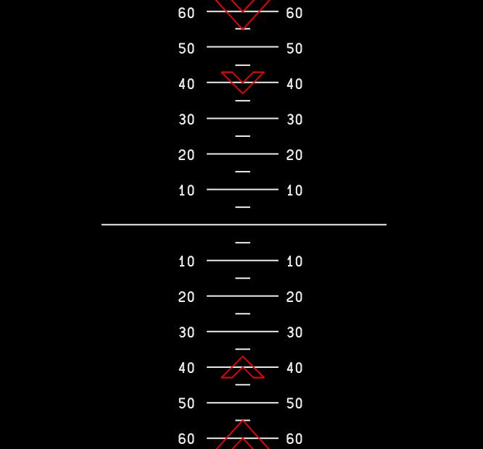

图

[注释]图件1-1-1-1-1-2-ScaleAndAlarms包含下列子辈图件/图元:

(1) 1-1-1-1-1-2-1-PitchScale

(2) 1-1-1-1-1-2-2-HighWarning

(3) 1-1-1-1-1-2-3-HighAlarm

(4) 1-1-1-1-1-2-4-LowWarning

(5) 1-1-1-1-1-2-5-LowAlarm

[注释]图件1-1-1-1-1-2-ScaleAndAlarms的别名是: symbology_layer/PFD/ADI/ADI_masked_parts/SkyEarthAndScales/ScaleAndAlarms

#### 图件1-1-1-1-1-2-1-PitchScale

[SDD-20]应按表17定义的规格设计图件1-1-1-1-1-2-1-PitchScale。

表

| Type: container | | |
| --- | --- | --- |
| Property | Value | Plugs expression |
| Visibility | true |  |
| Origin.x | 0.0 |  |
| Origin.y | 0.0 | PN_PITCH_ANGLE |
| Priority | -1 |  |
| Horizontal scale | 1.0 |  |
| Vertical scale | 1.0 |  |
| Rotate angle | 0.0 |  |
| Orientation | Counter Clockwise |  |
| Static properties | editorLinked="true" generateStaticSequence="true" maxX="202.021" maxY="128.672" minX="-202.021" minY="-128.789" |  |
| Static init | false |  |

[注释]图9是1-1-1-1-1-2-1-PitchScale的参考图像。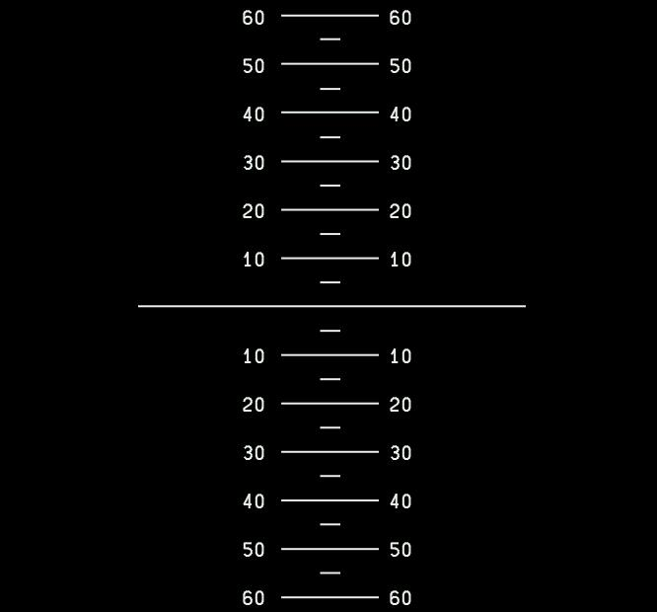

图

[注释]图件1-1-1-1-1-2-1-PitchScale包含下列子辈图件/图元:

(1) 1-1-1-1-1-2-1-1-SCALE_DAN_F00

[注释]图件1-1-1-1-1-2-1-PitchScale的别名是: symbology_layer/PFD/ADI/ADI_masked_parts/SkyEarthAndScales/ScaleAndAlarms/PitchScale

#### 图件1-1-1-1-1-2-1-1-SCALE_DAN_F00

[SDD-21]应按表18定义的规格设计图件1-1-1-1-1-2-1-1-SCALE_DAN_F00。

表

| Type: container | | |
| --- | --- | --- |
| Property | Value | Plugs expression |
| Visibility | true |  |
| Origin.x | 0.0 |  |
| Origin.y | 0.0 |  |
| Priority | -1 |  |
| Horizontal scale | 1.0 |  |
| Vertical scale | 1.0 |  |
| Rotate angle | 0.0 |  |
| Orientation | Counter Clockwise |  |
| Static properties | editorLinked="true" generateStaticSequence="true" maxX="202.021" maxY="128.672" minX="-202.021" minY="-128.789" |  |
| Static init | true |  |

[注释]图10是1-1-1-1-1-2-1-1-SCALE_DAN_F00的参考图像。

图

[注释]图件1-1-1-1-1-2-1-1-SCALE_DAN_F00包含下列子辈图件/图元:

(1) 1-1-1-1-1-2-1-1-1-begin_moving

[注释]图件1-1-1-1-1-2-1-1-SCALE_DAN_F00的别名是: symbology_layer/PFD/ADI/ADI_masked_parts/SkyEarthAndScales/ScaleAndAlarms/PitchScale/SCALE_DAN_F00

#### 图件1-1-1-1-1-2-1-1-1-begin_moving

[SDD-22]应按表19定义的规格设计图件1-1-1-1-1-2-1-1-1-begin_moving。

表

| Type: container | | |
| --- | --- | --- |
| Property | Value | Plugs expression |
| Visibility | true |  |
| Origin.x | 1.941 |  |
| Origin.y | 0.358 |  |
| Priority | -1 |  |
| Horizontal scale | 1.0 |  |
| Vertical scale | 1.0 |  |
| Rotate angle | 0.0 |  |
| Orientation | Counter Clockwise |  |
| Static properties | editorLinked="true" generateStaticSequence="true" maxX="202.021" maxY="128.672" minX="-202.021" minY="-128.789" |  |
| Static init | false |  |

[注释]图11是1-1-1-1-1-2-1-1-1-begin_moving的参考图像。

图

[注释]图件1-1-1-1-1-2-1-1-1-begin_moving包含下列子辈图件/图元:

(1) 1-1-1-1-1-2-1-1-1-1-PART_4

(2) 1-1-1-1-1-2-1-1-1-2-PART_1

(3) 1-1-1-1-1-2-1-1-1-3-PART_3

(4) 1-1-1-1-1-2-1-1-1-4-PART_2

(5) 1-1-1-1-1-2-1-1-1-5-HORIZON_LINE

[注释]图件1-1-1-1-1-2-1-1-1-begin_moving的别名是: symbology_layer/PFD/ADI/ADI_masked_parts/SkyEarthAndScales/ScaleAndAlarms/PitchScale/SCALE_DAN_F00/b1-1-1-1-1-2-1-1-1-

#### 图件1-1-1-1-1-2-1-1-1-1-PART_4

[SDD-23]应按表20定义的规格设计图件1-1-1-1-1-2-1-1-1-1-PART_4。

表

| Type: container | | |
| --- | --- | --- |
| Property | Value | Plugs expression |
| Visibility | true |  |
| Origin.x | -1.941 |  |
| Origin.y | -343.674 |  |
| Priority | -1 |  |
| Horizontal scale | 1.0 |  |
| Vertical scale | 1.0 |  |
| Rotate angle | 0.0 |  |
| Orientation | Counter Clockwise |  |
| Static properties | editorLinked="true" generateStaticSequence="true" maxX="91.27835" maxY="128.672" minX="-94.209" minY="-111.447" |  |
| Static init | false |  |

[注释]图12是1-1-1-1-1-2-1-1-1-1-PART_4的参考图像。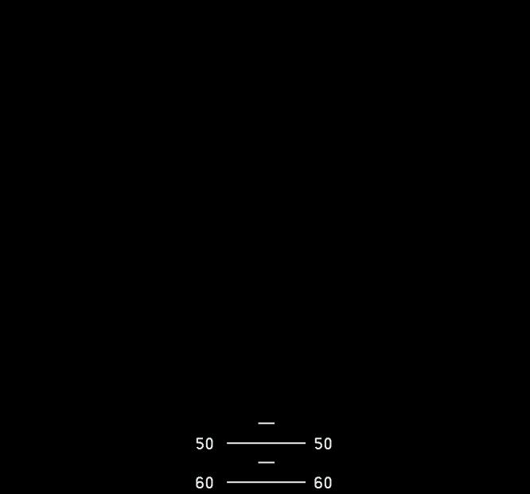

图

[注释]图件1-1-1-1-1-2-1-1-1-1-PART_4包含下列子辈图件/图元:

(1) 1-1-1-1-1-2-1-1-1-1-a-text

(2) 1-1-1-1-1-2-1-1-1-1-b-text

(3) 1-1-1-1-1-2-1-1-1-1-c-text

(4) 1-1-1-1-1-2-1-1-1-1-d-text

(5) 1-1-1-1-1-2-1-1-1-1-e-text

(6) 1-1-1-1-1-2-1-1-1-1-f-text

(7) 1-1-1-1-1-2-1-1-1-1-g-text

(8) 1-1-1-1-1-2-1-1-1-1-h-text

(9) 1-1-1-1-1-2-1-1-1-1-i-line

(10) 1-1-1-1-1-2-1-1-1-1-j-line

(11) 1-1-1-1-1-2-1-1-1-1-k-line

(12) 1-1-1-1-1-2-1-1-1-1-l-line

(13) 1-1-1-1-1-2-1-1-1-1-m-line

(14) 1-1-1-1-1-2-1-1-1-1-n-line

(15) 1-1-1-1-1-2-1-1-1-1-o-line

(16) 1-1-1-1-1-2-1-1-1-1-p-line

(17) 1-1-1-1-1-2-1-1-1-1-q-line

(18) 1-1-1-1-1-2-1-1-1-1-r-text

(19) 1-1-1-1-1-2-1-1-1-1-s-text

(20) 1-1-1-1-1-2-1-1-1-1-t-line

[注释]图件1-1-1-1-1-2-1-1-1-1-PART_4的别名是: symbology_layer/PFD/ADI/ADI_masked_parts/SkyEarthAndScales/ScaleAndAlarms/PitchScale/SCALE_DAN_F00/b1-1-1-1-1-2-1-1-1-1-

#### 图元1-1-1-1-1-2-1-1-1-1-a-text

[SDD-24]应按表21定义的规格设计图元1-1-1-1-1-2-1-1-1-1-a-text。

表

| Type: text | | |
| --- | --- | --- |
| Property | Value | Plugs expression |
| Visibility | true |  |
| Multiline | false |  |
| Position.x | -88.209 |  |
| Position.y | 41.688 |  |
| Text maximum length | 255 |  |
| Text representation | char |  |
| Text value | [54, 48, 0] |  |
| Haloing | false |  |
| Outline color | WHITE1 [#41] |  |
| Font line width | {2.75, 2.25, 4.25} [#2] |  |
| Font id | 1 |  |
| Horizontal alignment | left |  |
| Vertical alignment | bottom |  |

[SDD-25]应按表22设置适用于1-1-1-1-1-2-1-1-1-1-a-text的mask的状态：

表

| Applicable Mask | State |
| --- | --- |
| 1-1-1-1-a-_MaskOutlinerADI_001 | Active |

[注释]图元1-1-1-1-1-2-1-1-1-1-a-text的别名是: symbology_layer/PFD/ADI/ADI_masked_parts/SkyEarthAndScales/ScaleAndAlarms/PitchScale/SCALE_DAN_F00/b1-1-1-1-1-2-1-1-1-1-a

#### 图元1-1-1-1-1-2-1-1-1-1-b-text

[SDD-26]应按表23定义的规格设计图元1-1-1-1-1-2-1-1-1-1-b-text。

表

| Type: text | | |
| --- | --- | --- |
| Property | Value | Plugs expression |
| Visibility | true |  |
| Multiline | false |  |
| Position.x | 61.256 |  |
| Position.y | 41.688 |  |
| Text maximum length | 255 |  |
| Text representation | char |  |
| Text value | [54, 48, 0] |  |
| Haloing | false |  |
| Outline color | WHITE1 [#41] |  |
| Font line width | {2.75, 2.25, 4.25} [#2] |  |
| Font id | 1 |  |
| Horizontal alignment | left |  |
| Vertical alignment | bottom |  |

[SDD-27]应按表24设置适用于1-1-1-1-1-2-1-1-1-1-b-text的mask的状态：

表

| Applicable Mask | State |
| --- | --- |
| 1-1-1-1-a-_MaskOutlinerADI_001 | Active |

[注释]图元1-1-1-1-1-2-1-1-1-1-b-text的别名是: symbology_layer/PFD/ADI/ADI_masked_parts/SkyEarthAndScales/ScaleAndAlarms/PitchScale/SCALE_DAN_F00/b1-1-1-1-1-2-1-1-1-1-b

#### 图元1-1-1-1-1-2-1-1-1-1-c-text

[SDD-28]应按表25定义的规格设计图元1-1-1-1-1-2-1-1-1-1-c-text。

表

| Type: text | | |
| --- | --- | --- |
| Property | Value | Plugs expression |
| Visibility | true |  |
| Multiline | false |  |
| Position.x | -88.209 |  |
| Position.y | -7.357 |  |
| Text maximum length | 255 |  |
| Text representation | char |  |
| Text value | [55, 48, 0] |  |
| Haloing | false |  |
| Outline color | WHITE1 [#41] |  |
| Font line width | {2.75, 2.25, 4.25} [#2] |  |
| Font id | 1 |  |
| Horizontal alignment | left |  |
| Vertical alignment | bottom |  |

[SDD-29]应按表26设置适用于1-1-1-1-1-2-1-1-1-1-c-text的mask的状态：

表

| Applicable Mask | State |
| --- | --- |
| 1-1-1-1-a-_MaskOutlinerADI_001 | Active |

[注释]图元1-1-1-1-1-2-1-1-1-1-c-text的别名是: symbology_layer/PFD/ADI/ADI_masked_parts/SkyEarthAndScales/ScaleAndAlarms/PitchScale/SCALE_DAN_F00/b1-1-1-1-1-2-1-1-1-1-c

#### 图元1-1-1-1-1-2-1-1-1-1-d-text

[SDD-30]应按表27定义的规格设计图元1-1-1-1-1-2-1-1-1-1-d-text。

表

| Type: text | | |
| --- | --- | --- |
| Property | Value | Plugs expression |
| Visibility | true |  |
| Multiline | false |  |
| Position.x | 61.256 |  |
| Position.y | -7.357 |  |
| Text maximum length | 255 |  |
| Text representation | char |  |
| Text value | [55, 48, 0] |  |
| Haloing | false |  |
| Outline color | WHITE1 [#41] |  |
| Font line width | {2.75, 2.25, 4.25} [#2] |  |
| Font id | 1 |  |
| Horizontal alignment | left |  |
| Vertical alignment | bottom |  |

[SDD-31]应按表28设置适用于1-1-1-1-1-2-1-1-1-1-d-text的mask的状态：

表

| Applicable Mask | State |
| --- | --- |
| 1-1-1-1-a-_MaskOutlinerADI_001 | Active |

[注释]图元1-1-1-1-1-2-1-1-1-1-d-text的别名是: symbology_layer/PFD/ADI/ADI_masked_parts/SkyEarthAndScales/ScaleAndAlarms/PitchScale/SCALE_DAN_F00/b1-1-1-1-1-2-1-1-1-1-d