Assignment – 1
- Bar Chart – (Sales by Product Line)
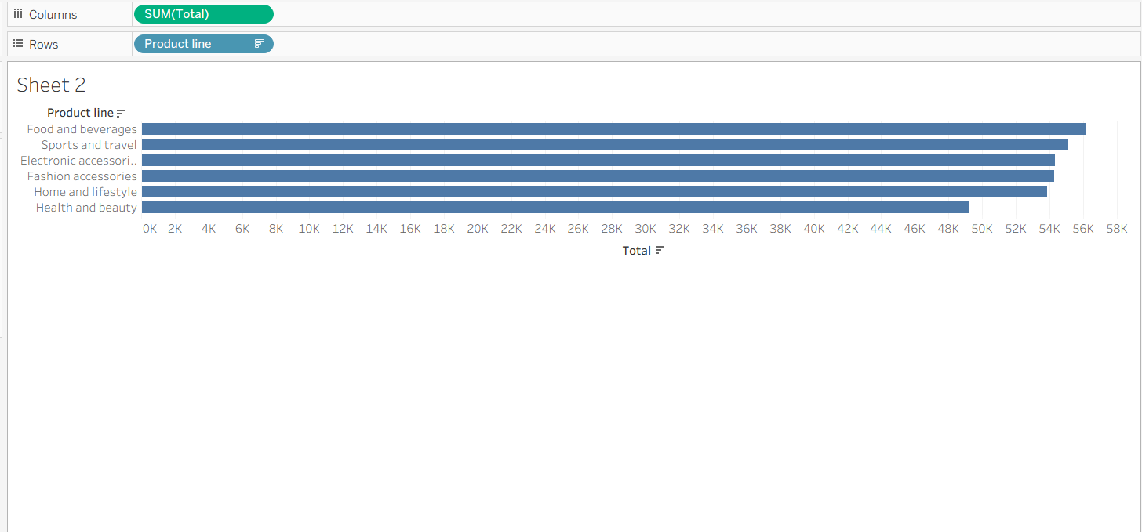
- Pie chart – (Customer Type Distribution)
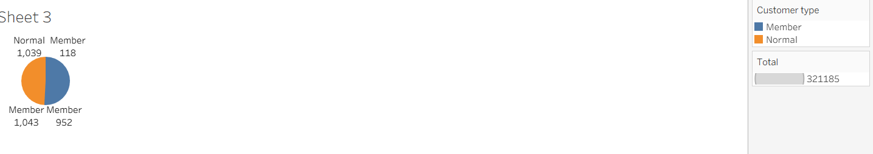
- Stacked Bar Chart – (Branch Sales by Gender)
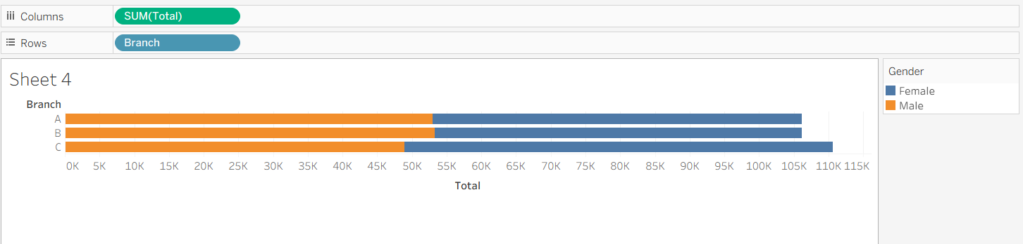
- Line Chart- (Sales Trend Over Time)
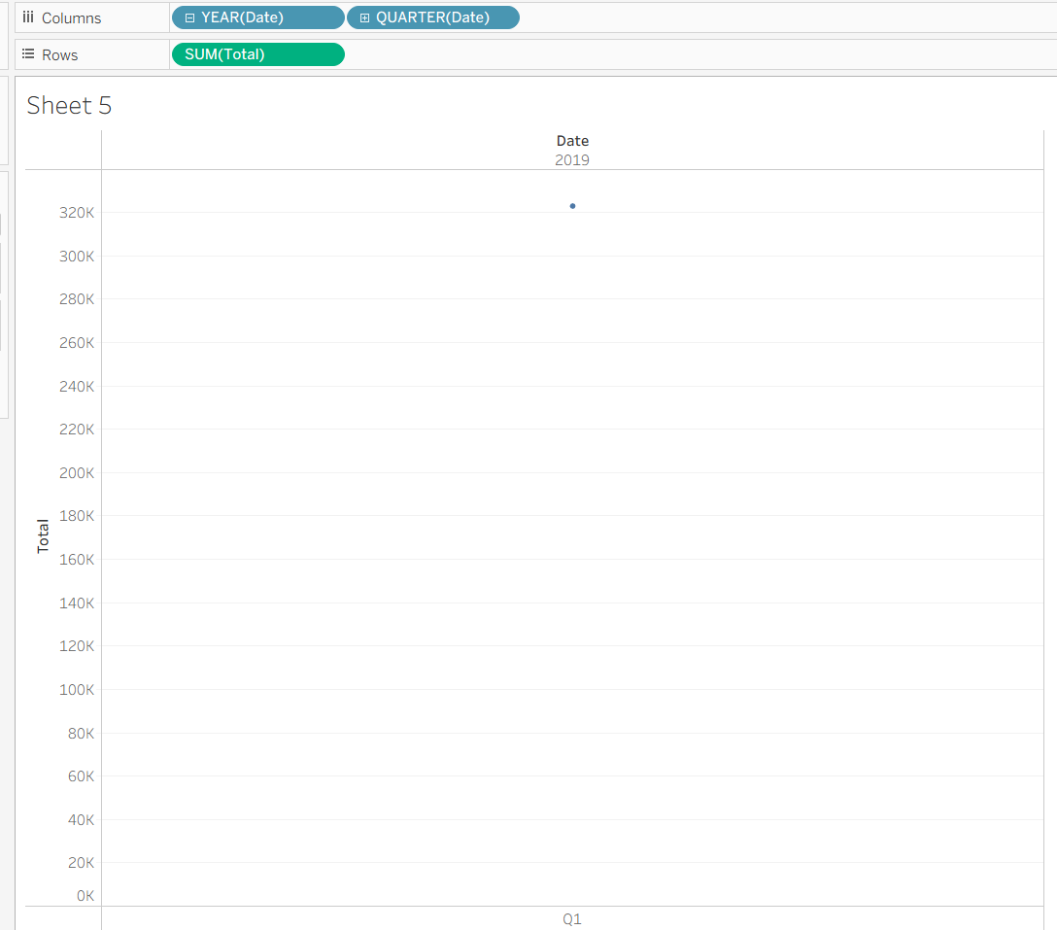
- Dashboard

