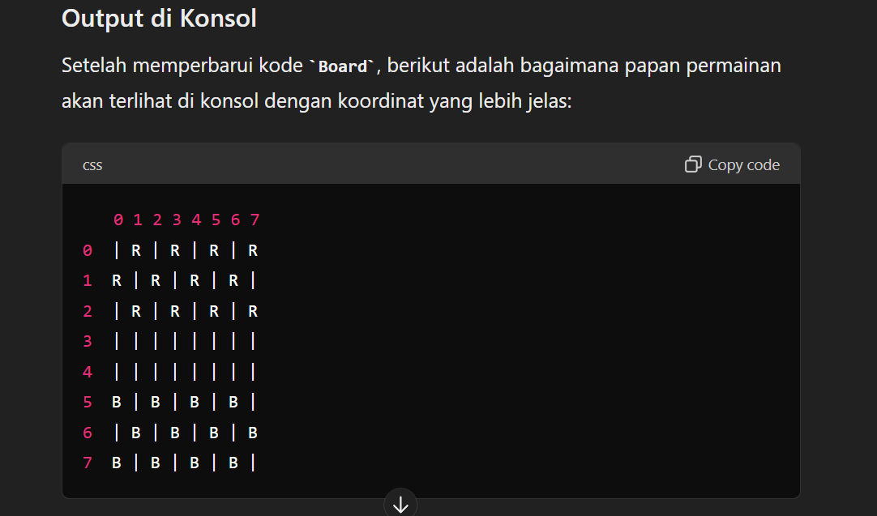

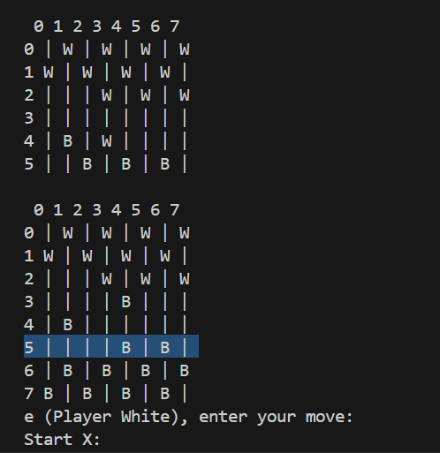

1,2

2,3

0,5

1,4

2,3

3,4

2,5

4,3

3.2

5.4

Lain

// public bool MovePiece(int startX, int startY, int endX, int endY)

// {

// IPiece piece = grid[startX, startY];

// if (piece == null || piece.Type == PieceType.Empty)

// {

// return false;

// }

// if (piece.Move(startX, startY, endX, endY))

// {

// grid[endX, endY] = piece;

// grid[startX, startY] = new Piece(PieceType.Empty);

// return true;

// }

// return false;

// }

//2 loncat

if (Math.Abs(dx) == 2 && Math.Abs(dy) == 2)

{

int captureX = startX + dx / 2;

int captureY = startY + dy / 2;

IPiece capturedPiece = grid[captureX, captureY];

if (capturedPiece != null && capturedPiece.Type != PieceType.Empty && capturedPiece.Type != piece.Type)

{

// Menangkap bidak

grid[captureX, captureY] = new Piece(PieceType.Empty);

grid[endX, endY] = piece;

grid[startX, startY] = new Piece(PieceType.Empty);

return true;

}

}