SQL BUSINESS CASE

**1. Import the dataset and do usual exploratory analysis steps like checking the structure & characteristics of the dataset.**

**A. Data type of all columns in the “customers” table.**

DESCRIBE

From business_data.customers;

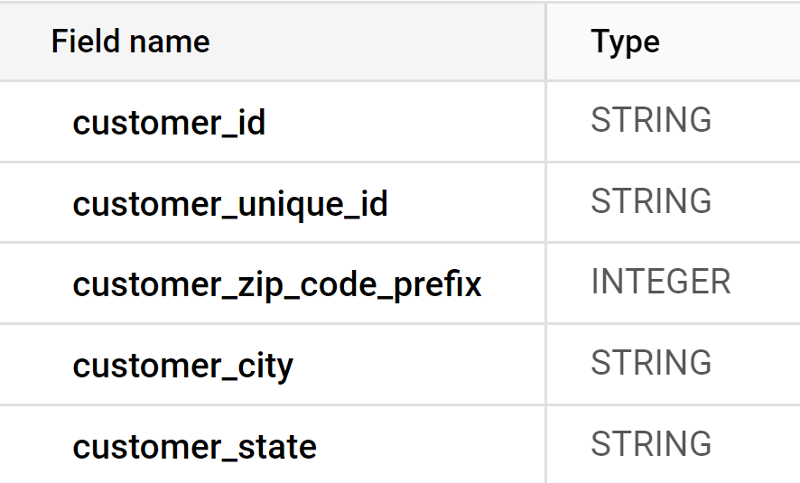

B. Get the time range between which the orders were placed.

Select

min (order_purchase_timestamp) as first_order,

max(order_purchase_timestamp) as last_order

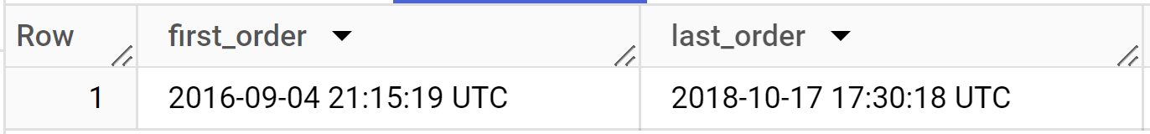From business_data.orders;

C. Count the Cities & States of customers who ordered during the given period.

with demo as (

select * from business_data.orders as o

join business_data.customers as c

on o.customer_id = c.customer_id)

select

count(distinct customer_city) as num_unique_cities,

count(distinct customer_state) as num_unique_states

from demo

where order_purchase_timestamp between "2016-09-04" and "2018-10-17”;

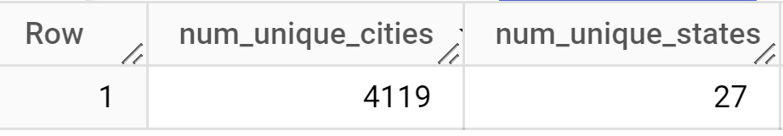

II.In-depth Exploration:

A. Is there a growing trend in the no. of orders placed over the past years?

Select

Extract (year from or der_purchase_timestamp) as order_year,

Count(*) as order_count

From business_data.orders

Group by (year from order_purchase_timestamp)

Order by order_year;

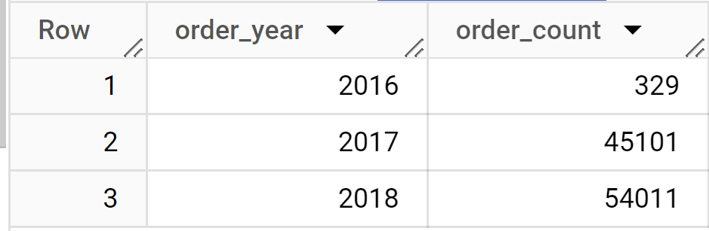

B. Can we see some kind of monthly seasonality in terms of the no. of orders being placed?

Select

extract(year from order_purchase_timestamp) as year,

extract(month from order_purchase_timestamp) as month,

count(*) as order_count

from business_data.orders

Group by

extract(year from order_purchase_timestamp),

extract(month from order_purchase_timestamp)

order by year,month;

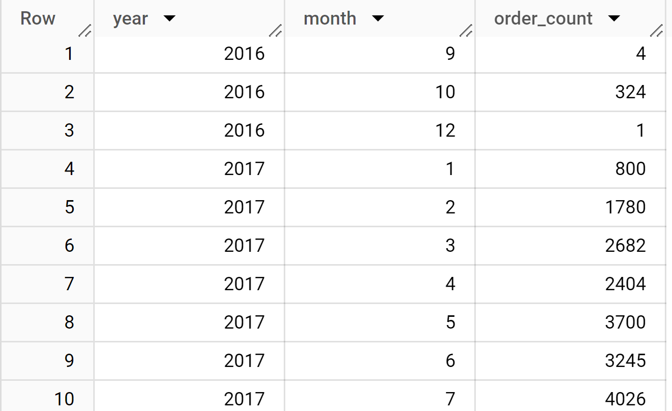

C. During what time of the day, do the Brazilian customers mostly place their orders?

(Dawn, Morning, Afternoon or Night)

● 0-6 hrs : Dawn

● 7-12 hrs : Mornings

● 13-18 hrs : Afternoon

● 19-23 hrs : Night.

Select c.customer_city,

case

when extract(hour from order_purchase_timestamp) between 0 and 6 then "dawn"

when extract(hour from order_purchase_timestamp) between 7 and 12 then "morning"

when extract(hour from order_purchase_timestamp) between 13 and 18 then "afternoon"

else "night"

end as order_time_category,

count(*) as order_count

from business_data.orders as o

 join business_data.customers as c

 on o.customer_id = c.customer_id

where c.customer_city = "brasilia"

group by order_time_category,c.customer_city

order by order_count desc;

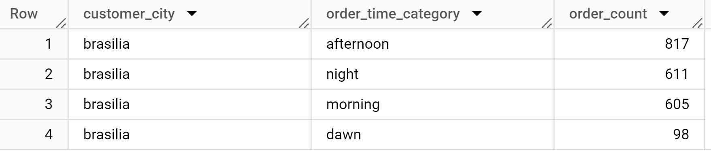

III. Evolution of E-commerce orders in the Brazil region:

A.Get the month on month no. of orders placed in each state.

With demo as (

Select *

from business_data.customers as c

Right join business_data.orders as o

On c.customer_id=o.customer_id)

Select extract ( month from order_purchase_timestamp) as month,

customer_state,

count (*)as num_orders

From demo

Group by month,customer_state

Order by month,customer_state;

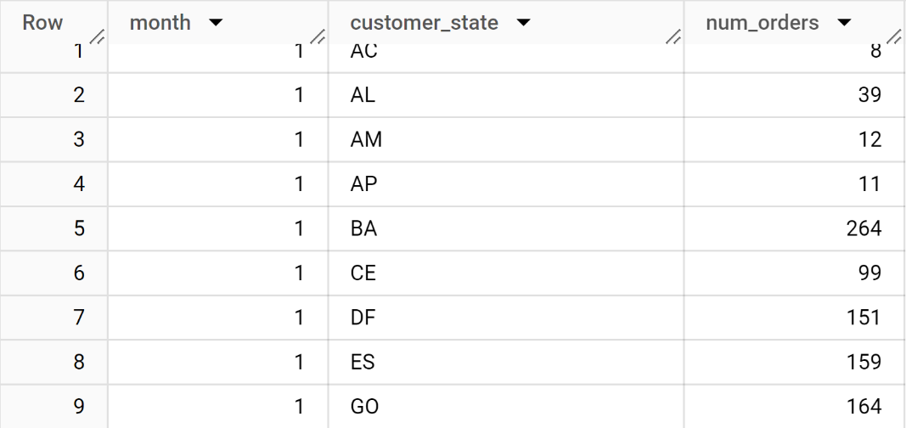

B. How are the customers distributed across all the states?

Select Customer_state,count (*)as customer_count

From business_data.customers

Group by customer_state

Order by customer_count desc;

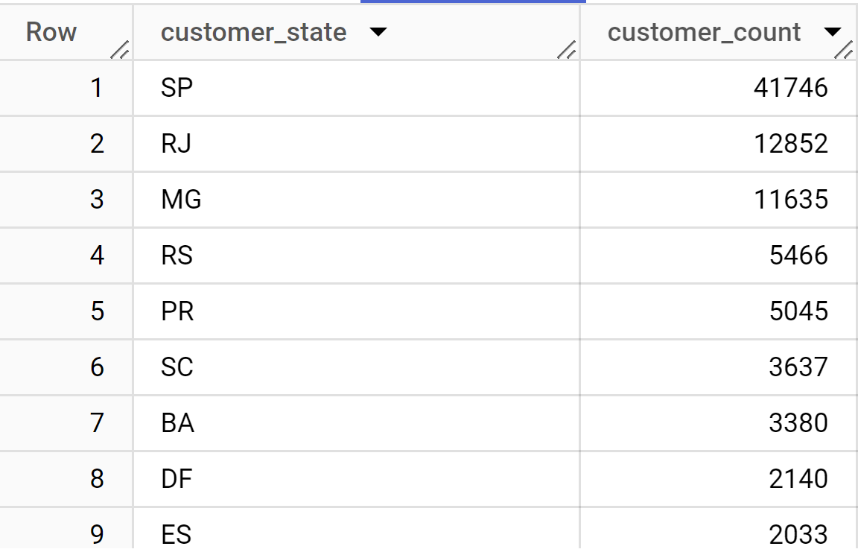

IV. .Impact on Economy: Analyze the money movement by e-commerce by looking at order prices, freight and others.

A. Calculate the Total & Average value of order price for each state.

Select s.seller_state, sum(price) AS total_order_price,

avg (price)as avg_order_price from business_data.sellers as s

Join business_data.order_items as o

On s.seller_id = o.seller_id

Group by s.seller_state;

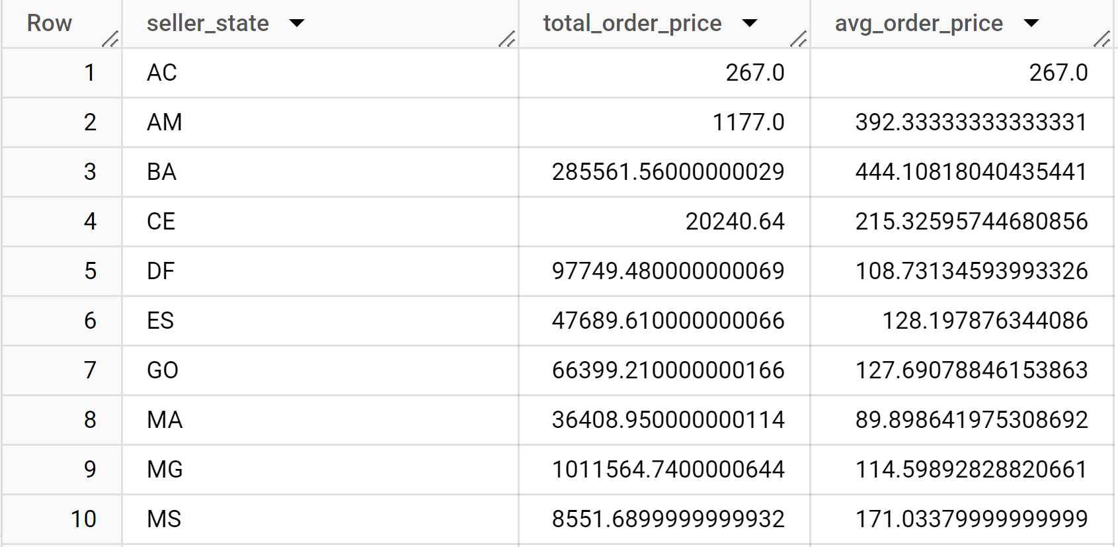

B.Calculate the Total & Average value of order freight for each state.

Select s.seller_state,sum(freight_value) as total_order_freight,

avg(freight_value) as avg_order_freight from business_data.order_items as o

join business_data.sellers as s

on o.seller_id = s.seller_id

group by s.seller_state;

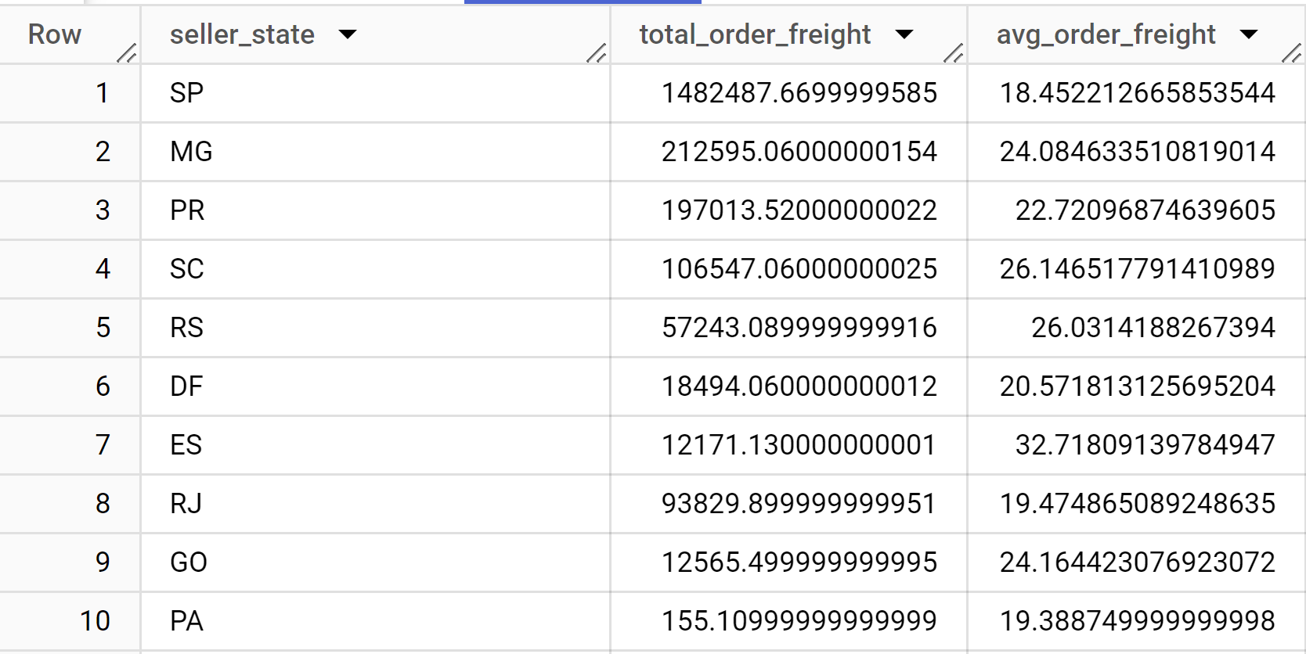

V. Analysis based on sales, freight and delivery time.

A.Find the no. of days taken to deliver each order from the order’s purchase date as delivery time. Also, calculate the difference (in days(between the estimated & actual delivery date of an order. Do this in a single query.

Select order_id,

DATE_DIFF(order_delivered_customer_date,order_purchase_timestamp,DAY)as delivery_time,

DATE_DIFF(order_estimated_delivery_date,order_delivered_customer_date,DAY)as diff_estimated_delivery

from business_data.orders;

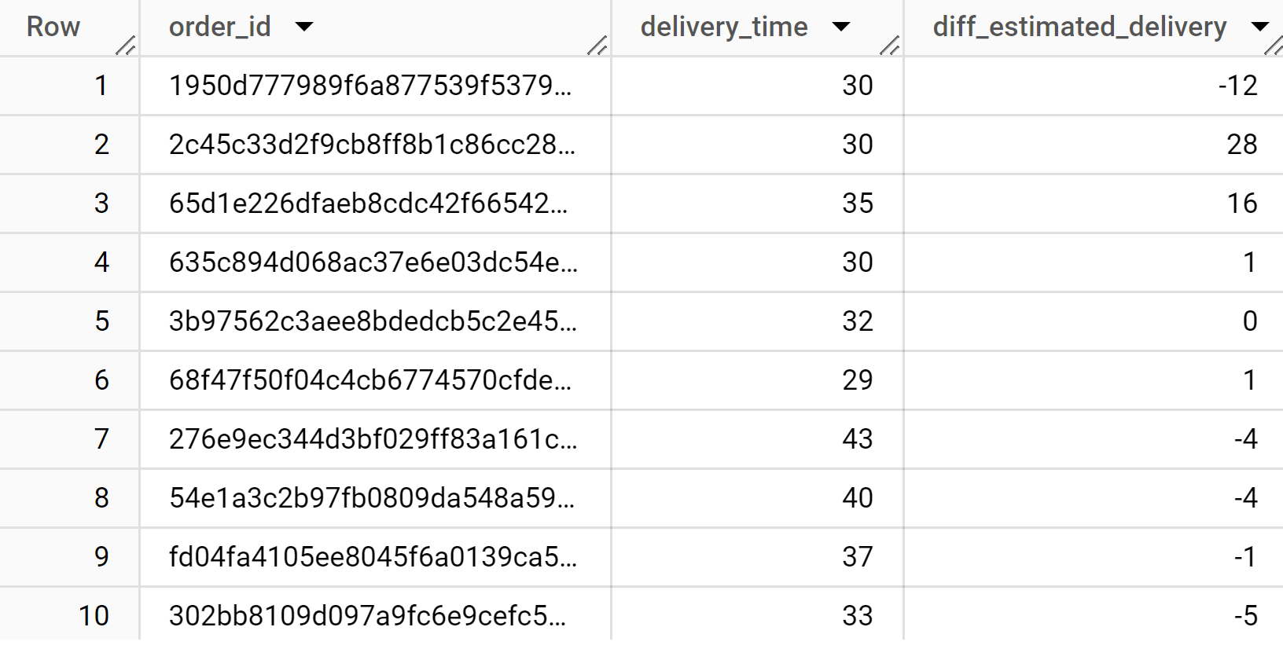

B.Find out the top 5 states with the highest & lowest average freight value.

**TOP 5 state highest average freight value**

Select s.seller_state,avg (freight_value) as avg_freight_value

from business_data.order_items as o

full join business_data.sellers as s

 on o.seller_id = s.seller_id

 group by s.seller_state

 order by avg_freight_value desc

 limit 5;

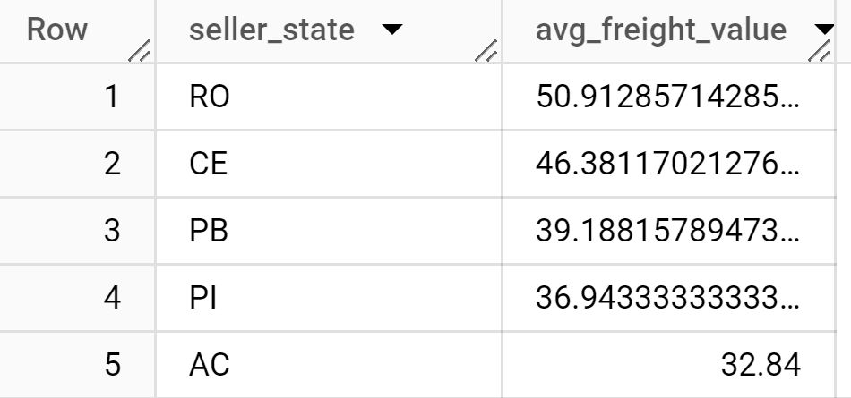

**TOP 5 state lowest average freight value**

select s.seller_state,avg(freight_value) as avg_freight_value

from business_data.order_items as o

full join business_data.sellers as s

on o.seller_id = s.seller_id

group by s.seller_state

order by avg_freight_value asc

limit 5;

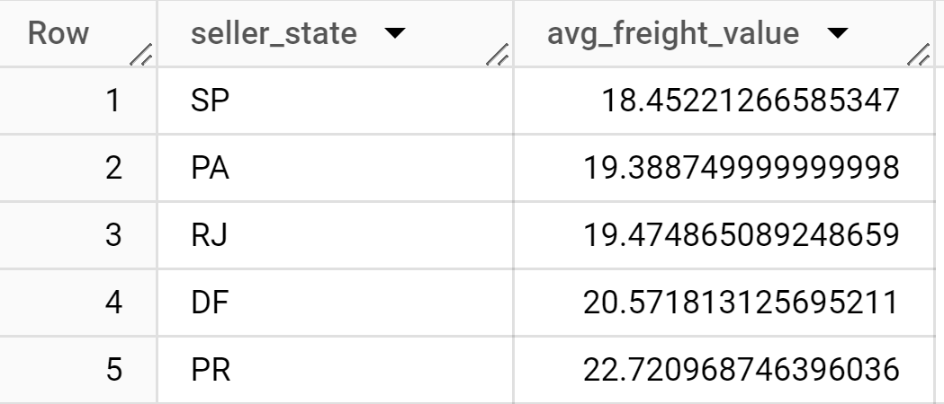

C.Find out the top 5 states with the highest & lowest average delivery time.

Top 5 state highest average delivery time

with demo as (

select * from business_data.orders as o

join business_data.customers as c

on o.customer_id = c.customer_id

)

select customer_state, avg(DATE_DIFF(order_delivered_customer_date,order_purchase_timestamp,HOUR)) as avg_delivery_time

from demo

group by customer_state

order by avg_delivery_time desc

limit 5;

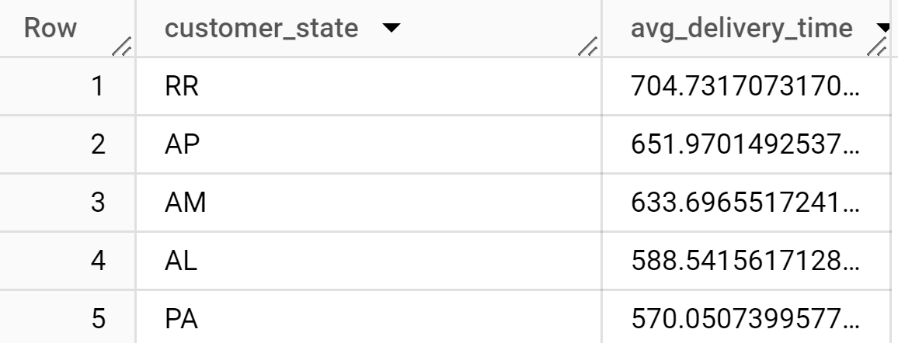

Top 5 state lowest average delivery time

with demo as (

select * from business_data.orders as o

join business_data.customers as c

on o.customer_id = c.customer_id

)

select customer_state, avg(DATE_DIFF(order_delivered_customer_date,order_purchase_timestamp,HOUR)) as avg_delivery_time

from demo

group by customer_state

order by avg_delivery_time asc

limit 5;

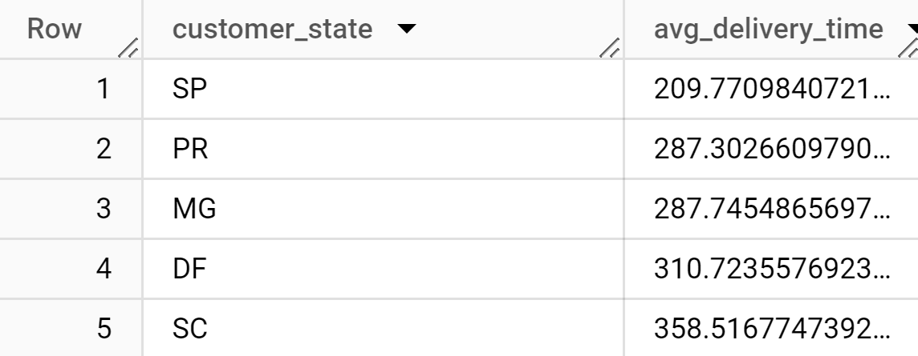

D. Find out the top 5 states where the order delivery is really fast as compared to the estimated date of delivery. You can use the difference between the averages of actual & estimated delivery date to figure out how fast the delivery was for each state.

with demo as

(select * from business_data.orders as o

join business_data.customers as c

on o.customer_id = c.customer_id)

select customer_state,

date_diff(order_delivered_customer_date,order_purchase_timestamp,day)-

date_diff(order_estimated_delivery_date,order_purchase_timestamp, day)

as delivery_speed

from demo

where order_status="delivered"

group by customer_state,delivery_speed

order by delivery_speed desc

limit 5;

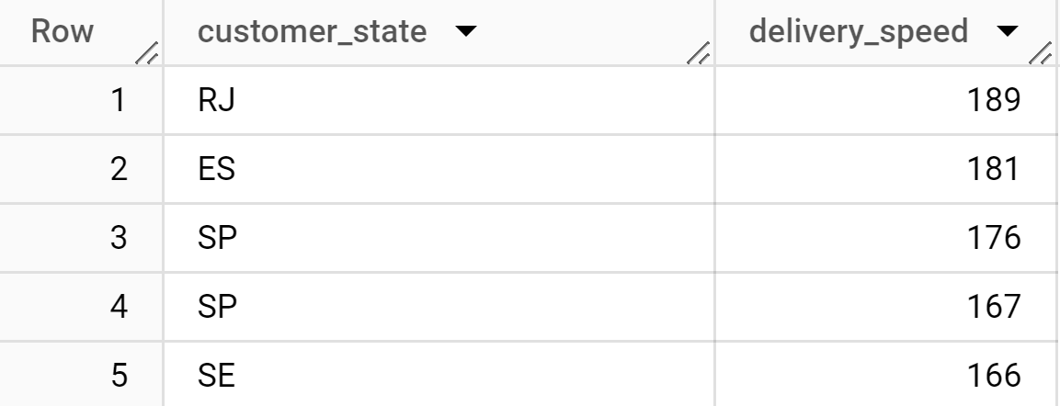

VI. Analysis based on the payments:

A.Find the month on month no. of orders placed using different payment types.

select

extract(year from o.order_purchase_timestamp) as year,

extract(month from o.order_purchase_timestamp) as month,

p.payment_type,

count(*) as num_orders

from business_data.orders as o

join business_data.payments as p

on o.order_id = p.order_id

group by year,month,p.payment_type

order by year,month,p.payment_type

limit 10;

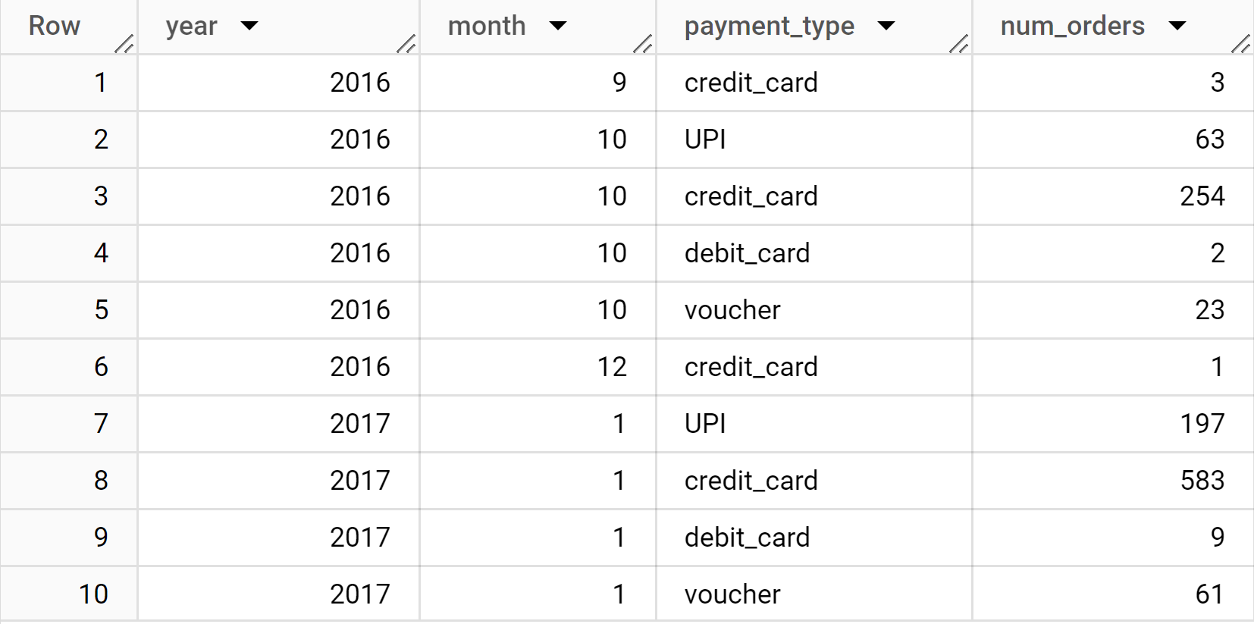

B.Find the no. of orders placed on the basis of the payment installments that have been paid.

Select count(distinct order_id) as num_orders

from business_data.payments

where payment_installments =1;

