FACULTY OF ENGINEERING
AHMADU BELLO UNIVERSITY, ZARIA

COMPARATIVE ANALYSIS OF UNSUPERVISED ANOMALY DETECTION MODELS FOR CRYPTOCURRENCY TRANSACTIONS

BY

NAZRUL ISLAM MUHAMMAD AL ABBAD

P25EGC8074

PROGRAMME:
MSc ARTIFICICIAL INTELLIGNECE

JUNE 2026.

1.ABSTRACT
There has been a tremendous rise in the volume of digital currency transactions which provides an opportunity for innovation within the domain as well as cybercriminals and illegal actions. This paper addresses detection of suspicious transactions in the blockchain using unsupervised machine learning techniques applied to the Elliptic Bitcoin dataset.
For experimentation, three algorithms named Isolation Forest, Local Outlier Factor (LOF) and DBSCAN were used after feature engineering and dimensionality reduction by applying PCA method. Evaluation metrics include Precision, Recall and F1-score measures.
The experiments yielded that Isolation Forest did not show good results; DBSCAN showed high Recall but many False Positives, while LOF showed best Precision and Recall and thus obtained maximum F1-score.
2.0 INTRODUCTION AND PROBLEM STATEMENT
The fast proliferation of cryptocurrencies like Bitcoin has revolutionized financial transactions using decentralized and transparent peer-to-peer platforms. Unfortunately, the rise of cryptocurrencies has also provided an avenue for money laundering, fraudulent activities, ransomware attacks, and other types of illicit business transactions that have made the detection of suspicious transactions more difficult.
Conventional rule-based detection tools tend to perform poorly when detecting suspicious blockchain transactions due to complex patterns. Also, it is aggravated by imbalanced data sets with few fraudulent transactions amid thousands of normal ones. As fraudulent transactions usually mimic genuine transactions, manual identification is not feasible.
The research examines three unsupervised machine learning algorithms on how well they perform anomaly detection on blockchain transactions using the Elliptic Bitcoin data set. Isolation Forest, Local Outlier Factor (LOF), and DBSCAN are the unsupervised algorithms that will be compared in terms of their effectiveness in detecting potential fraudulent blockchain transactions.
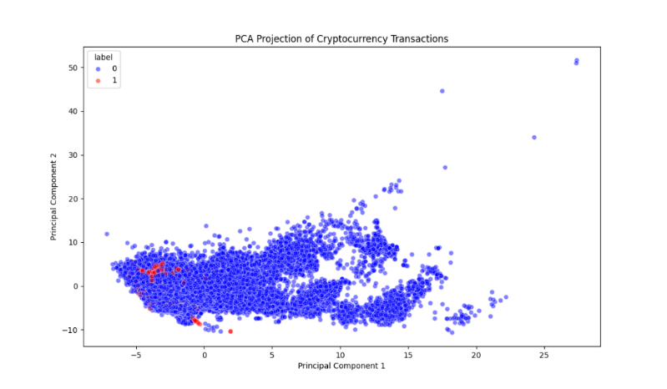
Figure 1 PCA Visualization Figure
3.0 OBJECTIVES
The main objective of this project is to investigate the effectiveness of unsupervised machine learning models for cryptocurrency transaction anomaly detection.
- To preprocess and analyze the Elliptic Bitcoin transaction dataset.
- To apply dimensionality reduction and visualization techniques using Principal Component Analysis (PCA).
- To implement and evaluate Isolation Forest, Local Outlier Factor, and DBSCAN anomaly detection models.
- To compare the performance of the implemented models using Precision, Recall, and F1-score metrics.
- To identify the most suitable anomaly detection model for detecting suspicious cryptocurrency transactions
5.0 Dataset Description
Table 1
Dataset Component | Description
Features Dataset | 203,769 Bitcoin transactions with 166 numerical features
Classes Dataset | Labels indicating licit, illicit, or unknown transactions
Edgelist Dataset | Network connections between transactions

6.0 DATASET DESCRIPTION
A real-world cryptocurrency transaction dataset called the Elliptic Bitcoin Dataset was used. It is a widely popular blockchain dataset that is often used to study blockchain-based fraud detection.
In total, there are three main files in the dataset:
• Features Dataset – includes transaction IDs, time steps of transactions, and 165 features related to each transaction.
• Classes Dataset – transaction classes split into licit, illicit, and unknown types.
• Edgelist Dataset – represents relationships between transactions through edges indicating connections between the transactions in the blockchain network.
The initial dataset included 203,769 transaction records in total. However, unknown transactions were not considered in the analysis since their classification could not be verified.

7.0 METHODOLOGY
A systematic approach was followed, which included data preprocessing, exploratory data analysis, dimensional reduction, model creation, and comparison of results.
At first, the data files comprising features and labels were combined using a unique txId number. This combined file was then analyzed for inconsistencies, missing data, and class distribution.
After this, the data was normalized using the StandardScaler technique, due to the sensitivity of certain algorithms like LOF and DBSCAN to the scale of data points.
Finally, Principal Component Analysis (PCA) was applied for dimensionality reduction. Several configurations (10, 20, 30, and 50 components) were tested, and 30 components were selected as they provided the best balance between reducing dimensionality and preserving important information.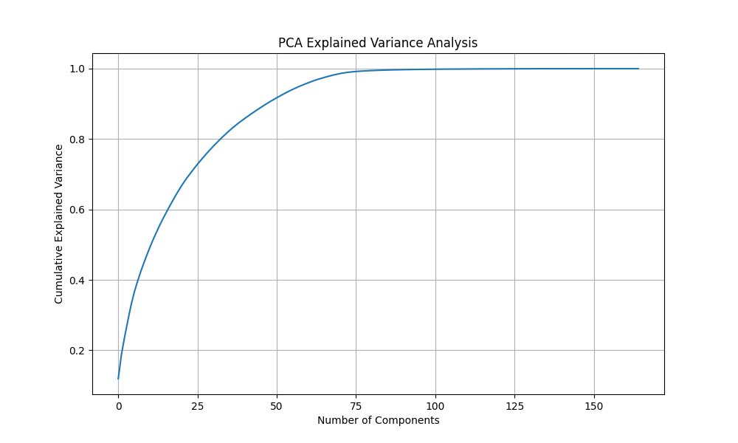
Figure 2: PCA Explained Variance Analysis
Finally, three anomaly detection algorithms were implemented as follows:
1. Isolation Forest
2. Local Outlier Factor (LOF)
3. DBSCAN
Isolation Forest algorithm isolates anomalies by randomly splitting the dataset into partitions. LOF finds anomalies by analyzing differences in density of neighboring points. Finally, DBSCAN finds anomalies among non-clustered transactions.
All models were compared using Performance Metrics: Precision, Recall, and F1-score.

8.0 EXPLORATORY DATA ANALYSIS
Exploratory Data Analysis was carried out to investigate the characteristics of the transaction dataset related to cryptocurrencies.
Class distribution indicated an imbalanced data set since the number of licit transactions exceeded that of illicit transactions, which signifies that the phenomenon of fraud is uncommon in real life.
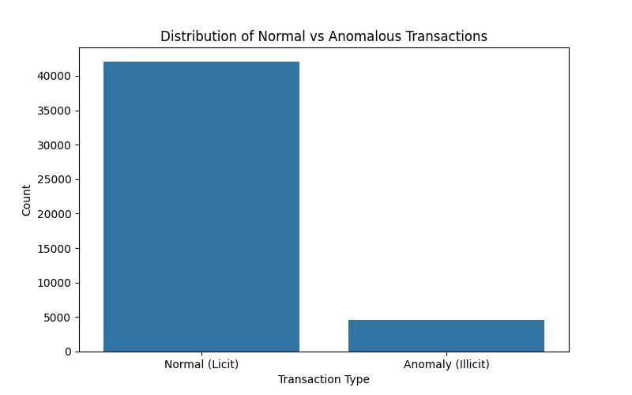
Figure 3: Distribution of Licit and Illicit Transactions
To visualize the data in two dimensions, PCA projection was used. As seen from the analysis results, there is considerable overlapping between illicit and licit transactions.
Various numerical features were analyzed to examine their distribution. As can be concluded from the exploration results, detecting cryptocurrency fraud is a difficult task, as fraudulent behavior is interwoven with normal transaction behavior.
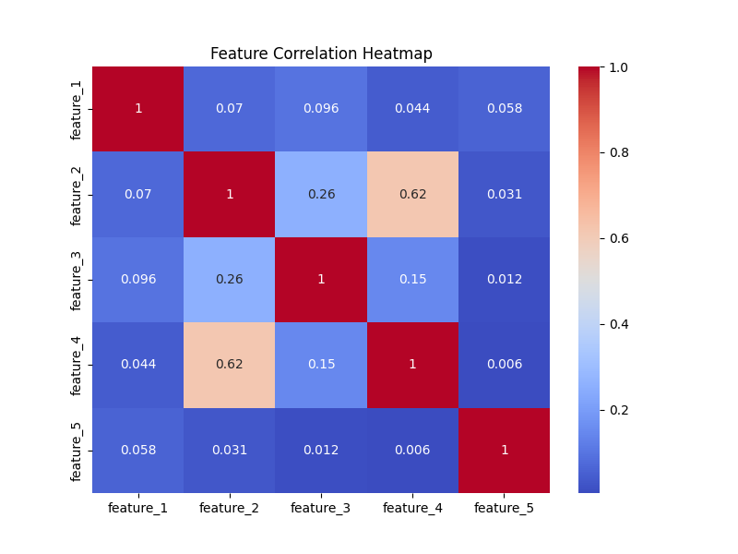
Figure 4: Feature Correlation Heatmap
9. MODEL IMPLEMENTATION
Three different unsupervised machine learning models were developed and assessed for their efficacy in detecting anomalies in cryptocurrencies transactions: Isolation Forest, Local Outlier Factor (LOF), and DBSCAN. These models were chosen due to their diverse nature when it comes to identifying anomalies and because they are frequently employed in finance literature to detect fraudulent activities.
9.1 ISOLATION FOREST
The Isolation Forest algorithm belongs to the class of ensemble methods, and its main principle is to divide the data points randomly in order to identify anomalies. The basis of the algorithm is the following: since anomalies occur in much fewer instances compared to normal observations, and are substantially different from them, they are easier to isolate.
In the current case, the Isolation Forest was trained on the scaled features of the transactions. At first, the contamination rate was set at 0.10 and then adjusted experimentally during the process of tuning hyperparameters to see if there would be any improvement.
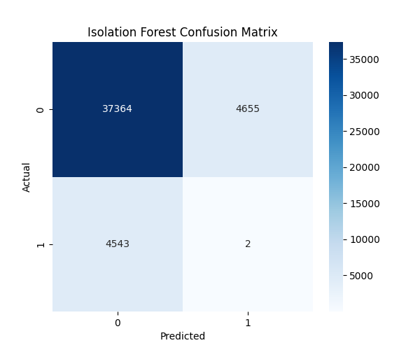
Figure 5 Isolation Forest Confusion Matrix
9.2 LOCAL OUTLIER FACTOR (LOF)
Local Outlier Factor is an anomaly detection method based on density estimation which detects anomalous observations by assessing the difference between the local density of an observation and its nearest neighbours' densities. This technique relies on the concept of local neighbourhood rather than separation across the whole dataset.
It would be effective to apply LOF to detecting fraud transactions in cryptocurrencies since a suspicious transaction might look normal on a global scale yet be anomalous when compared to other close-by transactions.
In our experiment, the model used 20 nearest neighbours with a contamination parameter value equal to 0.10.
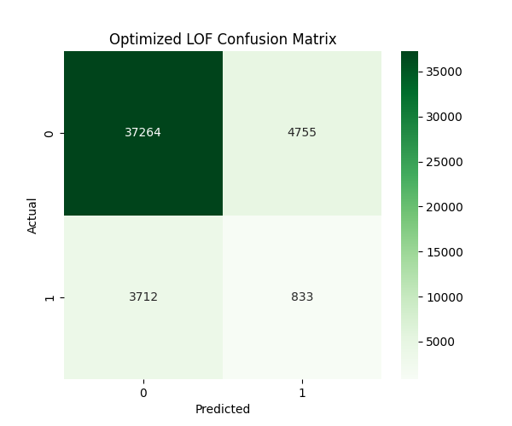
Figure 6 Optimised LOF Confusion Matrix
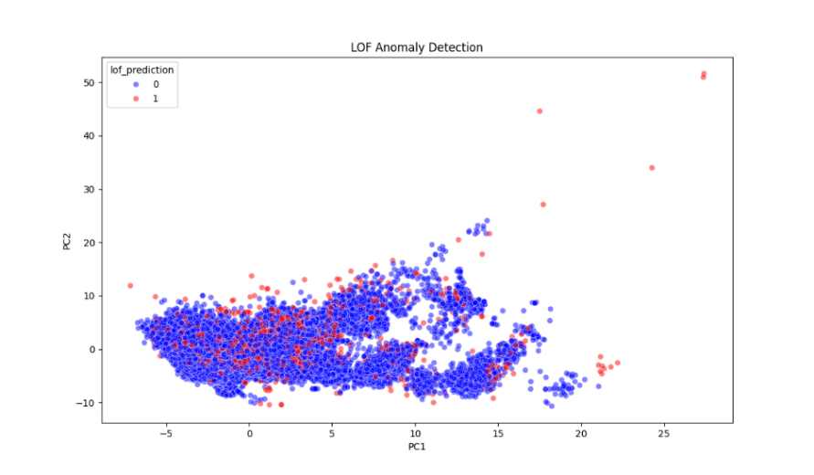
Figure 7 LOF PCA Visualization
The LOF visualizations illustrate how density-based anomaly detection identifies suspicious transaction behaviour within local transaction neighbourhoods.
9.3 DBSCAN
DBSCAN is a clustering technique whereby the algorithm places observations into dense clusters, while sparse observations are viewed as noise. In anomaly detection, any observation marked as noise by the DBSCAN algorithm will be regarded as anomalous.
As the DBSCAN algorithm is computation-heavy, especially when dealing with big data, a sample size of 10,000 transactions was utilized during the implementation of the model.
For the DBSCAN model, the values of epsilon and the minimum sample size were set at 3 and 10 respectively.
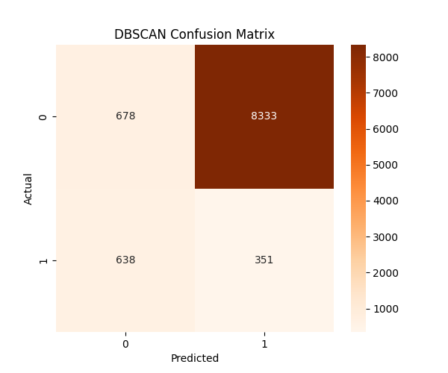
Figure 8 DBSCAN Confusion Matrix
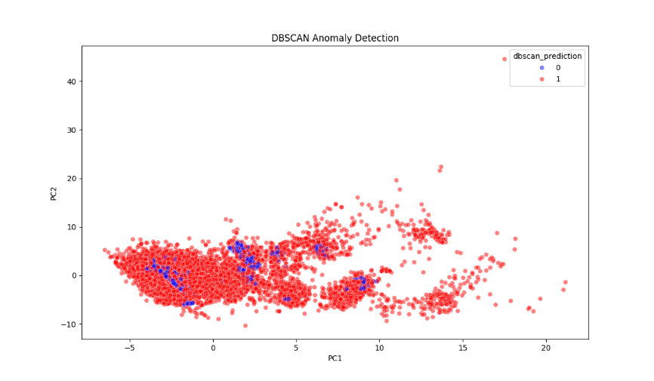
Figure 9 DBSCAN PCA Visualization
The DBSCAN visualizations demonstrate the algorithm’s ability to identify sparse transaction regions that may contain suspicious financial activity.

9.4 LOF Hyperparameter Optimization
Following the initial LOF implementation, additional experiments were conducted to improve anomaly detection performance. Hyperparameter tuning was performed by varying the number of nearest neighbours and contamination rates. The evaluated neighbour values included 5, 8, 10, 12, and 15, while contamination values ranged from 0.10 to 0.15.
The optimization experiments demonstrated that a configuration of 5 neighbours and a contamination rate of 0.12 produced the best performance. This optimized configuration achieved the highest F1-score and was therefore selected as the final anomaly detection model.
9.5 APPROACH FOR EVALUATION OF MODEL
Though the models used were unsupervised, labeled data could be obtained to evaluate the algorithms. This meant that the models would be evaluated based on their Precision, Recall, and F1-score.
The choice of metrics is mainly due to the nature of data, which is highly unbalanced, and as such, accuracy would not have been suitable as a measure.
10. RESULTS AND DISCUSSION
This contains the performance outcomes of all the three anomaly detection models that have been developed namely; Isolation Forest model, LOF model and DBSCAN model. Precision, Recall and F1 score are used as the evaluation parameters since there are too many anomalies in the datasets and normal parameters cannot offer much useful information.
10.1 Model Performance Comparison
Table 2 presents the performance metrics obtained from the experimental evaluation.
Table 2: Performance Comparison of Anomaly Detection Models
Model | Precision | Recall | F1-Score
Isolation Forest | 0.0004 | 0.0002 | 0.0003
Optimised Local Outlier Factor (LOF) | 0.1491 | 0.1833 | 0.1644
DBSCAN | 0.0404 | 0.3549 | 0.0726

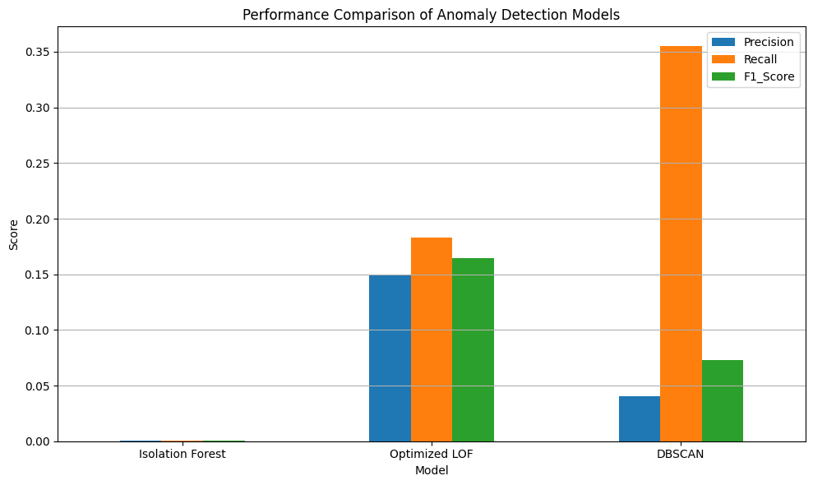
Figure 10 Model Performance Comparison
The results show significant differences in behaviour among the three anomaly detection approaches.
10.2 ISOLATION FOREST PERFORMANCE EVALUATION
Isolation Forest performed poorly compared to all other examined algorithms. It resulted in very low scores for Precision, Recall, and F1-score metrics, which implies that the algorithm performed poorly in determining illicit bitcoin transactions.
This means that fraudulent transactions in the Elliptic Bitcoin database do not exist as globally isolated anomalies. Fraudulent transactions have features similar to those of legal transactions, making global isolation impossible
10.3 OPTIMIZED LOCAL OUTLIER FACTOR PERFORMANCE
After completing the steps of dimensionality reduction and optimizing the hyperparameters, Local Outlier Factor proved to be the most efficient model among all the models examined. It made use of 30 principal components from PCA, 5 nearest neighbors, and the contamination percentage of 0.12.
The optimized LOF model yielded the highest values for Precision (0.1491), Recall (0.1833), and F1-score (0.1644). Compared to the initial implementation of the LOF algorithm, there was a significant improvement.
10.4 DBSCAN PERFORMANCE
DBSCAN generated a completely different profile for anomaly detection than any other algorithm used in the study. In particular, this algorithm demonstrated the best Recall rate compared to all other approaches considered, meaning that it could detect a higher percentage of illicit activities. On the other hand, the increased Recall rate was obtained at the cost of reduced Precision. Such performance of DBSCAN is likely caused by the fact that this approach is extremely sensitive to sparsely populated areas of the feature space.
10.5 COMPARATIVE ANALYSIS
The outcomes of the experiment reveal that different methods for anomaly detection represent cryptocurrency transactions differently. Isolation Forest is aimed at the global isolation of anomalies and performed badly as fraudster behavior was not separated from legitimate transactions. LOF pays attention to local density variations and proved to be most balanced in its capability for detecting anomalies and controlling for false alarms. DBSCAN concentrates on clustering by density structure and managed to uncover numerous suspicious behaviors.
In general, it can be concluded that crypto fraudster behavior could be better described as a local density anomaly than a globally isolated observation. It explains the superiority of LOF compared to other models used in this experiment.
11. ETHICS AND CONSTRAINTS
11.1 Ethical Issue
-False Positives: Machine learning models may incorrectly flag legitimate transactions as suspicious, leading to investigations, account restrictions or delays for innocent users.
-Privacy Concerns: Although blockchain transactions are publicly available, extensive analysis of transaction patterns can raise concerns about user privacy and surveillance.
-Algorithmic Bias: Machine learning models may inherit biases present in the training data, making their predictions potentially unfair or inaccurate.
-Human Oversight: Anomaly detection results should support decision-making and not be used as the sole basis for identifying illegal activities.
11.2 LIMITATIONS OF THIS PROJECT
Limitations
- The Elliptic Bitcoin dataset contained many transactions with unknown labels; therefore, only transactions with known classifications were used for evaluation.
- The study focused on feature-based anomaly detection and did not utilize transaction network information from the edgelist dataset.
- Due to high computational requirements, DBSCAN was applied to a sampled subset of the data.
- The research was limited to three unsupervised anomaly detection methods, while other techniques may offer improved performance and warrant further investigation.
12. CONCLUSION AND RECOMMENDATION
This project investigated the use of unsupervised machine learning techniques for cryptocurrency transaction anomaly detection using the Elliptic Bitcoin dataset. The study implemented and evaluated three anomaly detection algorithms: Isolation Forest, Local Outlier Factor (LOF), and DBSCAN.
The dataset underwent preprocessing, feature scaling, dimensionality reduction, and exploratory analysis before model implementation. Performance evaluation was conducted using Precision, Recall, and F1-score metrics to assess the effectiveness of each anomaly detection approach.
The experimental results showed that Isolation Forest performed poorly on the dataset, indicating that illicit cryptocurrency transactions are not easily identifiable as globally isolated anomalies. DBSCAN achieved the highest Recall but generated a large number of false positives, reducing overall precision.
The optimized Local Outlier Factor model achieved the highest overall performance with a Precision of 0.1491, Recall of 0.1833, and F1-score of 0.1644, outperforming both Isolation Forest and DBSCAN. The results demonstrate that cryptocurrency fraud within the Elliptic Bitcoin dataset is more effectively identified through local density-based anomaly detection than through global anomaly isolation techniques. This suggests that fraudulent cryptocurrency transactions are more effectively characterized as local density anomalies rather than globally isolated observations.
Based on the experimental findings, Local Outlier Factor is recommended as the most suitable anomaly detection technique among the evaluated approaches for identifying suspicious cryptocurrency transactions within the Elliptic Bitcoin dataset.
Future work should investigate graph-based machine learning methods, deep learning approaches, and hybrid anomaly detection systems that can leverage both transaction features and blockchain network structures to improve detection performance.
-
REFERENCES
1. Pedregosa, F., Varoquaux, G., Gramfort, A., Michel, V., Thirion, B., Grisel, O., ... & Duchesnay, E. (2011). Scikit-learn: Machine Learning in Python. Journal of Machine Learning Research, 12, 2825–2830.
Liu, F. T., Ting, K. M., & Zhou, Z. H. (2008). Isolation Forest. IEEE International Conference on Data Mining.
Breunig, M. M., Kriegel, H. P., Ng, R. T., & Sander, J. (2000). LOF: Identifying Density-Based Local Outliers. ACM SIGMOD International Conference on Management of Data.
Ester, M., Kriegel, H. P., Sander, J., & Xu, X. (1996). A Density-Based Algorithm for Discovering Clusters in Large Spatial Databases with Noise. KDD Conference.

