# Phase 5 Documentation CI/CD Pipeline

# Eclipse IDEScreenshot (325)Screenshot (324)

## I created a Simple Spring boot Application to

## build a CI/CD pipeline to demonstrate continuous deployment

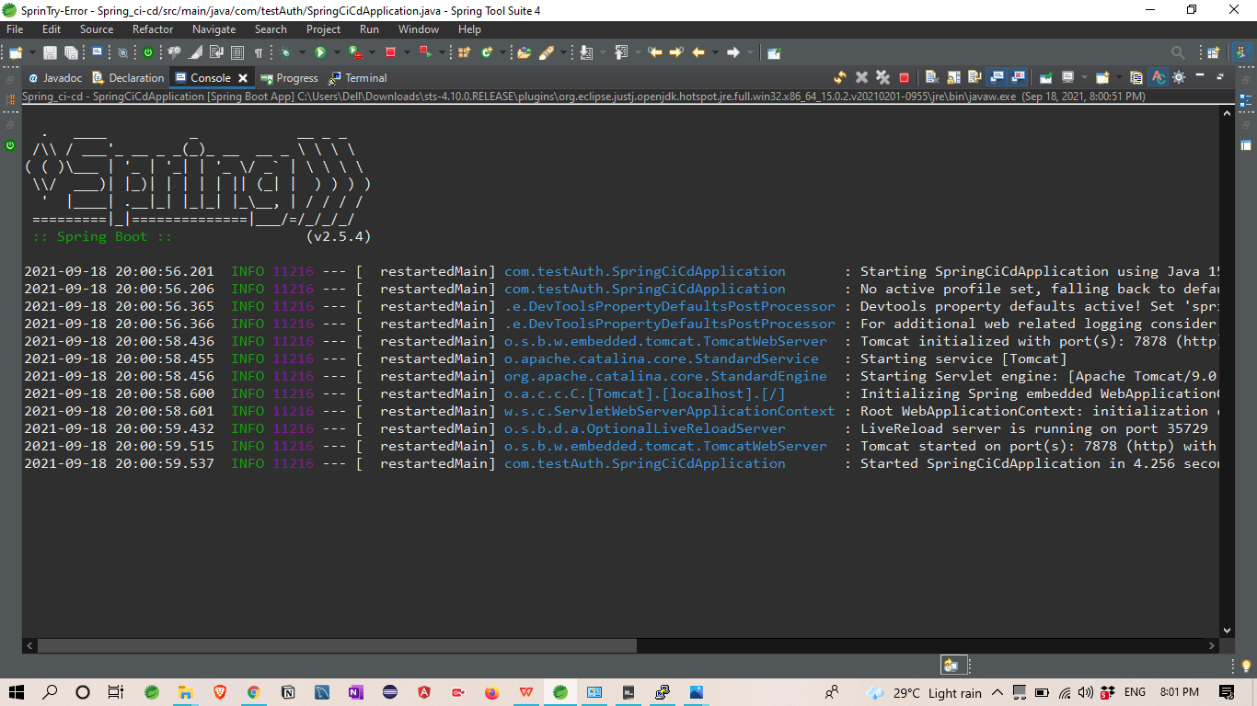

Output :-

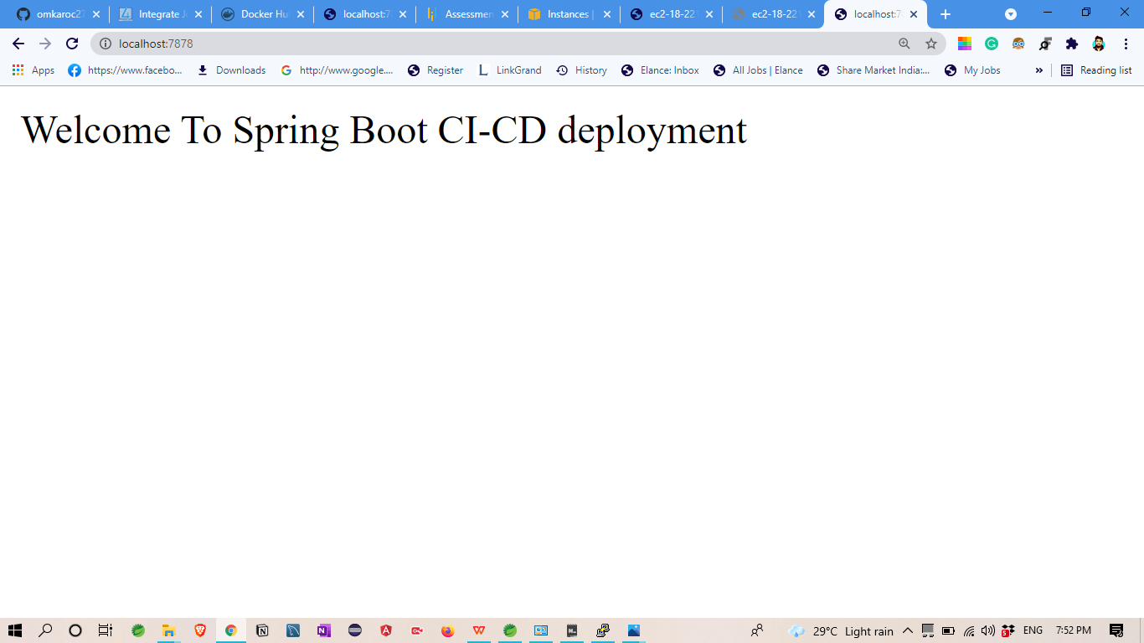

# Git Hub: Application Deploy on git Hub

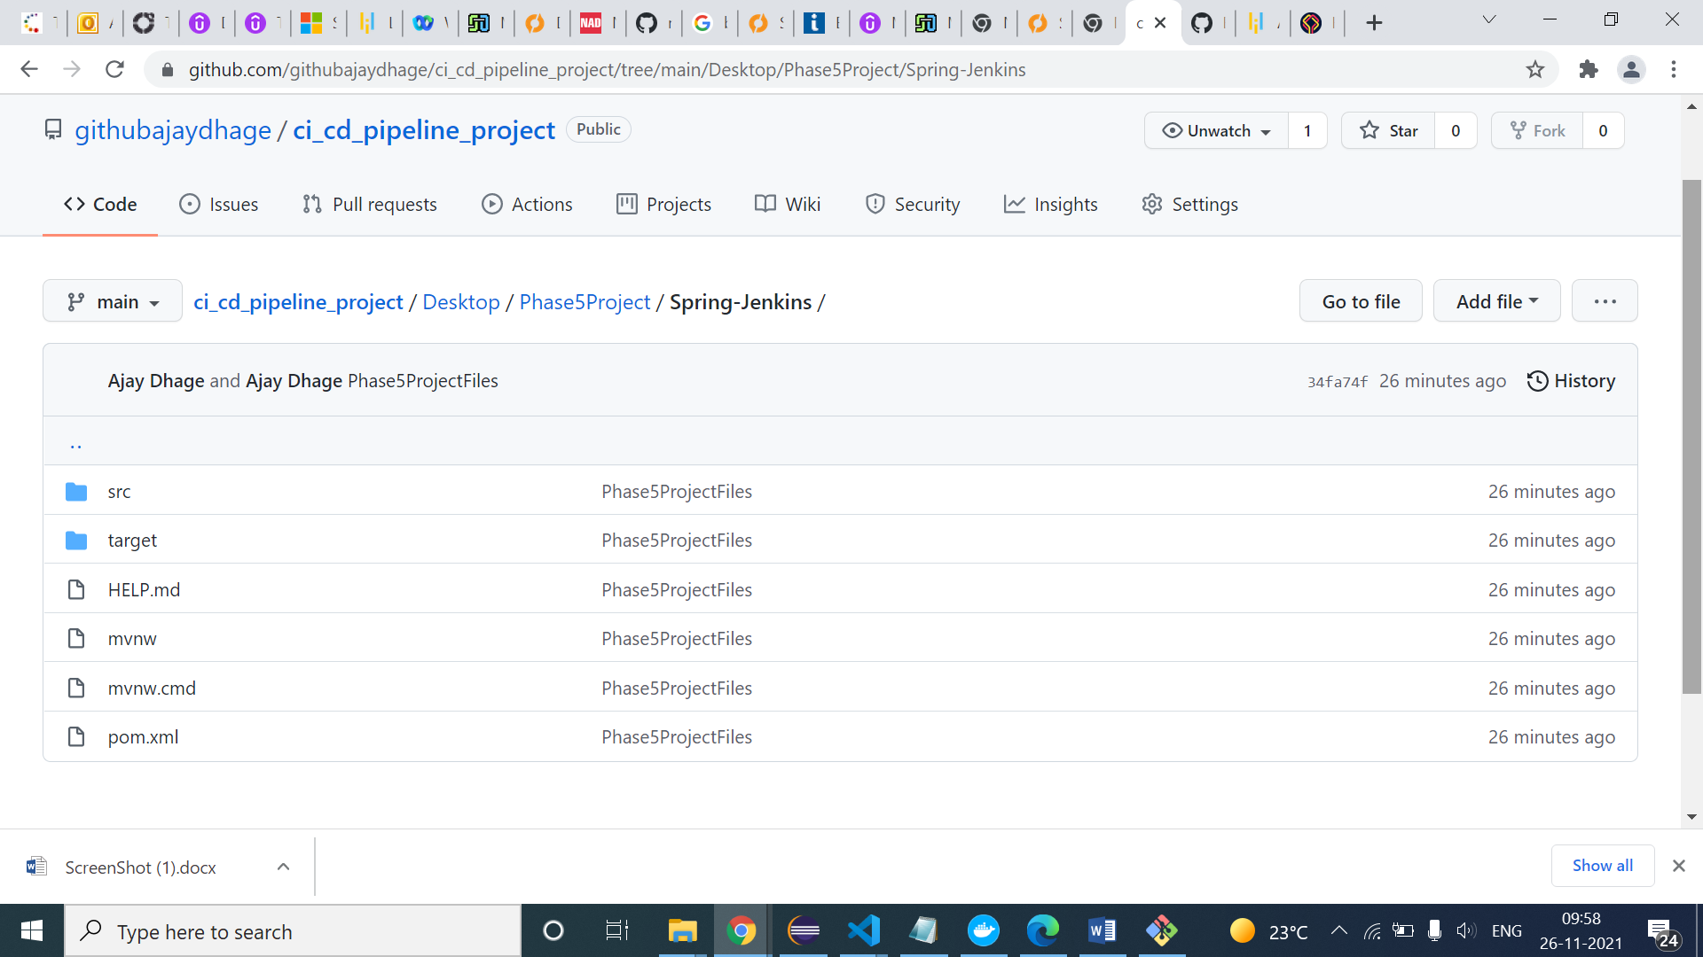

## 2.

## Then that application Uploaded on Git Hub

# GitHub link-

<https://github.com/githubajaydhage/ci_cd_pipeline_project/tree/main/Desktop/Phase5Project>

# Jenkins : Run Jenkins

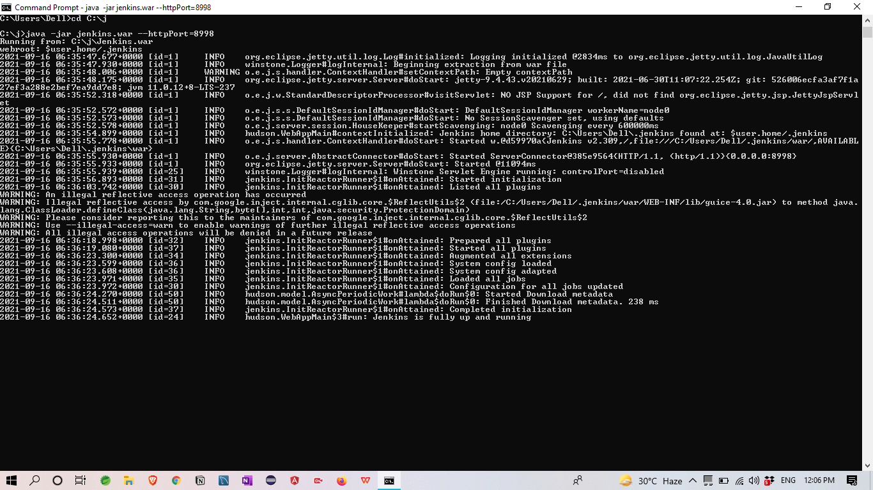

**CREATE THREE JENKINS PROJECT DEPLOYMENT**:-

DEPLOYMENT-TESTING-PRODUCTION

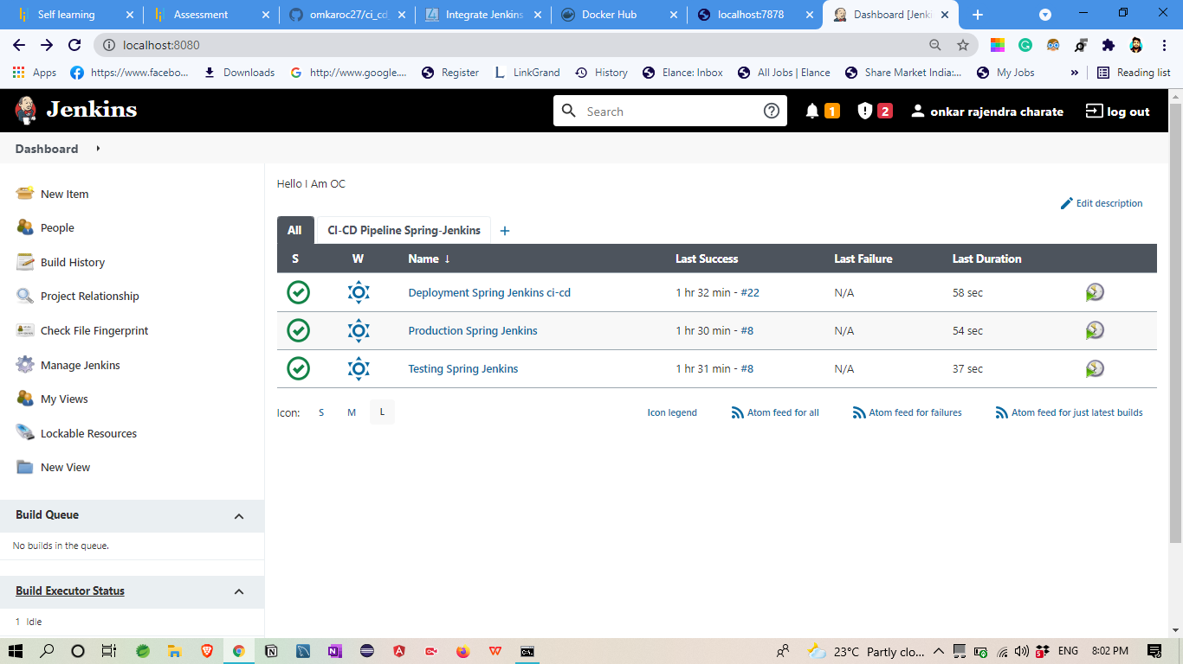

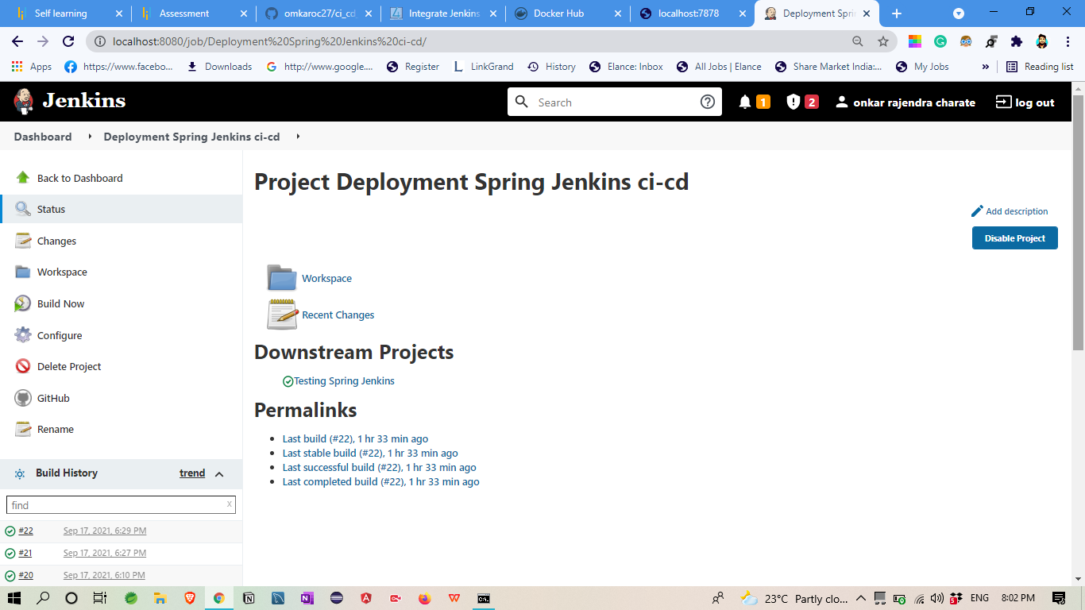

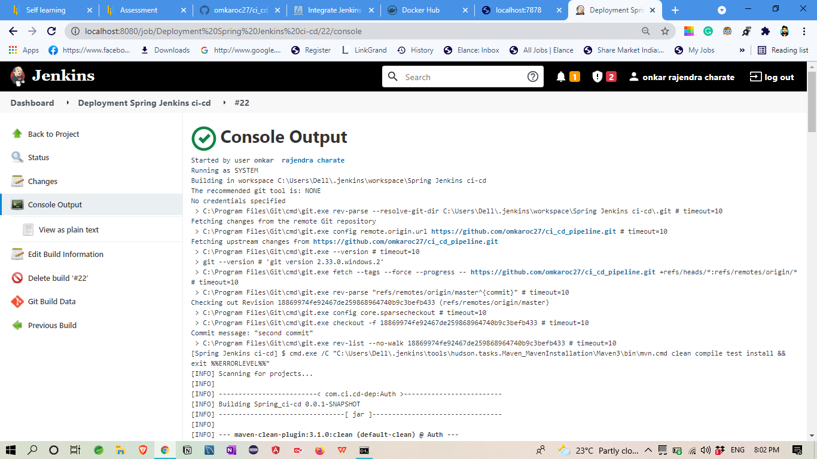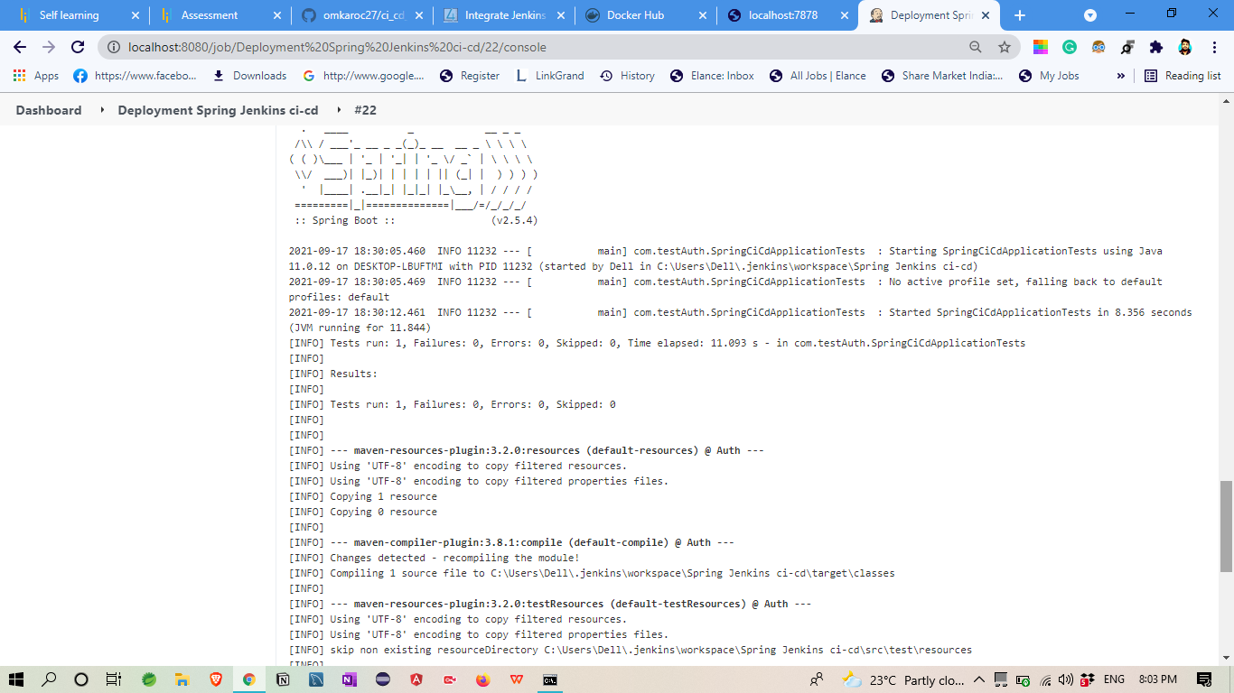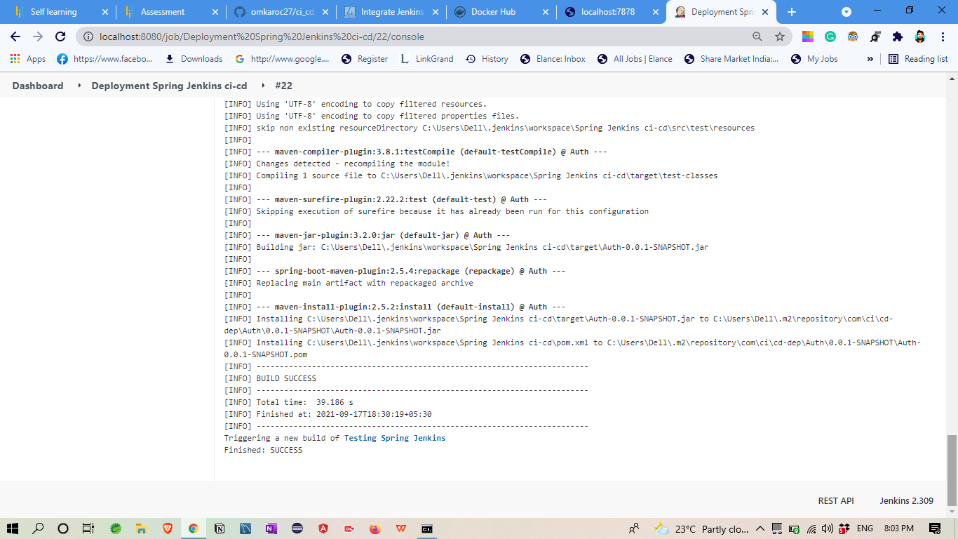

**TESTING**

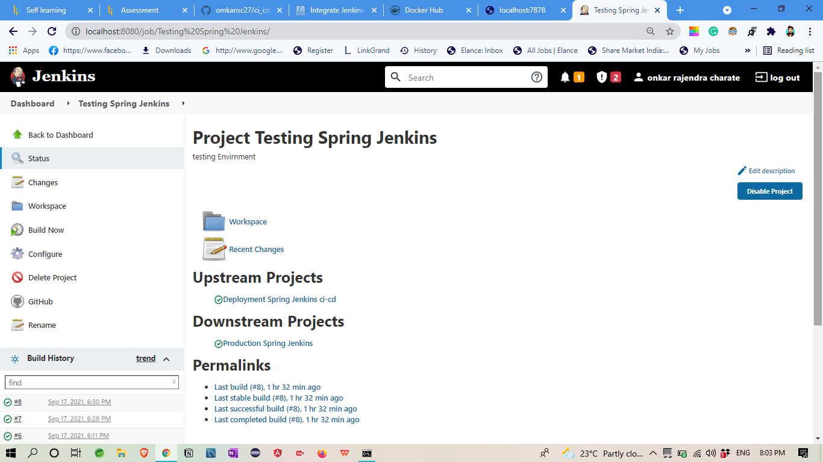

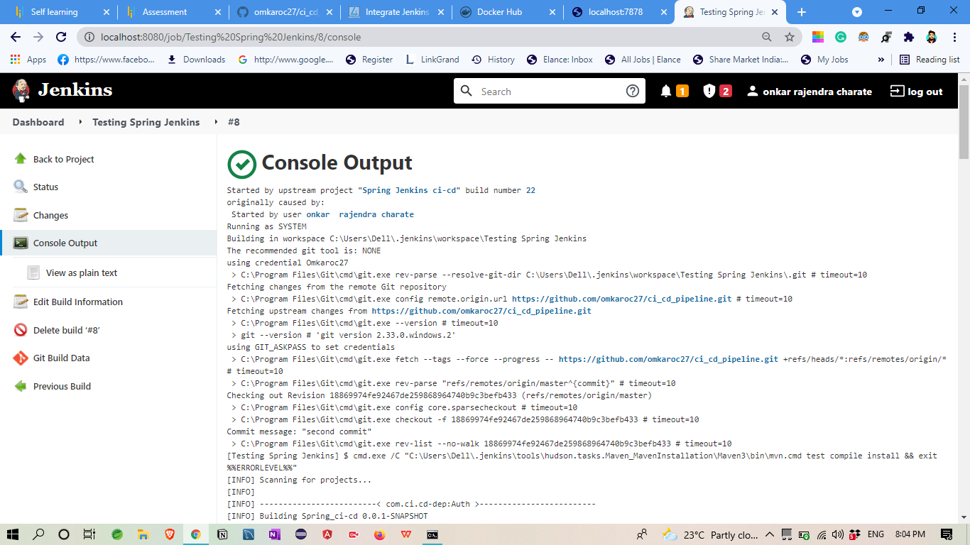

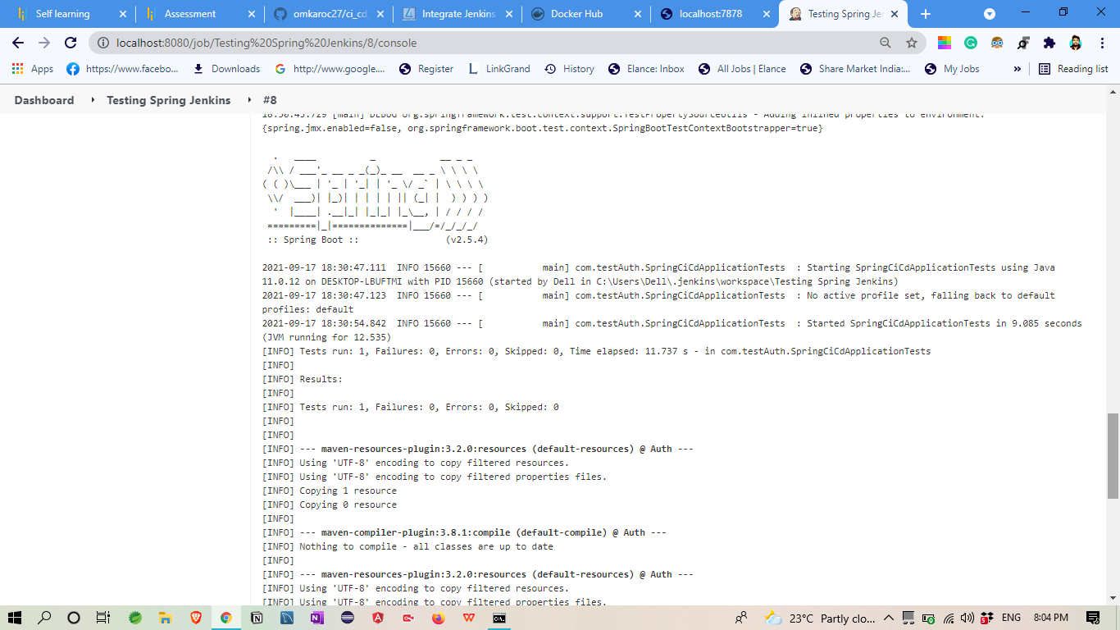

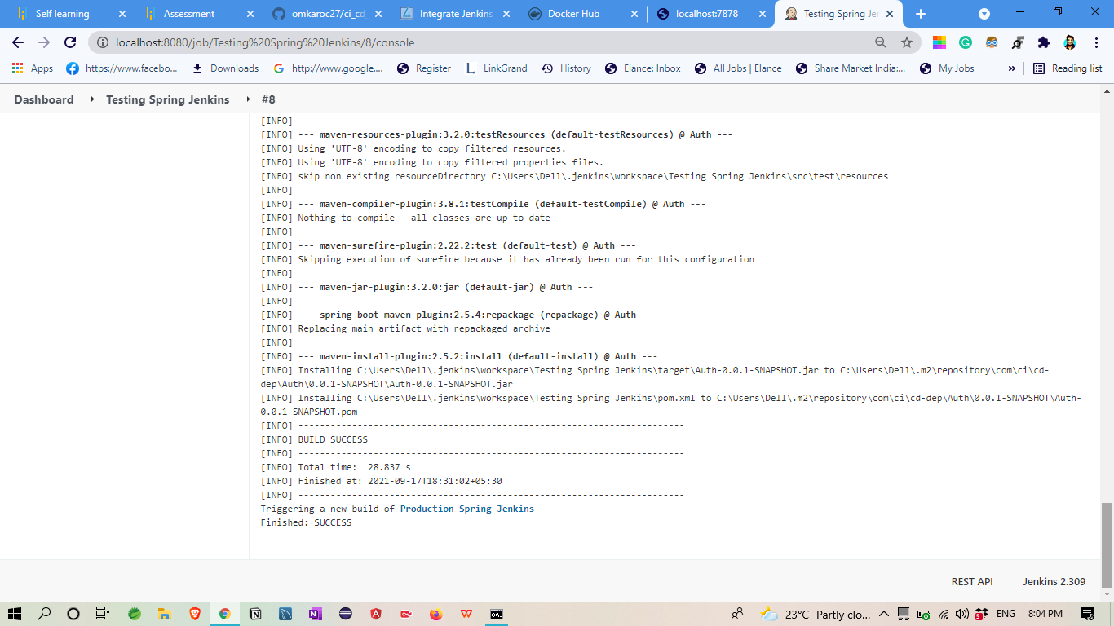

PRODUCTION

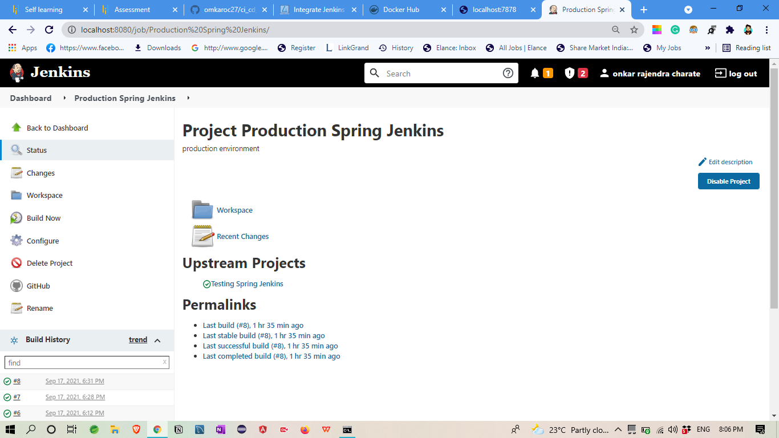

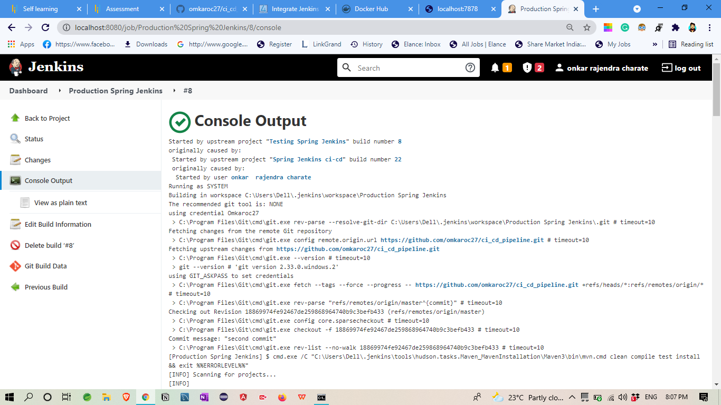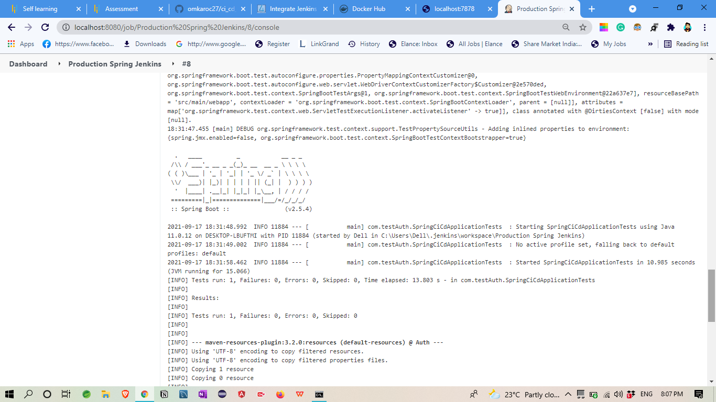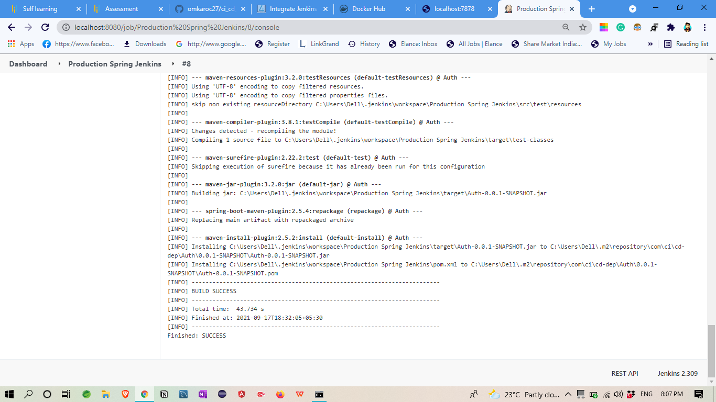

## In Jenkins I created three build for continous deployment

## And pipeline them

**Built a CI/CD pipeline to demonstrate continuous deployment**

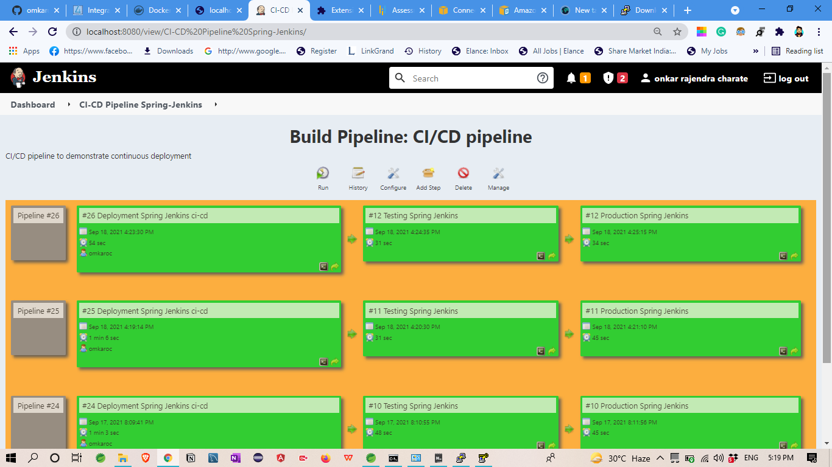

**AWS EC2**

1. First I create EC2 instance
2. Create Spring boot Application jar file

(Spring_CI-CD-deployment-exe.jar)

1. Then its store in s3 bucket

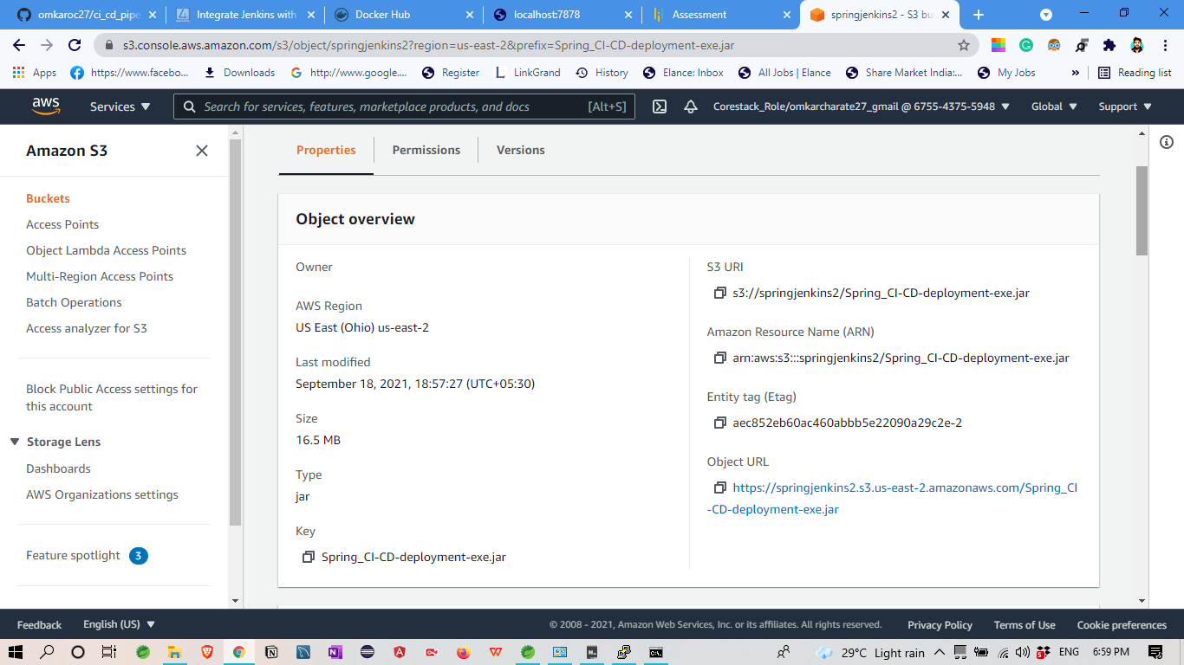

1. Then open command line and deploy Application in EC2 Instance

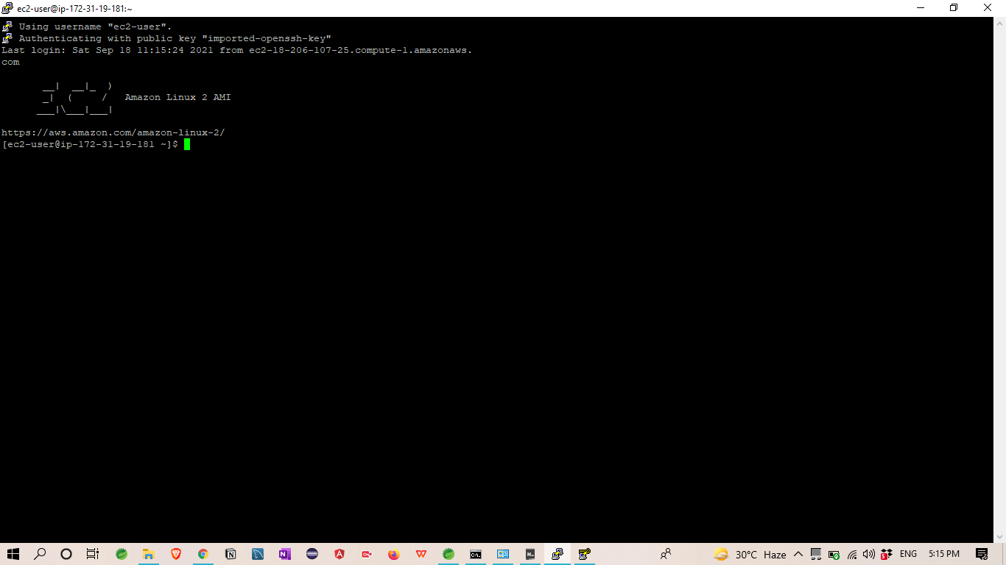

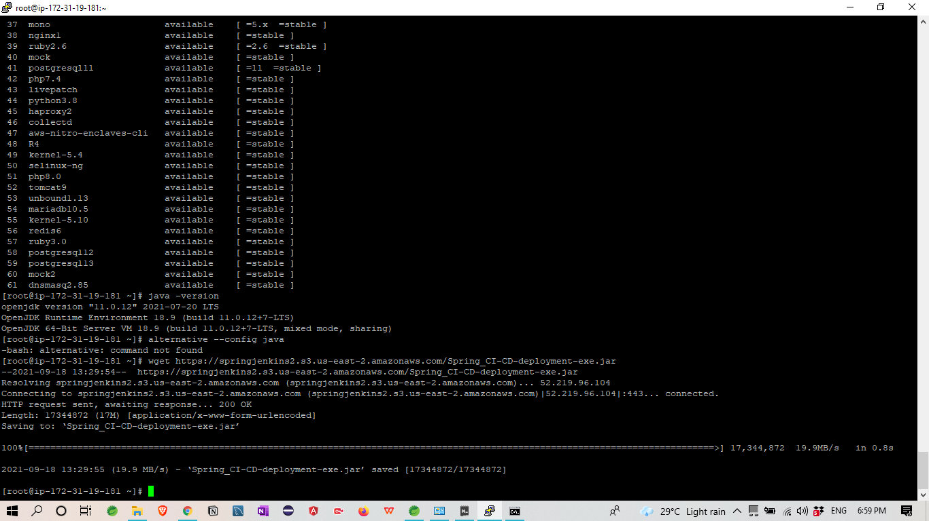

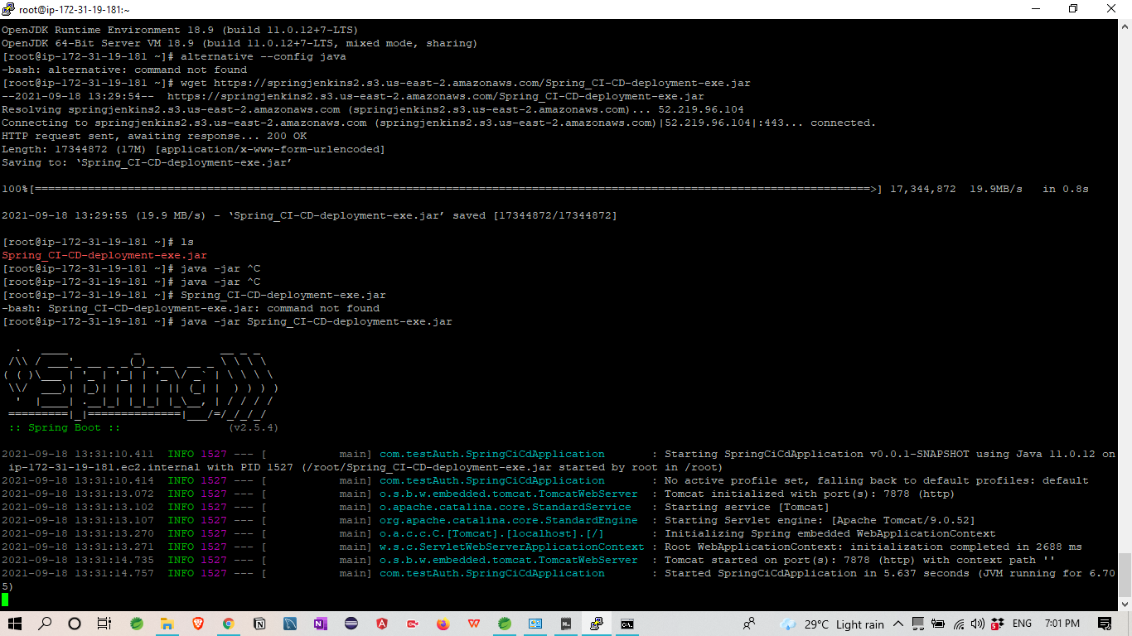

1. Application Started running with Port no 7878

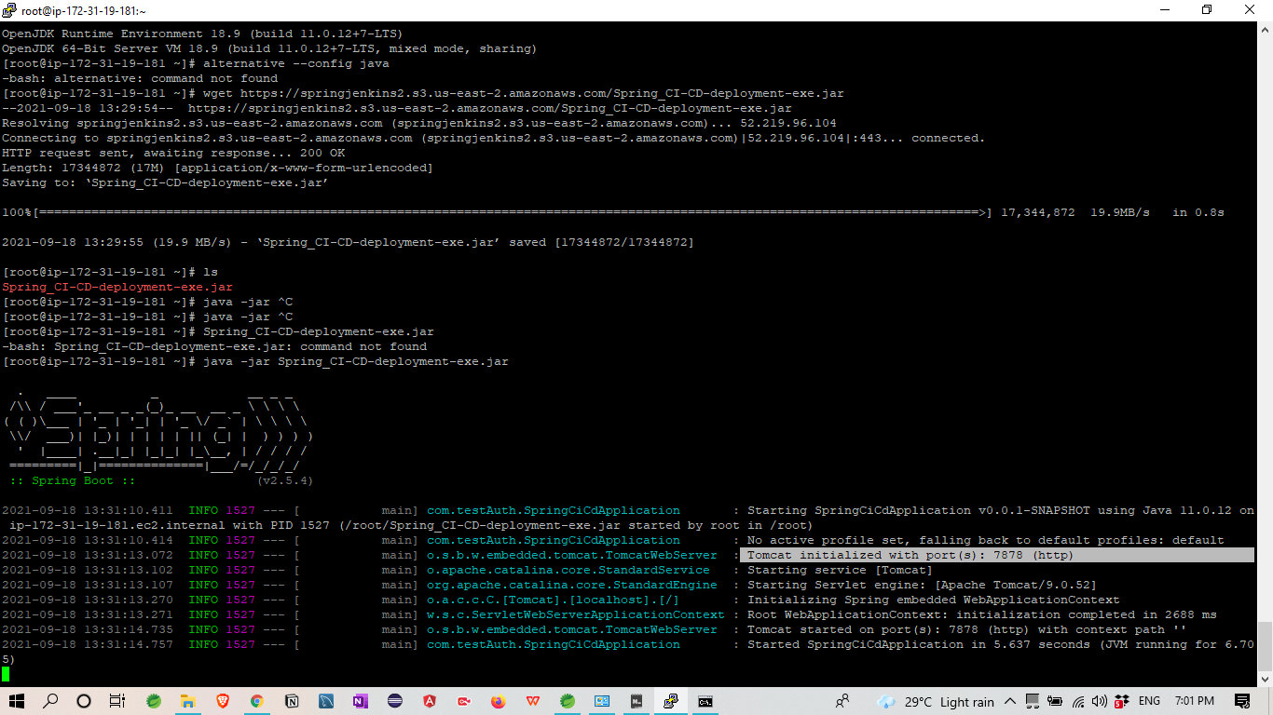

6.Last **host the application on AWS EC2 instance.**

Application running with this URL:-

ec2-18-221-78-17.us-east-2.compute.amazonaws.com:7878/

Final Output:-

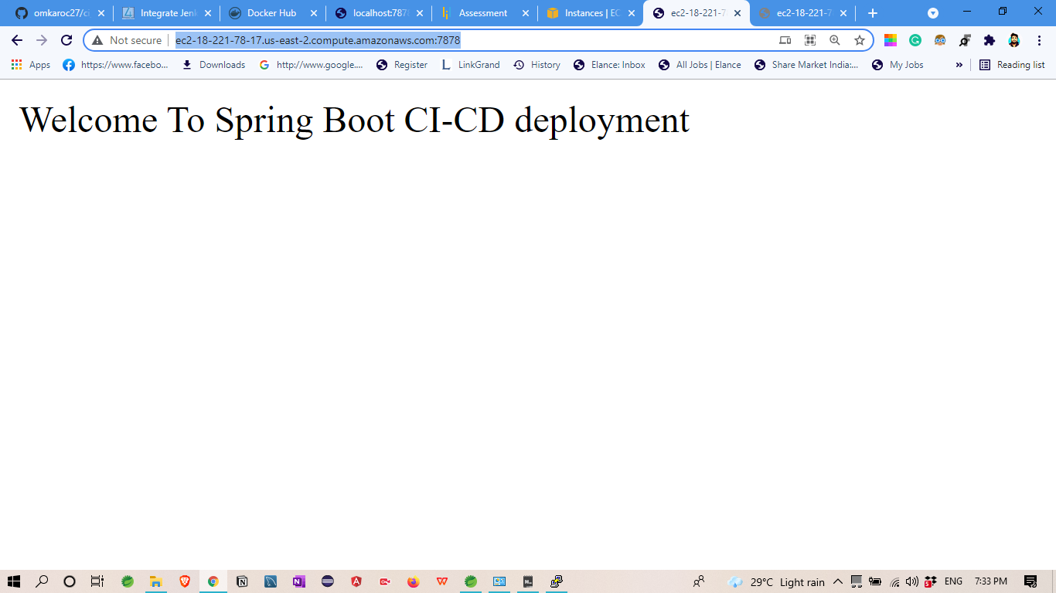

With this AWS Hosted URL

