**CLASS 6** **ASSIGNMENT 10**

**Flow Chart:**

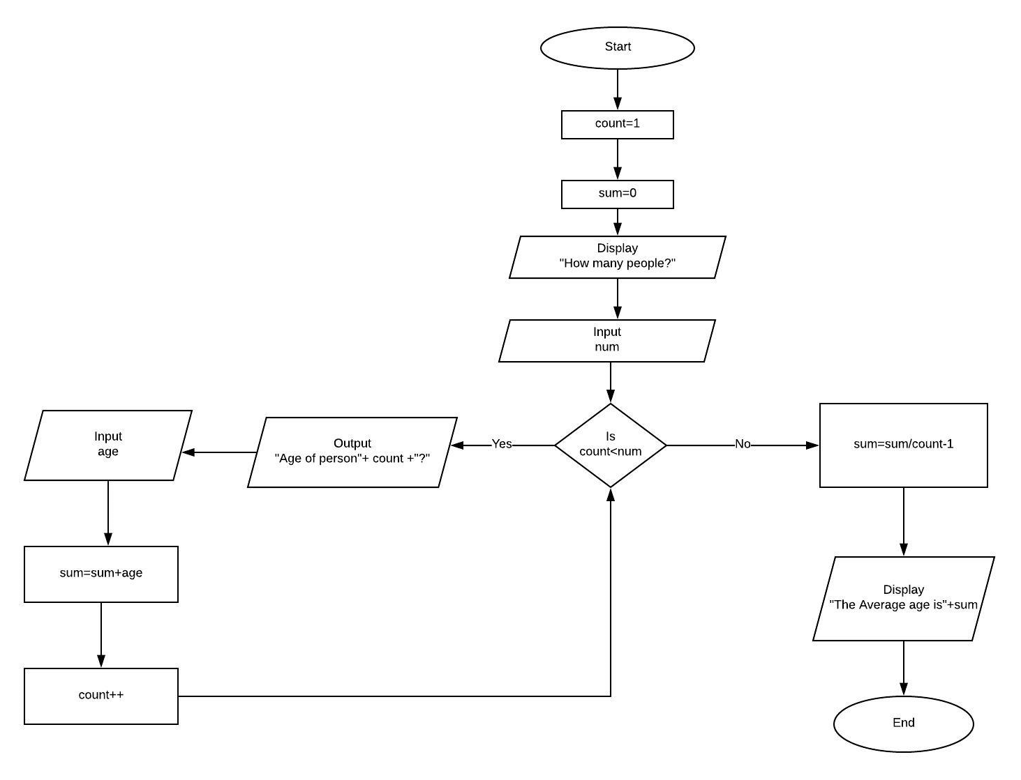

**Pseudocode:**

1. DECLARE INT Count



1. DECLARE INT num
2. DECLARE INT age
3. DECLARE INT sum
4. sum=0
5. DISPLAY “How many people?”
6. INPUT num
7. for(count=1; count<=num; count++ )
8. {
9. OUTPUT “Age of Person” + Count + ”?”
10. INPUT age
11. sum=sum+age
12. }
13. sum=sum/count-1
14. DISPLAY “The average age is=”+ sum
15. ENDIF

**Trace:**

|  |  |  |  |  |  |  |
| --- | --- | --- | --- | --- | --- | --- |
| Line no. | Input Buffer | Count | Num | Age | Sum | Output Buffer |
| 1. |  | - | X | X | X |  |
| 2. |  | - | - | X | X |  |
| 3. |  | - | - | - | X |  |
| 3. |  | - | - | - | - | “How many people” |
| 4. | 3 | - | 3 | - | - | - |
| 5. | 1 | 1 | 3 | - | 0 | Age of person 1? |
| 6. | 20 | 1 | 3 | 20 | 0 | - |
| 7. | - | 1 | 3 | 20 | 20 | - |
| 8. | - | 2 | 3 | 20 | 20 | - |
| 9. | - | 2 | 3 | 20 | 20 | Age of person 2? |
| 10. | - | 2 | 3 | 30 | 20 | - |
| 11. | - | 2 | 3 | 30 | 50 | - |
| 12. | - | 3 | 3 | 30 | 50 | - |
| 13. | - | 3 | 3 | 30 | 50 | Age of person 3? |
| 14. | 40 | 3 | 3 | 40 | 90 | - |
| 15. | - | 4 | 3 | 40 | 90 | - |
| 16. | - | 4 | 3 | 40 | 30 | - |
| 17. | - | 4 | 3 | 40 | 30 | The average age is 30 |