**Anisur Rahman**

ASSOCIATE SOFTWARE ENGINEER

**BIOGRAPHY**

I am a programmer and web developer. I am passionate about problem solving and learning new things. I am working as an Associate Software Engineer at Brain Station-23. I worked with Angular Js and SharePoint 2016. Now, I am working with .Net Core as backend and Angular as frontend. I seek out new knowledge and actively develop new skills. I am always looking out for and learning new and better approaches and technologies that help me do a better job.



**EXPERIENCE**

**ASSOCIATE SOFTWARE ENGINEER**



**Brain Station 23 Ltd | Sep 2020- Continuing**



**EDUCATION**

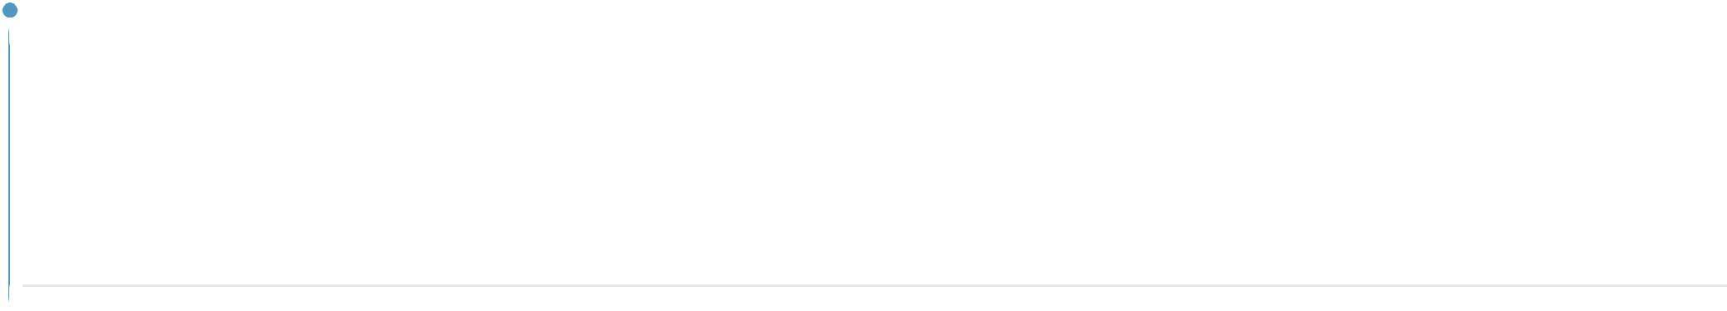

**BSC**

**International University of Business Agriculture & Technology** Group: Computer Science & Engineering Passing Year: 2019

GPA: 3.53

**WORK SKILLS**



Angular 8 (6/10) 

Angular Js (5/10) 

React Js (5/10)



C++ (8/10) 

C# (7/10) 

SharePoint (5/10) 

JavaScript (7/10)



ASP.Net Core (6/10) 

**PROJECT**



**Project Name:** Automation of Service request solution

**Technology Used:** SharePoint Server 2016, Angular Js.

**Technical Responsibility:** Developing feature, Requirement collection,

Testing, Deployment.

**Project Duration:** Nov 2020-Jan 2021

**Short Description:** This application is developed to process company’s

internal request through a approval Process.



**Project Name:** HSBC QMS development.

**Technology Used:** .Net Core, Angular 8.

**Technical Responsibility:** Developing feature, Requirement collection,

Testing, Deployment.

**Project Duration:** Dec 2020-Continue

**Short Description:** This application is developing for serving the customer in a queue.



**ACHIEVEMENTS**

National Collegiate Programming Contest (NCPC).

IUBAT | 2018

National Collegiate Programming Contest (NCPC).

CUET | 2017

A certification for participating in SUST Intra University programming contest

SUST | 2017

