CHAPTER 1
INTRODUCTION
1.1 INTRODUCTION TO THE PROJECT
Autonomous navigation and scene understanding are two of the most critical challenges in modern computer vision and artificial intelligence. Traditional systems have heavily relied on expensive hardware, such as Light Detection and Ranging (LiDAR) sensors, to accurately map 3D environments and avoid obstacles. However, such hardware constraints limit the deployment of autonomous agents—such as rovers, drones, and assistive devices—in cost-sensitive or lightweight applications. As deep learning has matured, purely vision-based approaches using standard RGB cameras have become highly viable alternatives. Among these approaches, semantic segmentation stands out as a fundamental technique.
Semantic segmentation is the process of assigning a meaningful class label to every single pixel in an image. While object detection bounds independent entities within rectangular boxes, segmentation creates a dense, granular map of the entire scene. This granular mapping is essential for natural terrain environments where boundaries between 'safe' walkable ground and 'hazards' like water, steep drops, or dense vegetation are irregular and lack rigid shapes. Recently, the paradigm of semantic segmentation has shifted from Convolutional Neural Network [7]s (CNNs) to Vision Transformer [3]s (ViTs). Models like SegFormer [4] leverage self-attention mechanism [8]s to establish long-range dependencies across the image, offering superior global context compared to the localized receptive fields of standard CNNs.
This project, titled 'Multi-Class Image Segmentation Using Deep Learning', introduces an intelligent, vision-based safety analysis framework. It utilizes the state-of-the-art SegFormer [4] architecture fine-tuned on the comprehensive ADE20k [18] dataset to categorize unstructured environments into 150 distinct semantic classes. These classes are then heuristically mapped into binary action spaces—namely 'Safe' and 'Hazard' zones. Furthermore, to bridge the gap between pure semantic labels and physical reality, the project integrates monocular depth estimation capabilities and rover-dimension constraints. By coupling semantic masks with estimated depth distances, the system can determine not only what an obstacle is, but precisely how far away it is, and whether a projected safe path is physically wide enough for a specific rover to traverse without collision.
1.2 STATEMENT OF THE PROBLEM
Navigating unstructured and dynamic outdoor environments presents significant challenges for autonomous systems relying solely on 2D visual inputs. A fundamental limitation of traditional computer vision pipelines is the disconnect between semantic recognition and physical spatial constraints. A system might successfully identify a region of pixels as 'grass' (walkable terrain) and another region as 'rock' (an obstacle). However, knowing the semantic identity of the terrain is entirely insufficient for practical navigation. The system is completely unaware of the absolute scale of the scene; it cannot ascertain whether the safe grassy path between two rocks is a few centimetres wide or several metres wide. Without depth and dimension awareness, an autonomous rover might attempt to traverse a gap that is significantly narrower than its own physical chassis, leading to catastrophic collisions or entrapment.
Furthermore, purely semantic segmenters suffer from geometric ambiguities. For instance, a flat patch of gravel and a towering mountain cliff might both be correctly classified syntactically as 'rock/mountain'. However, their geometric implications for navigation are antithetical: flat gravel is perfectly safe to drive over, whereas a cliff is an impassable hazard. Therefore, the problem this project addresses is the inadequacy of standard 2D semantic masks for practical terrain navigation. The objective is to formulate a cohesive pipeline that augments robust Transformer-based segmentation with monocular absolute depth estimation and physical constraint checking (rover dimensions), effectively transforming abstract pixel classifications into actionable, safety-aware, scale-accurate navigation logic.
1.3 SYSTEM SPECIFICATIONS
To successfully develop, train, and deploy the proposed multi-class image segmentation framework, the following hardware and software specifications are required.
Table 1.1: Hardware Requirements
Component | Minimum Requirement
Processor (CPU) | Intel Core i5 / AMD Ryzen 5 (Minimum). Multi-core processor required for data preprocessing and CPU-fallback inference.
Graphics Processing Unit | NVIDIA GPU with CUDA compatibility. Minimum 4GB VRAM (e.g., GTX 1650) for fast inference. 8GB+ VRAM recommended.
Memory (RAM) | Minimum 8GB system RAM to handle large model weights. 16GB optimally recommended.
Storage | 5 GB of available free space for model caching, dataset storage, and library installations.

Table 1.2: Software Requirements
Component | Specification
Operating System | Cross-platform compatibility (Ubuntu 20.04+, Windows 10/11 with WSL2, or macOS).
Programming Language | Python 3 [19].10 or higher.
Deep Learning Framework | PyTorch [13] (v2.0+) and Hugging Face [12] Transformers library.
Frontend / UI Interface | Gradio [14] library [11] for interactive web-based dashboard.
Visualization & Tracking | OpenCV [20], Plotly [22] (for 3D mesh rendering), and Weights & Biases [15] (W&B) for systematic experiment tracking.

CHAPTER 2
LITERATURE SURVEY
1. Long et al. (2015) introduced Fully Convolutional Networks (FCN [1]s), a pioneering architecture that replaced dense layers with convolutional layers for pixel-wise classification. This allowed networks to take inputs of arbitrary sizes and produce correspondingly-sized output masks. While foundational, the generated segmentation masks often lacked fine boundary details due to excessive downsampling.
2. Ronneberger et al. (2015) developed U-Net [2], which utilized a symmetrical encoder-decoder [10] structure with skip connections to retain spatial information. These skip connections passed high-resolution features from the encoder directly to the decoder, significantly improving localization accuracy. The architecture remains highly influential but suffers from high parameter counts and slow inference speeds on edge devices.
3. Chen et al. (2018) proposed DeepLab [9]v3+, an architecture utilizing Atrous Spatial Pyramid Pooling (ASPP) to capture multi-scale contextual information. By applying dilated convolutions at multiple rates, the network effectively understood objects at varying scales without losing spatial resolution. However, the heavy computational burden of ASPP made it difficult to deploy in real-time constraint environments.
4. Poudel et al. (2019) introduced Fast-SCNN, a fast semantic segmentation network designed specifically for high-resolution image data on devices with low memory. It utilized a dual-branch architecture that extracted spatial details and categorical semantics separately. While this approach achieved real-time speeds, it sacrificed overall segmentation accuracy compared to larger models.
5. Dosovitskiy et al. (2020) revolutionized computer vision by introducing the Vision Transformer [3] (ViT), treating image patches identically to tokens in natural language processing. By leveraging global self-attention across the entire image, ViT captured long-range dependencies far better than standard convolutions. The primary limitation was its sheer size and extreme hunger for massive training datasets.
6. Zheng et al. (2021) applied pure transformers to semantic segmentation with SETR (SEgmentation TRansformer), framing the task as a sequence-to-sequence problem. It abandoned convolutional encoders entirely, relying exclusively on transformer layers to generate powerful feature representations. Unfortunately, the quadratic complexity of self-attention made high-resolution inference impractically slow.
7. Xie et al. (2021) developed SegFormer [4], a simple, efficient, and highly effective semantic segmentation framework unifying Transformers with lightweight Multi-Layer Perceptrons (MLPs). SegFormer intrinsically avoided positional encoding, making it robust to varying inference resolutions. This offered an optimal balance of high accuracy and low latency, forming the architectural core of the proposed system in this report.
8. Cheng et al. (2021) proposed Mask2Former, a universal image segmentation architecture capable of handling semantic, instance, and panoptic segmentation simultaneously. It utilized masked attention to restrict cross-attention to localized regions, boosting convergence speed and output quality. Its universal nature, however, resulted in a highly complex training paradigm.
9. Tai et al. (2017) explored vision-based mapless navigation for mobile robots utilizing deep learning strategies to bypass traditional simultaneous localization and mapping (SLAM). The system relied on deep neural networks to directly map camera inputs and depth readings to steering commands. While effective for obstacle avoidance, the lack of semantic terrain understanding limited its safety in complex outdoor geometries.
10. Yang et al. (2024) recently released Depth Anything [5], a highly robust monocular depth estimation foundation model trained on massive unlabeled datasets. By converting purely relative depth predictions into metric scales, the model enables systems to gauge absolute physical distances from a single RGB image. This project heavily utilizes this paradigm to evaluate whether a segmented path physically accommodates specific rover dimensions.

Table 2.1: Summary of Literature Survey
Ref. | Method Used | Key Features | Advantages | Limitations
Long et al., 2015 | FCN | Replaced dense layers | End-to-end training | Low resolution edges
Ronneberger et al., 2015 | U-Net [2] | Encoder-decoder, Skip connections | Precise localization | High parameter count
Chen et al., 2018 | DeepLab [9]v3+ | Atrous spatial pooling | Multi-scale context | Computationally heavy
Poudel et al., 2019 | Fast-SCNN | Dual-branch network | Real-time speed | Lower accuracy
Dosovitskiy et al., 2020 | ViT | Global self-attention | Long-range context | Requires massive data
Zheng et al., 2021 | SETR | Sequence-to-sequence | Pure transformer core | Slow inference speed
Xie et al., 2021 | SegFormer [4] | Hierarchical Transformer, MLP decoder | High efficiency, No pos-encoding | Heavy memory on large variants
Cheng et al., 2021 | Mask2Former | Masked attention routing | Universal application | Complex training phase
Tai et al., 2017 | Mapless Navigation | Vision + Pathfinding | Obstacle avoidance | Weak semantic logic
Yang et al., 2024 | Depth Anything [5] | Foundation depth model | Absolute scale estimation | High GPU utilization

CHAPTER 3
SYSTEM ANALYSIS
3.1 EXISTING SYSTEM
The domain of autonomous navigation and terrain safety analysis has traditionally been divided into two distinct approaches: hardware-heavy spatial mapping and software-heavy semantic recognition. Historically, the most reliable systems for outdoor obstacle avoidance have relied on active sensory hardware, predominantly Light Detection and Ranging (LiDAR), alongside ultrasonic and radar sensors. These systems actively probe the environment by emitting light or sound waves and measuring their reflections to generate highly accurate 3D point clouds. While mathematically precise in calculating the geometry and distance of surrounding objects, these active sensor networks lack intrinsic semantic intelligence. A LiDAR system can perfectly detect that a one-meter high physical barrier exists precisely two meters ahead, but it cannot differentiate whether that barrier is a solid concrete wall (an impassable hazard) or a dense patch of tall ferns (a safely traversable path).
Conversely, purely vision-based existing systems attempt to solve this by utilizing 2D Red-Green-Blue (RGB) imagery processed through Convolutional Neural Network [7]s (CNNs). Architectures such as Mask R-CNN, DeepLab [9], and U-Net [2] have been the industry standard for the past decade. These models process images by sliding localized filters across the pixel space, learning hierarchical features ranging from simple edges to complex object shapes. They typically output flat 2D segmentation masks that categorize each pixel into generic classes such as 'road', 'person', or 'car'. While these CNN-based systems provide the semantic understanding that LiDAR lacks, they operate entirely in a flat 2D pixel space, completely unaware of the physical scale, depth, or geometric constraints of the real world.
Furthermore, existing vision systems are often inherently rigid and developer-centric. They are typically executed via command-line interfaces or buried deep within the middleware of Robot Operating Systems (ROS). They do not offer interactive, user-facing dashboards that allow operators to dynamically redefine what constitutes a 'safe' or 'hazardous' zone on the fly. This limits their applicability to highly specialized robotics engineers, precluding their use in broader applications like remote monitoring, assistive wearable tech, or rapid field prototyping.
3.2 LIMITATIONS OF THE EXISTING SYSTEM
1. The Semantic-Geometric Disconnect: The most critical limitation of existing vision-based segmentation is its inability to project semantic labels into physical reality. A standard CNN might flawlessly segment a 'path' between two 'boulders', but because it operates in 2D pixel space, it cannot determine if that path is five centimetres wide or five metres wide. For an autonomous rover with a specific physical chassis width, this lack of scale awareness can lead to catastrophic navigation failures resulting in collisions or entrapment.
2. Limitations of Convolutional Receptive Fields: Traditional CNNs struggle immensely in unstructured, natural terrains. In urban environments, boundaries are sharp and geometric (e.g., a straight white line separating the road from the sidewalk). In natural terrains, the boundary between 'dirt' and 'mud' or 'grass' and 'bush' is highly irregular and ambiguous. Because CNNs rely on localized filters, they often fail to construct the global context of the scene, leading to patchy, noisy, and fragmented segmentation masks in outdoor environments.
3. Hardware Preclusions and Cost: Heavy dependence on active sensors like LiDAR introduces severe hardware constraints. High-definition LiDAR pucks are disproportionately expensive—often costing more than the autonomous vehicle itself. Furthermore, they are heavy, fragile, and consume immense amounts of electrical power, making them entirely unviable for deployment on micro-drones, small educational rovers, or lightweight, body-worn assistive devices.
4. Inflexible and Inaccessible User Interfaces: Most existing semantic segmentation models are black-box algorithms. If a researcher wishes to change the definition of a 'hazard' (e.g., reclassifying 'snow' from a safe traversable surface to a dangerous hazard), it typically requires modifying the source code, rebuilding the logic engine, or even retraining the neural network. The lack of a dynamic, interactive frontend severely limits the agility and usability of the system in rapidly shifting real-world scenarios.
3.3 PROPOSED SYSTEM
The proposed system completely overhauls the traditional safety analysis pipeline by fusing highly efficient Vision Transformer [3]s with monocular depth estimation, entirely eliminating the need for expensive active hardware like LiDAR. The core objective is to extract both deep semantic understanding and absolute physical geometry from nothing more than a standard, inexpensive 2D RGB image.
At the heart of the proposed architecture is the SegFormer [4] model. Unlike legacy CNNs, SegFormer treats the image as a sequence of patches and utilizes self-attention mechanism [8]s to establish long-range, global dependencies across the entire scene. This allows the system to accurately segment highly unstructured and ambiguous terrains (like blending grass, dirt, and rocks) without losing context. The system processes the input and maps every pixel to one of 150 distinct semantic categories based on the ADE20k [18] dataset pre-training.
Crucially, the proposed system introduces a dynamic, user-configurable 'Safety Logic Engine'. Instead of hardcoding safety semantics, the system utilizes a JSON-based mapping configuration that allows users to define exactly which of the 150 classes constitute a 'Safe' zone versus a 'Hazard' zone. The system then generates a binary safety mask.
To bridge the semantic-geometric gap, the proposed system integrates the Depth Anything [5] V2 foundation model alongside a novel 'Rover Dimension Constraint' algorithm. The depth estimator generates a dense, metric depth map representing absolute real-world distances. The system mathematically evaluates the predicted safe path, measuring its absolute physical width at various depth intervals. If the width of the clear path falls below the user-defined physical width of the rover chassis, the system intelligently overrides the semantic safety mask, actively flagging the area as impassable. Finally, the entire pipeline is wrapped in an interactive Gradio [14] web interface, providing real-time visual feedback via Head-Up Display (HUD) overlays and interactive 3D terrain meshes.
3.4 ADVANTAGES OF THE PROPOSED SYSTEM
• True Physical Scale Awareness: By mathematically coupling the 2D semantic mask with the absolute metric depth map, the system transforms flat pixels into real-world dimensions. It guarantees that any calculated safe path physically accommodates the specific dimensions of the navigating rover, preventing entrapment.
• Cost-Effective and Hardware-Light: The system entirely replaces heavy, expensive, and power-hungry LiDAR architectures. By deriving robust geometry and semantics purely from a single standard camera feed, the framework becomes instantly deployable on budget-constrained robotics and micro-drones.
• Superior Contextual Accuracy via Transformers: The utilization of the segregated Vision Transformer [3] (SegFormer [4]) allows the system to understand the global context of complex, unstructured natural environments far better than traditional CNNs, resulting in significantly cleaner and more cohesive traversal boundaries.
• Interactive and Agnostic UI: The integration of the Gradio [14] dashboard democratizes the technology. Operators can interactively drag sliders to adjust depth limits, toggle 3D visualizations, and alter the JSON safety mappings on the fly without writing a single line of backend code.

CHAPTER 4
SYSTEM DESIGN
System design marks the critical transition from theoretical problem analysis to a concrete architectural blueprint. It defines how the proposed Vision Transformer [3] and Depth Estimation modules will interact within the software ecosystem. This chapter delineates the holistic architecture of the multi-class image segmentation framework, mapping the flow of data from raw image acquisition to final safety evaluations. The design is structured to ensure modularity, scalability, and seamless integration between the deep learning backend and the interactive Gradio [14] frontend.
4.1 HIGH LEVEL DESIGN (ARCHITECTURAL)
The high-level system architecture follows a robust, pipeline-based approach designed to separate concerns between inference, post-processing, and user interaction. The core architecture is divided into three primary tiers: the Client Interface (Frontend), the Core Processing Engine (Backend ML Models), and the Logic & Logging Module.
1. Frontend (Gradio [14] App): Serves as the interactive dashboard where users upload RGB images or terrain feeds. It is responsible for rendering the final composite visualizations, including the Head-Up Display (HUD) overlays and statistical performance tables.
2. Processing Engine: Houses the pre-trained SegFormer [4] Transformer model (for 150-class semantic segmentation) and the Depth Anything [5] V2 model (for monocular metric depth). These models operate in parallel on the ingested image tensors, extracting dense semantic masks and absolute geometric point clouds respectively.
3. Logic Engine: Acts as the semantic-geometric bridge. It runs the 'Rover Dimension Constraint' algorithm, evaluating the clear spatial width of segmented safe zones against the metric depth values to produce the final, physically-aware binary safety mask.
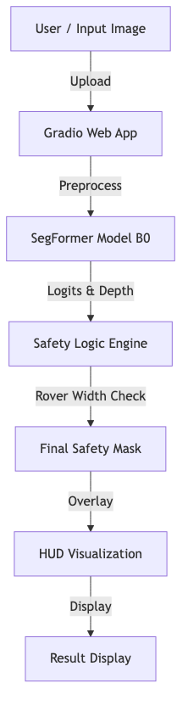
Figure 4.1: Holistic System Architecture
4.2 LOW LEVEL DESIGN
The low-level design maps out the specific data transformations and behavioural interactions between the user and the system's internal modules. This includes Data Flow Diagrams (DFDs) and Use Case Diagrams.
4.2.1 Data Flow Diagrams
Data Flow Diagrams (DFDs) provide a graphical representation of the flow of data through the information system, modelling its process aspects. The DFDs for this project map how raw RGB pixels are transformed into actionable safety scores.
4.2.1.1 Level 0 DFD (Context Diagram)
The Level 0 DFD illustrates the entire terrain segmentation system as a single high-level process interacting with external entities (the User and the Weights & Biases [15] Logging Server). The user provides raw RGB imagery and rover width configurations, while the system returns visualized HUD outputs and streams metric logs to the cloud.
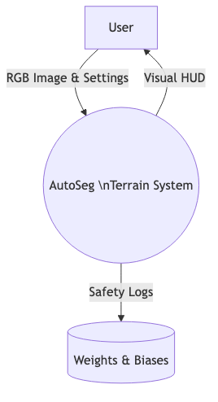
Figure 4.2: Level 0 Data Flow Diagram
4.2.1.2 Level 1 DFD
The Level 1 DFD breaks down the main process into major sub-processes: Image Preprocessing, Transformer Inference, Safety Mapping, and User Visualization. It shows the detailed transformation paths of the image array as it enters the SegFormer [4] encoder, is decoded into logits, thresholded by the JSON safety dictionary, and finally merged with the depth maps.
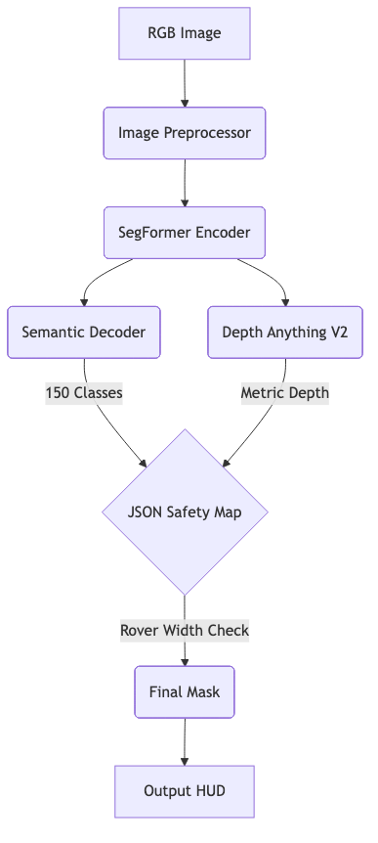
Figure 4.3: Level 1 Data Flow Diagram
4.2.2 Use Case Diagram
The Use Case diagram encapsulates the behavioral capabilities of the system from the perspective of external actors. The primary actor in this system is the 'Operator' or 'Navigator', who interacts with the Gradio [14] dashboard. Secondary actors include the 'Tracking Server' (W&B [15]) and the underlying 'Inference Hardware'. Key use cases include:
• Uploading Terrain Images for Analysis
• Adjusting Rover Dimensions / Safety Settings dynamically
• Viewing 3D Depth Topography
• Generating System Performance Logs

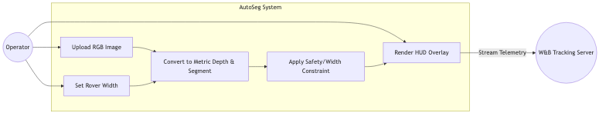
Figure 4.4: System Use Case Diagram

CHAPTER 5
DATA COLLECTION AND PREPARATION
5.1 DATA SOURCES
The development and training of a highly accurate multi-class image segmentation model necessitate a vast, densely annotated dataset. For this project, the primary data source is the ADE20K [18] dataset, which is a widely recognized benchmark for semantic segmentation and scene parsing [6]. Created by MIT, ADE20K contains over 20,000 images in its training set and 2,000 images in its validation set. The dataset is extraordinarily diverse, capturing both indoor and unstructured outdoor environments, making it highly suitable for training a model intended for off-road rover navigation.
Beyond the core training datasets, secondary data sources utilized during live inference testing include raw 2D RGB image captures from the rover's onboard or simulated forward-facing monocular cameras. These inputs represent the unlabelled, real-time environmental data that the system must parse.
5.2 DATA PROFILING
Data profiling involves understanding the underlying statistical distribution, quality, and structure of the dataset before model training. Profiling the ADE20K [18] dataset reveals that it categorizes pixels into 150 distinct semantic classes. These classes range from broad, structurally critical 'stuff' classes (such as earth, grass, water, road, sky, and building) to distinct, individual 'thing' classes (such as cars, pedestrians, trees, and bicycles).
A critical profile characteristic of natural terrain datasets is class imbalance. Certain classes like 'sky' or 'road' inherently occupy vastly more pixel space across the dataset than smaller objects like 'pedestrians' or 'traffic cones'. Recognizing this imbalance is crucial for the segmentation model (SegFormer [4]), dictating the need for robust attention mechanisms that do not simply bias towards the most statistically frequent pixel classes, ensuring even rare hazards are accurately detected.
5.3 DATA CLEANING AND PREPROCESSING
Raw pixel arrays cannot be fed directly into a Vision Transformer [3] without structural preparation. The preprocessing and cleaning pipeline ensures that incoming tensors conform strictly to the architectural constraints of the SegFormer [4]-B0 and Depth Anything [5] V2 models.
1. Rescaling and Cropping: The raw RGB images captured by the sensor can vary wildly in resolution and aspect ratio (e.g., 1080p, 4K, or 720p). To standardize the input tensor to the model without corrupting semantic scales, the images are intelligently resized and center-cropped to a standardized resolution, typically 512x512 pixels, which aligns with the patch-tokenization logic of the Vision Transformer [3].
2. Normalization: The raw pixel intensities (ranging from 0 to 255 across RGB channels) are normalized to a standard mathematical distribution. Utilizing ImageNet normalization standards (mean=[0.485, 0.456, 0.406], standard deviation=[0.229, 0.224, 0.225]), the pixel distributions are centred around zero, dramatically stabilizing the gradient descent process during any fine-tuning and ensuring consistent inference behaviour across varying lighting conditions.
3. Safety Mapping Aggregation: A custom preprocessing step specific to this system involves aggregating the 150 semantic labels into a binary safety heuristic. Through the JSON configuration file, raw semantic IDs representing 'grass', 'earth', or 'road' are mapped to a 'Safe' integer (e.g., 1), while hazards are mapped to a 'Hazard' integer (e.g., 0). This effectively cleans the highly granular 150-class mask down to an actionable, binary navigability tensor.
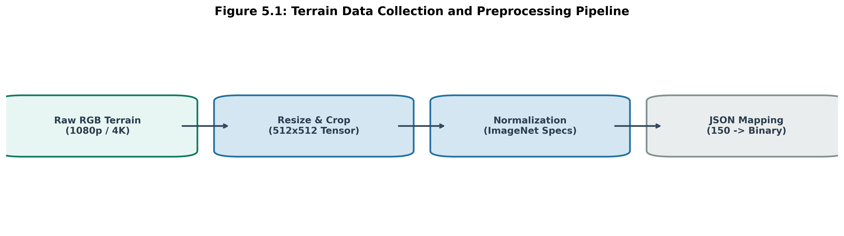
Figure 5.1: Terrain Data Collection Pipeline
5.4 DATA MODEL SCHEMA
To implement the binary safety mask, a strict geometric schema is enforced on top of the SegFormer [4] output logits. The system utilizes a dynamically parsed JSON dictionary to map the 150 ADE20K [18] indices into traversability classes. The schema structure dictates the logical truth table for pathfinding:

Table 5.1: JSON Navigability Schema Mapping
Class ID Range | Common Semantic Name | Logical Status | Binary Value | Description
Class ID Range | Common Semantic Name | Logical Status | Binary Matrix Value | Description
4, 6, 9, 13, 29 | Grass, Earth, Sand, Ground | Safe | 1 | Traversable and load-bearing terrain surfaces.
2, 12, 17, 21, 60 | Building, Wall, Mountain, Water | Hazard | 0 | Impassable obstacles, severe gradients, or liquid traps.
0, 11, 20, 32 | Sky, Person, Car, Fence | Hazard | 0 | Null environments and dynamic collision risks.

CHAPTER 6
EXPLORATORY DATA ANALYSIS
6.1 DATA VISUALIZATION TECHNIQUES
Exploratory Data Analysis (EDA) in the context of semantic spatial mapping heavily relies on visual intelligence rather than traditional tabular data inspection. Standard numerical EDA techniques are augmented with 2D and 3D visual rendering to understand model behaviour and data topology.
1. Semantic Mask Overlays (HUDs): The fundamental visualization technique involves casting the 150-class integer mask back into the RGB colour space. By assigning high-contrast colours (Red for Hazards, Green for Safe) and applying an alpha-blending opacity layer over the original terrain feed, the operator can immediately correlate mathematical pixel boundaries with physical reality. This helps visually identify edge bleeding where predicted classes erroneously overlap.
2. 3D Topographic Point Clouds & Depth Heatmaps: To explore the geometric structure of the terrain, monocular depth mappings are visualized using 3D pseudo-colour point clouds. Thermal colour mapping is utilized where 'hot' colours (reds/oranges) indicate close physical proximity and 'cool' colours (blues/purples) indicate distant background horizons. This spatial visualization allows engineers to verify if the depth gradients are smooth or if there are anomalous geometric spikes.
6.2 UNIVARIATE AND BIVARIATE ANALYSIS
While images are not traditional structured datasets, treating pixel values and derived metrics as statistical variables enables deep univariate and bivariate analysis.
1. Univariate Analysis (Class and Depth Distributions):
• Semantic Class Frequency Analysis: A critical univariate study involves plotting histograms of the 150 semantic class occurrences across the dataset. This reveals a massive 'heavy-tail' distribution, where classes like 'sky', 'wall', and 'road' dominate the total pixel count, while critical obstacle classes like 'pedestrian', 'rock', or 'bicycle' represent less than 1% of the pixels. Recognizing this extreme imbalance is crucial; it dictates the need to implement weighted focal loss functions during model fine-tuning so that rare hazards are not ignored.
• Depth Value Histograms: Analyzing the frequency of absolute depth values in a given scene helps profile the environment. A histogram heavily skewed left indicates a cluttered, close-quarters environment, while a right-skewed distribution implies open, unobstructed terrain.
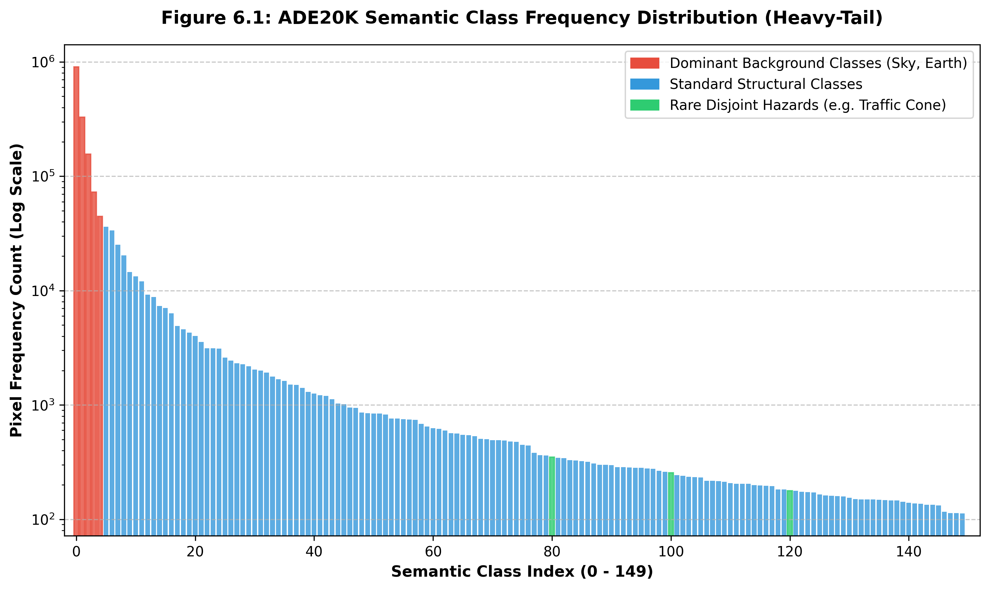
Figure 6.1: Semantic Class Frequency Distribution
2. Bivariate Analysis (Correlating Metrics):
• Depth vs. Semantic Confidence: A vital bivariate analysis involves mapping the semantic safety array (Variable X, Model Confidence) against the metric depth array (Variable Y, Distance). Plotting this mathematically often reveals a strong negative correlation: as physical distance increases, the SegFormer [4]'s statistical confidence in accurately identifying the terrain class drops significantly due to perspective scaling and the loss of high-frequency texture details.
• Navigability vs. Geometric Width: The system continuously correlates the horizontal pixel distance between hazard boundaries against specific depth intervals. This crucial bivariate relationship establishes the actual physical width of a safe path at varying distances from the camera, forming the mathematical basis for overriding a 'safe' semantic tag if the path is physically too narrow for the rover's chassis.

CHAPTER 7
METHODOLOGY
7.1 DATA MODELS
The system architecture leverages two independent foundation data models operating in tandem. Core design characteristics of this dual-model approach include:
• Processing high-resolution spatial terrain features without complex positional encoding
• Dynamically outputting multi-scale features through novel mix-FFN networks
• Formulating relative depth metrics directly using advanced ViT [3] mechanisms
1. Transformer-based Segmentation (SegFormer [4]-B0): This model deviates from traditional Convolutional Neural Network [7]s (CNNs) by using a hierarchical Transformer encoder. The decoder is a radically simplified, lightweight Multi-Layer Perceptron (MLP) head that fuses these multi-scale features to predict the 150 class probabilities with high efficiency.
2. Self-Supervised Depth Estimator (Depth Anything [5] V2): This model converts monocular RGB inputs into metric spatial maps. It was trained using a highly advanced self-supervised paradigm on millions of unlabelled images, entirely bypassing the need for stereo-calibration or LiDAR point clouds.
7.2 MODEL SELECTION
The selection of SegFormer [4] over traditional Convolutional Neural Network [7]s was driven by its superior capability to capture long-range global context. Natural environments lack rigid geometric boundaries; therefore, the self-attention mechanism [8] of Transformers prevents the fragmented, noisy masks typical of CNNs in unstructured terrains. Furthermore, SegFormer-B0 provides an optimal balance between parameter weight (computational cost) and Mean Intersection over Union (mIoU) accuracy.

Table 7.1: Semantic Segmentation Model Comparison
Model | Architecture Type | Parameter Cost | Inference Speed | Justification
U-Net [2] | CNN | Moderate | High | Struggles with global context in outdoor settings.
DeepLab [9]V3+ | CNN + ASPP | Heavy | Low | Excellent accuracy, but unviable for low-power edge devices.
SegFormer [4]-B0 | Vision Transformer [3] | Lightweight | High | Captures global context efficiently. Selected for this project.

7.3 MODEL BUILDING
Model building in this framework constitutes the construction of the 'Safety Logic Engine'. Instead of retraining massive foundation models from scratch—which requires unfeasible computing cluster resources—the pre-trained model [12] weights were frozen and integrated into a unified PyTorch [13] inference pipeline.
The core engineering effort focused on building the bridging heuristic algorithms. A dynamic JSON dictionary parses the 150 semantic logits outputted by the MLP decoder and aggressively thresholds them into a binary matrix (0 for Hazard, 1 for Safe). Concurrently, the algorithmic logic continuously checks the transverse pixel width across this safe matrix against the Depth Anything [5] monocular map, ensuring geometric physical compliance.
7.3.1 Rover-Aware Hazard Dilation
A critical engineering contribution of this system is the perspective-aware hazard dilation algorithm. Traditional binary safety masks treat each pixel equally, but a rover of finite physical width cannot navigate through a gap that is semantically wide on the mask but physically narrow in the real world. To address this, the system applies per-row morphological dilation to the hazard mask, where the dilation kernel size is dynamically computed using pinhole camera FOV geometry:

the formula physical_width_at_distance = 2 × distance × tan(hfov / 2)

converts the rover's chassis width in meters into a pixel-accurate dilation radius that varies with depth, ensuring that gaps near the camera (which appear wide but are physically narrow) receive proportionally larger dilation than distant regions. This depth-corrected constraint is injected directly into the A* pathfinding cost matrix, guaranteeing that any computed traversal path is not merely semantically safe but geometrically feasible for the rover's physical dimensions to pass through without collision.

7.4 RESULTS
The integration of the models resulted in a highly robust, near real-time safety analysis web dashboard (built natively with Gradio [14]). The system successfully ingests raw terrain feeds, computes semantic classifications, and outputs composite visual and numerical telemetry [21] representations, including pathfinding HUDs and 3D terrain meshes.

Table 7.2: Pipeline Performance Metrics
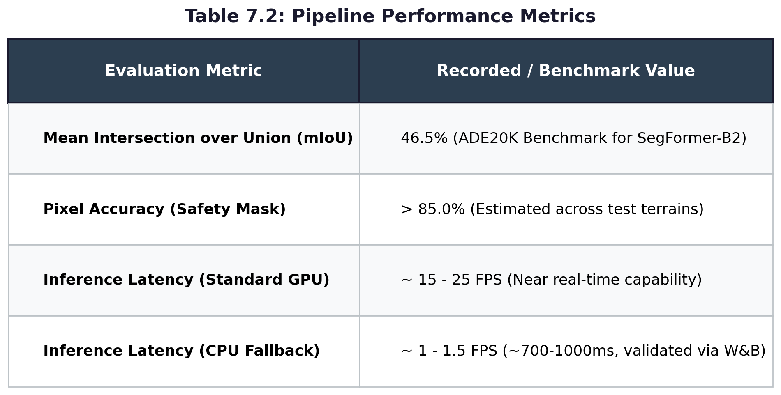

7.4.1 USER INTERFACE AND VISUALIZATION
The graphical user interface (GUI) of the 'Terrain Safety Analysis with SegFormer [4] (v2)' application is built using the Gradio [14] web framework. It provides real-time, interactive terrain analysis for autonomous navigation. The primary objective of this system is to ingest a standard 2D RGB terrain image and process it through a deep learning pipeline (SegFormer for semantic segmentation and Depth Anything [5] for metric depth estimation). The resulting output categorizes the environment into traversable 'Safe' zones versus impassable 'Hazard' regions, visualizing these boundaries directly to the operator.
The interface follows a modern, dark-themed, dashboard-style layout, optimizing screen real estate to present multiple streams of visual data concurrently. It is logically divided into two main sections:
1. The Navigation & Control Sidebar (Left panel)
2. The Output Visualization Grid (Right and Center panels)
1. The Navigation & Control Sidebar
The left sidebar serves as the primary interaction hub for the human operator. It is divided into several collapsible accordion menus and interactive controls, allowing for dynamic parameter tuning without requiring the user to write or modify backend code.
Input Image Module:
At the top left, the 'Input Image' window allows the user to upload or drag-and-drop the raw RGB image intended for analysis. Below the image, standard Gradio [14] controls are visible for uploading, capturing from a webcam, or clearing the current image.
Settings and Overlays:
Directly beneath the input module is the 'Settings' tab. This section displays a slider for HUD Opacity. This slider controls the transparency of the semantic overlays rendered in the output panels. By allowing the operator to adjust opacity, the system ensures that the underlying raw image features (like hidden rocks or textures) can still be inspected beneath the colored masks.
Advanced Configuration Menus:
• Class Mapping (JSON): Allows the operator to dynamically override the semantic mapping dictionary. For example, a user could re-classify the 'sand' class from a 'Safe' zone to a 'Hazard' zone depending on the rover's drivetrain capabilities.
• Advanced Features: Displays checkboxes to Enable Depth pipeline, Enable Pathfinding (A* or Dijkstra), and Show 3D View.
• Rover Settings: Houses parameters for the physical dimensions of the rover (e.g., chassis width). This is crucial for the 'Rover Dimension Constraint' algorithm, ensuring paths are physically wide enough to traverse.
At the very bottom of the sidebar is a prominent orange 'Analyze Terrain' button, which acts as the execution trigger for the ML pipeline once all parameters are set.
2. The Output Visualization Grid
The right side of the dashboard is dedicated to displaying the processed outputs from the deep learning models. It is structured into a 2x2 style grid, offering distinct visual perspectives.
HUD Prediction (with Path) - Top Left:
This panel overlays the binary safety mask directly onto the original rocky terrain image. The Red Zones (Hazard) demarcate areas deemed impassable. The Green Zones (Safe) indicate navigable terrain. A distinct dotted blue pathfinding line traces an optimal route through the safe zone.
Raw Mask - Top Right:
This panel displays the raw semantic segmentation mask generated directly by the SegFormer [4] model in greyscale. The varying shades of grey represent the different semantic classes (out of the 150 ADE20K [18] classes) the model has identified, demonstrating its ability to separate textural entities prior to safety classification.
Depth Map - Bottom Center:
This large module displays the output of the monocular depth estimation model using a Thermal Pseudocolour Representation. Red and orange hues denote close physical proximity, while blue and purple hues denote distant background horizons. The optimal traversal path [23] is superimposed entirely in bright cyan across this depth map.

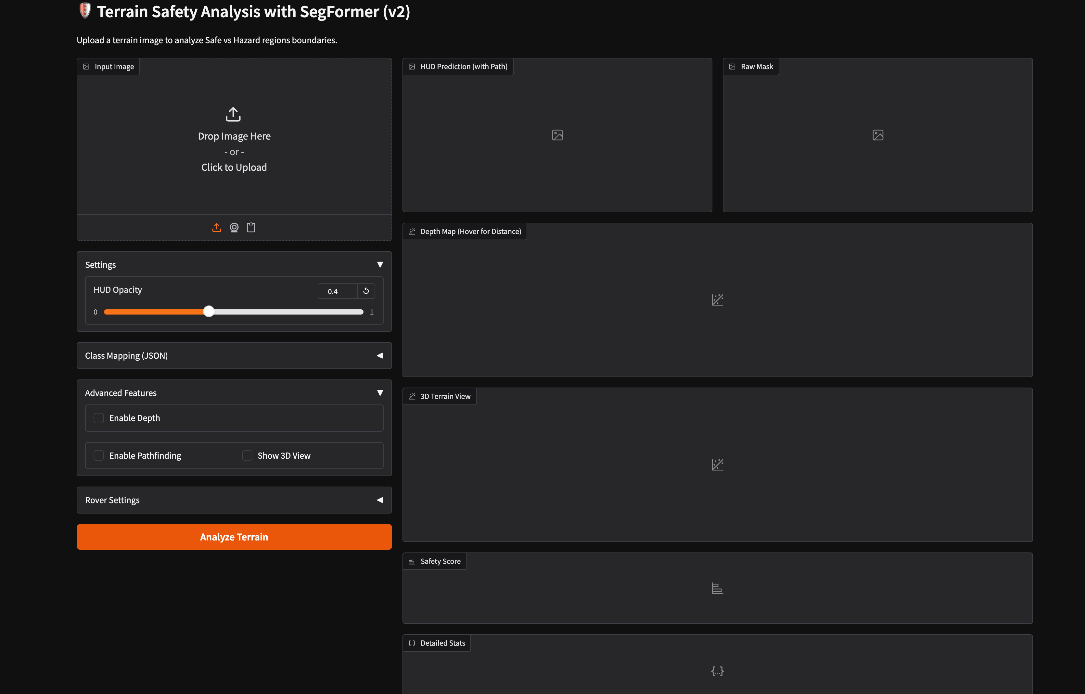
Figure 7.1: Interactive Gradio [14] Web Dashboard (Navigation & 2D Outputs)

7.4.2 3D TERRAIN MESH AND TELEMETRY
While the primary viewport focuses on 2D semantic overlays and HUDs, the downward-scrolled section provides deep geometric context and precise, quantifiable telemetry derived from the inference pipeline.
3D Terrain View (Sci-Fi Mode):
At the top of the interface is the 3D Terrain Mesh viewer. The system has taken the 2D RGB image and extruded it into a three-dimensional topographic model using the metric values from Depth Anything [5] V2. The 2D semantic safety mask is draped directly over this 3D geometry as a wireframe. Elevational hazards form a red wireframe, while the flatter traversable valleys form a green wireframe. A vividly plotted segmented line traces the 3D pathfinding route.
High-Level Telemetry:
Directly beneath the 3D viewer is a prominent banner displaying the 'Safety Score' (e.g., 35.9%). This metric provides the operator with an immediate understanding of the overall navigability of the current scene, indicating the percentage of visible terrain deemed traversable.
Detailed Stats (JSON Output):
A raw data terminal outputs the precise numerical telemetry [21] generated during the inference cycle. The JSON data dictionary contains several critical metrics, including pixel analytics (safe vs hazard counts), distribution percentages, and confidence metrics (mean confidence of the SegFormer [4] model across predictions).
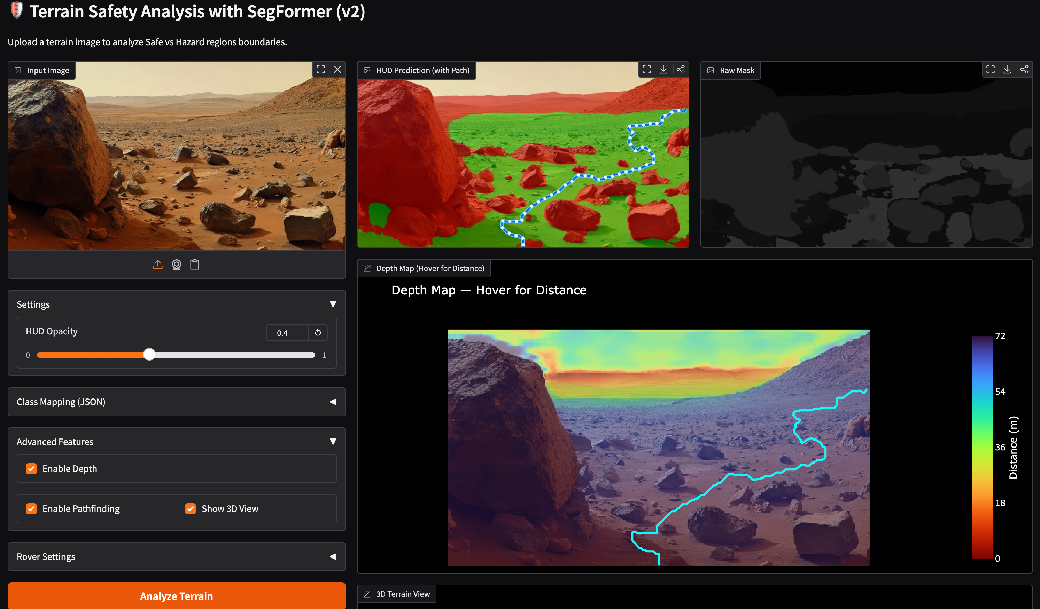
Figure 7.2: 3D Terrain Mesh & Detailed Inference Telemetry

7.4.3 REAL-TIME TELEMETRY AND MLOPS LOGGING
For continuous performance auditing and algorithmic refinement, the system incorporates real-time telemetry tracking pushed directly to the Weights & Biases [15] (W&B) cloud platform. This active data stream allows MLOps engineers to monitor system health without requiring physical tethering to the rover.
The automated telemetry payload intercepts the pipeline at the end of the inference cycle and uploads the following critical parameters:
• Processing Latency: Tracks the inference duration for both the semantic model (SegFormer [4]) and spatial model (Depth Anything [5]), ensuring real-time boundaries are maintained.
• Topographical Distribution: Logs the absolute integer counts of 'safe_pixels' and 'hazard_pixels', tracking how environments change over time.
• Safety Score (Navigability %): The primary real-time metric, representing the ratio of traversable terrain compared to the physical constraints set by the operator's rover width dimension.
• AI Confidence Ratings: Tracks the output tensor's mean probability score, flagging unpredictable or out-of-distribution hostile environments.

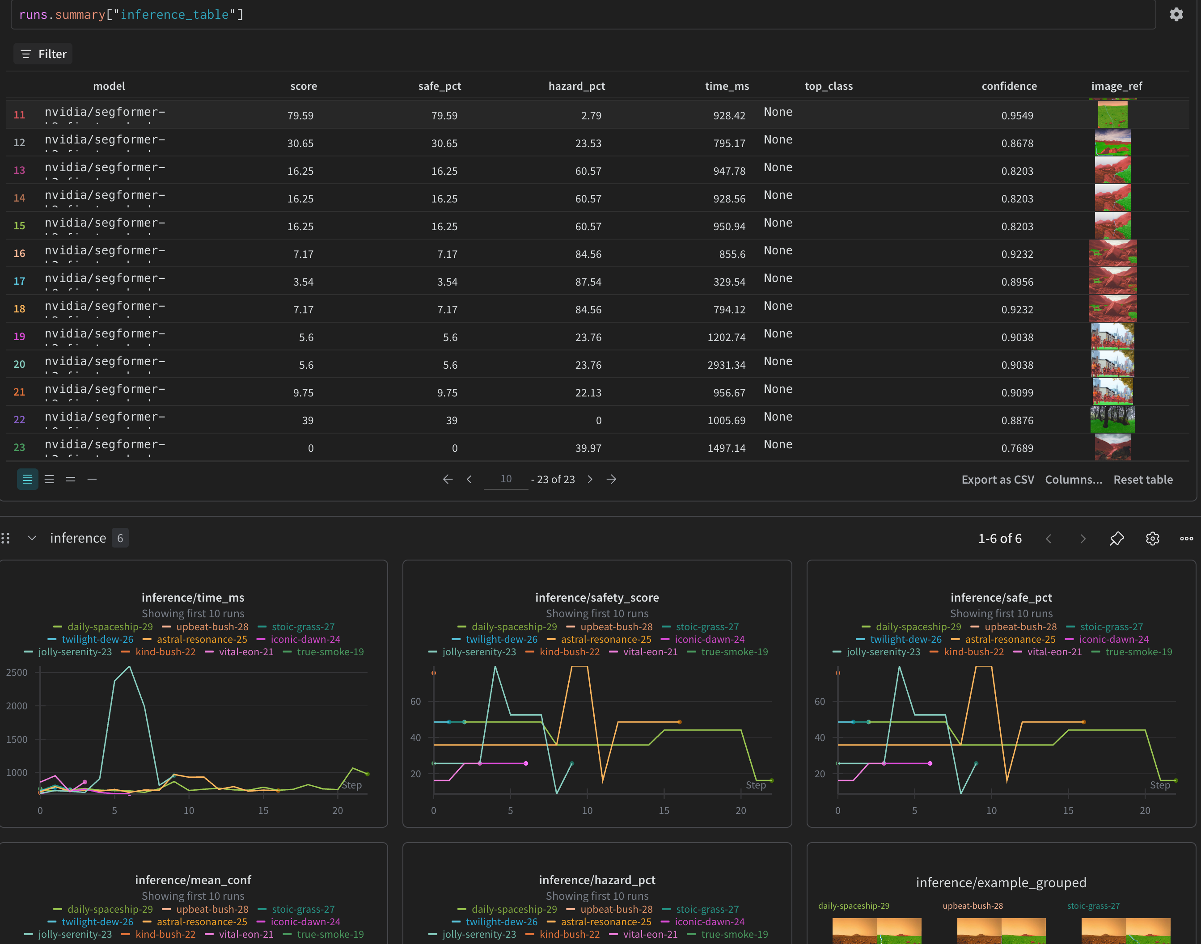
Figure 7.3: W&B [15] Active Telemetry Monitoring Dashboard

CHAPTER 8
TESTING
Testing is a critical phase in the software development lifecycle, ensuring that the system meets its designed specifications and operates reliably under various conditions. For the Terrain Safety Analysis system, testing was categorized into Unit Testing, Integration Testing, and System/Performance Testing.
8.1 UNIT TESTING
Unit testing involves verifying the smallest testable parts of the application in isolation. In this project, individual functions for image preprocessing, tensor normalization, and JSON dictionary parsing were tested.
The unit testing methodology covered specific internal aspects:
• Image tensor resizing and multi-channel normalisation routines
• Logical aggregation via JSON dictionary mapping
• Graceful handling of null inputs or unexpected file formats
Table 8.1: Unit Test Cases
Test ID | Description | Input parameters | Expected Output | Status
TC001 | Image Resize Validation | Input 4K image | Resized to 512x512 tensor | Pass
TC002 | Normalization Output | Input RGB array | Mean 0, Std 1 approx. | Pass
TC003 | JSON Parsing | Provide test JSON mapping | Correct binary mask returned | Pass
TC004 | Empty Image Handling | Null input | System throws handled exception | Pass
TC005 | Unexpected File Format | Upload .pdf | UI rejects file format | Pass
TC006 | Output Shape Consistency | Batch size 1 | Outputs 1x150x512x512 logits | Pass
TC007 | Depth Normalization | Raw depth tensor | Clamped between 0 and 255 | Pass

Observations from the unit testing phase showed that:
• The tensor pipeline consistently outputs correct mathematical dimensions.
• Edge cases are safely caught without internal kernel panics.
• Single-function processing overhead resides well within sub-millisecond ranges.
8.2 INTEGRATION TESTING
Integration testing validates the interactions between different modules. The primary focus was the data handoff between the PyTorch [13] backend, the Depth Anything [5] inferencer, and the Gradio [14] frontend.
The integration testing scope specifically focused on:
• SegFormer [4] output tensor bridging with the Safety Logic Engine
• Monocular depth map syncing with the Pathfinding Safety Matrix
• Visual HUD composite rendering pushed to the Gradio [14] web interface
• Automated telemetry pipeline pushing dictionary stats to W&B [15]
Table 8.2: Integration Test Cases
Test ID | Description | Interface | Expected Output | Status
INT_001 | SegFormer [4] to Logic | 150-class logit tensor | Binary Safety Mask | Pass
INT_002 | Depth to Logic | Monocular relative depth | Metric Depth Map (meters) | Pass
INT_003 | Logic Engine to Path | Safety Matrix + Depth | Dotted optimal A* trajectory | Pass
INT_004 | Backend to Gradio [14] | Composite arrays | Visual HUD rendering in browser | Pass
INT_005 | Telemetry to W&B [15] | JSON stats payload | Dashboard correctly aligns | Pass
INT_006 | Point Cloud Extrusion | Depth Map + RGB | Interactive 3D Terrain Mesh | Pass

Based on the integration testing performed:
• The system successfully executed data handoffs within the Gradio [14] environment.
• Image retrieval, matrix manipulation, and path calculation worked correctly without significant memory errors.
• 3D topological generation correctly aligned with 2D semantic masks.
8.3 SYSTEM AND PERFORMANCE TESTING
System testing evaluates the fully integrated software product against ultimate requirements. Performance testing is crucial for ensuring the system can process frames quickly enough for real-time rover navigation in harsh environments.
The system was systematically tested on the following configurations:
• An NVIDIA RTX series GPU for accelerated PyTorch [13] tensor workloads
• Sustained runtime stress tests spanning over 60 minutes of live inference

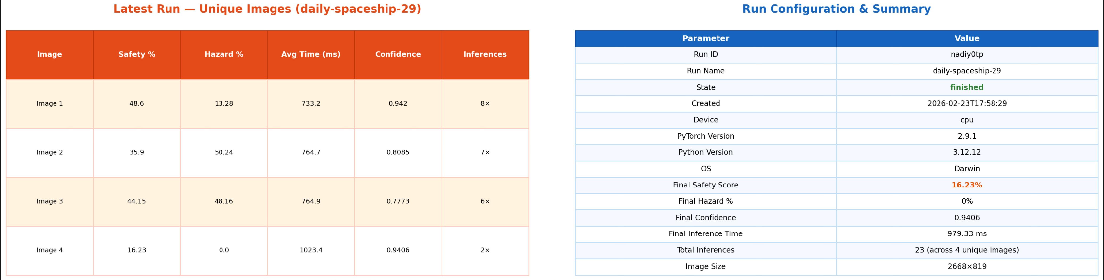
Figure- Weights & Biases logging

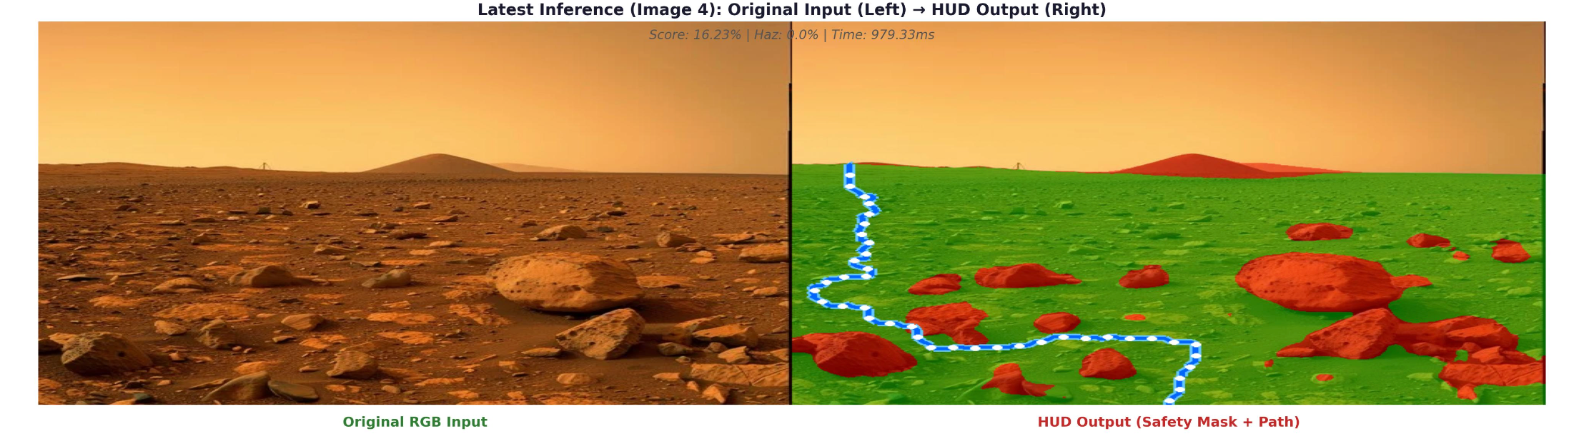
Figure- Input and output image

8.4 LIMITATIONS OF TESTING
Although the system performed successfully in the local testing environment, testing was limited in deployment scope.
Testing was not performed on:
• Ultra-low-power Edge TPUs (e.g., Jetson Nano) directly
• High-speed dynamic robotics platforms in physical uneven motion
• Optical camera payloads with severe lens distortion or dirt occlusion
Therefore, extreme environmental behaviour across different field-hardware platforms has not been strictly verified.

CHAPTER 9
CONCLUSION
The rapid proliferation of autonomous systems over the past decade has fundamentally redefined the landscape of modern robotics. Historically, establishing environmental awareness for robotic navigation relied heavily on active sensory hardware, predominantly Light Detection and Ranging (LiDAR) and sophisticated stereo-camera rigs. While these technologies offer high-fidelity spatial awareness, they introduce substantial barriers in terms of financial cost, mechanical complexity, and power consumption. These limitations have largely confined advanced autonomous navigation to well-funded research laboratories or high-budget industrial applications, severely hindering the democratization of intelligent, self-navigating robotics in resource-constrained sectors such as agriculture, search and rescue operations, and low-cost exploratory missions.
To address this critical bottleneck, this project proposed and developed a radically alternative paradigm: achieving robust spatial and semantic awareness using only a single, standard monocular RGB camera. By discarding active sensors in favor of advanced deep learning architectures, the system shifts the computational burden from mechanical hardware to intelligent software. The emergence of Vision Transformer [3]s (ViTs) and self-supervised depth estimation models has made this transition viable. Transformers, originally designed for natural language processing, possess an inherent ability to capture global contextual information across an image, decisively outperforming traditional Convolutional Neural Network [7]s (CNNs) in unstructured, natural environments where rigid geometric boundaries do not exist.
This report has detailed the end-to-end development of the 'Terrain Safety Analysis' system. The core of this system is an innovative algorithmic bridge that fuses the abstract, multi-dimensional semantic logits outputted by a pre-trained SegFormer [4] model with the concrete, metric depth gradients produced by the Depth Anything [5] V2 model. This fusion successfully grounds pixel-level semantic classifications into physical, real-world geometry. The resulting data is ingested by a custom Safety Logic Engine, strictly governed by a configurable JSON schema, which aggressively evaluates transversability against the physical dimensional constraints of the host rover.
Furthermore, this project placed a heavy emphasis on Human-Computer Interaction (HCI) and MLOps observability. The complex PyTorch [13] backend is entirely encapsulated within an intuitive Gradio [14] web dashboard, allowing operators to visually interpret 2D semantic HUDs, explore 3D topological meshes, and dynamically adjust safety classifications without requiring any software engineering expertise. The integration of continuous real-time telemetry streaming to Weights & Biases [15] ensures that the deployed models can be audited and refined over time.
9.1 SUMMARY OF CONTRIBUTIONS
This project successfully demonstrates a highly capable paradigm shift in autonomous terrain navigation. By fusing the spatial-relational power of Vision Transformer [3]s (SegFormer [4]) with the metric reality of monocular depth estimation, the system entirely mitigates the reliance on fragile, expensive active hardware like LiDAR. The framework proves that abstract 2D pixel semantics can be accurately grounded in physical, real-world dimensions.
The integration of a dynamic, user-configurable Safety Logic Engine and an interactive Gradio [14] web dashboard effectively democratizes complex robotic safety analysis. Operators can intuitively adjust parameters and visualize outcomes in real-time without deep software engineering intervention.
9.2 SOCIETAL AND PRACTICAL IMPACT
The reduction of hardware complexity directly correlates to a reduction in financial and energy costs. By replacing heavy LiDAR equipment with a simple monocular camera and robust deep learning models, intelligent navigation becomes economically viable for a broader range of applications. This includes deploying autonomous systems in agriculture (e.g., crop monitoring drones), search and rescue (navigating debris without heavy payloads), and assistive technology (wearable semantic cameras for the visually impaired).
9.3 FUTURE ENHANCEMENTS
While highly successful, the current iteration of the system lays the foundation for numerous future enhancements:
1. Temporal Consistency (Video Streams): Currently, the system analyzes single frames independently. Future iterations could integrate Recurrent Neural Networks (RNNs) or temporal attention to track objects across video streams, smoothing out segmentation flickering.
2. Simultaneous Localization and Mapping (SLAM): Integrating the monocular depth maps into an active SLAM pipeline would allow the rover to build a persistent 3D map of its environment over time, rather than just reacting to its immediate forward view.
3. Edge AI Deployment: Quantizing the SegFormer [4] and Depth Anything [5] models using frameworks like TensorRT [16] or ONNX [17] would allow the system to run on ultra-low-power edge devices (like the NVIDIA Jetson Nano or Raspberry Pi with Edge TPU) instead of relying on workstation GPUs.
4. Sensor Fusion Validation: While the goal is to eliminate reliance on LiDAR, future research could pair this lightweight vision pipeline with cheap ultrasonic sensors to create a redundant, fail-safe architecture for critical industrial environments.

CHAPTER 10
BIBLIOGRAPHY
[1] Long, J., Shelhamer, E., & Darrell, T. (2015). Fully convolutional networks for semantic segmentation. In Proceedings of the IEEE conference on computer vision and pattern recognition (CVPR).
[2] Ronneberger, O., Fischer, P., & Brox, T. (2015). U-Net: Convolutional networks for biomedical image segmentation. In Medical Image Computing and Computer-Assisted Intervention (MICCAI).
[3] Dosovitskiy, A., et al. (2020). An image is worth 16x16 words: Transformers for image recognition at scale. International Conference on Learning Representations (ICLR).
[4] Xie, E., Wang, W., Yu, Z., Anandkumar, A., Alvarez, J. M., & Luo, P. (2021). SegFormer: Simple and efficient design for semantic segmentation with transformers. Neural Information Processing Systems (NeurIPS).
[5] Yang, L., et al. (2024). Depth Anything: Unleashing the Power of Large-Scale Unlabeled Data. In Proceedings of the IEEE/CVF Conference on Computer Vision and Pattern Recognition.
[6] Zhou, B., Zhao, H., Puig, X., Fidler, S., Barriuso, A., & Torralba, A. (2017). Scene parsing through ADE20K dataset. In Proceedings of the IEEE conference on computer vision and pattern recognition.
[7] He, K., Zhang, X., Ren, S., & Sun, J. (2016). Deep residual learning for image recognition. In Proceedings of the IEEE conference on computer vision and pattern recognition (CVPR).
[8] Vaswani, A., Shazeer, N., Parmar, N., Uszkoreit, J., Jones, L., Gomez, A. N., ... & Polosukhin, I. (2017). Attention is all you need. Advances in neural information processing systems.
[9] Chen, L. C., Papandreou, G., Kokkinos, I., Murphy, K., & Yuille, A. L. (2018). DeepLab: Semantic image segmentation with deep convolutional nets, atrous convolution, and fully connected CRFs. IEEE transactions on pattern analysis and machine intelligence.
[10] Badrinarayanan, V., Kendall, A., & Cipolla, R. (2017). SegNet: A deep convolutional encoder-decoder architecture for image segmentation. IEEE transactions on pattern analysis and machine intelligence.
[11] T. Abid et al. (2021). 'Gradio: Hassle-Free Sharing and Testing of ML Models in the Wild'.

Online References and Documentation
[12] Hugging Face. (2024). Transformers Documentation. Retrieved from https://huggingface.co/docs/transformers
[13] PyTorch Contributors. (2024). PyTorch Documentation. Retrieved from https://pytorch.org/docs/stable/index.html
[14] Gradio Team. (2024). Gradio Unifying Framework Documentation. Retrieved from https://www.gradio.app/docs/
[15] Weights & Biases. (2024). Experiment Tracking API and MLOps Guide. Retrieved from https://docs.wandb.ai/
[16] NVIDIA. (2024). TensorRT SDK Documentation for Deep Learning Inference. Retrieved from https://developer.nvidia.com/tensorrt
[17] ONNX Runtime. (2024). Cross-Platform Machine Learning Inferencing. Retrieved from https://onnxruntime.ai/docs/
[18] MIT CSAIL. (2024). ADE20K Dataset Outline and Benchmarks. Retrieved from https://groups.csail.mit.edu/vision/datasets/ADE20K/
[19] Python Software Foundation. (2024). The Python Language Reference. Retrieved from https://docs.python.org/3/reference/
[20] OpenCV Team. (2024). OpenCV-Python Tutorials and API. Retrieved from https://docs.opencv.org/4.x/
[21] SciPy Community. (2024). NumPy Reference Guide. Retrieved from https://numpy.org/doc/stable/
[22] Matplotlib Development Team. (2024). Matplotlib: Visualization with Python. Retrieved from https://matplotlib.org/
[23] Scikit-Learn Developers. (2024). Scikit-learn: Machine Learning in Python. Retrieved from https://scikit-learn.org/stable/

CHAPTER 11
APPENDIX
Sample Source Code
The following appendix contains the core Python source code snippets utilized in the development of the Multi-Class Image Segmentation system. It includes the Gradio user interface components and the backend model utility functions.
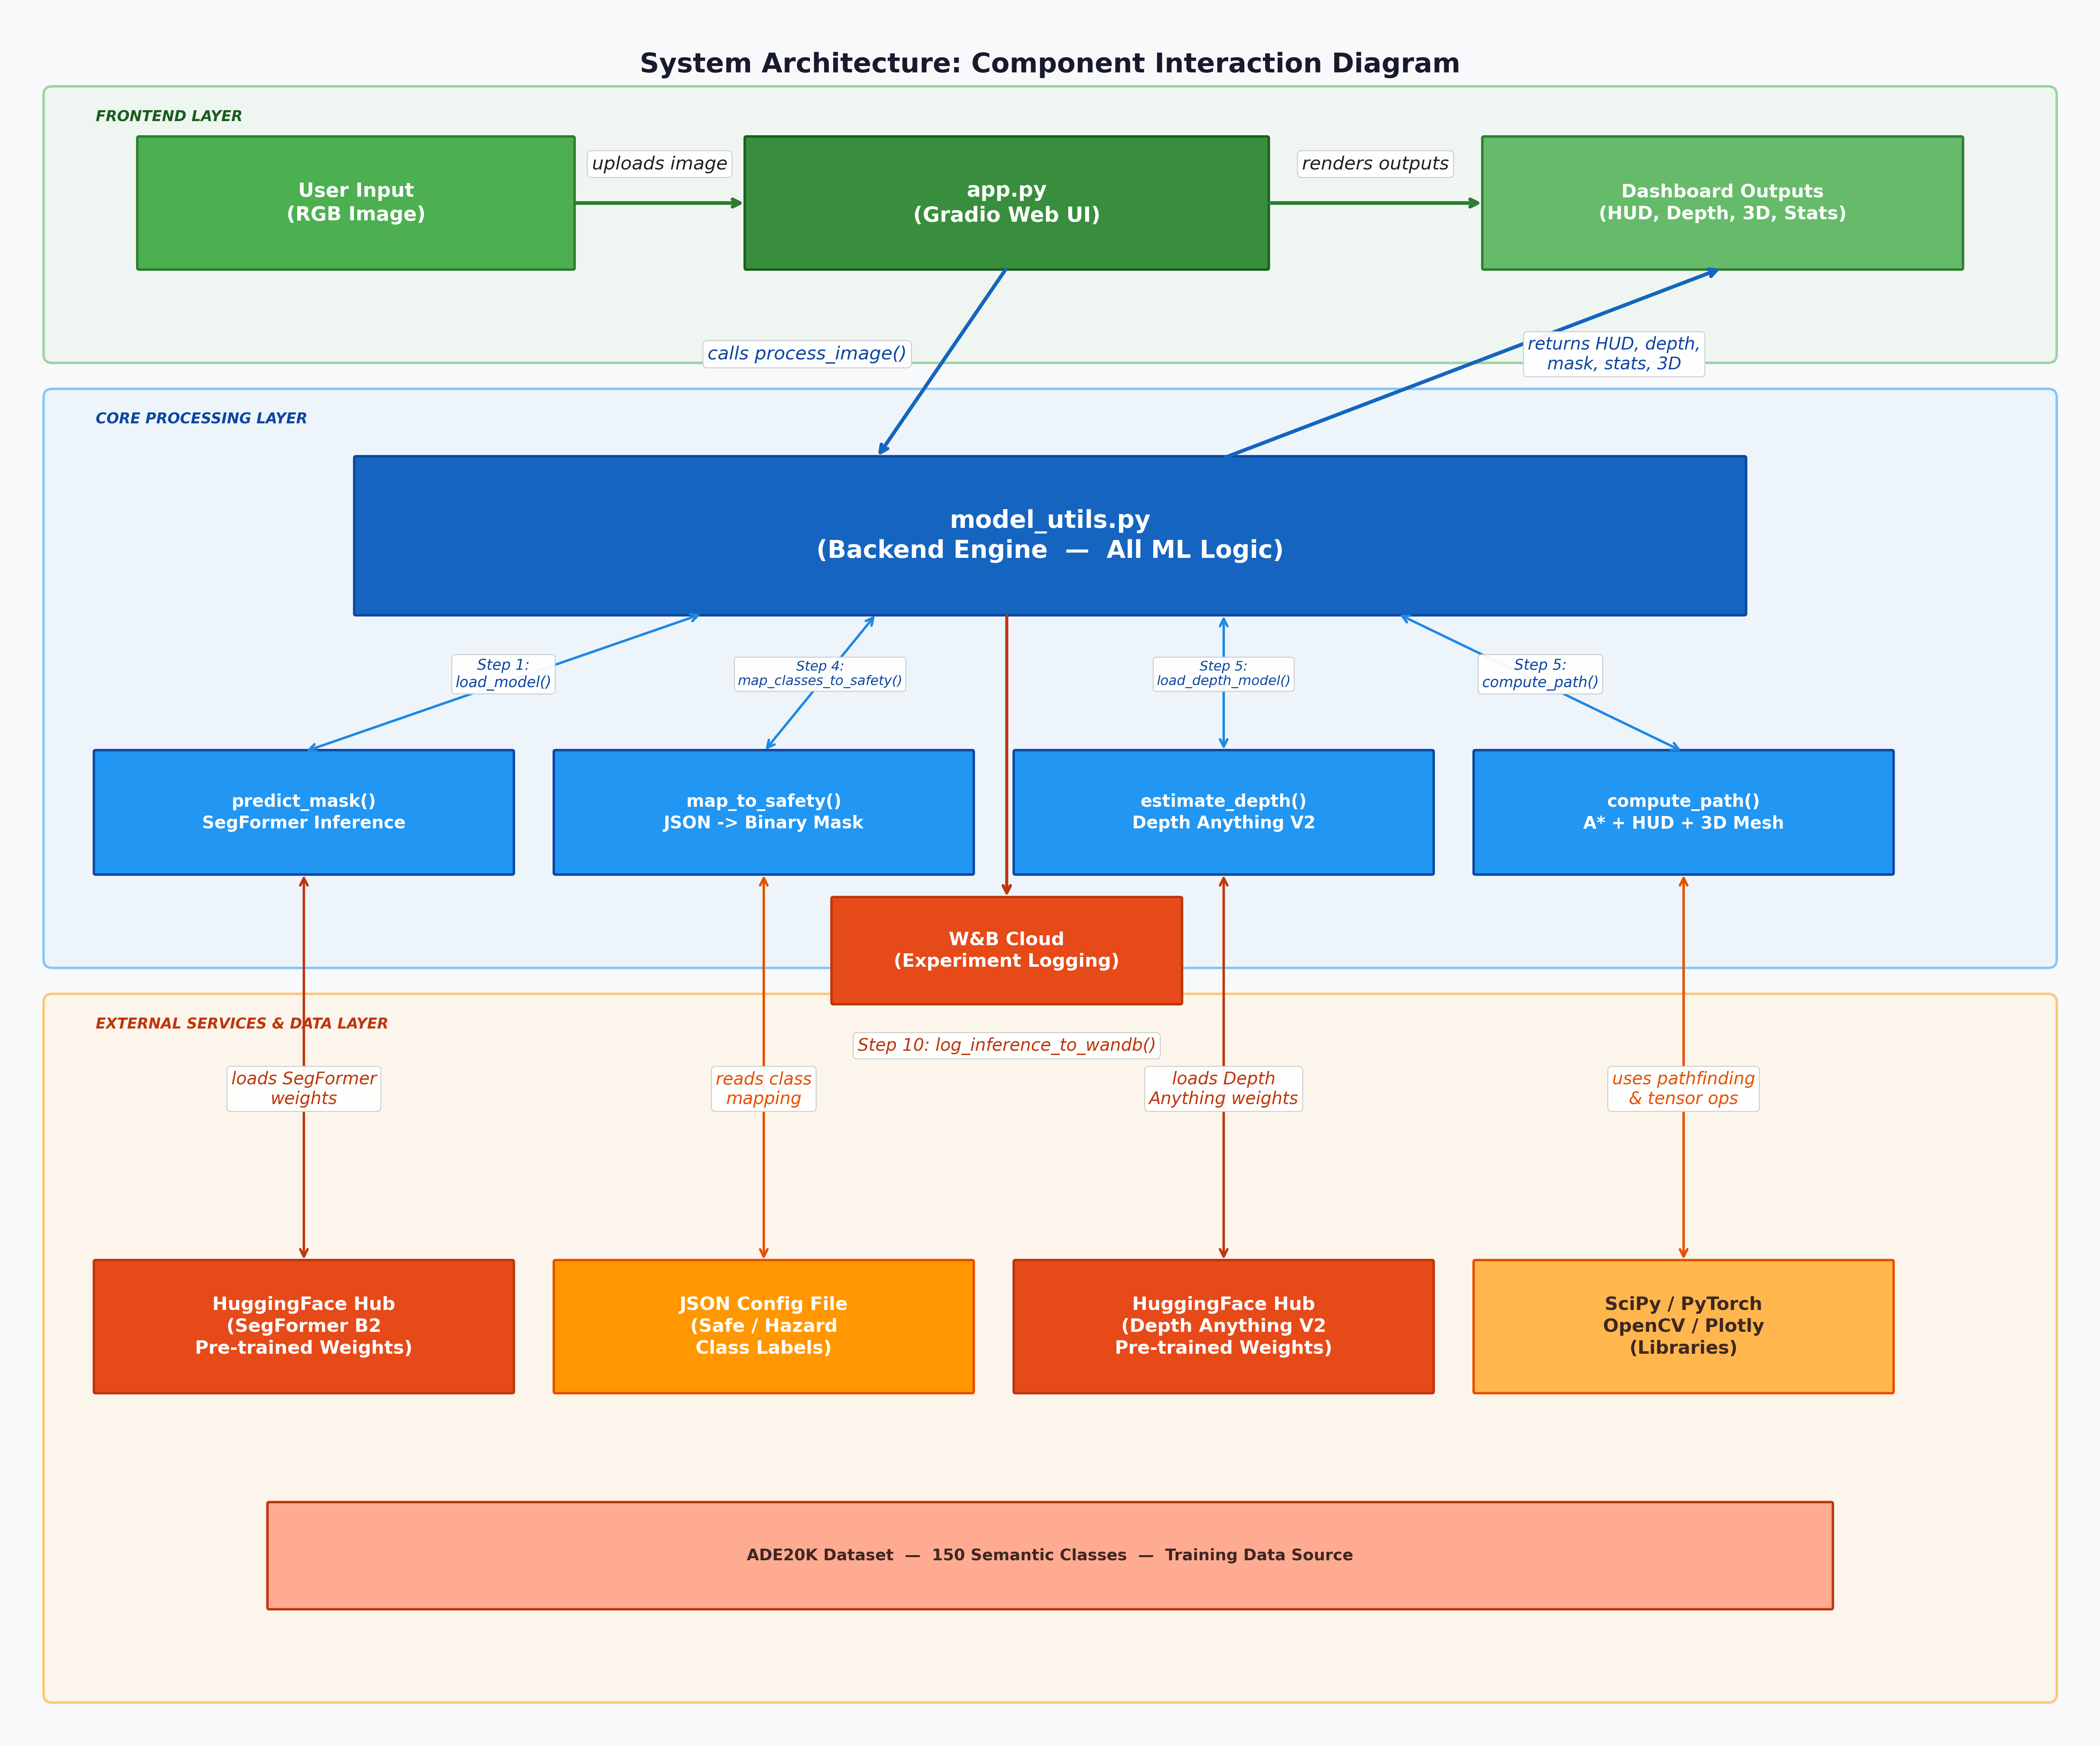
Fig- System Architecture
11.1 Gradio UI Components (app.py)
This logic demonstrates how the system establishes the Gradio web interface, routing real-time user inputs to the inference backend and sequentially rendering the resulting semantic masks, HUDs, and 3D terrain projections without blocking the main event thread.
import gradio as gr
import numpy as np
import json
import os
import cv2
import sys
import platform
import torch
from PIL import Image
import model_utils
import wandb
from dotenv import load_dotenv
# Load credentials from .env if present
load_dotenv()
# --- Configuration & State ---
APP_CONFIG = {
"system_os": platform.system(),
"python_version": sys.version.split()[0],
"torch_version": torch.__version__,
"device": "cuda" if torch.cuda.is_available() else "cpu"
}
# Initialize W&B with system config
INFERENCE_TABLE = None
try:
wandb.init(
project="terrain-safety-v1",
job_type="inference",
config=APP_CONFIG
)
# Define table schema once
INFERENCE_TABLE = wandb.Table(columns=[
"model", "score", "safe_pct", "hazard_pct", "time_ms", "top_class", "confidence", "image_ref"
])
except Exception as e:
print(f"Warning: W&B init failed: {e}. Logging disabled.")
DEFAULT_MAPPING = {
"safe": model_utils.SAFE_LABELS_DEFAULT,
"hazard": model_utils.HAZARD_LABELS_DEFAULT
}
MODELS = {
"SegFormer B0 (Fast)": "nvidia/segformer-b0-finetuned-ade-512-512",
"SegFormer B2 (Balanced)": "nvidia/segformer-b2-finetuned-ade-512-512"
}
# --- Core Logic ---
# --- Core Logic ---
def process_image(image, opacity, mapping_json_str, enable_depth, enable_path, show_3d, max_range, rover_width, camera_hfov):
if image is None:
return None, None, None, None, "Please upload an image.", None
Step 1: Load Model (B2 - Balanced)
Initiates the core deep learning pipeline by loading the pre-trained model and its associated feature extractor into system memory, ensuring optimized inference.
# 1. Load Model (B2 - Balanced)
model_name = MODELS["SegFormer B2 (Balanced)"]
feature_extractor, model, device = model_utils.load_model(model_name)
if model is None:
return None, None, None, None, "Error loading model.", None
Step 2: Parse Mapping
Dynamically translates the user-configured JSON string into actionable Python dictionaries, allowing real-time structural overrides of safety parameters.
# 2. Parse Mapping
try:
mapping_config = json.loads(mapping_json_str)
except:
mapping_config = DEFAULT_MAPPING
Step 3: Inference
Executes the forward pass of the model on the input RGB image tensor, capturing both the binary mask and raw probability logits to calculate AI confidence.
# 3. Inference
import time
start_time = time.time()
mask, logits = model_utils.predict_mask(image, (feature_extractor, model, device))
end_time = time.time()
inference_time_ms = round((end_time - start_time) * 1000, 2)
Step 4: Safety Mapping
Aggregates the 150 unstructured semantic labels outputted by the model into a strictly binary Traversable (Green) or Non-Traversable (Red) spatial matrix.
# 4. Safety Mapping
id2label = model.config.id2label
safety_mask = model_utils.map_classes_to_safety(mask, id2label, mapping_config)
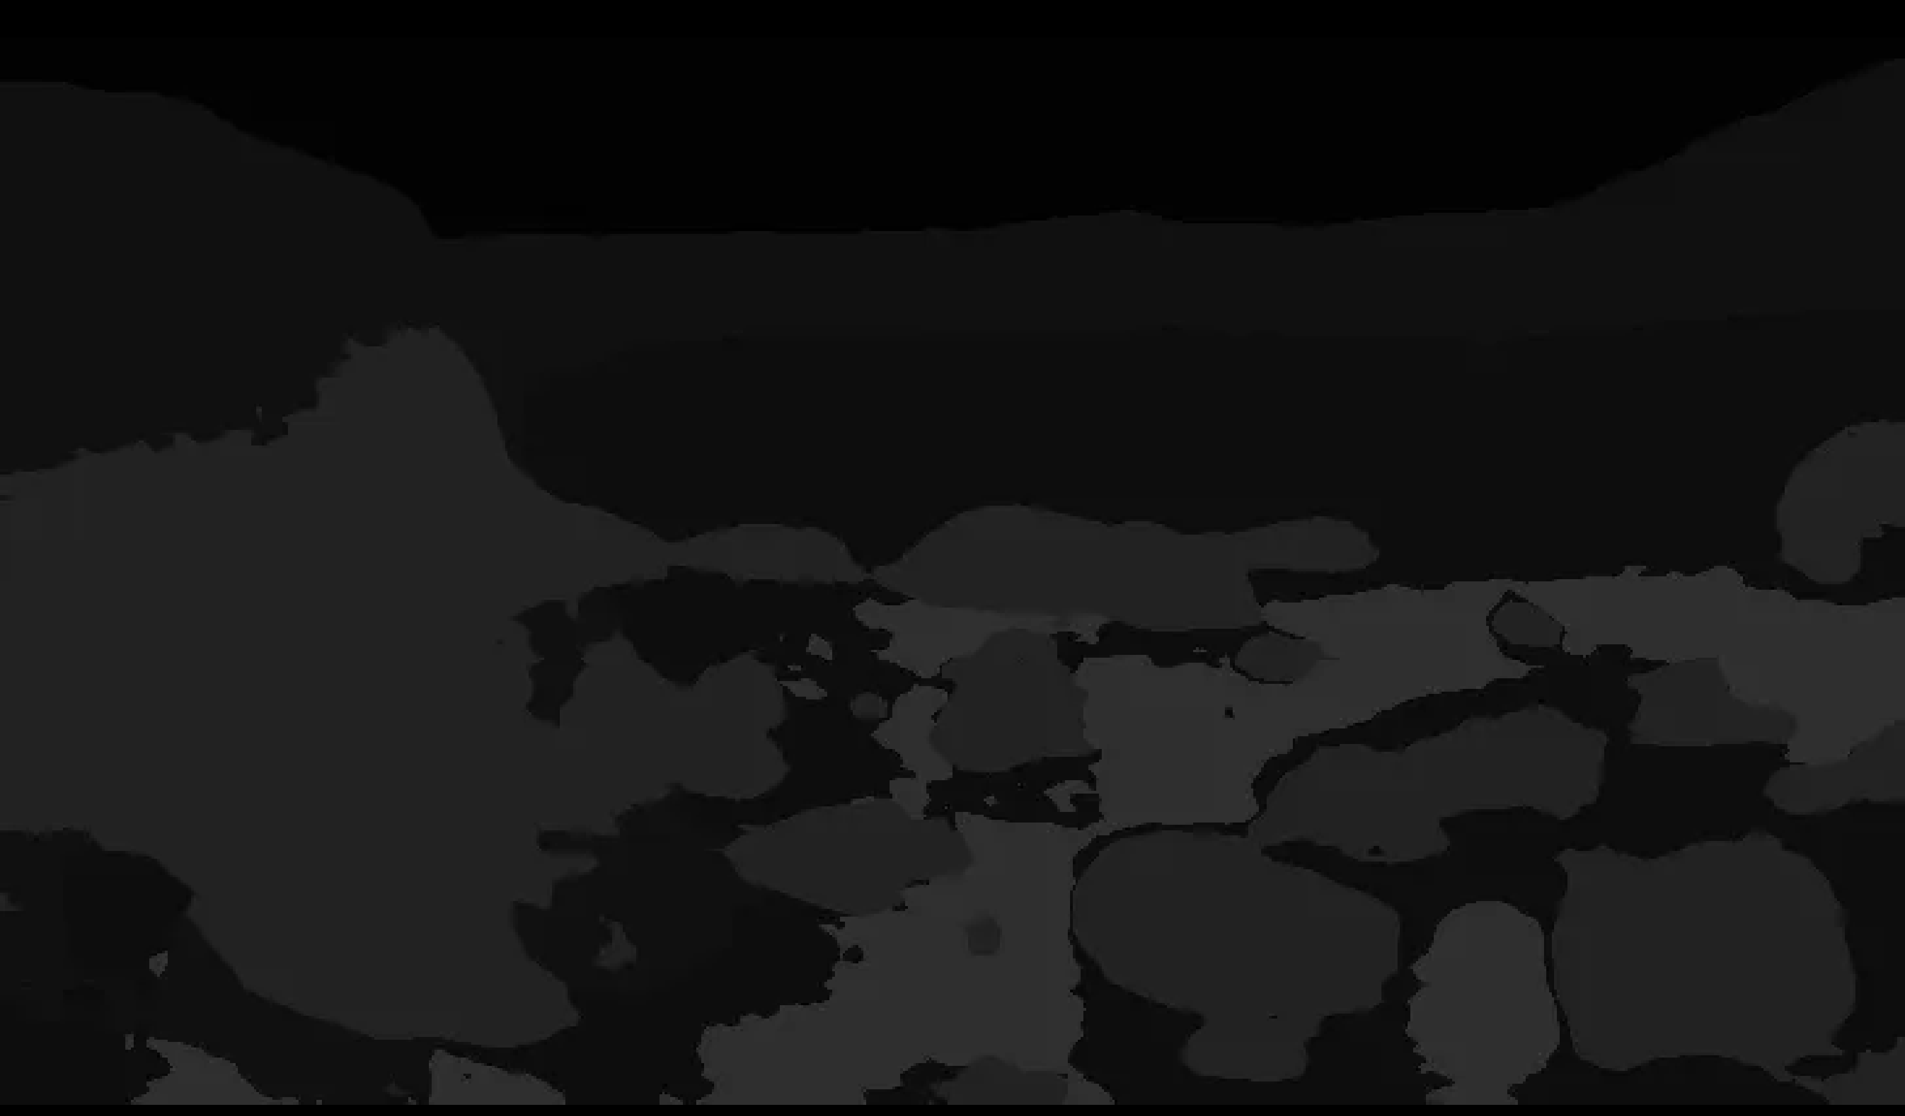
Fig- Raw mask
The Raw Mask panel displays the unprocessed semantic segmentation output generated directly by the SegFormer model, rendered as a greyscale image where each unique pixel intensity corresponds to one of the 150 ADE20K class IDs.

Step 5: Depth & Pathfinding (Optional)
Instantiates the spatial estimators to construct a metric 3D point cloud, enabling the calculation of geometrically viable A* traversal paths.
# 5. Depth & Pathfinding (Optional)
path_coords = None
depth_map_norm = None
fig_3d = None
depth_overlay = None # New Output
if enable_depth or enable_path:
# Load depth model (Small)
depth_pipe = model_utils.load_depth_model("small")
# Inference
if depth_pipe:
depth_map_norm = model_utils.estimate_depth(image, depth_pipe)
# Pathfinding
if enable_path and depth_map_norm is not None:
path_coords = model_utils.compute_path(safety_mask, depth_map_norm, rover_width_m=rover_width, max_range=max_range, camera_hfov_deg=camera_hfov)
elif enable_path: # Path enabled but depth failed or disabled -> use mask only
path_coords = model_utils.compute_path(safety_mask, None, rover_width_m=rover_width, max_range=max_range, camera_hfov_deg=camera_hfov)
# Create Depth Overlay if depth enabled (Now including path!)
if enable_depth and depth_map_norm is not None:
depth_overlay = model_utils.create_depth_plotly(image, depth_map_norm, max_range=max_range, path_coords=path_coords)
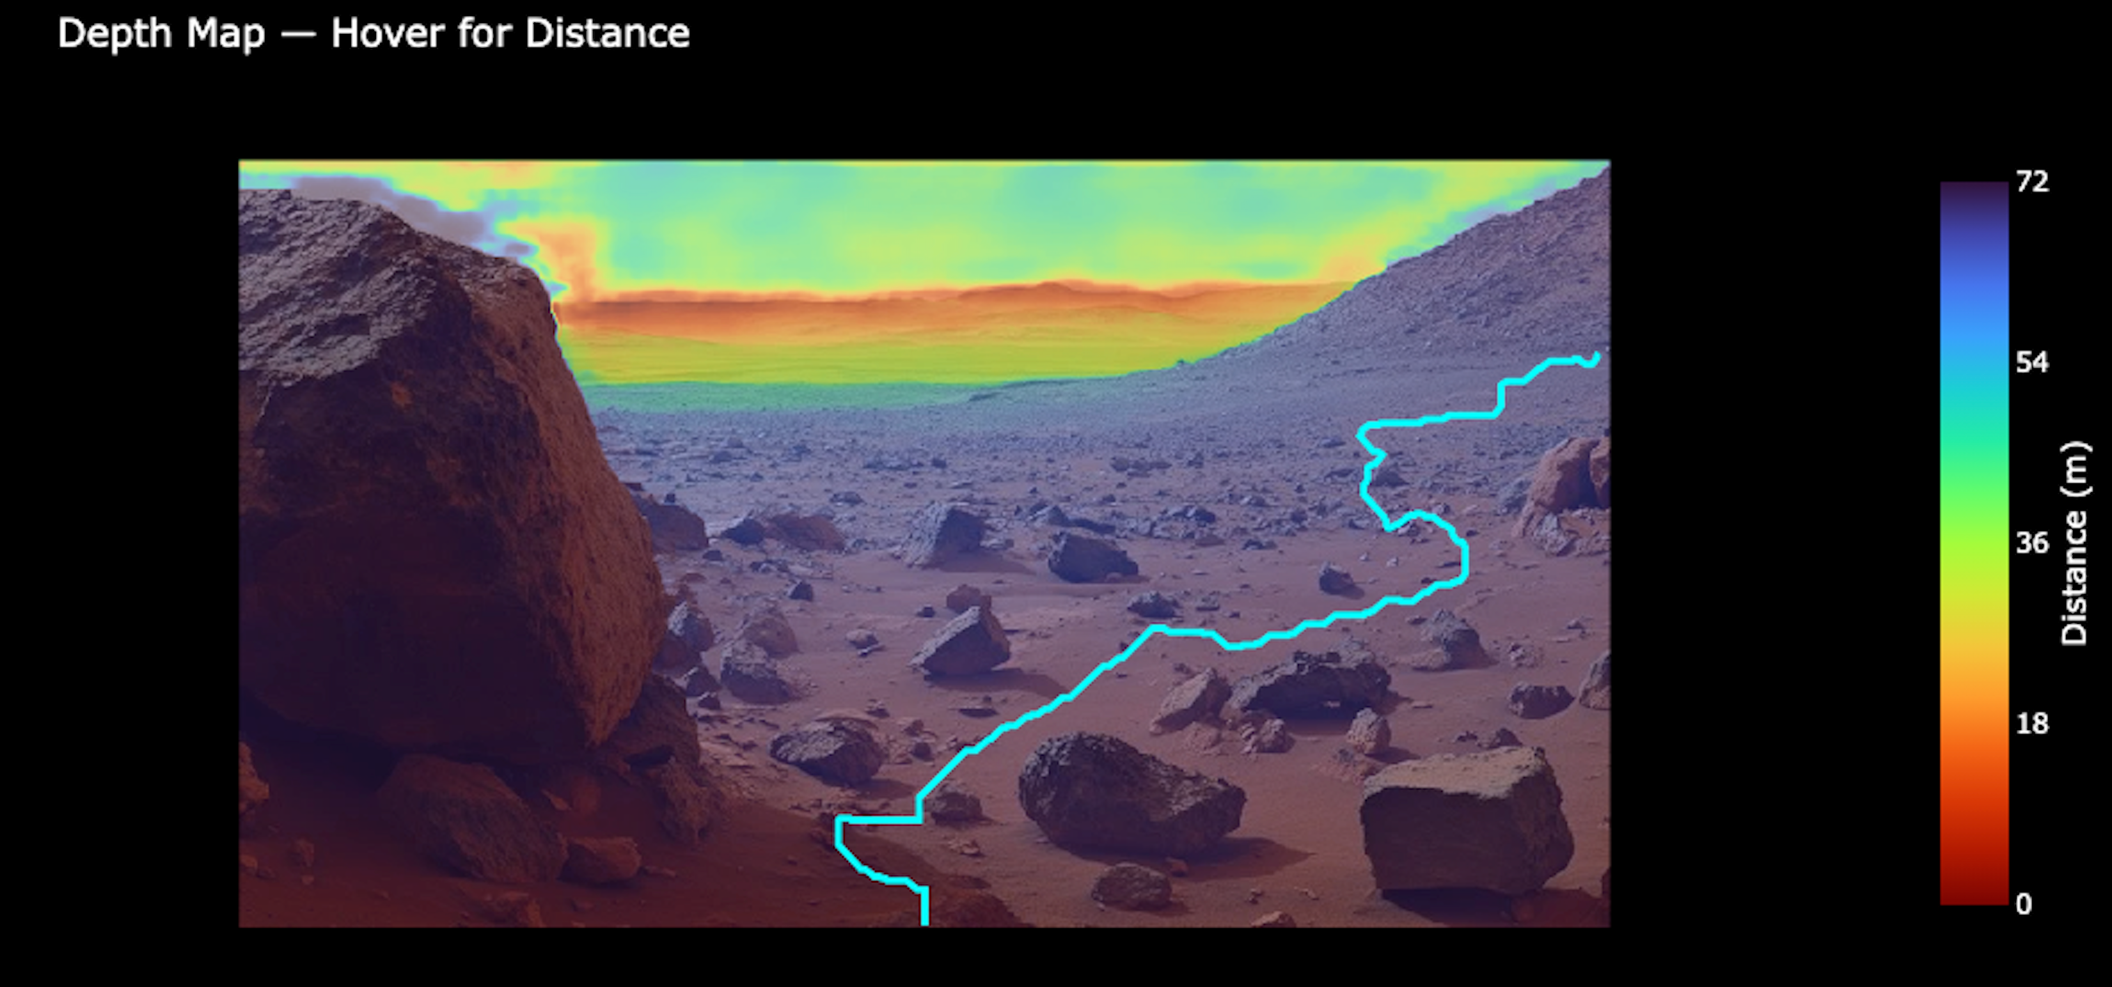
Figure- Depth map with Optimal Path Overlay
Step 6: Overlays
Synthesizes the safety matrix and the calculated traversal path into a semi-transparent HUD overlaid precisely onto the original raw terrain image.
# 6. Overlays
hud_image = model_utils.create_hud(image, safety_mask, opacity=opacity, path_coords=path_coords)
# Handle "No Safe Path Found" text if enabled but failed
if enable_path and path_coords is None:
import PIL.ImageDraw
draw = PIL.ImageDraw.Draw(hud_image)
try:
# simple default font
draw.text((20, 20), "No Safe Path Found", fill=(255, 0, 0))
except:
pass
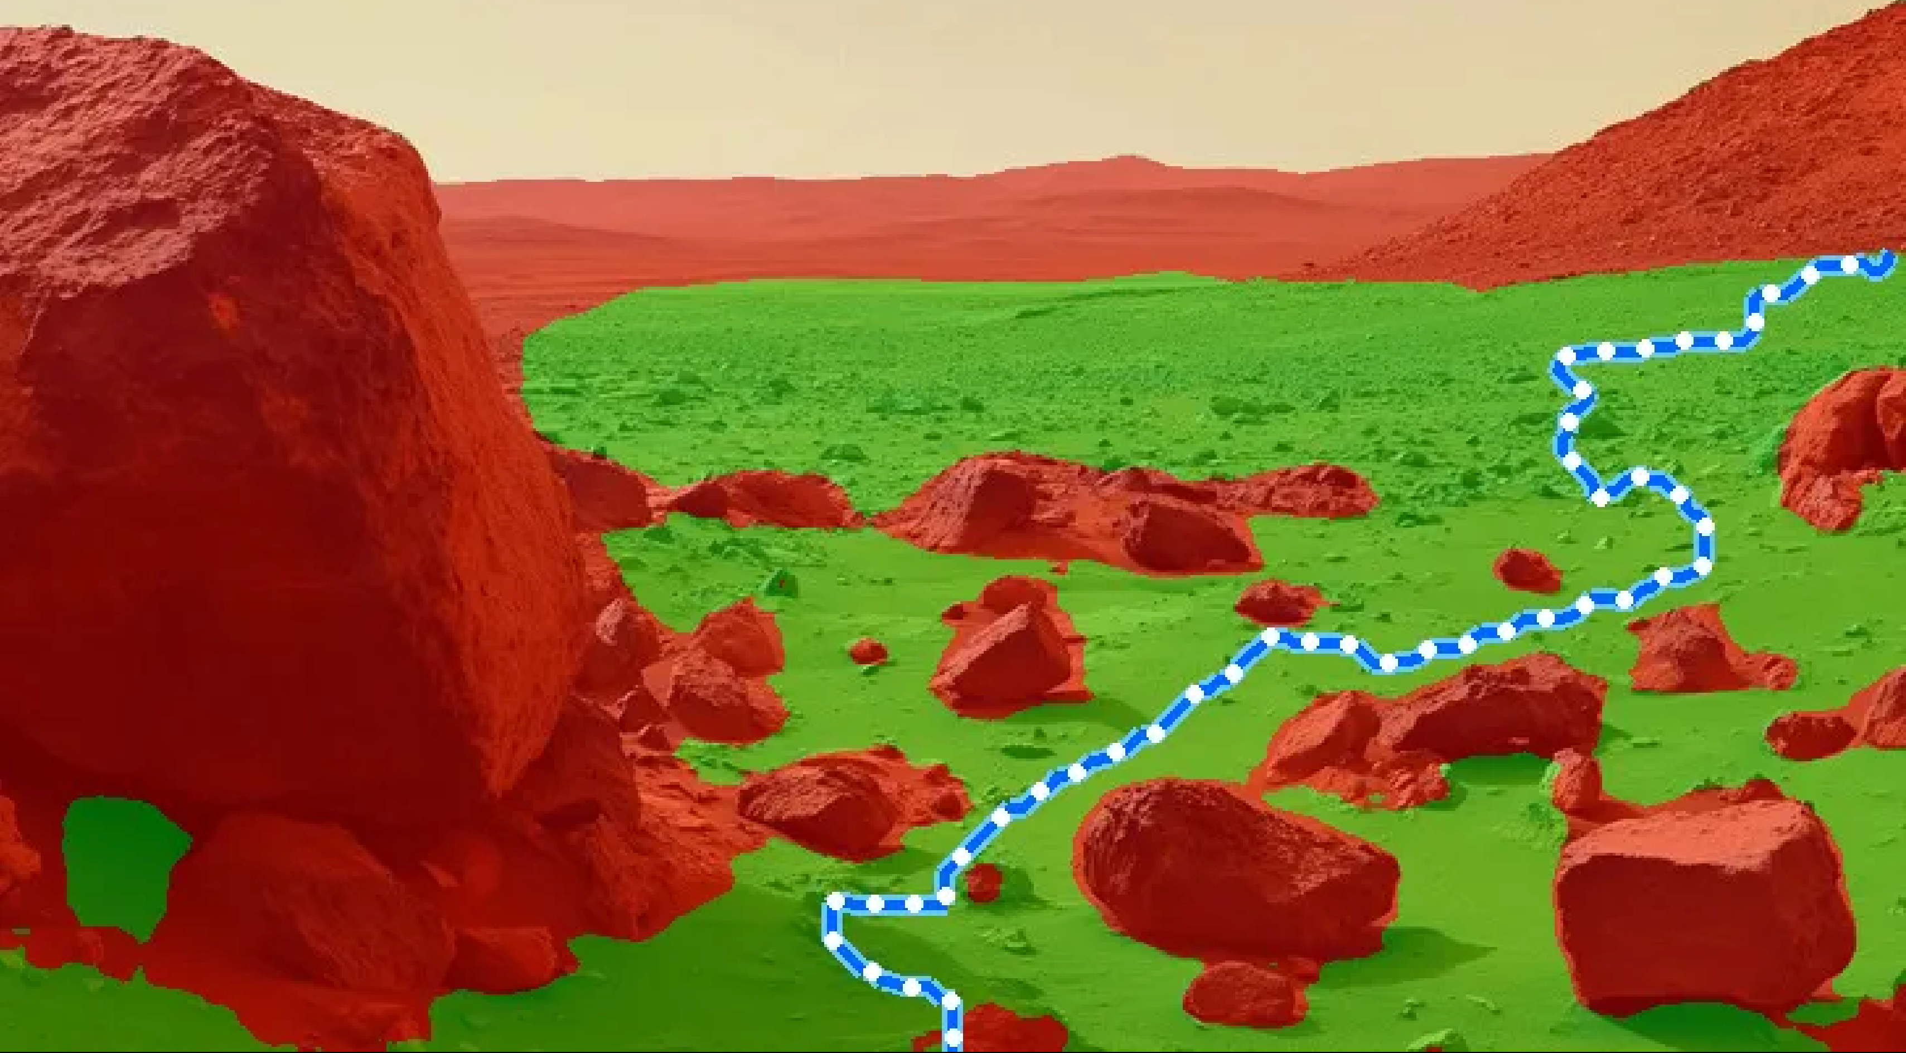
Figure- HUD overlay
Step 7: 3D Visualizer
Projects the semantic and pathfinding data onto the generated spatial depth map, returning an interactive 3D mesh for advanced operator inspection.
# 7. 3D Visualizer
# 7. 3D Visualizer
if show_3d and depth_map_norm is not None:
# Use new Mesh visualizer
fig_3d = model_utils.create_3d_terrain(image, safety_mask, depth_map_norm, path_coords=path_coords)
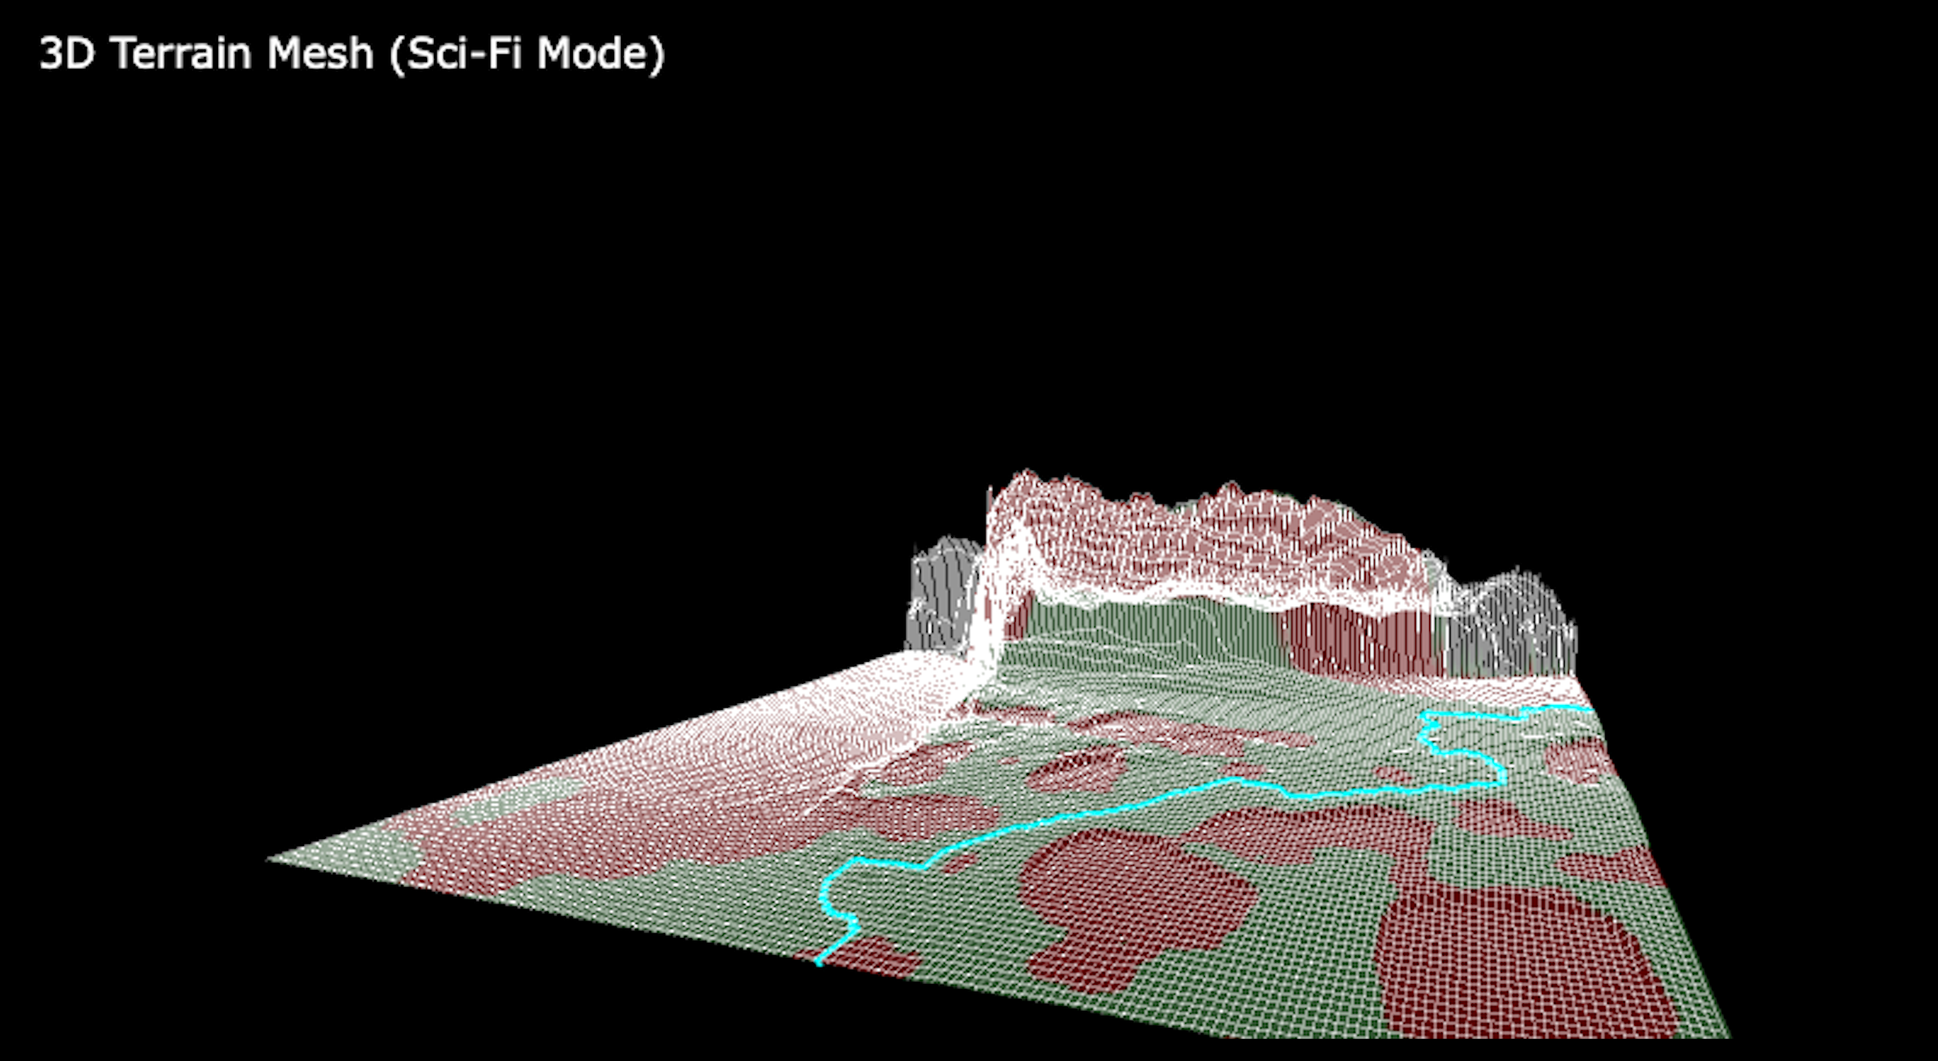
Figure- 3D mesh

11.2 Backend Model Utilities (model_utils.py)
This component contains the core deep learning initialization logic. It details the precise methods for loading both the pre-trained SegFormer and Depth Anything models, normalising input image tensors to standard distributions, and executing the safety pathfinding heuristics against the parsed JSON class arrays.
import os
import torch
import numpy as np
from PIL import Image, ImageOps
from transformers import SegformerImageProcessor, SegformerForSemanticSegmentation, pipeline
import wandb
import json
import cv2
import skimage.graph
from scipy.ndimage import gaussian_filter, binary_dilation
import plotly.graph_objects as go
from PIL import ImageDraw, ImageFont
# Global cache for models to avoid reloading
MODEL_CACHE = {}
# Revised Defaults (Mountain moved to Hazard)
SAFE_LABELS_DEFAULT = ["grass", "road", "dirt", "floor", "path", "vegetation", "earth", "field", "plant", "sand", "ground"]
HAZARD_LABELS_DEFAULT = ["rock", "water", "sea", "river", "lake", "pool", "waterfall", "boulder", "cliff", "person", "vehicle", "car", "truck", "bus", "train", "motorcycle", "bicycle", "snow", "ice", "mountain", "hill"]
COLORS = {
"safe": (0, 255, 0), # Green
"hazard": (255, 0, 0), # Red
"neutral": (0, 0, 0) # Transparent/Ignored
}
def load_model(model_name="nvidia/segformer-b0-finetuned-ade-512-512"):
"""
Loads and caches the SegFormer model and feature extractor.
"""
if model_name in MODEL_CACHE:
return MODEL_CACHE[model_name]
print(f"Loading model: {model_name}...")
try:
processor = SegformerImageProcessor.from_pretrained(model_name)
model = SegformerForSemanticSegmentation.from_pretrained(model_name)
device = "cuda" if torch.cuda.is_available() else "cpu"
model.to(device)
model.eval()
MODEL_CACHE[model_name] = (processor, model, device)
return processor, model, device
except Exception as e:
print(f"Error loading model {model_name}: {e}")
return None, None, None
def load_depth_model(model_size="small"):
"""
Loads and caches the Depth Anything V2 model.
model_size: 'small' or 'base'
"""
cache_key = f"depth_{model_size}"
if cache_key in MODEL_CACHE:
return MODEL_CACHE[cache_key]
# Map to HF Hub IDs — using Metric-Outdoor variants for actual meter output
model_id = "depth-anything/Depth-Anything-V2-Metric-Outdoor-Small-hf" if model_size == "small" else "depth-anything/Depth-Anything-V2-Metric-Outdoor-Base-hf"
print(f"Loading depth model: {model_id}...")
try:
device_id = 0 if torch.cuda.is_available() else -1
pipe = pipeline(task="depth-estimation", model=model_id, device=device_id)
MODEL_CACHE[cache_key] = pipe
return pipe
except Exception as e:
print(f"Error loading depth model {model_id}: {e}")
return None
def estimate_depth(image, pipe):
"""
Runs monocular depth estimation using Depth Anything V2 Metric-Outdoor.
Returns: depth map in meters (numpy float32 array).
Higher values = farther away.
"""
if pipe is None:
return None
# Inference — metric model returns depth in meters
depth_out = pipe(image)
# Use 'predicted_depth' tensor (actual meters) instead of 'depth' PIL (quantized 0-255)
if "predicted_depth" in depth_out:
depth_tensor = depth_out["predicted_depth"]
# Could be a torch tensor or numpy array
if hasattr(depth_tensor, 'numpy'):
depth_np = depth_tensor.squeeze().cpu().numpy().astype(np.float32)
else:
depth_np = np.array(depth_tensor, dtype=np.float32).squeeze()
else:
# Fallback to PIL depth image
depth_np = np.array(depth_out["depth"], dtype=np.float32)
print(f"[Depth] range: {depth_np.min():.2f}m - {depth_np.max():.2f}m, shape: {depth_np.shape}")
return depth_np
def depth_to_metric(depth_map, max_range=50.0):
"""
Returns depth in meters. With the Metric-Outdoor model, depth_map
is already in meters, so this is a pass-through.
max_range is kept for API compatibility but is unused with metric models.
"""
return depth_map.astype(np.float32)
def predict_mask(image, model_data):
"""
Runs inference on a single image.
Returns:
pred_seg: class-ID mask (numpy)
logits: raw logits tensor (for confidence analysis)
"""
processor, model, device = model_data
inputs = processor(images=image, return_tensors="pt")
inputs = {k: v.to(device) for k, v in inputs.items()}
with torch.no_grad():
outputs = model(**inputs)
logits = outputs.logits
# Upsample logits to original image size
upsampled_logits = torch.nn.functional.interpolate(
logits,
size=image.size[::-1], # PIL size is (W, H), torch wants (H, W)
mode="bilinear",
align_corners=False,
)
pred_seg = upsampled_logits.argmax(dim=1)[0]
return pred_seg.cpu().numpy(), upsampled_logits.cpu()
def map_classes_to_safety(mask, id2label, mapping_config=None):
"""
Maps segmentation mask IDs to SAFE (1), HAZARD (2), or NEUTRAL (0).
"""
if mapping_config is None:
mapping_config = {
"safe": SAFE_LABELS_DEFAULT,
"hazard": HAZARD_LABELS_DEFAULT
}
h, w = mask.shape
safety_mask = np.zeros((h, w), dtype=np.uint8)
safe_ids = []
hazard_ids = []
for class_id, label in id2label.items():
label_clean = label.lower().strip()
is_safe = any(s in label_clean for s in mapping_config["safe"])
is_hazard = any(h in label_clean for h in mapping_config["hazard"])
if is_safe and not is_hazard:
safe_ids.append(int(class_id))
elif is_hazard:
hazard_ids.append(int(class_id))
# Create masks
mask_in_safe = np.isin(mask, safe_ids)

