**Industrial Internship Report on**

**”Human Resource Management System”**

**Prepared by**

**[Bhabani Deo]**

|  |
| --- |
| *Executive Summary* |
| This report provides details of the Industrial Internship provided by upskill Campus and The IoT Academy in collaboration with Industrial Partner UniConverge Technologies Pvt Ltd (UCT).  This internship was focused on a project/problem statement provided by UCT. We had to finish the project including the report in 6 weeks’ time.  My project was ( About Human Resource Management System)  This internship gave me a very good opportunity to get exposure to Industrial problems and design/implement solution for that. It was an overall great experience to have this internship. |

**TABLE OF CONTENTS**

1 Preface 3

2 Introduction 4

2.1 About UniConverge Technologies Pvt Ltd 4

2.2 About upskill Campus 8

2.3 Objective 9

2.4 Reference 9

2.5 Glossary 10

3 Problem Statement 11

4 Existing and Proposed solution 12

5 Proposed Design/ Model 13

5.1 High Level Diagram (if applicable) 13

5.2 Low Level Diagram (if applicable) 13

5.3 Interfaces (if applicable) 13

6 Performance Test 14

6.1 Test Plan/ Test Cases 14

6.2 Test Procedure 14

6.3 Performance Outcome 14

7 My learnings 15

8 Future work scope 16

# Preface

“Human Resource Management System” was my project.

The quiz and videos were very helpful.

This Internship helped me testing out the practical aspects of what I know and focus on how to do a particular job.

* In first week, I completed all of my codes.
* In second week focused on other videos related to my project.
* In third week thoroughly check my codes for adding some new code.
* In 4th,5th, and 6th week I tried to add some codes to complete my project.

This is the greatest Opportunity given by USC/UCT to build my career.

How Program was planned

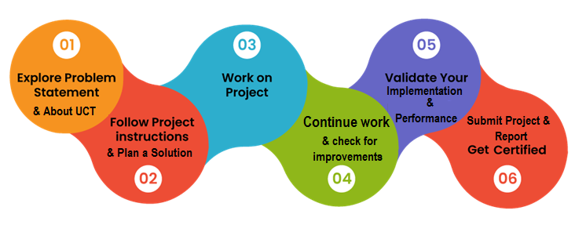

From this project I learned many things and got confidence on my work.

# Introduction

## About UniConverge Technologies Pvt Ltd

A company established in 2013 and working in Digital Transformation domain and providing Industrial solutions with prime focus on sustainability and RoI.

For developing its products and solutions it is leveraging various**Cutting Edge Technologies e.g. Internet of Things (IoT), Cyber Security, Cloud computing (AWS, Azure), Machine Learning, Communication Technologies (4G/5G/LoRaWAN), Java Full Stack, Python, Front end**etc.

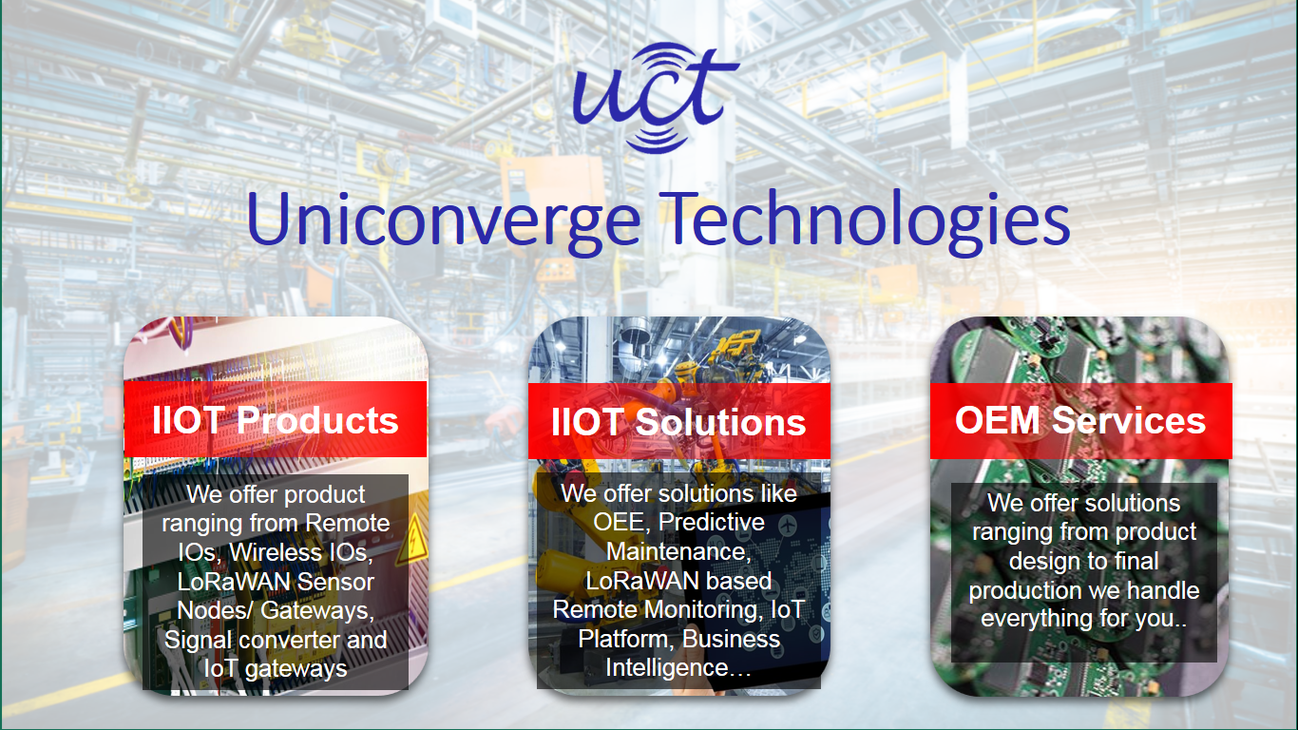

1. UCT IoT Platform **(****)**

**UCT Insight** is an IOT platform designed for quick deployment of IOT applications on the same time providing valuable “insight” for your process/business. It has been built in Java for backend and ReactJS for Front end. It has support for MySQL and various NoSql Databases.

* It enables device connectivity via industry standard IoT protocols - MQTT, CoAP, HTTP, Modbus TCP, OPC UA
* It supports both cloud and on-premises deployments.

It has features to  
• Build Your own dashboard  
• Analytics and Reporting  
• Alert and Notification  
• Integration with third party application(Power BI, SAP, ERP)  
• Rule Engine

 

1. **Smart Factory Platform (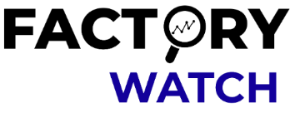)**

Factory watch is a platform for smart factory needs.

It provides Users/ Factory

* with a scalable solution for their Production and asset monitoring
* OEE and predictive maintenance solution scaling up to digital twin for your assets.
* to unleased the true potential of the data that their machines are generating and helps to identify the KPIs and also improve them.
* A modular architecture that allows users to choose the service that they what to start and then can scale to more complex solutions as per their demands.

Its unique SaaS model helps users to save time, cost and money.

 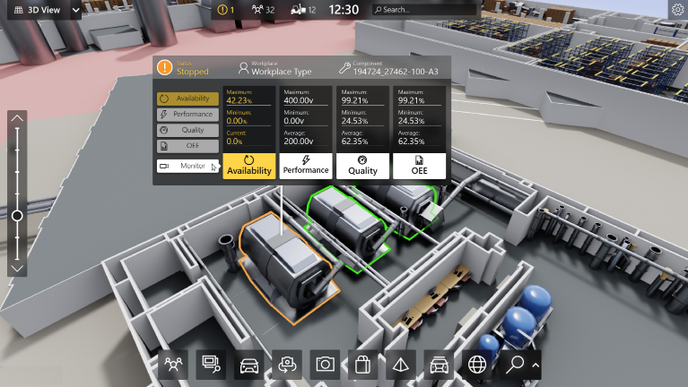

1. 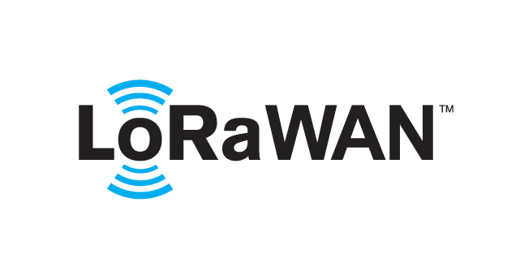 based Solution

UCT is one of the early adopters of LoRAWAN teschnology and providing solution in Agritech, Smart cities, Industrial Monitoring, Smart Street Light, Smart Water/ Gas/ Electricity metering solutions etc.

1. Predictive Maintenance

UCT is providing Industrial Machine health monitoring and Predictive maintenance solution leveraging Embedded system, Industrial IoT and Machine Learning Technologies by finding Remaining useful life time of various Machines used in production process.



## About upskill Campus (USC)

upskill Campus along with The IoT Academy and in association with Uniconverge technologies has facilitated the smooth execution of the complete internship process.

USC is a career development platform that delivers **personalized executive coaching** in a more affordable, scalable and measurable way.



Seeing need of upskilling in self paced manner along-with additional support services e.g. Internship, projects, interaction with Industry experts, Career growth Services

<https://www.upskillcampus.com/>

upSkill Campus aiming to upskill 1 million learners in next 5 year

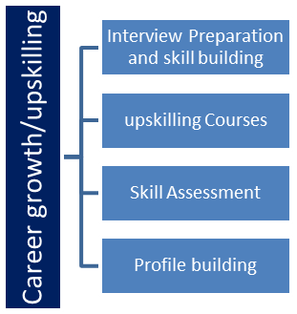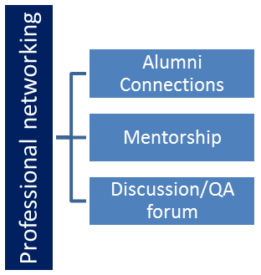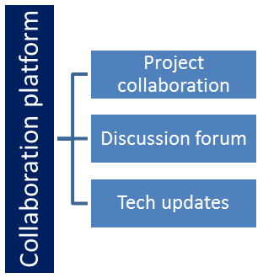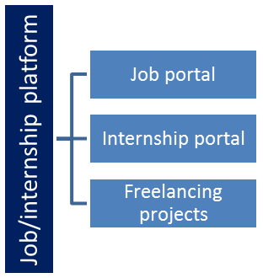

## The IoT Academy

The IoT academy is EdTech Division of UCT that is running long executive certification programs in collaboration with EICT Academy, IITK, IITR and IITG in multiple domains.

## Objectives of this Internship program

The objective for this internship program was to

 ☛ get practical experience of working in the industry.

 ☛ to solve real world problems.

 ☛ to have improved job prospects.

 ☛ to have Improved understanding of our field and its applications.

 ☛ to have Personal growth like better communication and problem solving.

## Reference

[1] Upskill videos.

[2] https://www.youtube.com/@codeforinterview

## Glossary

|  |  |
| --- | --- |
| Terms | Acronym |
| class | In Java a class definition defines instance and class variables and methods as well as specifying the interfaces the class implements and the immediate superclass of the class |
| Class method | A method that is invoked without to a particular object. |
| Class variables | A data item associated with a particular class as a whole not with particular instances of the class. |
| Comment | Explanatory text that is ignored by the compiler. |
| Compiler | A program to translate source code into c2ode to be executed. |

# Problem Statement

In the assigned problem statement

In this project I faced some problems. Some codes which I did not know but by practicing the codes I got the knowledge about this and also got the confidence of my work. The upskill videos helped me a lot.

# Existing and Proposed solution

Provide summary of existing solutions provided by others, what are their limitations?

What is your proposed solution?

What value addition are you planning?

## Code submission (Github link)

**https://github.com/githubbhabani/core-java**

## Report submission (Github link) : first make placeholder, copy the link.

## https://github.com/githubbhabani/core-java

# Proposed Design/ Model

Given more details about design flow of your solution. This is applicable for all domains. DS/ML Students can cover it after they have their algorithm implementation. There is always a start, intermediate stages and then final outcome.

## High Level Diagram (if applicable)

Figure 1: HIGH LEVEL DIAGRAM OF THE SYSTEM

## Low Level Diagram (if applicable)

## Interfaces (if applicable)

Update with Block Diagrams, Data flow, protocols, FLOW Charts, State Machines, Memory Buffer Management.

# Performance Test

This is very important part and defines why this work is meant of Real industries, instead of being just academic project.

Here we need to first find the constraints.

How those constraints were taken care in your design?

What were test results around those constraints?

Constraints can be e.g. memory, MIPS (speed, operations per second), accuracy, durability, power consumption etc.

In case you could not test them, but still you should mention how identified constraints can impact your design, and what are recommendations to handle them.

## Test Plan/ Test Cases

## Test Procedure

## Performance Outcome

# My learnings

The lessons learned is the knowledge I gained from the process of conducting this project. The ideas are to repeat the positive aspects and not to repeat the mistakes. I gained responsibility and commitment because this project showed me that when you are responsible you are more trusted and commitment shows that you are dedicated and you will do what you say.

# Future work scope

This is a good platform of showing my talent. This future work scope often contain valuable research information and give the researchers hints of new research directions and ideas.