Battle of the neighbourhoods

Opening a new Jazz Club in Manhattan

Author: Mark Chinnock
Date: June 2020

Content
- Introduction
1.1 Discussion of the "background situation"
1.2 Problem
1.3 Audience
- Data
- Methodology
- Results
- Discussion
- Conclusion

1. Introduction
I am a successful Jazz musician wanting to move to New York City and open a new venue of my own in Manhattan. I want to locate my venue away from other clubs but in a similar neighborhood. I have a limited knowledge of the neighborhoods.

1.1 Background
Where is the best location to open a new Jazz Club in Manhattan? Determine similar neighborhoods to where existing Jazz venues are and find similar ones without a local Jazz Club.

1.2 Problem
The business understanding is to identify which neighborhood(s) are a best match for a location, based on:
- Finding where existing Jazz Clubs are currently located
- Discovering what type of neighborhood category they are in
- Find a similar neighborhood that doesn't currently have a Jazz Venue

1.3 Audience
The target audience for this would be anyone considering moving to Manhattan without detailed knowledge of the area. This report is a specific study on Jazz Club categories but this approach and the search criteria could easily be amended to repeat the exercise for a different category of venue.

2. Data
To investigate this problem the following datasets of information were required:
- List of neighborhoods in Manhattan
- Population density
- Location of existing Jazz Clubs and other venues
- Population density
Using the neighborhood data from the dataset previously provided on this course (https://cocl.us/new_york_dataset) we can obtain the geo coordinates of the Manhattan neighborhoods and store the following information:
Borough Neighborhood Latitude Longitude
6 Manhattan Marble Hill 40.876551 -73.910660
100 Manhattan Chinatown 40.715618 -73.994279
101 Manhattan Washington Heights 40.851903 -73.936900
This data provides:
- Borough name - eg Manhattan
- Neighborhood - eg marble hill, highlights the area within Manhattan
- Latitude - latitude coordinate for mapping
- Longitude - longitude coordinate for mapping
Additionally, we can retrieve Population information for each neighborhood from the NYC open source: https://opendata.cityofnewyork.us/
This data can can read in using geopandas and then we are able to perform various mapping functions against the dataframe which may help with the investigation.
The neighborhood data will be compared using the venue data retrieved from foursquare to produce clusters of similar neighborhoods. The Jazz Club venues will then be placed in those clusters to see whether there is a pattern of cluster for a venue such as a jazz Club to help form a recommendation.

3. Methodology
In this project we directed our efforts on finding existing Jazz Clubs in the Manhattan borough of New York City, identify the neighborhoods where they reside, and then looking for neighborhoods with similar characteristics based on other venue types and population density, but with fewer Jazz Clubs (or hopefully none!)

In first step I collected the required data: location and type (category) of every Jazz Club within 10km from the centre of Manhattan. We have also identified all the venues within Manhattan currently held in the Foursquare database, which returned data as shown in the following sample.
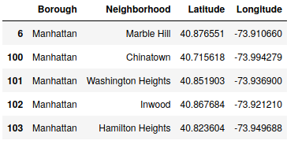Table 1: sample data collected from foursquare

I used python folium library to visualize geographic details of Manhattan and its neighborhoods. Geodata and choropleth maps were used to identify population density (neighborhood area / population count recorded) in each neighborhood, and comparing which neighborhoods are similar but without Jazz Clubs.
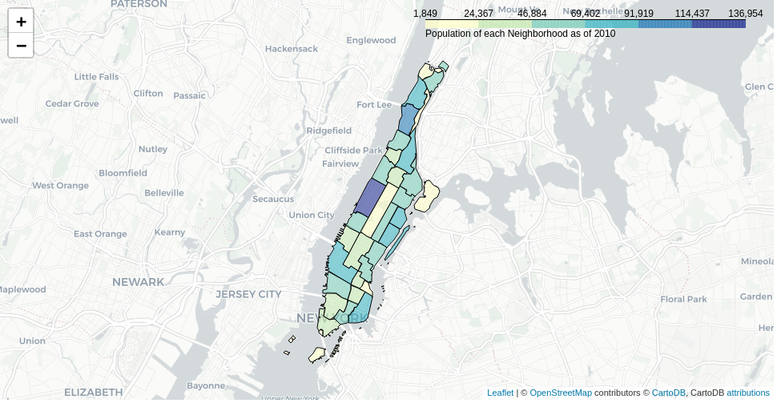Illustration 1: Population density for each of the neighborhoods

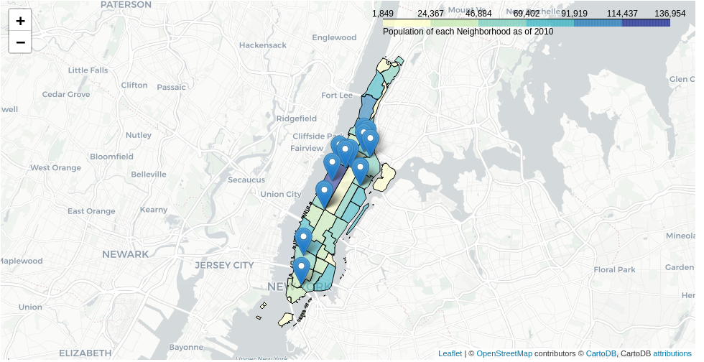Illustration 2: Population density with Jazz Club location markers overlaid
The Jazz clubs are located in neighborhoods with very similar population density. The most densely populated neighborhood has the most Jazz clubs, so that would indicate this is an important feature that should not be overlooked.

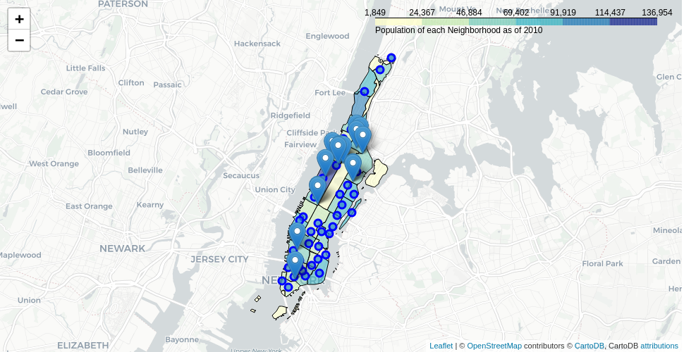Illustration 3: neighborhood central points before clustering was applied

Table 2: table showing a sample of venue data collected for all the neighborhoods

Once all the venue data for all categories of venue was collected from foursquare API, this data was stored in a dataframe (above). We have some common venue categories in the neighborhoods so unsupervised learning K-means algorithm was chosen to cluster the data.

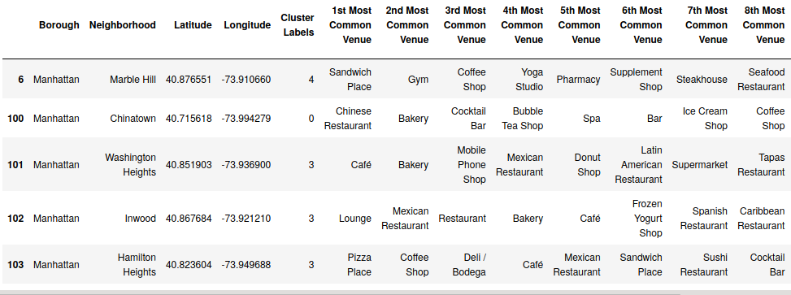Table 3: the data after cluster labelling has been applied

When we take a look at the specific neighborhoods containing Jazz venues we see they are all catergorized as cluster 0
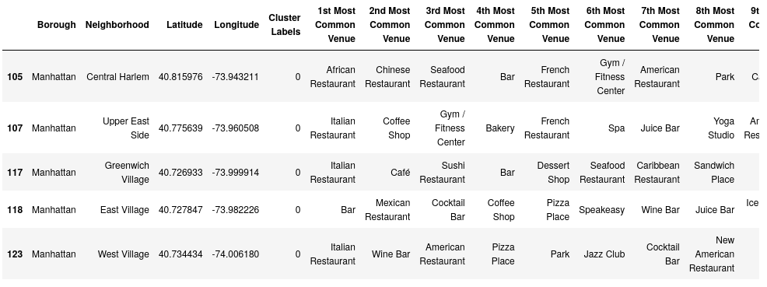Table 4: each neighborhood with an existing jazz club is cluster 0
The clustering label can be visually represented on a standard map with colours applied for each cluster:

Cluster 0 = red
Cluster 1 = purple
Cluster 2 = blue
Cluster 3 = green
Cluster 4= orange
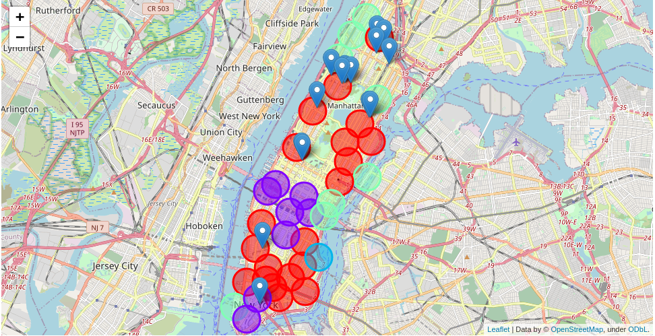Illustration 4: neighborhoods after clustering has grouped and coloured similar neighborhoods
The map shows how all the existing Jazz venues are within cluter 0 (red) .

4. Results
The analysis shows that there are approximately 30 Jazz Club venues spread all around Manhattan with more centred around Manhattan Valley, near West 106th Street, and 3 near Central Harlem, around West 131-133rd Street. These are both towards the northern end of Manhattan.
All of the neighborhoods with existing Jazz Clubs were put into the cluster 0.
There are several cluster 0 neighborhoods with similar population density without an existing Jazz Club towards the east and south east of Manhattan (namely Lower East Side, Lenox Hill) with similar population density to the existing Jazz neighborhoods but are distanced from existing clubs.

5. Discussion
From the analysis, cluster 0 neighborhoods appear to be good candidates to locate a Jazz Club. However, there could be other factors as to why they haven't been chosen as venues before. Also, perhaps it would be better to locate a specialist music club such as a Jazz venue nearer to other existing clubs where it may benefit from an existing ambiance and clientele.

6. Conclusion
The purpose of this project was to identify a potential Jazz Club location in Manhattan in a neighhorhood where ther wasn't currently a Jazz Club. Additional information of characteristics of neighborhoods, population density and clustering of similar venue types together were also used to provide a scientific approach to the research.
The final decision on where to location a new Jazz Club would still require additional information and research, taking into account the general atmosphere of a location, closeness to major roads, rental prices, whether tourism numbers has an effect on such a venue, etc.

