Microsoft 365 Integration
With the integration of Microsoft 365 into the vitallskills.life domain, staff members can now securely sign in using their domain email accounts (e.g., name@vitallskills.life). This provides a unified identity across all Microsoft services, ensuring consistent login experience across Outlook, Teams, SharePoint, and OneDrive.

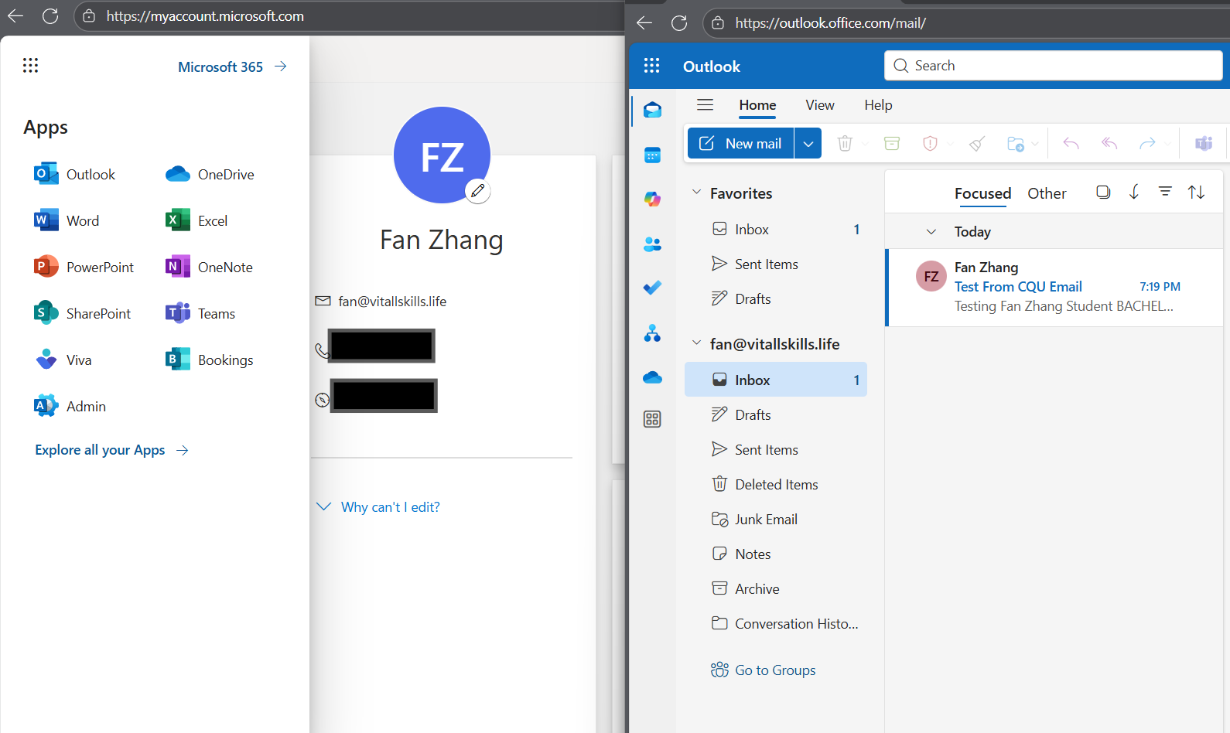

1. User Accounts and Access Management
- All staff accounts are created and managed in Microsoft Entra ID (Azure AD), linked to the vitallskills.life domain.
- New users are added through the Microsoft 365 Admin Center, where appropriate licenses (Business Basic, Standard, or Premium) are assigned.
- Centralized account policies include:
- Password management (complexity rules, expiry, self-service reset).
- Multi-Factor Authentication (MFA) to enhance security.
- Conditional Access rules to restrict sign-ins based on device compliance, location, or risk level.
This ensures that staff and students only access the applications and services they require.
2. Productivity Applications
Licensed users gain access to the full Microsoft 365 suite of productivity apps:
- Word, Excel, PowerPoint, and Outlook for essential productivity.
- OneNote for note-taking and shared learning content.
- Teams for collaboration, chat, and video conferencing.
- OneDrive and SharePoint for secure file storage and sharing.
All applications are available through the web portal, with desktop and mobile clients for seamless access on any device.
3. Collaboration and Data Sharing
- Staff securely share files through OneDrive (personal storage) and SharePoint (team-based collaboration).
- Real-time co-authoring in Word, Excel, and PowerPoint eliminates version conflicts.
- Microsoft Teams integrates chat, meetings, and file sharing in a single platform, streamlining collaboration between trainers, administrators, and students.
4. Application Controls and Security
Microsoft 365 apps are governed by enterprise-grade security and compliance features:
- App access management via the Admin Center to control third-party integrations.
- Mobile Device Management (MDM) with Intune, enforcing encryption, PIN policies, and blocking of unmanaged devices.
- Data Loss Prevention (DLP) policies to prevent accidental sharing of sensitive information.
- Microsoft Defender for Office 365 to provide protection against phishing, malware, and ransomware.
5. Benefits of Integration
- Unified login with the vitallskills.life domain email.
- Centralized user and license management.
- Access to Microsoft 365’s productivity and collaboration suite.
- Secure, compliant data sharing with governance controls.
- Scalable solution for future growth of the organisation.

