VitalSkills Network Simulation

Network Simulation Overview
This network simulation models the VitalSkills Office Network with multiple VLANs, an on-premises router performing inter-VLAN routing, and an access/distribution switch connecting various end-user devices. The simulation demonstrates VLAN segmentation, DHCP configuration, and device interconnectivity using a hybrid of wired and wireless connections.
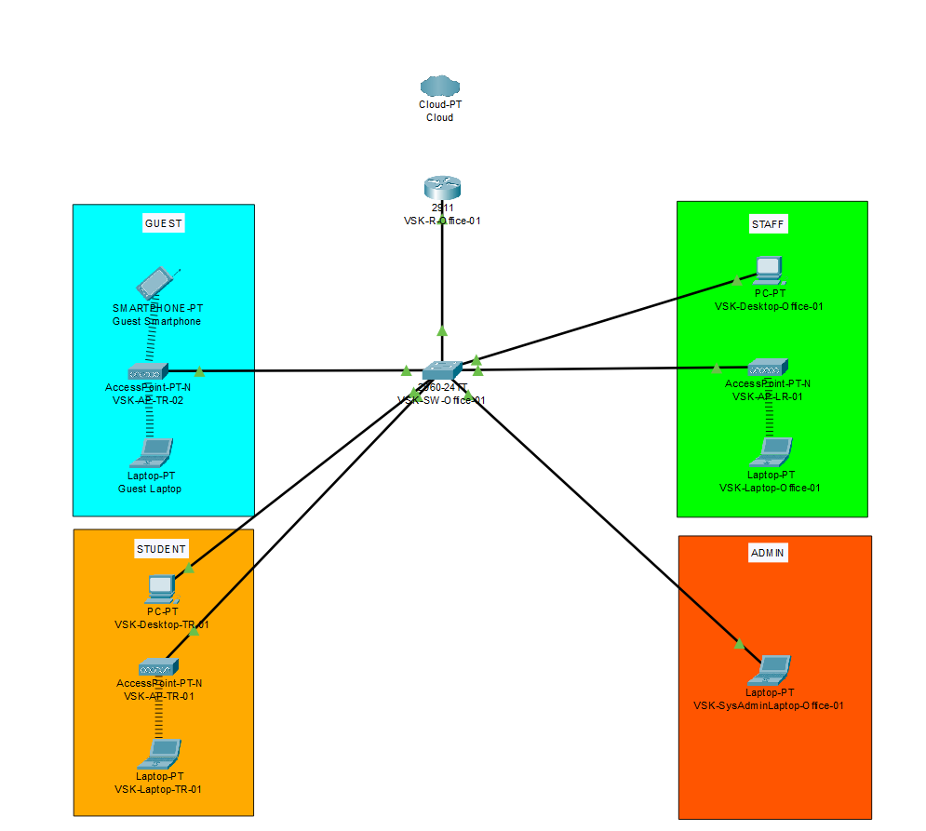

Core Components
Router (VSK-R-Office-01):
• Performs Router-on-a-Stick inter-VLAN routing using subinterfaces for VLANs 10, 20, 30, 40, and 50.
• Hosts DHCP pools for each VLAN, assigning IP addresses and default gateways.
• Connected upstream to the cloud (simulated Cloud-PT).
Switch (VSK-SW-Office-01):
• Acts as the main distribution switch.
• Configured with access ports mapped to specific VLANs for different device groups.
• Trunk uplink to the router, carrying VLANs 10, 20, 30, 40, and 50.

VLAN Segmentation & IP Schema
VLAN ID | VLAN Name | Network | CIDR | Usable IP Range | Broadcast Address | Available IPs
10 | Student | 10.86.96.0 | /26 | 10.86.96.1 – 10.86.96.62 | 10.86.96.63 | 62
20 | Staff | 10.86.96.64 | /27 | 10.86.96.65 – 10.86.96.94 | 10.86.96.95 | 30
30 | Management | 10.86.96.96 | /28 | 10.86.96.97 – 10.86.96.110 | 10.86.96.111 | 14
40 | Guest | 10.86.96.112 | /29 | 10.86.96.113 – 10.86.96.118 | 10.86.96.119 | 6
50 | Admin | 10.86.96.120 | /30 | 10.86.96.121 – 10.86.96.122 | 10.86.96.123 | 2

End-User Device Assignments
Guest VLAN (40):
• Access Point: VSK-AP-TR-02 (wireless access for guests)
• Devices: Guest Smartphone, Guest Laptop
Student VLAN (10):
• Access Point: VSK-AP-TR-01 (classroom wireless access)
• Devices: Student PC, Student Laptop
Staff VLAN (20):
• Access Point: VSK-AP-LR-01 (lunchroom wireless access)
• Devices: Staff Desktop, Staff Laptop
Admin VLAN (50):
• Devices: Admin Laptop (VSK-SysAdmin-Laptop-Office-01)

Key Features Demonstrated in Simulation
1. Logical Separation – VLANs isolate traffic between departments, improving security and performance.
2. DHCP Allocation – Router assigns IPs dynamically per VLAN, reducing manual configuration overhead.
3. Inter-VLAN Routing – Router-on-a-stick provides controlled communication between VLANs.
4. Wireless Integration – Access Points bridge wired and wireless networks per VLAN.
5. Scalable Addressing – IP schema accommodates current devices with room for growth.

