**Home:**

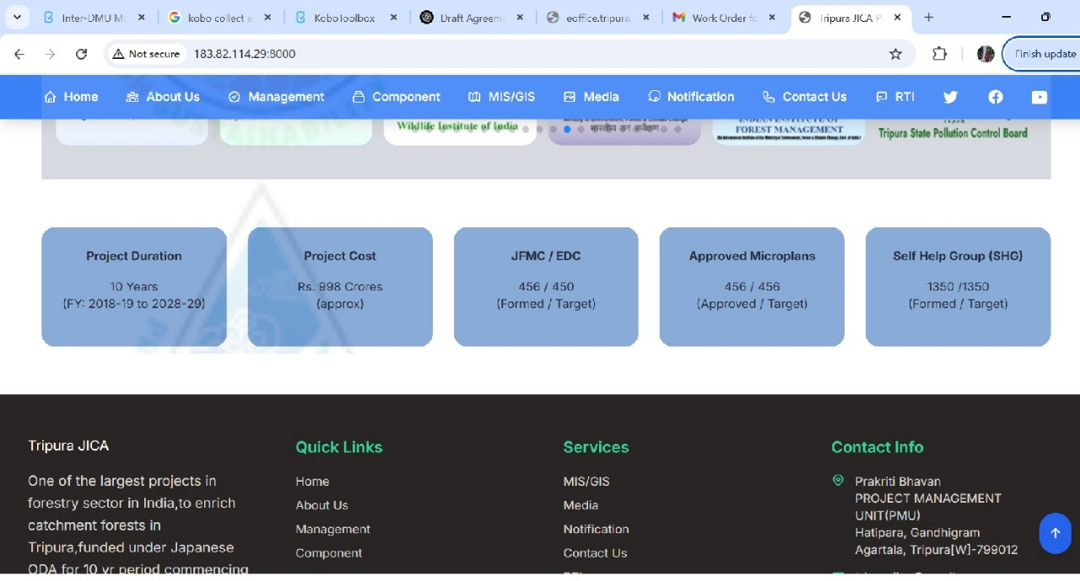

Here

1. JFMC/EDC - Target is 450 and Formed 457
2. Approved Microplans - Target is 450 and Approved 457

**Management:**

Here

1. In PMU section...add Dr. before the name of the Biplab
2. In SDMU section, Serial no 5....Ms Sushmita Das, IFS....replace IFS to TFS