

2020

2020

Guideline on Teak Plantation Management

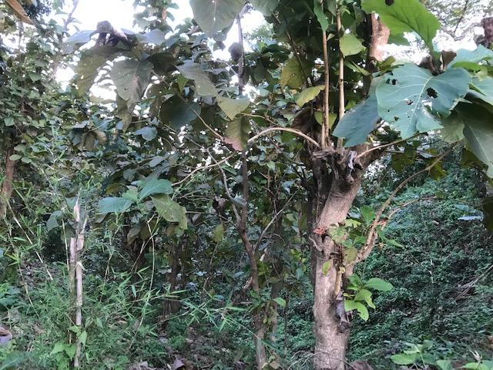

***SCATFORM Manual and Guideline Series No.4***





Photograph

**Dr. Alind Rastogi, IFS**

PCCF & HoFF, Tripura

**Date:**

**Message**

Teak (*Tectona grandis*) is a tropical hard wood tree species belonging to verbenaceae family and native to south and south-east Asia including Bangladesh and India. Tripura is considered as suitable home ground having all favourable prerequisites for the luxuriant growth of teak.

Teak being a highly demanded species for its timber is often exposed to challenges such as illicit felling, fire and poor management leading to less productivity. Therefore, teak plantations are required be to managed systematically to obtain optimum level of return by the farmers /JFMC members. Thus a Teak Plantation Management guideline under JICA Project (SCATFORM) has been developed with an objective to meet the queries of farmers and practitioners as a practical guide for establishing and managing teak plantations. This will specifically guide the small growers as well as commercial planters in a precise and scientific manner. Moreover, adoption of a need based cutting system and some traditional wisdom are also included in this manual.

I expect this document will be useful not only for the teak farmers of the state and departmental staffs but also for the policy makers and researchers. Moreover, it will ensure some sustainable livelihood for the marginal farmers of JFMC/SHGs.

I compliment the remarkable efforts and contribution of all the officers and staffs towards its formulation and best wishes for successful implementation. I express my earnest wishes for publication of this guiding document and its best usefulness.

**(Dr. Alind Rastogi, IFS)**

 Government of Tripura

Forest Department

**Project Management Unit,Tripura JICA Project**

(Project for Sustainable Catchment Forest Management in Tripura)

PrakritiBhawan, Gandhigram, West Tripura 799012

Phone: +91-3812397022, e-mail: [tripurajica@gmail.com](mailto:tripurajica@gmail.com), Website: www.scatfrom.com

Photograph

**Angshuman Dey, IFS**

Chief Executive Officer & Project Director

Dated, Agartala, XX March 2020

**Preface**

Project for Sustainable Catchment Forest Management in Tripura (SCATFORM) has been launched in 2019 with Japanese assistance made available through Govt. of India aims at improving quality of forests in the targeted river catchments of Tripura by sustainable forest management, soil and moisture conservation and livelihood development, there by contributing to development of forest ecosystem services and livelihood improvement of forest dependent communities in the State. Teak plantation management is an important activity under Sustainable Forest Management component of the Project. The activity is designed to rejuvenate the degraded teak plantations through gap planting with bamboo and other associates of teak as well as cutting of messy stumps to encourage rigorous coppicing under the system of coppice with standards prescribed under Working Plans.

The guideline on Teak Plantation Management has been formulated to provide a frame work for the above activity to be used as field manual as prescribed in the MoD of SCATFORM. A total of 15000 ha of degraded teak plantation are to be taken up under this activity for improving the quality of teak forest while providing small wood and fuel wood to the local community (JFMCs) and share benefits with them.

The Guidelines have been prepared by the PMC Experts on the basis of MoD in consultation with Working Plans and realistic calculations in discussion with field officials as norms are not provided under Departmental SoR 2019. However, the plantation and related activities are as per ANR norms. I hope field functionaries will find this Guideline useful in planning and implementation of this component and enrich our teak forests, which is under urgent need of quality improvement.

(**Angshuman Dey**)

Guideline on Teak Plantation Management

**Table of Contents**

**1**. **Introduction** 4

**2.** **SCATFORM approach** 4

**3.** **Silviculture operation** 8

**4.** **Benefit sharing** 11

**5.** **Work plan and required labour** 11

1. Introduction

Teak produces high value timber and fits the environmental conditions of Tripura. Teak is classified as a pioneer species, light demanding, fast growth tree and exotic (not endemic) to Tripura. Teak can attain 60cm DBH in 60 years.

However, the condition of many teak plantations in Tripura is not very good and many of them are highly degraded. Two types of teak plantation degradation are observed: 1) teak plantations having strong human pressure in highly populated area creating severe degradation by frequent fuel wood felling and grazing (Photo 1 & 2), 2) teak plantations replaced by cash crop cultivation on ROFR lands with remaining stock being susceptible against illegal felling in the less populated tribal areas (Photo 3-5).

The objective of teak plantation is to produce quality teak timber. Teak plantation is not considered to be suitable for protection of catchment due to poor growth of understory vegetation by a negative allelopathic effect by leaves and large leaves causing higher pressure of rainfall drops on the ground. In order to produce saleable size of teak, at least 15-20 years old are needed. In working plan, teak plantation management is prescribed in Teak working circle and Teak Coppice with the standard working circle. These circles are found in Kanchanpur Forest Division (North District), Telimura Forest Division (Khowai District), Kailasahr Forest Division (Unakoti District) and Gumti Forest Division (Gumti District). Those include plantation established by JFMCs in Gumti (1999 - 2004) and in Teliamura (2002 – 2011).

The objective of Teak Plantation Management (TPM) in SCATFORM is to enhance livelihoods of forest dependent communities by increasing forest cover of the plantation site. In order to reach the goal, the demand of the local communities, site potential, empirical results of existing teak plantations, and the role of the project need to be carefully looked at for appropriate implementation.

1. **SCATFORM approach**

Four types of silvicultural operation, 1) thinning, 2) gap planting, 3) coppicing, and 4) replacement with other species, can be undertaken by SCATFORM for TPM at the existing teak plantation based on the tree canopy cover and quality of teak stands (Table 1&2, Figure 1). Stand quality is decided by magnitude of human pressure and capacity to control the plantation to obtain the products. Silvicultural operation is mostly based on the prescription of working circles and forest schedule. The site for TPM needs to be identified by Beat Forest Basic Plans (BFBP) or micro plans. In SCATFORM, 15,000 hectares of TPM is planned in 135 beats. On an average size of TPM is 35 ha per JFMC and 105 ha per beat.

* Thinning (TH): Old well grown teak plantation with high canopy cover, malformed trees and trees supressing each other are selectively thinned based on the remaining stock volume specified. Remaining stock including malformed trees are pruned for future production.
* Gap planting (GP): Teak plantation with low tree canopy cover, gap will be filled with associated species. (Same as Aided Natural Regeneration: ANR)
* Coppicing (CP): Harvest of malformed teak trees while maintaining teak tree density for the plantation age. Harvest at the bottom of stump to promote coppice growth by power chain saw.
* Replacement with another species (RP): Degraded teak plantation with poor quality caused by strong anthropogenic pressure are replaced with other species desired by JFMC (Same as Afforestation: AR)

**Table 1: Classification of teak plantation management by canopy density and stand quality class**

|  |  |  |  |
| --- | --- | --- | --- |
| Tree canopy density | Stand quality | Silviculture practice | Expected output |
| >70% | Good | Teak WC  Thinning and pruning | Large timber  Small timber |
|  | Medium | Coppice with ST WC  Coppicing and pruning | Small timber |
|  | Low | Afforestation (AR)  Removal of teak and replacement with other species | Other products |
| 40-70% | Good | Teak WC  Pruning | Large timber Small timber |
|  | Medium | Coppice with ST WC  Coppicing and pruning | Small timber |
|  | Low | Afforestation (AR)  Removal of teak and replacement with other species | Other products |
| <40% |  | Gap planting (ANR) | Other products |

Remark: stand quality index: Good (no or limited human intervention, possible to produce timber of long rotation >35 years), Medium (limited or organized human intervention (e.g. development of ROFR lands), controllable to produce small timber (10-15 years rotation), Bad (strong human intervention, e.g. fuelwood felling, grazing etc. and unable to maintain the plantation)

**Table 2: Type of Silvicultural operation for teak plantation**

|  |  |  |
| --- | --- | --- |
| Type | Site selection | Action |
| Thinning (TH) | * Teak plantation with good growth older than 15 years old * Teak canopy cover >70% * Outside of 5km range from village (Dept. mode) * Non ROFR land only | Thinning of malformed teak remaining 560 trees (15 years old), 336 trees (30 years old), and 160 trees (45 years old) Remaining trees are pruned up to 5m height |
| Gap planting  (GP)  (Same as Aided Naturel Regeneration: ANR) | * Teak plantation with low canopy cover (20-40%, open forest) * Within 5km from village (JFMC mode) * Non ROFR land | Planting bamboo, and other teak associated species on gap 250 trees/ha |
| Coppicing  (CP) | * Teak plantation with malformed trees with high density (> 560 trees for 15 years old plantation, >336 trees for 30 years old plantation and >160 trees for 45 years old plantation) * Within 5km from village (JFMC mode) * Non ROFR land (Coppicing teak stumps are outside of ROFR lands) | Harvest malformed teak maintaining tree density for the plantation age.  Harvest at the bottom (10-20cm) above the ground to promote coppicing  Maintain two healthy shoots (coppice) and remove others  Maintain them for 10 years to produce small timber |
| Replacement with other species (RP)  (Same as Afforestation: AR Mix or Bamboo) | * Teak cover >40% * More than 80% of teak are malformed * Within 5km from village (JFMC mode) * Non ROFR land | * Removal of malformed/ improper teak * Plant bamboo, other high potential and selected species by JFMC * 1100 trees/ha |

Special Notes

The following criteria should be considered for site selection of TPM.

* Slope (>20%) is priority for catchment protection.
* Treatment area does not include ROFR lands; for the area where ROFR is issued, ROFR lands in the same CS plot should be identified not to cover the treatment area.
* Forest protection with JFMC against fire, grazing and fuelwood collection should be ensured by JFMC through micro plan.
* Minimum size: 5ha and Maximum size: 35ha/JFMC, 105ha/beat

Stand Quality Index

Good

No Action

Thinning

Gap Planting (ANR)

Coppicing

Medium

Bad

Replacement with another species (AR)

20%

70%

40%

0%

100%

Tree Canopy Cover

Figure 1: Teak plantation management by tree canopy cover and quality of standing volume

1. **Silviculture operation**

**Thinning**

In order to reduce competition between trees for soil nutrients, water and sunlight, accelerating the growth of the stem diameter, thinning can be undertaken for well grown teak plantation with a high density of canopy cover. According to Working plan prescription for Teak working circle, 1100 trees are initially planted for 60 year rotation. With thinning of the 15 year cycle 3 times, 560 trees, 336 trees, and 160 trees remain after 1st, 2nd and 3rd thinning, respectively. Thinning intensity is 20%-30%. Typical teak volume at 15 year is about 86.3m3/ha.

In the working plan of Teliamura 2012-2022, Teak thinning is prescribed as 16 years old teak, with volume of 186m3/ha, thinning intensity 20%, 31 years old, 238.8m3/ha, 30%, 46 years old 257.15m3/ha 30%. However, due to the damage to teak plantations caused by biotic interference (illicit felling, jhuming, grazing, fires, fuelwood collection etc.), normal conditions of teak plantation hardly exist. Therefore, it is prescribed that 10% of ideal volume to be thinned. It suggests that 16 year old teak, 3.73m3/ha, 31 years old 7.16m3/ha, 46 years old 7.71m3/ha (Table 3).

In SCATFORM, this operation is undertaken by department mode, at least 5km away from villages.

Table 3: Permissible volume for thinning by remaining standing trees based on working plan

|  |  |  |  |  |  |  |
| --- | --- | --- | --- | --- | --- | --- |
| Planting year | Age | Ideal volume (m3 /ha) | Intensity (%) | Ideal thinning volume (100%) (m3 /ha) | Medium (50% thinned) (m3 /ha) | Low (10% thinned) (m3 /ha) |
| 1974 | 45 | 257.16 | 30 | 77.15 | 38.6 | 7.71 |
| 1989 | 30 | 238.8 | 30 | 71.64 | 35.8 | 7.16 |
| 2004 | 15 | 186 | 20 | 37.20 | 18.6 | 3.72 |

**Gap planting (Same as ANR)**

Gap planting can be undertaken for largely degrade teak plantation which has open land larger than 60% of the entire area. Bamboo, other teak associated species on gap with tree density of 250 trees/ha. Spacing can be decided depending upon the size of gap with minimum of 3mx3m.

**Coppicing**

In order to regenerate teak for small timber (10-20 years old) from degraded teak plantations (tree canopy cover of the teak >40%), coppicing can be promoted. Malformed teak is harvested to maintain the teak tree density specified for the plantation age.

The selected teak can be cut at the bottom, 10-20cm above the ground for coppicing. The surface of the stump should be smooth and bark should not be damaged for good coppicing (Figure 2). When coppices come out, maintain two healthy coppices and remove others. For coppicing, the stem needs to be cut by saw in order not to damage the bark. The cutting surface of the stump should have some declining angle in order not to keep moisture to avoid decomposition of root system. In order to avoid leaning by wind, the selected coppices should be against common direction of winds of the site (Figure 3).

In Kanchanpur division, Teak coppice with the standard working circle is prescribed in the working plan between 2012-2022. Silvicultural operation prescribes is the removal of 50% tree (remaining trees is 555 trees/ha) for 500 ha per year at 15 years old by coppicing.

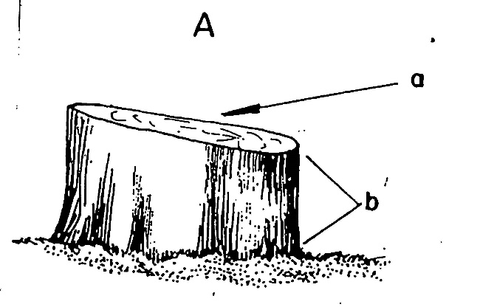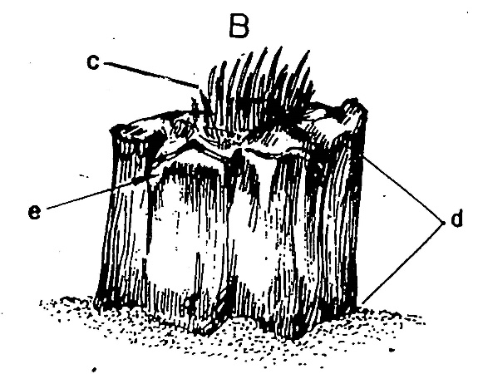

|  |  |
| --- | --- |
| A: Good stump  a: smooth surface  b: close to ground (10-12cm) | B: Bad stump  c: irregular surface  d: higher stump  e: damaged bark |

Figure 2: Cutting for good coppicing

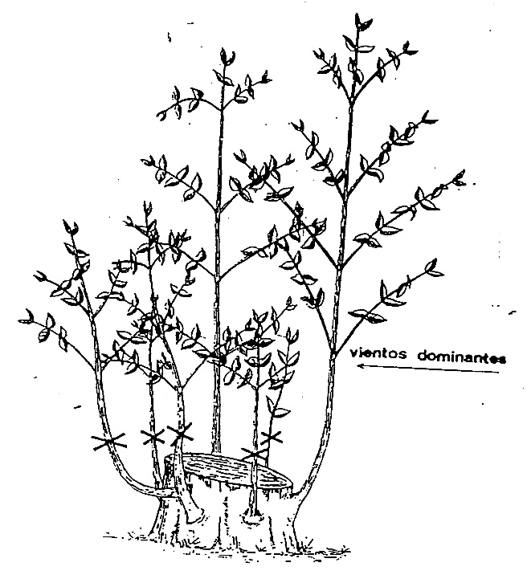

wind

Figure 3: Selection of coppice based on objective of production (keep large coppice with vigour against wind)

**Replacement with another species (Same as Afforestation: AR)**

For degraded teak plantation which has a high percentage of canopy cover or high tree density of teak (Photo 1 and 2) but poor quality stands, can be replaced with other species.

1. **Benefit sharing**

In case of JFMC mode, removed stems and branch will be provided to JFMC and the revenue from them will be deposited to JFMC revolving fund.

1. **Work plan and required labour**

Three year operation is undertaken based on the schedule of rate. The cost offencing maintenance, monitoring and evaluation will be 10 % of the total cost of planting.

|  |  |  |  |  |  |
| --- | --- | --- | --- | --- | --- |
| **No.** | **Work specification for TPM (GP, CP, TH only, RP is same as AR)** | **Timing** | | **Rate (Day Labour/ ha)** | |
| **Preparation activities and advanced actions** | | | | | |
| 1 | Identify the area of TPM and collect information of the site (degradation level, gap planting species, area, age, etc.) (consult working plan, BFBP, micro plan, etc.) | Jan.- Mar. or before | |  | |
| 2* | Pre-survey by clearing jungle 1.5m wide strip by using GPS instrument. Track polygon (raw data) is to be submitted within 5 days after completion of survey | Jan-Mar  (GP, CP, RP) | |  | |
| 3 | Inventory (enumeration of teak by girth class with photos and videos along with local communities) and marking teak stems for thinning/pruning coppicing | Jan-Mar.  (TH, CP) | | By number and girth class rate | |
| 4 | Site clearing including cutting of jungle slush to the ground, pruning, disposal of debris etc. and marking teak stems | Jan-Mar.  (GP, RP) | | 10 | |
| **1st year** | | | | | |
| 1 | Digging of pits of 30 cm x 30cm x 30 cm size up to 250tree/ha GP, 1100tree/ha RP pits 3m x 3m spacing and slashing down the new growth of weeds | Mar.-Apr.  (GP, RP) | | 7 (GP) | |
| 2* | Cutting and dressing of stump by power chain saw of old malformed trunk at the bottom of stem if any to support coppicing from root stock. | Jan-Feb  (CP) | | By number and girth class rate | |
| 3* | Pruning of unwanted branches of stems, Removal of unwanted stem, Cutting of old malformed stem | Apr.-May  (TH) | | By number and girth class rate | |
| 4 | Refilling of pits and planting seedling/rhizome (250trees/ha GP) cost of rhizome is as per SOR | Apr.-May  (GP) | | 8 (GP) | |
| 5 | First weeding including base cleaning at a radius of 0.5 m and cutting weeds in between the lines flush to the ground level.  Vacancy filling with required plant sp. including digging of pits, refilling & planting including carrying of seedlings over the entire plantation area | July-Aug. (GP, RP) | | 12 | |
| 6 | Making of fire line 4m wide & diagonal inspection path 1 m wide by scraping with spade and maintenance of the same throughout the dry season. | Nov.-Dec (GP, RP) | | 5 | |
| **2nd year** | | | | | |
| 1 | Removal of unwanted coppice from the coppicing stump including singling out of best two vigorous ones | | Apr. (CP) | |  |
| 2 | Weeding including base cleaning at a radius of 0.5 m and cutting weeds in between the lines flush to the ground level.  Vacancy filling including digging of pits, refilling & planting including carrying of seedlings etc. | | May-June | | 12 |
| 3 | Making of fire line 4m wide& diagonal inspection path 1 m wide by scraping with spade and maintenance of the same throughout the dry season. (GP, RP) | | Nov.-Dec. | | 5 |
| 4 | Earth Mounding for bamboo sp. with scraping of soil with spade ramming properly up to 1m dia. (if necessary and or proportionate) | | Feb.-Mar. (GP) | | 5 |
| 5 | Engagement of watch and Ward responsible for maintenance of fencing, cattle watching etc. His continuation will be based on survival percentage of seedling watch and Ward for min. 10 ha. (contiguous or discrete). | | Apr-Mar. (GP) | | 1 |
| **3rd year** | | | | | |
| 1 | One weeding including cleaning of base at a radius of 0.5 m by scraping with spade and cutting of weeds in between the lines flush to the ground level | | June -July | | 10 |
| 2 | Making of fire line 4m wide& diagonal inspection path 1 m wide by scraping with spade and maintenance of the same throughout the dry season. (GP, RP) | | Nov.-Dec. | | 5 |
| 3 | Engagement of watch and Ward responsible for maintenance of fencing, cattle watching etc. His continuation will be based on survival percentage of seedling watch and Ward for min. 10 ha. (contiguous or discrete). | | Apr-Mar | | 1 |

Remark: *Use the Harvest cost by Girth class table to calculate the budget

Source: Schedule of rates 2019. TN: thinning, GP: Gap planting, CP: coppicing, RP: replacement

Harvest cost by Girth Class

|  |  |  |  |
| --- | --- | --- | --- |
| No. | Girth class (by GBH) | INR per tree | |
| 1 | 30cm-50cm | 5 | |
| 2 | 50cm-70cm | 7 | |
| 3 | 70cm-90cm | 9 | |
| 4 | 90cm-110cm | 11 | |
| 5 | 110cm-130cm | 13 | |
| 6 | 130cm-150cm | 15 | |
| 7 | >150cm | 20 | |
|  | | |  | |
| Photo 1: Degraded teak plantation in Nutan Bazar Beat (high density teak with poor quality on relatively flat area) | | | Photo 2: Degraded teak plantation in Nutan Bazar Beat (high density teak with poor quality on relatively flat area) | |
|  | | |  | |
| Photo 3: Illicit felling and remainig teaks in Beramura beat. ROFR land holders developed the area in the vicinity for citirus cultvation. | | | Photo 4: Remaining teaks in Teak plantation in Beramura beat (Area is surrounded by scattered sweet lemon cultivation) | |
|  | | |  | |
| Citrus cultivation in Teak plantation area | | |  | |