Color Bricks Testing
Dashboard
Custom time (the day should stop by today)
Project Dashboard - Total Outstanding is not getting calculated correctly
Notification (there is no notifications showing)
While touching ‘Budget vs actual’ after I gave 10 crore crore as
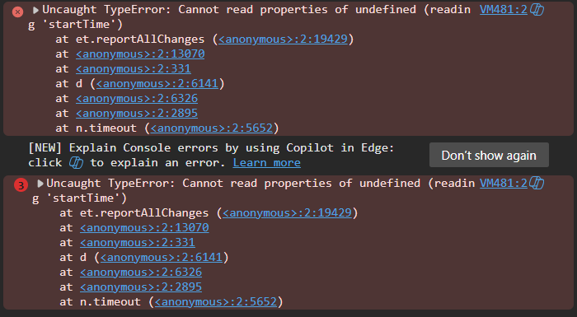
Outstanding is not showing correctly in the Project Master > Dashboard
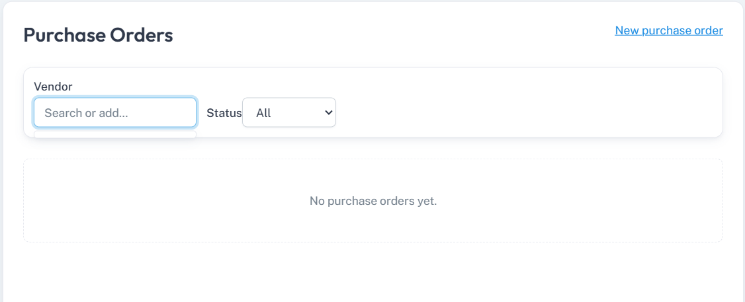

Vendor Outstanding report – there is a dropdown for ‘Report’
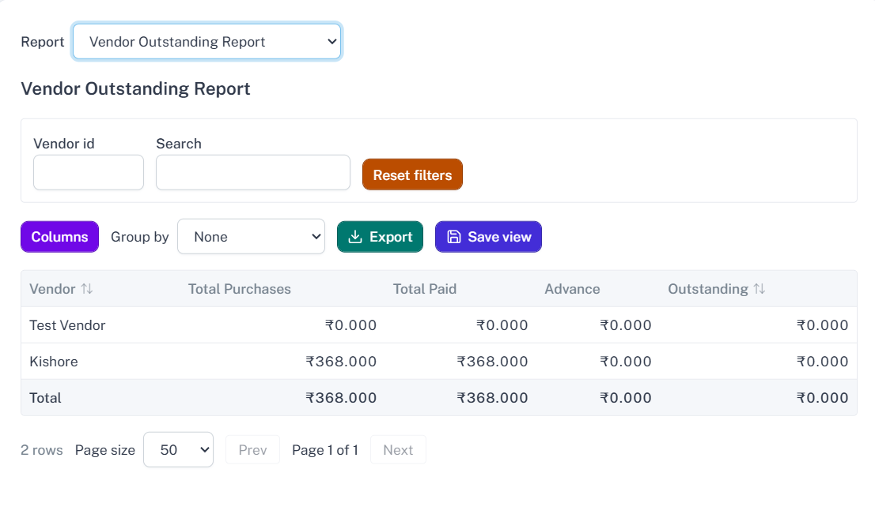
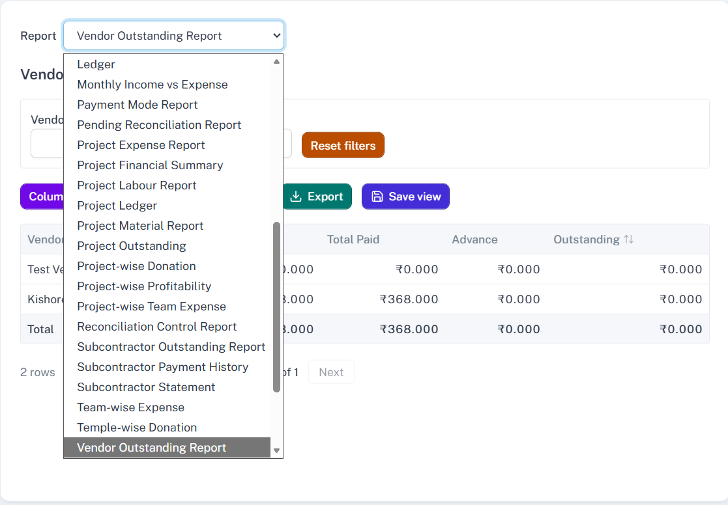

While saving loan there is an pop coming as “One or more validation error occurred”
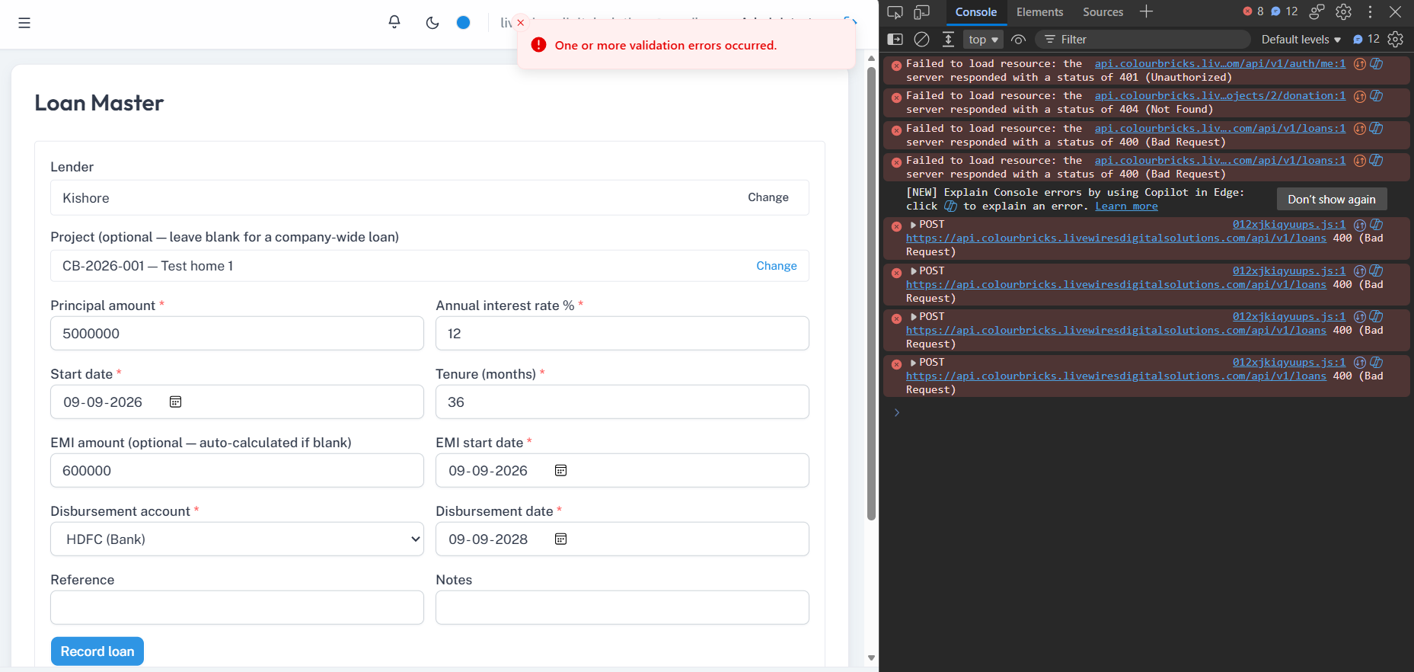
Same error for office expenses
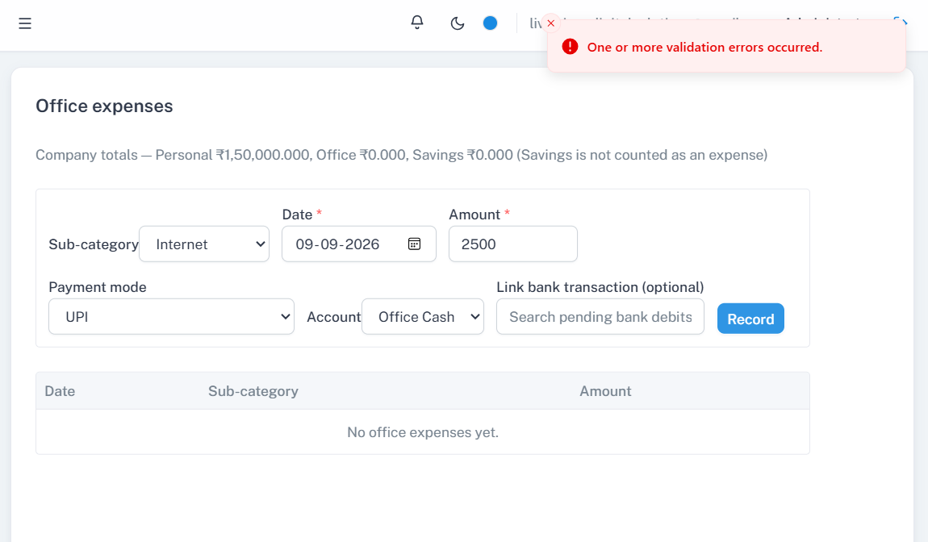
While choosing roles in administration, all these three are getting selected
