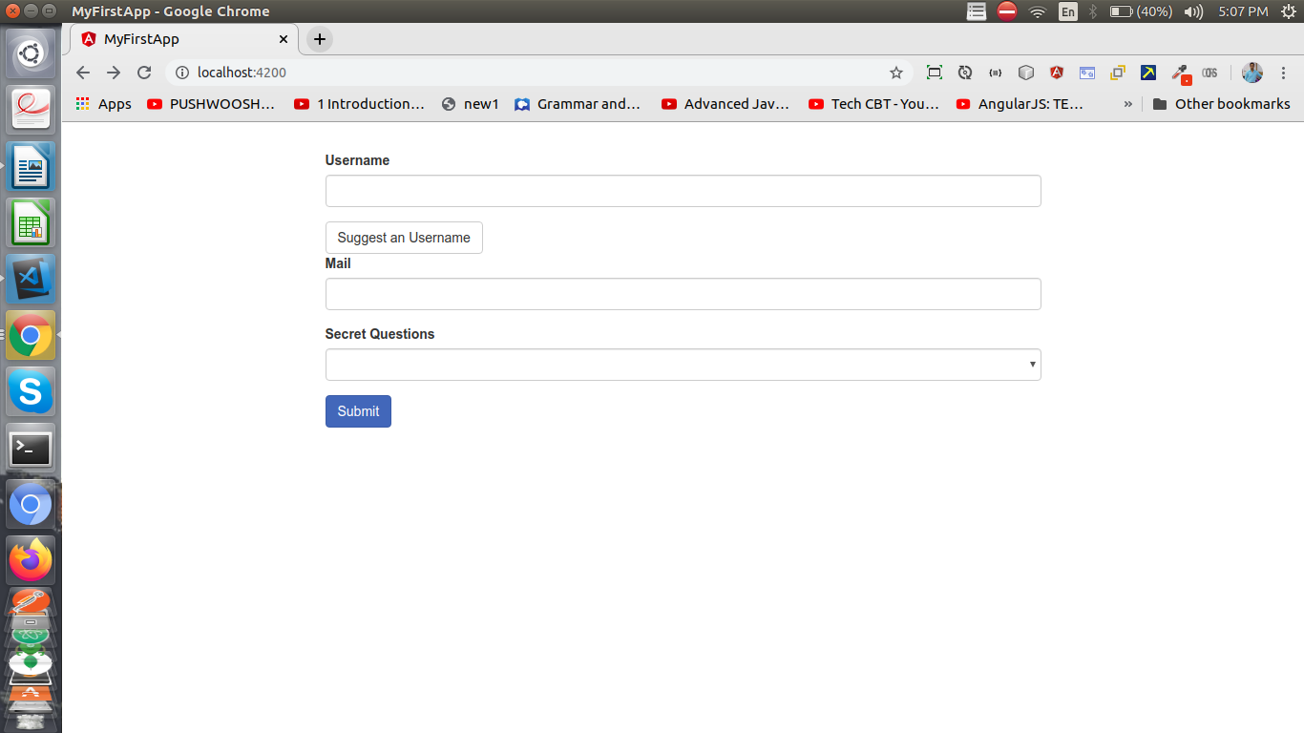

Created custom pipe and filter the data from the list of data List

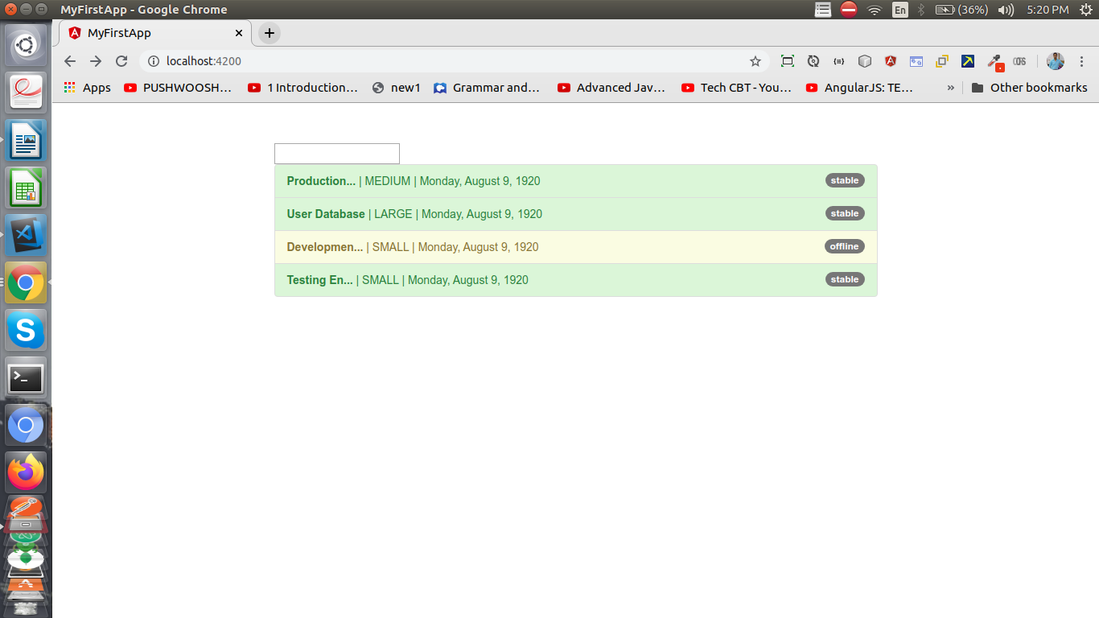

Created project and bind the data using string interpolation, property binding, one way binding and two way data binding

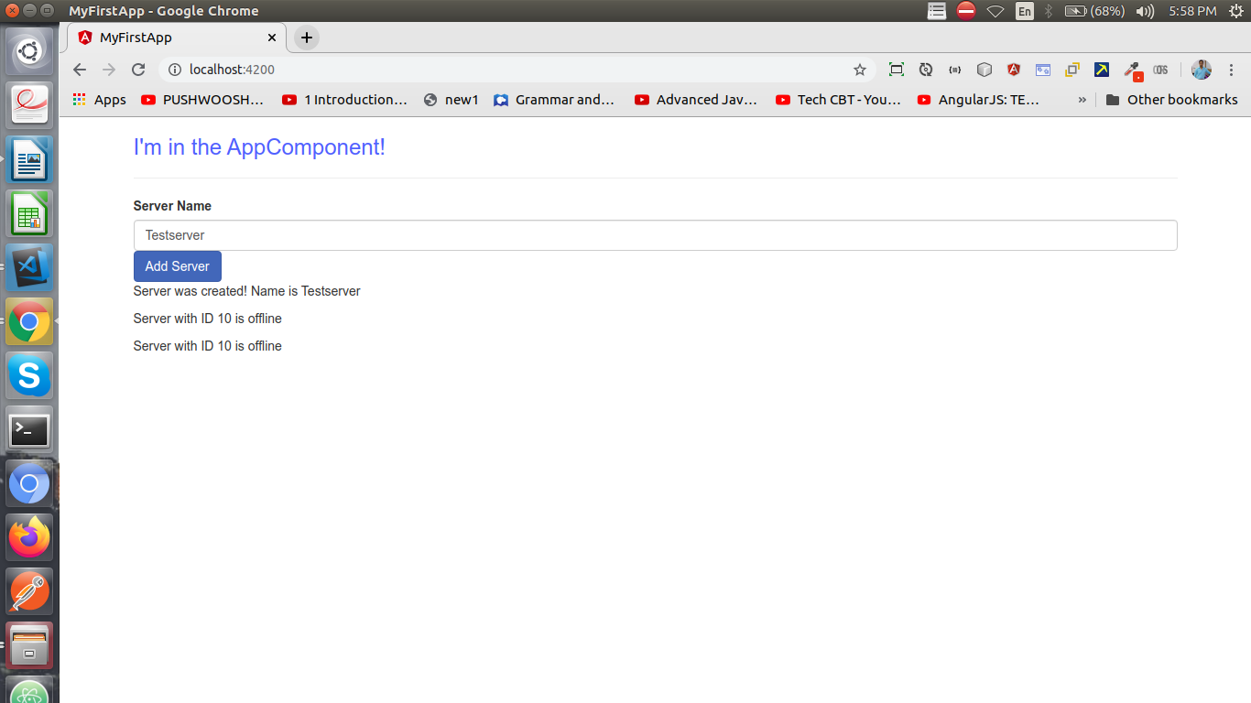Using the Http Interceptor for send request and showing error message and when request not send

