<div class="row">

<div class="col-lg-12">

{{video.SINGERNAME}}

</div>

<video controls="controls" name="Video Name" ng-src="{{getVideoUrl()}}"></video>

</div>

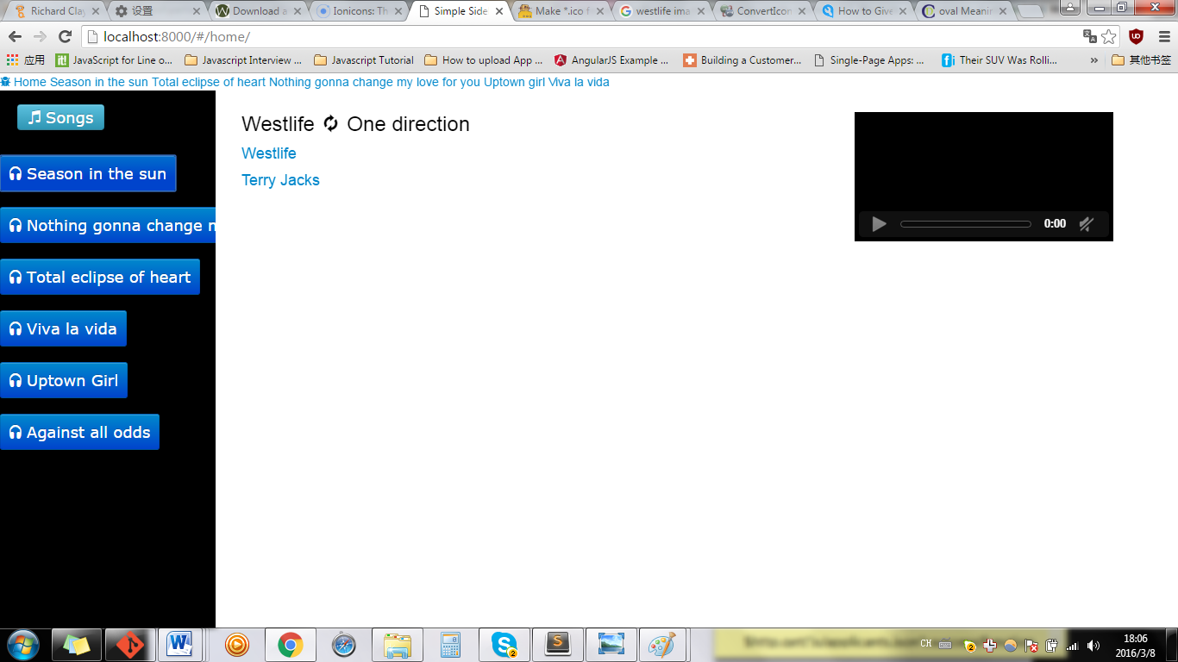

<div class="row">

<div class="col-lg-12">

{{video.SINGERNAME}}

<video controls="controls" name="Video Name" ng-src="{{getVideoUrl()}}"></video>

</div>

</div>

