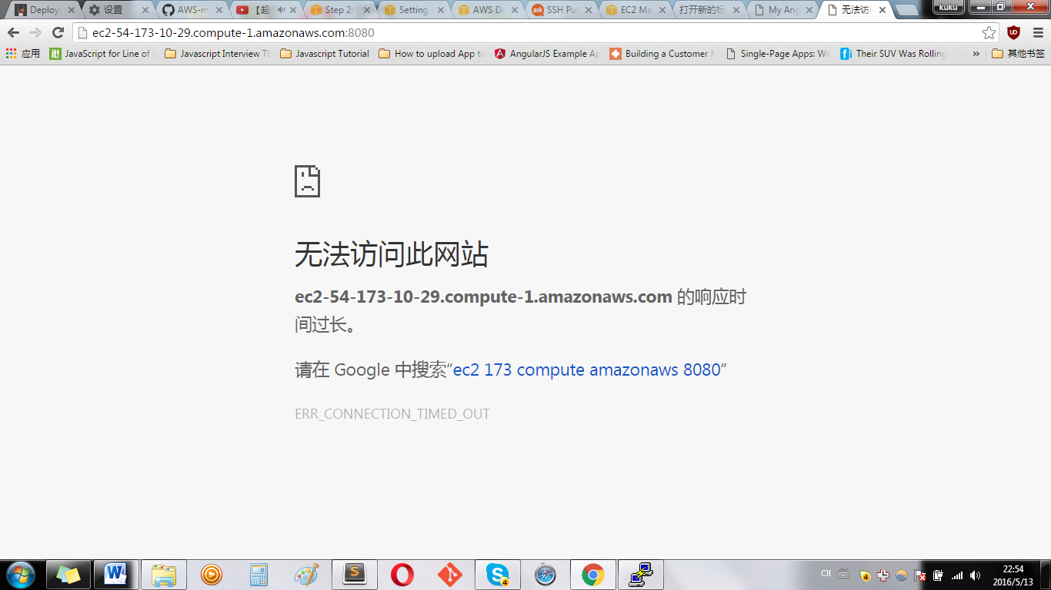

Can’t access AWS EC2 ‘s public DSN:port name,

The reason: Security Group---Inbound

Open up your web browser and navigate back to the AWS EC2 Dashboard. Then, using the menu on the left, open up the Security Groups panel. Click on the row associated with our MEAN application. (It will have a Group name like: “MEAN powered by Bitnami”). Beneath our row is a set of Inbound and Outbound rules specifying which ports are accessible for the application and by the outside world.

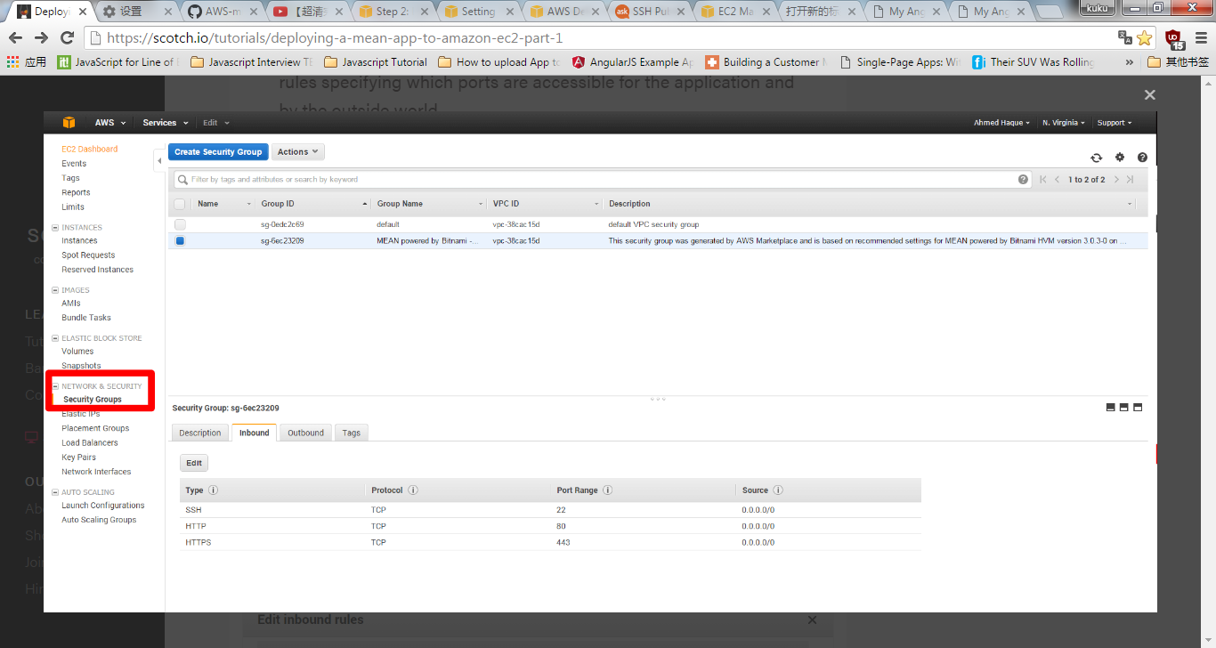

We need to create a custom inbound TCP rule that makes port 8080 accessible. Set the Protocol to TCP, the Port Range to 8080, and the source 0.0.0.0/0 (anywhere). Additionally, we’ll do the same for port 27017, which will be used by MongoDB.

