**WRONG**

.controller('ContinuteCtrl', function($scope,’TripService’) {

$scope.test2="cinttttttttt";

$scope.tripList=TripService.list();

})

**RIGHT**

.controller('ContinuteCtrl', function($scope,TripService) {

$scope.test2="cinttttttttt";

$scope.tripList=TripService.list();

})

**WRONG**

.controller('ContinuteCtrl', function($scope,TripService) {

$scope.test2="cinttttttttt";

$scope.tripList=TripService.list;

})

.service('TripService', function (){

var trips=[{"NAME":"Mave","AGE":45,"GENDER":"Female"},

{"NAME":"Baoji","AGE":73,"GENDER":"Female"}];

this.list = function () {

return trips;

}

});

**RIGHT**

.controller('ContinuteCtrl', function($scope,TripService) {

$scope.test2="cinttttttttt";

$scope.tripList=TripService.list();

})

.service('TripService', function (){

var trips=[{"NAME":"Mave","AGE":45,"GENDER":"Female"},

{"NAME":"Baoji","AGE":73,"GENDER":"Female"}];

this.list = function () {

return trips;

}

});

**WRONG**

**.service('TripService', function (){**

**var trips=[{"NAME":"Mave","AGE":45,"GENDER":"Female"},**

**{"NAME":"Baoji","AGE":73,"GENDER":"Female"}];**

**this.list = function () {**

**return trips;**

**}**

**this.save=function(trip){**

**trips.push(trip);**

**}**

**});**

**.controller('CreateCtrl', function($scope,TripService) {**

**$scope.tripList=TripService.list();**

**$scope.createRecord=function(){**

**TripService.save($scope.newTrip);**

**$scope.newTrip={};**

**}**

**</label>**

**<input type="text" placeholder="Visiting clients" ng-model="newTrip.NAME">**

**<label class="item item-input item-stacked-label">**

**<span class="input-label">Vehicle type</span>**

**</label>**

**<input type="text" placeholder="Toyota RAV4" ng-model="newTrip.AGE">**

**<label class="item item-input item-stacked-label">**

**<span class="input-label">Unit Price</span>**

**</label>**

**<input type="text" placeholder="0.70c/unit" ng-model="newTrip.GENDER">**

**<label class="item item-input item-stacked-label">**

**Once the data type you entry fron web page does not match the original type, newTrip can not be save into tripList;**

**RIGHT**

**.service('TripService', function (){**

**var trips=[{}];**

**this.list = function () {**

**return trips;**

**}**

**this.save=function(trip){**

**trips.push(trip);**

**}**

**});**

**RIGHT**

**<!DOCTYPE html>**

**<html>**

**<head>**

**<meta charset="utf-8">**

**<meta name="viewport" content="initial-scale=1, maximum-scale=1, user-scalable=no, width=device-width">**

**<title></title>**

**<link href="lib/ionic/css/ionic.css" rel="stylesheet">**

**<link href="css/style.css" rel="stylesheet">**

**<link href="lib/ionic/css/ionicons.css" rel="stylesheet">**

**<link href="lib/ionic/css/ionicons.min.css" rel="stylesheet">**

**<!-- IF using Sass (run gulp sass first), then remove the CSS include above**

**<link href="css/ionic.app.css" rel="stylesheet">**

**-->**

**</head>**

**<body ng-app="starter" animation="slide-left-right-ios7">**

**<ion-nav-bar type="bar-positive"**

**animation="nav-title-slide-ios7"**

**back-button-type="button-icon button-clear"**

**back-button-icon="ion-ios7-arrow-back"></ion-nav-bar>**

**<!--**

**The views will be rendered in the <ion-nav-view> directive below**

**Templates are in the /templates folder (but you could also**

**have templates inline in this html file if you'd like).**

**-->**

**<ion-nav-view></ion-nav-view>**

**<!-- ionic/angularjs js -->**

**<script src="lib/ionic/js/ionic.bundle.js"></script>**

**<!-- cordova script (this will be a 404 during development) -->**

**<script src="cordova.js"></script>**

**<!-- your app's js -->**

**<script src="js/app.js"></script>**

**<script src="lib/ionic/js/ngstorage/ngStorage.js"></script>**

**<script src="lib/ionic/js/ngstorage/ngStorage.min.js"></script>**

**</body>**

**</html>**

**WRONG:**

**<!DOCTYPE html>**

**<html>**

**<head>**

**<meta charset="utf-8">**

**<meta name="viewport" content="initial-scale=1, maximum-scale=1, user-scalable=no, width=device-width">**

**<title></title>**

**<link href="lib/ionic/css/ionic.css" rel="stylesheet">**

**<link href="css/style.css" rel="stylesheet">**

**<link href="lib/ionic/css/ionicons.css" rel="stylesheet">**

**<link href="lib/ionic/css/ionicons.min.css" rel="stylesheet">**

**<!-- IF using Sass (run gulp sass first), then remove the CSS include above**

**<link href="css/ionic.app.css" rel="stylesheet">**

**-->**

**<script src="js/app.js"></script>**

**<script src="lib/ionic/js/ngstorage/ngStorage.js"></script>**

**<script src="lib/ionic/js/ngstorage/ngStorage.min.js"></script>**

**</head>**

**<body ng-app="starter" animation="slide-left-right-ios7">**

**<ion-nav-bar type="bar-positive"**

**animation="nav-title-slide-ios7"**

**back-button-type="button-icon button-clear"**

**back-button-icon="ion-ios7-arrow-back"></ion-nav-bar>**

**<!--**

**The views will be rendered in the <ion-nav-view> directive below**

**Templates are in the /templates folder (but you could also**

**have templates inline in this html file if you'd like).**

**-->**

**<ion-nav-view></ion-nav-view>**

**<!-- ionic/angularjs js -->**

**<script src="lib/ionic/js/ionic.bundle.js"></script>**

**<!-- cordova script (this will be a 404 during development) -->**

**<script src="cordova.js"></script>**

**<!-- your app's js -->**

**</body>**

**</html>**

**.controller('purposeCtrl', function($scope,$localStorage,TripService) {**

**$scope.$storage=$localStorage.$default({purpose: Kyle Rd});**

**})**

**.controller('purposeCtrl', function($scope,$localStorage,TripService) {**

**$scope.$storage=$localStorage.$default({purpose: "Kyle Rd"});**

**})**

**<span class="input-label"><i class="icon ion-ios7-speedometer"></i> End meter</span>**

**<input type="text" placeholder="Visiting clients" ng-model="$storage.endMetre">**

**</label>**

**<div>**

**<a href="/#/countCost">**

**<button class="button button-block button-positive" type="submit">**

**Go to end meter <i class="icon ion-arrow-right-a"></i></button>**

**</a>**

**\*\*\*\*\*\*\*\***

**</div>**

**<div class="tabs tabs-icon-left">**

**<a class="tab-item">**

**<i class="icon ion-home"></i>**

**Home**

**</a>**

**<a class="tab-item">**

**<i class="icon ion-star"></i>**

**Favorites**

**</a>**

**<a class="tab-item">**

**<i class="icon ion-gear-a"></i>**

**Settings**

**</a>**

**</div>**

**</form>**

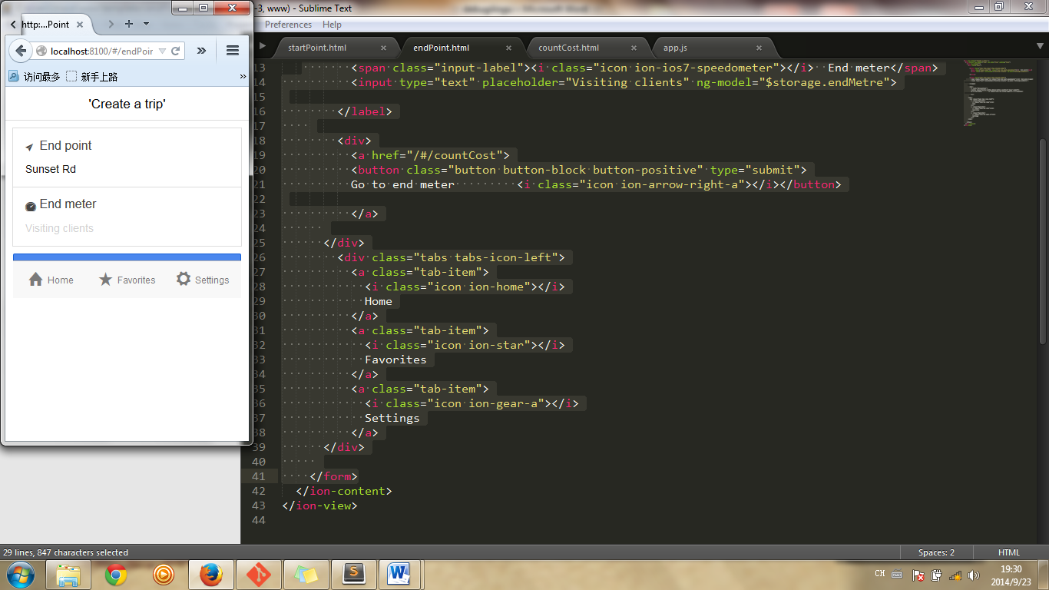

**</label>**

**<div>**

**<a href="/#/countCost">**

**<button class="button button-block button-positive" type="submit">**

**Go to end meter <i class="icon ion-arrow-right-a"></i></button>**

**</a>**

**</div>**

**</div>**

**<div class="tabs tabs-icon-left">**

**<a class="tab-item">**

**<i class="icon ion-home"></i>**

**Home**

**</a>**

**<a class="tab-item">**

**<i class="icon ion-star"></i>**

**Favorites**

**</a>**

**<a class="tab-item">**

**<i class="icon ion-gear-a"></i>**

**Settings**

**</a>**

**</div>**

**</form>**

**</ion-content>**

**</ion-view>**

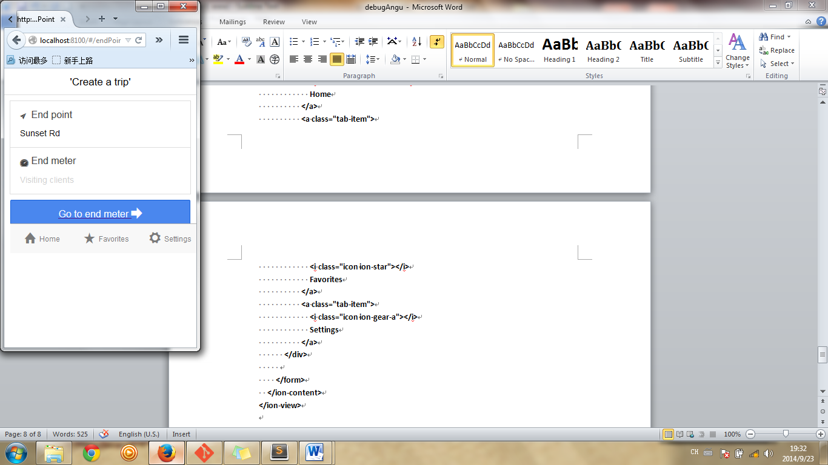

**<label class="item item-input item-stacked-label">**

**<span class="input-label">Start meter</span>**

**</label>**

**<input type="text" placeholder="Visiting clients" ng-model="newTrip.PURPOSE">**

**<div>**

**<a href="/#/endPoint">**

**<button class="button button-block button-positive" type="submit">**

**Go to end point<i class="icon ion-arrow-right-a"></i></button>**

**</a>**

**</div>**

**</div>**

**<div class="tabs tabs-icon-left">**

**<a href="/#/startPoint" class="tab-item">**

**<i class="icon ion-home"></i>**

**Home**

**</a>**

**<a href="/#/history" class="tab-item">**

**<i class="icon ion-star"></i>**

**History**

**The above can’t run propertly in Mobile**

**<label class="item item-input item-stacked-label">**

**<span class="input-label">Start meter</span>**

**</label>**

**<input type="text" placeholder="Visiting clients" ng-model="newTrip.PURPOSE">**

**<div>**

**<a href="#/endPoint">**

**<button class="button button-block button-positive" type="submit">**

**Go to end point<i class="icon ion-arrow-right-a"></i></button>**

**</a>**

**</div>**

**</div>**

**<div class="tabs tabs-icon-left">**

**<a href="#/startPoint" class="tab-item">**

**<i class="icon ion-home"></i>**

**Home**

**</a>**

**<a href="#/history" class="tab-item">**

**<i class="icon ion-star"></i>**

**History**

**<!-- cordova script (this will be a 404 during development) -->**

**<script src="cordova.js"></script>**

**<!-- your app's js -->**

**<script src="js/controller.js"></script>**

**<script src="js/app.js"></script>**

**<script src="lib/ionic/js/ngstorage/ngStorage.js"></script>**

**<script src="lib/ionic/js/ngstorage/ngStorage.min.js"></script>**

**</body>**

**</html>**

**WRONG: app not defined**

**<!-- cordova script (this will be a 404 during development) -->**

**<script src="cordova.js"></script>**

**<!-- your app's js -->**

**<script src="js/app.js"></script>**

**<script src="js/controller.js"></script>**

**<script src="lib/ionic/js/ngstorage/ngStorage.js"></script>**

**<script src="lib/ionic/js/ngstorage/ngStorage.min.js"></script>**

**</body>**

**</html>**

**.controller('countCostCtrl', function($scope,$localStorage,TripService) {**

**$scope.$storage=$localStorage.$default({ newTrip:{},**

**tripList:[{}]**

**});**

**$scope.$storage.newTrip=TripService.getTrip();**

**$scope.distance=0;**

**$scope.testList=[{}];**

**if($scope.newTrip.endMeter!=undefined && $scope.newTrip.startMeter!=undefined){**

**$scope.distance=Number($scope.newTrip.endMeter)-Number($scope.newTrip.startMeter);**

**}**

**<label class="item item-input item-stacked-label">**

**<span class="input-label"> <i class="icon ion-ios7-calculator"></i> Distance</span>**

**<input type="text" placeholder="Visiting clients" >**

**</label>**

**{{distance}}**

**{{testList[0].endPoint}}**

**<label class="item item-input item-stacked-label">**

**<span class="input-label"> <i class="icon ion-ios7-calculator"></i> Cost</span>**

**<input type="text" placeholder="Visiting clients" >**

**</label>**

**REASON:** **$storage.newTrip not yet instancial before using**

**Storage.id=uid++ == storage.id=”uid=uid+1”**

**Uid++ != uid+1**

**.controller('historyCtrl', function($scope,$localStorage,TripService) {**

**$scope.$storage=$localStorage.$default({ newTrip:{},**

**tripList:[{}]**

**});**

**$scope.testDelete="";**

**// $scope.$storage.newTrip=TripService.getTrip();**

**$scope.$storage.tripList=TripService.getStorTripList();**

**$scope.deleteTrip=function(){**

**for(i in $storage.tripList){>>>>>>>lack of $scope.**

**if($storage.tripList[i]).id==id{**

**$storage.tripList.splice(1,1);**

**/ }**

**}**

**// $scope.testDelete="test delete";**

**TripService.deleteTrip();**

**}**

**})**

**.controller('historyCtrl', function($scope,$localStorage,TripService) {**

**$scope.$storage=$localStorage.$default({ newTrip:{},**

**tripList:[{}]**

**});**

**$scope.testDelete="";**

**// $scope.$storage.newTrip=TripService.getTrip();**

**$scope.$storage.tripList=TripService.getStorTripList();**

**$scope.deleteTrip=function(){**

**for(i in$scope. $storage.tripList){**

**if($scope.$storage.tripList[i]).id==id{**

**$scope.$storage.tripList.splice(1,1);**

**/ }**

**}**

**// $scope.testDelete="test delete";**

**TripService.deleteTrip();**

**}**

**})**

**.controller('historyCtrl', function($scope,$localStorage,TripService) {**

**$scope.$storage=$localStorage.$default({ newTrip:{},**

**tripList:[{}]**

**});**

**$scope.testD="";**

**$scope.$storage.tripList=TripService.getStorTripList();**

**$scope.deleteTrip=function(id){**

**TripService.deleteTrip(id);>>>>>>>>this id must be a $scope variable within this controller, can not pass function(id)’s parameter directly into TripService.deleteTrip(id)!!**

**$scope.testD="fasfda";**

**}**

**<ul ng-repeat='trip in $storage.tripList'>**

**<li >**

**{{trip.id}} {{trip.startPoint}} {{trip.endPoint}}**

**<button type="submit" ng-click='deleteTrip(trip.id)'>**

**<i class="icon ion-ios7-trash"></i></button>**

**.controller('historyCtrl', function($scope,$localStorage,TripService) {**

**$scope.$storage=$localStorage.$default({ newTrip:{},**

**tripList:[{}]**

**});**

**$scope.$storage.tripList=TripService.getStorTripList();**

**$scope.deleteTrip=function(id){**

**//TripService.deleteTrip(id);**

**for(i in $scope.$storage.tripList){**

**if($scope.$storage.tripList[i].id==id){**

**$scope.$storage.tripList.splice(i,1);**

**}**

**}**

**}**

**})**

**$scope.saveOldTrip=function(trip){**

**for(i in $scope.$storage.tripList){**

**if($scope.$storage.tripList[i].id==trip.id){**

**$scope.$storage.newTrip=angular.copy(trip);**

**TripService.pushTrip($scope.$storage.newTrip);**

**}**

**}**

**}**

**$scope.saveOldTrip=function(trip){**

**for(i in $scope.$storage.tripList){**

**if($scope.$storage.tripList[i].id==trip.id){**

**// $scope.$storage.newTrip=angular.copy(trip);**

**TripService.pushTrip($scope.$storage.tripList[i]);>>>>>> >>bad solution!!**

**Bad result:1) screen need to reflesh to show added item; 2)repeated added item has the same id with the original one.**

**}**

**}**

**}**

**$scope.deleteTrip=function(id){**

**// if($scope.$storage.tripList.length>1){**

**for(i in $scope.$storage.tripList){**

**if($scope.$storage.tripList[i].id==id){**

**// $scope.$storage.tripList.splice(i,1);**

**//TripService.deleteTrip(id);>>>>>>>>WRONG: CANNOT PASS FUNCTION(id)’S id TO TripService.deleteTrip(id**

**TripService.deleteTrip($scope.$storage.tripList[i].id)**

**}**

**}**

**// }**

**.service('TripService', function ($localStorage){**

**var trip={};**

**var trips=[{}];**

**var uid=1;**

**var stor=1;**

**var $storage=$localStorage.$default({ uid:1,**

**notDone:true,>>>>>CANNOT RETURN TRUE AS A DEFAULT VALUE**

**newTrip:{},**

**notDoneTrip:{},**

**tripList:[{}],**

**});**

**this.setNotDone=function(){**

**$storage.notDone=!$storage.notDone;**

**R**

**}**

**this.getNotDone=function(){**

**return $storage.notDone; >>>>>CANNOT RETURN TRUE AS A DEFAULT VALUE**

**}**

**this.clearNotDoneTrip=function(){**

**$storage.notDoneTrip={};>>>>>> $storage.notDoneTrip={} IS NOT MEAN $storage.notDoneTrip==null, BUT IT MEAN: $storage.notDoneTrip.startPoint==null**

**==null MEANS undefined**

**.controller('endPointCtrl', function($scope,$localStorage,TripService) {**

**$scope.notDone=TripService.getNotDone();**

**$scope.notDoneTrip=TripService.getNotDoneTrip();**

**$scope.newTrip=TripService.getNotDoneTrip();**

**if($scope.notDoneTrip==null){**

**$scope.newTrip=TripService.getTrip();**

**}**

**else{**

**$scope.newTrip=angular.c opy($scope.notDoneTrip);**

**}>>>>>>>LOGIC PROBLEM: THE ABOVE RED SNAPIT WOULD EXECUTEAD TWICE: 1ST TIME WHEN THE PROGRAMM FIRSTLY LOADED; 2ND TIME AFTER THE FOLLOWING FUNCTION $scope.saveNotDoneTrip=function() EXECUTED , AS THE CONDITION if($scope.notDoneTrip==null) IS CHANGED**

**//\*\*\*\*\*\*\*\*\*\*\*\*\*\*\*\*\*\*\*\*\*\*\*\*\*\*\*\*\*\*\***

**$scope.saveNotDoneTrip=function(){**

**TripService.setNotDone();**

**$scope.notDoneTrip.startPoint=$scope.newTrip.startPoint;**

**$scope.notDoneTrip.startMeter=$scope.newTrip.startMeter;**

**$scope.notDoneTrip.endPoint=$scope.newTrip.endPoint;**

**$scope.notDoneTrip.endMeter=$scope.newTrip.endMeter;**

**TripService.setNotDoneTrip($scope.notDoneTrip);**

**}**

**//\*\*\*\*\*\*\*\*\*\*\*\*\*\*\*\*\*\*\*\*\*\*\*\*\*\*\*\*\***

**$scope.saveNewTrip=function(){**

**TripService.setTrip($scope.newTrip);**

**}**

**})**

**.controller('historyCtrl', function($scope,$stateParams,TripService) {>>>FOR IONIC UI ROUTER; IF ANGULAR ROUTER, $stateParams SHOULD BE $routeParams**

**// $scope.$storage=$localStorage.$default({ newTrip:{},**

**// tripList:[{}]**

**// });**

**$scope.newTrip={};**

**angular.module('starter', ['ui.router.router','ionic','ngStorage'])>>>>>>> >>>FOR IONIC UI ROUTER; IF ANGULAR ROUTER, ui.router.router SHOULD BE ngRoute**

**.config(function($stateProvider, $urlRouterProvider) {**

**========================================================================**

**.state('history', {**

**url: '/history',**

**templateUrl: 'templates/history.html',**

**controller: 'historyCtrl'**

**})**

**.state('history:itemId', {**

**url: '/history/:itemId',>>>>>>>DIFFERENT WITH ngRouter**

**templateUrl: 'templates/historyDetails.html',**

**controller: 'historyCtrl'**

**});**

**.service('TripService', function ($localStorage){**

**var trip={};**

**var trips=[{}];**

**var $storage=$localStorage.$default({ uid:1,**

**notDone:true,**

**newTrip:{},**

**notDoneTrip:{},**

**tripList:[{}],**

**unitPrice:1**

**});**

**this.setUnitPrice=function(unitPrice){**

**// $storage.unitPrice=unitPrice;>>>>>>>>>> $storage.unitPrice ALWAYS STAY “0”**

**$storage.unitPrice=0+unitPrice;>>>>>>WORK PROPERTLY**

**this.getUnitPrice=function(){**

**return $storage.unitPrice;**

**}**

**\*\*\*\*\*\*\*\*\*\*\*\*\*\*\*\*\*\*\*\*\*\*\*\*\*\*\*\*\*\*\*\*\*\*\*\*\*\*\*\*\*\*\*\*\*\*\*\*\*\*\*\*\*\*\*\*\*\*\*\*\*\*\*\*\*\*\*\*\*\*\*\*\*\*\***

**.controller('setCarCtrl', function($scope,$localStorage,TripService) {**

**// $scope.unitPrice=TripService.getUnitPrice();**

**$scope.newSetting=TripService.getNewSetting();**

**$scope.setNewSetting=function(){**

**TripService.setNewSetting($scope.newSetting);**

**}**

**})**

**setCar.html:**

**<input type="text" placeholder="unit price"ng-model="newSetting.unitPrice">>>>>>CAN’T DIRECTLY SET unitPrice, unitPrice MUST HAVE A KEY**

**.service('TripService', function ($localStorage){**

**var $storage=$localStorage.$default({ uid:1,**

**notDone:true,**

**newSetting:{},**

**this.setNewSetting=function(setting){**

**$storage.newSetting=angular.copy(setting);**

**}**

**this.getNewSetting=function(){**

**return $storage.newSetting;**

**}**