FIFA Booking app is a responsive Single Page Application: Featuring navigating , add to shopping card, making comments. It was implemented in AngularJS,Node.js, which provided clear MVC structure and shorter code

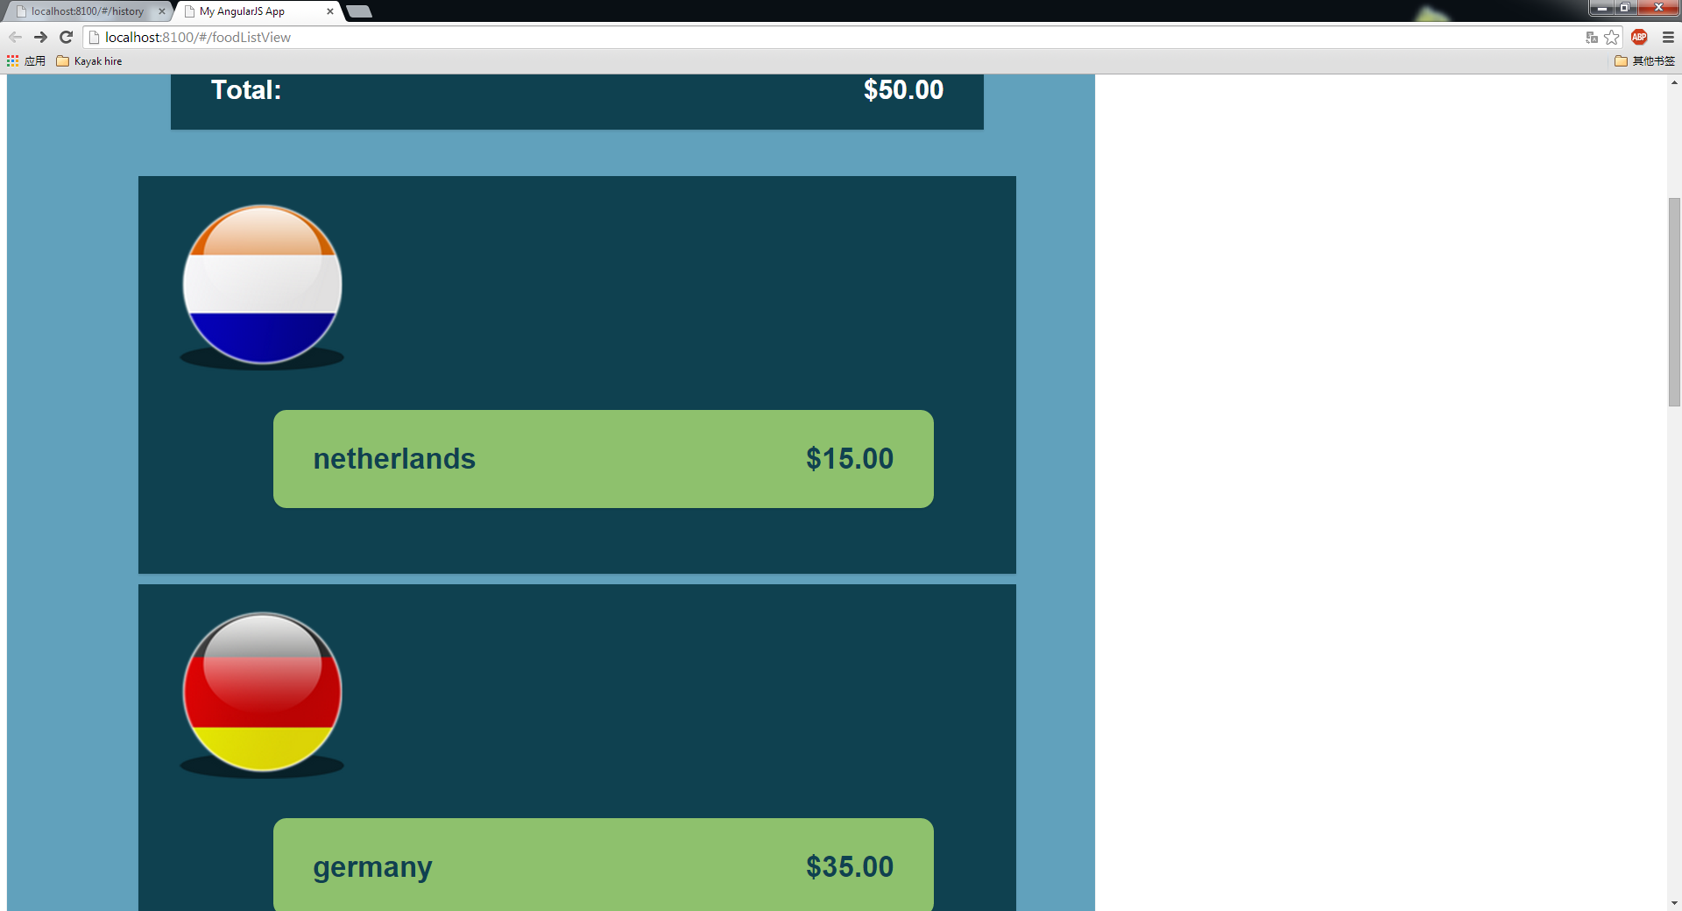

1. Above: Simply click ticket-to-book, the total costs would show on top-right screen simultaneously, the chosen panel would change to green the same time.

Technique: Angular two-way data-binding;

CSS3

* 1. Below: Click picture to see details. Different item’s details show in Single Page

Technique: Angular router

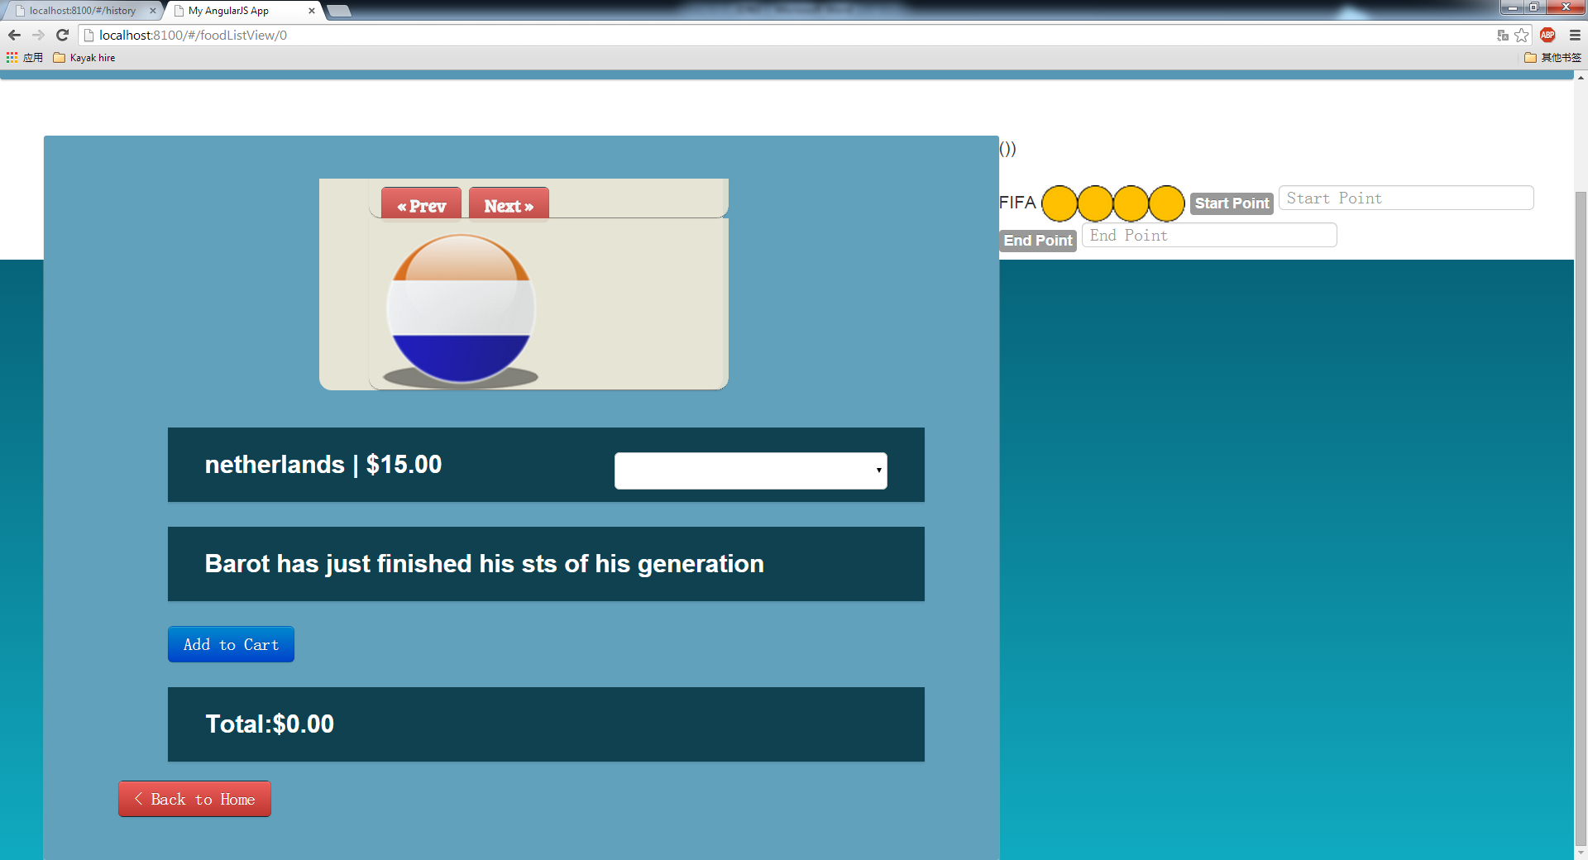

1. Above: Add to Shopping Card function

Technique: Angular http service, JSON

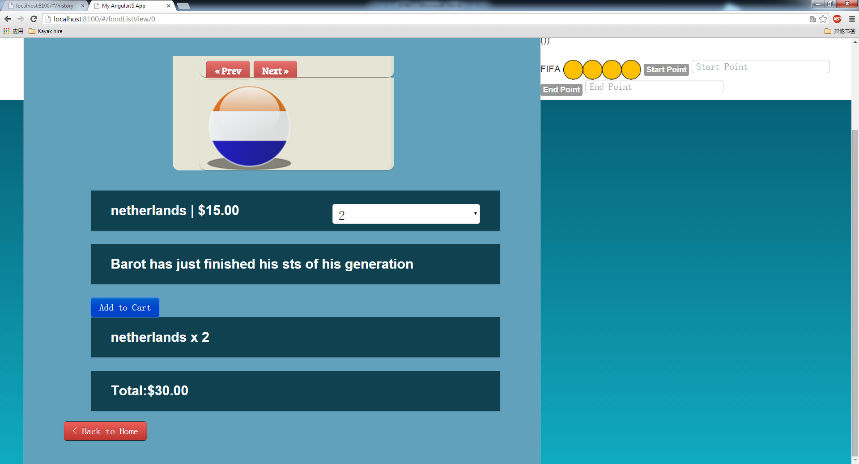

1. Above: Add to Shopping Card function

Technique: Angular http service, JSON

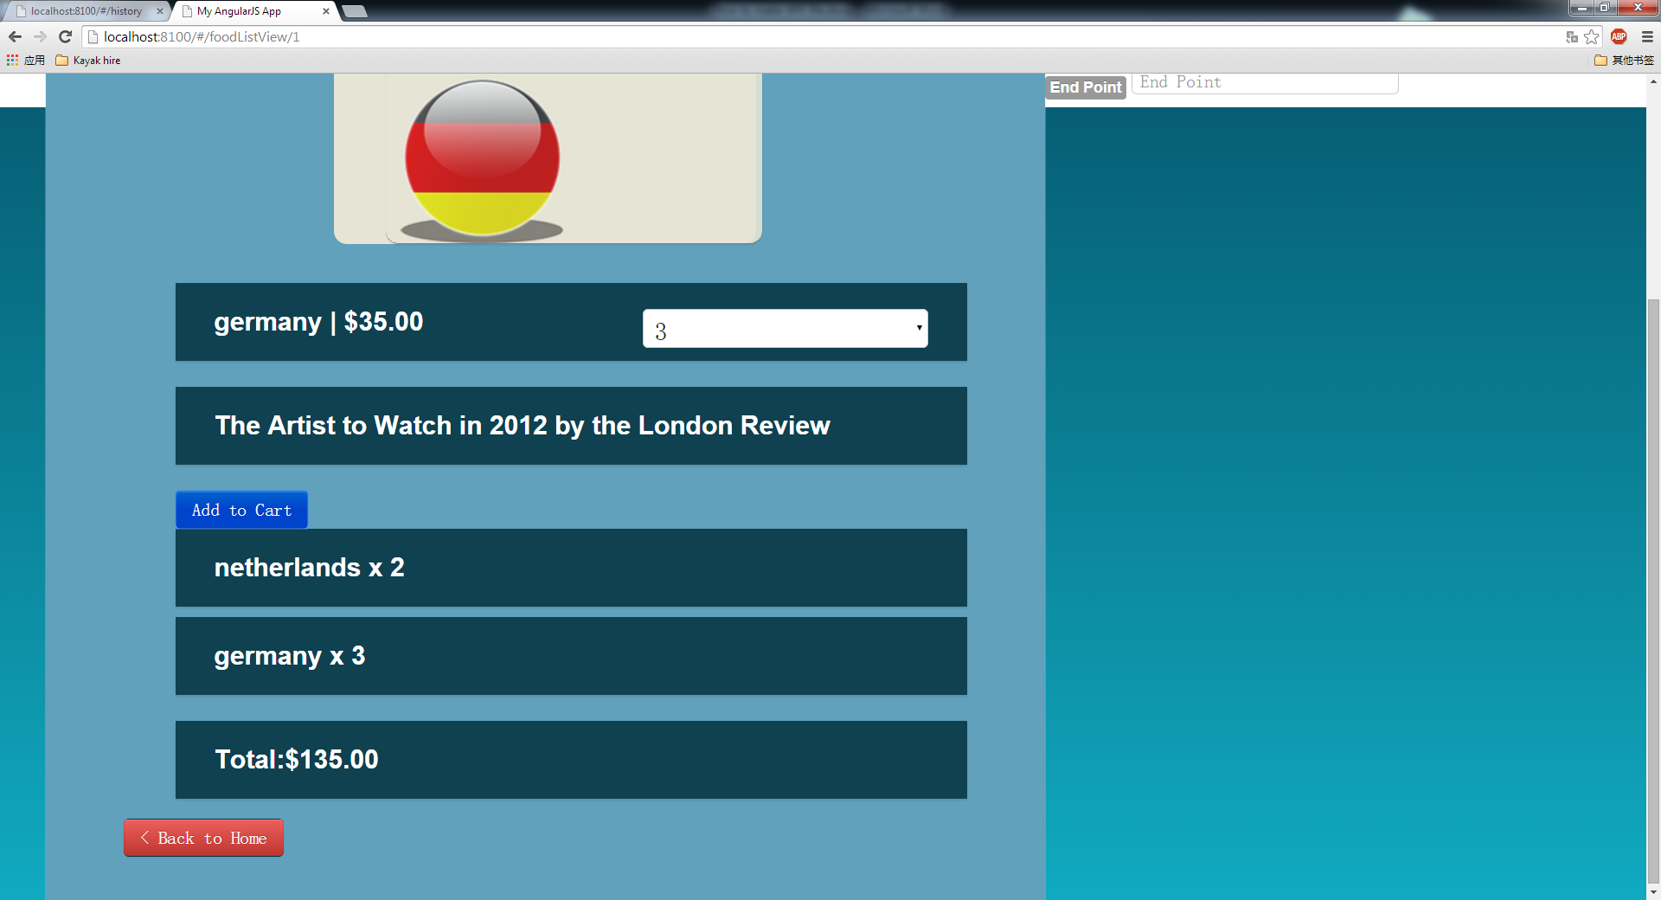

1. Above: Add to Shopping Card function

Technique: Angular http service, JSON