**IvoteIndia – e Voting solution help documentation**

**Login**

Username and Password if you have already registered.

If new, then register using registration link provided below login box.

If you have forgot your password you can reset using forgot password link.

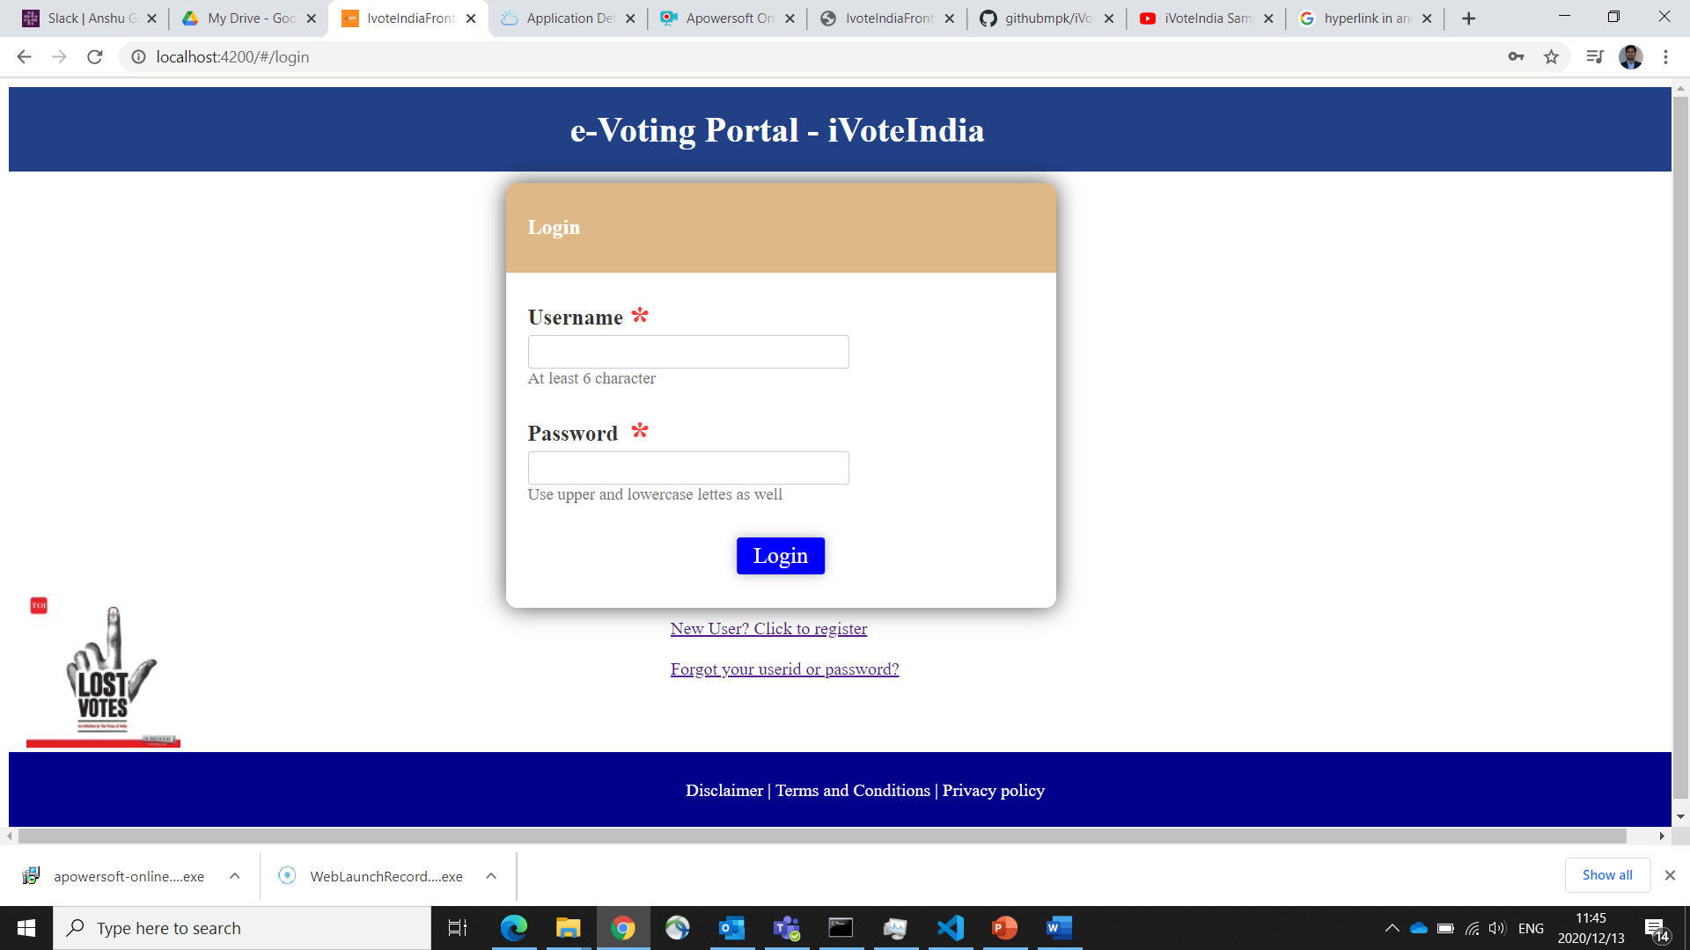

**First time registration, you need to fill the below form**

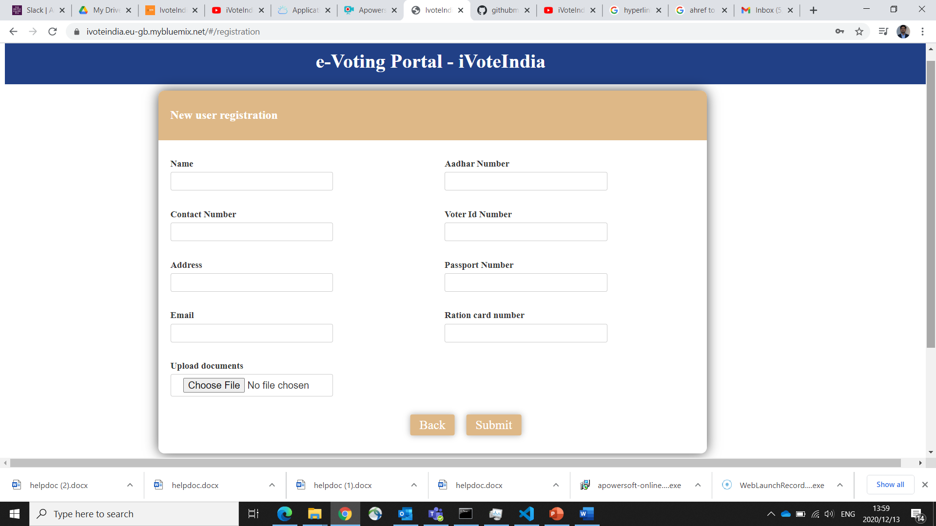

Fill all the necessary details and upload scanned documents, once done submit he form to get a reference number

Below is the screen showing the reference number on successful submission

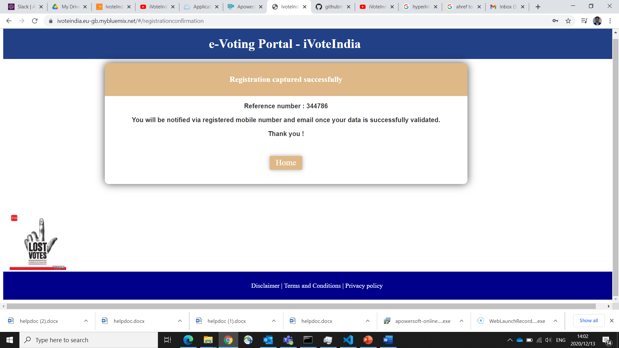

If you have registered and forgot your password then at home page you can click on forgot password

You need to provide registered email id and phone number to receive reset link

**Reset password**

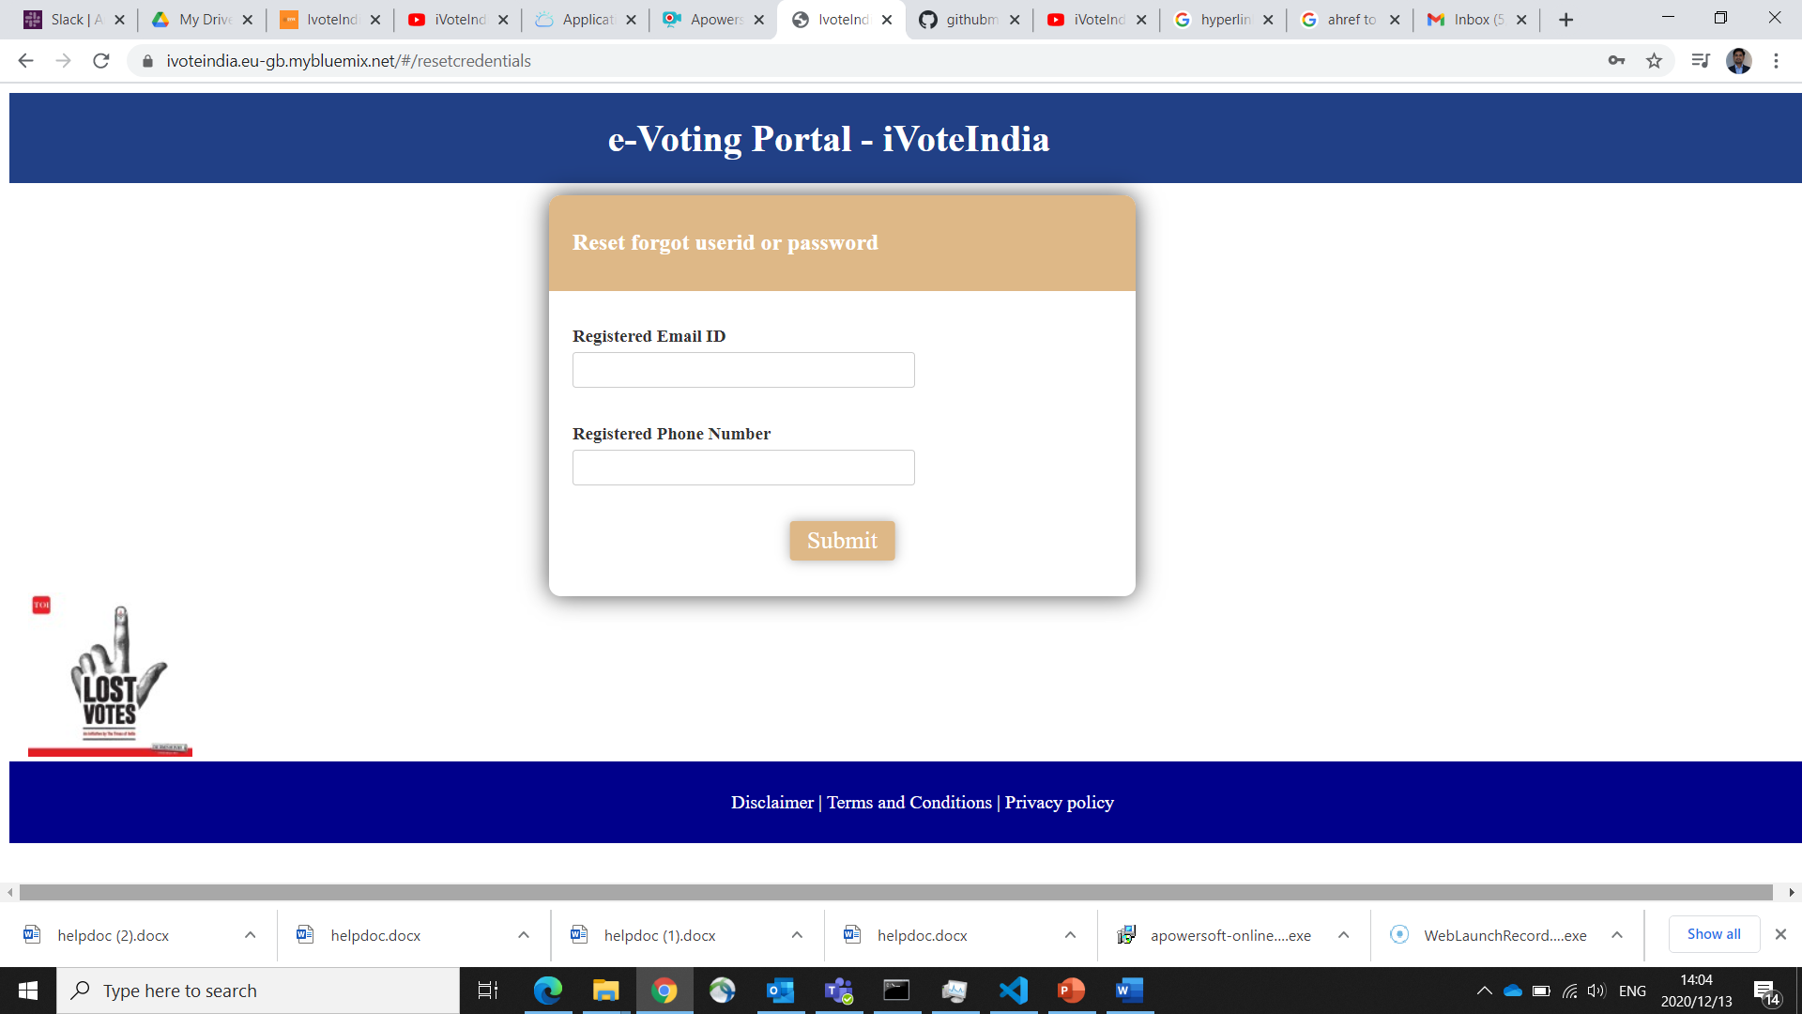

On successful login, you will visit your home screen.

**Home screen**

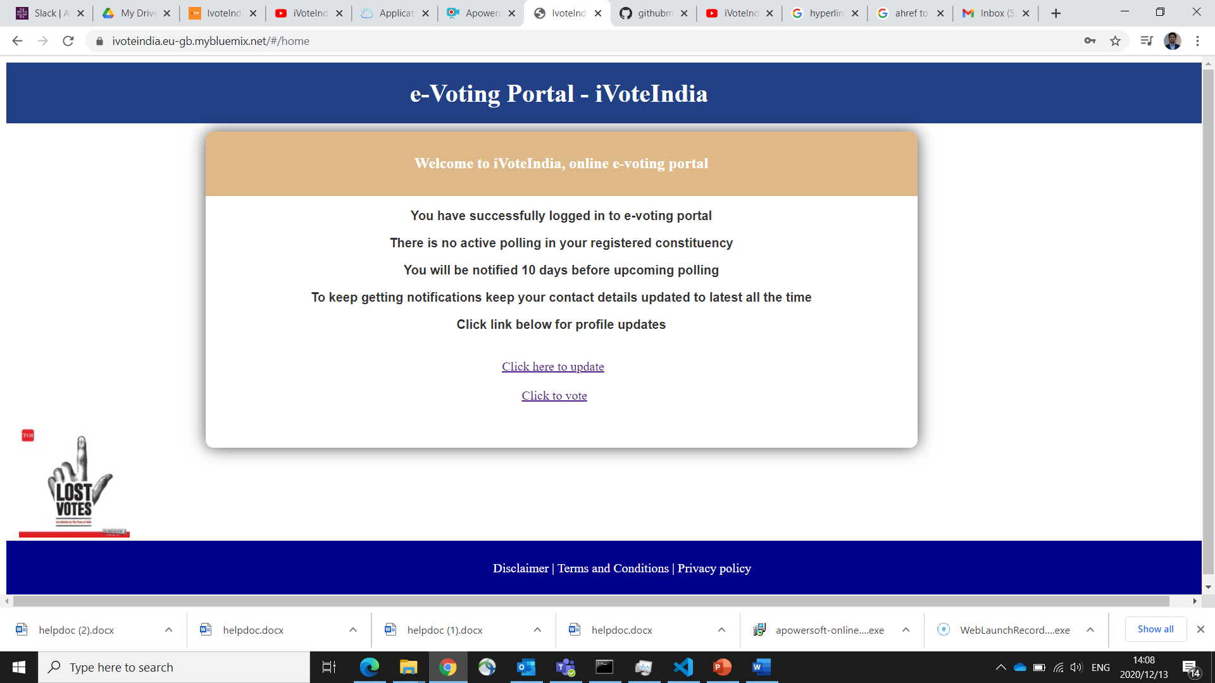

You are allowed to update profile, if you don’t have upcoming vote in your registered constituency

**Update profile**

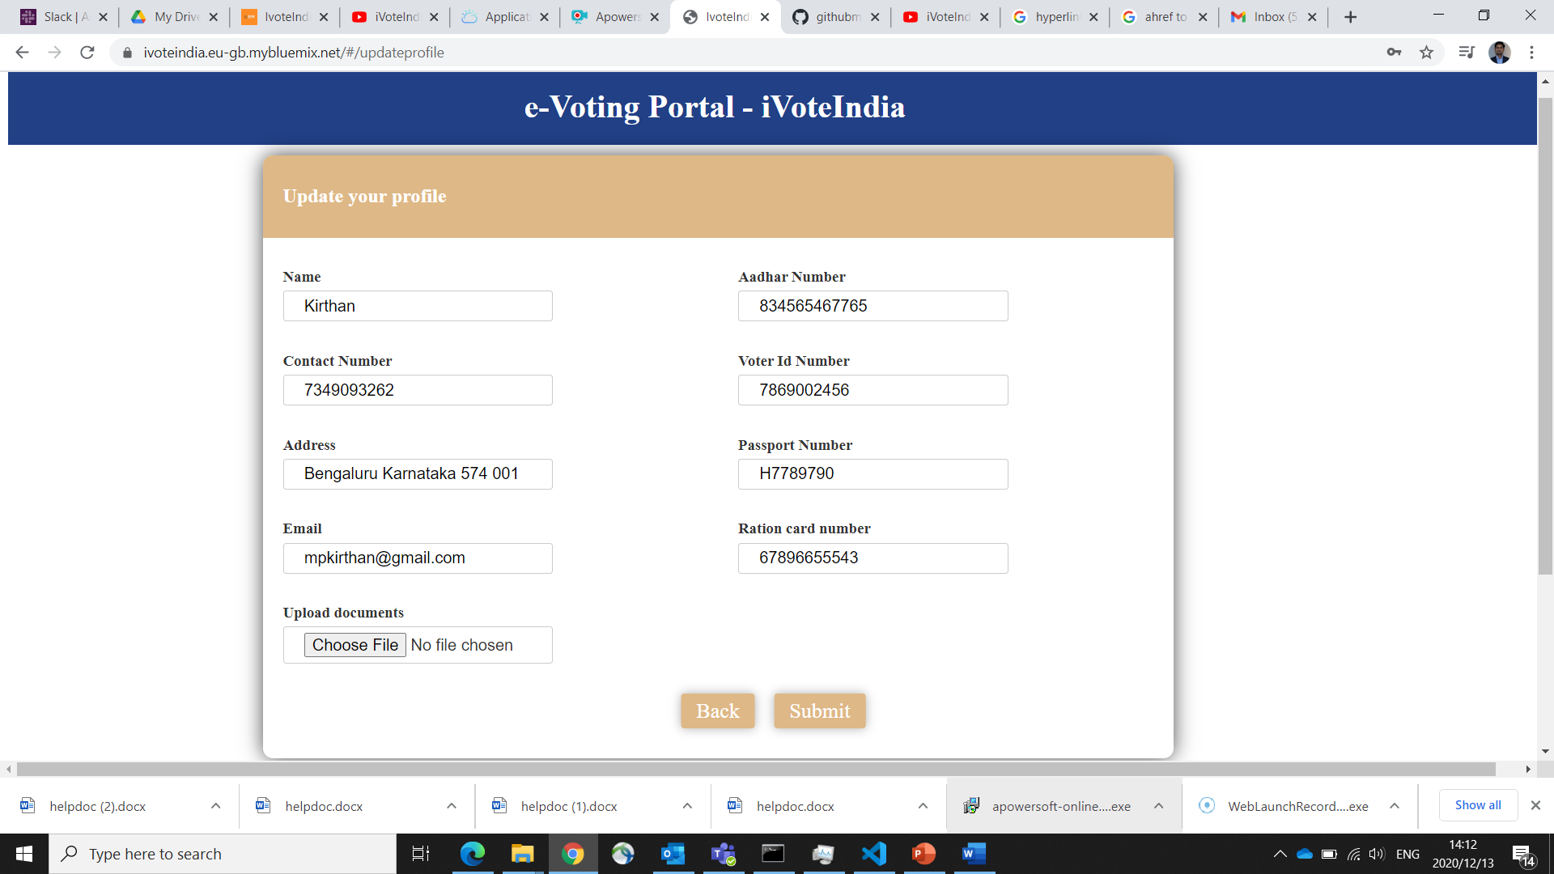

e-Vote at designated polling station

**e-Vote:**

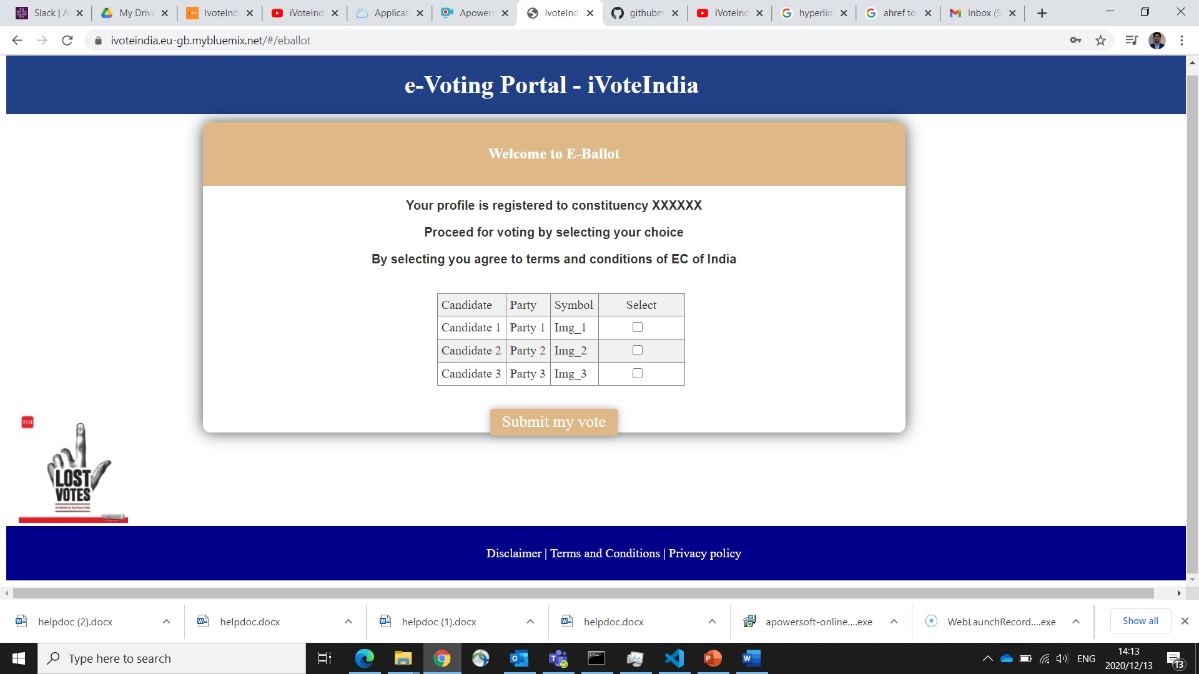

Submit e-vote

