Hontucan, Kenneth Rey B.

BSIT 4th Year Student

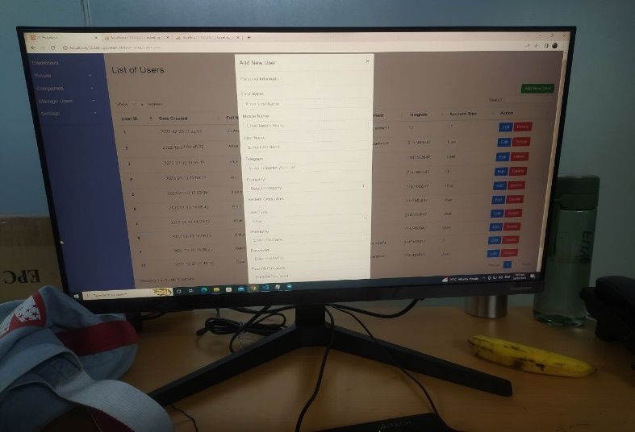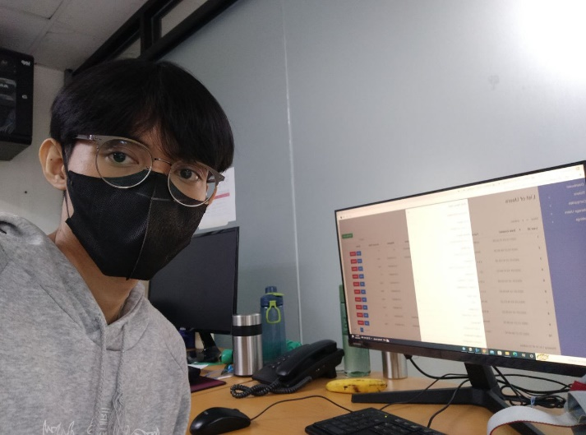January 13, 2023 at the office, I started my day communicating with my Supervisor through telegram since he was not around the office. He asked me to send screenshots of the User Interface of my current project from there, he gave me his comments about additions and revisions for the project. Right after that I started analyzing the comments and do it 1 at a time. After hours of coding and solving errors I managed to add the new functionality to the project that gives the Admin or IT users to register a new account after they logged in. Because before, account Registration can only be done if you are not logged in.