* **Ansible can execute 2 ways**

1. Ansible control machine ----SSH-🡪 python execution at remote machine
2. Ansible control machine executes playbooks locally that calls API of remote machine and execute commands. Example) NETCONF over SSH in juniper device

* Ansible scripts = playbooks in YAML format
* Playbooks in YAML format
  + start with ‘---‘
  + YAML matters indentation
  + ‘-‘ represents element of a list
  + YAML also support key:value such as dictionary
  + break down to **plays** as below
    - *play 1*

-hosts : xxx:yyy *#where the scripts running on, can define multiple hosts or groups with ‘:’*

vars: *#define variables to be used in playbooks*

tasks: *#actions*

-name:  *#description of task name*

template: src = /../../../../router.j2

dest=/…/…/../router1.txt

-name:  *#description of task name*

template: src = /../../../../router2.j2

dest=/…/…/../router5.txt

* + - *play 2*

-hosts : xxx *#where the scripts running on*

vars: *#define variables to be used in playbooks*

tasks: *#actions*

-name:  *#description of task name*

template: src = /../../../../switch.j2

dest=/…/…/../switch1.txt

-name:  *#description of task name*

template: src = /../../../../switch2.j2

dest=/…/…/../switch5.txt

* Inventory file : located at **/etc/ansible/hosts** by default
  + [xxx] *#group name*
  + resolvable_device_name **ansible_ssh_host**=1.2.2.2 **ansible_ssh_user**=pkim **ansible_ssh_port**=8222
* ansible xxx –m ping *#xxx:group name, -m:module name, output is json format*
* J2 file(xx.j2) is template file and it has {{ }} which is replaced with the variable at playbook file(xxxx.yml)
* ansible-playbook router.yml –check *#router.yml is playbook file name. Check what might be changed*
* ansible-playbook router.yml *#Execute the playbook named router.yml*
* dictionary of yaml file should have no space between key and ‘:’ like ‘key:’ and space between ‘:’ and value like ‘: pynet-rtr1’

- {hostname: pynet-rtr1, ip_addr: 1.1.1.1}

* yaml file is very sensitive to a couple of things per my testing. Mainly it doesn't like "Tab space".  
  1. indentation must be done with single space(s) **NOT** with Tab space(s)  
  2. must have a space(or multiple single spaces) between '-' and objects such as hosts,name,dictionaries under with loop,and etc (Again **No** Tab space(s))
* yaml for loop example
  + simple list

|  |
| --- |
| ---  - hosts: local  tasks:  - name: testing basic ansible palybook  template: src=./router.j2 dest=./{{item}}.txt  with_items:  - pynet-rtr1  - pynet-rtr2  - pynet-rtr3 |

* + list of dictionary

|  |
| --- |
| ---  - hosts: local  tasks:  - name: testing basic ansible palybook  template: src=./router.j2 dest=./{{item.hostname}}.txt  with_items:  - {hostname: pynet-rtr1, ip_addr: 1.1.1.1}  - {hostname: pynet-rtr2, ip_addr: 1.1.1.2}  - {hostname: pynet-rtr3, ip_addr: 1.1.1.3} |

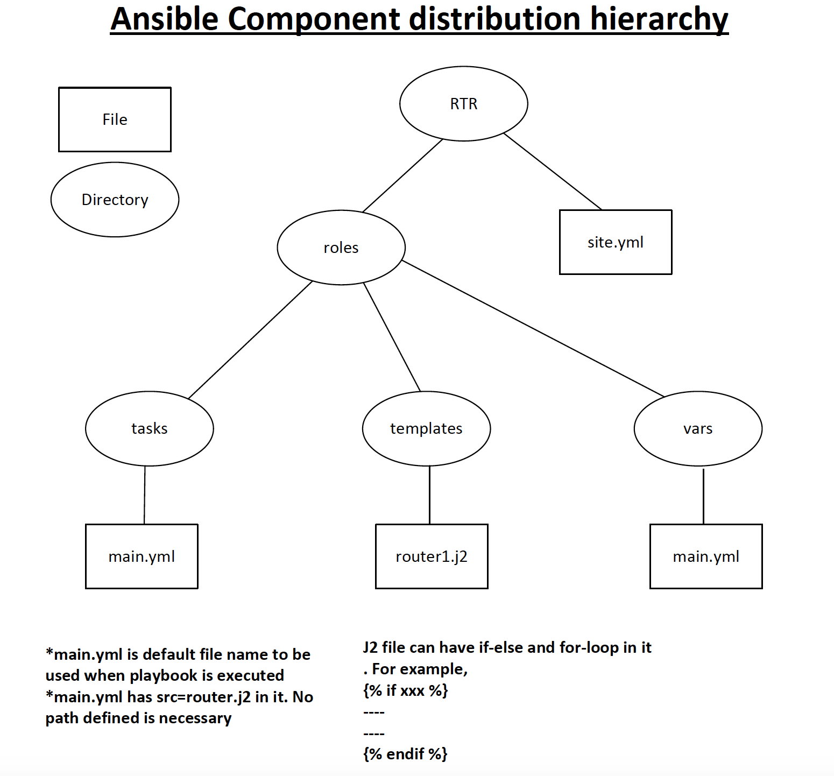

**\*Ansible over Arista eAPI**

**<Inventory file>**

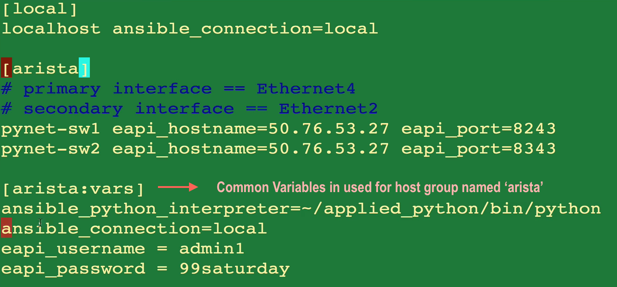

**<playbook yaml file>**

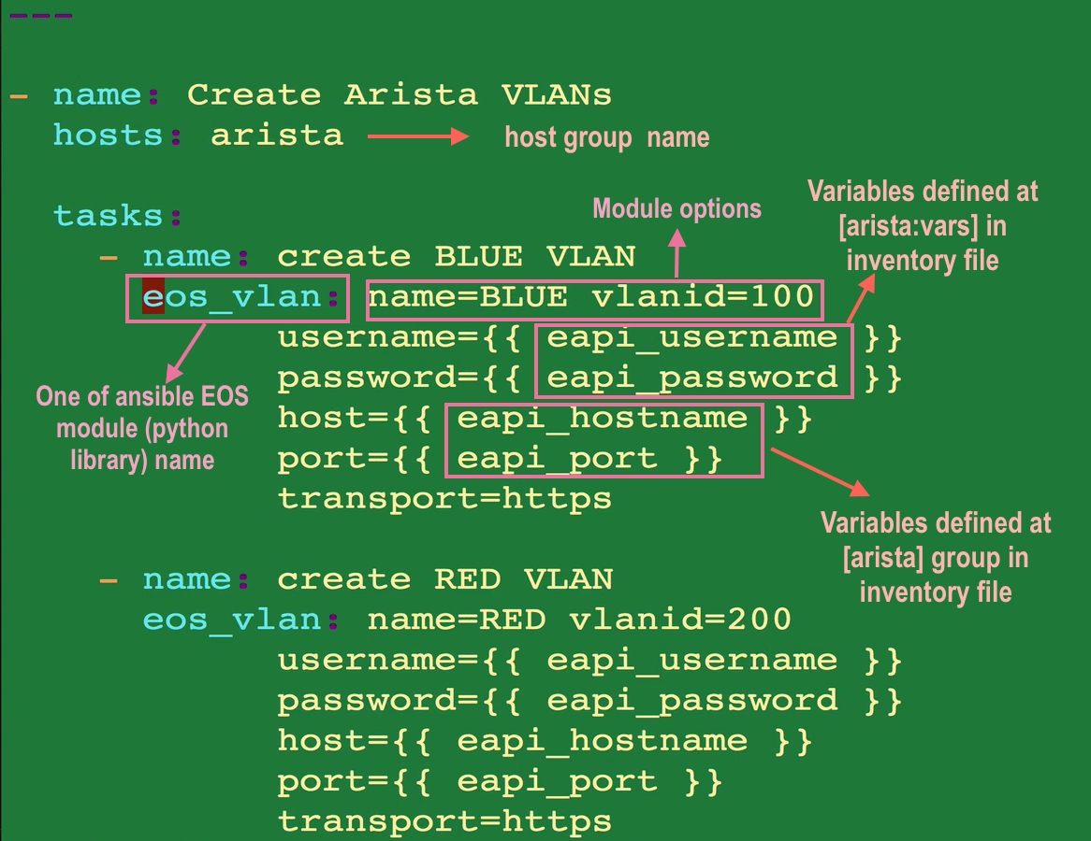

**<another playbook yaml file>**

