**Pull this repository to your local drive:**

https://github.com/githubplayer007/lightfeather

**Build jar:**

…\ lightfeather\mvn clean package

**Build docker image:**

...\ lightfeather\docker build --tag=lightfeather **.**

**Run docker image in a container:**

docker run -p 8080:8080 --name lightfeather lightfeather

**Test the two end-points with Postman:**

<http://localhost:8080/api/supervisors>

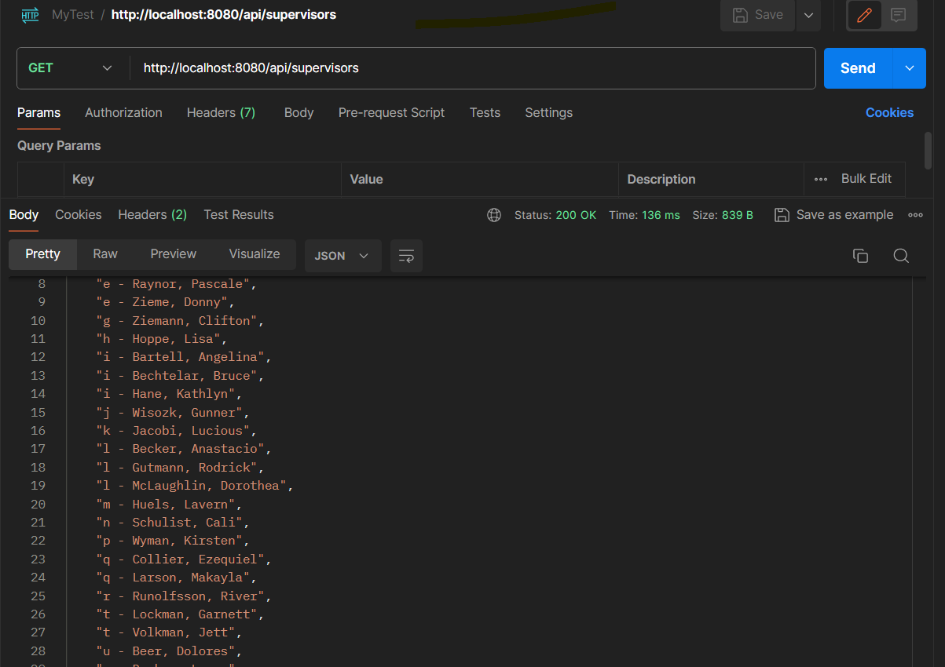

<http://localhost:8080/api/submit>

{

"firstName" : "Mark",

"lastName" : "Smith",

"supervisor" : "AAA",

"phoneNumber" : "121212121",

"email" : "sfdsf@gmail.com"

}

