**Final Paper**

Dhrumilkumar Panchal (8854214)

Prabhnoor Kaur (8856211)

Shalmonne Berson (8852748)

Shivani Nalamati (8853177)

**Capstone Project**

Digital Solutions Management 1524G, Conestoga College

Randall Kozak

01 December 2023

# Executive Summary

This project centers around Mood Predict, a cutting-edge platform harnessing advanced natural language processing (NLP) and machine learning for predicting emotional states through speech patterns. In response to the critical mental health landscape in Canada, where a significant portion of the population lacks adequate care, Mood Predict seeks to empower individuals by offering insights into their emotional well-being.

* **Purpose:** Develop Mood Predict to leverage NLP and machine learning for predicting emotional states from speech, addressing the prevalent issue of inadequate mental health care in Canada.
* **Objective:** Provide users valuable insights into their emotional well-being, enabling early intervention and personalized mental health support through an innovative platform.
* **Scope of Work:** We're building Mood Predict, a tool using language tech to guess emotions from speech. It's all about tackling mental health gaps in Canada by giving people insights for early help. This document covers what, how, and expected impact of Mood Predict.
* **Key Findings or Recommendations:** We found most folks in Canada lack enough mental health support. Our advice is to use Mood Predict to show how people feel early on, helping them get personalized help. Decision-makers, it's time to prioritize this tool to fix mental health care issues.
* **Key Metrics or Performance Indicators:** Look at how many people Mood Predict helps, how often it catches problems early, and if mental health improves overall. These numbers will tell us how well the project is doing and where we can improve it.
* **Target Audience:**  This document is for healthcare folks, policymakers, and anyone working on mental health in Canada. We're sharing info to help improve mental health care by giving a heads-up on emotions and offering personalized support.
* **Risks:** This will include Privacy challenges, User acceptance, Ethical considerations, Resource constraints, Regulations, and technology dependencies.

# List of Key words

* MoodPredict
* Emotional well-being
* Speech patterns
* NLP (Natural Language Processing)
* Machine learning
* User interface
* Mental health apps
* Real-time feedback
* Early intervention
* Web Research
* Emo Watch
* AI chatbot
* Cognitive behavioural therapy (CBT)
* Security and privacy
* Voice-enabled chats
* Meditation and breathing exercises
* Community support
* Mood monitoring
* Relaxation games
* Literature Search
* Corpus processing
* Classification methods
* Journals
* Conferences (EMNLP, CHI)
* Prospective Journals and Conferences

# Table of Content

|  |  |  |
| --- | --- | --- |
| **S.No** | **Title** | **Page No.** |
| 1 | Introduction | 6 |
| 2 | Proposed Topic | 6 |
| 3 | A discussion of factors that make a successful research project | 7 |
| 4 | Business Case | 8 |
| 5 | Web Research | 10 |
| 6 | Literature Search | 16 |
| 7 | Personas and Market Analysis | 24 |
| 8 | Ethics Research Plan | 26 |
| 9 | Results | 28 |
| 10 | Discussion and Analysis | 32 |
| 11 | Future Work | 33 |
| 12 | Conclusions | 35 |

# Introduction

In a country where mental health affects millions, MoodPredict can empower individuals by providing insights into their emotional well-being. Over 70% of Canadians with mental health issues receive inadequate care (Mental Health Commission of Canada), highlighting the need for innovative solutions like MoodPredict. With statistics revealing that approximately 1 in 5 Canadians experiences a mental health issue each year (Canadian Mental Health Association), MoodPredict's ability to predict mood from speech patterns can be transformative.

Canada's mental health care expenditure is estimated at over $50 billion annually, with a growing focus on early intervention and personalized care (Mental Health Commission of Canada). MoodPredict's predictive capabilities can drive cost-effective interventions and personalized support, significantly impacting this market.

MoodPredict is uniquely positioned to address Canada's pressing mental health concerns, improve user experiences, and contribute to an evolving market driven by the need for better emotional well-being support. With its potential to impact lives and enhance business strategies, MoodPredict stands as a transformative solution with statistics and numbers to back its promise.

# Proposed Topic

MoodPredict, a pioneering platform harnessing advanced NLP and machine learning, holds significant promise in the Canadian market. Canada places a high value on mental health and well-being, making MoodPredict's application in emotional intelligence, mental health support, and user experience enhancement particularly relevant. With a growing demand for such solutions in the Canadian market, it is well-positioned to address the nation's needs while contributing to improved emotional well-being and user interactions in various sectors.

The development of a mood prediction platform using speech pattern analysis is highly relevant in Canada due to the significant impact of mental health issues. Approximately 20% of Canadians experience mental illness in their lifetime, with related costs exceeding $51 billion annually. Such a platform could aid in the early identification of mood changes, support remote monitoring, reduce stigma, and enhance mental health awareness and accessibility to services, making it a valuable tool in addressing Canada's mental health challenges.

# Factors impacting the success of the Project

Among the three ideas presented, the first objective related to mental health stands out as particularly impactful and essential. This objective addresses a critical and growing concern: mental health. The use of advanced machine learning and natural language processing (NLP) techniques to predict emotional states from speech patterns has the potential to revolutionize mental health support and monitoring.

Following factors were considered for the success of the project:

* **User Engagement**: The platform's effectiveness depends on user engagement and adherence to recommended activities. Providing a user-friendly interface and personalized experiences can enhance engagement.
* **Data Privacy and Security**: Ensuring robust data privacy measures is crucial to build trust among users. Strict security protocols and transparent communication about data handling practices are essential.
* **Accuracy of Predictive Models**: The success of the platform relies on the accuracy of predictive models. Continuous refinement and updates based on real-world data can enhance the precision of mood predictions.
* **Accessibility and Inclusivity**: Making the platform accessible to a diverse user base, considering different demographics and abilities, is important. This can involve addressing language barriers, cultural sensitivities, and ensuring compatibility with various devices.
* **Integration with Mental Health Professionals**: Collaborating with mental health professionals and integrating their expertise into the platform can improve its overall effectiveness. This ensures a holistic approach to mental health support.
* **Regular Updates and Improvements**: Staying abreast of the latest research and technology trends is essential. Regular updates to the platform, incorporating user feedback, and implementing technological advancements can contribute to sustained success.
* **Community Support**: Building a supportive community within the platform can foster a sense of belonging and encouragement. Features like forums or peer support mechanisms can enhance the overall user experience.
* **Education and Awareness:** Promoting mental health awareness and educating users about the platform's capabilities can encourage participation and help users make the most of the resources available.

# Business Case

In a country where mental health affects millions, MoodPredict can empower individuals by providing insights into their emotional well-being. Over 70% of Canadians with mental health issues receive inadequate care (Mental Health Commission of Canada), highlighting the need for innovative solutions like MoodPredict. With statistics revealing that approximately 1 in 5 Canadians experiences a mental health issue each year (Canadian Mental Health Association), MoodPredict's ability to predict mood from speech patterns can be transformative.

Canada's mental health care expenditure is estimated at over $50 billion annually, with a growing focus on early intervention and personalized care (Mental Health Commission of Canada). MoodPredict's predictive capabilities can drive cost-effective interventions and personalized support, significantly impacting this market.

MoodPredict is uniquely positioned to address Canada's pressing mental health concerns, improve user experiences, and contribute to an evolving market driven by the need for better emotional well-being support. With its potential to impact lives and enhance business strategies, MoodPredict stands as a transformative solution with statistics and numbers to back its promise.

**Problem Statement**

Understanding and managing emotions is crucial for mental health and well-being. However, people often struggle to accurately recognize and express their emotions. MoodPredict addresses this challenge by offering a data-driven solution that can analyze speech patterns to predict emotional states, providing individuals with a greater understanding of their emotions and promoting emotional wellbeing.

**Key Features**

1. **Speech Analysis:** MoodPredict employs state-of-the-art NLP and machine learning models to analyze speech patterns, including tone, pitch, cadence, and word choice.
2. **Real-Time Feedback:** Users can receive real-time feedback on their emotional state through a user-friendly interface, making it a valuable tool for personal development.
3. **Applications:** MoodPredict can be integrated into mental health apps, customer service platforms, and virtual assistants to enhance emotional intelligence and user experiences.   
     
   **Benefits**
4. **Improved Mental Health:** MoodPredict can assist individuals in recognizing and managing their emotional well-being, potentially reducing stress, anxiety, and depression.
5. **Enhanced User Experiences:** Companies can leverage MoodPredict to create more empathetic and responsive user interfaces and customer interactions.
6. **Early Intervention:** In mental health contexts, MoodPredict can provide early warning signs of emotional distress, allowing for timely intervention and support.

# Web Research

**Emo Watch:** We would like to refer to our application as Emowatch.

Many applications in the market offer mental health services and have similar functionality as Emowatch. Some of them are listed here: Youper, Wysa, Talkspace, reflect, etc

### 1) Wysa: Mental Health Support

[**https://www.choosingtherapy.com/wysa-app-review/**](https://www.choosingtherapy.com/wysa-app-review/)

**Written by: Catlin Bell, Published: April 27, 2022**

Wysa is an application that uses an AI chatbot that helps in Cognitive behavioral therapy(CBT). It also provides key features such as Yoga, Meditation, and personalized journals and therapists. It offers both subscription premium access and free access for a few features.

**Ratings** 4.9-star from 9,500+ reviews in the Apple App Store and a 4.8-star rating from 115,000+ reviews in the Google Play Store.

Currently, the application has 6,002,452 users who are actively communicating with Wysa.

**Reviews:** The application has excellent ratings, but it still has many negative reviews that talk about the application’s main feature, the chatbot and how it could not understand many things the user is trying to explain.

**Security and privacy:** Wysa will not ask the customer to create an account or give their email address. All the customer needs to do is provide them with a pet name to communicate with the chatbot.

**Key features:**

1. **Voice-Enabled Chats:** Wysa allows users to interact with the chatbot using their voice.
2. **Personalized resolutions:** IT provides personalized responses based on user conversations.
3. **Thoughts journalizing:** They can record their thoughts and feelings; this helps them to do self-reflection.
4. **Meditation and breathing exercises:** Wysa offers meditation sessions that help in relaxation. It also provides breathing and relaxation exercises that allow them to relieve stress.
5. **Therapist:** Wysa offers a therapy session on a monthly and daily basis, which is paid.
6. **Customized feedback:** The AI chatbot can offer individualized feedback and insights from user interactions and emotional monitoring.  
     
   **Pros of Wysa:**
7. Support for mental health based on CBT
8. Yoga, meditation, and access to treatment are some of the highlights.
9. Possibilities for both free and paid subscriptions.
10. Positive user reviews.
11. Voice-activated chat.
12. Customized criticism.

**Cons of Wysa:**

1. Limits of chatbots.
2. Expensive counseling sessions.
3. Little information on privacy and security.

### 2) Youper-CBT therapy chatbot

[**https://www.youper.ai/how-it-works**](https://www.youper.ai/how-it-works)

**Ratings:** In the Apple App Store, Youper boasts an impressive rating of 4.7 stars based on feedback from over 14,000 users. Similarly, the Google Play Store maintains a solid 4.2-star rating, with reviews exceeding 49,000.

**Business Model:** Youper’s follows a freemium business model, i.e., it offers both free and premium access to the app.

**Key features:**

1. **It uses NLP (natural language processing) to assist users**
2. **AI chatbot:** The chatbot helps people with text-based conversations. It responds with empathy.
3. **Quizzes:** Youper helps users with mental health assessments and quizzes in order to gain knowledge on their health
4. **Community support:** The users can get help from communities to develop their mental health condition.
5. **Reports:** Youper generates mood reports by understanding the user’s emotions. These reports can be tracked and compared. It also follows moods and emotions.
6. **Meditation exercises:** It offers some meditation exercises that help with relaxation**.**

**Pros of Youper:**

1. high reviews from users in app stores.
2. Both free and paid access choices.
3. A chatbot with empathy is enabled by NLP.
4. Mental health evaluations.
5. Participation in society.
6. Mood monitoring statistics.
7. Relaxation and meditation activities

### 3) Talk Thru- Mental health therapy AI chatbot:

It offers a choice between AI-driven support and access to licensed human therapists, all within a safe and convenient digital environment.

**Key features:**

* **AI chatbot:** an artificial intelligence that uses empathy and helps with therapy. Users can use this 24/7 and talk about their feelings.
* **Personalized environment:** The app creates a customized environment using clinically backed techniques to improve users' moods.
* **Mood analysis**: Talkthru conducts meticulous mood analysis to understand users' anxiety and uncover depression, stress, and underlying concerns.
* **Pricing:** It offers three subscriptions: AI therapy, Standard, and Elite, which can be taken monthly or weekly.
* **Self-care therapy:** The app provides personalized self-care treatments backed by scientific evidence. These help empower users to manage anxiety, improve sleep, handle difficult conversations, and enhance productivity. It's like having a personal coach in your pocket.
* **Human therapist:** Talkthru provides access to a team of highly experienced and licensed human therapists. Users can schedule quick appointments with human therapists who are highly qualified.

[**https://talkthru.me/**](https://talkthru.me/)

**Pros:**

* **24/7 Accessibility:** Offers round-the-clock support.
* **Choice of AI or Human Therapists:** Provides flexibility in therapist selection.
* **Evidence-Based Therapies:** Offers science-backed exercises.
* **Safe and Confidential:** Creates a secure space for discussions.
* **Convenience:** easily accessible on mobile devices.

**Cons:**

* **Human Connection:** It may lack the depth of human connection.
* **Subscription Cost:** Potential financial barrier
* **Privacy Concerns:** Privacy of Personal Data
* **Limited Scope:** This may not suit complex issues.
* **Technology Dependence:** Risk of over-reliance on the App

## Emo Watch:

**What makes our application better than the others:**

1. **Speech Analysis:** Speech analysis using NLP, machine learning, and speech to text converters
2. **Dashboards:** This includes history, medical records for references, and progress graphs.
3. **Real-Time Feedback:** Users can receive real-time feedback on their emotional state through a user-friendly interface, making it a valuable tool for personal development.
4. **Advanced mood tracking:** recording and recording data such as sleep patterns, heart rates, and diet
5. **Videos:** YouTube links to funny, yoga, and motivational videos.
6. **Relaxation games:** Our application would offer gamessuch as puzzles and coloring games.
7. **Recommendations:** The app will recommend therapy sessions based on the patient's mental status.
8. **Real-time Emotional Support:** AI-powered conversational agent that can provide immediate emotional support and uses empathy to respond.
9. **Certified therapy:** The app works as a two-sided market, and there will be certified therapists whom people can book appointments with.

# Literature Search

This part of the research was done after investigating technical journals, including technical journals and business journals, for relevant and helpful methodologies.

## Referred Conference Proceedings:

### **ACL (Association for Computational Linguistics):**

1. **ACL Annual Meeting:** The ACL Annual Meeting is the flagship conference in the field of NLP and Computational Linguistics. It covers a wide range of topics related to language processing and AI.
2. **Proceedings:** The proceedings of ACL conferences include a wealth of research papers, posters, and presentations on various NLP topics. These proceedings are a valuable resource for researchers and practitioners in the field. They often include papers on machine translation, sentiment analysis, named entity recognition, syntactic and semantic parsing, dialogue systems, and more.
3. **ACL Anthology:** The ACL Anthology is a digital archive of ACL conference proceedings, which spans several years. Researchers can access papers, datasets, and resources related to NLP and language processing. It serves as a comprehensive repository of knowledge in the field.
4. **Workshops and Tutorials:** ACL conferences also host a variety of workshops and tutorials, covering specialized topics in NLP. These events provide opportunities for in-depth discussions and hands-on learning.

### **NAACL (North American Chapter of the Association for Computational Linguistics):**

1. **NAACL Annual Conference:** NAACL, a regional chapter of ACL, hosts its own annual conference with a focus on NLP research.
2. **Proceedings:** Similar to ACL, NAACL's proceedings include research papers, presentations, and posters on a wide range of NLP topics. Researchers present their work in areas such as machine translation, dialogue systems, discourse analysis, and more.
3. **Student Research Workshop:** NAACL often includes a Student Research Workshop where young researchers can present their work and receive feedback from the community. This is an excellent platform for graduate students and early-career researchers to showcase their contributions.
4. **Demos and Exhibitions:** NAACL conferences may feature demonstrations of NLP technologies and exhibitions by companies and organizations working in the field.

### **EMNLP (Conference on Empirical Methods in Natural Language Processing):**

1. **Overview:** EMNLP is a premier conference in the NLP community that focuses on empirical and data-driven research methods. It provides a platform for researchers to present and discuss their work in various aspects of NLP.
2. **Proceedings:** The proceedings of EMNLP conferences feature a wide range of research papers covering topics such as machine learning for NLP, neural network models, sentiment analysis, text generation, and more. EMNLP is known for its emphasis on empirical evaluation, which means that papers often include experimental results and thorough analysis.
3. **Resources:** In addition to research papers, EMNLP provides valuable resources to the NLP community. These resources include shared datasets, evaluation metrics, and benchmarks that facilitate research in the field.
4. **Workshops and Tutorials:** EMNLP hosts workshops and tutorials on specialized topics within NLP. These events allow researchers to dive deeper into specific areas of interest and learn about the latest techniques and advancements.

### **CHI (Conference on Human Factors in Computing Systems):**

1. **Overview:** While CHI is not solely an NLP conference, it is a prominent conference in the field of Human-Computer Interaction (HCI). CHI focuses on the design and usability of interactive systems, which often includes applications related to natural language processing.
2. **Proceedings:** The CHI proceedings include a diverse range of research papers and presentations on HCI topics. Some of these papers may discuss the design and evaluation of NLP-based interfaces, chatbots, and interactive language systems. Researchers often explore how to make NLP technologies more user-friendly and effective.
3. **Design for Well-being:** CHI conferences often feature research related to the impact of technology on mental health and well-being. This can include studies on the use of chatbots or text-based interventions to provide emotional support or therapy.
4. **Interactive Demonstrations:** CHI conferences may include interactive demonstrations where researchers showcase their NLP-related applications and systems. This provides a hands-on experience for attendees to see how NLP technologies can be used in practical, user-friendly ways.
5. **Cross-Disciplinary Collaboration:** CHI brings together researchers from various fields, including computer science, psychology, design, and linguistics. This interdisciplinary approach can lead to innovative solutions and insights into the design of NLP-driven systems.

## **Use of NLP and Machine Learning in Mental health analysis**

In the preprocessing phase, various methods are employed to prepare the textual data for analysis. These methods can be categorized into different types:

* Word-Level Methods:
  1. Lemmatization: Reducing words to their base form (e.g., singular form for nouns).
  2. Part of Speech (POS) Tagging: Labeling words based on their grammatical function.
  3. cTAKES and CUIs: Mapping words or noun phrases to concepts in ontologies (e.g., UMLS) for precise semantics.
  4. tf-idf: Assigning a value to words based on their significance in characterizing documents or classes.
  5. Embedding: Representing words as vectors in a high-dimensional space.
  6. Named-Entity Recognition: Identifying whether a word or phrase is a named entity (e.g., a person's name).
  7. LIWC: Linguistic Inquiry and Word Count, a tool for analyzing text content for social and psychological insights.
* Higher Structure Methods:
  1. N-grams: Treating sequences of n subsequent words as entities and measuring their frequencies.
* Sentence/Document-Level Methods:
  1. SentiAna: Analyzing sentiments or emotions in text.
  2. LDA and LSA: Calculating sets of topics, determining their significance in documents, and providing representative words for each topic.  
       
     The most used preprocessing methods in NLP include lemmatization, part-of-speech tagging, n-grams, and tf-idf. In the context of medical texts, methods like CUI extraction (utilizing cTAKES and CUIs) are prominent. The use of word embedding techniques is mostly associated with neural networks and represents a more recent development. Lastly, some methods, such as topic detection, named-entity recognition, and sentiment or emotion analysis, are primarily applied to free-text data.  
       
     After research from technical papers and conference proceedings we have found that applications of Machine Learning (ML) and Natural Language Processing (NLP) in the field of mental health can be categorized along several key dimensions:  
       
     1.  **Corpus Type:** These applications often rely on textual data, which can come from various sources, including electronic health records (EHRs), Psychological Evaluation Reports, Coroner Reports, social media platforms (e.g., Twitter, Reddit), or transcribed patient interviews.  
       
     2.  **Corpus Processing:** Depending on the nature of the corpus, different processing techniques are employed. For EHRs, medical terms are extracted and linked to Unified Medical Language System (UMLS) Concept Unique Identifiers (CUIs). In contrast, for other textual data sources, general NLP methods are used to derive features that are then analyzed using ML algorithms.  
       
     3. **Classification Methods:** ML techniques such as decision trees, support vector machines, conditional random fields, random forests, and neural networks (NNs) are commonly used for classification tasks in mental health applications.  
       
     4. **Goal:** The primary goal of these applications is often hypothesis validation or studying the behavior of specific patient populations.  
       
     This review covers the wide range of corpora used in mental health research, from massive social media datasets to smaller clinical notes. It discusses the application of Natural Language Processing (NLP) techniques, including UMLS CUI extraction from Electronic Health Records (EHRs) and general NLP methods for feature derivation in Machine Learning (ML). NLP and ML tools are valuable in addressing data challenges, offering insights into mental health, and enabling semi-automated systems for diagnosis and severity estimation. However, ethical and legal concerns regarding data consent and patient autonomy arise when using AI for predictive analysis in mental health. Overall, the review explores the technical aspects and potential contributions of these methods to clinical practice in mental health research.

# Prospective Journals and Conferences

## Journals:

### 1. Journal of Medical Internet Research Journal (JMIR)

**Mission:** To focus on healthcare informatics and eHealth. It is a good option for a study analyzing the use of technology in mental health because it publishes research on these topics.

**Benefits:** A large audience in the medical and informatics sectors, relevance to the healthcare industry, and a strong internet presence.

**Challenges:** Because of its popularity, publishing is very competitive.

### 2. International Journal of Artificial Intelligence in Education (IJAIED)

**Mission:** To apply AI principles to the field of education. This journal can be appropriate if the study involves educational components of mental health analysis.

**Benefits:** A niche audience, applicability to the education industry, and the chance to affect the subject of AI in education.

**Challenges:** Ensuring the work aligns with the journal's unique educational goal is challenging.

## Conferences:

### 1. Conference on Empirical Methods in Natural Language Processing (EMNLP)

**Mission:** EMNLP is one of the most prestigious NLP research conferences. Its broad coverage of NLP subjects makes it applicable to text-based analyses of mental health.

**Benefits:** Exposure to the NLP community, the possibility for cooperation, and a venue for showcasing cutting-edge NLP research.

**Challenges:** Because of its selectivity, there is fierce rivalry for admittance.

### 2. International Conference on Health Informatics (HEALTHINF)

**Mission:** To examine how informatics and healthcare interact. This meeting can be pertinent if the research stresses the healthcare implications of mental health analysis.

**Benefits:** Exposure to the healthcare informatics community, multidisciplinary cooperation possibilities, and applicability to healthcare applications are all advantages.

**Challenges:** Meeting the strict requirements for healthcare-related research set by the conference.

**\*\*\*Research Tracker is included in the Appendix\*\*\***

# Personas and Market Analysis

## Target Market:

The primary target market for the mental health analysis platform includes individuals seeking accessible and technology-driven solutions for emotional well-being. The secondary market comprises mental health practitioners and healthcare institutions aiming to integrate innovative tools into their practices.

## Competitive Landscape:

The mental health tech industry is competitive, with various applications offering a range of services from mood tracking to therapy sessions. Notable competitors include established mental health apps, AI-driven platforms, and those specializing in natural language processing.

## Market Trends:

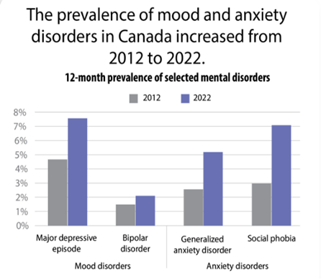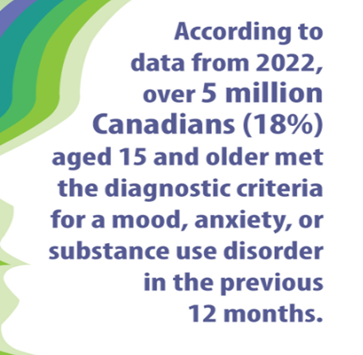

* Growing acceptance of technology in mental health care.
* Increasing demand for personalized and data-driven well-being solutions.
* Emphasis on real-time emotional support and mood tracking.

The following are the user personas we identified:

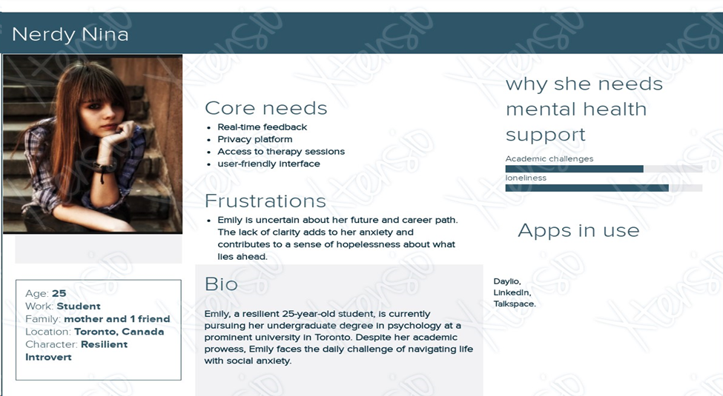

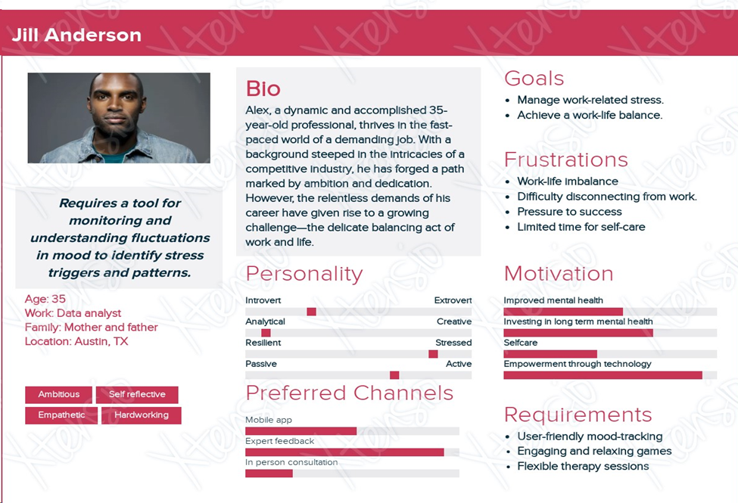

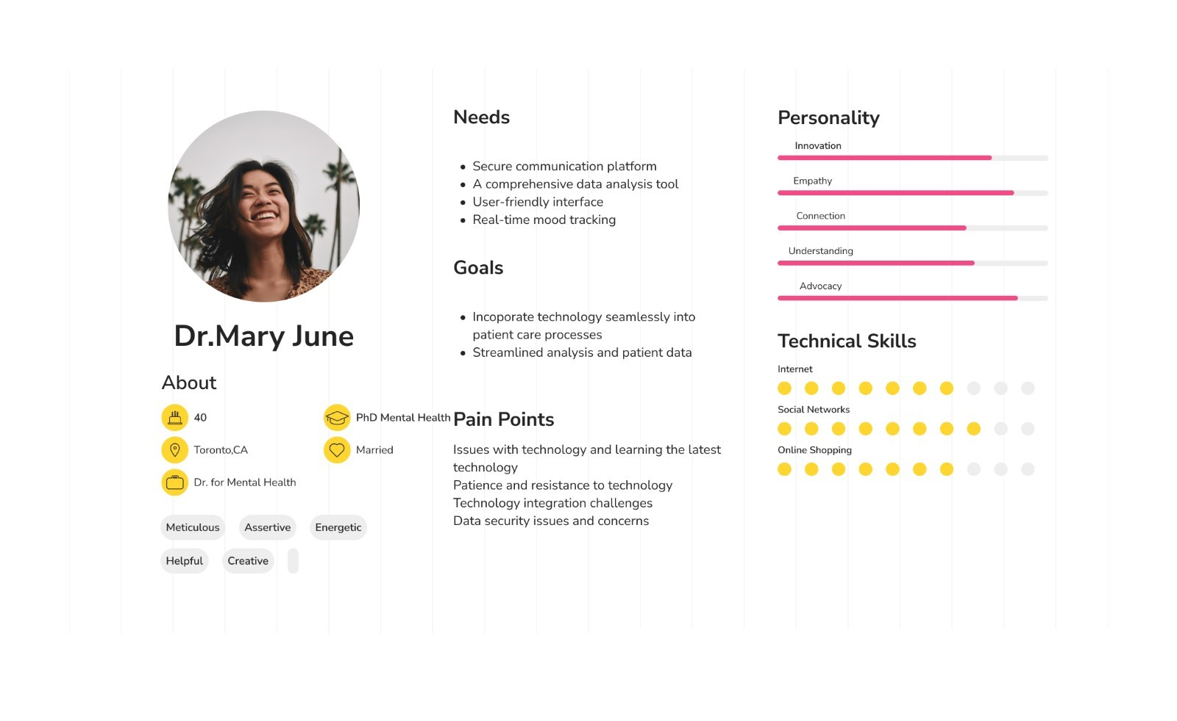

# Ethics Research Plan

The project uses natural language processing (NLP) to examine mental wellness. Sensitive data must be gathered and analyzed for this, which calls for careful consideration of ethical considerations. This document describes any ethical issues that could arise and suggests a strategy for resolving them in keeping with the Government of Canada Guidelines.

## Ethical Concerns

With the research, on MoodPredict following ethical concerns can be surfaced:

1. **Research on Human Subjects**
2. **Data Privacy and User’s Consent**
3. **Ethics of the System of Future**

Analyzing data from human beings is part of the research, which raises questions regarding permission, privacy, and confidentiality. Gaps could rise from the different levels of being informed for the participants using the product. Staying up to date with technology and evolving regulations is tiresome for many which puts focus and consideration on ethical promotion and marketing of MoodPredict, to avoid any exaggeration of its capabilities and benefits to prevent raising unrealistic expectations.

Even though, maintaining anonymity is crucial since the research contains potentially sensitive information about people's mental health. It is essential to ensure that user data is securely stored, and that privacy regulations and best practices are adhered to, such as obtaining informed consent. Subjects must be entirely aware of how their data would be used and should have the option to provide or withdraw consent through transparent communication. Some hesitancy to use such a platform due to the stigma associated with mental health can be solved by creating a safe and non-stigmatizing environment for subjects. As MoodPredict is expected to be integrated with third-party applications and services, ethical concerns may arise regarding how those services use the data.

The construction and usage of the NLP system must be done ethically, considering any biases in the data, and ensuring the technology is utilized correctly. Machine learning models can inherit biases from the data they are trained on, which brings in the need for addressing the potential bias in the model and data to ensure that the platform's predictions are fair and do not discriminate against certain groups. When providing real-time feedback on emotional states, the platform needs to be held accountable for any errors or misinterpretations that might affect users' well-being. While the platform may offer early intervention, it should be used with caution, as overreliance on technology for mental health could potentially neglect the human element of emotional support.

# Results

At its core, this project strives to design and implement a sophisticated platform that can provide precise and timely predictions of an individual's emotional state by analyzing their speech-to-text patterns. With the goal of creating a valuable tool for both mental health professionals and individuals, this platform aims to monitor and support emotional well-being.

The list of features to be included in our software system is listed as follows:

● **Speech Analysis:** Speech analysis using NLP, machine learning, and speech to text converters

● **Dashboards:** This includes history, medical records for references, and progress graphs.

● **Real-Time Feedback:** Users can receive real-time feedback on their emotional state through a user-friendly interface, making it a valuable tool for personal development.

●  **Advanced mood tracking:** recording and recording data such as sleep patterns, heart rates, and diet

● **Videos:** YouTube links to funny, yoga, and motivational videos.

● **Relaxation games:** Our application would offer gamessuch as puzzles and coloring games.

● **Recommendations:** The app will recommend therapy sessions based on the patient's mental status.

● **Real-time Emotional Support:** AI-powered conversational agent that can provide immediate emotional support and uses empathy to respond.

● **Certified therapy:** The app works as a two-sided market, and there will be certified therapists whom people can book appointments with.

**Website for the Project:**

<https://mentalhealthusingmoodpredict.mydurable.com/>

The work till now

|  |  |  |  |  |
| --- | --- | --- | --- | --- |
|  | ***Emily (Student)*** | ***Alex (Working Professional)*** | ***Dr. Patel (Psychologist)*** | ***Weighted Sum*** |
| ***Weight ( %)*** | 80 | 70 | 50 |  |
| ***Weight ( 0 to 1)*** | 1 | 0.5 | 0.4 | 1.9 |
| ***Speech Analysis*** | 4 | 3 | 4 | 11 |
| ***Real-time Feedback*** | 5 | 2 | 4 | 11 |
| ***Avance Mood tracking*** | 5 | 2 | 2 | 9 |
| ***Relaxation Games*** | 5 | 5 | 1 | 11 |
| ***Recommendations*** | 5 | 2 | 4 | 11 |
| ***Real-time Emotional Support*** | 5 | 5 | 2 | 12 |
| ***Certified Therapy*** | 4 | 4 | 1 | 9 |

**Discussion and analysis:**

Several noteworthy findings have surfaced in reviewing and discussing the outcomes of our mental health app development project.

•**User engagement and customization:** Our app's development prioritized user engagement. The evolution from a wide array of emotional responses to personalized feedback highlights the significance of tailoring the user experience. This iterative process has been successful, underscoring the effectiveness of providing personalized emotional support.

•**User interface designs:** In our project, the development of user interface designs has been crucial. We started by focusing on making it easy to use, and we are planning to improve the Experience based on user feedback. By adding gamification elements and ensuring smooth transitions on the dashboard, we're dedicated to improving the user experience with intuitive design.

•**Data security measures:** securing user data, especially in handling sensitive mental health information. To do this, we would be working closely with legal policies. We will try to implement robust data encryption and ensure users are informed about privacy rules. This builds trust, ensuring we handle data ethically and responsibly.

•**Integration with practitioner:** We know that connecting our platform with mental health professionals will bring challenges since it’s a two-way platform and chances for growth. Our commitment is evident in facilitating training sessions, creating flexible features, and addressing modification issues. This journey emphasizes the importance of blending technological innovation with established practices.

**Future work:**

Our future work includes potential improvements or extensions of the project. And through this, we aim to maximize the impact within the existing scope.

**•Internal testing:** Before making our app public, we must prioritize internal testing and feedback. Testing all features within our custom environment will help refine the application further.

•**Incorporating wearables:** If the app succeeds, we can work on wearable devices to gather additional data for mood tracking. Incorporating physiological indicators could provide more insights into users' emotional well-being.

•**Machine Learning for Personalized Recommendations:** Machine learning algorithms can be added to provide personalized recommendations based on users' usage patterns, preferences, and mood data. This can further enhance the customization aspect of the app.

•**Educational Modules and Resources:** We will add educational modules within the app to provide users with insights into mental health topics, coping mechanisms, and self-help strategies. This can empower users to take a proactive approach to their mental well-being.

•**Expansion:** We can consider expanding features within the project's original scope. This could involve adding more customization options, fine-tuning existing features, or introducing new elements to enhance the overall user experience.

•Documentation and knowledge transfer: In the spirit of a custom project, investing in comprehensive documentation and knowledge transfer within the team is crucial. This ensures that the valuable insights gained during the development process are well preserved and can be applied to potential future projects or adaptations.

**Conclusions**

Collaborating as a cohesive team has proven instrumental, infusing our endeavors with enthusiasm and a unified purpose. At the core of our project is the creation of a platform that extends beyond mere emotional analysis, evolving into a steadfast companion in the realm of mental well-being. Our refined project description accentuates our commitment to developing technology that not only comprehends but also supports users on their individual journeys.

Throughout the course of our project, our implementation plan flexibly adapted to evolving goals, demonstrating our ability to tackle challenges head-on. Challenges such as seamlessly integrating real-time emotional support and ensuring robust data security underscored our adept problem-solving and collaborative skills. The tangible results showcased on our website echo the vibrancy of our project, with compelling screenshots and user personas spotlighting the platform as an effortlessly accessible tool.

The incorporation of multilingual support and contextual analysis enhances the relatability and universal inclusivity of our platform. Envisaging commercialization, we aspire for our creation to sustain itself and significantly enhance users' well-being. Our ambitions extend beyond the project's conclusion, with a desire to share the insights gained during our journey, aspiring to benefit others in the process.

This assignment signifies the culmination of a chapter marked by collaboration, adept problem-solving, and a sincere belief in the transformative potential of our Mental Health Analysis Platform. Serving as a stepping stone to future chapters in our shared professional journey, this assignment has deepened our understanding of the critical importance of mental health.

As a suggestion for future writers, we advocate for a more profound exploration of the societal impact of mental health technology, placing emphasis on ethical considerations and the potential for positive change. This persuasive approach can further underscore the significance of our Mental Health Analysis Platform within the broader context of well-being and technology. Here's to the ongoing success of our collective efforts and the positive impact we aim to foster in mental health support through our platform.

**Appendix**

# Search Table

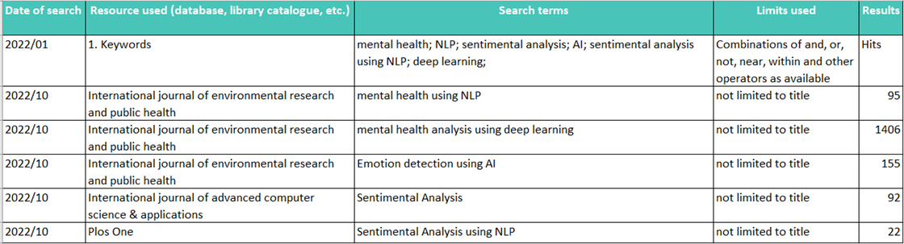

### DATABASE

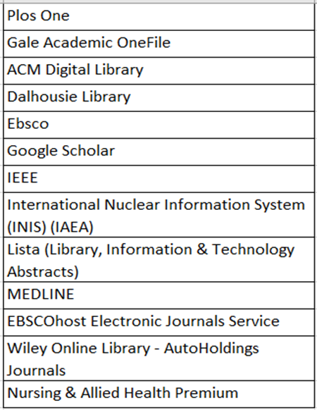

### SUBJECT INVENTORY

|  |  |
| --- | --- |
| **Keyword** | **Results** |
| Sentimental* | 12 |
| Sentimental Analysis | 8 |
| Natural Language* | 1 |
| Mental Health* | 150 |
| Mental Health Aid | 46 |
| Sentiment Analysis | 9 |
| Predictive Analysis | 15 |

**References:**

1. Low, D. M., Bentley, K. H., & Ghosh, S. S. (2020). Automated assessment of psychiatric disorders using speech: A systematic review. Laryngoscope Investigative Otolaryngology, 5(1), 96–116. <https://doi.org/10.1002/lio2.354>
2. CALVO, R. A., MILNE, D. N., HUSSAIN, M. S., & CHRISTENSEN, H. (2017). Natural language processing in mental health applications using non-clinical texts. Natural Language Engineering, 23(5), 649–685. <https://doi.org/10.1017/S1351324916000383>