**Process**

1.What is process

->A process is a set of instruction which executes in the memory. It is created in the memory when a program or command is executed.

Every process is identifies by a unique no i.e PID which is process ID

Several processes are stored at boot time and which are running at background call daemons

The Linux kernel is used to communicate with the program by their process ID’s

Daemons is a process running in the background initd=1pid , system=1pid

A.ps

#ps:It just a snap shot of the current status of the processes its gives only one terminal not all the terminal info

#top: using top command we can monitor the processes continue By default every 3 sec it will refresh data

>processes are run generally on linux.

They are having three types

>Interactive Processes

>System Processes or daemons

>Automatic or batch

1)Interactive Processes:-

interactive processes are those processes that are invoked by a user and can interact with the user. for eg #vi or #vim are the interactive processes

2)System Processes or daemons:-

daemons is refer to processes that are running on the computer and provide service but do not interact with the console.

Most server software is implemented as a daemons ex.samba,apache,sshd are the daemons

3)Automatic Processes:-

Automatic Processes are not connected to terminal and queued inta a spooler area where they wait executed FIFO

At certain date & time : done using the “at ” command

**Stages of the process**

Running [R] :-- process running on cpu or waiting to run on cpu

Sleeping

A] [S]: Interruptiable process waiting for particular condition to satisfied once satisfied then returned to running state (waiting fir I/O)or need user input

b)[D]:-Non interruptible , not respond to any signal

c)[K]:-Killable : respond to kill signal

3)Stopped [T]:-stopped by user temporarily

Suspend :- debugged process also temporarily stopped or suspend

3)Parent Process:-

The process which start or creates another is called parent process

Initd process is the parent process to all the running processes in the linux system

The parent processes is identified by ppid(parent process id)

4)Child Process:-

A process which started or created by the parents process is called child processes and identifies by pid userful #ps command

#ps -a [It display all the terminal process info ]

#ps -au[It display all the with user names]

#ps -aux[It display all the including background process with username]

*To communicate the process

#kill:-it will kill the processes with pid

#pkill:-It will kill the process with the username

#kill -l command [List all the signals with no and there are 64 signals]

5)Signals:-Signals are a way of sending simple message to processes

6)Signals in process management:

1-i-SIGHUP-To reload

2-ii-SIGINT-To interrupt from the keyboard.

3-iii-SIGQUIT-to quit the process from keyboard

9-iv-SIGKILL-to kill the process forecefully

15-v-SIGTERM-wait for completing the process and then terminates

18-vi-SIGCONT-to continue or resumes the process If it is stopped

19-vii-SIGSTOP-to terminate the process

20-viii-SIGHTSTP-to stop the process

**Commonly used signals are 1,9,15,20**

The default signals is 15 [gracefully]

#kill – signal process id

#kill -9 1219

9)Zombie process:-

Defaullent process

When we start the parent process 🡪start some child processes🡪After some time the child process will be died because of not knowing the parent processes

The parent processes (which are running without child process) is called zombie process

10)Set priority for a process :-

Process priority means managing processor time processor or cpu – multiple task at the same time

In Linux we can set guidelines for the cpu to follow when it is looking all tasks.these guidelines are called niceness or nice value

**Nice Value:**

The Linux nice value scale goes from -20 to 19

Nice value is higher number like is the task will be set to the lowest priority and the cpu

The default nice value is 0 zero

There are two options to reduce / increase the value of a process nice or renice

Eg: nice -n nice value range from -20 to 19

#ps -elf [to check the nice value for that command]

?(Question mark ) If it is appered at tty column indicates background process

#ps -ef [display total processes into with parent process id ppid]

#ps -p <process id > [display the process name If we know the process id ppid]

#pidof<process name>(too see the process id specified process)

#pidof initd[see the processes id of the init process]

#pstree [to display the parent and child process structure in the tree structure]

#ps -u <username> (To display all the process of specified names)

#ps -G <group name> for a particular group

#ps -G pid , comm,%mem,%cpu [display all id,command,%memory,%cpu utilization]

#ps -Ao pid,comm %mem %cpu [display same but including some more info]

#ps -aux | grep firefox [to check whether the firefox is running or not]

#pgrep -u username [All the process id’s only for user]

#ps -elf to check the the Nice value

#renice <nice value (-20 to 19)> <pid>

Top command :

--top command is a to see the processes status and statuses information continuously until we quit by pressing “q”

By default top command will refresh the data for every 3 sec

Running process showing bellow

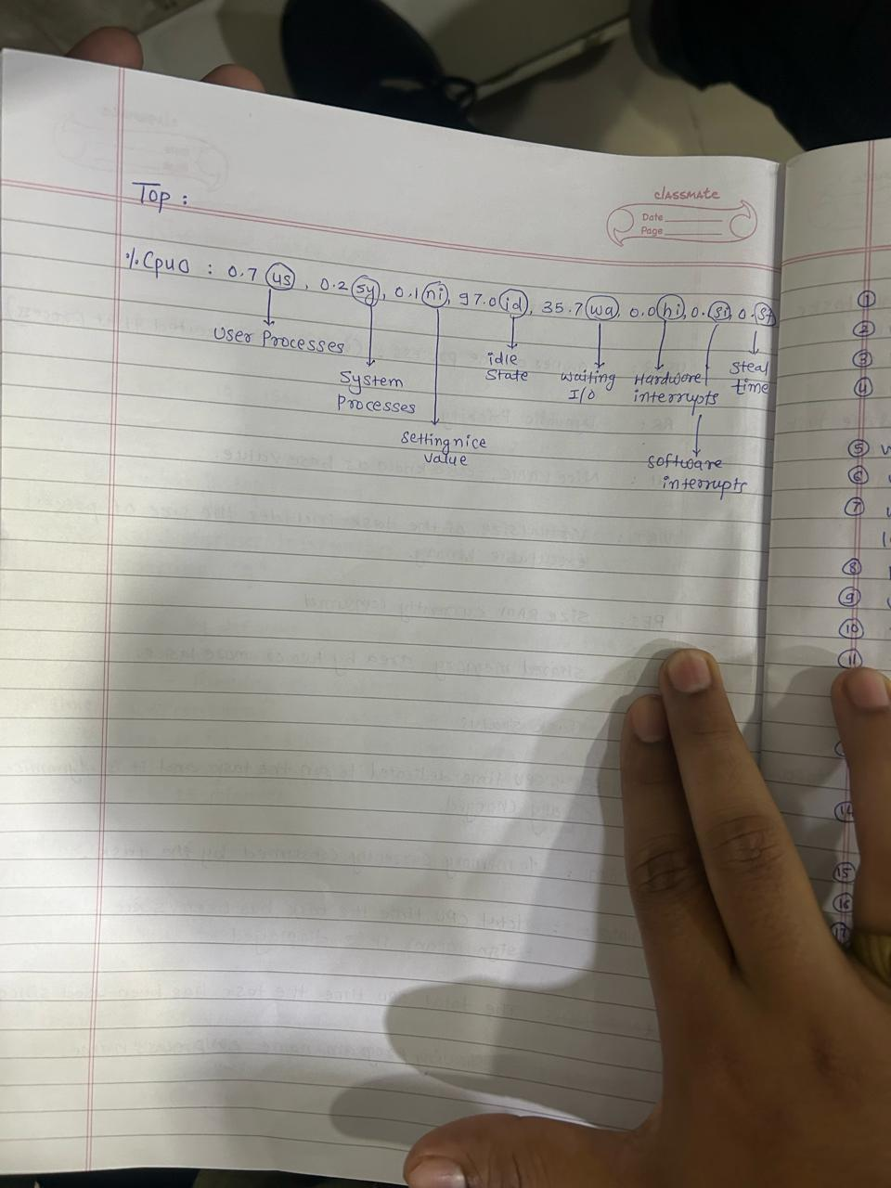

1st line :-

Current time “up 1 day” shows how long the system has been up for “3 user” how many users login users “load average : 0.01,0.00,0.23” the load average of the system 1,5,15 minutes

2nd line:-

No of process and their current status

3rd line:-

CPU utilization details like % of the user processes % of the system process % of the available cpu and % of the cpu waiting time for I/O input and output

4th line:-

The totally physical memory in the system , free physical memory,bufferd physical memory, swap memory

5th line :-

used swap memory free swap memory , cache swap memory

**TOP command dynamic view explanation given below**

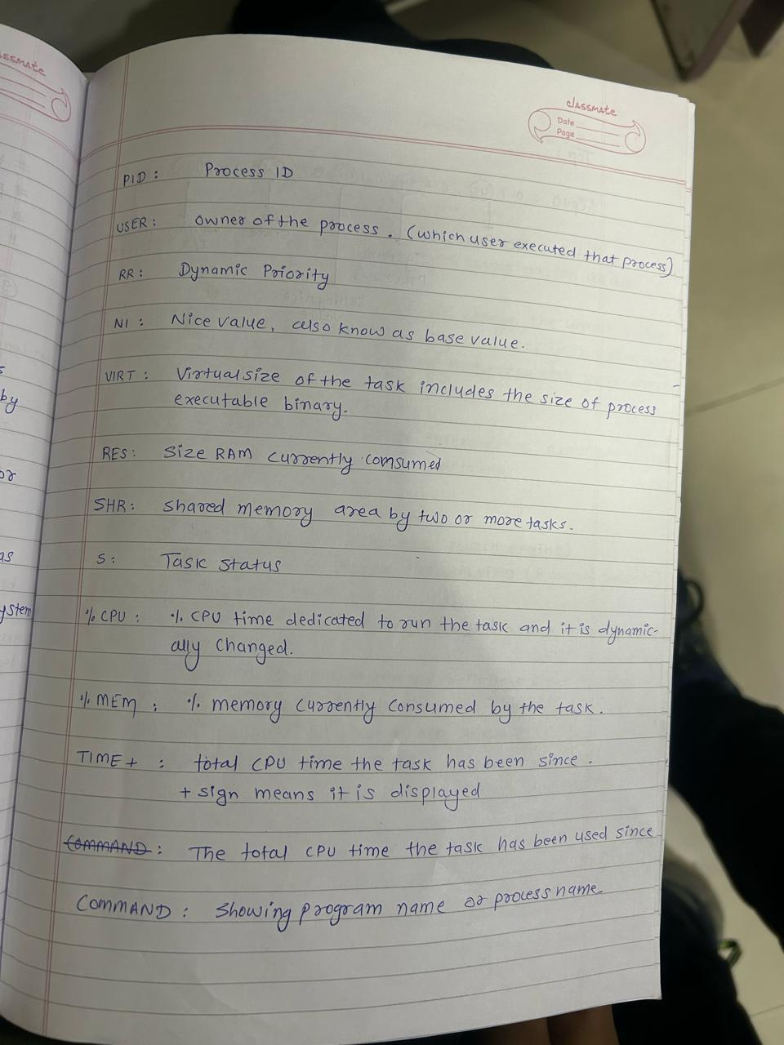

| Top | ps |
| --- | --- |
| The top command gives dynamic view of process the system which means after every 3 sec it gets refreshes by itself | The ps command gives the static view of the processes in the system which means it does not refresh by itself |
| Here we can use kill signals as well as change priorities of the processes simultaneously | Here it is not possible |

Jobs :-- To see process in background and foreground

Load Average :-- The average system load for a certain period of time

#w -f

#w

#uptime

#/etc/proc/loadavg

#top

Ctrl+Z:-is used to suspend the process by giving SIGSTOP signal

Ctrl+C:--is used to kil a process using SIGTERM signal

*Foreground processes:-

the processes which are running on screen are

#fg %1

*Background process :--

the processes which are running or stopped in background

#bg %1

**Concept of priority and niceness

Niceness

1]Their range between -20 to 19

2]They both are reciprocal to each other

Priority

>>priority value can be defined as the importance given by system to that process

>>It range from 0 to 39

>>We can use nice value to change priority of certain processes