Model | Context architecture | Encoding-strength modulation | Information available | Free parameters | Key prediction
CMR | Temporal context only | No emotion or LPP term | Item identity | 9 | Neither category-level emotional advantage nor LPP-recall relationship
CMR+LPP | Temporal context only | $κ_{L}L_{i}$ for all items | Item identity + trial-level LPP | 10 | LPP-recall relationship; only weak indirect category separation
eCMR | Temporal + emotional context | $ϕ_{emot}e_{i}$ | Item identity + emotional/neutral category | 10 | Emotional recall advantage, but no item-level LPP-recall relationship
LPP-eCMR | Temporal + emotional context | $ϕ_{emot}e_{i}+κ_{EL}L_{i}e_{i}$ | Category + trial-level LPP | 11 | Both emotional recall advantage and LPP-recall relationship

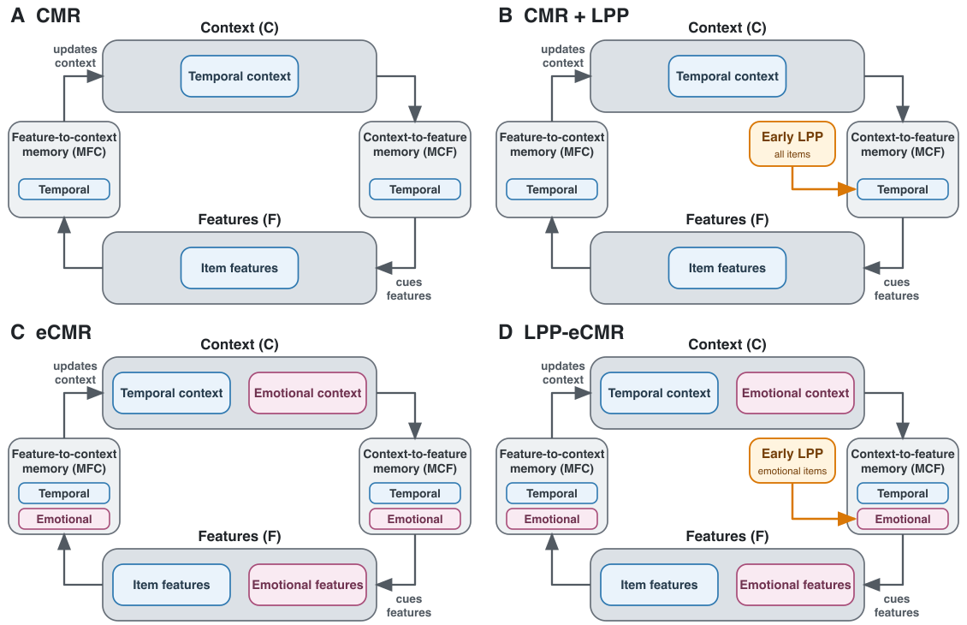
Figure 1: Conceptual comparison of the four models. Blue components denote temporal context, item features, and temporal memory pathways; pink components denote emotional context, emotional features, and emotional memory pathways. Early LPP modulates temporal context-to-feature learning for all items in CMR+LPP and emotional context-to-feature learning for emotional items in LPP-eCMR.

