Model | Architecture | Encoding-strength modulation | Model inputs | Emotional advantage | LPP-recall relation | Parameters
CMR | Temporal only | No emotion or LPP term | Item identity | No | No | 9
CMR+LPP | Temporal only | $κ_{L}L_{i}$; Temporal MCF, all items | Item identity + trial-level LPP | Weak/indirect | Yes | 10
eCMR | Temporal + emotional | $ϕ_{emot}e_{i}$; Emotional MCF, emotional items | Item identity + category | Yes | No | 10
LPP-eCMR | Temporal + emotional | $ϕ_{emot}e_{i}+κ_{EL}L_{i}e_{i}$; Emotional MCF, emotional items | Item identity + category + trial-level LPP | Yes | Yes | 11

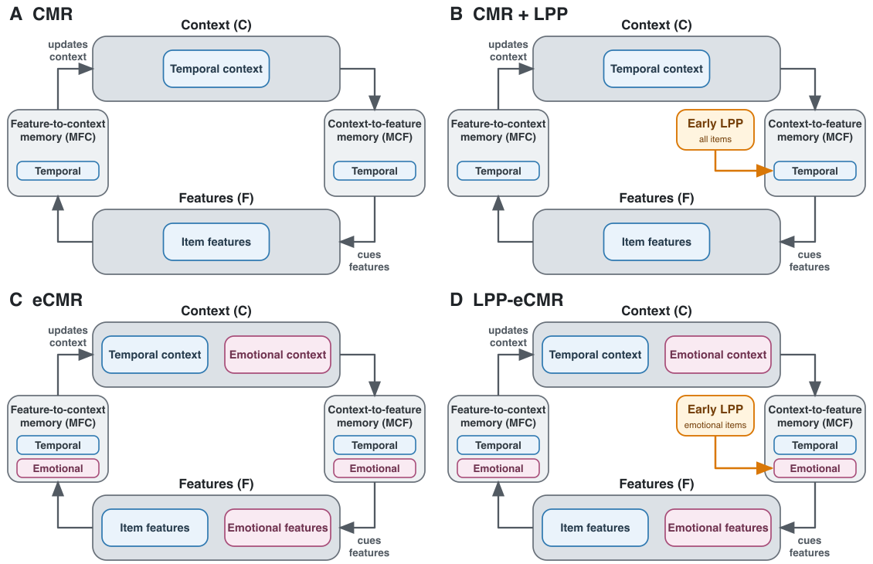
Figure 1: Conceptual comparison of the four models. Blue components denote temporal context, item features, and temporal memory pathways; pink components denote emotional context, emotional features, and emotional memory pathways. Early LPP modulates temporal context-to-feature learning for all items in CMR+LPP and emotional context-to-feature learning for emotional items in LPP-eCMR.

