Model | Information used by model | Key prediction
CMR | Item identity only | No category-level emotional advantage; no LPP-recall relationship
CMR+LPP | Item identity + trial-level LPP for all items | Only weak indirect category separation; LPP-recall relationship across all items
eCMR | Item identity + emotional/neutral category | Emotional recall advantage; no item-level LPP-recall relationship
LPP-eCMR | Item identity + emotional/neutral category + trial-level LPP for emotional items only | Emotional recall advantage; LPP-recall relationship specific to emotional items

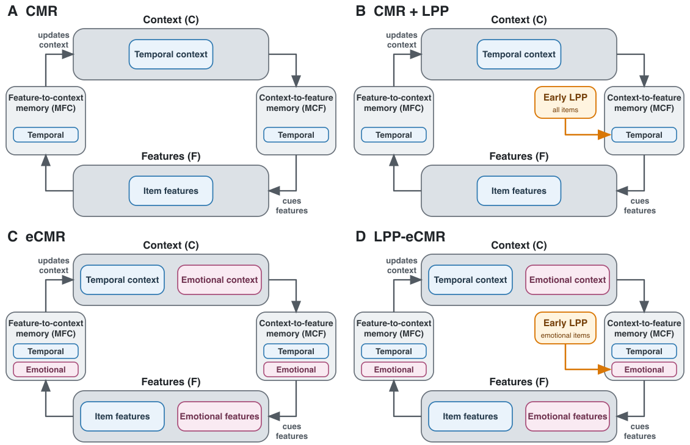
Figure 1: Conceptual comparison of the four models. Blue components denote temporal context, item features, and temporal memory pathways; pink components denote emotional context, emotional features, and emotional memory pathways. Early LPP modulates temporal context-to-feature learning for all items in CMR+LPP and emotional context-to-feature learning for emotional items in LPP-eCMR.

