Contribution of the Late Positive Potential to Emotional Memory: A Joint Neuro-Cognitive Approach to Memory Prediction

Robin Hellerstedt¹, Jordan Gunn², and Deborah Talmi²
¹University
²University of Cambridge

Author Note

Contribution of the Late Positive Potential to Emotional Memory: A Joint Neuro-Cognitive Approach to Memory Prediction

Computational modeling of the Early-LPP contribution to emotional recall
The behavioral and EEG analyses identified two forms of variation in recall. At the category level, negative items were recalled more often than neutral items. At the item level, Early LPP was more strongly associated with subsequent recall for negative than neutral items. The empirical analyses distinguish these patterns statistically, but they do not determine how trial-level Early LPP should be mapped onto the encoding mechanism proposed to produce emotional memory enhancement. We therefore tested whether using item-level Early LPP to scale learning strength could replace a category-wide increase in learning strength, or whether the two forms of modulation explained complementary variation in which items were recalled.
We organized this comparison around three focused questions. We tested (1) whether preferential learning of negative items improved prediction of which items were recalled; (2) whether scaling learning with item-level Early LPP could replace that category-wide advantage or improve prediction after the advantage was included; and (3) whether Early-LPP scaling was better applied to both negative and neutral items or only to negative items. We therefore crossed the presence or absence of preferential emotional learning with three LPP specifications: no LPP-based learning modulation, one relationship shared across negative and neutral items, or one relationship limited to negative items. This crossing produced six models. All six models used the same memory architecture. We first describe that shared architecture and show where preferential emotional learning and Early LPP altered learning strength. We then describe model fitting, compare the six models, and use simulations to determine which observed patterns the fitted models reproduced.

eCMR Model Specification
We modeled recall with an adaptation of emotional Context Maintenance and Retrieval (eCMR) (Talmi et al., 2019). Like other retrieved-context models (Howard & Kahana, 2002; Polyn et al., 2009), eCMR represents context as a continuously updated internal state that carries information from recently processed events. Studying an item changes this state and forms associations in both directions: the item can later reinstate aspects of its study context, and the current context can later provide retrieval support for the item. During free recall, items receiving greater support are more likely to be selected. Recalling an item then reinstates aspects of its study context, changing the cue that guides the next recall. In the present comparison, stronger context-to-item learning could therefore increase an item’s probability of entering the recalled set. We first specify this common retrieval mechanism and then explain how the models differed in their scaling of source learning strength.
eCMR distinguishes temporal and source information within the context representation. Temporal context represents the evolving sequence of recently processed events, whereas source context represents non-temporal information about an event—in the present model, whether an item was negative or neutral. Recalling an item reinstates both components, so its category-related source state can increase support for other items associated with similar source information. It also allows a category-wide multiplier on the associations formed by negative items, representing the hypothesis of preferential emotional learning (Talmi et al., 2019). All six models represented negative and neutral items with distinct source-context states. We varied whether negative items received this category-wide learning advantage and whether learning was also scaled by each item’s Early LPP. Fixing the category-wide multiplier at 1 therefore removed that advantage without removing negative/neutral information from source context.
To formalize this account, we first define how the model represented items and context and then follow those representations through study and recall. Within each list $j$, the model represented each studied item $i$ with a feature vector $f_{i}$ containing one entry for every item on the list. The entry corresponding to item $i$ was 1, and all remaining entries were 0, so each vector uniquely identified one studied item. This representation allowed the model to learn separate associations between each item and context. The complete context state contained the temporal and source components introduced above,
$$c_{i}=\left[\begin{matrix}c_{i}^{T} \\ c_{i}^{S}\end{matrix}\right].$$
The two components were updated and normalized separately, but together formed one context representation rather than independent memory systems. Both components included a start-of-list state, and all context states and associations were initialized anew for each list.
Items and context interacted through two associative mappings with opposite directions. The feature-to-context mapping $M^{FC}$ transformed an item into contextual input, allowing the item to reinstate context when it was later recalled. The context-to-feature mapping $M^{CF}$ transformed the current context into support for candidate items. Each mapping operated on both temporal and source context. At the start of each list, temporal associations supplied item-specific and shared background support, whereas source context supported items only through associations learned during study. Core symbols are collected in Supplementary Table 6.
Study followed the same three-step sequence for every item. First, the item generated temporal and source input through the corresponding feature-to-context mappings. Second, temporal and source context moved toward those inputs. Only after both context components had been updated did the model strengthen associations between the item and its new context state in both directions. Feature-to-context learning stored the context that the item could later reinstate, whereas context-to-feature learning determined how strongly that context would later support the item. Preferential emotional learning and Early-LPP modulation affected only source context-to-item learning. The account below follows these operations in the same order.
First, the presented item generated unit-length temporal and source contextual inputs through the corresponding feature-to-context mappings.
Second, each new item shifted each context component toward its corresponding input while allowing part of the preceding state to persist. For either component, the update took the form
$$c_{i}=ρ_{i}c_{i−1}+βc_{i}^{IN}.$$
In this expression, the drift parameter $β$ controlled how strongly the current item changed context, whereas $ρ_{i}$ kept the updated context at unit length. Temporal and source context used the separate encoding-drift parameters $β_{enc}^{T}$ and $β_{enc}^{S}$, respectively. Smaller values retained more of the preceding state, whereas larger values gave the current item greater influence.
Only after both context components had been updated were the item’s associations learned. The item was therefore bound to temporal and source states that it had already helped create, rather than to the states that preceded its presentation. This post-update order was held fixed across the comparison.
Feature-to-context learning stored the updated state that a later presentation or recall of the item could reinstate. The same fitted learning rate $γ$ applied to temporal and source feature-to-context associations.
Context-to-feature learning stored the reverse associations through which context could later support the item:
$$ΔM_{T,i}^{CF}=ϕ_{i}f_{i}{\left(c_{i}^{T}\right)}^{T}, ΔM_{S,i}^{CF}=S_{ij}^{S}f_{i}{\left(c_{i}^{S}\right)}^{T}.$$
The context-to-feature learning strengths determined how strongly the updated temporal and source states became associated with each item. In the temporal pathway, $ϕ_{i}=1+ϕ_{s}exp\left[−ϕ_{d}\left(i−1\right)\right]$ gave early list positions a temporary advantage: $ϕ_{s}$ controlled the size of that advantage and $ϕ_{d}$ controlled its decay. The source learning strength $S_{ij}^{S}$ included the same primacy gradient, a source-learning scale, and the emotional-learning and Early-LPP multipliers defined below. Only the source learning strength contained the two focal multipliers. This placement allowed their effects to be compared through the same learning pathway, while the temporal learning specification remained unchanged across models.
Having specified how study updated both associative mappings, we next describe how those mappings generated recall. During recall, the current context supported candidate items through the context-to-feature mapping, whereas a recalled item reinstated context through the feature-to-context mapping.
At recall onset, $β_{start}$ shifted both context components toward their start-of-list states. The current temporal and source states then supplied additive support for each item that had not yet been recalled:
$$a_{i}={\left[M^{CF}c\right]}_{i}={\left[M_{T}^{CF}c^{T}\right]}_{i}+{\left[M_{S}^{CF}c^{S}\right]}_{i}.$$
The choice-sensitivity parameter $τ_{c}$ determined how strongly differences in support influenced recall. Among the studied items not yet recalled, the probability of selecting item $i$ next was
PRt=i∣At=aiτck∈At​akτc, i∈At,
where $A_{t}$ is the set of studied items still available at recall step $t$. Larger $τ_{c}$ made the model more likely to select the item with greater support.
After an item was recalled, temporal context moved toward its retrieved temporal input at rate $β_{rec}^{T}$, and source context fully moved toward its retrieved source input by fixing $β_{rec}^{S}=1$. The retrieved source input contained both the item’s category feature and the source state learned during study.
The recalled item was then removed from the available set, so repeated recalls were disallowed. Context-guided selection and reinstatement complete the pathway through which source learning strength can change which items enter the recalled set.
The fitted model was an adaptation rather than an unchanged implementation of published eCMR. It omitted item-specific semantic similarities among the pictures and the published source-switch mechanism, in which a transition between negative and neutral categories produces additional disruption of temporal context. We omitted the source-switch mechanism because recall order was unavailable to diagnose category-boundary effects and because the present comparison concerned learning strength rather than temporal disruption at source transitions.
The retrieval process also differed from published eCMR. Source reinstatement was fixed at its maximum rather than estimated: without recall order, we treated partial source reinstatement as difficult to distinguish from source-learning strength and recall-choice sensitivity. Normalized selection among unrecalled items replaced the published leaky competitive accumulator and stopping process, and repeated recalls were disallowed. The likelihood therefore conditioned on each list’s observed recall count, as described below, rather than modeling when recall terminated. These choices were fixed across all six models, which differed only in how source learning strength was scaled rather than in their retrieval architectures.

Encoding-strength hypotheses
Every model estimated a shared source-learning baseline $ωϕ_{i}$. The parameter $ω$ scaled source learning relative to temporal learning, for which the corresponding scale was fixed at 1. Estimating $ω$ in every model allowed source context to contribute even when neither focal mechanism was enabled. The first focal hypothesis was that negative items should receive a category-wide emotional-learning multiplier on this shared baseline.
Preferential emotional learning was represented by $ϕ_{emot}^{e_{i}}$, where $e_{i}=1$ for a negative item and $e_{i}=0$ for a neutral item. The multiplier therefore equaled $ϕ_{emot}$ for negative items and 1 for neutral items. Models without category-wide emotional-learning modulation fixed $ϕ_{emot}=1$, whereas models testing preferential emotional learning estimated the multiplier over the range $(0,10]$. Values above 1 strengthened source context-to-item learning for negative items relative to neutral items, whereas values below 1 attenuated it. That range allowed attenuation as well as enhancement of negative-item learning; “preferential emotional learning” names the directional hypothesis, and interpreting the fitted multiplier as enhancement requires an estimate above 1. The category-wide emotional-learning multiplier can change the average recall difference between negative and neutral items, but it cannot distinguish two negative items on the basis of their different Early-LPP amplitudes. Early-LPP modulation supplied that item-level variation.
For item $i$ on 20-item study-test list $j$, the model used within-list mean-centered Early LPP,
$$z_{ij}={EarlyLPP}_{ij}−{\overline{EarlyLPP}}_{j}.$$
A positive value of $z_{ij}$ means that an item elicited a larger Early LPP than the average item on the same list; a negative value means that it elicited a smaller one. This predictor isolates within-list variation and removes differences between list means by construction. The present models can therefore test whether relatively larger Early LPP predicts which items enter a list’s recalled set, but not whether lists with larger average Early LPP produce more recalls. The preceding empirical regression did not separate within-list variation from differences among list means and participants. The computational coefficient addresses only the within-list relationship and is therefore not a numerical counterpart of the empirical regression coefficient.
Source learning strength was the product of the ordinary source-learning baseline, the category-wide emotional-learning multiplier, and an item-level Early-LPP multiplier:
$$S_{ij}^{S}=ωϕ_{i}×ϕ_{emot}^{e_{i}}×exp​\left[κz_{ij}+κ_{emot}e_{i}z_{ij}\right].$$
The coefficient $κ$ is the General Early-LPP slope on log learning strength, and $κ_{emot}$ is an additional negative-item slope. The resulting log-learning slope is $κ$ for neutral items and $κ+κ_{emot}$ for negative items. At the list mean, where $z_{ij}=0$, the Early-LPP multiplier equals 1 and the model recovers its ordinary category-level learning baseline. The exponential link guarantees positive learning strength, but positivity is not its only implication: the link assumes that a one-unit Early-LPP difference produces a proportional rather than a constant absolute change in learning. The model comparison tests whether one such proportional relationship improves prediction when it applies to both categories or only to negative items.
No-LPP models fixed both Early-LPP coefficients at zero. General-LPP models estimated $κ$ and fixed $κ_{emot}=0$, applying one slope to negative and neutral items. Emotion-dependent-LPP models fixed $κ=0$ and estimated $κ_{emot}$, applying one slope only to negative items. General and Emotion-dependent models therefore estimated the same number of parameters and differed only in the items to which their single Early-LPP slope applied. The empirical interaction motivated this matched comparison, but the model comparison determined which mapping better predicted the recalled sets.

Model-comparison design
Crossing a fixed or freely estimated emotional-learning multiplier with the three Early-LPP mappings produced the six models in Table 1.

Table 1
Six models formed by crossing Early-LPP modulation with a fixed or estimated emotional-learning multiplier. All models contained temporal and negative/neutral source-context components; parenthetical values are numbers of free parameters. Estimating the multiplier tested the directional hypothesis of preferential emotional learning while also permitting attenuation.
Early-LPP modulation | Emotional-learning multiplier fixed at 1 | Emotional-learning multiplier estimated
None | Source-context baseline (11) | Preferential-learning model (12)
General | General-LPP model (12) | Preferential learning + General-LPP model (13)
Emotion-dependent | Emotion-dependent-LPP model (12) | Preferential learning + Emotion-dependent-LPP model (13)
Canonical implementation identifiers corresponding to these manuscript labels are reported in Supplementary Table 5.
The grid supports the three comparisons introduced at the beginning of this section. Within each row, comparing the two columns tests whether freeing the emotional-learning multiplier improves prediction while holding the Early-LPP mapping fixed. Within each column, comparing an Early-LPP model with the No-LPP model tests whether the neural measure adds predictive information while holding fixed whether the emotional-learning multiplier was estimated. Finally, comparing General with Emotion-dependent LPP within either column tests two equal-complexity placements of one Early-LPP coefficient. The shared architecture in every cell makes these contrasts interpretable.
The grid also implements the substitution test proposed in the original motivation for constraining encoding strength with LPP. The General-LPP model with the emotional-learning multiplier fixed and the Preferential-learning model without LPP each had 12 free parameters. Each model introduced one free parameter that scaled the same source context-to-item learning strength: the General-LPP model scaled learning from item-level LPP, whereas the Preferential-learning model scaled negative-item learning with $ϕ_{emot}$. Their comparison therefore tests whether LPP-derived scaling can replace a free emotional-learning multiplier; the equal-complexity Emotion-dependent-LPP model provides a second LPP-derived alternative.
Table 2 summarizes the parameters and the constraints that created the six cells. The eleven common free parameters governed temporal and source updating, pre-experimental support, associative learning, primacy, and recall choice. Estimating the emotional-learning multiplier or either one-slope Early-LPP mapping added one free parameter.

Table 2
Parameters in the six-model specification.
Parameter | Role | Fitted range or fixed value
$β_{enc}^{T}$ | Temporal-context drift during study | $\left(0,1\right)$
$β_{enc}^{S}$ | Source-context drift during study | $\left(0,1\right)$
$β_{start}$ | Drift toward start-of-list context before recall | $\left(0,1\right)$
$β_{rec}^{T}$ | Temporal-context reinstatement after recall | $\left(0,1\right)$
$β_{rec}^{S}$ | Source-context reinstatement after recall | $1$ (fixed)
$α$ | Shared pre-experimental context-to-item support | $(0,100]$
$δ$ | Item-specific pre-experimental context-to-item support | $(0,100]$
$γ$ | Feature-to-context learning rate | $\left(0,1\right)$
$ϕ_{s}$ | Primacy scale | $(0,100]$
$ϕ_{d}$ | Primacy decay | $(0,100]$
$τ_{c}$ | Recall-choice sensitivity | $(0,100]$
$ω$ | Source learning relative to temporal learning | $(0,10]$
$ϕ_{emot}$ | Emotional-learning multiplier for negative items | $1$ (fixed) or $(0,10]$
$κ$ | General Early-LPP slope on log learning strength | $0$ (fixed) or $\left[0,0.2145\right]$
$κ_{emot}$ | Additional negative-item Early-LPP slope; when $κ=0$, the entire negative-item slope | $0$ (fixed) or $\left[0,0.2145\right]$
The primary grid does not estimate General and emotion-dependent Early-LPP coefficients simultaneously. It therefore asks whether one coefficient is more useful when shared by both categories or limited to negative items; it does not test whether a residual General component is exactly zero after an emotion-dependent component is fitted. The same learning-strength equation also defines a Full-LPP mapping in which $κ$ and $κ_{emot}$ are estimated together. In that mapping, $κ_{emot}$ is formally an additional negative-item slope; when $κ=0$, it supplies the entire negative-item slope. We fitted the two source-context Full-LPP variants exploratorily, but their best-found solutions did not consistently recover the likelihoods of their nested one-slope models. We therefore excluded them from the primary comparison and report them separately as optimization-incomplete fits.
The comparison also holds source context constant across all six models. It can compare alternative scalings of source learning strength within that architecture, but it cannot establish that the predictive Early-LPP relationship is specific to source-context rather than temporal-context learning. Having defined the alternatives, we next describe the common evidence used to compare them.

Pooled estimation and evaluation
The modeling dataset matched each of the 6,840 study events to its recall outcome and Early-LPP value. As described in the preceding EEG methods, each single-trial ERP was first standardized relative to its own prestimulus interval, using the mean and standard deviation from $−200$ to 0 ms separately for each electrode. Early LPP was then extracted from the prespecified 400–1000 ms window and centroparietal electrodes.
Early-LPP values were unavailable for 371 events (5.4%). Before within-list centering, these values were imputed in three steps: first from available items of the same condition on the same participant’s list, then from all available items on that list if the condition-specific mean was unavailable, and finally from the dataset-wide mean for the corresponding condition. Recall status was not used in the imputation. This procedure yielded one complete 20-item input sequence for each list.
Each model was fitted with one parameter vector shared across all 342 study-test lists from 38 participants. The pooled analysis asks whether one parameterization captures the population-level pattern across the full dataset. It does not estimate participant-specific model parameters or individual differences. This restriction is important because each participant contributed only nine lists, too few independent list histories to support stable estimation of 11 to 13 parameters per participant.
The available recall records identified which items were recalled, but their output order was not available for modeling. This creates a problem because eCMR assigns probability to an ordered recall sequence: after each recall, the retrieved item changes context and therefore changes the probabilities of subsequent recalls. An unordered set of $n_{j}$ items is compatible with $n_{j}!$ possible orders. Enumerating all of those orders was impractical, so we approximated the evidence for each recalled set using 50 sampled orders.
Let $S_{j}$ denote the items recalled from list $j$, let $n_{j}=\left|S_{j}\right|$, let $π_{jk}$ be the $k$th sampled ordering of those items, and let $θ$ denote a model’s parameter vector. For each list, the model was supplied with $n_{j}$ and evaluated on which studied items composed $S_{j}$. Using $K=50$ fixed sampled orders, the fitted score for the set was
$$\tilde{P}\left(S_{j}∣θ,n_{j}\right)=\frac{1}{K}\sum_{k=1}^{K}{\prod_{t=1}^{n_{j}}{P}}​\left(R_{jt}=π_{jk,t}∣π_{jk,1:\left(t−1\right)},θ\right).$$
Each product in this expression is the probability of one possible ordered recall sequence; the outer average combines the 50 sampled sequences. Multiplying the average by $n_{j}!$ would estimate the full sum over compatible orders. Because this factor depends only on the observed list and not on the model parameters, omitting it adds the same constant to every negative log-likelihood (NLL). It therefore does not change fitted parameters; after model complexity is considered, it likewise does not change differences or rankings under Akaike’s information criterion (AIC), defined below. The same sampled orders and random seed were used for every model, so differences between models could not arise from evaluating different order samples.
Termination events were excluded from the likelihood. Accordingly, the model predicts which items enter the recalled set conditional on the number of items the participant recalled from that list. The analysis does not explain why that number of items was recalled and does not test a process for deciding when recall stops. Stopping may depend on the state of retrieval in free recall, but evaluating such a process requires a separate, validated termination model. The current likelihood keeps the present comparison focused on recalled-item identity.
We minimized the summed negative log of the approximate set scores using differential evolution, a population-based parameter search (Storn & Price, 1997). Each optimization began with a Latin-hypercube sample that spread its initial candidate vectors across the allowed parameter space. The search population contained 15 candidate vectors per free parameter, yielding 165, 180, or 195 candidates for models with 11, 12, or 13 free parameters, respectively. The crossover probability was 0.9, the differential weight varied between 0.5 and 1.0, and the relative convergence tolerance was ${10}^{−4}$. Optimization continued for at most 1,000 generations and was repeated from three independent starts; the lowest NLL found across the three starts was retained.
The Early-LPP coefficients were constrained to be nonnegative in accordance with the directional empirical hypothesis. Their upper bound of 0.2145 limited either Early-LPP coefficient to a tenfold multiplier at the largest observed centered Early LPP. The resulting estimates and rankings are conditional on this search budget and these parameter ranges.
Lower NLL indicates that a model assigned greater probability to the observed recalled sets. We compared the best-found solutions using Akaike’s information criterion, $AIC=2NLL+2p$, where $p$ is the number of free parameters (Burnham & Anderson, 2002). Lower AIC indicates a better trade-off between conditional fit and model complexity. AIC indicates whether a model containing an optional learning multiplier improved prediction enough to offset its additional parameter, but it does not identify which empirical pattern drove that improvement. We therefore paired the model comparisons with simulations showing the predictions of each fitted specification.
For each fitted parameter vector, we generated 200 complete simulated datasets containing the same 342 study lists and the same item-level Early-LPP values as the observed dataset. For each list, we generated exactly its observed number of recalled items, matching the conditioning used in the likelihood.
We summarized two patterns in each simulated dataset: the negative-versus-neutral recall difference and the remembered-versus-forgotten difference in Early LPP. For continuity with the preceding empirical analysis, we summarized the Early-LPP difference on the original z-transformed scale, although the models used within-list-centered Early LPP to modulate learning. The parameters changed which studied items the model recalled; they did not change the Early-LPP value attached to an item. These summaries were not optimized as separate fitting targets. They are therefore explanatory diagnostics of the fitted recalled-set model, not independent or out-of-sample validation.

Model-comparison results

Overall comparison
The model combining preferential emotional learning with Emotion-dependent Early-LPP modulation had the lowest AIC (Table 3). Its best-found NLL was 8240.310 with 13 free parameters, yielding an AIC of 16506.619. The overall ranking provides an initial orientation; the three planned comparisons determine what the ranking means. We report those comparisons in the order introduced above.

Table 3
Pooled fit of the six eCMR model variants. The first two columns identify which learning mechanisms were available for estimation; they do not indicate whether either mechanism improved fit. $p$ is the number of free parameters; NLL is the best-found negative log-likelihood across three differential-evolution starts; $Δ$AIC is relative to the lowest-AIC model. Bold values identify the best-fitting model.
Emotion-based learning boost | LPP-based learning boost | $p$ | NLL | AIC | $Δ$AIC
No | None | 11 | 8313.531 | 16649.062 | 142.443
No | All items | 12 | 8300.740 | 16625.480 | 118.861
No | Negative items only | 12 | 8280.693 | 16585.387 | 78.768
Yes | None | 12 | 8255.712 | 16535.424 | 28.805
Yes | All items | 13 | 8251.121 | 16528.242 | 21.623
Yes | Negative items only | 13 | 8240.310 | 16506.619 | 0.000
The fit statistics quantify differences in conditional prediction, whereas the simulations show how those differences appear in the empirical summaries. For readability, the figures and diagnostic table label preferential emotional learning as an “emotion-based learning boost,” General LPP as an “LPP-based learning boost for all items,” and Emotion-dependent LPP as an “LPP-based learning boost for negative items only.” The two figures use the same four panels: observed data; Emotion-dependent LPP without preferential emotional learning; preferential emotional learning without LPP; and the model combining both mechanisms. This matched set isolates the complementary contribution of the two focal mechanisms. The General-LPP models remain in the fit and diagnostic tables, where the placement of the Early-LPP slope can be compared across all six specifications.

Contribution of preferential emotional learning
The first comparison asks whether preferential learning of negative items improves prediction of which items are recalled. Freeing the emotional-learning multiplier lowered AIC under every Early-LPP specification: by 113.639 points with no LPP, by 97.238 points with General LPP, and by 78.768 points with Emotion-dependent LPP. The fitted multiplier exceeded 1 in all three models and therefore enhanced rather than attenuated negative-item learning. The recall-rate diagnostic in Figure 1 explains this consistent advantage. Models with preferential emotional learning produced negative-minus-neutral recall differences between 0.118 and 0.134, close to the observed difference of 0.124; models without preferential emotional learning produced differences between 0.001 and 0.019.
Because every model represented negative and neutral source features, this result concerns preferential emotional learning rather than the mere presence of category information. Preferential emotional learning supplied category-level recall structure, leaving the item-level contribution of Early LPP as the next question.

Contribution of Early LPP
The second comparison asks whether Early LPP adds predictive information beyond a model with no EEG input. Without preferential emotional learning, General LPP lowered AIC by 23.582 points and Emotion-dependent LPP lowered it by 63.676 points relative to the source-context baseline. With preferential emotional learning, the corresponding AIC improvements were 7.182 and 28.805 points. Early LPP therefore improved conditional prediction when the emotional-learning multiplier was fixed and when it was estimated.
The equal-complexity substitution comparisons asked a different question and produced a different result. The Preferential-learning model had an AIC 90.057 points lower than the General-LPP model and 49.963 points lower than the Emotion-dependent-LPP model; all three models had 12 free parameters. Within the fitted specification and parameter ranges, neither LPP-derived scaling rule matched the free emotional-learning multiplier, even though Early LPP improved prediction when added to models with or without that multiplier. This pattern favors complementarity over substitution.
The Early-LPP diagnostic in Figure 2 identifies the additional pattern captured by Early-LPP modulation. In the observed data, remembered items had a 0.455 larger mean Early-LPP z score than forgotten items within the negative category, whereas the corresponding neutral-item difference was 0.035. Models without Early-LPP modulation produced little remembered-versus-forgotten separation in either category. Because the Early-LPP values themselves remained fixed, remembered–forgotten differences arose only when a model preferentially recalled items with larger values. Early-LPP modulation therefore supplied item-level information that the category-wide emotional-learning multiplier did not contain.
Because both Early-LPP mappings added information, the final comparison asks where their single slope should apply.

General versus Emotion-dependent Early LPP
The third comparison contrasts one slope shared across categories with one slope limited to negative items. The two alternatives had equal numbers of parameters, so their AIC difference reflected fit rather than a difference in the complexity penalty. Emotion-dependent LPP lowered AIC by 40.094 points relative to General LPP when preferential emotional learning was absent and by 21.623 points when preferential emotional learning was present. The diagnostic contrasts in Table 4 show the patterns that accompanied these fit differences.

Table 4
Observed and model-predicted recall-rate and original-z Early-LPP contrasts. Parentheses give prediction minus observed; predictions are means across 200 complete simulated datasets. The Early-LPP contrasts were not separately fitted.
eCMR specification | Recall rate: Negative $−$ Neutral | Early LPP: Remembered $−$ Forgotten, Negative items | Early LPP: Remembered $−$ Forgotten, Neutral items | Early LPP: Negative items (Remembered $−$ Forgotten) $−$ Neutral items (Remembered $−$ Forgotten)
Observed data | 0.124 | 0.455 | 0.035 | 0.420
Baseline | 0.001 (−0.123) | 0.029 (−0.425) | 0.015 (−0.020) | 0.014 (−0.406)
All-item LPP boost | 0.007 (−0.117) | 0.260 (−0.194) | 0.214 (+0.179) | 0.046 (−0.374)
Negative-item LPP boost | 0.019 (−0.105) | 0.524 (+0.069) | 0.022 (−0.013) | 0.502 (+0.083)
Emotion-based boost | 0.118 (−0.006) | 0.030 (−0.425) | 0.008 (−0.027) | 0.021 (−0.398)
Emotion-based + all-item LPP boosts | 0.134 (+0.010) | 0.372 (−0.082) | 0.076 (+0.041) | 0.297 (−0.123)
Emotion-based + negative-item LPP boosts | 0.130 (+0.006) | 0.395 (−0.059) | 0.015 (−0.020) | 0.380 (−0.040)
General LPP separated remembered and forgotten items in both categories, whereas Emotion-dependent LPP concentrated the separation among negative items, as in the observed pattern. With preferential emotional learning, the predicted negative-versus-neutral difference between the two memory contrasts was 0.297 under General LPP and 0.380 under Emotion-dependent LPP, compared with 0.420 in the observed data. When the models were each given one Early-LPP coefficient, that coefficient was therefore more useful when applied to negative items.
This comparison is conditional on the declared parameter ranges. In the model combining preferential emotional learning with General LPP, $\hat{κ}=0.208$, or 97% of its upper bound of 0.2145, and no wider-bound sensitivity analysis was conducted. We therefore cannot establish whether the Emotion-dependent mapping would remain preferred under a wider Early-LPP bound. The supported conclusion is narrower: within the declared range and equal-complexity comparison, the Emotion-dependent mapping predicted the recalled sets better.
A second near-bound estimate cautions against interpreting the General-LPP coefficients in isolation. In the General-LPP fit with the emotional-learning multiplier fixed, the source-learning scale approached its upper bound: $\hat{ω}=9.047$ on the range $(0,10]$. This pattern suggests that the source-learning scale and the General Early-LPP coefficient may compensate for one another.
The preferred model used both proposed mechanisms. It estimated a source-learning scale of 0.930, an emotional-learning multiplier of 1.946, and an emotion-dependent log-learning slope of 0.128. These focal parameters were estimated jointly with context drift, choice sensitivity, and the remaining model parameters, so isolated parameter magnitudes should not be assigned direct psychological meanings or compared across models without considering the complete parameter vector.
The exploratory Full-LPP fits did not resolve whether a residual General component remained. Their original best-of-three solutions failed a basic optimization check: their NLLs were 3.265 and 1.294 points above their nested Emotion-dependent models without and with preferential emotional learning, respectively. Evaluating each nested parameter vector through the corresponding Full likelihood at $κ=0$ reproduced the parent NLL exactly. We therefore excluded the Full variants from the six-model ranking, report the original optimization-incomplete fits and parameter vectors in Supplementary Table 9 and Table 10, and do not use them to infer whether a residual General component remains.

Summary and scope
Taken together, the comparisons support complementary roles for preferential emotional learning and Early-LPP modulation. The emotional-learning multiplier reproduced the higher recall rate for negative than neutral items. The item-level Early-LPP multiplier distinguished which negative items were recalled. The preferred specification combined preferential emotional learning with Emotion-dependent LPP. It implements the proposed pathway from Early LPP through source context-to-item learning strength to the conditional probability of entering the recalled set, while also reproducing the emotional-memory advantage. The comparison thereby implements the original proposal to use an independent neural measure to constrain the same source-learning pathway governed at the category level by $ϕ_{emot}$. The results show that LPP-derived scaling complemented, rather than replaced, the fitted emotional-learning multiplier.
The conclusion is deliberately narrower than a general account of emotional memory. It concerns within-list variation in Early LPP and recalled-item identity conditional on the observed recall count, using one parameter vector shared across participants.
The analysis does not explain total recall or stopping and does not estimate effects of between-list mean Early LPP. It also does not characterize participant-specific mechanisms, compare source with temporal implementations, or identify Early LPP uniquely with attention, arousal, or stimulus significance. Those questions require different data or additional models rather than stronger interpretation of the present comparison.
Finally, the numerical conclusions are conditional on the 50-order recalled-set approximation, the declared parameter bounds, and the differential-evolution search. The mechanistic conclusions concern the stated eCMR adaptation, including its omission of semantic similarity and source-switch disruption. Within those limits, a category-wide emotional-learning multiplier and an emotion-dependent item-level neural multiplier accounted for complementary structure in the observed recalled sets.

Supplementary material

Model-label mapping

Table 5
Mapping between the manuscript-facing labels and the executable model registry.
Manuscript label | Canonical registry identifier
Source-context baseline | CategoryOnly_eCMR
General-LPP model | CategoryOnly_eCMR_LPP_General
Emotion-dependent-LPP model | CategoryOnly_eCMR_LPP_EmotionalOnly
Preferential-learning model | EEM_eCMR
Preferential learning + General-LPP model | EEM_eCMR_LPP_General
Preferential learning + Emotion-dependent-LPP model | EEM_eCMR_LPP_EmotionalOnly

Core notation
Table 6 collects the formal objects that recur across the specification. The fitted parameters and their roles are listed separately in Table 2.

Table 6
Core notation used in the model specification and recalled-set likelihood.
Symbol | Meaning
$i$, $j$, $t$ | Studied item, study-test list, and recall-output position, respectively
$f_{i}$ | One-hot feature vector identifying studied item $i$
$c$, $c^{T}$, $c^{S}$ | Complete context state and its temporal and source components
$c_{i}^{IN}$ | Unit-length contextual input generated by item $i$
$M^{FC}$, $M^{CF}$ | Complete feature-to-context and context-to-feature associative mappings
$M_{T}^{FC}$, $M_{S}^{FC}$, $M_{T}^{CF}$, $M_{S}^{CF}$ | Temporal and source blocks of the two associative mappings
$ϕ_{i}$ | Serial-position-dependent primacy multiplier for item $i$
$S_{ij}^{S}$ | Completed source context-to-item learning strength for item $i$ on list $j$
$e_{i}$ | Negative-item indicator: 1 for negative and 0 for neutral
$z_{ij}$ | Within-list mean-centered Early LPP for item $i$ on list $j$
$a_{i}$ | Context-derived support for item $i$
$A_{t}$ | Studied items still available at recall position $t$
$S_{j}$, $n_{j}$ | Observed recalled set from list $j$ and its size
$θ$ | Complete fitted parameter vector for one model

Complete pooled parameter estimates
Table 7 defines the compact model codes used in Table 8.

Table 7
Key for the six primary model columns in Table 8.
Code | Emotional-learning multiplier | Early-LPP mapping | Manuscript label
A | Fixed at 1 | None | Source-context baseline
B | Fixed at 1 | General | General-LPP model
C | Fixed at 1 | Emotion-dependent | Emotion-dependent-LPP model
D | Estimated | None | Preferential-learning model
E | Estimated | General | Preferential learning + General-LPP model
F | Estimated | Emotion-dependent | Preferential learning + Emotion-dependent-LPP model

Table 8
Best-found pooled parameter estimates for the six primary models. Values are rounded for presentation; square brackets identify fixed values. Parameter roles and fitted ranges are reported in Table 2.
Parameter | A | B | C | D | E | F
$β_{enc}^{T}$ | 0.86396 | 0.73472 | 0.75960 | 0.83243 | 0.00084 | 0.80907
$β_{enc}^{S}$ | 0.18153 | 0.02849 | 0.11016 | 0.04012 | 0.72584 | 0.08675
$β_{start}$ | 0.97321 | 0.98771 | 0.99999 | 0.99999 | 0.03122 | 0.99999
$β_{rec}^{T}$ | 0.70721 | 0.67079 | 0.14344 | 0.18358 | 0.05141 | 0.15337
$β_{rec}^{S}$ | [1] | [1] | [1] | [1] | [1] | [1]
$α$ | 0.24130 | 3.53733 | 1.69400 | 3.81835 | 74.64477 | 1.85902
$δ$ | 68.959 | 28.732 | 39.126 | 18.541 | 48.979 | 27.334
$γ$ | 0.79003 | 0.46162 | 0.13427 | 0.25922 | 0.28439 | 0.21391
$ϕ_{s}$ | 28.721 | 0.48668 | 0.19390 | 0.02896 | 2.35576 | 0.22806
$ϕ_{d}$ | 2.20620 | 1.38064 | 4.43143 | 1.40662 | 2.11887 | 57.41072
$τ_{c}$ | 0.19046 | 2.17085 | 1.75392 | 3.32237 | 1.19079 | 1.57723
$ω$ | 0.22586 | 9.04693 | 1.38513 | 1.45162 | 1.03720 | 0.92996
$ϕ_{emot}$ | [1] | [1] | [1] | 1.50441 | 7.52498 | 1.94591
$κ$ | [0] | 0.05973 | [0] | [0] | 0.20799 | [0]
$κ_{emot}$ | [0] | [0] | 0.18410 | [0] | [0] | 0.12805

Exploratory Full-LPP fits
Table 9 reports the two original Full-LPP optimizer outputs. Because a model cannot fit worse than a nested model at the optimum, their higher NLLs indicate incomplete optimization rather than evidence that the General slope harmed fit. Evaluating the corresponding primary-model vectors through the Full likelihood at $κ=0$ reproduced their NLLs exactly; those already reported vectors are not repeated here.

Table 9
Original optimizer results for the two exploratory source-context Full-LPP models. Both are retained as optimization-incomplete attempts rather than treated as maximum-likelihood solutions.
Preferential emotional learning | $p$ | Full NLL | Full AIC | NLL above the $κ=0$ model
Absent | 13 | 8283.958 | 16593.916 | 3.265
Present | 14 | 8241.604 | 16511.207 | 1.294
Table 10 reports their original parameter estimates. These values are retained for transparency and are not interpreted individually.

Table 10
Original parameter estimates from the two optimization-incomplete Full-LPP fits. Square brackets identify values fixed by the model; parameter roles and fitted ranges are reported in Table 2.
Parameter | G: Preferential learning absent | H: Preferential learning present
$β_{enc}^{T}$ | 0.63919 | 0.75269
$β_{enc}^{S}$ | 0.048073 | 0.090636
$β_{start}$ | 0.99928 | 0.99992
$β_{rec}^{T}$ | 0.19682 | 0.14939
$β_{rec}^{S}$ | [1] | [1]
$α$ | 6.4214 | 7.5665
$δ$ | 29.362 | 61.357
$γ$ | 0.48335 | 0.26261
$ϕ_{s}$ | 0.29664 | 0.73550
$ϕ_{d}$ | 1.0567 | 0.85239
$τ_{c}$ | 3.1391 | 1.7813
$ω$ | 6.9497 | 3.5453
$ϕ_{emot}$ | [1] | 1.7823
$κ$ | 0.001684 | 0.006867
$κ_{emot}$ | 0.10562 | 0.11559

Figure 1
Observed and model-predicted recall rates for negative and neutral items. Brackets show the negative-minus-neutral difference. Observed error bars are 95% participant-cluster bootstrap confidence intervals; predicted error bars are central 95% intervals across 200 complete simulated datasets.
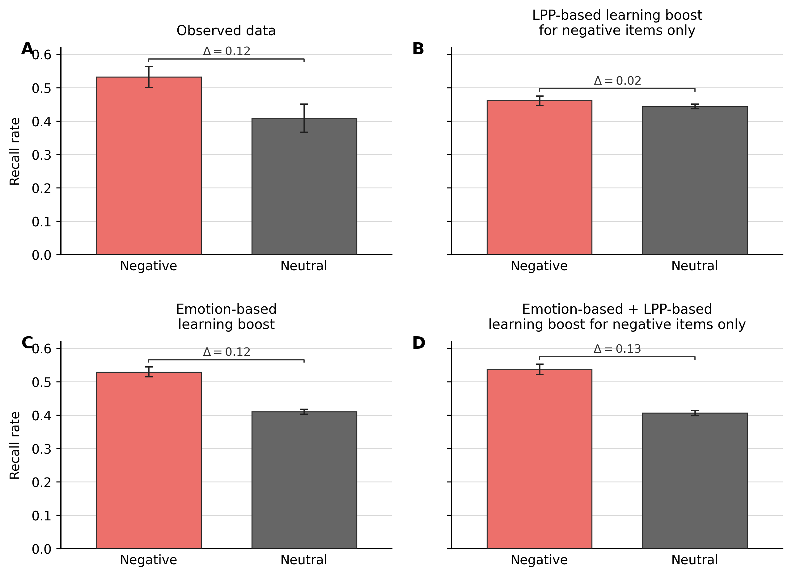

Figure 2
Observed and model-predicted original z-transformed Early LPP by item category and memory status. Brackets show remembered-minus-forgotten differences within each category. Observed error bars are 95% participant-bootstrap confidence intervals; predicted error bars are central 95% intervals across 200 complete simulated datasets.
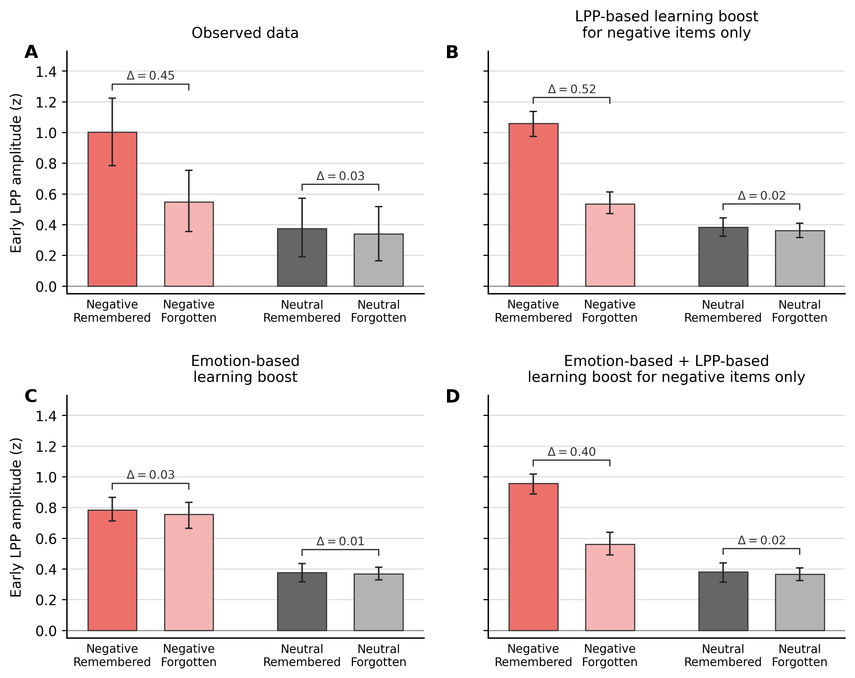

Burnham, K. P., & Anderson, D. R. (2002). Model selection and multimodel inference: A practical information-theoretic approach (2nd ed.). Springer. https://doi.org/10.1007/b97636
Howard, M. W., & Kahana, M. J. (2002). A distributed representation of temporal context. Journal of Mathematical Psychology, 46(3), 269–299. https://doi.org/10.1006/jmps.2001.1388
Polyn, S. M., Norman, K. A., & Kahana, M. J. (2009). A context maintenance and retrieval model of organizational processes in free recall. Psychological Review, 116(1), 129–156. https://doi.org/10.1037/a0014420
Storn, R., & Price, K. (1997). Differential evolution – a simple and efficient heuristic for global optimization over continuous spaces. Journal of Global Optimization, 11(4), 341–359. https://doi.org/10.1023/A:1008202821328
Talmi, D., Lohnas, L. J., & Daw, N. D. (2019). A retrieved context model of the emotional modulation of memory. Psychological Review, 126(4), 455–485. https://doi.org/10.1037/rev0000132

