Contribution of the Late Positive Potential to Emotional Memory: A Joint Neuro-Cognitive Approach to Memory Prediction

Robin Hellerstedt¹, Jordan Gunn², and Deborah Talmi²
¹University
²University of Cambridge

Author Note

Contribution of the Late Positive Potential to Emotional Memory: A Joint Neuro-Cognitive Approach to Memory Prediction

Computational modeling of the Early-LPP contribution to emotional recall
The behavioral and EEG analyses identified two forms of variation in recall. At the category level, negative items were recalled more often than neutral items. At the item level, Early LPP was more strongly associated with subsequent recall for negative than neutral items. The empirical analyses distinguish these patterns statistically, but they do not determine how trial-level Early LPP should be mapped onto the encoding mechanism proposed to produce emotional memory enhancement. We therefore tested whether using item-level Early LPP to scale learning strength could replace a category-wide increase in learning strength, or whether the two forms of modulation explained complementary variation in which items were recalled.
We organized this comparison around three focused questions. We tested (1) whether preferential learning of negative items improved prediction of which items were recalled; (2) whether scaling learning with item-level Early LPP could replace that category-wide advantage or improve prediction after the advantage was included; and (3) whether Early-LPP scaling was better applied to both negative and neutral items or only to negative items. We therefore crossed the presence or absence of preferential emotional learning with three LPP specifications: no LPP-based learning modulation, one relationship shared across negative and neutral items, or one relationship limited to negative items. This crossing produced six models. All six models used the same memory architecture. We first describe that shared architecture and show where preferential emotional learning and Early LPP altered learning strength. We then describe model fitting, compare the six models, and use simulations to determine which observed patterns the fitted models reproduced.

eCMR Model Specification
We modeled recall with an adaptation of emotional Context Maintenance and Retrieval (eCMR) (Talmi et al., 2019). Like other retrieved-context models (Howard & Kahana, 2002; Polyn et al., 2009), eCMR represents context as an evolving internal state shaped by recently processed events. A studied item changes this state and forms associations in both directions: the item can later reinstate its study context, and the current context can later support retrieval of the item. Because a recalled item reinstates context before the next recall, stronger context-to-item learning can change which items enter the recalled set.
The context representation contained temporal and source components,
$$c_{i}=\left[\begin{matrix}c_{i}^{T} \\ c_{i}^{S}\end{matrix}\right].$$
Temporal context represented the evolving sequence of events, whereas source context represented whether an item was negative or neutral. These were components of one context representation rather than separate memory systems. All six models represented both source categories; models without preferential emotional learning therefore still distinguished negative from neutral items.
Within each list, a feature vector $f_{i}$ uniquely identified each studied item $i$. Two associative mappings connected item features and context. The feature-to-context mapping $M^{FC}$ allowed an item to reinstate context, whereas the context-to-feature mapping $M^{CF}$ allowed context to support candidate items. On each study trial, the item first generated temporal and source contextual input, and both context components moved toward their respective inputs:
$$c_{i}=ρ_{i}c_{i-1}+βc_{i}^{IN}.$$
Here, $β$ controlled how strongly the current item changed context, and $ρ_{i}$ kept context at unit length. Temporal and source context used separate encoding-drift parameters. Only after both components had been updated did the model learn the item’s associations, binding the item to a context state it had already helped create.
Feature-to-context learning stored the updated context that the item could later reinstate. Context-to-feature learning determined how strongly that context would later support the item:
$$ΔM_{T,i}^{CF}=ϕ_{i}f_{i}{\left(c_{i}^{T}\right)}^{T}, ΔM_{S,i}^{CF}=S_{ij}^{S}f_{i}{\left(c_{i}^{S}\right)}^{T}.$$
The primacy gradient $ϕ_{i}=1+ϕ_{s}exp\left[-ϕ_{d}\left(i-1\right)\right]$ temporarily strengthened learning for early list positions. The focal emotional-learning and Early-LPP multipliers entered only the source learning strength $S_{ij}^{S}$, allowing them to be compared through the same pathway while temporal learning remained unchanged.
At recall onset, both context components shifted toward their start-of-list states. Temporal and source context then provided additive support $a_{i}$ for each candidate item:
$$a_{i}={\left[M^{CF}c\right]}_{i}={\left[M_{T}^{CF}c^{T}\right]}_{i}+{\left[M_{S}^{CF}c^{S}\right]}_{i}.$$
Among the studied items not yet recalled, choice sensitivity $τ_{c}$ converted this support into the probability of selecting item $i$ next:
PRt=i∣At=aiτck∈At​akτc, i∈At,
where $A_{t}$ contains the items still available at recall step $t$. After each selection, the item was removed from this set and reinstated its temporal and source context, changing the cue for the next recall. This cycle links source learning strength to an item’s probability of entering the recalled set.
The fitted model omitted item-specific semantic similarities and the source-switch disruption used in published eCMR; recall order was unavailable to diagnose either contribution to retrieval dynamics. It also fixed source reinstatement at its maximum and replaced the published accumulator and stopping process with normalized selection among unrecalled items. The likelihood consequently conditioned on each list’s observed recall count rather than predicting when recall stopped. These choices were fixed across all six models, which differed only in their scaling of source learning strength.

Encoding-strength hypotheses
Every model estimated a source-learning baseline $ωϕ_{i}$, where $ω$ scaled source relative to temporal learning and $ϕ_{i}$ supplied the primacy gradient. Preferential emotional learning multiplied this baseline by $ϕ_{emot}^{e_{i}}$, where $e_{i}=1$ for negative items and $e_{i}=0$ for neutral items. Models without this modulation fixed $ϕ_{emot}=1$; the remaining models estimated it over $(0,10]$, allowing either enhancement or attenuation of negative-item learning. Because this category-wide multiplier cannot distinguish among negative items, Early LPP supplied the item-level variation.
For item $i$ on 20-item study-test list $j$, the model used within-list mean-centered Early LPP,
$$z_{ij}={EarlyLPP}_{ij}-{\overline{EarlyLPP}}_{j}.$$
A positive $z_{ij}$ therefore identifies an item with a larger Early LPP than its list average. Centering isolates whether relatively larger Early LPP predicts which items enter a list’s recalled set; it removes between-list differences and cannot test whether lists with larger average Early LPP produce more recalls. Because the preceding empirical regression did not separate these sources of variation, its coefficient is not a numerical counterpart of the computational coefficient.
Source learning strength was the product of the ordinary source-learning baseline, the category-wide emotional-learning multiplier, and an item-level Early-LPP multiplier:
$$S_{ij}^{S}=ωϕ_{i}×ϕ_{emot}^{e_{i}}×exp​\left[κz_{ij}+κ_{emot}e_{i}z_{ij}\right].$$
The General coefficient $κ$ applied to both categories, whereas $κ_{emot}$ added a negative-item slope. The exponential link kept learning strength positive and made Early-LPP effects proportional; when $z_{ij}=0$, its multiplier equaled 1 and recovered the category-level baseline. No-LPP models fixed both coefficients at zero. General-LPP models estimated $κ$ alone, whereas equal-complexity Emotion-dependent-LPP models estimated $κ_{emot}$ alone. The empirical interaction motivated this contrast, but the model comparison determined which placement better predicted the recalled sets.

Model-comparison design
Crossing a fixed or freely estimated emotional-learning multiplier with the three Early-LPP mappings produced the six models in Table 1.

Table 1
Six models formed by crossing Early-LPP modulation with a fixed or estimated emotional-learning multiplier. All models contained temporal and negative/neutral source-context components; parenthetical values are numbers of free parameters. Estimating the multiplier tested the directional hypothesis of preferential emotional learning while also permitting attenuation.
Early-LPP modulation | Emotional-learning multiplier fixed at 1 | Emotional-learning multiplier estimated
None | Source-context baseline (11) | Preferential-learning model (12)
General | General-LPP model (12) | Preferential learning + General-LPP model (13)
Emotion-dependent | Emotion-dependent-LPP model (12) | Preferential learning + Emotion-dependent-LPP model (13)
Canonical implementation identifiers corresponding to these manuscript labels are reported in Supplementary Table 5.
Within each row, the two columns test preferential emotional learning while holding the Early-LPP mapping fixed. Within each column, the LPP models test whether the neural measure adds information beyond the corresponding No-LPP model. The General and Emotion-dependent rows compare two equal-complexity placements of one Early-LPP coefficient. The 12-parameter General-LPP and Emotion-dependent-LPP models can also be compared directly with the 12-parameter Preferential-learning model, testing whether LPP-derived scaling can replace a free category-wide multiplier.
Table 2 summarizes the parameters and the constraints that created the six cells. Eleven common parameters governed context updating, associative learning, primacy, and recall choice; each optional learning multiplier added one parameter.

Table 2
Parameters in the six-model specification.
Parameter | Role | Fitted range or fixed value
$$β_{enc}^{T}$$ | Temporal-context drift during study | $$\left(0,1\right)$$
$$β_{enc}^{S}$$ | Source-context drift during study | $$\left(0,1\right)$$
$$β_{start}$$ | Drift toward start-of-list context before recall | $$\left(0,1\right)$$
$$β_{rec}^{T}$$ | Temporal-context reinstatement after recall | $$\left(0,1\right)$$
$$β_{rec}^{S}$$ | Source-context reinstatement after recall | $1$ (fixed)
$$α$$ | Shared pre-experimental context-to-item support | $$(0,100]$$
$$δ$$ | Item-specific pre-experimental context-to-item support | $$(0,100]$$
$$γ$$ | Feature-to-context learning rate | $$\left(0,1\right)$$
$$ϕ_{s}$$ | Primacy scale | $$(0,100]$$
$$ϕ_{d}$$ | Primacy decay | $$(0,100]$$
$$τ_{c}$$ | Recall-choice sensitivity | $$(0,100]$$
$$ω$$ | Source learning relative to temporal learning | $$(0,10]$$
$$ϕ_{emot}$$ | Emotional-learning multiplier for negative items | $1$ (fixed) or $(0,10]$
$$κ$$ | General Early-LPP slope on log learning strength | $0$ (fixed) or $\left[0,0.2145\right]$
$$κ_{emot}$$ | Additional negative-item Early-LPP slope; when $κ=0$, the entire negative-item slope | $0$ (fixed) or $\left[0,0.2145\right]$
The grid estimates one Early-LPP coefficient at a time and therefore does not test for a residual General slope after an Emotion-dependent slope is included. It also holds the source-context pathway fixed and cannot establish that the predictive Early-LPP relationship is specific to source rather than temporal learning. Having defined the alternatives, we next describe the common evidence used to compare them.

Pooled estimation and evaluation
The modeling dataset matched all 6,840 study events to recall outcomes and the Early-LPP values described in the preceding EEG methods. Values missing for 371 events (5.4%) were imputed without using recall status: first from the same condition on the participant’s list, then from the complete list, and finally from the dataset-wide condition mean. Each model used one parameter vector shared across all 342 lists from 38 participants; the analysis therefore estimates a pooled pattern rather than participant-specific mechanisms.
The records identified each list’s recalled items but not their output order. Let $n_{j}=\left|S_{j}\right|$ be the number of items in recalled set $S_{j}$, let $π_{jk}$ be its $k$th sampled order, and let $θ$ be the model parameters. Because reinstatement makes eCMR sequence-dependent, we approximated the evidence for each set by averaging the probabilities of $K=50$ fixed sampled orders:
$$\tilde{P}\left(S_{j}∣θ,n_{j}\right)=\frac{1}{K}\sum_{k=1}^{K}{\prod_{t=1}^{n_{j}}{P}}​\left(R_{jt}=π_{jk,t}∣π_{jk,1:\left(t-1\right)},θ\right).$$
Each product is one possible recall sequence and the outer average combines the sampled sequences. The omitted factor $n_{j}!$ depends only on the observed set size, so it adds the same constant to every negative log-likelihood (NLL) and does not change parameter estimates or model rankings. Every model used the same sampled orders and random seed. Because the likelihood also excluded termination, it predicts recalled-item identity conditional on the observed number of recalls rather than explaining how many items were recalled.
We minimized summed NLL with differential evolution (Storn & Price, 1997), using 15 candidate vectors per free parameter for at most 1,000 generations. Three independent starts were run for each model, and the lowest NLL was retained. Early-LPP coefficients were constrained to $\left[0,0.2145\right]$ in accordance with the directional hypothesis; the upper bound permitted a tenfold multiplier at the largest observed centered Early LPP. We compared best-found solutions using $AIC=2NLL+2p$, where $p$ is the number of free parameters (Burnham & Anderson, 2002).
To interpret the fit differences, we generated 200 complete datasets from each fitted model using the observed lists, Early-LPP values, and recall counts. We summarized the negative–neutral recall difference and the remembered–forgotten Early-LPP difference within each category. The latter used the original z-transformed Early-LPP values for continuity with the empirical analysis, although within-list-centered values modulated learning. These summaries were consequences of which items the model recalled, not additional fitting targets, and therefore provide explanatory diagnostics rather than out-of-sample validation.

Model-comparison results

Overall comparison
The model combining preferential emotional learning with Emotion-dependent Early-LPP modulation had the lowest AIC (Table 3). Its best-found NLL was 8240.310 with 13 free parameters, yielding an AIC of 16506.619; the planned contrasts below explain this ranking.

Table 3
Pooled fit of the six eCMR model variants. The first two columns identify which learning mechanisms were available for estimation; they do not indicate whether either mechanism improved fit. $p$ is the number of free parameters; NLL is the best-found negative log-likelihood across three differential-evolution starts; $Δ$AIC is relative to the lowest-AIC model. Bold values identify the best-fitting model.
Emotion-based learning boost | LPP-based learning boost | $$p$$ | NLL | AIC | $Δ$AIC
No | None | 11 | 8313.531 | 16649.062 | 142.443
No | All items | 12 | 8300.740 | 16625.480 | 118.861
No | Negative items only | 12 | 8280.693 | 16585.387 | 78.768
Yes | None | 12 | 8255.712 | 16535.424 | 28.805
Yes | All items | 13 | 8251.121 | 16528.242 | 21.623
Yes | Negative items only | 13 | 8240.310 | 16506.619 | 0.000
The fit statistics compare conditional prediction, whereas the simulations show which empirical patterns accompanied those differences. The figures contrast the observed data with each focal mechanism alone and with their combination; the tables report all six models.

Contribution of preferential emotional learning
Freeing the emotional-learning multiplier lowered AIC under every Early-LPP specification: by 113.639 points with no LPP, by 97.238 points with General LPP, and by 78.768 points with Emotion-dependent LPP. The fitted multiplier exceeded 1 in all three models. In Figure 1, models with preferential emotional learning reproduced the observed negative-minus-neutral recall difference (predicted 0.118–0.134; observed 0.124), whereas models without it produced differences of only 0.001–0.019.
Because every model represented both source categories, this advantage reflects preferential emotional learning rather than the presence of category information alone.

Contribution of Early LPP
Without preferential emotional learning, General LPP lowered AIC by 23.582 points and Emotion-dependent LPP lowered it by 63.676 points relative to the source-context baseline. With preferential emotional learning, the corresponding AIC improvements were 7.182 and 28.805 points. Thus, Early LPP improved conditional prediction whether the emotional-learning multiplier was fixed or estimated.
The Preferential-learning model had an AIC 90.057 points lower than the General-LPP model and 49.963 points lower than the Emotion-dependent-LPP model; all three models had 12 free parameters. Neither LPP mapping therefore replaced the category-wide multiplier, even though both added predictive information to models with or without it.
In the observed data, remembered items had a 0.455 larger mean Early-LPP z score than forgotten items within the negative category, whereas the corresponding neutral-item difference was 0.035. Models without Early-LPP modulation produced little remembered-versus-forgotten separation in either category. Because simulations kept each item’s Early-LPP value fixed, the separation in Figure 2 arose only when a model preferentially recalled items with larger values. Early-LPP modulation therefore supplied item-level information absent from the category-wide multiplier.

General versus Emotion-dependent Early LPP
Emotion-dependent LPP lowered AIC by 40.094 points relative to General LPP when preferential emotional learning was absent and by 21.623 points when preferential emotional learning was present. Because the alternatives had equal numbers of parameters, these differences reflected fit rather than complexity penalties.

Table 4
Observed and model-predicted recall-rate and original-z Early-LPP contrasts. Parentheses give prediction minus observed; predictions are means across 200 complete simulated datasets. The Early-LPP contrasts were not separately fitted.
eCMR specification | Recall rate: Negative $-$ Neutral | Early LPP: Remembered $-$ Forgotten, Negative items | Early LPP: Remembered $-$ Forgotten, Neutral items | Early LPP: Negative items (Remembered $-$ Forgotten) $-$ Neutral items (Remembered $-$ Forgotten)
Observed data | 0.124 | 0.455 | 0.035 | 0.420
Baseline | 0.001 (−0.123) | 0.029 (−0.425) | 0.015 (−0.020) | 0.014 (−0.406)
All-item LPP boost | 0.007 (−0.117) | 0.260 (−0.194) | 0.214 (+0.179) | 0.046 (−0.374)
Negative-item LPP boost | 0.019 (−0.105) | 0.524 (+0.069) | 0.022 (−0.013) | 0.502 (+0.083)
Emotion-based boost | 0.118 (−0.006) | 0.030 (−0.425) | 0.008 (−0.027) | 0.021 (−0.398)
Emotion-based + all-item LPP boosts | 0.134 (+0.010) | 0.372 (−0.082) | 0.076 (+0.041) | 0.297 (−0.123)
Emotion-based + negative-item LPP boosts | 0.130 (+0.006) | 0.395 (−0.059) | 0.015 (−0.020) | 0.380 (−0.040)
General LPP separated remembered and forgotten items in both categories, whereas Emotion-dependent LPP concentrated the separation among negative items. With preferential emotional learning, the predicted negative-minus-neutral difference between the two memory contrasts was 0.297 under General LPP and 0.380 under Emotion-dependent LPP, compared with 0.420 observed. The General coefficient approached its upper bound ($\hat{κ}=0.208$ of 0.2145), and no wider-bound sensitivity was conducted; the preference for Emotion-dependent LPP is therefore conditional on the declared range.
The preferred model used both proposed mechanisms. It estimated a source-learning scale of 0.930, an emotional-learning multiplier of 1.946, and an emotion-dependent log-learning slope of 0.128. Because these parameters were estimated jointly with the remaining model, their isolated magnitudes should not be assigned direct psychological meanings.

Summary and scope
Taken together, the comparisons support complementary roles for preferential emotional learning and Early-LPP modulation. The category-wide multiplier reproduced the negative-item recall advantage, whereas Emotion-dependent Early LPP distinguished which negative items were recalled. Their combination was preferred, implementing the proposed pathway from Early LPP through source learning strength to the conditional probability of entering the recalled set. LPP-derived scaling therefore complemented rather than replaced preferential emotional learning.
This conclusion concerns within-list Early-LPP variation and recalled-item identity conditional on observed recall count, using one parameter vector across participants. It does not explain stopping, between-list LPP effects, participant-specific mechanisms, or whether LPP acts specifically through source rather than temporal learning. The numerical ranking is also conditional on the sampled-order approximation, declared bounds, and optimization search.

Supplementary material

Model-label mapping

Table 5
Mapping between the manuscript-facing labels and the executable model registry.
Manuscript label | Canonical registry identifier
Source-context baseline | CategoryOnly_eCMR
General-LPP model | CategoryOnly_eCMR_LPP_General
Emotion-dependent-LPP model | CategoryOnly_eCMR_LPP_EmotionalOnly
Preferential-learning model | EEM_eCMR
Preferential learning + General-LPP model | EEM_eCMR_LPP_General
Preferential learning + Emotion-dependent-LPP model | EEM_eCMR_LPP_EmotionalOnly

Core notation
Table 6 collects the formal objects that recur across the specification. The fitted parameters and their roles are listed separately in Table 2.

Table 6
Core notation used in the model specification and recalled-set likelihood.
Symbol | Meaning
$i$, $j$, $t$ | Studied item, study-test list, and recall-output position, respectively
$$f_{i}$$ | One-hot feature vector identifying studied item $i$
$c$, $c^{T}$, $c^{S}$ | Complete context state and its temporal and source components
$$c_{i}^{IN}$$ | Unit-length contextual input generated by item $i$
$M^{FC}$, $M^{CF}$ | Complete feature-to-context and context-to-feature associative mappings
$M_{T}^{FC}$, $M_{S}^{FC}$, $M_{T}^{CF}$, $M_{S}^{CF}$ | Temporal and source blocks of the two associative mappings
$$ϕ_{i}$$ | Serial-position-dependent primacy multiplier for item $i$
$$S_{ij}^{S}$$ | Completed source context-to-item learning strength for item $i$ on list $j$
$$e_{i}$$ | Negative-item indicator: 1 for negative and 0 for neutral
$$z_{ij}$$ | Within-list mean-centered Early LPP for item $i$ on list $j$
$$a_{i}$$ | Context-derived support for item $i$
$$A_{t}$$ | Studied items still available at recall position $t$
$S_{j}$, $n_{j}$ | Observed recalled set from list $j$ and its size
$$θ$$ | Complete fitted parameter vector for one model

Complete pooled parameter estimates
Table 7 defines the compact model codes used in Table 8.

Table 7
Key for the six primary model columns in Table 8.
Code | Emotional-learning multiplier | Early-LPP mapping | Manuscript label
A | Fixed at 1 | None | Source-context baseline
B | Fixed at 1 | General | General-LPP model
C | Fixed at 1 | Emotion-dependent | Emotion-dependent-LPP model
D | Estimated | None | Preferential-learning model
E | Estimated | General | Preferential learning + General-LPP model
F | Estimated | Emotion-dependent | Preferential learning + Emotion-dependent-LPP model

Table 8
Best-found pooled parameter estimates for the six primary models. Values are rounded for presentation; square brackets identify fixed values. Parameter roles and fitted ranges are reported in Table 2.
Parameter | A | B | C | D | E | F
$$β_{enc}^{T}$$ | 0.86396 | 0.73472 | 0.75960 | 0.83243 | 0.00084 | 0.80907
$$β_{enc}^{S}$$ | 0.18153 | 0.02849 | 0.11016 | 0.04012 | 0.72584 | 0.08675
$$β_{start}$$ | 0.97321 | 0.98771 | 0.99999 | 0.99999 | 0.03122 | 0.99999
$$β_{rec}^{T}$$ | 0.70721 | 0.67079 | 0.14344 | 0.18358 | 0.05141 | 0.15337
$$β_{rec}^{S}$$ | [1] | [1] | [1] | [1] | [1] | [1]
$$α$$ | 0.24130 | 3.53733 | 1.69400 | 3.81835 | 74.64477 | 1.85902
$$δ$$ | 68.959 | 28.732 | 39.126 | 18.541 | 48.979 | 27.334
$$γ$$ | 0.79003 | 0.46162 | 0.13427 | 0.25922 | 0.28439 | 0.21391
$$ϕ_{s}$$ | 28.721 | 0.48668 | 0.19390 | 0.02896 | 2.35576 | 0.22806
$$ϕ_{d}$$ | 2.20620 | 1.38064 | 4.43143 | 1.40662 | 2.11887 | 57.41072
$$τ_{c}$$ | 0.19046 | 2.17085 | 1.75392 | 3.32237 | 1.19079 | 1.57723
$$ω$$ | 0.22586 | 9.04693 | 1.38513 | 1.45162 | 1.03720 | 0.92996
$$ϕ_{emot}$$ | [1] | [1] | [1] | 1.50441 | 7.52498 | 1.94591
$$κ$$ | [0] | 0.05973 | [0] | [0] | 0.20799 | [0]
$$κ_{emot}$$ | [0] | [0] | 0.18410 | [0] | [0] | 0.12805

Figure 1
Observed and model-predicted recall rates for negative and neutral items. Brackets show the negative-minus-neutral difference. Observed error bars are 95% participant-cluster bootstrap confidence intervals; predicted error bars are central 95% intervals across 200 complete simulated datasets.
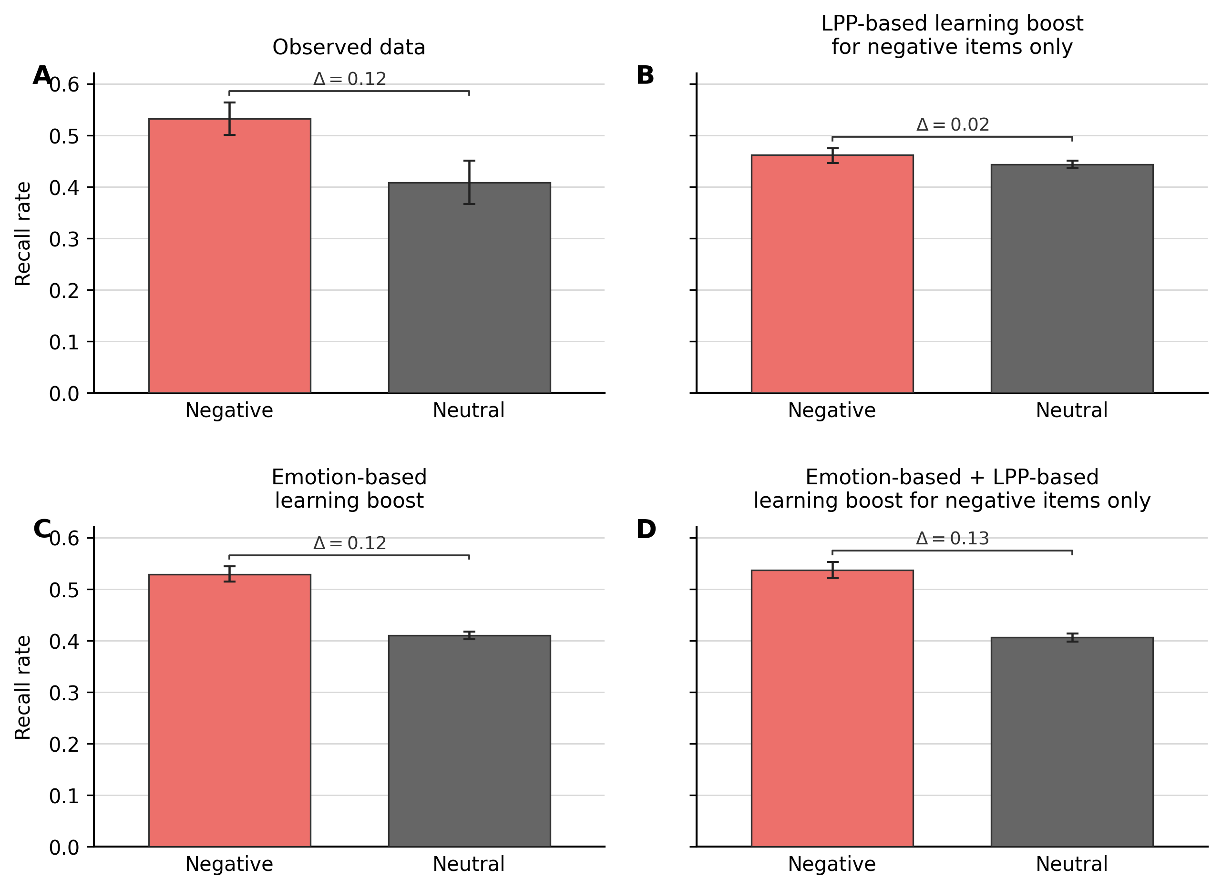

Figure 2
Observed and model-predicted original z-transformed Early LPP by item category and memory status. Brackets show remembered-minus-forgotten differences within each category. Observed error bars are 95% participant-bootstrap confidence intervals; predicted error bars are central 95% intervals across 200 complete simulated datasets.
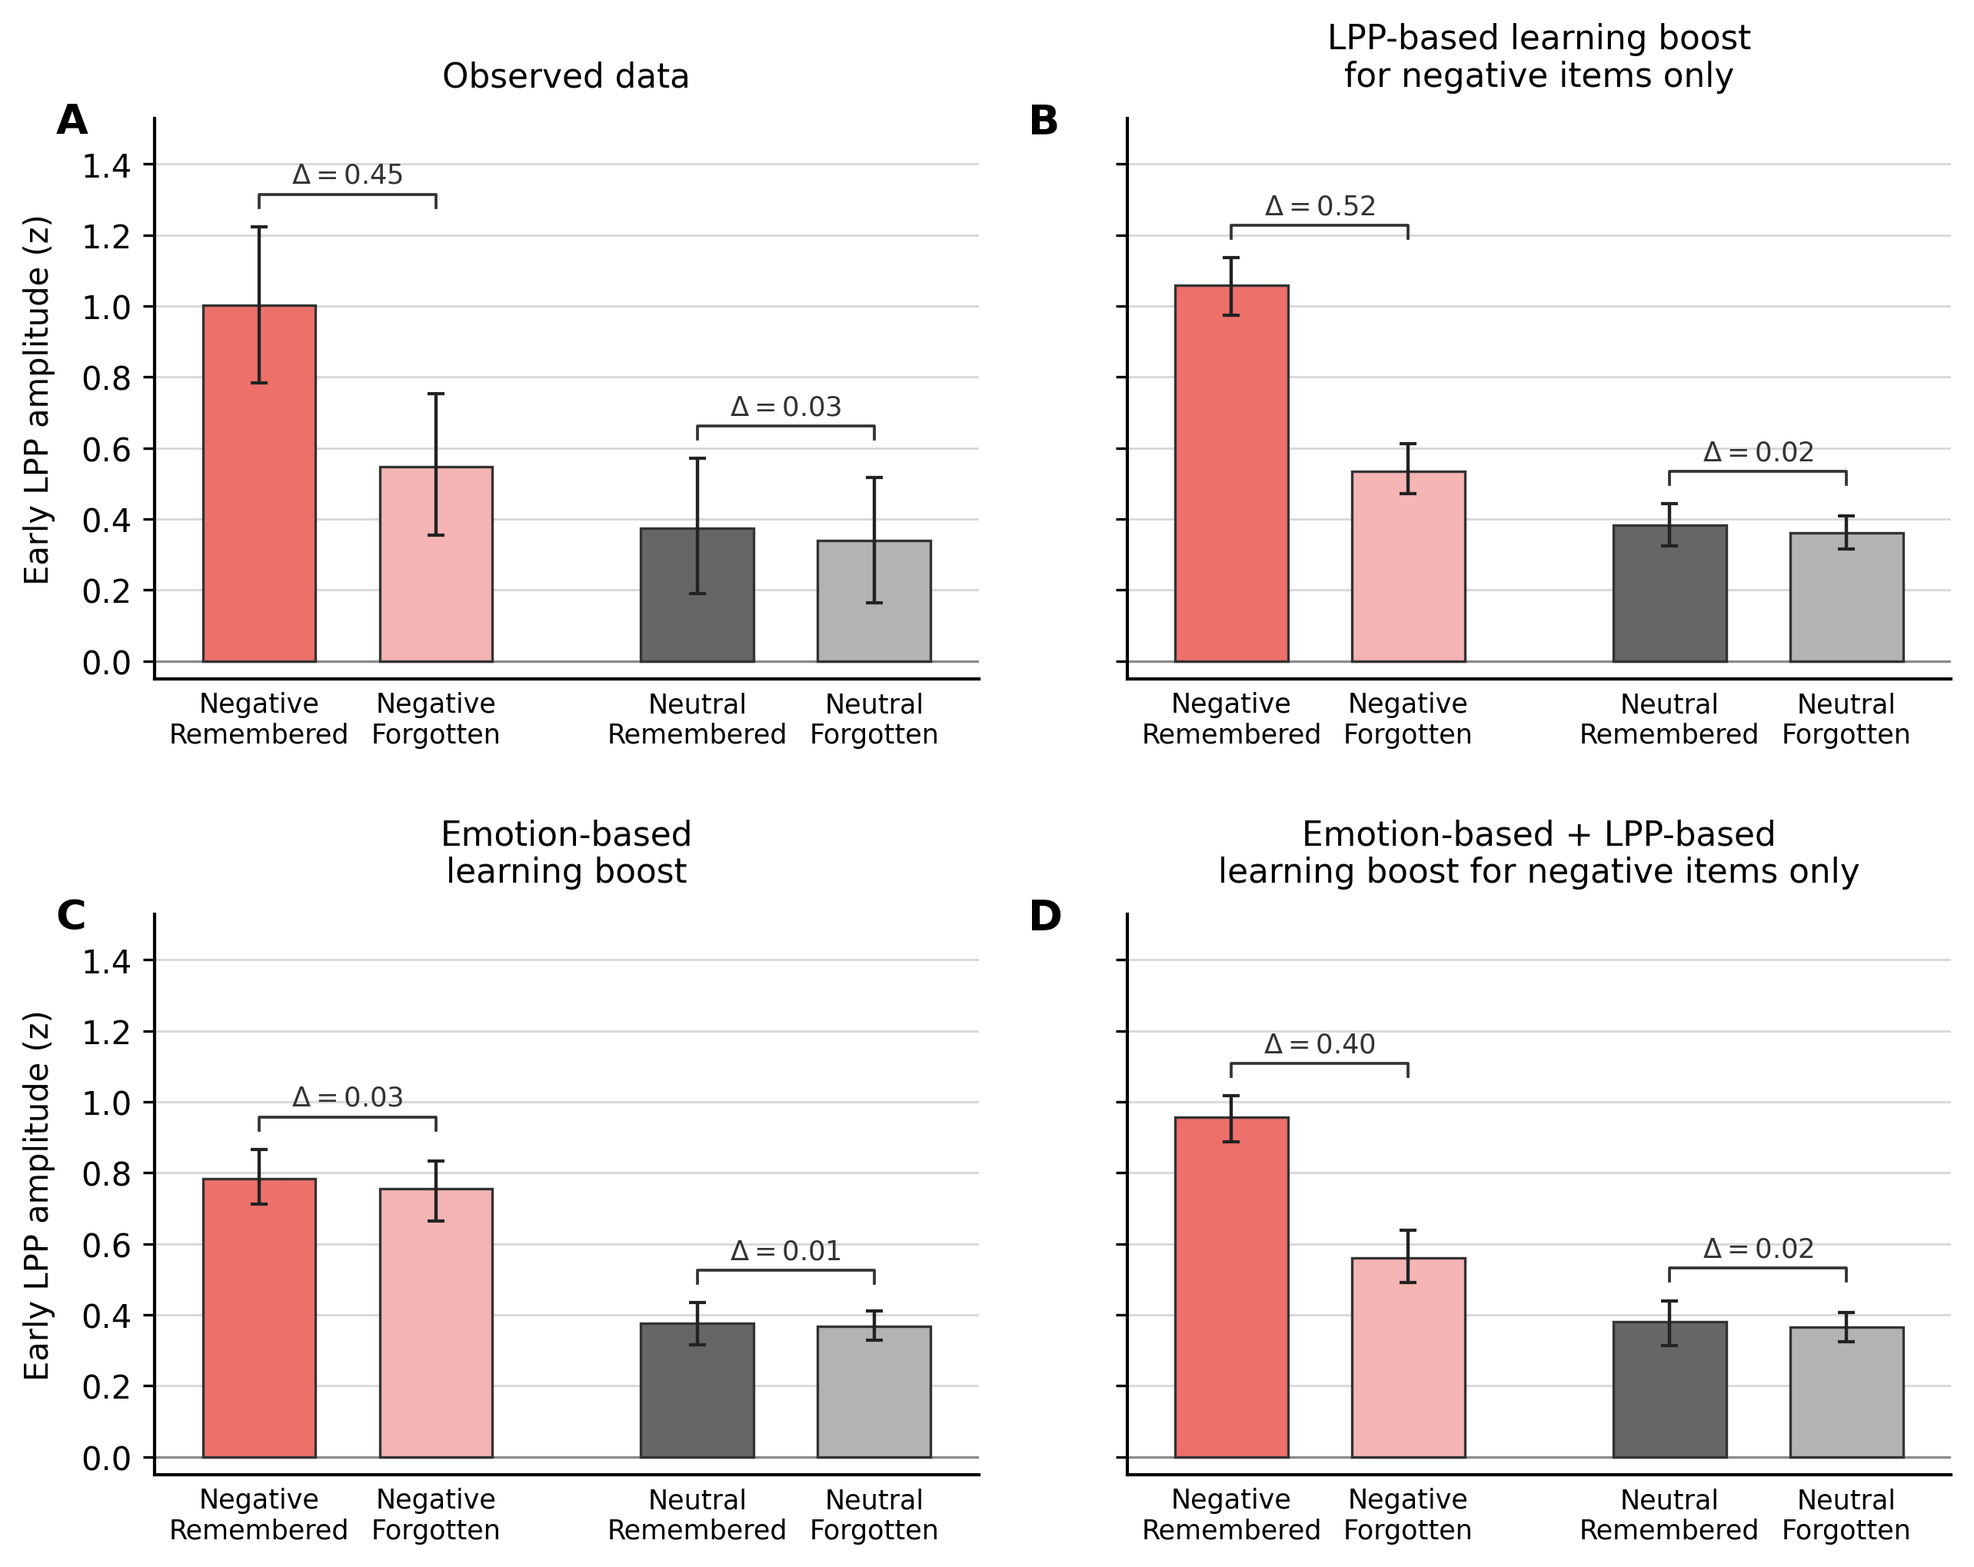

Burnham, K. P., & Anderson, D. R. (2002). Model selection and multimodel inference: A practical information-theoretic approach (2nd ed.). Springer. https://doi.org/10.1007/b97636
Howard, M. W., & Kahana, M. J. (2002). A distributed representation of temporal context. Journal of Mathematical Psychology, 46(3), 269–299. https://doi.org/10.1006/jmps.2001.1388
Polyn, S. M., Norman, K. A., & Kahana, M. J. (2009). A context maintenance and retrieval model of organizational processes in free recall. Psychological Review, 116(1), 129–156. https://doi.org/10.1037/a0014420
Storn, R., & Price, K. (1997). Differential evolution – a simple and efficient heuristic for global optimization over continuous spaces. Journal of Global Optimization, 11(4), 341–359. https://doi.org/10.1023/A:1008202821328
Talmi, D., Lohnas, L. J., & Daw, N. D. (2019). A retrieved context model of the emotional modulation of memory. Psychological Review, 126(4), 455–485. https://doi.org/10.1037/rev0000132

