Intrusive and Voluntary Memory from a Single System: A Retrieved-Context Account of Selective Interference

Jordan B Gunn
Department of Psychology, University of Cambridge

Author Note
This is an in-progress working draft. Please do not cite, quote, or circulate without the authors’ written permission.

Keywords: intrusive memories, voluntary memory, trauma-film paradigm, visuospatial intervention, selective interference, retrieved-context theory, computational modeling

Intrusive and Voluntary Memory from a Single System: A Retrieved-Context Account of Selective Interference

Abstract
In the trauma-film paradigm, visuospatial tasks performed after film encoding or a later film reminder can reduce intrusive memories while leaving voluntary memory relatively intact. This selective interference effect is often treated as evidence that intrusive and voluntary remembering depend on differently vulnerable memory representations. Here we simulate an alternative retrieved-context account in an emotional Context Maintenance and Retrieval (eCMR) model, in which unguided retrieval and deliberate recall draw on the same film and task associations but differ in how strongly retrieval is constrained toward film items. In the model, film context remains active after encoding and can later be reinstated by reminders, so an interfering task performed in either state associates task items with context states similar to film context. At retrieval, overlapping context can cue both film items and task competitors, reducing the probability that film items win retrieval even though stored film-item associations remain unchanged. Deliberate recall is less vulnerable when task goals provide a film-directed start cue and selection emphasizes film items over competitors; externally supplied film-related cues can also steer access toward film context across test formats. Together, the simulations reproduce selective impairment of unguided retrieval relative to deliberate recall and specify when the intrusion-voluntary-memory dissociation should be more or less pronounced, helping to interpret heterogeneity across empirical paradigms. Our results show that selective interference can arise from retrieval dynamics in a single retrieved-context system.

Introduction
Traumatic experience foregrounds a tension between durability and selectivity in episodic memory. A rational analysis of the functions of episodic memory suggests that highly consequential events should be retained well enough in memory that critical details remain accessible long into the future (XXX , also cite Boyle and Brown). At the same time, adaptive retrieval is selective: what comes to mind should normally depend on current concerns. Intrusive memories after trauma suggest that durable encoding can outpace regulatory control. In PTSD, the trauma event returns without being deliberately sought and without being well matched to the demands of the present (Brewin et al., 2010; Ehlers & Clark, 2000; Iyadurai et al., 2019; Krans et al., 2009). Understanding why such memories arise and how they differ from voluntary memory for the same event is therefore a shared target for both clinical science and basic memory theory.
The trauma-film paradigm provides a controlled setting for comparing intrusive and voluntary memory for the same event (Holmes & Bourne, 2008; James et al., 2016). Participants view distressing film material, record later intrusive memories of the film, and often complete voluntary-memory tests for the same material. This design makes it possible to ask whether the same encoded event can remain available to deliberate retrieval while becoming more or less likely to return involuntarily. In such research, voluntary memory can be relatively preserved, and its relationship to intrusion frequency can be weak, such that the two measures dissociate (Holmes et al., 2004; James et al., 2016). The same encoded episode can therefore support both involuntary and deliberate access, and these modes can come apart empirically (Holmes et al., 2004; Iyadurai et al., 2019).
Visuospatial interference tasks make this dissociation experimentally sharper. When brief tasks such as Tetris are performed after film encoding, subsequent intrusions can be reduced while voluntary memory for the same material shows little measurable impairment (Deeprose et al., 2012; Holmes et al., 2009, 2010; Lau-Zhu et al., 2019). Related post-reminder studies show that a reminder-plus-Tetris procedure can reduce later intrusions after a longer delay (James et al., 2015; Kessler et al., 2020). Similar procedures have also been extended to real-life traumatic events, including motor vehicle accidents, emergency caesarean section, and war-related trauma (Horsch et al., 2017; Iyadurai et al., 2018; Kanstrup et al., 2021). The effect of selective interference on involuntary memory has been supported by two recent meta-analyses, although the evidence base is heterogeneous, and there are recent reports of null effects, cautioning against treating the effect as settled (Asselbergs et al., 2023; Varma et al., 2024; Wessel et al., 2025). This selective interference effect therefore raises a theoretical question: when and why can a post-encoding or post-reminder manipulation alter one mode of retrieval more than another, even while both draw on the same recent experience?
One prominent family of interpretations treats the selective interference effect as evidence that the stored memory trace underlying intrusions is more vulnerable to interference than the memory supporting deliberate recall (Brewin et al., 1996; Brewin, 2014). Dual-representation accounts make this claim architecturally: traumatic experience is proposed to produce distinct sensory and contextual memory traces, with the first supporting involuntary re-experiencing and the second supporting deliberate recall (Brewin et al., 2010; Brewin, 2014). In immediate post-film interventions, a visuospatial task is then understood to compete with consolidation of the sensory or intrusion-supporting trace, reducing later intrusions while leaving the contextual trace and voluntary memory relatively preserved (Deeprose et al., 2012; Holmes et al., 2009, 2010). For post-reminder interventions, related interpretations often appeal to reconsolidation or post-reactivation restabilization: the reminder reactivates the relevant trace, and the interfering task disrupts its later availability (James et al., 2015; Kindt et al., 2009). Across these variants, selective interference is explained by treating the manipulation as acting more strongly on intrusion-supporting or reactivated memory than on the basis for deliberate recall.
Here we argue that selective interference need not be interpreted as evidence for separate memory representations. It may instead reflect differences in retrieval processes operating over a single memory trace. Mechanisms supporting selective, goal-directed retrieval in voluntary recall may be sufficient to sidestep or overcome interference that nonetheless reduces the likelihood of unintentional recall. On this interpretation, the selective interference effect reflects a capacity to intentionally focus retrieval on goal-relevant event information while reducing the influence of competing memories.
We formalize this proposal in an emotional variant (Cohen & Kahana, 2022; Talmi et al., 2019) of the Context Maintenance and Retrieval (CMR) framework (Polyn et al., 2009a) . Retrieved-context models treat context as a gradually changing state that is shaped by experience, reinstated by retrieval, and used to cue later memory search (Howard & Kahana, 2002; Polyn et al., 2009a; Sederberg et al., 2008). In CMR, items and context are linked by bidirectional associations: context cues candidate items, and retrieved or supplied items reinstate associated context (Polyn et al., 2009a, 2009b). Controlled retrieval can be represented in CMR in several ways: by allowing recall to begin from a cued or reinstated context, by varying how sharply context-to-item support is converted into item selection, and by monitoring sampled candidates against a retrieval target (Lohnas et al., 2015; Sederberg et al., 2008). Emotional CMR variants preserve these retrieved-context operations while adding an emotional-context pathway and emotion-dependent binding (Cohen & Kahana, 2022; Talmi et al., 2019). Together, these properties make CMR a principled setting for a single-system retrieved-context account of selective interference.
To map this framework onto the trauma-film paradigm, the model presents film, task, and delay-period items in sequence while context evolves. Film reminders can reinstate film-associated context before task encoding, so task items are encoded while context remains similar to states associated with film items. At retrieval, the current context state cues memory search, so film and task items are promoted for retrieval to the extent that they have been associated with similar context states. Unguided and deliberate retrieval can draw on the same learned associations while using different cues and applying enhanced monitoring during search. Whereas unguided retrieval remains broadly cue-driven by the current context – a simulation of involuntary recall - control processes during deliberate recall can keep search oriented toward film targets. The selective interference effect therefore reflects differential control over a shared associative memory, rather than selective vulnerability of separate memory representations.
The simulations decompose the account at the level where CMR makes concrete commitments: how recall is distributed across film, task, and delay-period items, and how that distribution changes when cues act on different parts of the item-context loop. Simulations 1 and 2 establish the core mechanism: reminder-driven task encoding creates position-structured overlap with the film context trajectory, and deliberate recall is protected when start-state control selects a diagnostic early-film context before retrieval. Simulations 3 and 4 then examine test-phase consequences of bidirectional item-context associations, testing whether supplied film information helps sidestep context-binding interference instantiated by task items. Simulation 5 examines possible accounts compatible with retrieved-context theory of how visuospatial interference tasks differ from comparison tasks in their effects on later memory, distinguishing encoding strength, context-drift, and source-context overlap accounts. The result is a mechanistic alternative to dual, differently-vulnerable memory representations, and a set of specific hypotheses about when selective interference should appear and how it should vary across paradigms.

A Retrieved-Context Account of Selective Interference
The simulations rely on three retrieved-context mechanisms. The first two are shared across all versions of CMR (). Context-to-item retrieval uses current context to cue candidate items. Competition follows when film items and task competitors are associated with similar context states. Item-to-context retrieval allows recalled items, reminder cues, and supplied film items to reinstate associated context. The third was proposed by ... Film-directed retrieval control changes the starting cue and selection rule used to favor film items over task competitors. Figure 1 shows how these mechanisms map onto the trauma-film paradigm.

Figure 1
A retrieved-context account of selective interference. Task items interfere when they are bound to film-associated context strongly enough to be cued with film items, and deliberate recall gains protection when control mechanisms favors film items within the same association set. (A) The simulated paradigm includes film encoding, a structured break, a film reminder, interference or comparison task, a delay period, and retrieval tests. (B) Film and task items remain distinct while becoming associated with context states active at encoding. Naturally within the CMR framework, contextual overlap makes task items likely to be cued alongside film items, and task encoding strength determines how strongly they compete once cued. (C) Context-to-item associations cue candidate items, and item-to-context associations let recalled, reminded, or supplied items reinstate associated context. (D) The same stored associations support unguided retrieval and deliberate recall, with deliberate recall gaining protection from a film-directed start cue and film-directed selection.
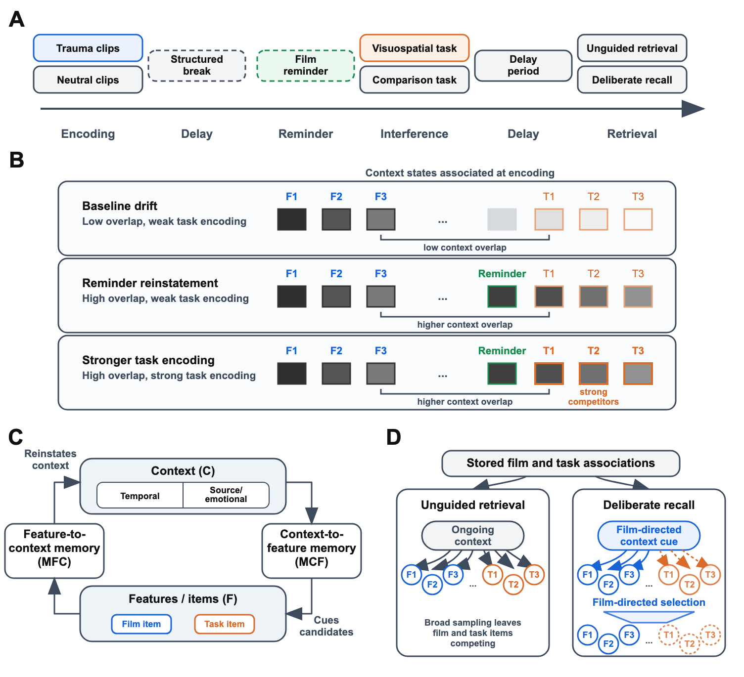

Contextual similarity is established during encoding. Film items and task items are distinct item representations, but each is linked to the context state active when it is encountered. Task items are most likely to share film-associated context when they are encoded soon after the film or after a reminder has reinstated film-associated context. Task items are also more likely to share film-associated context when they share a non-temporal feature with film items. Emotional extensions of CMR treat affect as one source-context dimension (Cohen & Kahana, 2022; Talmi et al., 2019), so when both film and task have the same valence (e.g. both neutral, or both negative), the emotional CMR framework simulates a shared “source context”. Delay periods, whether filled with distractor tasks at the lab or the daily activity of a participant at the end of the lab session, move context away from the film, reducing the likelihood that later retrieval cues film items and task competitors together. These conditions determine whether task “items” are likely to be cued alongside film “items”, with their relative encoding strength determining how successfully they compete at test. In the present model, shared source-context can amplify competition between film and task “items” share the marked source feature.
Context-to-item retrieval uses the current context state to cue candidate items. Unguided retrieval is the model’s analogue of conditions in which film memories come to mind with little guidance from task goals or external cues – a simulation of what happens when people are not intending to recall a past episode deliberately. When a retrieval context resembles states associated with both film items and task items, it acts as a weak cue for both of them. Such broad, weakly guided retrieval renders film “items” especially vulnerable to competition from task “items”: as task competitors receive support, any given film item becomes less likely to be selected for recall over competitor items. The size of this effect depends on the number of competitors, their learned support, and the similarity between their associated temporal or source-context states and film context. In the simulations reported below, task modality is represented through those quantities: the learned support task items receive and the similarity between task-associated context and film-associated context.
Item-to-context associations allow recalled items, reminder cues, and supplied film items to reinstate associated context. In ordinary recall, a retrieved item shifts context toward the state in which that item was encoded, making nearby studied items more likely to be retrieved next. This context-updating loop is the standard retrieved-context explanation of temporal contiguity and temporally organized recall (Howard & Kahana, 2002; Kahana, 1996; Sederberg et al., 2008). The same dynamics endure across filled delays and allow recent but irrelevant experiences to intrude during recall of a target episode, with intrusion frequency decaying gradually over intervening time (Howard et al., 2008; Lohnas et al., 2015; Zaromb et al., 2006). In experiments where there is a delay between film encoding and administration of the visuospatial interference task, a reminder of the film is often introduced before task encoding, typicallyinterpreted as memory reactivation (James et al., 2015; Kessler et al., 2020). On the present account, the reminder uses the same item-to-context pathway to reinstate film-associated context, paralleling temporal-context explanations of human post-reminder effects (Sederberg et al., 2011). Delayed interference is therefore graded by reminder strength and subsequent drift, because those quantities determine how much film-associated context remains available when the task is encoded.
The same item-to-context pathway also matters at test. During recall or monitoring, retrieved or presented items update context as retrieval unfolds. Retrieving a film item pulls context toward film-associated states and can support retrieval of additional film “items”, whereas retrieving a task competitor pulls context toward task-associated states and can prolong competition. Film-related cues supplied during test can likewise update context, making subsequent retrieval less dependent on internal cue maintenance. Retrieval tests that supply a film item can be less vulnerable to interference, because the supplied item reinstates associated context and reduces reliance on selecting film items from a mixed competitor set (Lau-Zhu et al., 2021).
Deliberate recall is represented as film-directed retrieval over the same stored associations. Its protection depends on how retrieval control changes the search. Like unguided recall, deliberate recall remains exposed to competitor interference. The first control lever is cue construction or start-state control, which can reinstate context from the beginning of the film sequence before recall and bias search toward film items. The second is competition focusing or filtering, which sharpens selection among candidates and favors strongly supported film items over weaker or off-target competitors. These levers yield graded protection from interference: deliberate recall can lose film items when competition is strong, but endogenous film-directed control can reduce that loss relative to broad retrieval from ongoing context.
The simulations reported below instantiate these commitments in an emotional CMR model (Cohen & Kahana, 2022; Talmi et al., 2019). The model departs from standard list-learning applications of CMR in two ways. First, film, delay periods, film reminder and post-film task form a continuous encoded stream. The film reminder reinstates film-associated context before task encoding. Second, non-film events, including both task “items” and those that participants encounter during delay periods are simulated as distinct, recallable items that can compete with film items during retrieval. This setup lets selective interference appear as a redistribution of retrieval across encoded phases, rather than as a direct reduction in film-item strength.

Model Specification
The formal model keeps the standard CMR separation between item features, context, feature-to-context memory, and context-to-feature memory. The section first defines these inherited representations and baseline parameters, then specifies the context-updating, learning, retrieval, and control operations used to configure the selective-interference simulations.

Representations and Parameters
Each study event $i$ has an orthonormal feature vector $f_{i}∈R^{N}$, where $N$ is the number of encoded item features in the simulated paradigm. The model maintains a unit-length context vector $c_{i}∈R^{D}$, where $D$ is the number of context units. The core context units represent the start state and item-associated temporal context. Before encoding begins, context is initialized to the start state $c_{0}$, with the start unit active and item-associated temporal-context units inactive. Subsequent events update this state, so the context associated with each film, task, or filler item depends on where it occurs in the continuous paradigm stream. The model contains two associative matrices. The matrix $M^{FC}∈R^{D×N}$ maps feature vectors to context input. The matrix $M^{CF}∈R^{N×D}$ maps context to feature support. All vectors are treated as column vectors, so $M^{FC}f$ is a context vector and $M^{CF}c$ is a feature-support vector.
Table 1 lists the symbolic base parameters used by the model. The table separates parameters that define the inherited CMR operations from parameters later scaled or manipulated in the simulations; numerical values and phase settings are specified in the simulation methodology.

Table 1
Base parameters and roles in the model specification.
Symbol | Name | Role
$β_{enc}$ | encoding drift rate | Context drift during study
$β_{start}$ | start-cue parameter | Start-of-list context reinstatement or film-directed cueing
$β_{rec}$ | recall drift rate | Context drift after recall
$γ$ | feature-to-context learning rate | Learning rate for $M^{FC}$
$λ$ | context-to-feature learning scale | Baseline or phase-scaled learning rate for $M^{CF}$
$α$ | shared support | Pre-experimental shared support in $M^{CF}$
$δ$ | self support | Pre-experimental self-support in $M^{CF}$
$ϕ_{s}$ | primacy scale | Initial boost to context-to-feature learning
$ϕ_{d}$ | primacy decay | Decay rate of primacy boost
$τ$ | choice sensitivity | Sharpness of retrieval competition
$β_{emot}$ | source-context drift rate | Source context drift
$ϕ_{emot}$ | source learning scale | Learning scale for the marked source feature
$κ$ | target-monitoring scale | Reduced context updating after sampled off-target candidates when target monitoring is enabled
$θ_{s}$ | stop scale | Baseline stopping probability
$θ_{r}$ | stop growth | Growth of stopping probability across retrieval-attempt positions
Pre-experimental associations represent background memory structure already present before the simulated paradigm begins. They give each item baseline self-support and shared support, so later retrieval reflects both pre-existing structure and associations learned during the film, task, and filler phases. The selective-interference simulations vary the new associations formed across phases. These baseline associations are fixed model architecture and are held constant across the selective-interference simulations. For the start unit and item-associated temporal context units:
$$M_{pre}^{FC}\left(j,i\right)=\left\{\begin{matrix}1−γ & \text{if }j=i+1 \\ 0 & \text{otherwise}\end{matrix}\right. \left(1\right)$$
$$M_{pre}^{CF}\left(i,j\right)=\left\{\begin{matrix}0 & \text{if }j=0 \\ δ & \text{if }j=i+1 \\ α & \text{if }j>0\text{ and }j≠i+1\end{matrix}\right. \left(2\right)$$
The start context has no pre-experimental context-to-feature support. For context units corresponding to items, $δ$ gives each item self-support and $α$ gives all other items shared support. This initialization supplies baseline support before experimental learning.

Context Updating, Learning, and Retrieval
Context updating defines both gradual drift during encoding and reinstatement by recalled, reminded, or supplied items. The same feature-to-context operation updates context when an item is encoded, recalled, or supplied as a cue. When feature $f_{i}$ is active, it probes feature-to-context memory to retrieve context input:
$$c_{i}^{IN}=M^{FC}f_{i} \left(3\right)$$
The model normalizes this input to unit length, yielding ${\hat{c}}_{i}^{IN}$. Context then drifts toward the normalized input with a drift rate $β$:
$$c_{i}=ρ_{i} c_{i−1}+β {\hat{c}}_{i}^{IN} \left(4\right)$$
Let $d_{i}=c_{i−1}⋅{\hat{c}}_{i}^{IN}$. The normalization coefficient is:
$$ρ_{i}=\sqrt{1+β^{2}\left(d_{i}^{2}−1\right)}−βd_{i} \left(5\right)$$
The coefficient $ρ_{i}$ is the nonnegative solution that keeps $c_{i}$ at unit length. Associative learning defines how encoded film, task, and filler events become later retrieval candidates. When a new event is encoded, the active feature and updated context are associated via outer-product learning. Feature-to-context associations update as:
$$ΔM^{FC}=γc_{i}f_{i}^{⊤} \left(6\right)$$
A primacy function weights context-to-feature learning:
$$ϕ_{i}=ϕ_{s} e^{−ϕ_{d}⋅i}+1 \left(7\right)$$
Context-to-feature associations update as:
$$ΔM^{CF}=λϕ_{i}f_{i}c_{i}^{⊤} \left(8\right)$$
Here, $λ$ scales context-to-feature learning, while $ϕ_{s}$ and $ϕ_{d}$ define the size and decay of the primacy boost. Retrieval uses the current context state to assign support to candidate items, sample from the resulting competition, and terminate the sampling sequence. During context-guided retrieval, current context cues encoded items through $M^{CF}$:
$$a_{i}={\left[M^{CF}c\right]}_{i} \left(9\right)$$
The choice sensitivity $τ$ sharpens competition among candidates:
$$A_{i}=a_{i}^{τ} \left(10\right)$$
The probability of sampling item $i$, conditional on continuing retrieval, follows a Luce choice rule over currently unsampled items:
Pi∣continue=Aik​Ak 11
At each retrieval step, the model may terminate with probability $P_{stop}\left(j\right)$ or sample an item with probability $\left(1−P_{stop}\left(j\right)\right)⋅P\left(i∣\text{continue}\right)$. Termination probability grows with retrieval-attempt position:
$$P_{stop}\left(j\right)=θ_{s}e^{jθ_{r}} \left(12\right)$$
Here, $j$ is the number of items already sampled, $θ_{s}$ sets the baseline termination probability, and $θ_{r}$ controls its growth. In simulations, this value is bounded to remain a valid probability. After a sampled item $r_{j}$, context is updated through the same feature-to-context pathway:
$$c_{j+1}=ρ_{rec,j} c_{j}+β_{rec} \hat{M^{FC}f_{r_{j}}} \left(13\right)$$
This sampled-item update drives context toward the sampled item’s encoding neighborhood, biasing subsequent retrievals toward nearby items and producing temporal organization in retrieval. Encoding operations use the context update and learning equations together, whereas reminders, sampled items, and supplied film items use the context update without adding a new recallable event.

Retrieval Control
Retrieval-control settings alter the starting state and selection process used by the same context-to-feature retrieval operation. Unguided retrieval and deliberate recall use the same retrieval-support and choice rules in Equation 9 and Equation 11. They differ in the control settings applied to the retrieval state and sampling process. The first deliberate-recall control setting is film-directed start/context cueing:
$$c_{\text{start}}=ρ_{\text{start}} c_{N}+β_{start} c_{0} \left(14\right)$$
Here, $ρ_{\text{start}}$ is calculated from Equation 5 using $β_{start}$. Simulation settings can use the fitted $β_{start}$ value directly or multiply it to vary the degree of start-of-list context reinstatement. The second control setting is sharper selection, implemented by scaling $τ$. Higher $τ$ sharpens competition among all candidates. It protects film recall only when film-directed cueing gives film items stronger support than task competitors. The third control setting is target monitoring after an off-target item is sampled. Let $t_{i}=1$ for film items and $t_{i}=0$ otherwise, and define $κ_{i}=t_{i}+\left(1−t_{i}\right)κ$. Target monitoring modifies the sampled-item context update in Equation 13. With target monitoring, the context update after sampled item $i$ becomes:
$$c_{j+1}=ρ_{rec,j} c_{j}+κ_{i}β_{rec} \hat{M^{FC}f_{i}} \left(15\right)$$
When $κ<1$, sampled off-target candidates have less influence on the next context state than sampled film items. This convention is used for deliberate recall when simulations manipulate rejected-sample updating. Tests that supply a film item are represented as cue-driven context reinstatement using the same feature-to-context input operation as Equation 3:
$$c_{\text{film}}^{IN}=M^{FC}f_{\text{film}} \left(16\right)$$
Supplied film items therefore use the same feature-to-context operation as sampled and reminded items.

Source Context
The source-context pathway adapts the emotional/source-context machinery of eCMR and CMR3 to the present trauma-film setting. In published emotional CMR models, emotional features update a source-context subregion and can form item-context associations (Cohen & Kahana, 2022; Talmi et al., 2019). Here, we use the same architectural role for a simplified film-source dimension: a non-temporal context feature that can organize recall when shared across items (Cohen & Kahana, 2022; Polyn et al., 2009a; Talmi et al., 2019). In the present simulations, this pathway is represented by a simplified source feature vector $s_{i}$ with a marked film/source feature and a neutral/default feature. Film items are assigned the marked source feature, whereas break, task, and filler items are assigned the neutral/default feature unless a later source-overlap manipulation states otherwise. The source feature vector initializes $M_{emot}^{FC}$ so that an item can cue its source-context components:
$$M_{emot}^{FC}\left(⋅,i\right)=\left(1−γ\right)s_{i} \left(17\right)$$
Source-context-to-feature support begins at zero:
$$M_{emot}^{CF}\left(i,⋅\right)=0 \left(18\right)$$
Thus, source context can update during experience before it contributes retrieval support. Source-context components use the same context-update rule in Equation 4 with source-context drift rate $β_{emot}$. Let $η_{s}$ denote baseline source-context-to-feature learning and let $ϕ_{emot,i}$ denote added learning for item $i$ in the marked source pathway. With the binary vector above, $ϕ_{emot,i}=ϕ_{emot}{\left[s_{i}\right]}_{1}$, so film items assigned the marked source feature receive $ϕ_{emot}$ and neutral/default items receive 0. When source-context learning is engaged, the source components of context receive additional context-to-feature learning:
$$ΔM_{emot}^{CF}=λϕ_{i}\left(η_{s}+ϕ_{emot,i}\right)f_{i}c_{emot,i}^{⊤} \left(19\right)$$
Here, $c_{emot,i}$ denotes the source components of context. Source-context support enters retrieval through learned source context-to-feature associations and contributes to the same competition defined in Equation 9. Because $η_{s}$ is nonzero in the current simulations, neutral/default items can weakly bind the source context active during encoding without being assigned the marked film/source feature. This lets task items inherit some influence from reinstated film-source context when the task is encoded after a film reminder, while still preserving a distinction between marked film items and neutral task competitors.
At retrieval onset, all simulations include a fixed partial reinstatement of the marked film-source context. This operation represents the test setting orienting retrieval toward the film episode at the level of source context. It is distinct from the temporal start-of-list cue manipulated in Simulation 2: an unguided-retrieval condition lacks deliberate temporal start-of-list reinstatement, but it is not a condition with no film-relevant test orientation at all. Task items are assigned the marked source feature only in later source-overlap variants. When film and task items share the marked source feature and source context-to-feature learning is enabled, Equation 19 can amplify competition beyond temporal proximity alone.
These equations define the item-context architecture used in all simulations. Because retrieval proceeds as a sequence of competitive samples terminated by a growing stop probability, task competitors can reduce film-item access by winning individual retrieval competitions before search terminates.

Simulations
The simulations instantiate the retrieved-context account in a controlled trauma- analogue laboratory task where immersing oneself in a film that depict threats, injuries, and death is used to investigate the memory processes that underly response to real-life trauma (XXX cite review, perhaps James). Simulations are organized into three linked groups: a core context-binding and retrieval-control demonstration, cue and test-format consequences of bidirectional item-context associations, and task-property boundary conditions. Simulation 1 shows how a post-reminder task attenuates film recall when task items receive strong context-to-feature learning in context states that overlap with the film trajectory. Simulation 2 adds the intentionality manipulation by comparing unguided retrieval with deliberate recall and then decomposing the film-directed control settings that protect deliberate recall. Simulation 3 varies test-phase film-item cues drawn from the film sequence to separate cue-driven film access from diagnostic retrieval control. Simulation 4 compares context-to-item recall with supplied-item access formats. Simulation 5 examines which task properties make the post-film task effective, including task-item learning strength, contextual similarity, and source-context overlap.

Methodology
Base parameters were anchored to an existing immediate free-recall dataset in which participants who reported concern about the war in Ukraine studied and recalled lists of war-related and neutral photographs (Dupertuys et al., 2026). The fitted dataset included 123 participants, four lists per participant, 492 immediate recall sequences, and 3,804 scored recall events. This dataset provides an externally estimated eCMR regime for deliberate context-guided recall of affective and neutral photographs. The fitted parameters set baseline encoding, retrieval, and stopping dynamics before the selective-interference manipulations are applied as phase-specific encoding or retrieval-control settings. In these simulations, film items reinstate the marked source feature into source context, neutral/default events can weakly bind active source context, and retrieval begins with partial film-source reinstatement. To accommodate the difference in total encoded items between the immediate-recall paradigm and the current simulations, the primacy profile is also moderated relative to the immediate-recall fit so that the film sequence is not dominated by an unrealistically steep first-item advantage. Table 2 gives the default numerical values used in the current simulations.

Table 2
Default numerical parameter values. Values are from a pooled eCMR fit to the immediate free-recall sequences from Dupertuys et al. (2026), with $α$ fixed to zero, except for the source-context and primacy settings described in the text.
Symbol | Value | Role
$β_{enc}$ | 0.440 | Encoding drift rate
$β_{start}$ | 0.766 | Start-cue parameter
$β_{rec}$ | 0.678 | Recall drift rate
$γ$ | 0.468 | Feature-to-context learning rate
$δ$ | 0.00022 | Pre-experimental self-support
$α$ | 0 | Pre-experimental shared support
$ϕ_{s}$ | 0.100 | Primacy scale used in simulations
$ϕ_{d}$ | 1.500 | Primacy decay used in simulations
$τ$ | 3.562 | Choice sensitivity
$β_{emot}$ | 0.696 | Source-context drift rate
$ϕ_{emot}$ | 0.130 | Learning scale for the marked source feature
$η_{s}$ | 0.050 | Baseline source-context-to-feature learning
$β_{film−source}$ | 0.500 | Fixed film-source reinstatement at retrieval onset
$θ_{s}$ | 0.0123 | Stop scale
$θ_{r}$ | 0.372 | Stop growth
The current simulations update associations after context integration and disallow repeated sampling of the same item.
Each simulated trial contains 16 film items, 16 break/buffer items, 16 task items, and 16 filler items. Equal phase lengths make redistribution across film, task, and filler periods directly comparable. Retrieval allows up to 48 sampling attempts. In context-to-item recall simulations, all encoded film, break/buffer, task, and filler items can enter the retrieval competition. The simulated retrieval sequence records sampled candidates rather than only final accepted responses. This convention lets target monitoring count an off-target sample as a retrieval attempt, attenuate its context update, and still allow search to continue.
Film, break/buffer, task, and filler items are encoded by the same CMR operations defined above. Phase settings control temporal drift and context-to-feature learning strength. In the no-reminder condition used for Simulation 1, the reminder-start and film-item reminder-cue drift scales are set to zero. In the with-reminder condition, context first shifts toward the start state and then receives sequential film-item reminder cues before task encoding. Reminder cues update context through Equation 3 and Equation 4, but they do not apply Equation 6 or Equation 8 and do not add new recallable items. Table 3 summarizes the phase structure and settings used for the current Figure 2 simulations.

Table 3
Phase structure and settings for the current Figure 2 simulations. Scale values multiply the corresponding base rates or learning strengths.
Phase or setting | Current value | Role
Film items | 16 | Target episode
Break/buffer items | 16 | Intervening non-film experience before reminder/task
Film reminder cues | 16 | Sequential film-item cues, no new learning
Task items | 16 | Potential competitors
Filler items | 16 | Post-task non-film experience
Maximum sampling attempts | 48 | Upper bound on sampled retrieval attempts
Simulated trials per sweep cell | 5000 | Replications used for Figure 2 estimates
Break and filler drift/learning scales | 1.0 | Baseline non-film encoding settings
No-reminder drift scales | 0.0 | Omits reminder-start and reminder-cue reinstatement
With-reminder drift scales | 1.0 | Applies reminder-start and film-item cue reinstatement
Task learning factor | 0.0–3.0 by 0.5 | Multiplies task-phase context-to-feature learning
Film source marking | On | Film items carry the marked source feature
Task source marking | Off | Task items use the neutral/default source feature
Baseline source learning | 0.05 | Neutral/default items weakly bind active source context
Film-source retrieval orientation | 0.5 | Fixed partial reinstatement of marked film-source context at retrieval onset
For each condition and sweep value, the model encodes the phase sequence, enters retrieval, samples recallable items using Equation 11 and Equation 12, and repeats this process across simulated trials. Serial-position curves estimate the probability that each encoded position appears at least once in the sampled retrieval sequence. The model-state analyses in Figure 2 quantify two quantities that explain the behavioral curves. The context-similarity analysis computes cosine similarity between unit-normalized temporal context states associated with film-item encoding and temporal context states active during task-item encoding. The support-allocation analysis forms a film-context cue from the centroid of film encoding context states, applies that cue to $M^{CF}$ after task encoding, and computes task support divided by the sum of film and task support.

Simulation 1: Task Encoding and Contextual Overlap
Simulation 1 demonstrates how a post-film task can reduce later film recall when task events are encoded in context states that overlap with the film sequence. To separate task encoding strength from reminder-driven context reinstatement, the simulation sweeps the task learning factor under no-reminder and with-reminder conditions. The plotted task learning factor multiplies task-phase context-to-feature learning in Equation 8. Retrieval settings are held fixed, so differences in recall reflect the item-context associations formed before retrieval rather than changes in retrieval control. Because context evolves continuously, the reminder manipulation also predicts where along the film sequence recall is lost, not only how much film recall changes. Simulation 2 then examines whether film-directed retrieval control can protect recall by cueing a more diagnostic part of the film trajectory.

Figure 2
Reminder-driven context overlap makes task encoding strength consequential for film recall. Simulation 1 demonstrates how task items can become competitors for film recall by varying task encoding strength with or without a sequential film-item reminder before task encoding. (A) Without a film reminder, task items become associated with later context states reached after drift away from the film, so stronger task encoding produces only modest redistribution from film items to task items. (B) With a film reminder, task items become associated with context states more similar to those associated with film items, so stronger task encoding produces larger redistribution from film items to task items. (C) The temporal-context trace remains position-resolved: reminder cues make the states active during task encoding more similar to positions along the film context trajectory. (D) When the model is probed with a broad film-context cue and the active source context, stronger task encoding assigns a larger share of item support to task items, especially after a film reminder.
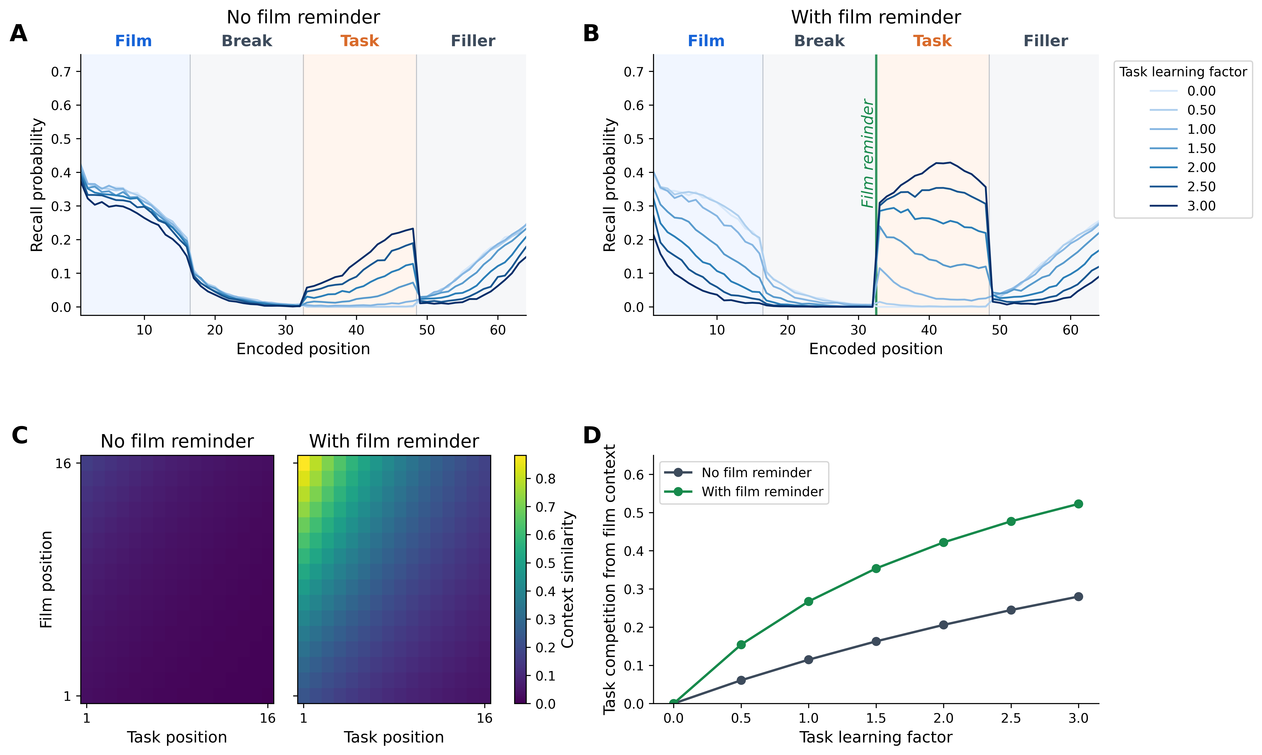
Panels A and B show phase-resolved recall probability across encoded positions. Without a film reminder, increasing task learning produces only modest loss of film recall and only modest gain in task recall, because task items become associated with later context states reached after drift away from the film. With a film reminder, the same task-learning manipulation produces a much larger redistribution from film positions to task positions. The with-reminder condition therefore shows that task encoding strength matters most when task “items” are associated with nearby positions on the film context trajectory. The serial-position curves also show that this temporal overlap is not uniform across film positions, even though the fixed source-context settings provide broader support for film items than temporal context alone. Because the sequential reminder drives context through film-item cues before task encoding, the strongest task competition arises when task items are encoded with both recent film-temporal context and active film-source context. At the endpoints of the task-learning sweep, mean film recall in the no-reminder condition changes from 0.318 at task learning factor 0.0 to 0.268 at factor 3.0, while mean task recall changes from 0.000 to 0.143. In the with-reminder condition, mean film recall changes from 0.306 to 0.064, while mean task recall changes from 0.000 to 0.384.
Panels C and D explain why the no-reminder and with-reminder curves diverge. Panel C quantifies temporal-context similarity between the states associated with film items and the states active during task encoding. When a sequential film-item reminder reinstates the film trajectory before task encoding, the model encodes task items in states more similar to film-associated positions. Panel D quantifies how much support task items receive from a broad film-context centroid cue after task encoding, including the source-context support available at that point in the paradigm. As task context-to-feature learning increases, task items receive a larger share of item support when this broad film-associated cue probes retrieval, especially after the film reminder. Across the task-learning sweep, film encoding settings remain unchanged. The loss of film recall comes from stronger support for task items that can be cued by film-associated context. Task items remain distinct from film items but become increasingly likely to win retrieval from film-related cues. Simulation 2 next examines whether film-directed retrieval control reduces the impact of these task-item associations by cueing a more diagnostic part of the film trajectory.

Simulation 2: Retrieval Control and Film-Directed Recall
Simulation 2 turns from encoding conditions to retrieval control. It decomposes deliberate recall into three film-directed control operations: start-of-list context reinstatement, selection sharpening, and target monitoring. Figure 3 isolates the first operation. In the model, deliberate recall can begin by drifting current context toward the start-of-list state before the first retrieval attempt. Because film items are encoded first, the start-of-list state is film-relevant in the present paradigm: reinstating it changes the context used to cue the first retrieval competition while leaving the learned film and task associations otherwise unchanged. This operation differs from test-phase film-item cueing: it targets the beginning of the film trajectory, where the retrieval context is more diagnostic of film items than of late non-film competitors. All conditions in the current Simulation 2 figures also include the fixed film-source retrieval orientation described above. Thus, “no start-of-list reinstatement” means no deliberate temporal start cue, not the absence of any film-relevant test context. The simulation holds the post-reminder task condition fixed at task learning factor 2.0 and varies the degree of start-of-list context reinstatement. The plotted reinstatement values are multiples of the fitted start-cue parameter, so 1.0 corresponds to $β_{start}$ in Equation 14.

Figure 3
Start-of-list context reinstatement protects deliberate film recall by changing the context that cues retrieval. Simulation 2 demonstrates how a deliberate-recall start operation can protect film recall after post-reminder task encoding by drifting retrieval context toward the start-of-list state immediately before the first retrieval attempt. (A) Before any item is sampled, stronger start-of-list context reinstatement makes the retrieval context support early film items rather than late filler items. (B) This pre-recall support shift makes recall more likely to begin with film items, especially items from the beginning of the film sequence. (C) Across the sampled retrieval sequence, stronger start-of-list context reinstatement increases access to film items, with the largest gains concentrated near the beginning of the film sequence. Because sampled early film items reinstate nearby early-film context, and because context drifts gradually during retrieval, a start-of-recall context shift can affect later samples as well as the first sampled item.
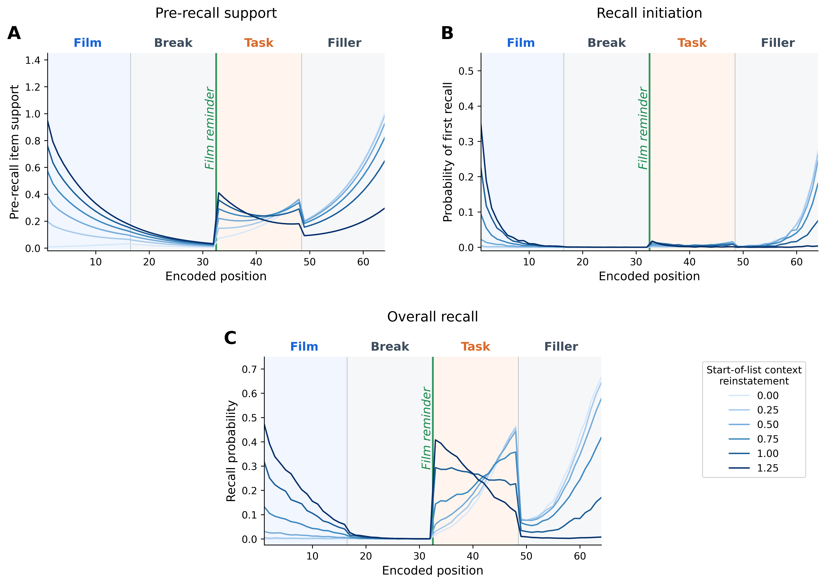
Panel A probes $M^{CF}$ with the pre-recall retrieval context before Luce choice, stopping, or sampled-item context updating. With no start-of-list context reinstatement, support is concentrated in late filler positions because the retrieval context reflects the post-filler state. As start-of-list context reinstatement increases, support shifts toward early film positions. Panels B and C apply the same retrieval settings to sampled retrieval sequences. Panel B shows that this support shift changes recall initiation, with first recalls moving from filler positions when start-of-list context reinstatement is omitted to early film positions as reinstatement increases. Panel C shows that the initiation shift has full-sequence consequences: sampled early film items reinstate nearby early-film context and raise film-item access across subsequent samples. Under the strong task setting used here, task items remain available to be sampled later in the sequence, so the next step is to examine how selection operates once a retrieval cue has been set.
The second control setting is retrieval selectivity. This manipulation scales the choice-sensitivity parameter $τ$ in Equation 10, changing how sharply candidate support is converted into selection probability. It does not supply a film cue by itself. Instead, it makes the current context more consequential. Figure 4 crosses retrieval selectivity with start-of-list context reinstatement while holding the same post-reminder task condition fixed. The final panel introduces target monitoring as a post-off-target recovery operation. Here, target monitoring refers to control engaged after a sampled candidate is recognized as off target: the operation can reduce how strongly that candidate pulls subsequent search away from film context that is already accessible. The concrete CMR-style implementation used here is rejected-sample updating. Sampled off-target candidates still occupy retrieval attempts, but their context update is multiplied by $κ$, with $κ=1$ giving the normal sampled-item update and $κ=0$ preventing off-target context updating.

Figure 4
Retrieval selectivity sharpens the current search path, while target monitoring limits drift after off-target samples. Simulation 2 demonstrates why deliberate recall requires more than globally sharper selection by first varying retrieval selectivity after post-reminder task encoding, with or without start-of-list context reinstatement, and then examining a rejected-sample implementation of off-target recovery. (A) With start-of-list reinstatement, higher retrieval selectivity increases short-lag transitions, indicating stronger local search around the currently active temporal neighborhood. (B) Without start-of-list reinstatement, sharper local search amplifies recall of late non-film items because the ongoing retrieval context most strongly supports those positions. (C) With start-of-list reinstatement, the same increase in retrieval selectivity amplifies recall of film items because retrieval begins from context that supports the start of the film sequence. (D) A concrete rejected-sample implementation shows the same constraint: reducing the context update after off-target samples helps retrieval return to film items only when start-of-list reinstatement has already made film items accessible. Together, the panels show that selection sharpening is conditional on the current retrieval context, whereas target monitoring can limit the aftereffects of off-target samples without supplying a film cue by itself.
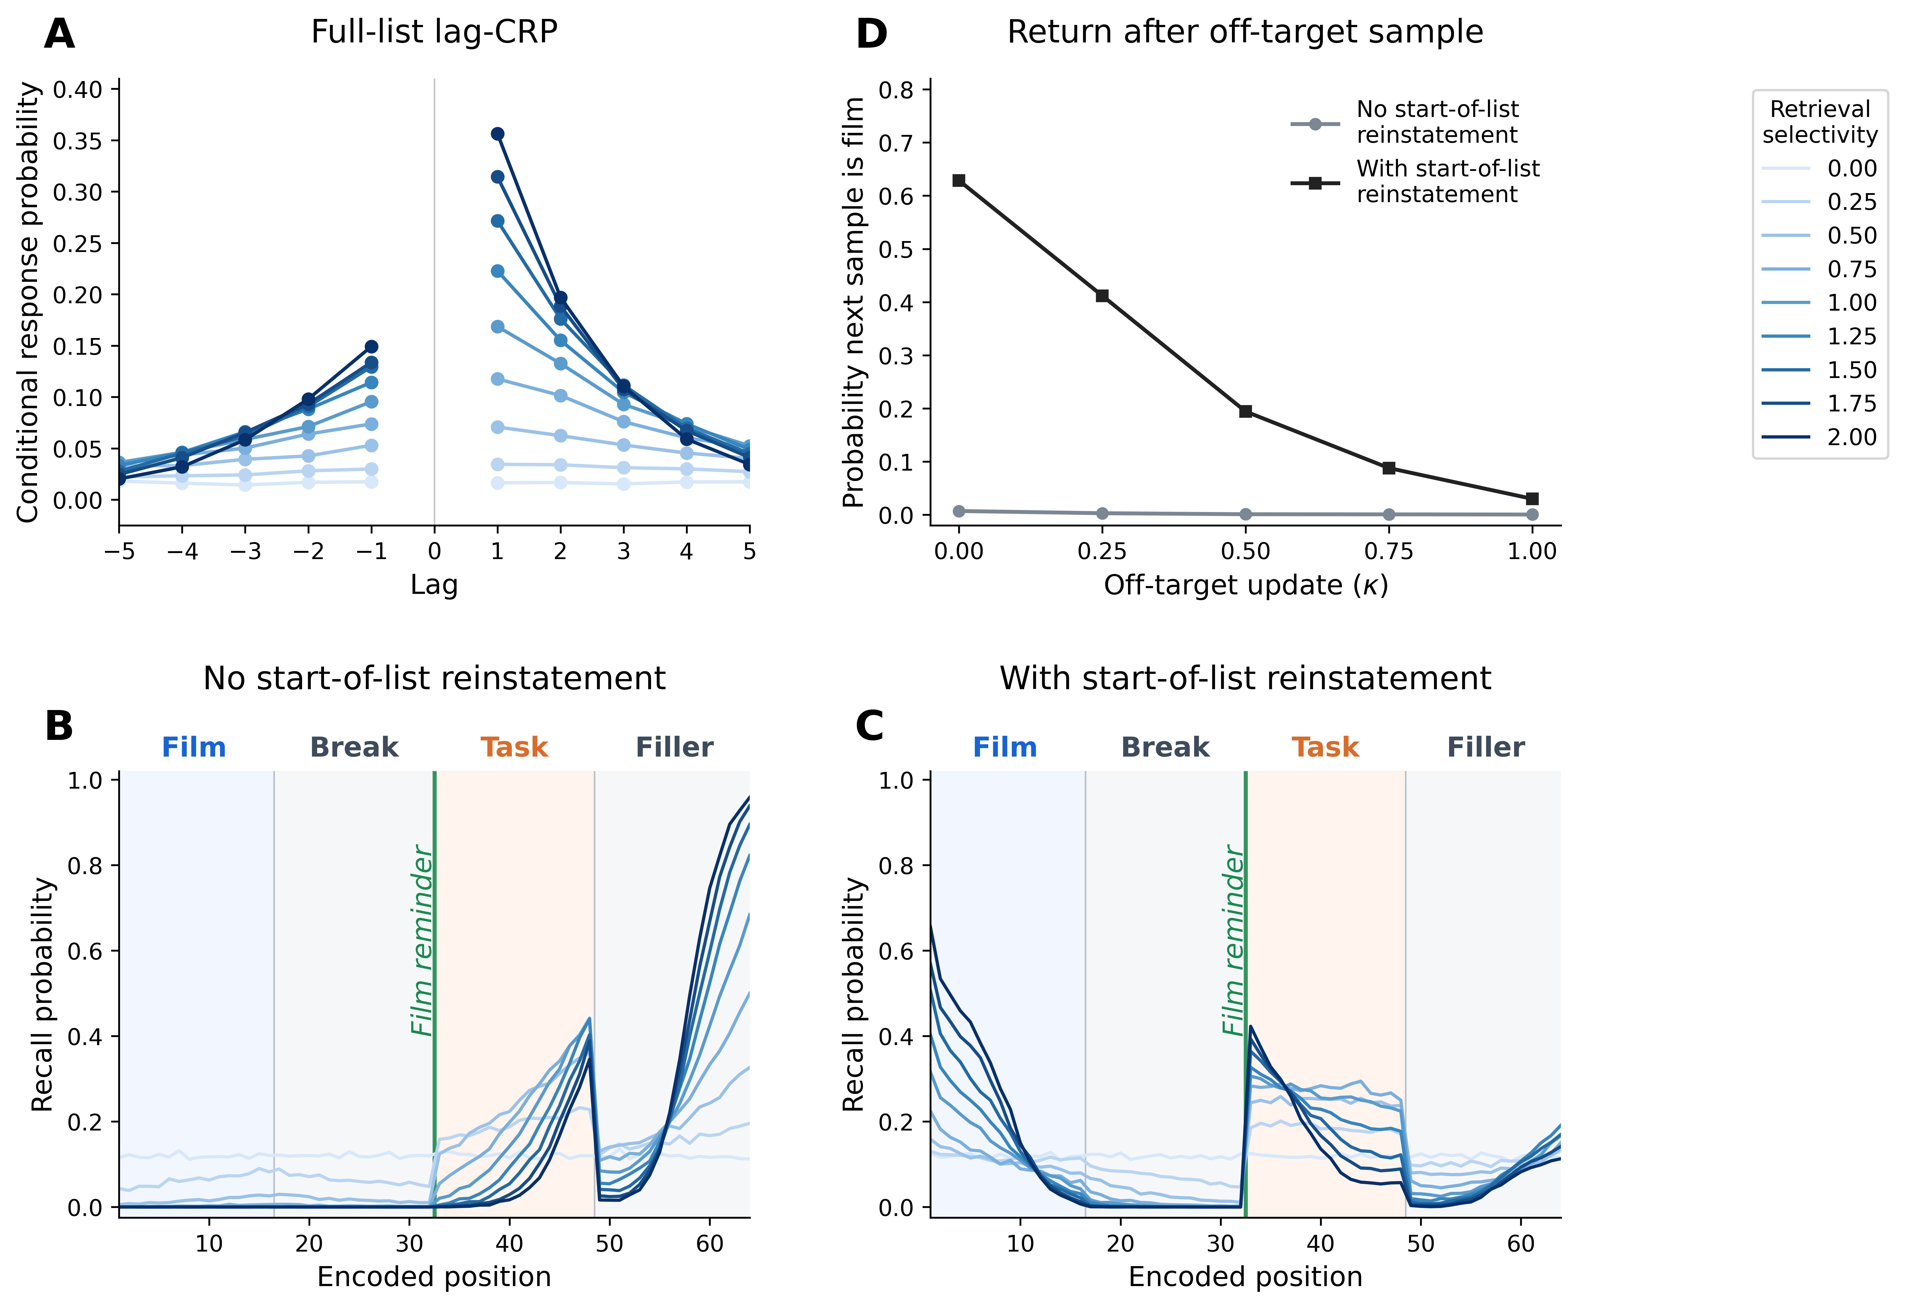
Panel A shows the local-search consequence of increasing retrieval selectivity in the start-of-list reinstatement condition. Because the Luce choice rule exaggerates differences in candidate support, higher values make successive recalls cluster more strongly around nearby encoded positions. Panels B and C show that the recall consequences of this local search depend on the retrieval context. When recall begins from the ongoing post-filler context, increasing retrieval selectivity favors the late non-film items most strongly supported by that context. When recall begins after start-of-list context reinstatement, increasing retrieval selectivity favors the early film items supported by the reinstated context. Panel D conditions on transitions where the current sample is off target, retrieval continues, and at least one film item remains unsampled. Without start-of-list context reinstatement, the probability that the next sample is a film item remains near zero across the $κ$ sweep. With start-of-list context reinstatement, lowering $κ$ from 1.0 to 0.0 raises this film-return probability from 0.059 to 0.643.
Across Figures 3 and 4, deliberate recall is protected by a sequence of control settings: start-of-list context reinstatement supplies a diagnostic early-film retrieval cue, retrieval selectivity sharpens whatever the current context supports, and target monitoring limits the context-updating consequences of sampled off-target candidates. This sequence motivates Simulation 3: externally supplied film-item cues also update context, but they sample positions from the film sequence rather than deliberately reinstating the start-of-list state. Their protective value therefore depends on whether the reinstated context favors film items over task competitors.

Simulation 3: Film Cue Inclusion and Retrieval Intentionality
Simulation 3 asks whether externally supplied film cues have the same protective value as deliberate start-of-list reinstatement. The model implements film cue inclusion as intermittent test-phase cues: after every fourth retrieval attempt, the test supplies a randomly selected film item. The supplied cue does not occupy a response slot, does not make the cued item unavailable for later recall, and adds no new learning. Instead, it updates temporal and source context through the supplied item’s feature-to-context associations, after which ordinary retrieval resumes. Cue strength is plotted as a multiplier on the fitted recall context-update rate $β_{rec}$. The vertical reference line in Figure 5 marks the cue strength that would make the supplied-cue context update approximately equal to the fitted encoding drift rate $β_{enc}$.

Figure 5
Intermittent test-phase film cues increase film access without replacing the intentionality manipulation. Simulation 3 compares unguided retrieval with deliberate recall while varying the strength of intermittent supplied film-item cues during retrieval. (A) Supplied film cues occur after scheduled retrieval attempts, update context, and then allow the next ordinary retrieval competition; they are not counted as responses and do not add learning. (B) Film-item recall increases with cue strength, but the deliberate-minus-unguided intentionality gap remains nearly stable across weak-to-moderate cue reinstatement. Only stronger cue reinstatement begins to narrow the gap. (C) Under unguided retrieval, supplied film cues modestly raise film recall but task and filler competitors remain prominent. (D) Under deliberate recall, film recall is already supported by start-of-list control, and supplied cues produce additional film access without eliminating task competition.
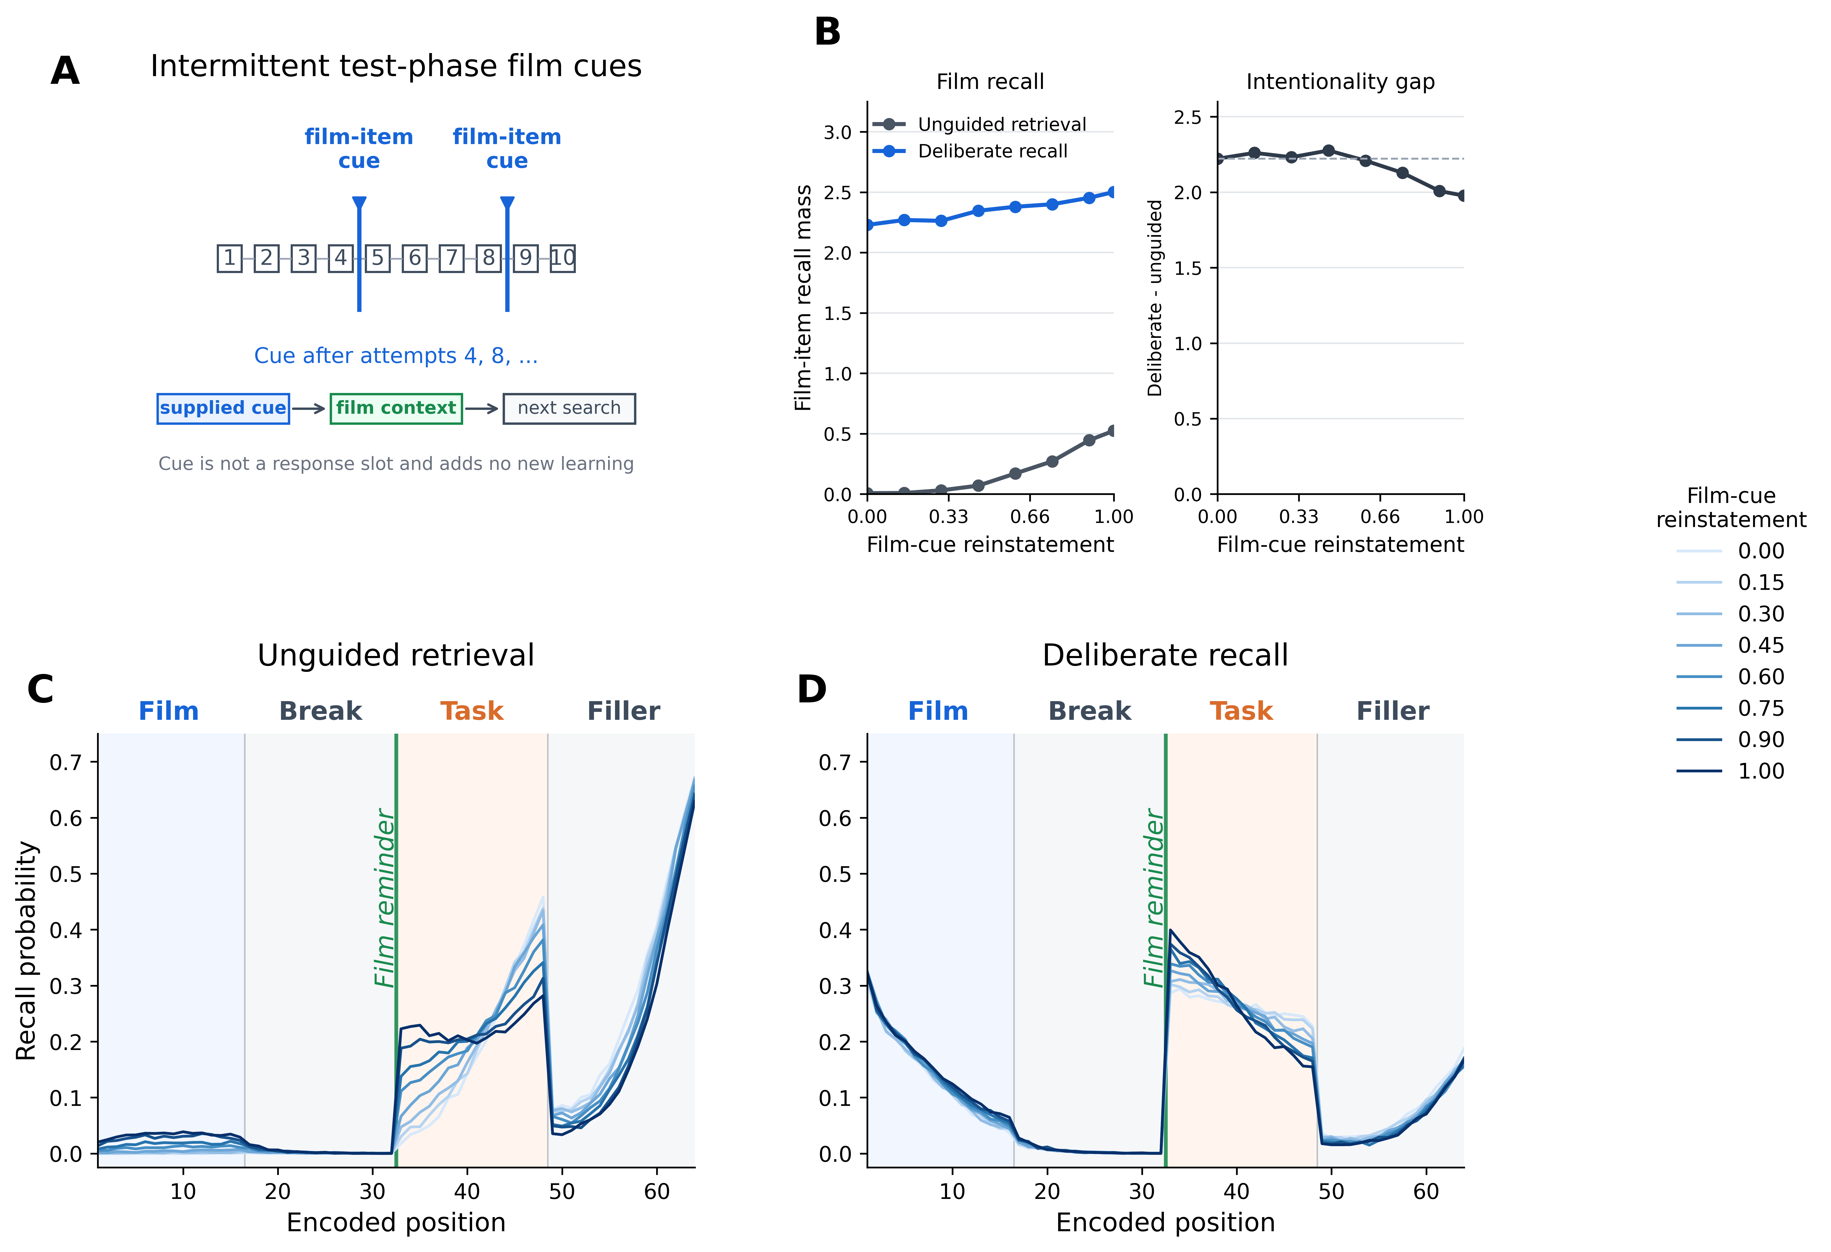
Panel B gives the primary test of the Simulation 3 prediction. Weak-to-moderate test-phase film cues increase film-item recall while leaving the intentionality gap largely intact. For example, increasing film-cue reinstatement from 0.00 to 0.60 raises film recall mass from 0.008 to 0.170 under unguided retrieval and from 2.229 to 2.379 under deliberate recall, while the deliberate-minus-unguided gap changes only from 2.221 to 2.209. This pattern shows that an externally supplied film cue can improve access to film material without acting like the diagnostic start-of-list control operation in Simulation 2. At stronger cue values, the intentionality gap begins to narrow because cue-driven context reinstatement itself becomes strong enough to guide unguided retrieval toward film items.
Panels C and D show how this effect unfolds over the full encoded sequence. The cue manipulation does not remove the task competitors created by reminder-driven task encoding. Instead, it changes the context available to subsequent search. The result is a graded cue effect: supplied film items can steer retrieval toward film context, but they reduce selective interference only to the extent that the reinstated context discriminates film targets from task and filler competitors.

Simulation 4: Context-to-Item and Item-to-Context Test Formats
Simulation 4 extends the cue logic to test format. The relevant architectural distinction is between context-to-item recall, in which film items must win selection from a mixed competitor set, and supplied-item access, in which the test provides item information that can reinstate associated context directly. This comparison does not require treating recognition as fully modeled by CMR. Instead, it asks whether a supplied film item changes vulnerability to context-binding interference because the retrieval problem no longer begins with selecting a film item from context alone.
The predicted contrast follows from the bidirectional item-context loop. When the test begins from context, film and task items compete according to their context-to-feature support. When the test supplies an item, the item-to-context pathway is engaged first, so performance can be less sensitive to whether a film item would have won an unguided context-to-item competition. This provides a test-format consequence of the same mechanism examined in Simulation 3, without assuming a separate recognition decision model.

Figure 6
Retrieval format changes where interference can enter. Simulation 4 distinguishes context-guided retrieval from supplied-item retrieval. (A) When retrieval begins from context, the same context state can cue multiple candidates; task items therefore compete with film items when both have been encoded in overlapping contexts. When retrieval begins from a supplied film item, the item reinstates its associated context instead, so the task item is not an equivalent competitor at the point of access. (B) In CMR, this asymmetry corresponds to two retrieval directions: context-to-feature associations cue candidate items, whereas feature-to-context associations reinstate context from a supplied item. Simulation 4 uses this distinction to ask why item-cued or recognition-like tests may show preserved access even when context-guided recall is sensitive to interference.
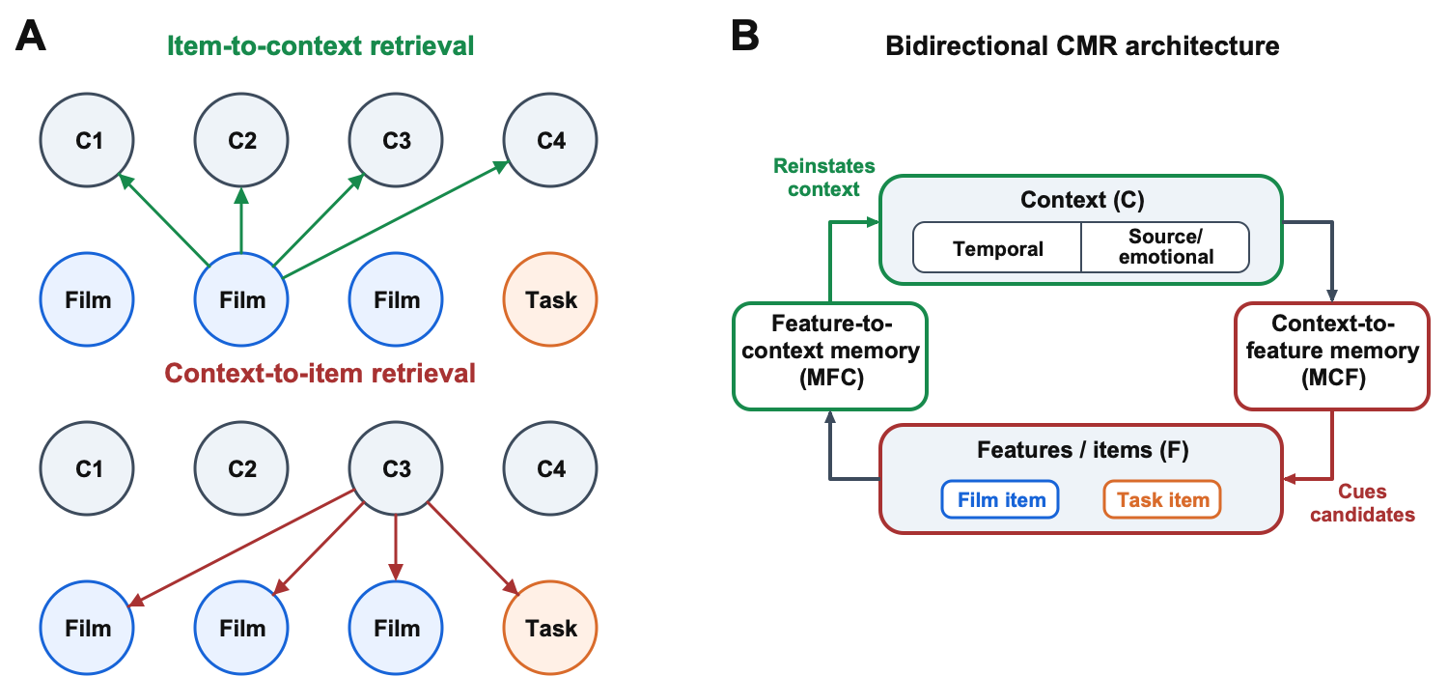

Simulation 5: Task Specificity and Source-Context Overlap
Simulation 5 turns to task specificity. In the model, “visuospatial” and “comparison” are not primitive task labels. A post-film task becomes effective when its items are strong competitors, when they are encoded in temporal-context states that overlap with the film trajectory, or when they share a source-context state with film items. These factors can vary independently, so a task label is interpretable only through its consequences for competitor strength and contextual overlap.
The task-specificity simulations therefore decompose three candidate routes to interference. Increasing task learning changes how strongly task items win once cued. Changing temporal overlap alters whether task items are cued alongside film items. Changing source-context overlap tests whether non-temporal source matching can amplify competition beyond temporal proximity alone. The predicted behavioral readouts are film-item access, task-competitor retrieval, and the phase-resolved distribution of recall across the encoded stream.

General Discussion

References
Asselbergs, J., van Bentum, J., Riper, H., Cuijpers, P., Holmes, E. A., & Sijbrandij, M. (2023). A systematic review and meta-analysis of the effect of cognitive interventions to prevent intrusive memories using the trauma film paradigm. Journal of Psychiatric Research, 159, 116–129. https://doi.org/10.1016/j.jpsychires.2023.01.028
Brewin, C. R. (2014). Episodic memory, perceptual memory, and their interaction: Foundations for a theory of posttraumatic stress disorder. Psychological Bulletin, 140(1), 69–97. https://doi.org/10.1037/a0033722
Brewin, C. R., Dalgleish, T., & Joseph, S. (1996). A dual representation theory of posttraumatic stress disorder. Psychological Review, 103(4), 670–686. https://doi.org/10.1037/0033-295X.103.4.670
Brewin, C. R., Gregory, J. D., Lipton, M., & Burgess, N. (2010). Intrusive images in psychological disorders: Characteristics, neural mechanisms, and treatment implications. Psychological Review, 117(1), 210–232. https://doi.org/10.1037/a0018113
Cohen, R. T., & Kahana, M. J. (2022). A memory-based theory of emotional disorders. Psychological Review, 129(4), 742–776. https://doi.org/10.1037/rev0000334
Deeprose, C., Zhang, S., DeJong, H., Dalgleish, T., & Holmes, E. A. (2012). Imagery in the aftermath of viewing a traumatic film: Using cognitive tasks to modulate the development of involuntary memory. Journal of Behavior Therapy and Experimental Psychiatry, 43(2), 758–764. https://doi.org/10.1016/j.jbtep.2011.10.008
Dupertuys, J., Shulhan, A., & Talmi, D. (2026). Ukraine Memory experiment data set.
Ehlers, A., & Clark, D. M. (2000). A cognitive model of posttraumatic stress disorder. Behaviour Research and Therapy, 38(4), 319–345. https://doi.org/10.1016/S0005-7967(99)00123-0
Holmes, E. A., & Bourne, C. (2008). Inducing and modulating intrusive emotional memories: A review of the trauma film paradigm. Acta Psychologica, 127(3), 553–566. https://doi.org/10.1016/j.actpsy.2007.11.002
Holmes, E. A., Brewin, C. R., & Hennessy, R. G. (2004). Trauma films, information processing, and intrusive memory development. Journal of Experimental Psychology: General, 133(1), 3–22. https://doi.org/10.1037/0096-3445.133.1.3
Holmes, E. A., James, E. L., Coode-Bate, T., & Deeprose, C. (2009). Can playing the computer game Tetris reduce the build-up of flashbacks for trauma? A proposal from cognitive science. PLoS ONE, 4(1), e4153. https://doi.org/10.1371/journal.pone.0004153
Holmes, E. A., James, E. L., Kilford, E. J., & Deeprose, C. (2010). Key steps in developing a cognitive vaccine against traumatic flashbacks: Visuospatial Tetris versus verbal Pub Quiz. PLoS ONE, 5(11), e13706. https://doi.org/10.1371/journal.pone.0013706
Horsch, A., Vial, Y., Favrod, C., Harari, M. M., Blackwell, S. E., Watson, P., Iyadurai, L., Bonsall, M. B., & Holmes, E. A. (2017). Reducing intrusive traumatic memories after emergency caesarean section: A proof-of-principle randomized controlled study. Behaviour Research and Therapy, 94, 36–47. https://doi.org/10.1016/j.brat.2017.03.018
Howard, M. W., & Kahana, M. J. (2002). A distributed representation of temporal context. Journal of Mathematical Psychology, 46(3), 269–299. https://doi.org/10.1006/jmps.2001.1388
Howard, M. W., Youker, T. E., & Venkatadass, V. S. (2008). The persistence of memory: Contiguity effects across hundreds of seconds. Psychonomic Bulletin & Review, 15(1), 58–63.
Iyadurai, L., Blackwell, S. E., Meiser-Stedman, R., Watson, P. C., Bonsall, M. B., Geddes, J. R., Nobre, A. C., & Holmes, E. A. (2018). Preventing intrusive memories after trauma via a brief intervention involving Tetris computer game play in the emergency department: A proof-of-concept randomized controlled trial. Molecular Psychiatry, 23(3), 674–682. https://doi.org/10.1038/mp.2017.23
Iyadurai, L., Visser, R. M., Lau-Zhu, A., Porcheret, K., Horsch, A., Holmes, E. A., & James, E. L. (2019). Intrusive memories of trauma: A target for research bridging cognitive science and its clinical application. Clinical Psychology Review, 69, 67–82. https://doi.org/10.1016/j.cpr.2018.08.005
James, E. L., Bonsall, M. B., Hoppitt, L., Tunbridge, E. M., Geddes, J. R., Milton, A. L., & Holmes, E. A. (2015). Computer game play reduces intrusive memories of experimental trauma via reconsolidation-update mechanisms. Psychological Science, 26(8), 1201–1215. https://doi.org/10.1177/0956797615583071
James, E. L., Lau-Zhu, A., Clark, I. A., Visser, R. M., Hagenaars, M. A., & Holmes, E. A. (2016). The trauma film paradigm as an experimental psychopathology model of psychological trauma: Intrusive memories and beyond. Clinical Psychology Review, 47, 106–142. https://doi.org/10.1016/j.cpr.2016.04.010
Kahana, M. J. (1996). Associative retrieval processes in free recall. Memory & Cognition, 24(1), 103–109.
Kanstrup, M., Kontio, E., Geranmayeh, A., Olofsdotter Lauri, K., Moulds, M. L., & Holmes, E. A. (2021). A single case series using visuospatial task interference to reduce the number of visual intrusive memories of trauma with refugees. Clinical Psychology & Psychotherapy, 28(1), 109–123. https://doi.org/10.1002/cpp.2489
Kessler, H., Schmidt, A.-C., James, E. L., Blackwell, S. E., von Rauchhaupt, M., Harren, K., Kehyayan, A., Clark, I. A., Sauvage, M., Herpertz, S., Axmacher, N., & Holmes, E. A. (2020). Visuospatial computer game play after memory reminder delivered three days after a traumatic film reduces the number of intrusive memories of the experimental trauma. Journal of Behavior Therapy and Experimental Psychiatry, 67, 101454. https://doi.org/10.1016/j.jbtep.2019.01.006
Kindt, M., Soeter, M., & Vervliet, B. (2009). Beyond extinction: Erasing human fear responses and preventing the return of fear. Nature Neuroscience, 12(3), 256–258. https://doi.org/10.1038/nn.2271
Krans, J., Näring, G., Becker, E. S., & Holmes, E. A. (2009). Intrusive trauma memory: A review and functional analysis. Applied Cognitive Psychology, 23(8), 1076–1088. https://doi.org/10.1002/acp.1611
Lau-Zhu, A., Henson, R. N., & Holmes, E. A. (2019). Intrusive memories and voluntary memory of a trauma film: Differential effects of a cognitive interference task after encoding. Journal of Experimental Psychology: General, 148(12), 2154–2180. https://doi.org/10.1037/xge0000598
Lau-Zhu, A., Henson, R. N., & Holmes, E. A. (2021). Selectively interfering with intrusive but not voluntary memories of a trauma film: Accounting for the role of associative memory. Clinical Psychological Science, 9(6), 1128–1143. https://doi.org/10.1177/2167702621998315
Lohnas, L. J., Polyn, S. M., & Kahana, M. J. (2015). Expanding the scope of memory search: Modeling intralist and interlist effects in free recall. Psychological Review, 122(2), 337–363. https://doi.org/10.1037/a0039036
Polyn, S. M., Norman, K. A., & Kahana, M. J. (2009a). A context maintenance and retrieval model of organizational processes in free recall. Psychological Review, 116(1), 129–156. https://doi.org/10.1037/a0014420
Polyn, S. M., Norman, K. A., & Kahana, M. J. (2009b). Task context and organization in free recall. Neuropsychologia, 47(11), 2158–2163. https://doi.org/10.1016/j.neuropsychologia.2009.02.013
Sederberg, P. B., Gershman, S. J., Polyn, S. M., & Norman, K. A. (2011). Human memory reconsolidation can be explained using the temporal context model. Psychonomic Bulletin & Review, 18(3), 455–468. https://doi.org/10.3758/s13423-011-0086-9
Sederberg, P. B., Howard, M. W., & Kahana, M. J. (2008). A context-based theory of recency and contiguity in free recall. Psychological Review, 115(4), 893–912. https://doi.org/10.1037/a0013396
Talmi, D., Lohnas, L. J., & Daw, N. D. (2019). A retrieved context model of the emotional modulation of memory. Psychological Review, 126(4), 455–485. https://doi.org/10.1037/rev0000132
Varma, M. M., Zeng, S., Singh, L., Holmes, E. A., Huang, J., Chiu, M. H., & Hu, X. (2024). A systematic review and meta-analysis of experimental methods for modulating intrusive memories following lab-analogue trauma exposure in non-clinical populations. Nature Human Behaviour, 8(10), 1968–1987. https://doi.org/10.1038/s41562-024-01956-y
Wessel, I., Krans, J., Albers, C. J., Chauhan, N., Ferreira de Sá, D. S., Hauck, A., Jaswetz, L., Michael, T., Nixon, R. D. V., Pearson, D. G., Slattery, I., Smeets, T., Takarangi, M. K. T., Willems, T. R. A., & van Schie, K. (2025). Evidence that Tetris reduces immediate but not subsequent daily intrusions of a trauma film: A multilab replication study. Collabra: Psychology, 11(1), 130791. https://doi.org/10.1525/collabra.130791
Zaromb, F. M., Howard, M. W., Dolan, E. D., Sirotin, Y. B., Tully, M., Wingfield, A., & Kahana, M. J. (2006). Temporal associations and prior-list intrusions in free recall. Journal of Experimental Psychology: Learning, Memory, and Cognition, 32(4), 792–804. https://doi.org/10.1037/0278-7393.32.4.792

