Figures Through Target Monitoring
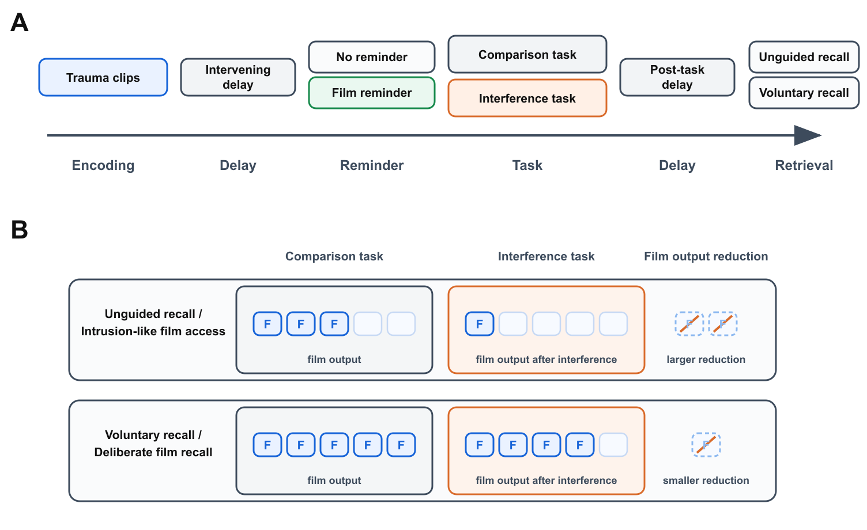
Figure 1: Paradigm variables and selective interference effect. (A) The modeled trauma-film paradigm includes film encoding, an intervening delay, a possible pre-task film reminder, an intervening task, a post-task delay, and a later test of unguided or voluntary recall. (B) In the selective interference effect, the interference task produces a larger reduction in unguided or intrusion-like film output than in voluntary film recall, while voluntary recall remains higher overall. The right column marks the within-row reduction from the comparison task to the interference task. Tokens are schematic and do not plot empirical counts, fitted values, or model output.

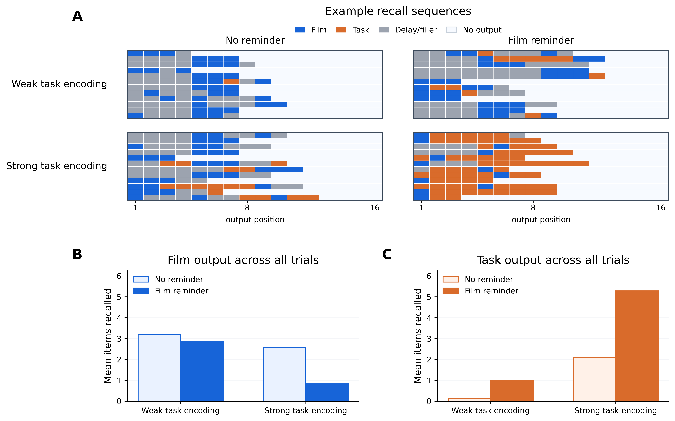
Figure 2: Simulation 1: unguided retrieval after task encoding. Reminder condition and task encoding strength were crossed while retrieval mode was held unguided; weak film cues were supplied periodically during recall in every condition. (A) Example generated recall sequences for each condition. Each horizontal lane is one simulated trial selected near the condition mean for film output, with output positions running left to right. Colors mark film items, task items, delay/filler items, and unfilled output positions. (B) Mean number of film items recalled across all simulated trials. (C) Mean number of task items recalled across all simulated trials. Film-item recall was lowest, and task-item recall highest, in the film-reminder/strong-task-encoding condition.

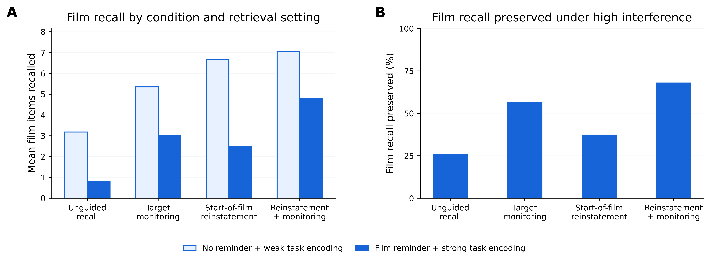
Figure 3: Simulation 2: retrieval control and the selective interference effect. Retrieval was compared across unguided recall and three deliberate-retrieval settings: target monitoring alone, start-of-film context reinstatement alone, and their combination. Each retrieval setting was evaluated under two endpoint conditions: low interference (no reminder, weak task encoding) and high interference (film reminder, strong task encoding). Weak film cues were supplied periodically during recall in all conditions. (A) Mean number of film items recalled across all simulated trials. Pale bars correspond to the low-interference condition, and solid bars correspond to the high-interference condition. (B) Film recall preserved in the high-interference condition, expressed as a percentage of recall in the low-interference condition for each retrieval setting. The model therefore simulates a selective interference effect: after the strong-interference intervention, film recall is least preserved under unguided recall and most preserved when deliberate retrieval combines start-of-film context reinstatement with target monitoring.

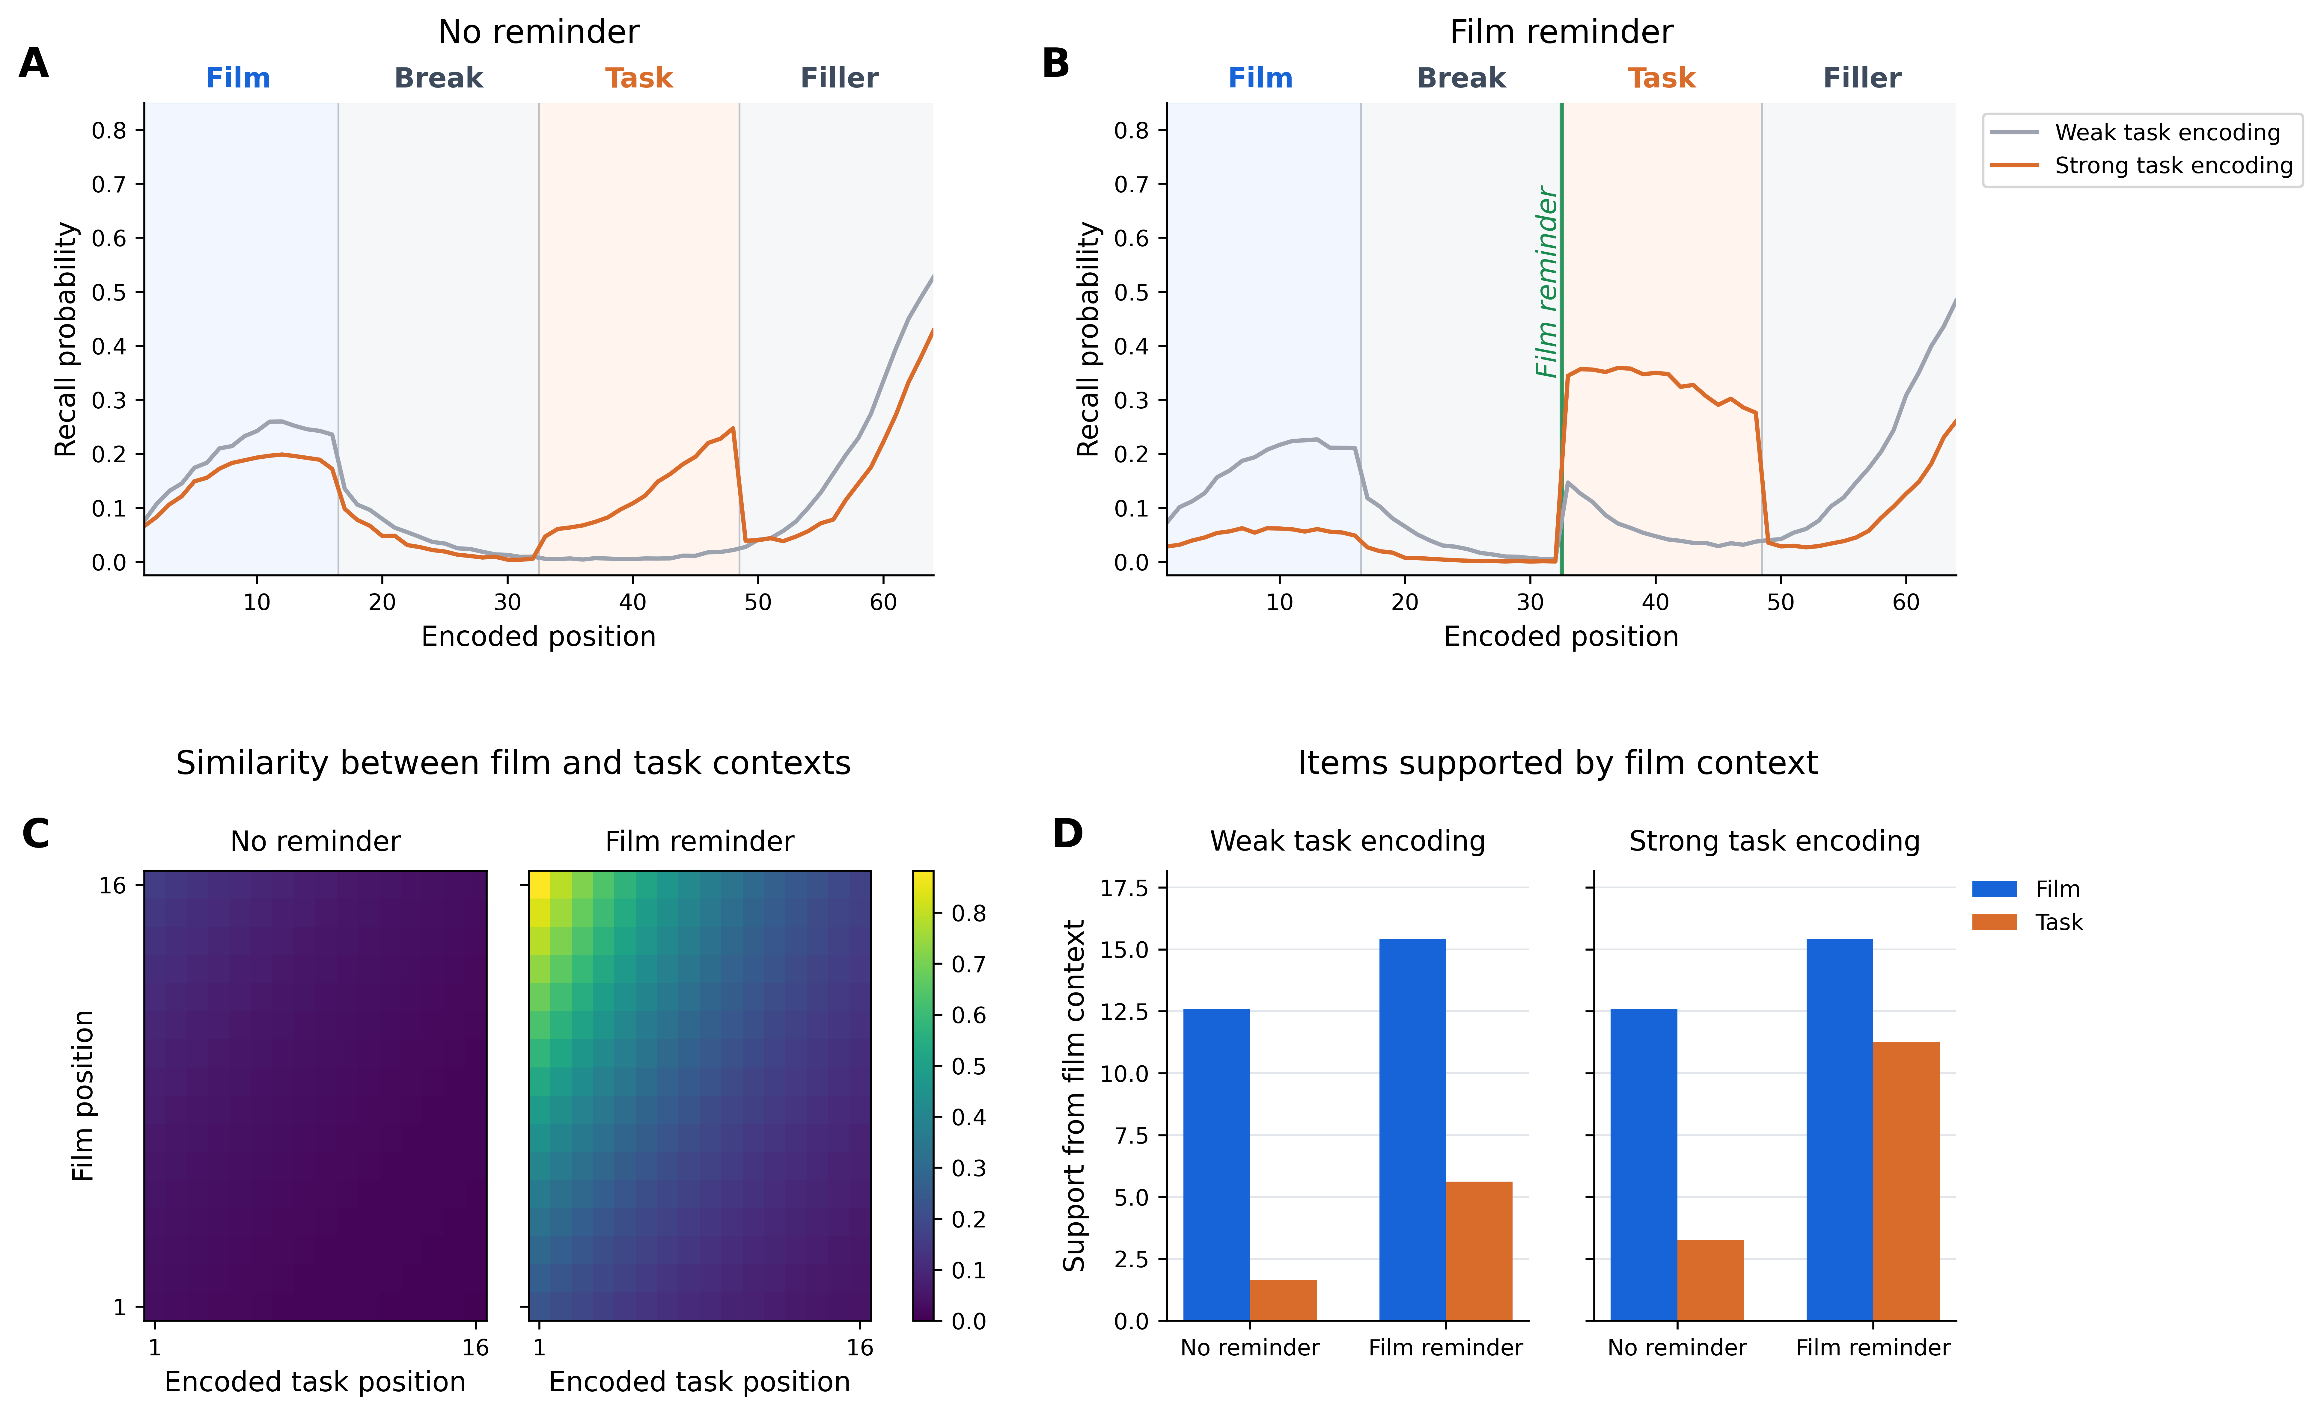
Figure 4: Simulation 1: context overlap and task support during unguided recall. Reminder condition and task encoding strength were crossed to test when task items compete with film items during unguided recall; weak film cues were supplied periodically during recall in all conditions. (A) Without a pre-task film reminder, strengthening task encoding produces only modest changes in recall probability across encoded positions. Curves compare weak task encoding and strong task encoding; shaded bands mark film, break, task, and filler positions. (B) With a pre-task film reminder, strong task encoding produces a clearer redistribution of recall from film positions to task positions. (C) Film-encoding contexts are compared with task-encoding contexts; brighter cells indicate greater similarity. The film reminder increases overlap between film-associated context and the contexts active during task encoding. (D) The model was cued with representative film context after task encoding to measure which item classes received retrieval support. Support for task items is highest after film reminder plus strong task encoding, showing how film-associated context can cue task competitors.

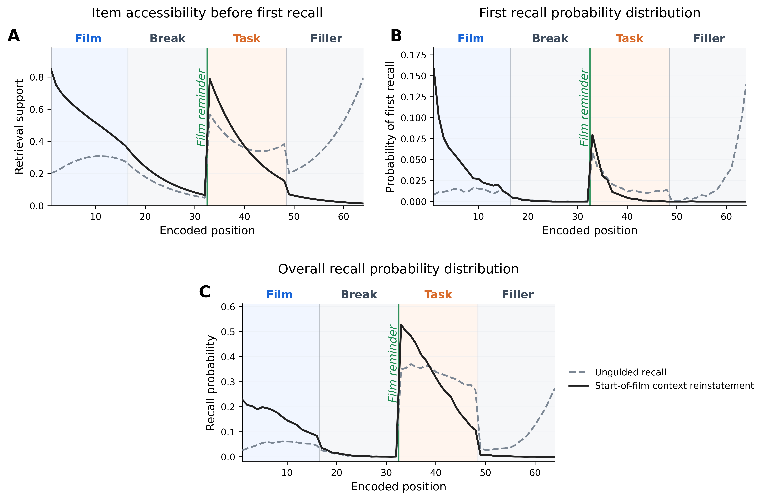
Figure 5: Simulation 2: start-of-film context reinstatement. Start-of-film context reinstatement initializes retrieval by drifting the current context toward the state present at the start of film encoding. The simulation held fixed the strongest interference condition from the preceding analysis: a film reminder before strong task encoding, with weak film cues supplied periodically during recall. Target monitoring was disabled. Shaded bands mark film, break, task, and filler positions; the green line marks the reminder immediately before task encoding. (A) Item accessibility before the first recall attempt. Reinstatement increases support for early film items and for task items encoded soon after the reminder, when task-encoding context still overlaps with film context. (B) First recall probability distribution. Reinstatement shifts recall initiation toward early film positions. (C) Overall recall probability distribution. Reinstatement increases recall probability for film positions and shifts task recall toward early task positions, with lower recall from filler positions. Start-of-film context reinstatement therefore improves film recall by orienting retrieval toward film context, while preserving reminder-linked task competition as recall unfolds.

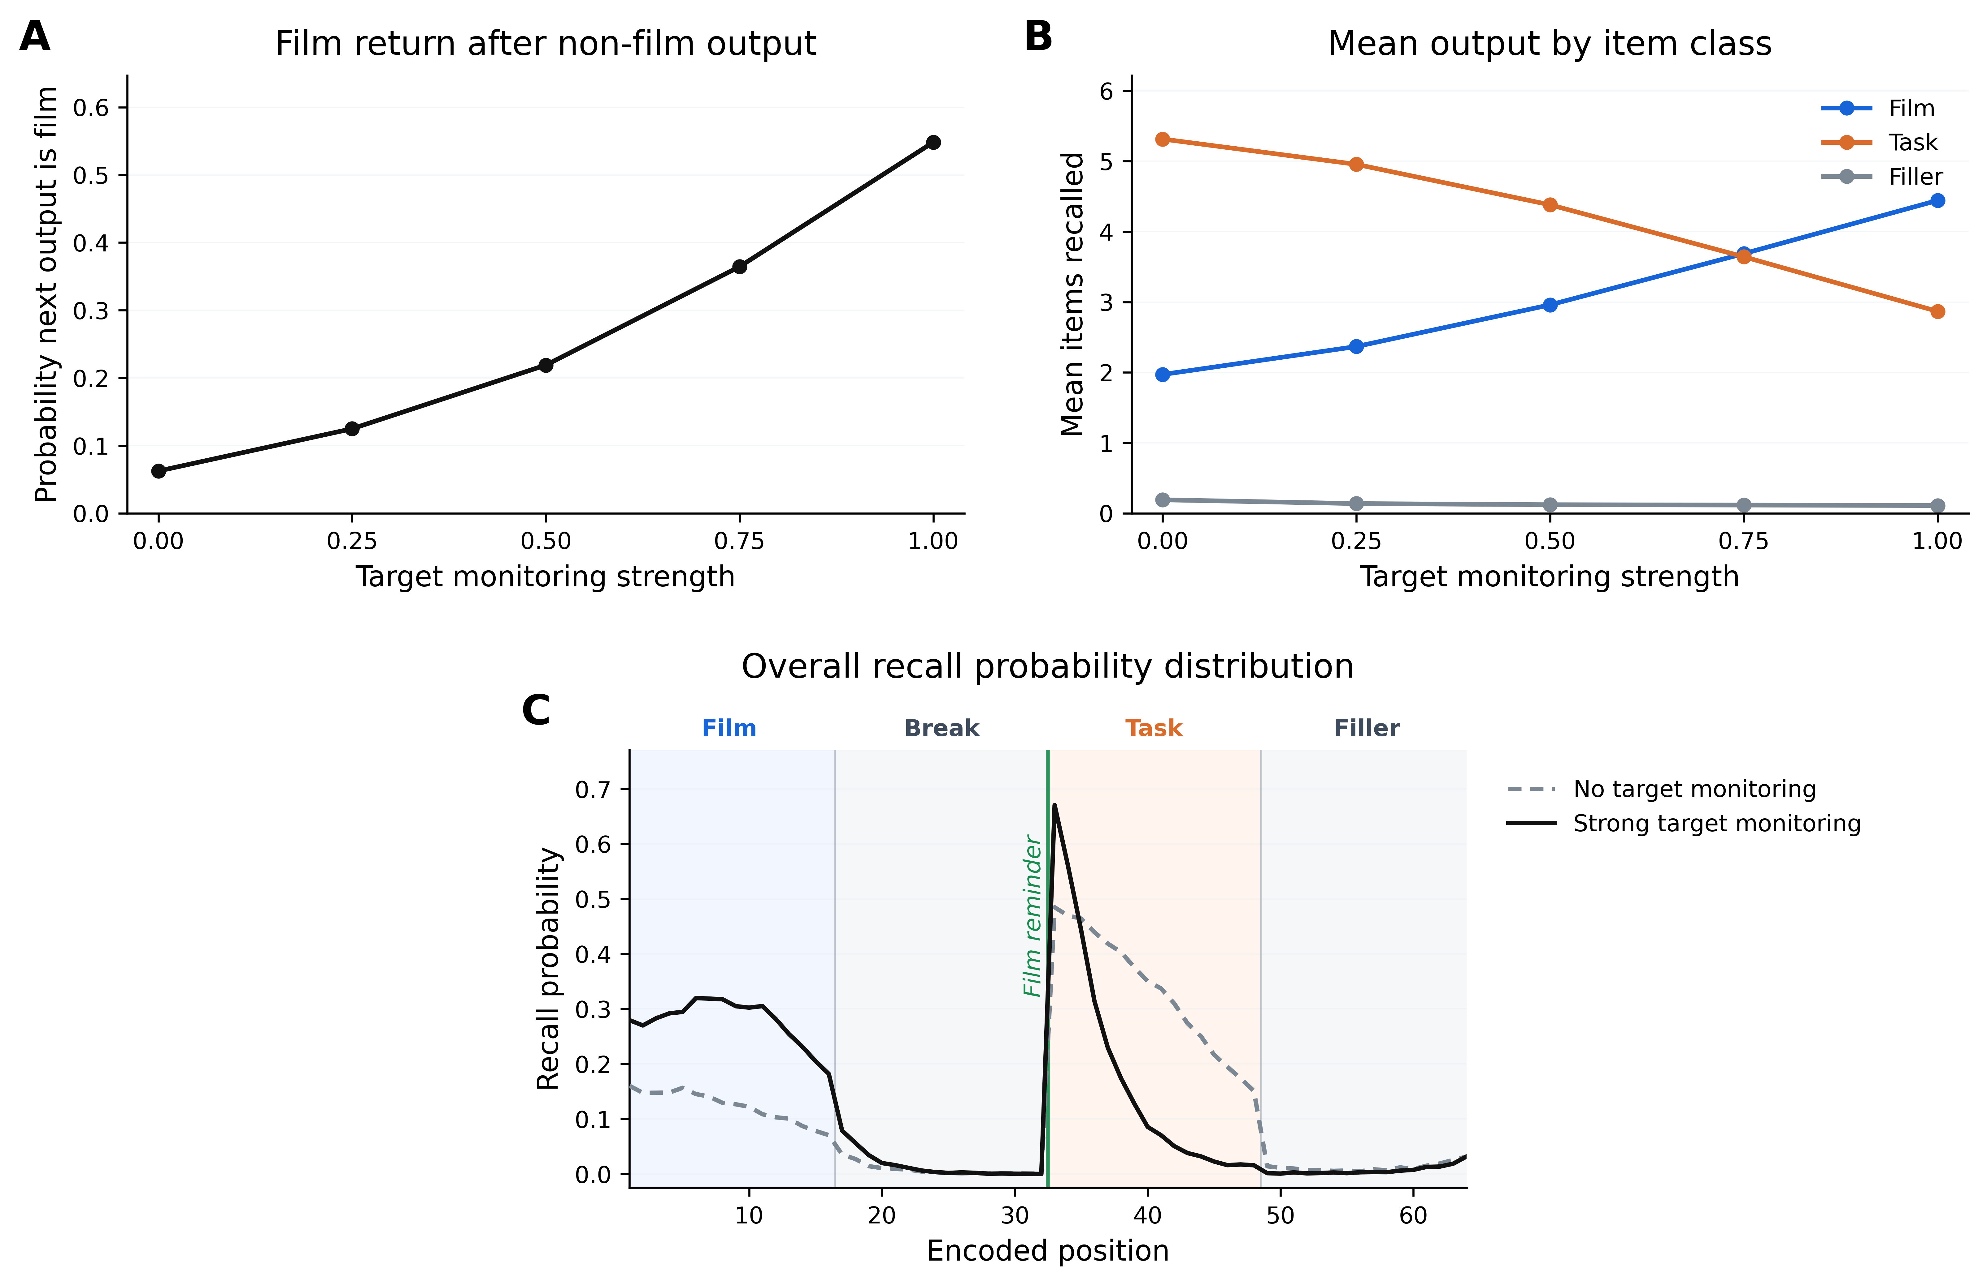
Figure 6: Simulation 2: target monitoring during high-interference deliberate recall. Target monitoring dampens context updating after non-film items are retrieved. The high-interference condition was held fixed: a film reminder preceded strong task encoding, weak film cues were supplied periodically during recall, and start-of-film context reinstatement was present but not varied. (A) Probability that a non-film output was followed by a film output as target monitoring strength increased. (B) Mean film, task, and filler output across the same monitoring sweep. (C) Recall probability by encoded position with no target monitoring versus strong target monitoring. Shaded bands mark film, break, task, and filler positions; the green line marks the pre-task film reminder. Increasing target monitoring makes film output more likely after non-film output and shifts aggregate recall from task items toward film items, while preserving high recall for task items encoded closest to the reminder.

