Intrusive and voluntary memory from a single system: A retrieved-context account of selective interference in the trauma-film paradigm
Jordan B Gunn¹, Richard N. Henson², Emily A. Holmes^{3,4}, Thomas G. W. McConnell¹, and Deborah Talmi¹
¹ Department of Psychology, University of Cambridge, Cambridge, UK
² MRC Cognition and Brain Sciences Unit, Department of Psychiatry, University of Cambridge, Cambridge, UK
³ Department of Women’s and Children’s Health, Uppsala University, Uppsala, Sweden
⁴ School of Psychology, Faculty of Environmental and Life Sciences, University of Southampton, Southampton, UK

Abstract
Memory theory must explain why interference can affect deliberate and involuntary remembering differently. Studies using distressing films show that a film reminder followed by an imagery-competing task such as Tetris can reduce later spontaneous memories of the film (intrusions) while leaving voluntary memory relatively intact. This selective interference effect is often interpreted through clinical theories of traumatic memory in which intrusive and voluntary remembering depend on different memory representations. We develop an alternative account in an emotional Context Maintenance and Retrieval (eCMR) model that predicts sequences of film and non-film recall events. Events become associated with context, a changing internal representation of experience. A film reminder reinstates film-associated context, so imagery generated during the subsequent task becomes associated with that context. During later retrieval, task memories compete with film memories cued by the same context, reducing film recall without weakening the original film associations. We propose that people pursue the goal of remembering the film by constructing and maintaining a retrieval cue that distinguishes film from task material. In simulations, sustained support from this cue was required to reproduce the selective-interference pattern across reminder and task conditions, protecting deliberate recall relative to involuntary retrieval. These results suggest that competitor learning and retrieval cueing can produce selective interference within a shared memory system, motivating tests in other memory tasks.
Keywords: intrusive memories, voluntary memory, trauma-film paradigm, visuospatial intervention, selective interference, retrieved-context theory, computational modeling, imagery-competing task intervention

Intrusive and voluntary memory from a single system: A retrieved-context account of selective interference in the trauma-film paradigm

Introduction
Traumatic experience foregrounds a tension between accessibility and selectivity in episodic memory. From a functional perspective, events with lasting significance need to remain accessible in memory so remembered details can guide later decisions (Zhou et al., 2025). At the same time, adaptive retrieval is selective: what comes to mind should normally depend on current goals, cues, and circumstances. Intrusive memories after trauma show how highly accessible event memories can strain the selectivity of retrieval. These intrusions arise involuntarily and often take the form of brief visual images of moments from the traumatic event. In posttraumatic stress disorder (PTSD), such memories can come to mind unbidden in inappropriate circumstances, causing distress and interfering with ongoing activity (Brewin et al., 2010; Ehlers & Clark, 2000; Iyadurai et al., 2019; Krans et al., 2009). Explaining how episodic memory keeps consequential event memories accessible while regulating their retrieval is therefore a shared target for both clinical science and mechanistic theories of memory.
The trauma-film paradigm provides a controlled setting for comparing intrusive and voluntary memory for the same material (Holmes & Bourne, 2008; James et al., 2016; see McConnell, Leehr, et al., 2026, for recent methodological guidance). Participants view a distressing film, record later intrusions as a measure of involuntary memory, and often complete voluntary-memory tests of its contents. This design makes it possible to ask whether the same material can remain accessible to voluntary retrieval while becoming more or less likely to come to mind involuntarily. In such research, intrusion frequency is often only weakly related to voluntary-memory performance (Holmes et al., 2004; James et al., 2016; Lau-Zhu et al., 2019, 2021). Memory for the same film can therefore arise involuntarily or be retrieved voluntarily, and these two outcomes can be largely independent.
Researchers have sharpened this dissociation using the imagery-competing task intervention (ICTI) and related procedures. In an ICTI, participants receive reminders of the target event and then complete a brief task designed to compete with the visual imagery those reminders call to mind (deBettencourt et al., 2026; Highfield et al., 2025). Imagery-competing tasks administered within hours of film viewing have reduced later film intrusions while voluntary memory for the same material has remained relatively intact (Asselbergs et al., 2024, Deeprose et al., 2012; Holmes et al., 2009, 2010; Lau-Zhu et al., 2019, 2021). In delayed variants, participants return a day or more after film viewing and receive a reminder before completing the task. These studies likewise report reduced intrusions while recognition performance remains relatively intact (James et al., 2015; Kessler et al., 2020). Clinical studies have also found that ICTIs reduce intrusive memories after real-world trauma (Beckenstrom et al., 2026; Iyadurai et al., 2023; Kanstrup et al., 2024; Kessler et al., 2018; Ramineni et al., 2023). The pattern of reduced intrusions alongside relatively preserved voluntary memory is termed ‘the selective interference effect’ (Lau-Zhu et al., 2019, 2021). Explaining this effect within a broader theory of episodic memory search is the central aim of this work.
One prominent existing explanation holds that intrusive and voluntary remembering depend on separate memory representations that are differently vulnerable to interference (Brewin et al., 1996; Brewin, 2014). Dual-representation accounts give this interpretation an architectural basis. They postulate that voluntary recollection arises from hippocampally supported representations that bind event elements within a spatiotemporal context (Bird et al., 2012; Bisby et al., 2020), whereas intrusive re-experiencing arises from activation of sensory and affective representations supported by amygdala and sensory systems (Bisby et al., 2020; Brewin et al., 2010). When the task follows soon after film viewing, it is proposed to interfere with consolidation of the sensory-perceptual representation (Holmes et al., 2009, 2010). When the intervention is delayed after film viewing (e.g. 24 hours later), the reminder is instead treated as reactivating the relevant memory before the task, allowing the interference procedure to alter later availability through reconsolidation or post-reactivation updating (James et al., 2015; Kindt et al., 2009). The selective interference effect is therefore interpreted as evidence that the intervention disrupts the sensory-bound representations that support intrusions more strongly than the contextualized representations that support voluntary recollection (Deeprose et al, 2012; Lau-Zhu et al., 2019).
Here we argue that preserved voluntary memory does not, by itself, establish that a separate representation was spared. More generally, differences in retrieval outcomes need not reveal differences in what was stored. The selective interference effect can instead arise from differences in how the same memory is cued and controlled at retrieval.
Retrieved-context models offer a general theory of episodic memory search in which context can guide goal-directed remembering and give rise to unintended intrusions (Cohen & Kahana, 2022; Lohnas et al., 2015; Polyn et al., 2011). Although recent extensions formalize particular forms of targeted search (Healey & Wahlheim, 2024; Lohnas, 2025), a general account of how retrieval goals and test format regulate competition during memory search remains unresolved (Healey & Uitvlugt, 2019; Lohnas et al., 2026; Zhou et al., 2025). We address this gap by comparing deliberate recall and deliberate recognition with involuntary retrieval, all generated from the same learned associations. We characterize how control mechanisms can make film recall less susceptible to interference when retrieval is deliberate rather than involuntary.
In our account, task material interferes with film recall by becoming a competitor during later memory search. Film events become associated with context, a gradually changing mental representation of recent experience (Howard & Kahana, 2002; Polyn et al, 2009a). Film-associated context may remain active immediately after film viewing or become active again (reinstated) following a later reminder. Imagery generated during the task while this context is active becomes linked to it. When this context later guides retrieval, it therefore cues memories of both the task and the film, placing them in competition for recall. The present simulations focus on the delayed case, comparing conditions with and without a reminder before task encoding.
How strongly this competition affects performance depends on test format and retrieval control. Deliberate recognition can be less affected because the test presents a candidate item for judgment rather than requiring that the item be brought to mind through context-guided search. Deliberate recall still depends on that search, so memories of the task continue to compete with memories of the film. We propose that people pursue the goal of remembering the film by constructing and maintaining a retrieval cue that distinguishes film from task material. This cue can give film candidates an additional source of support without equally supporting task competitors. We formalize this retrieval account in an emotional variant (Cohen & Kahana, 2022; Talmi et al., 2019) of the Context Maintenance and Retrieval (CMR) model (Polyn et al., 2009a). To represent the distressing material used in trauma-film studies, this variant includes affective information in context. Emotional memories can form stronger associations with this information, increasing the support it provides during retrieval.
We use eCMR to evaluate a retrieved-context account of selective interference in three simulations that move from competitor formation to the roles of test format and retrieval control. Panel A of Figure 1 summarizes the modeled paradigm while Panel B summarizes the canonical pattern of results for involuntary and deliberate film recall, i.e., the selective interference effect. Simulation 1 tests the account’s proposed interference mechanism by varying whether a film reminder precedes task encoding and how strongly task material becomes linked to film-associated context. Simulation 2 examines deliberate recognition, isolating the role of test format when the test supplies the candidate item. Simulation 3 compares start-of-film context reinstatement, a maintained film-category cue, and retrieval monitoring to determine which control operations can account for the relative preservation of deliberate recall. Together, the simulations specify a mechanistic alternative to selective-vulnerability accounts and identify when intrusive and voluntary remembering should diverge.

Figure 1
Modeled trauma-film paradigm and schematic selective-interference effect. (A) The modeled trauma-film paradigm includes film encoding, an intervening delay, a possible pre-task film reminder, a task phase, a post-task delay, and a later test of involuntary recall, deliberate recall, or deliberate recognition. (B) The recall simulations target an interaction among reminder condition, task condition, and retrieval condition. Columns distinguish whether the task is preceded by a film reminder, rows distinguish involuntary recall from deliberate recall, and paired bars compare film recall after a comparison/control condition versus an imagery-competing task condition. Following a film reminder, the task condition reduces involuntary recall more than deliberate recall. Bars are schematic; for individual experiments that contribute to this canonical pattern, see Figure 2.
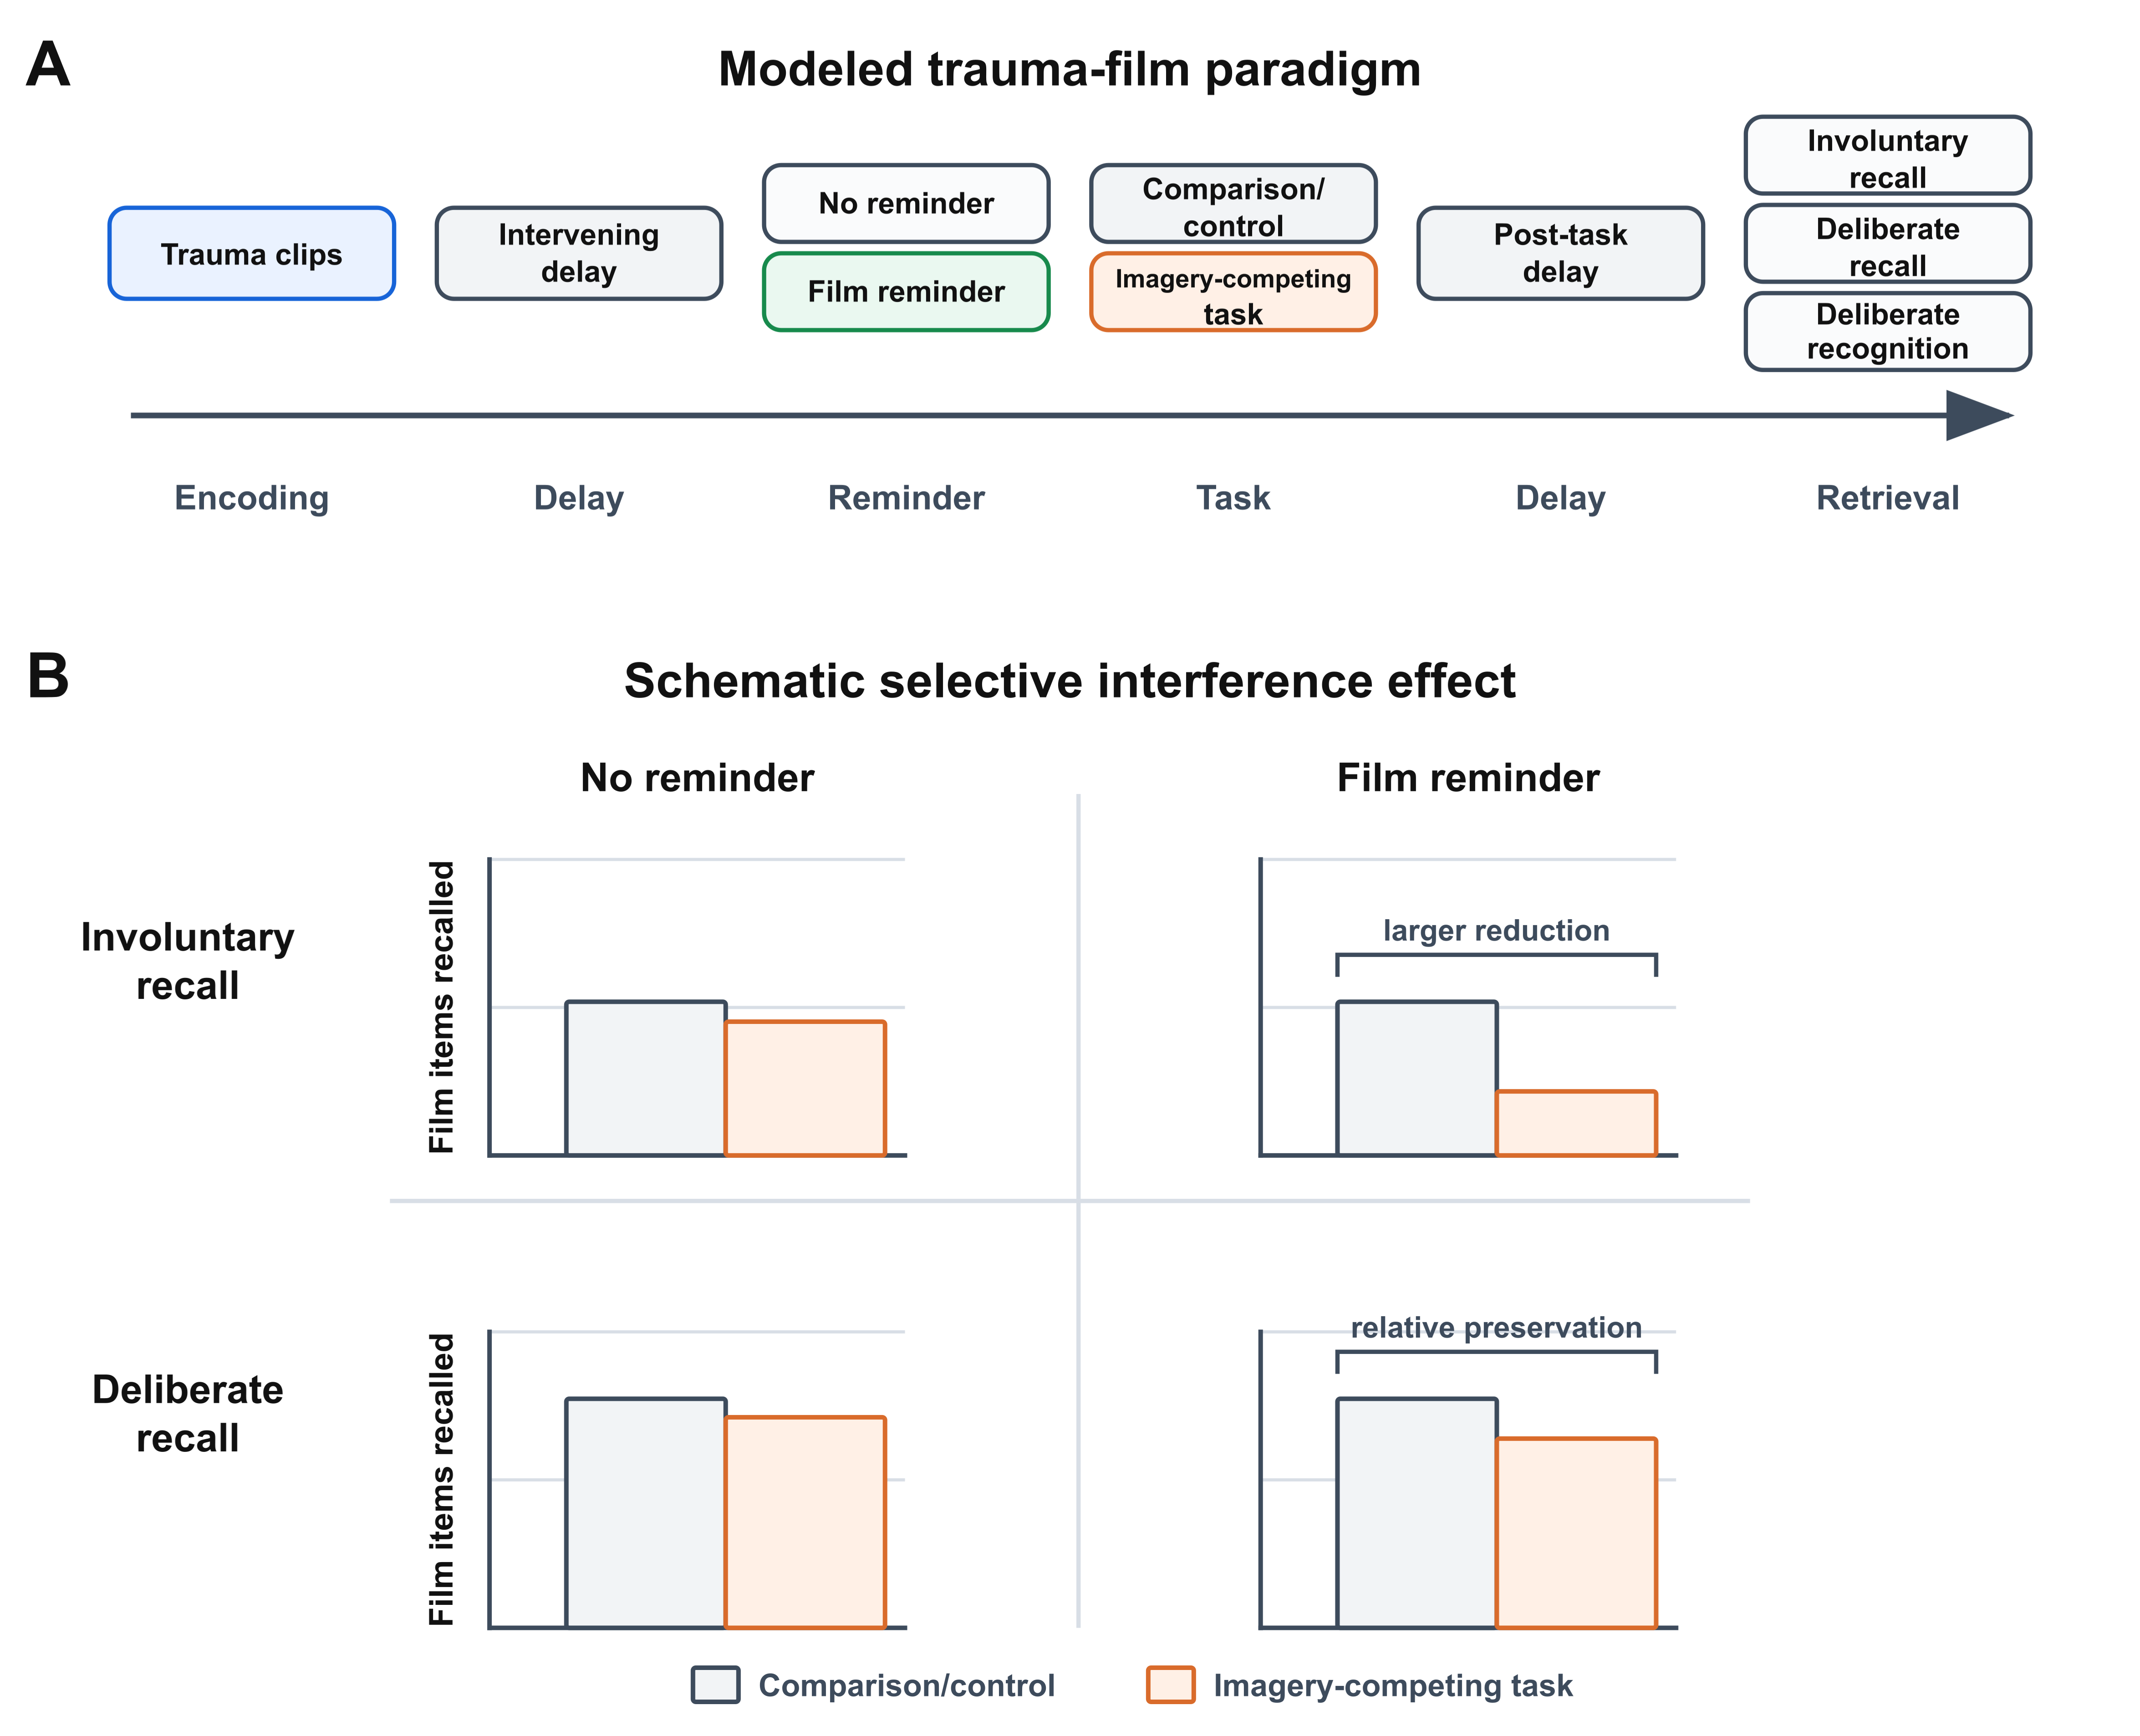

Intentionality and Test Format in Selective Interference
Empirical tests of selective interference combine different intrusion measures with different voluntary memory tests. Diary measures record intrusions that arise during daily life, whereas laboratory intrusion tasks collect reports during a defined monitoring period, sometimes while film cues are present. Voluntary memory is commonly assessed either by recall tests, which require participants to bring film details to mind, or by recognition tests, which present verbal or visual candidates for judgment (James et al., 2016; Lau-Zhu et al., 2019, 2021). These combinations vary in both retrieval intentionality and test format. Figure 2 illustrates selected examples.

Figure 2
Selected empirical comparisons across retrieval formats. Rows show studies pairing intrusion-like or involuntary-memory measures with voluntary-memory tests: diary intrusions with recognition, diary intrusions with free recall, laboratory intrusion reports with recognition, and matched voluntary and involuntary laboratory report tasks (James et al., 2015; Lau-Zhu et al., 2019, 2021; McConnell et al., 2026). Left panels show intrusion or involuntary-memory outcomes, and right panels show deliberate-memory outcomes. Gray bars indicate the study-specific comparison or control condition and orange bars indicate the imagery-competing task condition. Bracket labels summarize the plotted contrast and do not denote a uniform significance test. Bar heights reproduce reported condition means in their original units, so scales differ across outcomes.
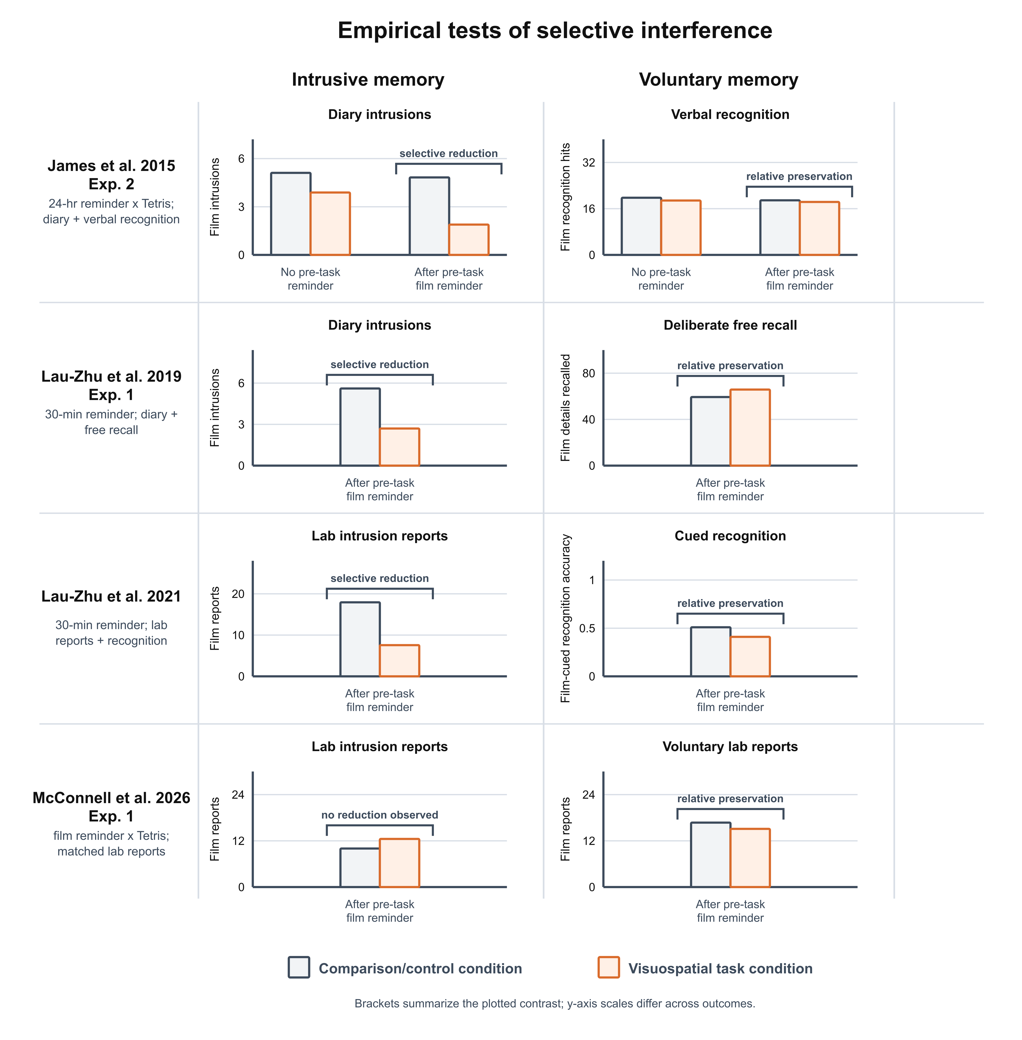
Many prominent demonstrations of selective interference compare diary or laboratory intrusion reports with recognition tests (Holmes et al., 2009, 2010; James et al., 2015; Lau-Zhu et al., 2021). Such comparisons confound retrieval intentionality with test format. Intrusion reports depend on film material coming to mind, whereas recognition measures the ability to judge material supplied by the test. Preserved recognition therefore does not establish that film material remains similarly accessible during deliberate recall or that intentionality alone produced the dissociation.
Free recall permits a more direct comparison with intrusion reports because both outcomes require film material to enter memory search before it can be reported. Selective interference has been observed with free recall, showing that the effect is not confined to recognition-based comparisons (Lau-Zhu et al., 2019). Intrusion reports and free recall are not equivalent, but this comparison more directly tests whether goal-directed retrieval preserves access to film material. Accordingly, we use involuntary versus deliberate recall to examine retrieval control and deliberate recognition to examine the separate contribution of test format. The central question is how deliberate recall can be less susceptible to interference than involuntary recall when both draw on the same memory system.

A Retrieved-Context Account of Selective Interference
Retrieved-context models explain recall as a search guided by a changing context state that is shaped by recent experience and prior retrieval. In CMR, bidirectional associations link items and context: context cues candidate items, while retrieved items and items presented at test reinstate the contexts associated with them (Howard & Kahana, 2002; Polyn et al., 2009a, 2009b; Sederberg et al., 2008). We first describe how these operations organize deliberate and involuntary recall. We then use this framework to explain how task material becomes a competitor for film recall and how deliberate recall controls that competition.
How Context Organizes Recall
Retrieved-context models were developed most prominently from laboratory free-recall studies in which participants deliberately studied and recalled a series of word lists. In this setting, recall favors recently studied items, and successive recalls tend to come from nearby study positions (Howard & Kahana, 2002; Kahana, 1996; Sederberg et al., 2008). Recency follows because retrieval context remains similar to contexts from recent study and recall events. Temporal contiguity follows because recalling an item reinstates context from its study position, which resembles the contexts associated with nearby items. Temporal contiguity is not confined to this setting. It has been observed in autobiographical recall, when words were delivered hourly by smartphone, and following an audio-guided museum tour (Cortis Mack et al., 2017; Diamond & Levine, 2020; Moreton & Ward, 2010). Temporal organization is weaker but still detectable after incidental encoding, a pattern that retrieved-context models can capture (Healey, 2018; Mundorf et al., 2021). The present account therefore extends the same contextual cuing and reinstatement mechanisms to memory for an incidentally encoded film.
Recall is also organized by shared content, task, and source. Semantically related items, items encoded under the same task, and items from the same source can cluster during recall (Lohnas et al., 2023; Morton & Polyn, 2016; Polyn et al., 2009a, 2009b, 2012). CMR captures semantic and source organization by allowing each form of information to contribute to the context state that guides retrieval. A target-category or source cue can therefore favor one subset of items even while temporal associations continue to organize retrieval within that subset (Lohnas et al., 2026; Polyn et al., 2011).
Emotional memory gives source organization a further role in the model used here. Emotional items can cluster together, and emotional material is often remembered better than neutral material (Talmi et al., 2007; Talmi, 2013; Talmi & Moscovitch, 2004). Emotional CMR represents affective information as a source-like context dimension and allows emotional items to form stronger source-context associations (Cohen & Kahana, 2022; Talmi et al., 2019). In the present account, film events therefore share affective source information while remaining distinct items with different temporal associations.

How Task Material Competes for Recall
The same contextual processes that organize target recall can also bring material outside the intended target into recall. In multi-list free recall, participants sometimes report items from earlier lists instead of the list they were asked to recall (Howard et al., 2008; Lohnas et al., 2015; Zaromb et al., 2006). Those prior-list intrusions are structured: they are biased toward recently studied prior lists and vary with intervening study or delay. Retrieved-context models explain this structure because current context can continue to support items from recent or related episodes. Although that support declines with further experience, some non-target items remain candidates for recall.
In the model, film, task, and delay periods are represented as sequences of potentially recallable events that update context. Film events correspond roughly to brief moments in the film, such as an approaching car or the moment of an accident. Particularly distressing moments (“hotspots”) can later recur as mental images (Singh et al., 2022). Task events represent imagery generated during the task, such as imagining how a Tetris block will rotate or fit into a gap. Delay events represent other intervening experiences, such as noticing an object in the room or thinking about a later activity. The model distinguishes individual events and their sources but does not explicitly represent the visual content or similarity of film and task imagery.
Task events become competitors when they are encoded while film-associated context is active, either soon after the film or after a reminder reinstates that context. When participants return to an earlier learning context, new material can become linked to the earlier episode (Hupbach et al., 2008; Sederberg et al., 2011). Under either condition, task events can acquire associations with context that also supports film events. The simulations focus on the delayed case by reinstating film-associated context before task encoding and varying how strongly task events become associated with that context. This manipulation adds task competitors without changing the film-item associations formed during film encoding. Panel B of Figure 3 summarizes this encoding structure.

Figure 3
Encoding and associative structure in the retrieved-context account. (A) The model stores bidirectional item-context associations: context-to-feature associations cue candidate items, while feature-to-context associations reinstate associated context. (B) Squares show successive context states, circles show events encoded in those states (F, film; D, filler or delay; T, task), and the diamond marks the film reminder. Arrows trace the encoding sequence from left to right until it branches into the no-reminder and reminder conditions. Film events are shown in blue, filler or delay events in gray, and task events in orange. Context states shift from blue toward gray as intervening events reduce their similarity to film-associated context. Without a reminder, the task sequence is encoded in these later context states. The film reminder instead reinstates film-associated context before the same task sequence is encoded, returning context to the film-phase hues. Task items can therefore become associated with context that also supports film items during later retrieval.
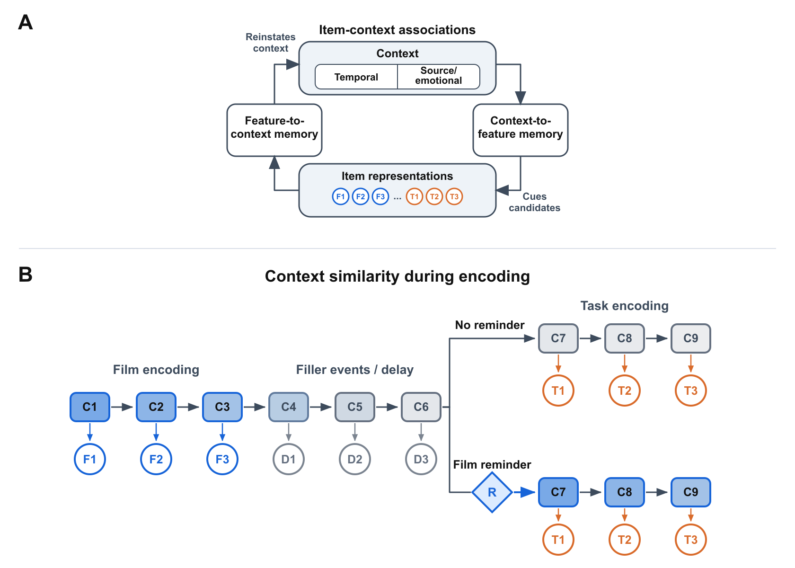

Retrieval Control in Deliberate Recall
Once target and competitor memories are both available, explaining deliberate recall requires specifying how a retrieval goal shapes the course of search. The present comparison holds learned associations constant across involuntary and deliberate recall. Any difference in their susceptibility to competition must therefore arise from control applied during deliberate retrieval. We consider three candidate processes that alter successive stages of search: orienting search toward the target episode before sampling, maintaining target-selective support during sampling, and limiting the influence of an off-target memory after it is sampled. The following paragraphs develop these processes in the order in which they act.
A retrieval goal may first orient memory search toward target material. When people are asked to recall an earlier studied list after studying a more recent one, their early responses are often already biased toward the instructed list rather than showing a gradual search backward through recent-list items (Healey & Wahlheim, 2024; Lohnas et al., 2015). Recall also shows a reliable tendency to start near the beginning of a studied list, especially when the usual end-of-list advantage is weakened by a delay (Healey & Kahana, 2014; Herrema & Kahana, 2024; Howard & Kahana, 1999). Several models account for these patterns by using list-related or pre-list context to cue recall (Cornell & Zhang, 2025; Healey & Wahlheim, 2024; Logan, 2021; Morton & Polyn, 2016).
Like study items, instructions identifying a list can acquire contextual associations during encoding. When presented before the list, an instruction also contributes to the context in which early items are encoded. A later instruction identifying the same list can reactivate its representation and associated context before recall begins (Healey & Wahlheim, 2024).
In the present simulations, we represent the effect of the film-recall instruction by shifting context toward the state present when film encoding began. This candidate tests whether orienting the start of search toward the target episode can reduce the effect of task competition once ordinary context-guided sampling resumes.
Orienting the start of search does not determine which candidates receive support as search unfolds. A retrieval goal may therefore also remain active during sampling, selectively supporting target memories. When people study mixed-category material and are asked to retrieve only one category, they can restrict recall to the target subset while temporal organization remains visible within that subset (Lohnas et al., 2026; Polyn et al., 2011). In this kind of task, intracranial recordings have revealed that category-selective activity tracks retrieval effort, remains active between reported recalls, and weakens before extra-category intrusions (Norman et al., 2017). Retrieved-context models provide a formal precedent for this kind of non-temporal support: semantic, task, and source information can contribute to candidate support alongside temporal context (Morton & Polyn, 2016; Polyn et al., 2009a, 2009b). Category-directed search has been formalized in associative memory models, and recent review work treats this as a natural but still underdeveloped direction for CMR (Lohnas et al., 2026; Raaijmakers & Shiffrin, 1980). A maintained film-category cue implements this form of control by adding support to film candidates without equally supporting task competitors. Because task candidates remain available through their associations with the current context, this candidate tests whether continuing target-selective support can reduce the effect of competition without removing the competitors.
Even target-selective support need not prevent an off-target memory from being sampled. Retrieval monitoring acts after a candidate has been sampled. Deliberate recall may therefore also involve monitoring sampled candidates and limiting their influence on subsequent search. Evidence for this possibility comes from externalized recall tasks where participants report every word that comes to mind and mark errors. These instructions reveal many more intrusions than standard recall, and many sampled intrusions are marked as errors, indicating that off-target candidates can enter retrieval without being accepted as target memories (Lohnas et al., 2015; Unsworth et al., 2010). Monitoring affects subsequent retrieval: when people fail to identify one response correctly, they are worse at rejecting the next intrusion (Unsworth et al., 2010). Sampled intrusions can also pull search away from the target list, as intrusions tend to cluster with other intrusions from related prior-list or semantic contexts (Unsworth et al., 2010; Zaromb et al., 2006). Retrieved-context implementations have treated monitoring as a target-match filter while still allowing rejected items to update the next retrieval context (Lohnas et al., 2015). Retrieval monitoring is implemented here by limiting how strongly a sampled non-film candidate updates context without changing the support that allowed it to be sampled. This candidate tests whether limiting the carryover of off-target retrieval can help deliberate recall recover after competition has already occurred. Figure 4 summarizes the three candidate processes and their positions in the retrieval cycle.

Figure 4
Retrieval operations in the retrieved-context account. The three panels locate retrieval control before, during, and after candidate sampling. (A) Involuntary and deliberate recall probe the same stored film and task associations from different initial context states. Involuntary recall begins from ongoing context, which can cue film and task candidates together. Deliberate recall can instead begin with start-of-film context reinstatement, which favors film candidates while leaving task candidates possible. (B) During sampling, ongoing context supports both film and task candidates, while a maintained film-category cue supplies additional support only to film candidates. (C) After an item has been sampled, feature-to-context memory updates the context used for the next sampling step. A sampled film item keeps subsequent search biased toward film candidates. Without monitoring, a sampled task item can redirect search toward task candidates. Retrieval monitoring dampens this task-item update, preserving some support for film candidates. Blue marks film items and film-favoring context or support; orange marks task items and task-favoring context or support. Gray elements depict the stored associations, ongoing context, and context-to-feature or feature-to-context pathways used across the compared conditions. Dashed outlines and arrows indicate weaker support or dampened updating, not unavailable candidates.
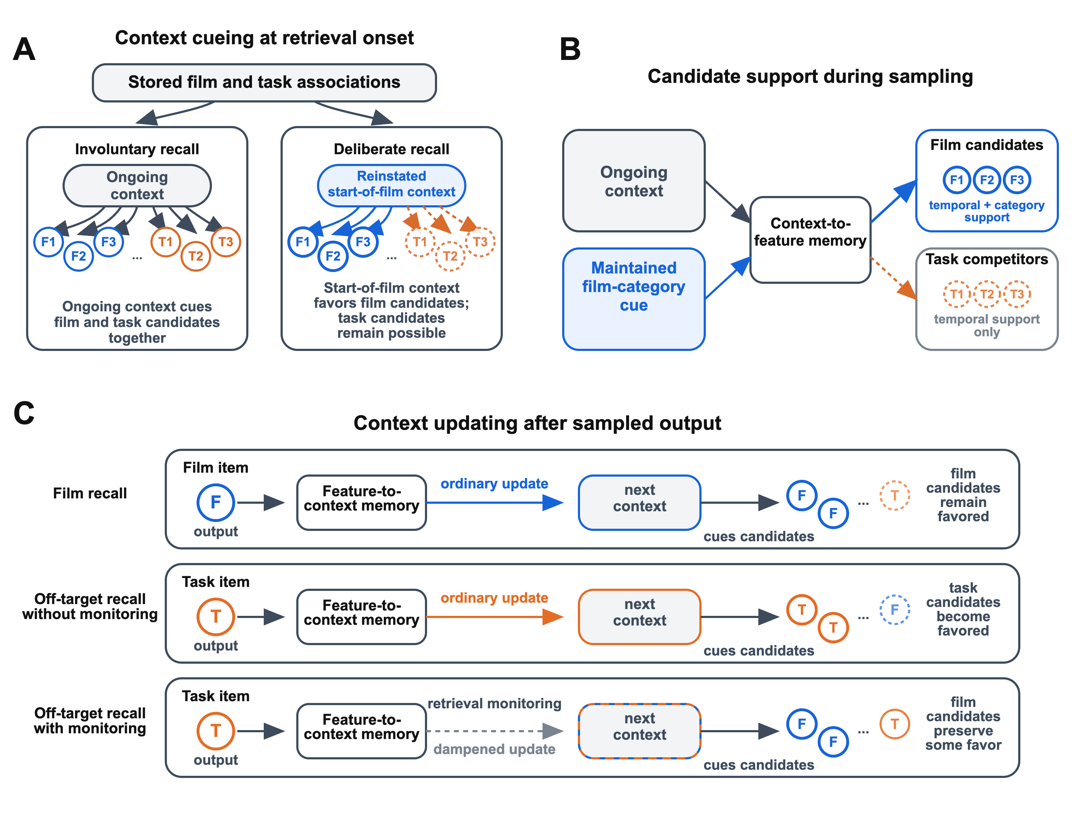

Deliberate Recognition
The control mechanisms considered above alter context-guided recall. Recognition instead uses the model’s bidirectional item-context associations in the opposite direction. During recall, current context cues candidate items, so a film item must be selected from candidates that can include task competitors. During recognition, a presented probe reinstates context associated with earlier encounters, and recognition evidence depends on the match between that context and the context active at test (Healey & Kahana, 2016; Jin et al., 2024). Task items therefore do not compete to be selected in place of the film probe, although task learning may still affect the contextual evidence it retrieves.
Taken together, the account separates what is learned from how it is later retrieved. Task events can become linked to film-associated context, while retrieval goals and test operations determine how strongly those associations affect access to film material. Selective interference can therefore emerge within a common episodic memory system without requiring intrusive and voluntary remembering to depend on separately vulnerable representations.

Model Specification
The formal model places film and non-film material within a common item-context memory. During recall, both enter the same sampling process, so task competition can alter what is retrieved while the associations supporting film memory remain available (Polyn et al., 2009a; Sederberg et al., 2008). We first specify the representations and learning rules that constitute this memory. The remaining subsections define the manipulations of reminder presence and task association strength used in Simulation 1, the operation used to model deliberate recognition in Simulation 2, and the retrieval control mechanisms compared in Simulation 3.
The formal model represents this sampling process with separate item and context representations. Each encoded event at position $i$ is represented by an item feature vector $f_{i}$, a one-hot vector that distinguishes that event from other encoded events in the simulated paradigm. Context $c_{i}$ denotes the internal context state after event $i$ has updated context. As film, task, and filler events occur, they update context and become associated with the context active around them. During recall, the current context state determines which candidate items receive support.
During encoding, items and states of context are linked through bidirectional associations represented in two matrices. Context-to-feature memory, $M^{CF}$, maps context states to item support, allowing current context to cue candidate items during recall. Feature-to-context memory, $M^{FC}$, maps item features to context states so that cued, reminded, or recalled items can reinstate associated context. All vectors are treated as column vectors, so $M^{FC}f_{i}$ is a context vector and $M^{CF}c_{i}$ is a feature-support vector.
Context and corresponding associations are further subdivided into temporal and source components. Temporal context distinguishes unique items so different film, task, and filler events can produce distinct context states even if items come from the same phase of the paradigm or share other features. Source context represents coarser information shared across related events, allowing recall to be shaped by task, semantic, or source relationships among items (Polyn et al., 2009a, 2009b). Emotional CMR variants distinguish emotional from neutral material in source context and give emotionally salient items stronger source-context associations (Cohen & Kahana, 2022; Talmi et al., 2019). In the present implementation, each item also has a source feature vector $s_{i}$. Film items share a film-source feature, whereas task and filler items carry a neutral/default source feature.

Encoding the Paradigm Sequence
Film, task, and filler events become later recall candidates through context updating and item-context learning. Each event updates context and becomes associated with the resulting state. During later recall, candidate support depends on how strongly studied items are associated with the context states active during retrieval.
Before the simulated film starts, context is initialized to $c_{0}$, a start state with no item-associated context units active. Memory matrices are initialized with pre-experimental associations that reflect baseline structure already present before the simulated paradigm begins. In $M^{FC}$, each item $i$ can cue its paired context unit with weight $1−γ$. In $M^{CF}$, each item is most strongly supported by its paired context unit, with weight $δ$. The other item-associated context units provide weaker background support to that item, with weight $α$. The start state $c_{0}$ initially provides no item support in $M^{CF}$. The initial entries of $M^{FC}$ and $M^{CF}$ are therefore:
$$M_{pre}^{FC}\left(j,i\right)=\left\{\begin{matrix}1-γ & \text{if }j=i+1 \\ 0 & \text{otherwise}\end{matrix}\right. \left(1\right)$$

$$M_{pre}^{CF}\left(i,j\right)=\left\{\begin{matrix}0 & \text{if }j=0 \\ δ & \text{if }j=i+1 \\ α & \text{if }j>0\text{ and }j≠i+1\end{matrix}\right. \left(2\right)$$

When event $i$ is encountered, its representation $f_{i}$ retrieves context input through feature-to-context memory:
$$c_{i}^{IN}=M^{FC}f_{i} \left(3\right)$$

Context then drifts toward the normalized input. The coefficient $ρ_{i}$ keeps context normalized after the update:
$$c_{i}=ρ_{i}c_{i-1}+β_{enc}{\hat{c}}_{i}^{IN} \left(4\right)$$

Each event also encodes associations between its item features and the current context state. Feature-to-context learning updates $M^{FC}$ so later cues or sampled items can reinstate associated context:
$$ΔM^{FC}=γc_{i}f_{i}^{⊤} \left(5\right)$$

Context-to-feature learning updates $M^{CF}$ so later context can support the item during sampling:

$$ΔM^{CF}=ϕ_{i}f_{i}c_{i}^{⊤} \left(6\right)$$
Here, $γ$ controls feature-to-context learning. To capture primacy effects in recall, $ϕ_{i}$ starts at $1+ϕ_{s}$ for the first encoded event in the paradigm. Its increment above 1 decreases by a factor of $e^{−ϕ_{d}}$ with each subsequent event.
Encoding events also have a source feature vector $s_{i}$ that distinguishes film items from non-film items. The source component of context follows the same normalized-drift form as temporal context, with source drift rate $β_{emot}$. All items can form associations with the source context active for that event, scaled by a baseline source-learning term $η_{s}$. For film encoding events, the source-context portion of the context-to-feature update receives an additional $ϕ_{emot}$ scale to reflect stronger encoding of emotional material in the trauma-film paradigm (Cohen & Kahana, 2022; Talmi et al., 2019). Task and filler events carry the neutral/default source feature, so they use the baseline source-learning scale without the added film-source term. After encoding, film, task, and filler candidates can all enter later recall through the temporal and source-context associations learned for each item.

Task Encoding After a Film Reminder
After the film-delay period, the simulated paradigm can present film reminders before the task begins. The reminder phase reinstates film-associated context before task items are encoded. Task items encoded from that state can later receive support for recall from context that also supports film material.
The reminder phase begins by updating context toward the start state of the film sequence. Let $c_{b}$ denote the context state after the break period. The reminder-phase start update is:
$$c_{r,0}=ρ_{r,0}c_{b}+β_{rem,start}c_{0}. \left(7\right)$$

The model then applies a sequence of film-item reminder cues. Each item from the film phase is presented as a reminder cue in the order it was encoded. Feature-to-context memory retrieves reminder input as in Equation 3, and context drifts toward that input using the normalized update in Equation 4 with the reminder drift rate. Reminder cues update context but do not become recallable items and do not add new context-to-feature learning. This isolates the reminder’s effect to reinstating film-associated context rather than adding new film-item associations.
Task events are then encoded by the ordinary event-learning rules with the reminder-updated context as the starting state. Task items carry the neutral/default source feature rather than the film-source feature, so they do not receive the added $ϕ_{emot}$ term. To vary task association strength, the simulations apply a multiplier $m_{task}$to context-to-feature learning for task events:

$$ΔM_{task}^{CF}=m_{task}ϕ_{i}f_{i}c_{i}^{⊤} \left(8\right)$$
This sensitivity manipulation determines how strongly the context active during task encoding later supports task items during recall. Task items encoded after the reminder become competitors in later recall because they are associated with context states that are also linked to film material. The associations formed during film encoding remain unchanged.

Context-Guided Recall and Test-Phase Cues
Involuntary and deliberate recall both require film items to be sampled from a candidate set that also includes task and filler items. At sampling step j, the current context state assigns support to each candidate by probing context-to-feature memory:
$$a_{i,j}={\left[M^{CF}c_{j}\right]}_{i} \left(9\right)$$

The context vector $c_{j}$ includes both temporal and source-context components. By default, candidates already sampled in the current recall period are excluded from later sampling.
Sampling follows a Luce choice rule over the remaining candidates (Luce, 1959):
Pi∣continue=ai,jτremaining k​ak,jτ 10

Following likelihood-based CMR implementations, stopping is modeled as a position-dependent hazard independent of current candidate support (Kragel et al., 2015; Morton & Polyn, 2016):
$$P_{stop}\left(j\right)=θ_{s}e^{jθ_{r}} \left(11\right)$$

This value is bounded to remain a valid probability. Because stopping is independent of candidate support, interference is read from the identity of sampled items. A sampled task or filler item takes the place of a possible film sample.
After a candidate is sampled, feature-to-context memory updates temporal and source context separately toward the sampled item’s associated context. For the temporal component, identified by the superscript $temp$, the update is:

$$c_{j+1}^{temp}=ρ_{rec,j}^{temp}c_{j}^{temp}+β_{rec}\hat{{\left(M^{FC}f_{r_{j}}\right)}^{temp}} \left(12\right)$$
The source component follows the same update with its own drift rate, $β_{rec,src}$, fixed at 1. The retrieved input and updated context are normalized separately for each component. Together, these updates let sampled material shape later search. A sampled film item can keep later sampling near film-associated context. A sampled task or filler item can pull later sampling toward non-film material.
Test-phase film cues use the same feature-to-context operation without becoming recall outputs. When a film cue $q$ is presented, the cued item updates context through $M^{FC}f_{q}$. The cue is not counted as a recalled item, does not make the cued film item unavailable for later recall, and adds no new learning. Recall sampling then resumes from the updated context state.

Deliberate Recall Control Mechanisms
Deliberate recall uses the same sampling rule as involuntary recall, with control settings applied before, during, or after sampling. The control settings only change post-encoding processes, including the retrieval cue, candidate support, or sampled-item carryover. Crucially, they do not change the film and task associations learned during encoding. This lets the simulations distinguish retrieval operations that increase film recall overall from those that reduce competition from task items encoded after a film reminder.
Start-of-film context reinstatement drifts context toward the state present at the beginning of film encoding before the first sampling step. The retrieval context is drifted toward the context state used to begin the film sequence, with drift rate $β_{start}$. This can bias early sampling toward film candidates rather than starting from the ongoing context state produced by the final delay phase of the paradigm. This control mechanism can therefore increase film recall. However, the reinstated context can also support task items encoded after the reminder.
During deliberate recall, the model can maintain a film-category cue that is absent during involuntary recall. This cue abstracts the kind of semantic or category support used in retrieved-context models of selective recall, rather than updating temporal or source context during retrieval (Morton & Polyn, 2016; Polyn et al., 2011). The cue adds support to candidates marked as film items during sampling:
$$a_{i,j}^{cat}=a_{i,j}+ω_{cat}g_{i} \left(13\right)$$

Here, $g_{i}=1$ for film candidates and $g_{i}=0$ for task and filler candidates. The indicator $g_{i}$ is a retrieval-control cue, distinct from the source feature vector $s_{i}$ used during encoding. Task and filler candidates can still compete through $a_{i,j}$, but only film candidates receive the film-category increment. Therefore, a maintained film-category cue can reduce the effect of those task competitors on film recall.
Externalized free recall asks participants to report every word that comes to mind during recall and identify intrusions or repetitions, revealing nontarget memories that enter search even when they are recognized as errors. In a retrieved-context model of this procedure (Lohnas et al., 2015), monitoring occurs after sampling. A candidate is accepted as a target response when its retrieved context sufficiently matches the context associated with the target list. Whether accepted or not, the candidate updates the context guiding the next sample. The present simulations retain this timing but change the consequence of monitoring. Sampled task or filler candidates update the next retrieval context less strongly. Let $κ_{i}=1$ for film candidates and $κ_{i}=κ$ for task and filler candidates. Monitoring scales both retrieval drift rates by $κ_{i}$. The temporal-context update becomes:

$$c_{j+1}^{temp}=ρ_{j}^{temp}\left(κ_{i}β_{rec}\right)c_{j}^{temp}+κ_{i}β_{rec}\hat{{\left(M^{FC}f_{r_{j}}\right)}^{temp}} \left(14\right)$$
The corresponding source-context update uses $κ_{i}β_{rec,src}$. When $κ<1$, sampled non-film candidates still count as sampled outputs but both context components are updated less strongly toward their associated context. This reduces carryover from sampled task or filler candidates without changing the candidate support that made them available. Like start-of-film reinstatement, this operation does not by itself remove task support from film-associated context.
The three evaluated control mechanisms therefore enter the same retrieval cycle at different points: start-of-film context reinstatement before sampling, a maintained film-category cue during sampling, and retrieval monitoring after sampling.

Item Recognition
CMR has been used mainly to model recall, with relatively few extensions to recognition (Healey & Kahana, 2016; Jin et al., 2024; Lohnas et al., 2015). Here, recognition is represented only at the level of memory evidence: the model does not specify a decision criterion or generate an old/new response. A presented probe q retrieves associated context through feature-to-context memory, the same pathway used by reminders, cues, and sampled items. Recognition evidence is the similarity between the retrieved context and the context active during the test:
$$e_{q}={\left(M^{FC}f_{q}\right)}^{⊤}c_{test} \left(15\right)$$

This recognition implementation isolates the access difference between recognition and context-guided recall. Recall must select a film item among candidates supported by context, whereas recognition evaluates a film item supplied by the test.
The model therefore addresses whether task competitors linked to reinstated film-associated context reduce the evidence advantage of studied film items over unstudied foils with the same film-source feature. Converting this evidence into old/new responses would additionally require specifying how it determines the probability of an “old” judgment.

Simulations
The simulations examine a schematic delayed reminder-plus-task trauma-film paradigm, with James et al. (2015) and Kessler et al. (2020) providing procedural examples rather than fitted targets. The reminder-before-task sequence places task events after reminder-driven reinstatement of film-associated context, making it possible to examine whether those events become competitors during later retrieval. The core recall target is the model analogue of selective interference: strong task encoding following a film reminder reduces involuntary film recall more than deliberate film recall. The involuntary-recall condition provides a simplified model of film material coming to mind without deliberate intent to retrieve it; it does not reproduce diary or laboratory intrusion procedures. Simulation 1 shows how a task performed after a film reminder attenuates film recall when task items become strongly linked to reinstated film-associated context. Simulation 2 examines whether interference is reduced when the test presents a candidate film item for judgment rather than requiring that item to be sampled from context. Simulation 3 then adds the intentionality manipulation by contrasting the involuntary-recall condition with deliberate recall and examining control mechanisms that could protect film recall. Together, these simulations show how selective interference can arise from competitor encoding after reminder-driven context reinstatement and retrieval conditions that differ in how they access or support film material.

Methodology
The simulations follow a generalization-style modeling logic (Busemeyer et al., 2000; Lohnas et al., 2023). Core parameters are anchored in an independent affective free-recall dataset (Dupertuys et al., 2026), and no trauma-film outcomes are fitted. The simulations require default values for context drift, associative learning, sampling, and stopping before the trauma-film manipulations are applied. Estimating those values from selective-interference data would require the full modeled paradigm together with trial-by-trial recall sequences that identify which film, task, and non-film candidates entered retrieval. Published trauma-film studies motivate this qualitative target, but they typically report intrusion counts or final memory scores rather than the sequence-level data needed to estimate retrieval competition. We therefore use an immediate affective free-recall dataset to set the model’s core encoding, retrieval, and stopping parameters.
In that dataset, participants who reported concern about the war in Ukraine studied and recalled lists of war-related and neutral photographs (Dupertuys et al., 2026). The fitted dataset included 123 participants, four lists per participant, 492 immediate recall sequences, and 3,804 scored recall events. Parameters were estimated from the ordered recall sequences using the model likelihood, yielding a pooled parameter regime rather than separate fits to the selective-interference simulations. The resulting parameter values provide a starting regime for context-guided recall of affective and neutral photographs.
The selective-interference simulations then add the trauma-film phase structure and manipulations of reminder presence, task association strength, and retrieval control. Film items reinstate the marked source feature into source context, and neutral/default events can weakly bind active source context. Table 1 gives the default numerical values used in the simulations.

Table 1
Parameter values and roles in the simulations.
Symbol | Value | Role
$$β_{enc}$$ | 0.440 | Drift toward item-cued context during encoding
$$β_{start}$$ | 0.766 | Drift toward the start-of-film context during start-of-film reinstatement
$$β_{rec}$$ | 0.678 | Drift toward sampled-item temporal context during recall
$β_{rec,src}$ | 1.000 | Source-context drift toward sampled-item source context during recall
$$γ$$ | 0.468 | Feature-to-context learning
$$δ$$ | 0.00022 | Initial support from each item’s paired context unit
$$α$$ | 0 | Initial background support from other item-associated context units
$$ϕ_{s}$$ | 0.100 | Scale parameter for the primacy profile $ϕ_{i}$
$$ϕ_{d}$$ | 1.500 | Decay parameter for the primacy profile $ϕ_{i}$
$$τ$$ | 3.562 | Luce-choice exponent for candidate sampling
$$β_{emot}$$ | 0.696 | Drift toward the active source feature during encoding
$$ϕ_{emot}$$ | 0.130 | Added source-context learning for film items
$$η_{s}$$ | 0.050 | Baseline source-context-to-feature learning for all items
$$θ_{s}$$ | 0.0123 | Initial scale of the position-dependent stopping hazard
$$θ_{r}$$ | 0.372 | Growth of the stopping hazard across sampled outputs
$$κ$$ | Varied by condition | Degree to which sampled non-film items carry context forward
$$ω_{cat}$$ | Varied by condition | Added support for candidates matching the film-category cue
Note. Most default values were taken from a pooled eCMR fit to the immediate free-recall sequences from Dupertuys et al. (2026). During fitting, $α$ was fixed at 0 and $β_{rec,src}$ at 1. For the present simulations, $ϕ_{s}$ and $ϕ_{d}$ were set to 0.100 and 1.500 instead of their fitted values, and $η_{s}$ was set to 0.050. The retrieval-control parameters $κ$ and $ω_{cat}$ vary across conditions.
In all simulations, the model first encodes the paradigm events and then enters retrieval. Film, break/buffer, task, and filler items are encoded by the CMR operations defined above. Each simulated trial contains 16 film items, 16 break/buffer items, 16 task items, and 16 filler items unless otherwise noted. Break/buffer items implement the delay before the reminder or task, and filler items implement the post-task delay. Equal phase lengths make redistribution across film, task, and filler periods directly comparable.
In everyday life, partial environmental reminders can bring an event memory to mind involuntarily (Berntsen, 2021). Film stills and blurred film images provide controlled laboratory analogues of such reminders in tasks where participants monitor for or deliberately retrieve film memories (Lau-Zhu et al., 2019, 2021; McConnell et al., 2026). The recall simulations therefore include weak film cues. These cues are held constant across conditions so that differences reflect whether a reminder preceded task encoding, the strength of task encoding, and retrieval control rather than differences in the cues supplied at test. Reminder cues and film cues presented during retrieval update context through Equation 3 and Equation 4, but add neither recallable items nor new item-context learning.
In context-to-item recall simulations, all encoded film, break/buffer, task, and filler items can enter the retrieval competition. Retrieval allows up to 48 sampling steps. In the main analyses, sampled items are removed from the candidate set so the same item is not sampled twice. The simulated retrieval sequence records sampled candidates by type and encoded position, rather than only final film counts. This convention makes it possible to examine predictions about how interference redistributes recall across the encoded stream, rather than only reporting final recall counts.
Parameter sweeps rerun the full encode-then-retrieve simulation across planned values of a manipulated parameter. For each condition and manipulated parameter value, the model first completes the phase sequence, then enters retrieval and samples recallable items using Equation 10 and Equation 11. This procedure is repeated across simulated trials within each cell. When figures plot recall across the encoded stream, they summarize retrieval after the full phase sequence has been encoded. Serial-position curves plot the proportion of trials in which each encoding position was retrieved, and phase summaries average those proportions within each phase. Thus, position and phase labels identify encoding positions, whereas recall probabilities refer to subsequent retrieval.

Simulation 1: Task Association Strength and Context Similarity
Simulation 1 tests whether a film reminder before task encoding makes task items stronger competitors for involuntary film recall. Retrieval settings are held fixed, so differences across conditions reflect associations formed before retrieval rather than deliberate control. The design crosses pre-task reminder presence with task association strength while weak film cues are supplied periodically during recall in all conditions. In the no-reminder condition, the reminder-start and film-cue drift scales are set to zero. In the with-reminder condition, context first shifts toward the start state and then receives sequential film reminder cues before task encoding. Reminder cues update context without applying Equation 5 or Equation 6 and without adding recallable items. Task association strength is varied using the $m_{task}$ multiplier defined in Equation 8. The weaker and stronger settings probe the sensitivity of recall to this association strength; they do not represent particular intervention tasks or differences in engagement.
Figure 5 shows the aggregate result. Film recall is lowest when strong task encoding follows a film reminder, and task output increases in the same condition. The film loss therefore reflects redistribution toward task competitors under fixed retrieval settings.

Figure 5
Simulation 1: involuntary film recall by reminder condition and task association strength. Reminder condition and task association strength were crossed while all trials used the involuntary-recall condition; weak film cues were supplied periodically during recall in every condition. (A) Example generated recall sequences for each condition. Each row shows one simulated trial selected near the condition mean for the number of film items recalled; recalled items are ordered left to right by output position. Colors mark film items, task items, delay/filler items, and unfilled output positions. (B) Mean number of film items recalled across all simulated trials. The bracket marks the larger reduction from weak to strong task encoding when the task follows a film reminder. Film recall was lowest when a film reminder preceded strong task encoding, isolating the involuntary-recall component of the selective interference effect.

Figure 6 shows that the redistribution is position-resolved. Without a pre-task film reminder, increasing the task encoding multiplier produces only modest film loss and task gain, because task items become associated with later context states reached after drift away from the film. With a pre-task film reminder, the same task-encoding manipulation produces a larger drop in film-position recall and a larger rise in task-position recall. In other words, the effect of stronger versus weaker task associations is greater with than without the pre-task reminder (i.e. the two factors interact).

Figure 6
Simulation 1: Strengthening task associations after a film reminder shifts recall from film to task items. Reminder condition and task association strength were crossed while all trials used the involuntary-recall condition; weak film cues were supplied periodically during recall in all conditions. (A) Without a pre-task film reminder, recall probability by encoded position changes only modestly when task associations are strengthened. (B) With a pre-task film reminder, stronger task associations reduce recall from film positions and increase recall from task positions. Curves compare weaker and stronger task associations; shaded bands mark film, break, task, and filler positions, and the green vertical line marks the pre-task film reminder. Task association strength therefore changes recall probability by encoded position most clearly when task encoding follows a film reminder.

Because the reminder reinstates film-associated context before task encoding, increasing task association strength makes that context more likely to support task items during later recall. The reminder increases similarity between film- and task-encoding contexts (Supplementary Figure S1). Film-item associations remain unchanged; film recall falls because the retrieval context now also supports task competitors. Simulation 1 therefore shows how task items encoded after a film reminder can become competitors for involuntary film recall within a retrieved-context model. Simulation 2 examines the simpler boundary case in which recognition supplies the candidate item instead of requiring context to generate it.

Simulation 2: Recognition
The recognition simulation uses the same reminder conditions, task association strengths, and resulting item-context associations as the recall simulations. It changes the retrieval operation by presenting each candidate film item as a test probe rather than requiring that item to be sampled from context.
The simulation presents studied film items and unstudied foil identities that carry the same film-source feature as the studied items but lack their study-specific item-context associations. Because item features are localist, these film-source-matched foils do not represent graded perceptual or semantic similarity to studied film items. This permits the narrower test of whether linking task items to film-associated context reduces the evidence advantage for studied film probes. Each probe retrieves associated temporal and source context through feature-to-context associations, and recognition evidence is computed from the match between the probe-retrieved context and the current test context (Healey & Kahana, 2016; Jin et al., 2024). Decision criteria, confidence, and detailed foil-processing assumptions are left outside the present implementation.
Strong task encoding after a film reminder strongly reduces context-guided film recall but does not produce a corresponding reduction in recognition-evidence separation (Figure 7). Old-film minus foil evidence remains essentially unchanged across the four combinations of reminder presence and task association strength.

Figure 7
Recognition supplies the film candidate rather than selecting it among competitors. (A) When film-associated context cues items, film items and task items linked to that context can both receive support. In recognition, the test presents a candidate item as the probe. The probe retrieves associated context, which is compared with ongoing test context; stronger matches provide stronger evidence that the item appeared in the film. C1–C4 denote context components, and heavier outlines identify the retrieval input. Faded items depict other stored representations that are not presented as the probe. (B) Old-film minus foil recognition evidence is plotted across the same reminder conditions and task association strengths used in the recall simulations. The measure subtracts mean evidence for film-source-matched foils from mean evidence for studied film probes. Strong task encoding after a film reminder does not produce a corresponding reduction in recognition-evidence separation.
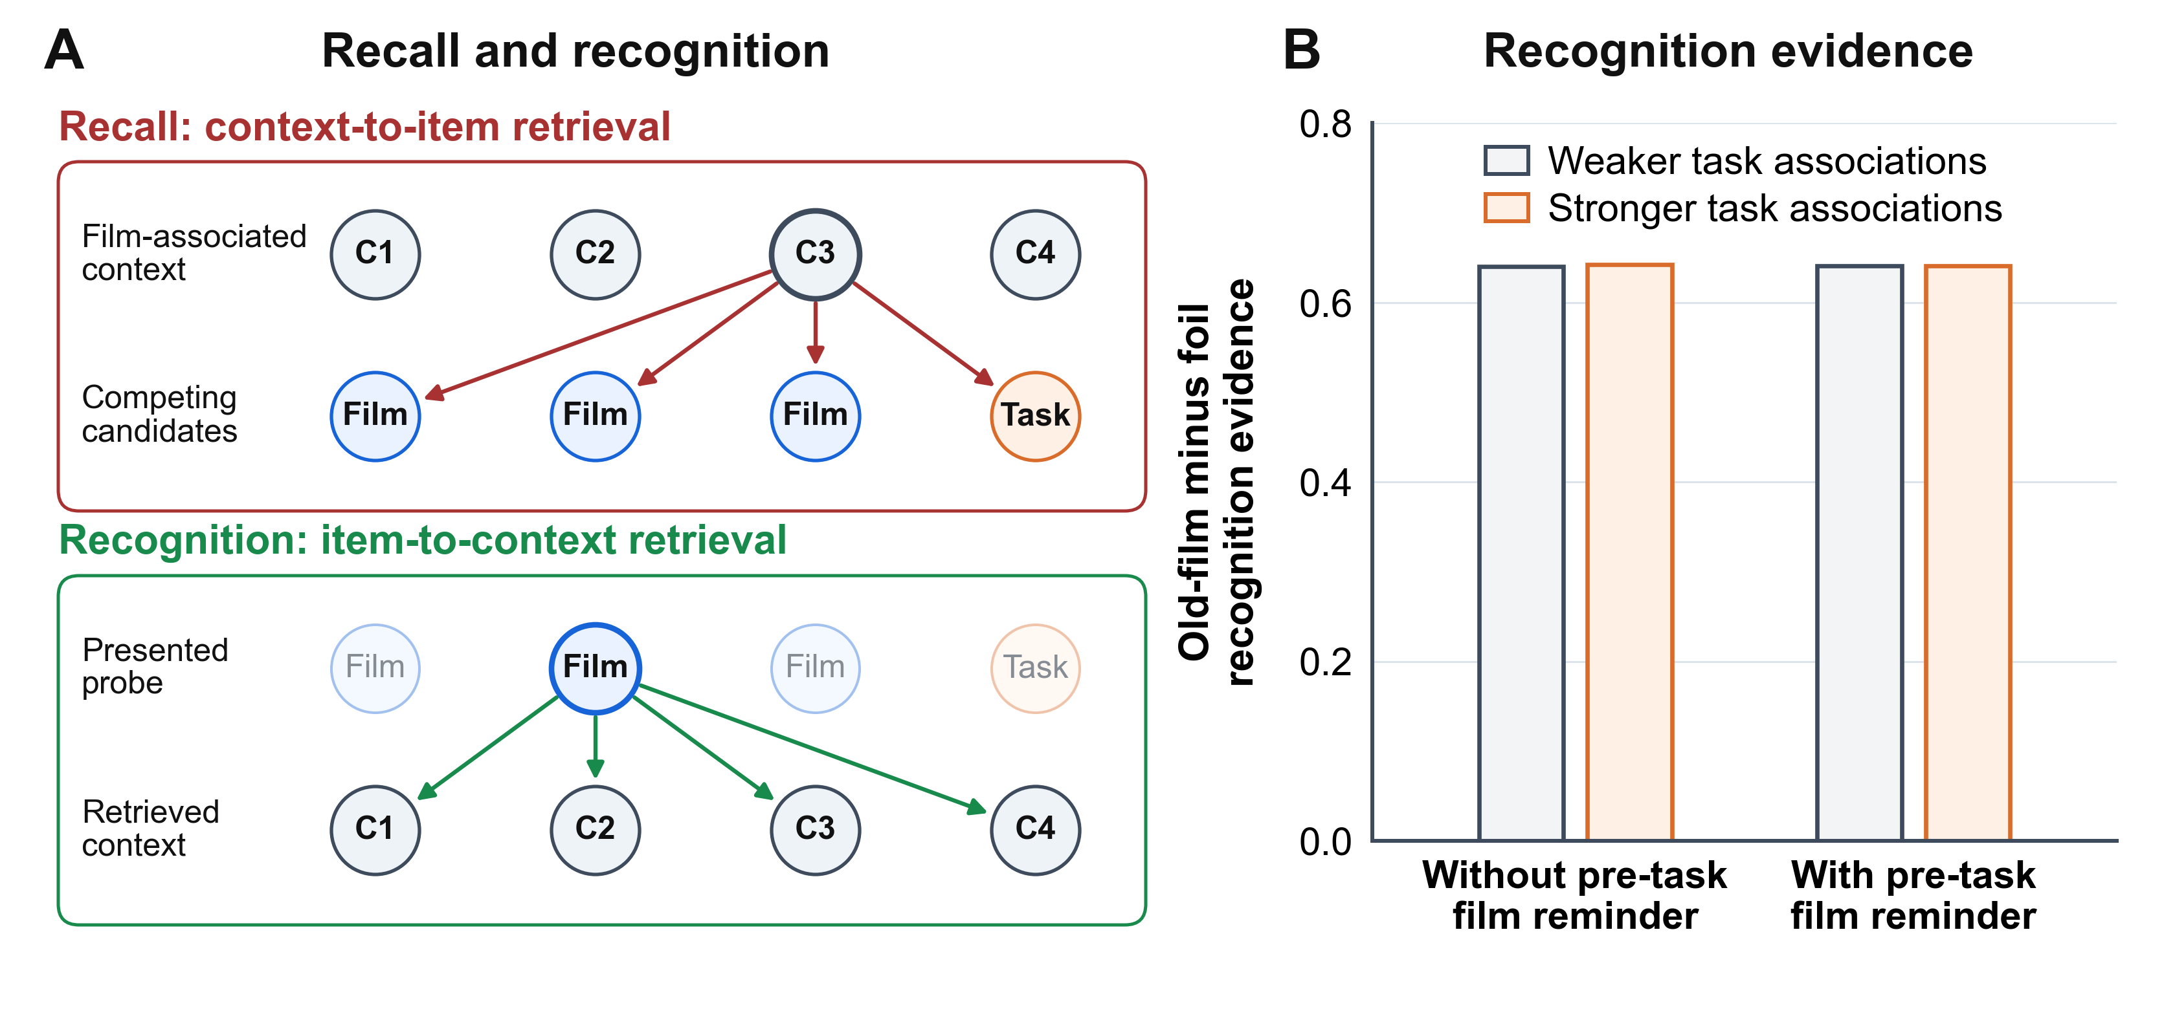
The simulation therefore identifies a test-format confound in designs that compare involuntary tests measuring whether film material comes to mind with voluntary tests that supply film material for recognition. Such designs do not isolate retrieval intentionality: preserved recognition alongside reduced intrusions may reflect a difference between test formats rather than a general sparing of voluntary recall.
Deliberate recall must still generate film candidates while task competitors remain eligible for sampling. Simulation 3 asks which control operations can protect deliberate recall under that competition.

Simulation 3: Control Mechanisms for Deliberate Recall
Simulation 3 examines how deliberate retrieval control can protect film recall across the same reminder conditions and task association strengths used in Simulation 1. It first compares involuntary and deliberate film recall across that design, then decomposes the control operations available during deliberate recall. The full deliberate-control condition combines three operations: start-of-film context reinstatement before sampling, a maintained film-category cue during sampling, and retrieval monitoring after non-film candidates are sampled. The main readout is how much strengthening task encoding reduces film recall in each reminder condition, rather than total film recall alone. We tested whether changing the strengths of reinstatement and monitoring could protect film recall without a maintained film-category cue. We crossed 11 levels of each mechanism, from absent to maximal, giving 121 combinations. We evaluated each combination under all four reminder and task-association conditions, holding the remaining model settings fixed. Each condition included 5,000 simulated trials divided into ten paired batches. For each retrieval setting, we measured how much a reminder increased the recall cost of stronger task encoding. Selective protection was the reduction in this reminder-dependent cost relative to the involuntary-recall condition.
We also tested whether selective protection depended on excluding repeated retrievals or on how film output was counted. We compared involuntary recall with the full deliberate-control condition across the same reminder and task-association conditions, with repeated sampling either prohibited or allowed. When repetition was allowed, sampled items remained available for retrieval throughout the same search. Each condition included 5,000 simulated trials divided into ten paired batches. We scored each sequence both as the total number of film retrieval events, including repetitions, and as the number of distinct film items retrieved at least once.
Figure 8 demonstrates the model’s simulation of the selective interference effect. In involuntary film recall, strong task encoding produces a small film-recall loss without a pre-task reminder and a much larger loss after a film reminder. Under deliberate film recall, strong task encoding after a film reminder produces a much smaller reduction. The full deliberate-control setting therefore reproduces the selective-interference pattern under the same learned task competitors.

Figure 8
Simulation 3: Deliberate film recall is relatively preserved when a film reminder precedes strong task encoding. Reminder condition and task association strength were crossed as in Simulation 1 while retrieval mode was varied between involuntary film recall and deliberate film recall. Deliberate film recall combined start-of-film context reinstatement, a maintained film-category cue, and retrieval monitoring. Weak film cues were supplied periodically during recall in all conditions. Rows compare retrieval modes, columns compare reminder conditions, and paired bars compare weak versus strong task encoding. In the with-reminder column, brackets label the selective reduction under involuntary film recall and relative preservation under deliberate film recall. Strong task encoding reduced film recall most clearly when it followed a film reminder, but this reduction was much larger under involuntary film recall than under deliberate film recall. The model therefore simulates a selective interference effect: strong task encoding after a film reminder substantially reduces involuntary film recall while leaving deliberate film recall relatively preserved.
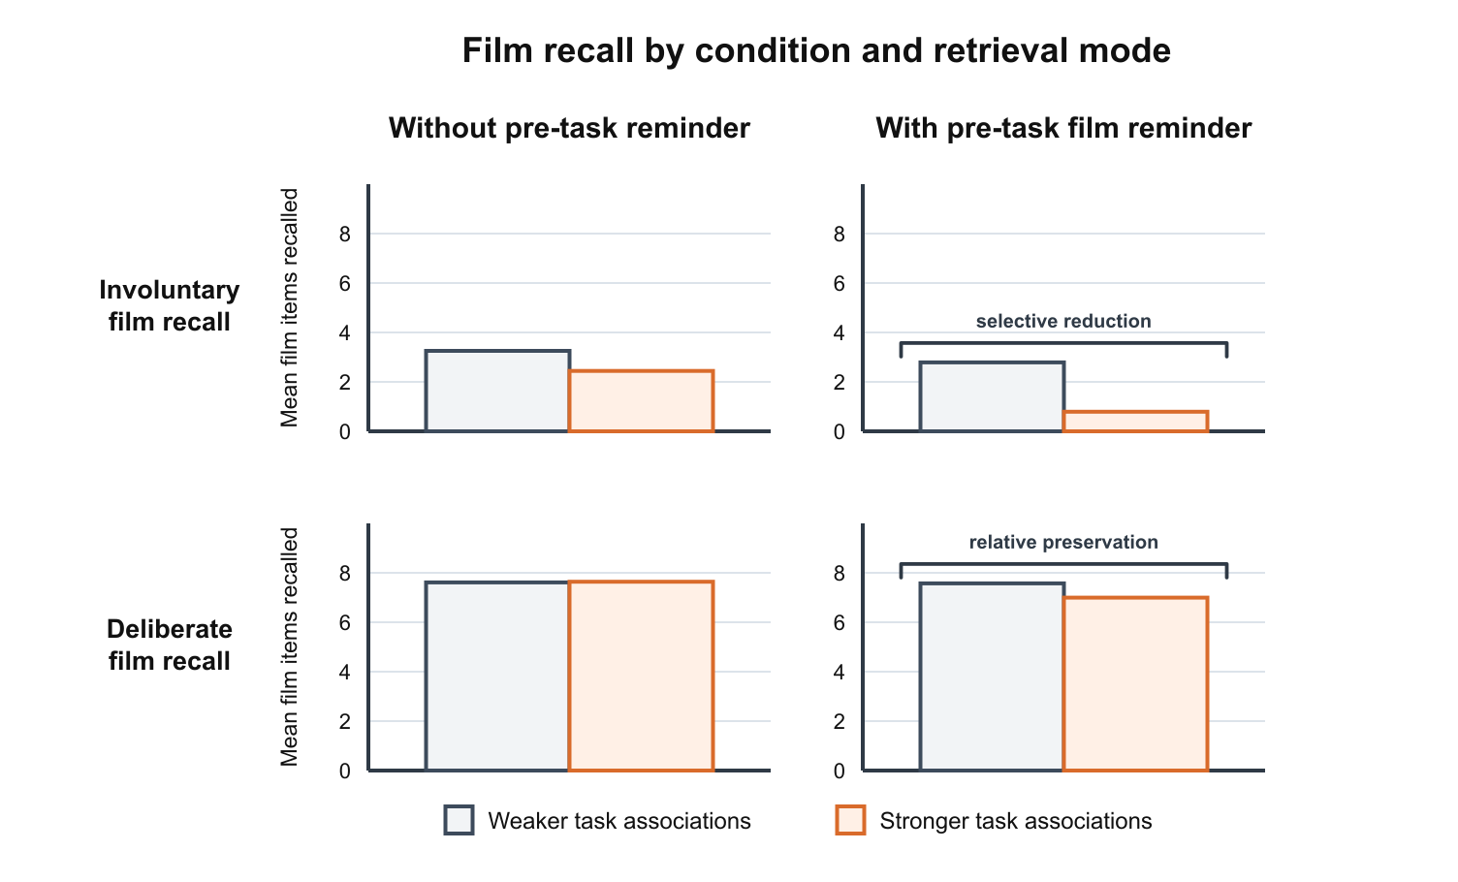
Selective protection remained when repeated sampling was allowed and each distinct film item was counted only once. Its magnitude was similar to that obtained when repeated sampling was prohibited. Counting every film retrieval event produced a larger contrast, indicating that repetitions amplified the measured dissociation, while protection also extended to distinct film memories.
Figure 9 decomposes how retrieval-control operations alter the film-recall loss produced when a film reminder precedes strong task encoding. The figure compares film recall in a low-interference condition, with no reminder and weak task encoding, against film recall in a high-interference condition, where a film reminder precedes strong task encoding. When the maintained film-category cue is absent, film recall remains much lower in the high-interference condition. Start-of-film reinstatement and retrieval monitoring can raise film recall, but the loss between the low- and high-interference conditions remains large. The maintained film-category cue most strongly reduces this loss by helping film candidates overcome competition from task competitors. In the model, the maintained film-category cue does not alter temporal context or the associations learned during encoding. It adds support to film candidates during sampling, providing a basis for selection that task competitors do not receive.

Figure 9
Simulation 3: different retrieval controls preserve film recall to different degrees. Each control setting was evaluated in two conditions: a low-interference condition with no pre-task reminder and weak task encoding, and a high-interference condition with a pre-task film reminder and strong task encoding. Weak film cues were supplied periodically during recall in all conditions. The involuntary-recall condition includes none of the three deliberate-control operations. Bars show mean number of film items recalled for each control setting in both conditions. Start-of-film reinstatement and retrieval monitoring increase film recall in some conditions, but the loss from the low- to high-interference condition is smallest when a maintained film-category cue is included.
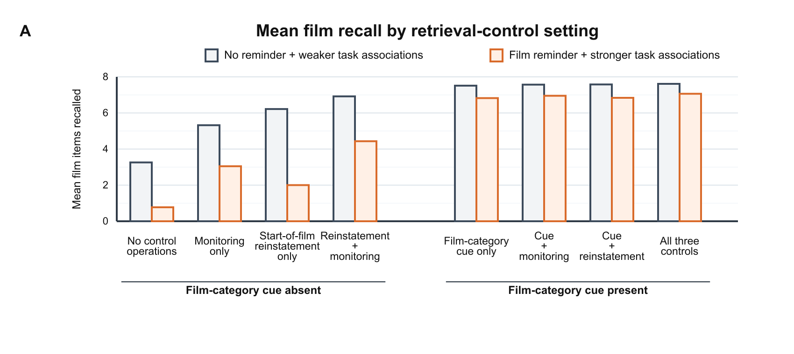
Across the tested combinations of reinstatement and monitoring, some settings modestly reduced the recall loss between the low- and high-interference conditions shown in Figure 9. Even the largest reduction was substantially smaller than that produced by the maintained cue alone. None of the settings reduced the reminder-dependent cost of stronger task encoding relative to the involuntary-recall condition. The maintained cue reduced that cost both alone and in combination with reinstatement and monitoring. Thus, the importance of sustained film-selective support extended beyond the default settings, although reinstatement and monitoring could provide limited protection on simpler comparisons.
Reinstatement and monitoring can contribute to deliberate recall even when they do not account for its relative protection from interference after a film reminder. Because these operations may occur alongside maintained cueing, we next examine their different consequences for which encoded positions are recalled (Figure 10) and what follows a non-film retrieval (Figure 11). These patterns provide ways to distinguish the mechanisms empirically.

Figure 10
Simulation 3: retrieval controls produce different patterns across encoded positions. The high-interference condition was held fixed: a pre-task film reminder preceded strong task encoding, and weak film cues were supplied before recall began and at four-attempt intervals throughout recall. Curves compare one control operation alone with the same no-control baseline: start-of-film context reinstatement (A), a maintained film-category cue (B), or retrieval monitoring (C). Solid lines show the named operation; dashed lines show the baseline with none of the three operations. Each curve gives the probability of recalling an item at each encoded position at any point during the search, based on 5,000 simulated trials per setting. Shaded regions identify the film, break, task and filler phases. Control strengths match the preceding decomposition (Figure 9); monitoring completely suppresses context updating after non-film samples.
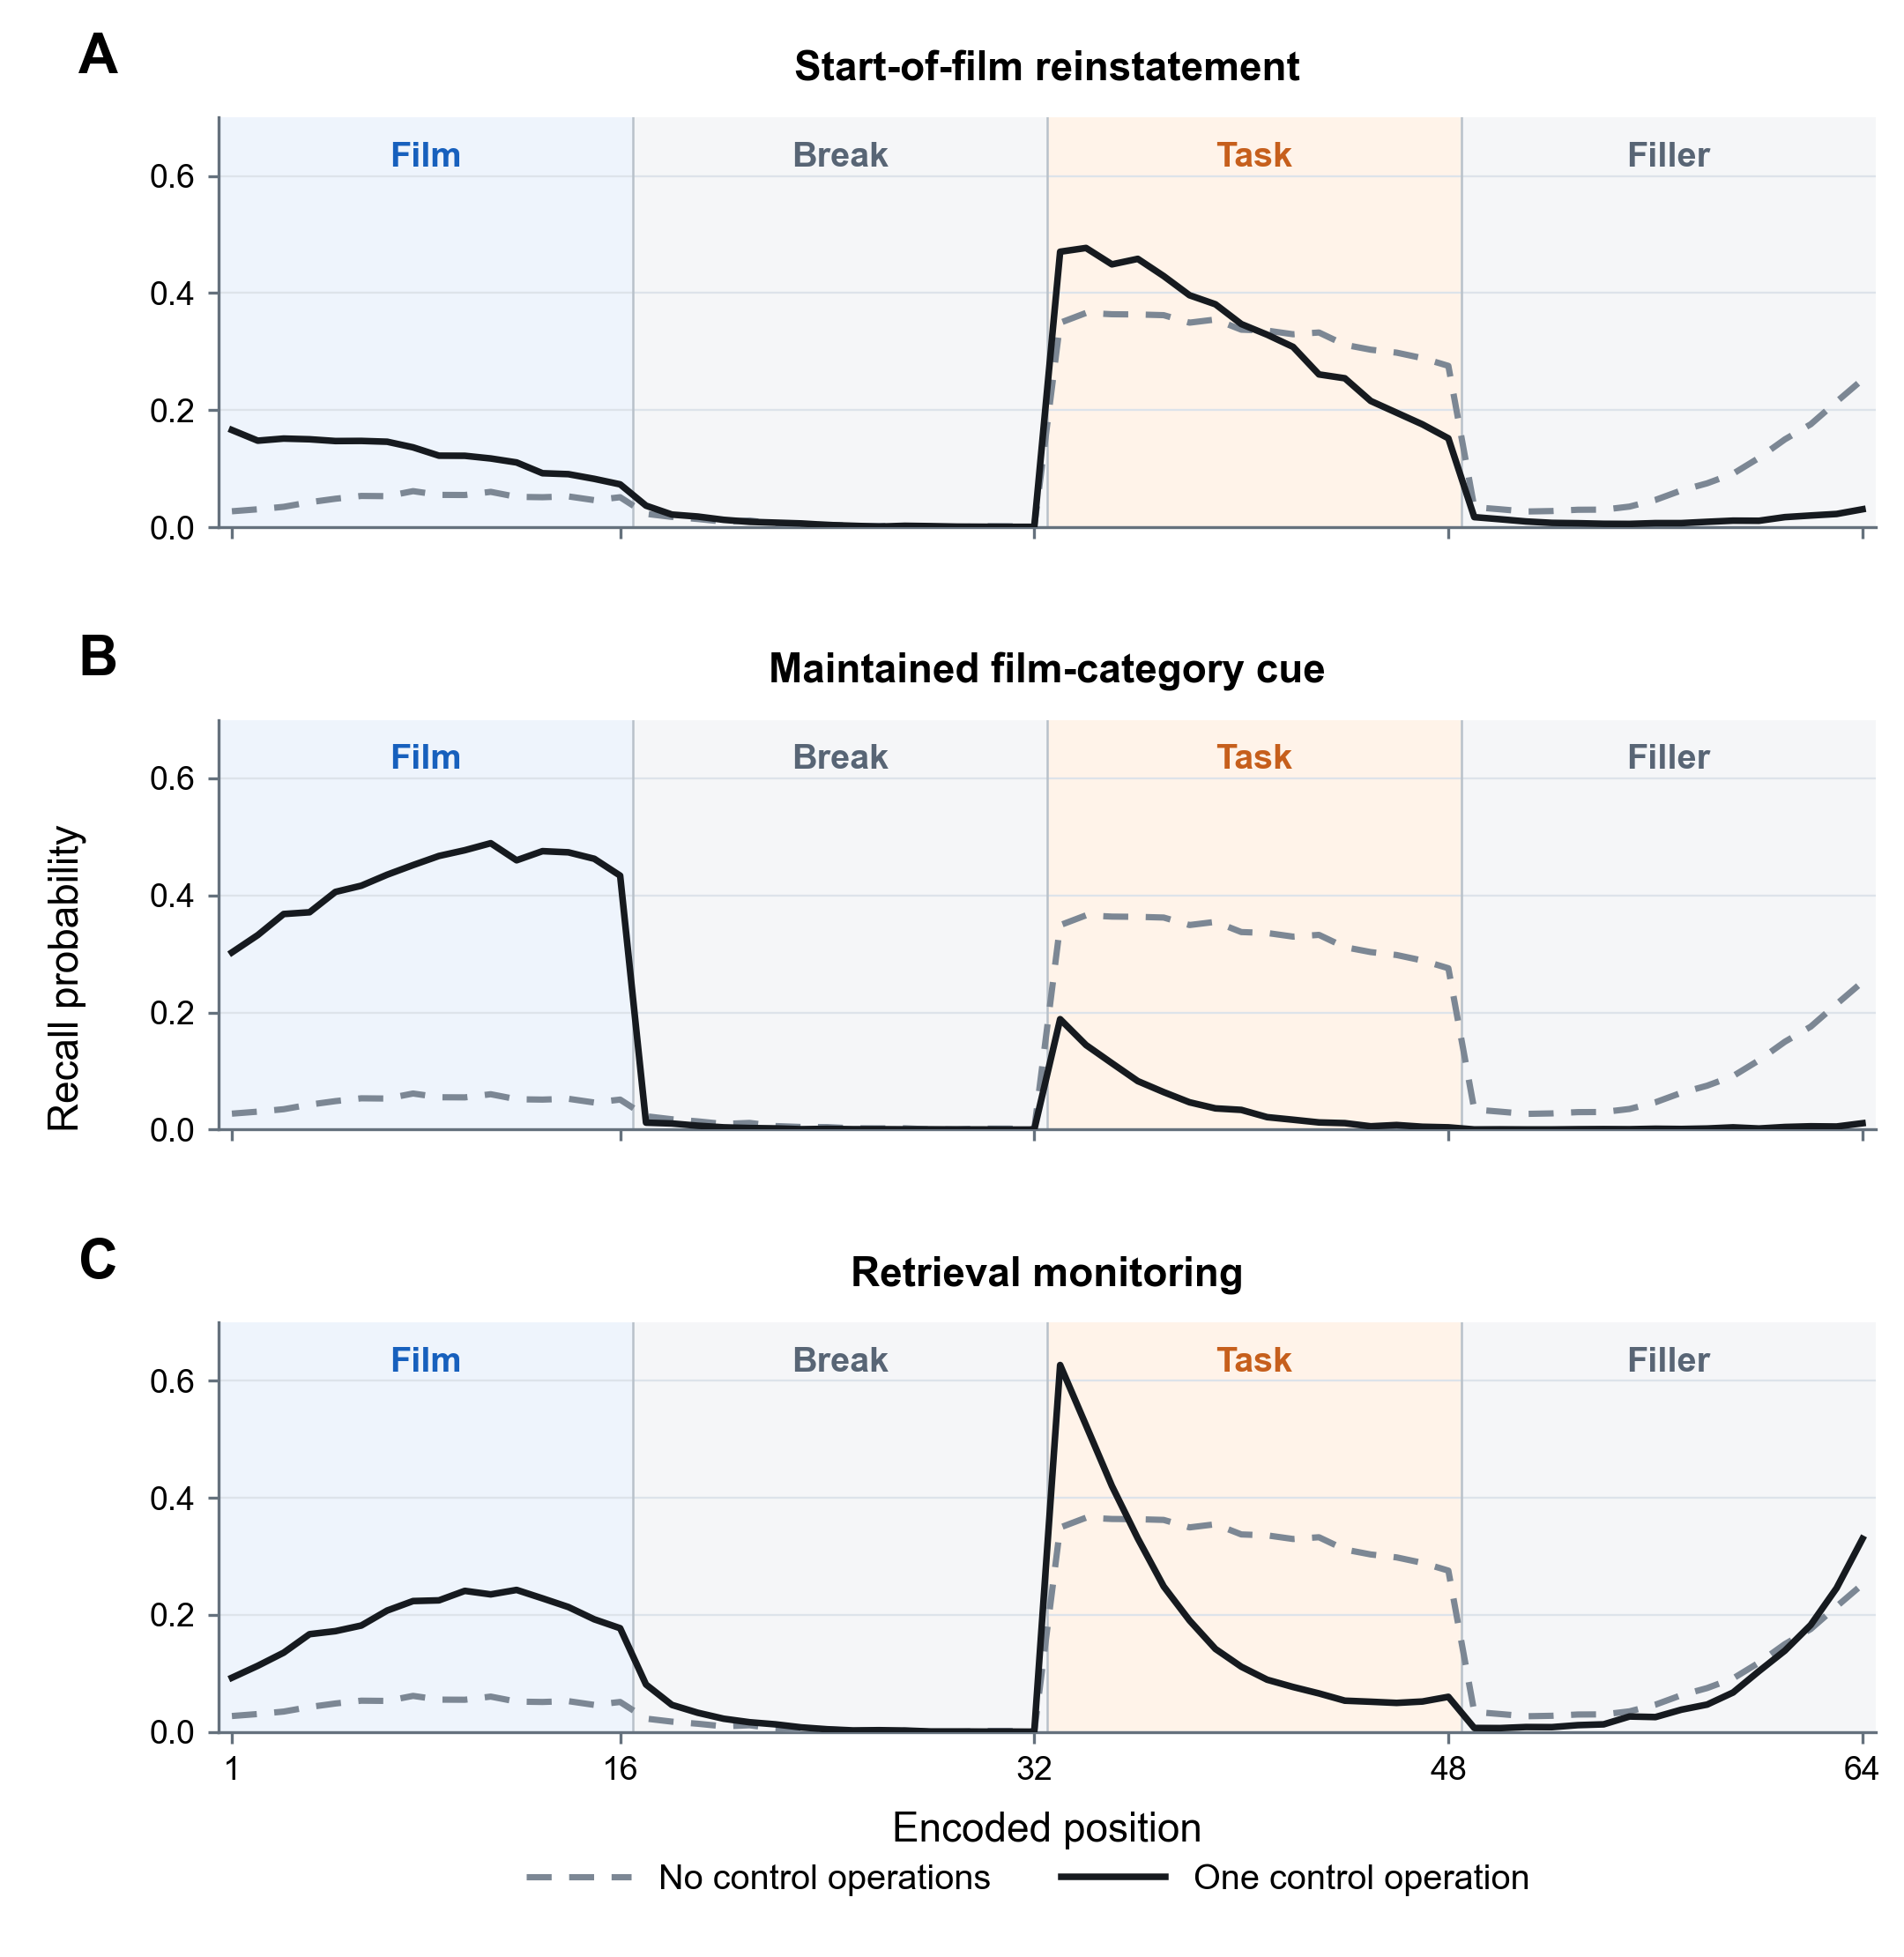
Figure 10 shows that start-of-film context reinstatement increased recall most at early film positions, but also increased recall of early task items. The maintained film-category cue increased recall throughout the film sequence while reducing recall of task items. Retrieval monitoring also increased film recall, with larger gains at later film positions, and reduced recall of most task items. If deliberate recall involves reinstating the context present at the start of a target sequence, the resulting recall benefit should therefore be strongest for material encountered near the beginning of that sequence.

Retrieval monitoring can be distinguished from start-state control and maintained film-category support by examining the order of items recalled. Monitoring acts after a non-film item has already been sampled. By dampening that item’s context update, monitoring limits how much the sample redirects subsequent retrieval. Figure 11 shows that monitoring increases the probability that a sampled non-film item is followed by recall of a film item. Monitoring therefore helps recall recover after task or filler material has entered the output sequence. It does not supply film-directed support before sampling occurs, so it provides only limited protection against task competition during film recall. Simulation 3 therefore constrains the account: deliberate recall is not spared by a generic voluntary-memory setting. It is less affected when control supplies film-directed support that task competitors do not share, whereas controls that only change retrieval initiation or post-sampling carryover remain more vulnerable.

Figure 11
Simulation 3: retrieval monitoring supports return to film recall. The curve shows how the probability of recalling a film item after a non-film sample changes with monitoring strength. All conditions included a film reminder followed by strong task encoding. During recall, start-of-film context was reinstated and weak film cues were supplied periodically, but the maintained film-category cue was absent. Monitoring ranged from allowing the full context update after non-film samples (0) to suppressing that update completely (1).
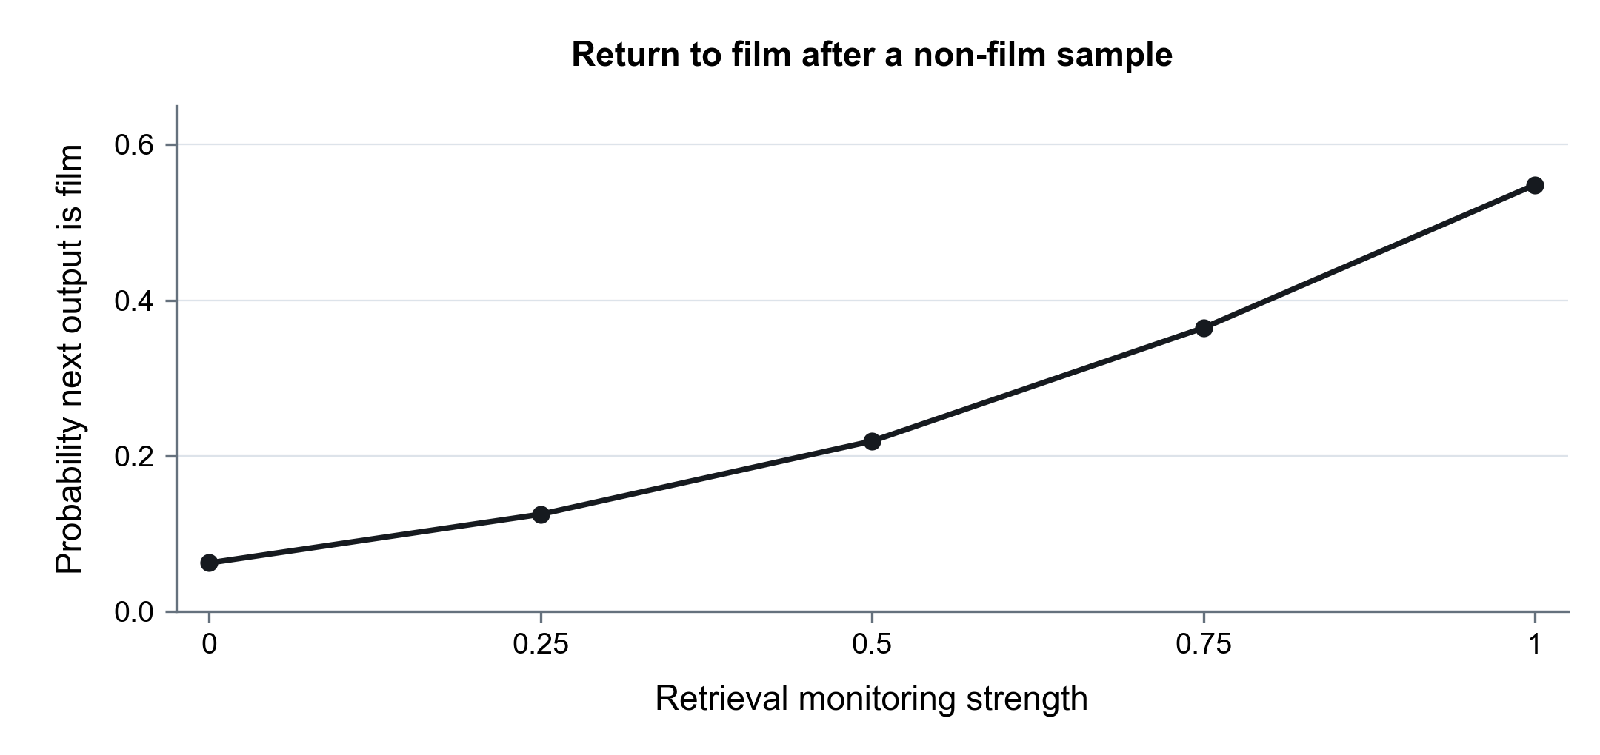

General Discussion

In trauma-film studies, tasks that engage visual imagery can reduce later involuntary memories of the film (intrusions) while leaving voluntary memory relatively preserved (Holmes et al., 2009; Lau-Zhu et al., 2019, 2021). Dual-representation accounts explain this selective interference effect by proposing that interference disrupts representations supporting intrusive memories more than those supporting deliberate recollection (Brewin et al., 2010; Brewin, 2014). Our simulations with the Context Maintenance and Retrieval (CMR) model show how the same dissociation can arise within a shared memory system, through differences in how involuntary and deliberate retrieval draw on the same learned associations.
A film reminder made subsequently encoded task items retrievable from film-associated context, reducing film recall when search relied on that context. Start-of-film reinstatement and retrieval monitoring improved film recall, but neither made recall comparably resistant to the learned task competitors. In simulations, reproducing the selective-interference pattern across reminder and task conditions required sustained support from a maintained film-category cue that supported film candidates without equally supporting task competitors. Recognition produced a separate form of preservation because the candidate film item was presented before its associated context was evaluated. Together, these results locate selective interference in the relation between what has been bound to context and how later retrieval selects or evaluates film material.

From Contextual Competition to Selective Retrieval
Context binding creates both access and interference. Reinstating a prior context before new learning can link later material to the earlier episode, allowing the earlier context to cue both sets of events (Hupbach et al., 2008; Sederberg et al., 2011). Film-associated context can therefore remain available while becoming less diagnostic of film material. Research on category-directed recall provides a complementary principle: people can maintain semantic or category information that favors target memories while temporal associations continue to organize retrieval (Lohnas et al., 2026; Norman et al., 2017; Polyn et al., 2011). Work on selective recollection places a further constraint on this account. Moccia and Morcom (2022) found target-selective recollection only when test cues overlapped more with the targeted than the competing source, even though pictures were remembered better regardless of which source was targeted. A multivariate analysis of the same experiments found that neural reinstatement could favor the competing source when the external cue matched it, whereas later recollection-related activity was more closely aligned with the current goal (Moccia et al., 2025). Together, these findings suggest that goal-directed remembering remains selective when retrieval can supplement shared context with information that favors targets over competitors.
This account changes what the selective-interference effect can establish about memory architecture. Dual-representation accounts attribute the selective pattern to stronger disruption of sensory-bound representations associated with intrusive re-experiencing than of contextualized representations proposed to support coherent deliberate recollection (Brewin et al., 2010; Brewin, 2014). The retrieved-context model includes a change in stored associative structure: task events acquire new associations with film-associated context while the learned film associations remain available. Retrieval goals and test format then determine how strongly those new competitors affect performance. Preserved deliberate memory therefore does not determine whether the intervention selectively spared one film representation while disrupting another. Sensory-bound and contextualized representations may still contribute to trauma memory, but the selective-interference contrast alone does not identify their contribution.
The protection produced by the maintained film-category cue depends on an explicit modeling commitment. The implementation gives every film candidate additional support while task and filler candidates receive none. At the psychological level, this operation represents a maintained film-category cue of the kind implicated in category-directed recall; the simulations do not derive how participants construct that cue or which film features it contains. Task association strength has a similarly delimited role. Following established CMR parameterizations of encoding priority, it scales newly learned context-to-task associations (Polyn et al., 2009a; Sederberg et al., 2008; Talmi et al., 2019). In the present simulations, it is therefore a sensitivity manipulation that varies competitor learning, not a direct representation of engagement, visuospatial processing, or a particular intervention task. The simulations consequently establish what follows when competitor learning varies and film-directed support discriminates film from task material.
In this account, selective interference need not be specific to emotional material. Task memories should compete with study memories during involuntary recall when both are associated with the study context. A maintained cue that distinguishes study from task material should protect deliberate recall, with less protection when the cue also supports task memories. Emotionality was held fixed in the present simulations, so this generalisation remains to be tested.

Interpreting Selective-Interference Evidence
The recognition analysis changes what the strongest positive selective-interference evidence can establish. Published demonstrations of reduced intrusion reports with preserved voluntary memory are dominated by designs that use recognition as the voluntary-memory test (Asselbergs et al., 2024; Holmes et al., 2009, 2010; James et al., 2015; Kessler et al., 2020; Lau-Zhu et al., 2021). In the model, a recognition probe does not need to defeat task candidates during context-to-item sampling because the candidate film item is already present. Preserved recognition can therefore accompany impaired context-guided film recall even when both tests depend on the same learned film associations. Such evidence establishes that presented film items can still recover useful contextual evidence, while leaving unresolved whether film material remains similarly available during deliberate recall.
Recall-based comparisons improve this inference but do not automatically isolate retrieval intentionality. Vigilance-intrusion tasks require film material to come to mind, yet they can present film cues and ask participants to monitor specifically for film intrusions (Lau-Zhu et al., 2019, 2021). External film cues can reinstate film-associated context, and film-monitoring instructions may encourage participants to construct and maintain a retrieval cue that distinguishes film from task material. The present simulations include weak film cues during recall but do not activate a maintained film-category cue in the involuntary-recall condition. They therefore cannot determine whether vigilance-intrusion-task monitoring engages the same selective support used during deliberate recall.
If participants maintained stronger film-selective cue support during McConnell et al.’s (2026) involuntary-memory task than during Lau-Zhu et al.’s (2019, 2021) tasks, task memories could exert less interference, producing a smaller reduction in reported film intrusions after Tetris. The studies do not establish this proposed difference in cue maintenance. Direct manipulations of cueing and retrieval goals would help test this proposed explanation. A difference confined to the laboratory task would also leave McConnell et al.’s null effect on diary intrusions unexplained.
Comparisons also depend on whether memory scores count every retrieval event or each distinct memory only once. Our auxiliary analysis showed that the modeled selective-interference pattern survived counting distinct film items, although including repeated retrievals increased its magnitude. Empirical comparisons should therefore distinguish changes in the number of different memories retrieved from changes in how often those memories recur. The present analysis addresses repetition within a single retrieval sequence; recurrence across separate intrusion episodes remains outside its scope.
Studies of related procedures have reported reductions in intrusive memories following real-life and occupational trauma, including motor vehicle accidents, emergency caesarean section, refugee trauma, and health-care work during COVID-19 (Beckenstrom et al., 2026; Horsch et al., 2017; Iyadurai et al., 2018, 2023; Kanstrup et al., 2021, 2024; Ramineni et al., 2023). Meta-analyses of trauma-film studies support reductions in intrusion frequency following visuospatial interventions (Asselbergs et al., 2023; Varma et al., 2024). These reductions are not found in every study or on every intrusion measure (Brennen et al., 2021; Hemi et al., 2023; Wessel et al., 2025). Establishing selective interference additionally requires evidence that voluntary memory for the same material is relatively preserved. This dissociation alone does not establish that task memories compete with memories of the event during retrieval.

Testing Competitor Learning and Retrieval Selectivity
The distinction between competitor learning and cue discriminability yields a specific hypothesis about intervention task content. Engagement may strengthen memory for task events, but it does not determine whether a film-directed cue can distinguish those events from film material. Tetris and active verbal tasks can be similarly enjoyable or demanding, yet their effects on intrusions have differed across studies, and both have reduced intrusions under some delayed conditions (Hagenaars et al., 2017; Holmes et al., 2010; Kessler et al., 2020). Hotspot memories often contain visual and spatial imagery, sometimes involving motion (Hoppe et al., 2022; Singh et al., 2022). We propose that imagery generated by mentally rotating or placing blocks can become a competitor when it is associated with film context. Its shared visual format with film imagery could make that competition stronger than for an equally engaging task that generates less imagery. Film and task images can nevertheless remain distinguishable in content and source. A strongly learned task should therefore permit selective interference when its contents remain distinguishable from film events but should impair deliberate as well as involuntary recall when its contents also match the film-directed cue. The simulations represent competitor learning and film-directed retrieval support, but do not explicitly represent visual-format overlap. Comparing imagery-generating and verbal tasks while assessing task learning would help test the proposed role of shared visual format.
Tetris imagery has been reported during waking and at sleep onset following game play (Stickgold et al., 2000). These observations show that game imagery can recur, but do not establish that it competes with film memories. Recording both film and task-image intrusions across reminder conditions would test whether making film context active before the task increases later retrieval of task imagery while reducing film intrusions.

A dual-list externalized free-recall design would isolate the roles of competitor learning and cue discriminability in a standard episodic-memory setting. Participants would study two labeled lists, with the retrieval target disclosed only after encoding, and then be instructed to recall the first list, the second list, or both. They would report every item that comes to mind and identify responses they believe fall outside the target set. Item sets would be counterbalanced across target status, so the same material could appear as target recalls, list intrusions, or recalls for which list membership is irrelevant while cue format and reporting demands remain constant. This design combines a list-before-last condition with externalized recall (Lohnas et al., 2026; Wahlheim et al., 2017). Retrieved-context models have used these procedures to contrast monitoring after a candidate is retrieved with control that reinstates a nonrecent target context before recall begins (Healey & Wahlheim, 2024; Lohnas et al., 2015).
The second list could provide a controlled analogue of the intervention task. Competitor learning could be varied through encoding priority, while cue discriminability could be varied independently by determining whether a category or source cue for the first list also supports second-list items. Temporal adjacency would provide contextual overlap in the initial experiment, so the core test would not depend on a reminder cue. The selective-interference prediction is an interaction, not simply better first-list recall. Stronger second-list encoding should reduce first-list output more when both lists are eligible for recall than when the first list is targeted with a diagnostic cue. That relative protection should disappear when the target cue also supports second-list items. Second-list target trials would establish that the competitors remain accessible, while externalized outputs would reveal whether they enter search and are rejected. First-output and transition measures could distinguish initial target-context reinstatement from sustained target-selective support, whereas participants’ classifications would measure monitoring after an off-target item comes to mind. Testing these predictions requires retaining the identities and study positions of recalled items together with their order of retrieval. The paradigm would therefore test how the same material becomes a target or a list intrusion as retrieval goals change, providing a general-memory test of the mechanism proposed here.

Limitations and Scope
The simulations are qualitative mechanism tests rather than fits to selective-interference data. Core eCMR parameters were estimated from an independent affective free-recall dataset, but the trauma-film sequence and retrieval settings were introduced to examine the consequences of the proposed account. The simulations therefore demonstrate that retrieved-context competitor learning and discriminating retrieval support can produce the qualitative pattern. They do not estimate how often participants use these operations or establish that the operations generated any particular empirical result. A matched dataset containing externalized film and non-film retrieval sequences would provide a stronger basis for parameter anchoring and model comparison.
Several implementation choices further limit the account. Task association strength scales context-to-feature learning for task items without deriving that learning from task engagement or content. The maintained film-category cue is perfectly selective, whereas real retrieval cues may support some competitors and fail to support some film details. The recognition simulation stops at item-to-context match evidence. Its film-source-matched foils are sufficient to test whether task items linked to film-associated context reduce the evidence separation between studied and unstudied film-source probes. They do not represent graded item similarity, and the analysis does not model false familiarity, false recollection, recollection rejection, confidence, or criterion placement in responses to similar lures (Parks et al., 2026). The recall simulations include test-phase film cues but do not represent all monitoring demands of diary or vigilance-intrusion procedures. Finally, the model addresses episodic retrieval processes relevant to intrusive remembering; it is not a model of PTSD, clinical outcome, or treatment efficacy.
The broader contribution is to connect an account of how competitors become bound to target-associated context with an account of how goal-directed retrieval remains selective. Context can continue to provide access to an event while losing its ability to distinguish that event from later material. In simulations, sustained support from a cue that distinguished film from task material was required to reproduce the selective-interference pattern across reminder and task conditions. The account also distinguishes three potentially co-occurring control operations through their consequences for recall initiation, selection during search, and retrieval following a non-film item. Recording recall by study position and output order would help distinguish their contributions, beyond measuring overall recall or interference alone. These results show how competitor learning and retrieval cueing can make deliberate recall less susceptible to interference than involuntary recall within a shared memory system.

References
Asselbergs, J., Riper, H., Engelhard, I. M., Mannes, F., & Sijbrandij, M. (2024). The effectiveness of two novel approaches to prevent intrusions: A pilot study comparing Tetris_dualtask and imagery rescripting to control. Journal of Behavior Therapy and Experimental Psychiatry, 82, 101920. https://doi.org/10.1016/j.jbtep.2023.101920
Asselbergs, J., van Bentum, J., Riper, H., Cuijpers, P., Holmes, E. A., & Sijbrandij, M. (2023). A systematic review and meta-analysis of the effect of cognitive interventions to prevent intrusive memories using the trauma film paradigm. Journal of Psychiatric Research, 159, 116–129. https://doi.org/10.1016/j.jpsychires.2023.01.028
Baddeley, A. D., & Andrade, J. (2000). Working memory and the vividness of imagery. Journal of Experimental Psychology: General, 129(1), 126–145. https://doi.org/10.1037/0096-3445.129.1.126
Beckenstrom, A. C., Bonsall, M. B., Markham, A., Slade, O., Ramineni, V., Iyadurai, L., Islam, Z., Highfield, J., Jaki, T., Goodwin, G. M., Dias, R., Daniels, R., Malik, A., Summers, C., Kingslake, J., & Holmes, E. A. (2026). A digital imagery-competing task intervention for stopping intrusive memories in trauma-exposed health-care staff during the COVID-19 pandemic in the UK: A bayesian adaptive randomised clinical trial. The Lancet Psychiatry, 13(3), 233–247. https://doi.org/10.1016/s2215-0366(25)00397-9
Berntsen, D. (2021). Involuntary autobiographical memories and their relation to other forms of spontaneous thoughts. Philosophical Transactions of the Royal Society B: Biological Sciences, 376(1817), 20190693. https://doi.org/10.1098/rstb.2019.0693
Bird, C. M., Bisby, J. A., & Burgess, N. (2012). The hippocampus and spatial constraints on mental imagery. Frontiers in Human Neuroscience, 6, 142. https://doi.org/10.3389/fnhum.2012.00142
Bisby, J. A., Burgess, N., & Brewin, C. R. (2020). Reduced memory coherence for negative events and its relationship to posttraumatic stress disorder. Current Directions in Psychological Science, 29(3), 267–272. https://doi.org/10.1177/0963721420917691
Brennen, T., Blix, I., Nissen, A., Holmes, E. A., Skumlien, M., & Solberg, Ø. (2021). Investigating the frequency of intrusive memories after 24 hours using a visuospatial interference intervention: A follow-up and extension. European Journal of Psychotraumatology, 12(1), 1953788. https://doi.org/10.1080/20008198.2021.1953788
Brewin, C. R. (2014). Episodic memory, perceptual memory, and their interaction: Foundations for a theory of posttraumatic stress disorder. Psychological Bulletin, 140(1), 69–97. https://doi.org/10.1037/a0033722
Brewin, C. R., Dalgleish, T., & Joseph, S. (1996). A dual representation theory of posttraumatic stress disorder. Psychological Review, 103(4), 670–686. https://doi.org/10.1037/0033-295X.103.4.670
Brewin, C. R., Gregory, J. D., Lipton, M., & Burgess, N. (2010). Intrusive images in psychological disorders: Characteristics, neural mechanisms, and treatment implications. Psychological Review, 117(1), 210–232. https://doi.org/10.1037/a0018113
Busemeyer, J. R., & Wang, Y.-M. (2000). Model comparisons and model selections based on generalization criterion methodology. Journal of Mathematical Psychology, 44(1), 171–189. https://doi.org/10.1006/jmps.1999.1282
Cohen, R. T., & Kahana, M. J. (2022). A memory-based theory of emotional disorders. Psychological Review, 129(4), 742–776. https://doi.org/10.1037/rev0000334
Cornell, C. A., & Zhang, Q. (2025). Hierarchical context guides human memory search. PsyArXiv. https://doi.org/10.31234/osf.io/mbwe9_v1
Cortis Mack, C., Cinel, C., Davies, N., Harding, M., & Ward, G. (2017). Serial position, output order, and list length effects for words presented on smartphones over very long intervals. Journal of Memory and Language, 97, 61–80. https://doi.org/10.1016/j.jml.2017.07.009
Deeprose, C., Zhang, S., DeJong, H., Dalgleish, T., & Holmes, E. A. (2012). Imagery in the aftermath of viewing a traumatic film: Using cognitive tasks to modulate the development of involuntary memory. Journal of Behavior Therapy and Experimental Psychiatry, 43(2), 758–764. https://doi.org/10.1016/j.jbtep.2011.10.008
Diamond, N. B., & Levine, B. (2020). Linking detail to temporal structure in naturalistic-event recall. Psychological Science, 31(12), 1557–1572. https://doi.org/10.1177/0956797620958651
Dupertuys, J., Shulhan, A., & Talmi, D. (2026). Ukraine Memory experiment data set.
Ehlers, A., & Clark, D. M. (2000). A cognitive model of posttraumatic stress disorder. Behaviour Research and Therapy, 38(4), 319–345. https://doi.org/10.1016/S0005-7967(99)00123-0
Hagenaars, M. A., Holmes, E. A., Klaassen, F., & Elzinga, B. (2017). Tetris and word games lead to fewer intrusive memories when applied several days after analogue trauma. European Journal of Psychotraumatology, 8(sup1), 1386959. https://doi.org/10.1080/20008198.2017.1386959
Healey, M. K., & Kahana, M. J. (2014). Is memory search governed by universal principles or idiosyncratic strategies? Journal of Experimental Psychology: General, 143(2), 575–596. https://doi.org/10.1037/a0033715
Healey, M. K. (2018). Temporal contiguity in incidentally encoded memories. Journal of Memory and Language, 102, 28–40. https://doi.org/10.1016/j.jml.2018.04.003
Healey, M. K., & Kahana, M. J. (2016). A four-component model of age-related memory change. Psychological Review, 123(1), 23–69. https://doi.org/10.1037/rev0000015
Healey, M. K., & Uitvlugt, M. G. (2019). The role of control processes in temporal and semantic contiguity. Memory & Cognition, 47(4), 719–737. https://doi.org/10.3758/s13421-019-00895-8
Healey, M. K., & Wahlheim, C. N. (2024). PEPPR: A post-encoding pre-production reinstatement model of dual-list free recall. Memory & Cognition, 52(1), 163–181. https://doi.org/10.3758/s13421-023-01453-z
Hemi, A., Sopp, M. R., Perel, A., Holmes, E. A., & Levy-Gigi, E. (2023). Cognitive flexibility moderates the efficacy of a visuospatial intervention following exposure to analog trauma. Journal of Behavior Therapy and Experimental Psychiatry, 81, 101858. https://doi.org/10.1016/j.jbtep.2023.101858
Herrema, H. G., & Kahana, M. J. (2024). First recall costs and benefits. PsyArXiv. https://doi.org/10.31234/osf.io/sm3fw
Holmes, E. A., & Bourne, C. (2008). Inducing and modulating intrusive emotional memories: A review of the trauma film paradigm. Acta Psychologica, 127(3), 553–566. https://doi.org/10.1016/j.actpsy.2007.11.002
Holmes, E. A., Brewin, C. R., & Hennessy, R. G. (2004). Trauma films, information processing, and intrusive memory development. Journal of Experimental Psychology: General, 133(1), 3–22. https://doi.org/10.1037/0096-3445.133.1.3
Holmes, E. A., James, E. L., Coode-Bate, T., & Deeprose, C. (2009). Can playing the computer game Tetris reduce the build-up of flashbacks for trauma? A proposal from cognitive science. PLoS ONE, 4(1), e4153. https://doi.org/10.1371/journal.pone.0004153
Holmes, E. A., James, E. L., Kilford, E. J., & Deeprose, C. (2010). Key steps in developing a cognitive vaccine against traumatic flashbacks: Visuospatial Tetris versus verbal Pub Quiz. PLoS ONE, 5(11), e13706. https://doi.org/10.1371/journal.pone.0013706
Hoppe, J. M., Walldén, Y. S. E., Kanstrup, M., Singh, L., Agren, T., Holmes, E. A., & Moulds, M. L. (2022). Hotspots in the immediate aftermath of trauma—Mental imagery of worst moments highlighting time, space and motion. Consciousness and Cognition, 99, Article 103286. https://doi.org/10.1016/j.concog.2022.103286
Horsch, A., Vial, Y., Favrod, C., Harari, M. M., Blackwell, S. E., Watson, P., Iyadurai, L., Bonsall, M. B., & Holmes, E. A. (2017). Reducing intrusive traumatic memories after emergency caesarean section: A proof-of-principle randomized controlled study. Behaviour Research and Therapy, 94, 36–47. https://doi.org/10.1016/j.brat.2017.03.018
Howard, M. W., & Kahana, M. J. (1999). Contextual variability and serial position effects in free recall. Journal of Experimental Psychology: Learning, Memory, and Cognition, 25(4), 923–941. https://doi.org/10.1037/0278-7393.25.4.923
Howard, M. W., & Kahana, M. J. (2002). A distributed representation of temporal context. Journal of Mathematical Psychology, 46(3), 269–299. https://doi.org/10.1006/jmps.2001.1388
Howard, M. W., Youker, T. E., & Venkatadass, V. S. (2008). The persistence of memory: Contiguity effects across hundreds of seconds. Psychonomic Bulletin & Review, 15(1), 58–63.
Hupbach, A., Hardt, O., Gomez, R., & Nadel, L. (2008). The dynamics of memory: Context-dependent updating. Learning & Memory, 15(8), 574–579. https://doi.org/10.1101/lm.1022308
Iyadurai, L., Blackwell, S. E., Meiser-Stedman, R., Watson, P. C., Bonsall, M. B., Geddes, J. R., Nobre, A. C., & Holmes, E. A. (2018). Preventing intrusive memories after trauma via a brief intervention involving Tetris computer game play in the emergency department: A proof-of-concept randomized controlled trial. Molecular Psychiatry, 23(3), 674–682. https://doi.org/10.1038/mp.2017.23
Iyadurai, L., Highfield, J., Kanstrup, M., Markham, A., Ramineni, V., Guo, B., Jaki, T., Kingslake, J., Goodwin, G. M., Summers, C., Bonsall, M. B., & Holmes, E. A. (2023). Reducing intrusive memories after trauma via an imagery-competing task intervention in COVID-19 intensive care staff: A randomised controlled trial. Translational Psychiatry, 13(1), 290. https://doi.org/10.1038/s41398-023-02578-0
Iyadurai, L., Visser, R. M., Lau-Zhu, A., Porcheret, K., Horsch, A., Holmes, E. A., & James, E. L. (2019). Intrusive memories of trauma: A target for research bridging cognitive science and its clinical application. Clinical Psychology Review, 69, 67–82. https://doi.org/10.1016/j.cpr.2018.08.005
James, E. L., Bonsall, M. B., Hoppitt, L., Tunbridge, E. M., Geddes, J. R., Milton, A. L., & Holmes, E. A. (2015). Computer game play reduces intrusive memories of experimental trauma via reconsolidation-update mechanisms. Psychological Science, 26(8), 1201–1215. https://doi.org/10.1177/0956797615583071
James, E. L., Lau-Zhu, A., Clark, I. A., Visser, R. M., Hagenaars, M. A., & Holmes, E. A. (2016). The trauma film paradigm as an experimental psychopathology model of psychological trauma: Intrusive memories and beyond. Clinical Psychology Review, 47, 106–142. https://doi.org/10.1016/j.cpr.2016.04.010
Jin, B. J., Halpern, D. J., & Kahana, M. J. (2024). A theory of memory for items and associations. https://memory.psych.upenn.edu/files/pubs/JinEtal24.pdf
Kahana, M. J. (1996). Associative retrieval processes in free recall. Memory & Cognition, 24(1), 103–109.
Kahana, M. J. (2020). Computational models of memory search. Annual Review of Psychology, 71, 107–138. https://doi.org/10.1146/annurev-psych-010418-103358
Kanstrup, M., Kontio, E., Geranmayeh, A., Olofsdotter Lauri, K., Moulds, M. L., & Holmes, E. A. (2021). A single case series using visuospatial task interference to reduce the number of visual intrusive memories of trauma with refugees. Clinical Psychology & Psychotherapy, 28(1), 109–123. https://doi.org/10.1002/cpp.2489
Kanstrup, M., Singh, L., Leehr, E. J., Göransson, K. E., Pihlgren, S. A., Iyadurai, L., Dahl, O., Falk, A.-C., Lindström, V., Hadziosmanovic, N., Gabrysch, K., Moulds, M. L., & Holmes, E. A. (2024). A guided single session intervention to reduce intrusive memories of work-related trauma: A randomised controlled trial with healthcare workers in the COVID-19 pandemic. BMC Medicine, 22(1), 403. https://doi.org/10.1186/s12916-024-03569-8
Kessler, H., Holmes, E. A., Blackwell, S. E., Schmidt, A.-C., Schweer, J. M., Bücker, A., Herpertz, S., Axmacher, N., & Kehyayan, A. (2018). Reducing intrusive memories of trauma using a visuospatial interference intervention with inpatients with posttraumatic stress disorder (PTSD). *Journal of Consulting and Clinical Psychology, 86*(12), 1076–1090. https://doi.org/10.1037/ccp0000340
Kessler, H., Schmidt, A.-C., James, E. L., Blackwell, S. E., von Rauchhaupt, M., Harren, K., Kehyayan, A., Clark, I. A., Sauvage, M., Herpertz, S., Axmacher, N., & Holmes, E. A. (2020). Visuospatial computer game play after memory reminder delivered three days after a traumatic film reduces the number of intrusive memories of the experimental trauma. Journal of Behavior Therapy and Experimental Psychiatry, 67, 101454. https://doi.org/10.1016/j.jbtep.2019.01.006
Kindt, M., Soeter, M., & Vervliet, B. (2009). Beyond extinction: Erasing human fear responses and preventing the return of fear. Nature Neuroscience, 12(3), 256–258. https://doi.org/10.1038/nn.2271
Kragel, J. E., Morton, N. W., & Polyn, S. M. (2015). Neural activity in the medial temporal lobe reveals the fidelity of mental time travel. Journal of Neuroscience, 35(7), 2914–2926. https://doi.org/10.1523/JNEUROSCI.3378-14.2015
Krans, J., Näring, G., Becker, E. S., & Holmes, E. A. (2009). Intrusive trauma memory: A review and functional analysis. Applied Cognitive Psychology, 23(8), 1076–1088. https://doi.org/10.1002/acp.1611
Lau-Zhu, A., Henson, R. N., & Holmes, E. A. (2019). Intrusive memories and voluntary memory of a trauma film: Differential effects of a cognitive interference task after encoding. Journal of Experimental Psychology: General, 148(12), 2154–2180. https://doi.org/10.1037/xge0000598
Lau-Zhu, A., Henson, R. N., & Holmes, E. A. (2021). Selectively interfering with intrusive but not voluntary memories of a trauma film: Accounting for the role of associative memory. Clinical Psychological Science, 9(6), 1128–1143. https://doi.org/10.1177/2167702621998315
Logan, G. D. (2021). Serial order in perception, memory, and action. Psychological Review, 128(1), 1–44. https://doi.org/10.1037/rev0000253
Lohnas, L. J. (2025). A retrieved context model of serial recall and free recall. Computational Brain & Behavior, 8(1), 1–35. https://doi.org/10.1007/s42113-024-00221-9
Lohnas, L. J., Healey, M. K., & Davachi, L. (2023). Neural temporal context reinstatement of event structure during memory recall. Journal of Experimental Psychology: General, 152(7), 1840–1872. https://doi.org/10.1037/xge0001354
Lohnas, L. J., Polyn, S. M., & Kahana, M. J. (2015). Expanding the scope of memory search: Modeling intralist and interlist effects in free recall. Psychological Review, 122(2), 337–363. https://doi.org/10.1037/a0039036
Lohnas, L. J., Polyn, S. M., & Kahana, M. J. (2026). Specialized recall procedures. Psychonomic Bulletin & Review, 33(3), 96. https://doi.org/10.3758/s13423-025-02744-z
Luce, R. D. (1959). Individual choice behavior: A theoretical analysis. Wiley.
McConnell, T. G. W., Bernhard, H., Holmes, E. A., Henson, R., & Talmi, D. (2026). Testing the dual representation account of memory for trauma. PsyArXiv preprint. https://osf.io/preprints/psyarxiv/m3pnz_v1/
McConnell, T. G. W., Leehr, E. J., Garner, M., Talmi, D., & Holmes, E. A. (2026). Exploring how to improve experimenter training in experimental psychopathology: Lessons from and for the trauma film paradigm. Clinical Psychology Review, 128, 102765. https://doi.org/10.1016/j.cpr.2026.102765
Moccia, A., & Morcom, A. M. (2022). Cue overlap supports preretrieval selection in episodic memory: ERP evidence. Cognitive, Affective, & Behavioral Neuroscience, 22, 492–508. https://doi.org/10.3758/s13415-021-00971-0
Moccia, A., Plummer, M., Simpson, I., & Morcom, A. M. (2025). The effects of external cue overlap and internal goals on selective memory retrieval as revealed by electroencephalographic (EEG) neural pattern reinstatement. European Journal of Neuroscience, 62(1), e70194. https://doi.org/10.1111/ejn.70194
Moreton, B. J., & Ward, G. (2010). Time scale similarity and long-term memory for autobiographical events. Psychonomic Bulletin & Review, 17(4), 510–515. https://doi.org/10.3758/PBR.17.4.510
Morton, N. W., & Polyn, S. M. (2016). A predictive framework for evaluating models of semantic organization in free recall. Journal of Memory and Language, 86, 119–140. https://doi.org/10.1016/j.jml.2015.10.002
Mundorf, A. M. D., Lazarus, L. T. T., Uitvlugt, M. G., & Healey, M. K. (2021). A test of retrieved context theory: Dynamics of recall after incidental encoding. Journal of Experimental Psychology: Learning, Memory, and Cognition, 47(8), 1264–1287. https://doi.org/10.1037/xlm0001001
Norman, Y., Yeagle, E. M., Harel, M., Mehta, A. D., & Malach, R. (2017). Neuronal baseline shifts underlying boundary setting during free recall. Nature Communications, 8(1), 1301. https://doi.org/10.1038/s41467-017-01184-1
Parks, C. M., Yonelinas, A. P., & Wahlheim, C. N. (2026). Towards a unified theory of false memory for similar episodes. Psychonomic Bulletin & Review, 33, 88. https://doi.org/10.3758/s13423-025-02855-7
Polyn, S. M., Erlikhman, G., & Kahana, M. J. (2011). Semantic cuing and the scale insensitivity of recency and contiguity. Journal of Experimental Psychology: Learning, Memory, and Cognition, 37(3), 766–775. https://doi.org/10.1037/a0022475
Polyn, S. M., Kragel, J. E., Morton, N. W., McCluey, J. D., & Cohen, Z. D. (2012). The neural dynamics of task context in free recall. Neuropsychologia, 50(4), 447–457. https://doi.org/10.1016/j.neuropsychologia.2011.08.025
Polyn, S. M., Norman, K. A., & Kahana, M. J. (2009a). A context maintenance and retrieval model of organizational processes in free recall. Psychological Review, 116(1), 129–156. https://doi.org/10.1037/a0014420
Polyn, S. M., Norman, K. A., & Kahana, M. J. (2009b). Task context and organization in free recall. Neuropsychologia, 47(11), 2158–2163. https://doi.org/10.1016/j.neuropsychologia.2009.02.013
Raaijmakers, J. G. W., & Shiffrin, R. M. (1980). SAM: A theory of probabilistic search of associative memory. In G. H. Bower (Ed.), The psychology of learning and motivation: Advances in research and theory (Vol. 14, pp. 207–262). Academic Press. https://doi.org/10.1016/S0079-7421(08)60162-0
Ramineni, V., Millroth, P., Iyadurai, L., Jaki, T., Kingslake, J., Highfield, J., Summers, C., Bonsall, M. B., & Holmes, E. A. (2023). Treating intrusive memories after trauma in healthcare workers: A bayesian adaptive randomised trial developing an imagery-competing task intervention. Molecular Psychiatry, 28(7), 2985–2994. https://doi.org/10.1038/s41380-023-02062-7
Schwartz, G., Howard, M. W., Jing, B., & Kahana, M. J. (2005). Shadows of the past: Temporal retrieval effects in recognition memory. Psychological Science, 16(11), 898–904. https://doi.org/10.1111/j.1467-9280.2005.01634.x
Sederberg, P. B., Gershman, S. J., Polyn, S. M., & Norman, K. A. (2011). Human memory reconsolidation can be explained using the temporal context model. Psychonomic Bulletin & Review, 18(3), 455–468. https://doi.org/10.3758/s13423-011-0086-9
Sederberg, P. B., Howard, M. W., & Kahana, M. J. (2008). A context-based theory of recency and contiguity in free recall. Psychological Review, 115(4), 893–912. https://doi.org/10.1037/a0013396
Singh, L., Garate, B., Hoppe, J. M., & Holmes, E. A. (2022). Qualitative analysis of hotspots and intrusive memories after viewing an aversive film highlights their sensory and spatial features. Scientific Reports, 12, Article 7049. https://doi.org/10.1038/s41598-022-10579-0
Stickgold, R., Malia, A., Maguire, D., Roddenberry, D., & O’Connor, M. (2000). Replaying the game: Hypnagogic images in normals and amnesics. Science, 290(5490), 350–353. https://doi.org/10.1126/science.290.5490.350
Talmi, D. (2013). Enhanced emotional memory: Cognitive and neural mechanisms. Current Directions in Psychological Science, 22(6), 430–436. https://doi.org/10.1177/0963721413498893
Talmi, D., Lohnas, L. J., & Daw, N. D. (2019). A retrieved context model of the emotional modulation of memory. Psychological Review, 126(4), 455–485. https://doi.org/10.1037/rev0000132
Talmi, D., Luk, B. T. C., McGarry, L. M., & Moscovitch, M. (2007). The contribution of relatedness and distinctiveness to emotionally-enhanced memory. Journal of Memory and Language, 56(4), 555–574. https://doi.org/10.1016/j.jml.2007.01.002
Talmi, D., & Moscovitch, M. (2004). Can semantic relatedness explain the enhancement of memory for emotional words? Memory & Cognition, 32(5), 742–751. https://doi.org/10.3758/bf03195864
Unsworth, N., Brewer, G. A., & Spillers, G. J. (2010). Understanding the dynamics of correct and error responses in free recall: Evidence from externalized free recall. Memory & Cognition, 38(4), 419–430. https://doi.org/10.3758/MC.38.4.419
Varma, M. M., Zeng, S., Singh, L., Holmes, E. A., Huang, J., Chiu, M. H., & Hu, X. (2024). A systematic review and meta-analysis of experimental methods for modulating intrusive memories following lab-analogue trauma exposure in non-clinical populations. Nature Human Behaviour, 8(10), 1968–1987. https://doi.org/10.1038/s41562-024-01956-y
Visser, R. M., Lau-Zhu, A., Henson, R. N., & Holmes, E. A. (2018). Multiple memory systems, multiple time points: How science can inform treatment to control the expression of unwanted emotional memories. Philosophical Transactions of the Royal Society B: Biological Sciences, 373(1742), 20170209. https://doi.org/10.1098/rstb.2017.0209
Wahlheim, C. N., Ball, B. H., & Richmond, L. L. (2017). Adult age differences in production and monitoring in dual-list free recall. Psychology and Aging, 32(4), 338–353. https://doi.org/10.1037/pag0000165
Wessel, I., Krans, J., Albers, C. J., Chauhan, N., Ferreira de Sá, D. S., Hauck, A., Jaswetz, L., Michael, T., Nixon, R. D. V., Pearson, D. G., Slattery, I., Smeets, T., Takarangi, M. K. T., Willems, T. R. A., & van Schie, K. (2025). Evidence that Tetris reduces immediate but not subsequent daily intrusions of a trauma film: A multilab replication study. Collabra: Psychology, 11(1), 130791. https://doi.org/10.1525/collabra.130791
Zaromb, F. M., Howard, M. W., Dolan, E. D., Sirotin, Y. B., Tully, M., Wingfield, A., & Kahana, M. J. (2006). Temporal associations and prior-list intrusions in free recall. Journal of Experimental Psychology: Learning, Memory, and Cognition, 32(4), 792–804. https://doi.org/10.1037/0278-7393.32.4.792
Zhou, C. Y., Talmi, D., Daw, N. D., & Mattar, M. G. (2025). Episodic retrieval for model-based evaluation in sequential decision tasks. Psychological Review, 132(1), 18–49. https://doi.org/10.1037/rev0000505
Supplementary Material
Supplementary Figure S1: Reminder reinstatement increases similarity between film- and task-encoding contexts in Simulation 1. Reminder condition was varied before task encoding while all trials used the involuntary-recall condition. (A) Mean context similarity between each encoded film and task item position, averaging across encoded task positions. (B) Full film-by-task context-similarity matrices for the same conditions; each cell compares the context state associated with one encoded film position to the context state active at one encoded task position. Brighter cells indicate greater context similarity. The film reminder increases similarity between film-encoding and task-encoding contexts, especially for later film positions and early task positions.


