**APPENDIX E**

**Cross-Functional Diagram**

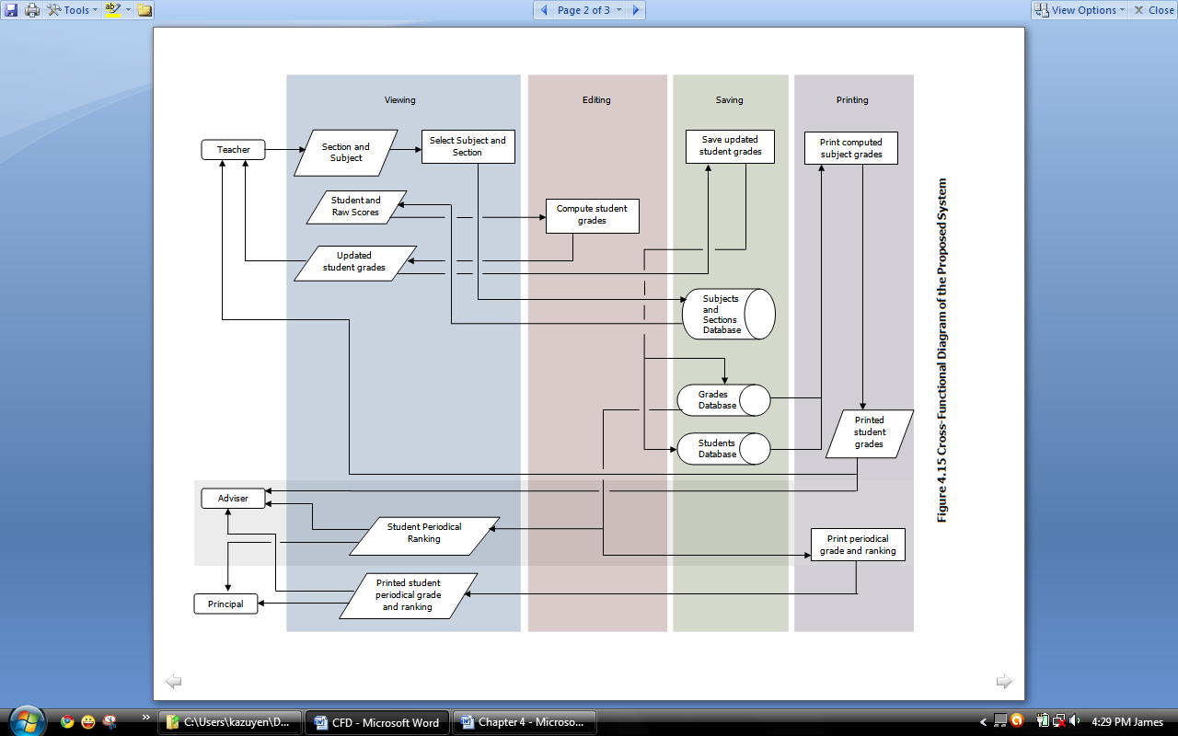

**Cross-Functional Diagram of the Existing System**

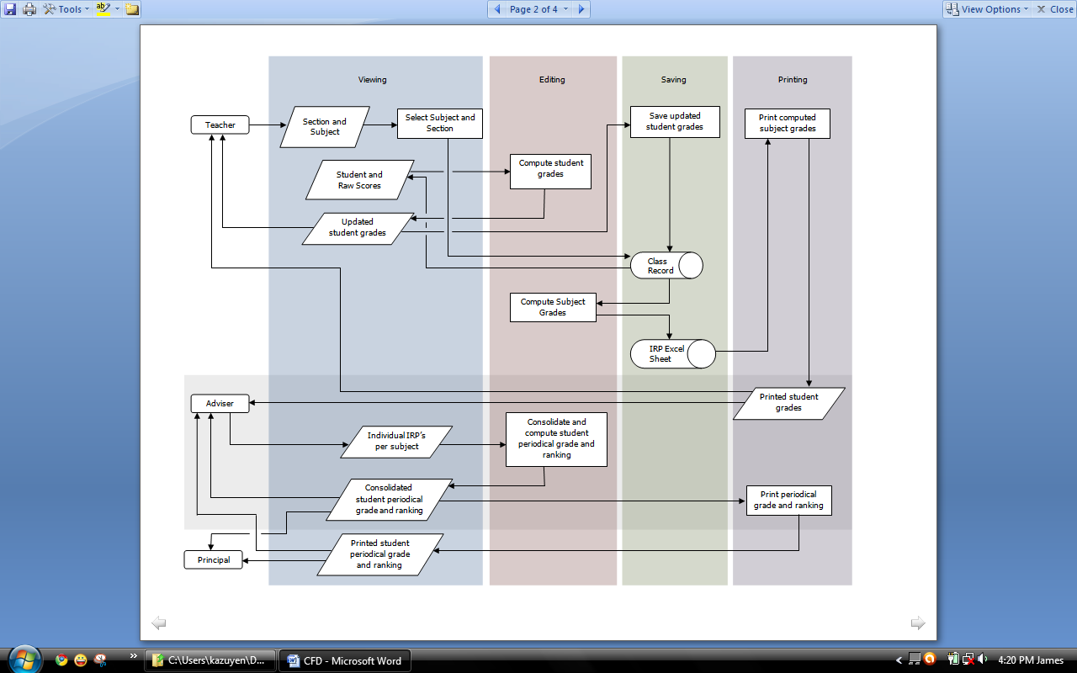

**Cross-Functional Diagram of the Developed System**