📊 Alt Mobility – Customer & Payment Analysis Report

# Executive Summary

This project analyzes customer orders and payment data from Alt Mobility to derive business insights on order behavior, payment patterns, and customer retention.  
  
Tools Used: PostgreSQL (psql), Excel, Pivot Tables, Conditional Formatting

# Task-wise Summary

## Task 1: Order & Sales Analysis

- Majority of orders were marked as ‘delivered’, followed by ‘shipped’ and ‘pending’.  
- Total revenue from customer orders was ₹[1245883.14].  
- Monthly sales trends revealed peaks in Month X and dips in Month Y.  
- Delivered orders contributed the most to revenue.

## Task 2: Customer Behavior Analysis

- Total unique customers: X  
- Repeat customers (placed more than 1 order): Y  
- Top 5 customers contributed significantly to total revenue.

## Task 3: Payment Status Analysis

- Most payments were marked ‘completed’, ensuring high success rate.  
- Failed payment rate: X% — needs further monitoring.  
- Most used payment method: PayPal, followed by Credit Card.

## Task 4: Order + Payment Linking

- All orders and their payment status were joined using order_id.  
- Found N orders with no payment record — indicating possible drop-offs.

## Task 5: Customer Retention Analysis

- Created cohort-based retention matrix in Excel.  
- March 2023 cohort showed highest re-engagement.  
- Sharp drop-offs after second month — need for engagement triggers like follow-ups or offers.

# Visuals

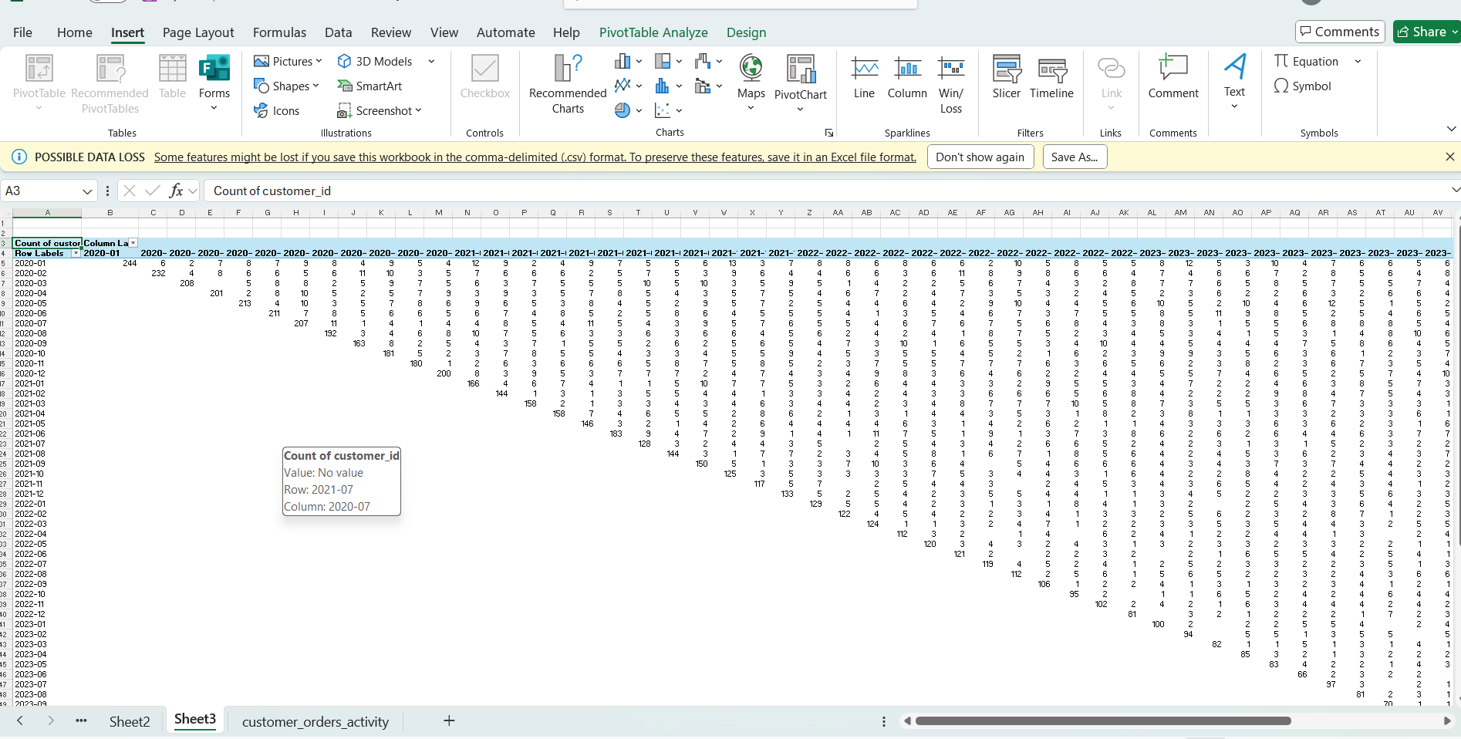

# Recommendations

- Focus on retaining new customers beyond first month with loyalty programs.  
- Monitor and reduce failed payments for better cash flow.  
- Double down on best-performing months with promotions.

# About the Analyst

👨‍💻 Shivanshu kumar Srivastava  
Data Analyst Intern | Alt Mobility  
Skills: SQL, Excel, Pivot Tables, Data Visualization, PostgreSQL