NAME | PICTURE | DISCRIPTION
4G80 swather/Harvester | 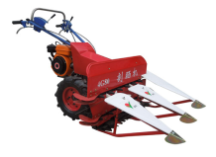 | Item: Index Cutting width(mm): 800 Min cutting heigh(mm): >=50 Placing type: Sidewise & Banded Placed Productivity( M2/hour): 1300-2000 Matched power(Kw): 4.0(5.5hp)gas-engine Net weight(Kg): 116 Gross weight(Kg): 146 Packing sizeL*W*H(M): 1.05*1.0*0.85
4G100 swather/Harvester | 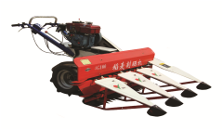 | Item: Index Cutting width(mm): 1000 Min cutting heigh(mm): >=50 Placing type: Sidewise & Banded Placed Productivity( M2/hour): 1500-2500 Matched power(Kw): 3.64(4.5horsepower)diesel engine Net weight(Kg): 210 Gross weight(Kg): 250 Packing sizeL*W*H(M): 1.30*1.05*0.65
4G120A swather/Harvester | 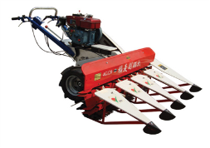 | Item: Index Cutting width(mm): 1200 Min cutting heigh(mm): >=50 Placing type: Sidewise & Banded Placed Productivity( M2/hour): 2000-3000 Matched power(Kw): 3.64(4.5horsepower) Net weight(Kg): 216 Gross weight(Kg): 260 Packing sizeL*W*H(M): 1.47*1.05*0.65
4G150 swather/Harvester | 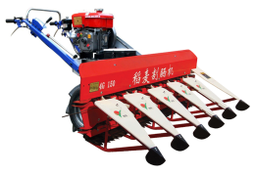 | Item: Index Cutting width(mm): 1500 Min cutting heigh(mm): >=30~50 Placing type: Sidewise & Banded Placed Productivity( M2/hour): 2300-3000 Matched power(Kw): 5(6.6hp)diesel engine Net weight(Kg): 230 Gross weight(Kg): 300 Packing sizeL*W*H(M): 1.80*0.78*0.8

