I

Department of Computer Applications

20mx25 - Software Engineering Methodologies- Test-2

Note: Answer all the questions

Recommended to use pencil for drawing models.

Duration: 90 minutes

1. a) Write an example for **a *Bad*** *User lntedace* with proper justification. [3]

.

/

* 1. Depict *Tea* - *Coffee* - *Milk* - *Sugar-* Problem using *Mul({ple Decision Tables* (7)
  2. i)
     1. Salesmen in a company are paid commission for the products sold by them. The procedure is as follows. Depict this logic using *NS Model*

Shady sellers operates a graded commission policy for their salesmen. The company makes a distinction between products sold for more than Rs.5000 and the number of items sold under 300.

Sales value of the items above Rs. 5000 is subjected to commission of 10%; if more than 300 it.er:ns are _s9ld ang the ales an's salary is below Rs. 20000. Salesmen getting salaries in the range between Rs. 20000 & Rs. 25000 gain of 8% commission and those getting salaries above Rs. 25000 gain of 7% commission. If less than or equal to 300 items are sold, then the commission is 8%, 7% and 6% for the same classification of salesmen.

For sales value of the items less than or equal to Rs. 5000 and number of

....

items sold more than 300 give a flat commission of 8%, to all categories of salesmen. [10]

* + 1. Draw a neat *Activity Diagram* to depict *•check-in•process* in the Airport.

[OR]

ii)

[5]

Depict *qJJe.JKe .£.QJlpboration Diagrams* to depict the *Counselin_g Pfo.ces.s* [only] for *f!JLCoucs _s AdmJ.s5i.Qn* to colleges affiliated to Anna University, Chennai through TANCET. [15]

[PTO]

o Scanned with OKEN Scanner

2) a) What is the *Principle of Pareto* and how is it applied in Software Testing? [3]



1. Ina private bank, interest rate is calculated based on the amount deposited and the period of deposit. It has been decided by the bank authority that,

minimum deposit amount as Rs. 10poo & the period of de.posit as1 *year* and

the maximum as Rs.250000 and 5 years respectively. If the deposit amount

- *(* r -

is Rs. 50000 & above and the period of deposit is more than 3 years, the

interest rate is 12 %.; for the same deposit and the period of deposit less than or equal to 3 years, the interest rate is 10 %. If the deposit amount is below,

Rs. 50000, the interest rate is 8%, whatever the period of deposit. List the suitable number of test cases to check this specification and present the same ina neat report using *Black Box Approach.* [No need for Pseuo Code / CFG etc.] [7]

1. A) Draw the control flow graph for the following function named "findmaximum•. Determine its cyclomatic complexity, *test the code* and

*report the results.* [10]

int findmaximum (int i, int j, int k)

{

int max;

if (i►j) then

if (i►k} then max = i;

else max=k; else if O►k} then max = j;

else max=k; return (max};

}

B} Design suitable test cases using *Black Box testing* for a function

•QuadraticSolver•. It asks for three values a, b & c and solve the quadratic equation ax2+bx+c = 0. Start the answer with a short description to explain the logic to find roots of a quadratic equation. [SJ

Dr.AS- 20mx25 - Test 2 - Co3 and Co4 - May 27, 2023

o Scanned with OKEN Scanner

No of **Pages** : 2 ' **5205**

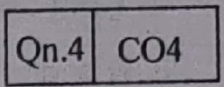

1. Answer **ALL** questions. Each question carries 25 Marks.
2. Subdivision (a) carries 3 marks each, subdivision (b) carries 7 marks each and

subdivision (c) carries 15 marks each.

1. Students are permitted to use COCOMO table
2. CourseOut e:\Qn.1\ COi I IQn.2\ CO2 I IQn.31 CO3

**INSTRUCTIONS:**

Course Code : **20MX25**

Roll No:'1.'l. '"\

(fo be filled in by the candidate)

PSG COLLEGE OF TECHNOLOGY' CO.IMBATORE 641 004 SEMESTER **EXAMINATIONS,** JUNE 2023

**MCA Semester: 2**

**20MX25 SOFTWARE ENGINEERING METHODOLOGIES**

**Time : 3 Hours** ' **Maximum Marks: 100**

1. a) What are the four key characteristics of Agile Methodology?

b} What are the prime factors that influence the choice of SDLC Models? Suggest and depict a suitable software development life cycle model with proper justification for the following scenario: If a company has already experienced in developing payroll software for different organizations is assigned for developing a similar software to an organization with few changes in the functionalities

c) i) Consider an Organic project and it is decomposed into 7 distinct functions. A ply Decomposition techniques to compute total number of lines of code, cost required and effort required to complete the project. Use the following empirical equation to

propose the LOC values: C, + C2F, where c, and C2 are constants and F is the

function number. Use the following constant table to propose three LOC values. Assume that 2% of m will be paid as $/Loe. and 7% of b will be used to propose number of lines per month. [10]

|  |  |  |  |
| --- | --- | --- | --- |
| **LOC**  **Constants** | a | m | b |
| C1 | 35 | 37 | 45 |
| C2 | . 62 | 69 | 73 |

ii) Tabulate the functional and non-functional requirements for an online train ticket booking system. [5]

1. a) What is the significance of 'Scope of effect' and 'Scope of control' of a module in the software design?
   1. Depict the NS Model for the TEA - COFFEE - MILK - SUGAR problem.
   2. i) A) Write Data Dictionary entries for a Train Ticket. (5)

B) Consider the following problem, express the logic using Decision Table [1O]

A private bank has introduced a special scheme to promote its customers to invest in the bank's fixed deposit (FD) schemes. The bank intends to have a different interest scheme for different account types, duration of the fixed deposit and the account balance of their bank accounts.

If the account Is a current account and the account balance is Rs.50000 or more, the bank pays 10% interest for a 3 months FD, 12% interest for a 6 months FD, 14% interest for a 12 months FD and 16% for a 24 months FD. If the account is a current account and the account balance less than Rs.50000 the bank pays 10% interest for a 6 months FD, 12% interest for a 12 month FD and 14% for a 24 months FD.

Page No.: I

**o** Scanned with OKEN Scanner

**Course Ccxla** . !



**aof.P•'"'-:***•***:***-''.•:* .. · . and the account balance is_ Rs.25000 or

If the account is a savings ccount f 6 months FD, 13% interest for a more the bank pays 11% interest or fhs FD If the account. is a savings

12 onths FD and 15% fora 241"! nthan R .25000,''the bank pays 10%

...account,and t2he accothunFtDb= ;;o/oefor a 24 months FD:·

interest for a 1 mon s • $1000

US

* • d th account balance is or

If the account is a NRFC oac ount an r : 24 months FD' and 18% for a more,, .the bank pays 16*Yo* !ntereSt fo unt and the account balance less

36.months FD. If the account isa NR_FCt ac ora months FD, 1q% interest

24

, · than US $1000, the bank pays 14% '"eres • •

for a 36 months FD.

(OR) d t using an online

ii) A) Depict a neat CAD to explain the purchase of pro ucs [9]

shopping portal.

B) Design a suitable User Interface to book a train ticket by the customer. [61

1. a) Why coding standards matter?
   1. Write a complete Use Case story to depict Cancellation of the booked train ticket using Railway Ticket Vending Machine System. Use the standard template meant for writing Use Case story.
   2. i) Depict the working of "Issue Book" and "Return Book" in our OPAC Library Management software using Sequence & Collaboration Diagrams

(OR)

* + 1. Design a neat Use Case Model to depict Lending Library Manag r:nent Software [LLMS] con idering the following processes - Member Registration, Member Authentication, Search Book, Lend Books, Return Books, Payment and Query Answering. Make your own assumptions to design the system. Also, write a detailed Use Case story to explain- "Member Authentication" using the standard template. •

1. a) What is the significance of Cyclomatic Complexity Constant?
   1. Justify the following statements: i) "Exhaustive Testing is practically impossible"
      1. uoevelop test cases using the black box method and then develop supplementary test cases as necessary by using the white box method"
   2. Write a complete pseudo code for the following problem and test the same using Basis PATH testing.

An Organization maintains record of their Employee details like Employee Id, Name of lhe employee, monthly salary and years of experience. Now, the management decides to increase the salary of each of the employees as per the following norms.

If the monthly salary is Rs. 55000 and above and the years of experience is 10 years ancl above, decided to increase 24%.

For the employee of same salary category and the years of experience is less than 10 years, decided to increase 20%.

If the monthly salary is less than Rs. 55000 and the years of experience is 10 years and ab?ve, decided to increase 18%

Otherwise, for all other employees, management decided to increase 15% regardless of monthly salary or years of experience.

**/END/**

**FD/RL**

Page No.: 2

**o** Scanned with OKEN Scanner

D PARTMENT OF COMPUTER APPLICATIONS 20MX25- SOFTWARE ENGINEERING METHODOLOGIES

COCOMO TABLES

|  |  |  |  |  |  |  |
| --- | --- | --- | --- | --- | --- | --- |
| **COCOMO EFFORT MULTIPLIERS TABLE** | | | | | | |
| **COST DRIVERS** | **VERY LOW** | **LOW** | **NOMINAL** | **HIGH** | **VERY HIGH** | **EXTRA HIGH** |
| **Software**  **Reliability** | 0.75 | 0.88 | 1.00 | 1.15 | 1.40 |  |
| **Data Base Size** |  | 0.94 | 1.00 | 1.08 | 1.16 |  |
| **Product**  **Complexity** | 0.70 | 0.85 | 1.00 | 1.15 | 1.30 | 1.65 |
| **Execution** Time  **Constraint** |  |  | 1.00 | 1.11 | 1.30 | 1.66 |
| **Main Storage Constraint** |  |  | 1.00 | 1.06 | 1.21 | 1.56  ' |
| **Virtual Machine**  **Constraint** |  | 0.87 | 1.00 | 1.15 | 1.30 |  |
| **Computer Turnaround Time** |  | 0.87 | 1.00 | 1.07 | 1.15 |  |
| **Analyst Capability** | 1.46 | 1.19-.. | 1.00 | 0.86 | 0.71 |  |
| **Applications Experience** | .._ 1.29 | 1.13 | 1.00 | 0.91 | 0.82 |  |
| **Programmer**  **Capability** | 1.42 | 1.17  I | 1.00 | 0.86 | 0.70 |  |
| **Virtual Machine**  **Experience** | 1.21 | 1.10 | 1.00 | 0.90 |  |  |
| **Programming**  **Language Experience** | 1.14 | 1.07 | 1.00 | 0.95 |  |  |
| Use Of Modern  **Programming Practices** | 1.24 | 1.10 | 1.00 | 0.91 | 0.82 |  |
| **Use Of Software**  Tools | 1.24 | 1.10 | 1.00 | 0.91 | 0.83 |  |
| Required  Development Schedule | 1.23 | 1.08 | 1.00 | 1.04 | 1.10 |  |

*I*

-

Prepared by: Dr.A.Sankar

Q.j Scanned with OKEN Scanner

MODE

COC

512

KLOC

|  |  |  |  |  |
| --- | --- | --- | --- | --- |
| OMO EFFORT DISTRIBUTION TABLE  PHASE . 2 8' 32 128 • | | | | |
|  | KLOC | KLOC | KLOC | KLOC6 |

ORGANIC

ANALYSIS 6 6 6

DESIGN 16 16 16 16

CODING 68 65 62 59

##### L----LT_! !E ST l!!NG ·J_1.

6 19 +2 2-=-t-=2=5-:;t--------

SEMI­

ANALYSIS 7 7 7 7 *J*

DETACHED

DES-IG1N-=17

--1-7--+1-7

-+--17t-=::1-7----

###### - t-

**EMBEDDED**

##### l--C:::.:O D IN G 64 6 1_j_,----1-..::..58=----1-=-s_s_--t-s---:2-:--

TESTING **19 22 25 28 31**

###### .:::....J. - : -i..:=---+ i-

ANALYSIS **8 8 8 8**  !

i-=.D-=ES::...:....GI =-.:N....:.. i_..=.18=---------L.:1=8----l-=18-=-----1-l_S_--+-l-8_

1---CO_D_I_NG---l.-=-6-=--0_..i...5_7_-1--5_4_---+-5_1_--+_48 ,_

L..-- _L_T_E_S_TI_N_G_1_2_2_i_2_5_ L_2_8_ _..L,3_1_-----1_3_-4 ---



|  |  |  |  |  |  |  |
| --- | --- | --- | --- | --- | --- | --- |
| **COCOMO** SCHEDULE **DISTRIBUTION TABLE** | | | | | |  |
| **MODE** | PHASE | 2  KLOC | 8  KLOC | **32**  KLOC | **128**  KLOC | **5**-**1**-----  **KLOC** |
| **ORGANIC** | ANALYSIS | 10 | 11 | 12 | **13** | ...--.  -----..:.  **28**  **40**  **32**  38  32  3 |
|  | DESIGN | 19 | **19** | 19 | 19 |
|  | CODING | 63 | 59 | **55** | **51** |
|  | TESTING | **18** | **22** | 26. | 30 |
| SEMI- | ANALYSIS | 16 | 18 | 20 | **22** |
| DETACHED | DESIGN | **24** | 25 | 26 | 27 |
| - |
| CODING | 56 | **52** | 48 | 44 |
|  | TESTING | 20 | **23** | 26 | 29 |
| EMBEDDED | ANALYSIS | **24** | **28** | 32 | 35 |
|  | DESIGN | 30 | **32** | 34 | 35 |
|  | CODING | 48 | 44 | 40 | 35 |
|  | TESTING | **22** | 24 | 26 | 30 |

Prepared by: Dr.A.Sankar

##### Q? Scanned with OKEN Scanne

**Department of Computer Applications 20MX25 - SEM -Software Testing Tutorial**



**Apply Basis Path Testing for the following Pseudo code meant for Bank - Deposit - Interest Rate - Problem**

Do {

100: Read Deposit Amount

If (Deposit Amount< Rs. 1000)

Goto 100

If (Deposit Amount > Rs. 25000)

Goto 100

200: Read Period of Deposit

If (Period of Deposit< 1 year) Goto 200

If (Period of Deposit> 5 years)

Goto 200

If (Deposit Amount> Rs. 5000)

If (Period of.Deposit> 3 Years) Interest Rate= 12 %

Else

Interest Rate= 10 %

Else

Interest Rate= 8 %

Display Deposit Amount, Period of Deposit Display "Interest Rate=", Interest Rate

Display "Do you want to continue (y/n)" Read Choice

} Choice= "y" END

**DRAS** - **20MX25** - **SEM** - **Software Testing Tutorial** - **26th April, 23**

**o** Scanned with OKEN Scanner

**Department of Computer Applications 20mx25-Software Engineering Methodologies-Test-1**

Note: Answer all the questions

COCOMO table is permitted to use Recommended to use pencil for drawing models.

Duration: 90 lliinutes



Co 1- Introduction, SDLC Models, Estimation Techniques

1. a) Draw Quality triangle that depicts the quality attributes required fora software product. [3)
   1. i) Suggesta suitable software development life cycle model (no need to draw the model} with proper

justification for the following scenario: If a company has already experienced in devel()ping payroll

software for different organizations is assigned for developing a similar software to an organization with few changes in the functionalities. **[3]**

ii) Writea short introduction for Agile Methodology. List the benefits of using agile approach in software development. **[4)**

* 1. i) Tabulate the functional and non-functional requirements for an online food deliverv system [like Zomato]. **[SJ**
* •- -, •--i ) -A-new-project-with-estimated-siz-e·of-40,-000 LOC·embedded system·has,to be·developed. Project ;

Manager of this project has a choice of hiring from two groups of develoP rs A & B. **Group A:** Very high application experience, very little experience in the programming L-1nguage and very· high skilled Analysts. **Group B:** Very low application experience, very high experience in the programming Language and very low skilled Analysts. Analyze and suggest to Project Manager with evidence, the impact of hiring the developers either from Group A or B. a=2.8, b 1.20, c=2.4, d=0.32. **[10)**

Co 2 -Analysis Models-CAD, DFD, DD, Use Case MQR ls & Stories

1. a) Write DD entries for a Train Ticket **(3)**
   1. Depict the PG Admission System through Tamil Nadu Common Entrance Test [TANCET] usin a neat Use Case Model. **(7]**
   2. A) Depict **DFDs** [5 Marks for CAD and 10 marks for DFD Level-1] to explain our college Library Management System [OPAC] limited to the following processes - Student Authentication, Search Book, Issue Book, Return Book, Reserve Book and Late fee Payment. **[15)**

**[OR)**

* + 1. 'depict USE CASE Model [5 Marks] for a Banking Software without ATM and write a !luitable USE CASE Story [10 Marks] to illustrate the Withdrawal of cash. **[15)**

**or.AS**- **20mx25** - **Col** & **Co2** - **Test 1- 24th March, 2023**

* Scanned with OKEN Scanner



#### Department of Computer Applications

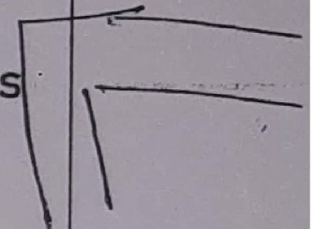

**20MX25-Software Engineering Methodologies-Tutoria-l 2**

Read the following Pseudo Code and answer the following questions

* + - 1. Convert this Pseudo code into its equivalent NS Diagram [10]
      2. Apply Path Testing for this and prepare a neat test case report [30]

1. Repeat

{

1. Display "Enter Employee ID and Name"
2. Read Employee ID, Gross Salary
3. While (Gross Salary ► 0)

{

1. if (Gross Salary<= Rs. 15,000)
2. increase in salary [%]= 15 else
3. if (Gross salary <= Rs. 22,000)
   * 8. increase in salary [%] = 10 else

9. increase in salary [%]= 5

J.O.New Gross Salary.= Gross Salary+ (increase in salary/ 100)* Gros Salary

1. Write •Employee Id=•, Employee Id
2. Write •Gross Salary=", Gross Salary
3. Write "Revised Gross Salary", New Gross Salary

} /*end of while*/

1. Write •Do you want to continue [y/h]"
2. Read Choice
3. } until (Choice = "y")
4. Display "Thank You"

ORAS- 20MX25- SEM - Assessment Tutorial - 2 - 161h May, 2023 [50Minutes]

* Scanned with OKEN Scanner



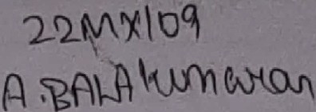Department of Computer Applications

**20MX25** - **SEM** - Cost Estimation Problem Sheet

1• Consider an Organic project and it is decomposed into 7 distinct functions. Apply decomposition techniques to compute total number of lines of code and **·ce2tro11:imd** ta. oomplete.the project. Use the following empirical equation to propose the LOC values: C1

+ C2F, where C1 and C2 are constants and F is the Function number. Use the following table to propose three LOC values

|  |  |  |  |
| --- | --- | --- | --- |
| **Constants/LOCs** | **a** | m | **b** |
| **C1** | **351** | **373** | **450** |
| C2 | **624** | **692** | **737** |

Using the above LOC value, apply COCOMO method to compute other estimates by assuming the following cost drivers. Very high skilled programmer and analyst; High - Data Base size; Low product complexity; High - application experience.

1. Assume that the size of an organic product has been estimated to be 32,000 lines of source code. Assume that the average salary of a software developer is Rs. 15,000 per month. Determine the effort required to develop the software product, the nominal development time, and the cost to develop the product.

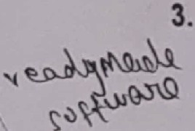Suppose that a certain software product for business application costs Rs. 50,000 to buy off-the-shelf and that tts size is 40 KLOC. Assuming that in-house developers cost Rs. 6000 per programmer-month (including overheads),would it be more cost-effective to buy the product or buildit?

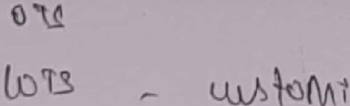

**o** Scanned with OKEN Scanner

1. Suppose thata certain software product for business application costs Rs. 50,000 to buy off-the-shelf and that its size is 40 KLOC. Assuming that in-house developers cost Rs. 6000 per programmer-month (including overheads), would it be more cost-effective to buy



the product or build it?

\Lot

1. If a software product of size s takes m months to develop, then according to the COCOMO estimation model, how long (in months) will it take to developa product of size

2 xs?

* 1. Greater than 2 x m months
     1. Greater than 3 x m months
     2. Less than 2 x m months •

*#"* d) ?reater than 4 x m months 1

\ VA n w project with estimated size of 400 KLOC embedded system has to be developed.

Project Manager of this project has a choice of hiring from two· \ woups of **developers A** & **B: Group A:** Very high application experience, very httle experience in the programming Language and very high skilled Analysts. **Group B:** Very low application experience, very high experience in the programming anguage and very low skilled Analysts. Analyze and suggest to Project Manager, the impact of hiring the developers either from Group A or B. **e a=2.8, b=1.20, c=2.4 and d=0.32.** Justify your suggestion to Project Manager with evidence.

**ORAS** - **SEM** - **COST Estimation Exercises** - **Tutorial Class** - **21st Feb 2023**

**o** Scanned with OKEN Scanner

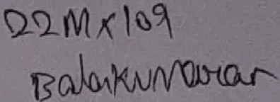lOMX25-SDepartment f Computer Applications

**oftware Engmeering Methodologies-Tutorial** - **1**

**[Col)** What are the p bl . . .

ftw

the d ro ems expected, if software engineering approach 1s·not applied m

so c_tre evelopment process? **[3]**

1. **[Co2)** Draw CAD to withdraw money from ab without ATM facility. **(3)**
2. 1;01] sume that the size of an organic type software product has been estimated to be

,OOO Imes of source code. Assume that the average salary of a software developer is

Rs.5,000 per month. Determine the effort required to develop the software product, the

nominal development time, and the cost to develop the product. Use a=3.2, b=l.05, c=2.5 and d=0.38 for organic project. **[5]**

1. **(Co2]** Write DD entries for Indian Railways (IR) card. **[5)**
2. **[Col]** Assume that, there is a software development request from a customer. They are ready to give complete requirements in the beginning itself; assured for not changing requirements in between. Only condition is that, they need to have the completed software at the earliest and no budget constraints. Is it possible to use hybrid approach for SDLC? If yes, suggest SDLC Models can be combined to meet the customer requirements. If no, suggest a SDLC model to meet the customer expectations. Draw the respective model(s) and justify your answer. [7]

**[PTO]**

## I

I

**o** Scanned with OKEN Scanner



-

6• **[Co ]** In existing **online booking for movie tickets,** once tickets are booketl, no provision to c cel the tickets at any_ ost. If you are asked to include **"cancellation of booked tickets",** e plam using a CAD Model to implement this facility in the proposed system. [7]

7• **[C ll** Apply **COCOMO** technique to compute all the estimates required for an embedded proJect having 4 modules of size **12.34 lttOC, 12,345 LOC, 33.125 KLOC and 23,678 LOC** ' respectively. Consider the following cost drivers: High Skilled Programmer and Analyst, High Database Size and Very High Use of Software Tools. **Use a=2.8, b=l.20, c=2.4 and d=0.32 for Embedded Systems project (10)**

1. **[Co2}** Design DFDs to depict Lending Library Management Software **[LLMS]** considering the following processes - **Member Registration, Member Authentication, Search Book, Lend Books, Return Books, Payment** and **Query Answering.** Make your own assumptions to design the system. • ' [I OJ

###### Dr AS - 20mx25 - SEM - Col and·Co2 - 50 Minutes -Answer for 25 Marks

'

.

o Scanned with OKEN Scanner

**Noof Pages: 2** *(}* , / _J_ .

- Roi: No: '2-_\ ,l'l.'2.."2- *(S*

To be lilted 111 by the candidate)

**4107**

Course Code: **20MX25**



PS I OLLI.:GE OF TECHNOLOGY, COIMBATORI -641 004

SEMESTER EXAMINATIONS, JUNE 2022

**MCA Semester: 2**

**20MX25 SOFTWARE ENGINEERING METHODOLOGIES**

**Tim** : 3 **Hours**

INSTRUCTIONS:

* 1. Answer **ALL** questions. Each question carries 25 Marks.

**Maximum Marks: 100**

* 1. Subdivision (a) carries J marks each, subdivision (b) carries 7 marks each and subdivision (c) carries 15 marks each.



* 1. **Students arc permitted to use COCOMO table.**

I I

* 1. CourseOutcomeTable: Ion.II COi I ,-lo-n-.2"T"l_c_o_2_I Ion.JI C03 lon.4I CO4

1. a) What are the objectives of Software Engineering? Write one important guideline to achieve these goals?
   1. Draw and briefly discuss **RAD Model** and write one suitable scenario to select tllis SDLC model.
   2. i) Apply COCOMO technique to compute all the estimates required for an embedded project having 4 n;i9dules of size 12.34 KLOC, 12,345 LOC, 33.125

*1*

*I* KLOC and 23,678 LdC respectively. [10]

ii) Suppose that a certain. software product for bus/ness application costs Rs. 50,000 to buy off-the-shelr *and.* that its si e is *49* KLOC. Assum_ing_that in-house develope,rs cost Rs. 6000 per programmer month (in.eluding oy,erheads), would it be more cost-effective to buy the product or build it? Justify your a swer. [5]

1. a) Write **DD** entries for the Railway Card issued in our Railway Ticket Vending machine System.
   1. Write a suitable USE **CASE STORY** to depict Customer Authentication in anA **TM**

Banking System.

* 1. Design DFDs to depict our college Library Management Sy'stem [OPAC} limited to the following processes - Student Authentication, Search Book, Issue Book, Return

Book, Reserve Book and Late fee Payment. Make your own assumptions to design the system.

1. a) What are the consequences expected, if a system is designed with more number of highly coupled modules.
   1. Drawa neat HIPO diagram to depict MCA admission system through TANCET.
   2. i) Considerthe followingproblem, express the logic using Multiple Decision Table

Pnge No.: I

\

**o** Scanned with OKEN Scanner

a n

If  t eccounl and th account balance ,s Rs 25,000/- or

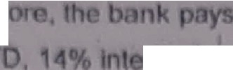m 10% int r t for a month

F,D 12% ,nterest for a 6 months

**A** CU

r t fora 12 month O and 16% for a 24 momh FD If the account nt ccount and the account balance les than Rs 25,000/·, Ille bank

re I for a 6 months FD, 12% interest for 8 12monlhs FD 8nd 14

pay 10% mt %

for A ?◄months FD

If th account Is a savings account and the account balance ,s Rs.15,000/- or

mor . the ban pays 11% interest for a 6 months FD, 13o/c interest fora 12 month FD and 15% for a 24 months FD. If the account is a savings account and the account balance less than Rs 15,000/-, the bank pays 10% interest fora 12

months FD and 12% for a 24 months FD

If the account Is a NRFC account and the account balance ts US $500 or more, the bank pays 16% interest for a 24 months FD and 18% for a 36 months FD If th account is a NRFC account and the account balance less than US $500, the bank pays 14% Interest for a 24 months FD, 16% interest for a 36 monlhs FD.

(OR)

ii) D pict th user authentication process or a Banking Software using neat Scqu nc and Collaboration Diagrams Consider stringent authentication follow d in bank, before permitting the user lo proceed with any services offered by th bon

4 Identify th problems that might occur if the engineers of an organization do not dher to any coding standard?

1. D fine the following terms· Black Box Testing and White Box Testing.

R commended approach for testing rs that "apply Black Bqx testing first and then While Box testing• - rite our comm ts on this statement

* + I

1. 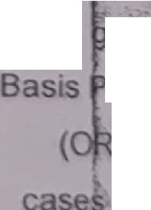i) Write a Pseudo code for a problem f fi 9ing the smallest among the given three

number and to also display The numb rs r3re all equal Appl

iven-lhree numbers are Equal" • •' r lh e given alh Testing to test this code.

)

*IA I*

1. Ot cu s Ill differ nl t st required to test the following
   * ithdra al of Ca:.h from **ATM"** horoughly using Black Bo Testing.

module

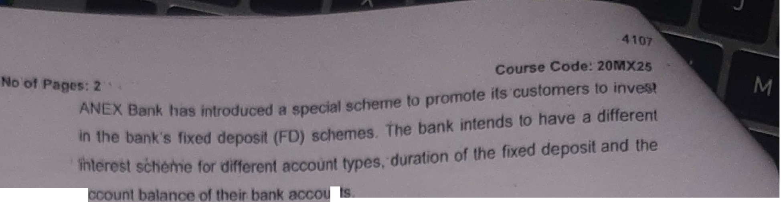

'1.

* + - Scanned with OKEN Scanner



2 l **M,l '2..2-2.**

.SI, I<. ·.5

**Department. of ompJter Applications 20MX25 - Software Engineering Methodologies Self-Assessment Tutorial**

1. Apply COCOMO technique to compute all the estimates required for an embedded project having 4 modules of size 12-. 34 KLOC, 12,345 LOC,

33.125 KLOC and 23,678 LOC respectively. Consider the following cost drivers: High Skilled Programmer and Analyst, High Database Size and Very High Use of Software Tools. **Use a=2.8, b=l.20, c=2.4 and d=0.32** for Embedded Systems project.

1. A new project with estimated size of **400 .KLOC** embedded system has to be developed. Project Manager of this project has a choice of hiring from two groups of developers A & s.

Group A: Very high application experience, very little experience in the programming Language and very high skilled Analysts.

Group B: Very low application experience, very high experience in the programming Language and very low skilled Analysts.

[PTO]

L

**o** Scanned with OKEN Scanner

Analy e and suggest to Project Manager, of hiring the developers either from Group **A** or B.

the impact

Justify your suggestion to Project Manager with evidence.



I

1. Suppose you are developing a software product of organic type. You have estimated the size of the product to be about 00,000 lines of code. j Compute the nominal effort and the development time. **Use a=3.2, b=l.05, c=2.5 and d=0. 8 for Organic Systems project.**

DRAS-20mx25-SEM-Self.-Assessment Tutorial - 23rd April 2022

\

* + - Scanned with OKEN Scanner

Department of Computer ApP.lications

\2'"41(2.2.'2.)

20MX25 - Software Engineering Methodologies Self-Assessment Tutorial - '

*&,J;f,i* Sh *kuN">aN* •.S

*1(1}'¢*

1. A new project with estimated·size of **40000** LOC embedded system has to be developed. Project Manager of this project has a choice of hiring from two groups of developers A & B.



Grau A: Very high Programmer, capability, very _less experience in the

\ programming Language and high skilled Analysts)

Group B: Low Programmer capability, very high experience in the Applications and no inal skilled Analysts.

Analyze and suggest to Project Manager, the impact of hiring the developers either from Group A or B. Justify your suggestion to Project Manager with evidence.

1. Draw CAD for cancellation of Train tickets booked using Railway Ticket Vending Machine System.

3, Draw CAD for Authentication of Customers in ATM Banking Software

1. Write DD entries for a train ticket

**DRA5-20mx25-SEM-Tutorial 1** - 9th **May 2022**

**o** Scanned with OKEN Scanner

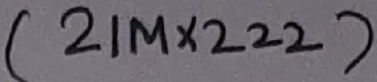

iemx25

Department of Computer Applications

- Software Engineering Methodologies- Test-1

###### Note: Answer all the questions

COCOMO table is permitted to use Use Pencil for drawing models and

Duration: 90 minutes pen for writings.

**Co 1** - **Introduction, SDLC Models, Estimation Techniques**

1 • a) What are the consequences of developing a ... software product without following any systematic approach? **[3 Marks]**

1. It is recommended that in some scenarios, hybrid of more than one SDLC Models for a project. To exercise this, consider the follo\'Jing case study and answer for the question given below.

I

l

l

--

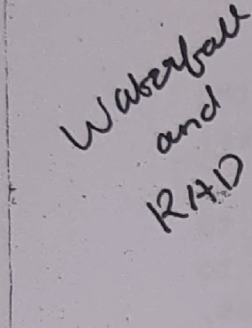**Case Study:** Assume that, there is a software development request

from a customer. They are ready to give complete requirements in the beginnin' itself; assured for no'I; changing requirements in between. On_J,;y c6ridition *is* that, they need to have the completed

,so-f-t-w-are- t the earliest and no budget constraints.

**Q**-**uestion:** .Wh' ich SDLC models can be combined to meet customer expectation? Justify your choices of SDLC models.

this

Design and depict the suggested **new SDLC model** • by suitable SDLC models.

combining

[7 Marks]

!r-------------=,.-=r:- -::r :-:-t '2-;L':'317/c ,< e:::-.::"5"¾-;;;-:- lb-rm <"7._=r-i("T,(oV'i'on-o 'Q"':')if-iQrtU;f':lll!

1. Consider an Organic proie,t and it is qecomposed into **5 distinct**

---""1 ...

**functions.** Apply **Decomposition Techniques** to compyte total

f'Y')<J-r\

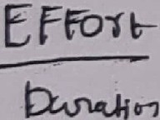

CA...

number of lines of code and . cost **required** to complete the project. Use the following empirical equation to propose the LDC values: C1. + C2F, where C1 and Cz are constants and F is the Function number. Use the followJ.ng table to propose three LDC values. To compute the cost required to complete the project, assume that 3% of mwill be paid as $/loc.

0T *C/J\ll 2>*·'2 l ·oS-

' °". i o I • lt--

*ct_P'o*

·t'

*,*'2.*i* ,*,2.,0*

Using the

**le,/** • **-/N. *Ji'(***

*Y'h.* rn *·o* s1-l-1' )

|  |  |  |  |
| --- | --- | --- | --- |
| **LOCs**  **Constants** | **a** | m | **b** |
| C1 | 35 | 37 | **45** |
| Cz | 62 | 69 | 73 |

above LOC value, apply **COCOMO** method to compute other

estimates by assuming the following cost drivers. Very high

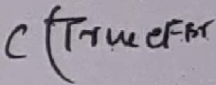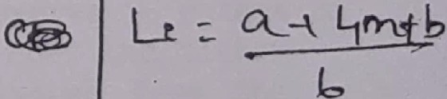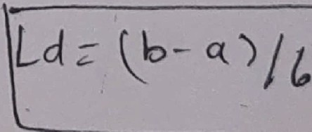

*l*.



*CP-k=--*Le *,<* j /;t,rzi...

\::

tJo or tlf\,o,,

|  |  |  |
| --- | --- | --- |
| *O-rtyi* | c_  2,_, | ol,  <!J l'i |
| d | 2·;- | *o- ,* |
| \; | 2·IJ | 0.52-- |

**o Scanned with OKEN Scanner**

skilled programmer and analyst; high

d**a**t**a,**base size; low procJuct

complexity; high application experience.

**(15 Marks]**

---

**Co 2** - **Req.uirements Elicitation, Analysis M defs**

1. a) What are the likely consequences, if the requirements are elucidated **[Elicitation]** by more than one customers? **[3 Marks]**
   1. Let us assume that, you are assigned to design the **Railwa Card** issued to customer after successfully completing **"Customer Registration"** process identified in our Railway Ticket Vending Machine (RTVM) System.,For that, you need .the contents to be printed in the railway card; you have decided to Use **Data**

**Dictionary** tool to design the suitable **Railway Card** with necessary details.

Write **DD entries** identified for the card conventions discussed.

according to the

**[7 Marks]**

* 1. Depict **DFOs [5 Marks for CAD** , **and 10 marks _for DFD Level-1]** to explain our college **Library Management Sy_ster,1 [OP.AC]** limited to the following processes - **Student Authentication, Search Book,**

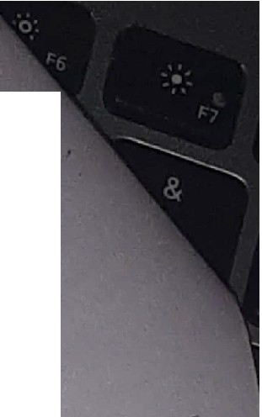

**·rssue Book, Return Book, Reserve Book and Late fee Payment.**

**[15 Marks]**

. ' l **[OR]** ,·.

cf Depict USE **CASE Model [5 Marks]** for the above system and write a suitable USE **CASE Story [10 Marks]** to illustrate the **Student Authentication** using the template discussed in the class.

**[15 Marks]**

**Dr.AS** - **20mx25** - **Col** & **Co2** - **Test 1** - **May 18, 2022**

•'

**Q}** Scanned with OKEN Scan

**20MX25**

### Department of Computer Applications

- **Software Engineering Methodologies - Test 2**

Note: Answer all the questions

Duration - 90 Minutes

In **each question, sub division a) carries 3, b) carries 7 and**

c) **carries 15 marks.**

**In question No. 1, answer either** c-i) **or c-ii).**

**C03: Software Design and Tools**

1. a) Write your brief comments on the following: A) **Loosely Coupled and Strongly Cohesive** Modules B) **High Fan-in and Low Fan-out.**

b) Following paragraph d picts the logic used to compute the interest to be paid to the customer based on the deposit amount and period of deposit as mentioned below.

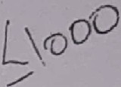In a private bank, interest rate is calculated based on the amount deposited and the period of deposit. It has been decided by the bank authority tbat, minimum deposit amount as Rs.1000 & the period of deposit as 1 year and the maximum as Rs.25,000 and 5 years respectively. If the deposit amount is above Rs. 5000 and the period of deposit is more than 3 years, the interest rate is 12%.; for the same deposit and the period of deposit less than or equai to 3 iears, the interest rate is 10%. If the deposit amount is below''or equal to Rs. 5000, the

interest rate is 8%, whatever the period of deposit.

p

d

Depict this logic using a neat **N5 Medd.-0 .s 1>**

##### c10c/J..



c)-i) Draw Sequence & Collaboration **Diagrams** for Railway Ticket Reservation *Vending* Machine Sysfem. The Railway Ticket Vending Machine"- similar to ATM for money transaction.

It is explained as follows: Customer register with Indian Railways.(IR) - IR issues a Railway card after a verification

* The card is like a credit ca1·d, but used only for booking train -tickets - customer inserts card in the Railway Ticket Vending Machine - enters PIN - if PIN is correct, menu displayed :... customer chooses an option to **reserve** - enters his/her travel plan - check the av\c3ilability - book th \ ticket
* payment using the same card -' ticket is issued from the machine. For **cancellation** : Insert the card and PIN - enter PNR number - ticket details arP displayed select the passenger to cancel - confirm the cancellation - a slip generated for the cancelled tickets with refund details - new ticket issued from the machine. For any **Query:** Insert the card & PIN - select the query - enter th1/ relevant inputs for the query - get the result.

**PTO**

**o Scanned with OKEN Scanner**

[OR]

c)-ii) Consider the following problem,

**Multiple Decision Table**

d deposit (FD) schemes.

express the logic using

ANEX Bank has

* troduced a sp,ecifa"l scheme

to promote its

customers to invest in the bank _s **ixe** . rest scheme for The bank intends to have a d1 fferent inte .t and different account !l- J) , dura*L*n*·* on ,of t,he, fixed deposi

in

the account balance of_their bank accounts.

1 ---

If the 'ae:count is a*--o:* current account and the account balance is Rs.25,000/- re, the bank pays 10% interest for a 3 months FD 12% interest for a 6 months FD, 14% interest for a 12 months'FD and 16% for a 24 months FD. If the account is a

current account and the account balance less than s.25,000/-, the bank pays.J.e._% interest for a 6 months FD, 12% interest for a 12 months FD and 14% for a 24 months FD.

If the account is a savings account and the account balance is Rs.15,000/- or more, the bank pays 11% interest for a 6 months FD, 13% interest for a 12 months FD and 15% for a 24 months FD. If the account is a savings aa,_count and the account balance less than Rs.15,000/-, the bank pays 10% interest for a 12 months FD and 12% for a 24 months FD.

*/*

If the account is a NRFC account and the account balance is US $500 or more, the bank pays 16% interest for a 24 months FD and 18% for a 36 months FD. If the account is a NRFC account and the account balance less than US $500, the bank

pays 14% interest for a 24 months FD, 16% interest for a 36 months FD.

C04 - Software Testing

1. a) Exhaustive Testin i:_ impractical - Why?
   1. Apply Black BOX testing to test a module which is meant for customer authentication in an ATM Banking System.
   2. Write a complete pseudo code to read a number and to display the input number is positive or negative or zero. Repeat the reading of numbers from the user till their response is NO; Output the count on positive, negative and zeros read.

Apply BASIS PATH testing for this code and present the test case report in the standard template.

DRAS '- 20MX25 SEM - Test-2 - 22nd June, 2022

# J_i"f

M .

pi. *vvw* et-

*t'n* w t

\· DW----

h7 t<.o 2-

.,,



**o** Scanned with OKEN Scanner



**Department of Computer Applications 20mx25 - Software Engineering Methodologies**

**Tutorial-2**

* + 1. Depict Banking software using **Structured Chart;**

assuming that the bank is not providing ATM card facility.

* + 1. An Organization maintains record of their Employee details like Employee Id, Nam of the employee, salary, years of experience etc. Now, management decides to increase the sa ary of each of the employees as per the following norms.

If the monthly salary is Rs. 55000 and *above* and the years of experience is 10 years and *above,* decided to increase 24%.

For the employee of same salary catego y and the years of experience is less than 10 years, , decided to increase 20%.

If the monthly salary is less than·Rs. 55000_and the years of experience is 10 years and *above,* decided to increase 18%

Otherwise, for all other e:nploye:es, management decided to increase 15% regardless of salary or years of experience. '

Depict this logic using appropriate **o·ecision**

**Table.**

* + 1. Depict the following logic using **NS diagram** to compute the interest to be paid to the customer based on the account balance and perio'd of deposit.

In a private bank, interest rate is calculated based on the amount deposited and the period of deposit. It has been decided by the bank authority that, minimum deposit amount. s Rs. & the period of deposit as 1 year and the maximum as Rs.25,000 and 5 years respectively. If the deposit amount e Rs. 5000 and the period of deposit *is* more th·an•3 years, the interest rate is l,.2%.; for the same deposit and the period of deposit less than or equal to 3 years, the interest rate is 10%. If the deposit amount is below or equal to Rs. 5000 the interest rate is 8%, whateve the period of deposit.

DrAS- 20mx2s- SEM - Ass ssment Tutorial - 2j17th June 2022

Answer all the questions '

**o** Scanned with OKEN Scanner

- lro

-*o(JV!--* "°J

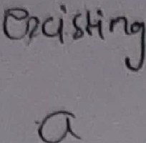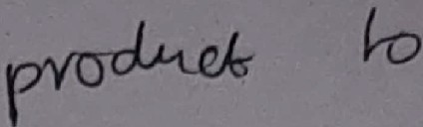proc.LJ1d. pa<l-t.*u *

*('*

*(*

()e"'1 pl -

--

(,u..M \ rwv'

*,....>* ---=

*tJ-J-u\ (-\l-4J*

I

# 2

## fC">'<._

...

'< ***l!>(\*** pvoJ4l--

on p-co1'ct--

r

*di bt?·o.J.f' l-j 4-o- Pk-*

##### )4, ·

n:w cJ.no :J;J

 

**°\ff"OO...c:J,** •

\_,\ "\re CAf_ 'tri..fO\ I *w.J.*

\t-hOlJ.J.fl y Y-CIT1 *I L-cv1*

lAJk(ll ( Ot'Y01

 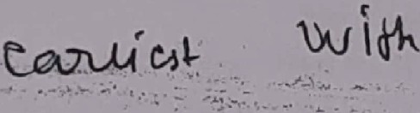  

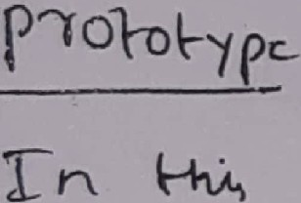

u..,n>(Y\(/\ *"""4* pen_ h.; no ·, _ c.oll -

*Y<'\)A'* p_,*clv,c.w'-* 1-1 O"-



n ***\.M***' **GV\** /(?r,

*ols- v'* Vr,ocJJ

.

LA/>

*'b("*

s

\ *(p* J c;,J-iv-Y'- \-ff\J n *tOte-h.* S t-,

***a>n,p\J.t*** Jri c,{- I

\"'\-t

0 *cx.Vc}*

**('"Kv76lu** .

.

t ctrJ-- *S \Jr* w

***\µ_M*** l)n k \b,01,L,ifl .

*-vu;cJAVJ*

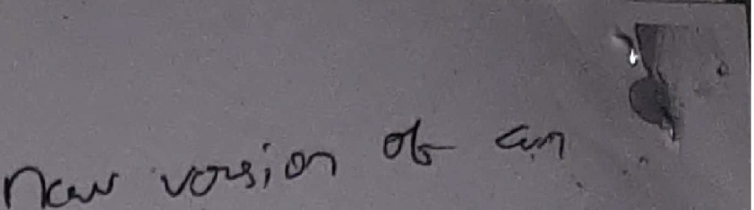

**o** Scanned with OKEN Scanner