**PSG COLLEGE OF TECHNOLOGY**

**DEPARTMENT OF COMPUTER APPLICATIONS**

**23MX26 - Java Programming Laboratory**

**Hands-on Worksheet 6**

1. 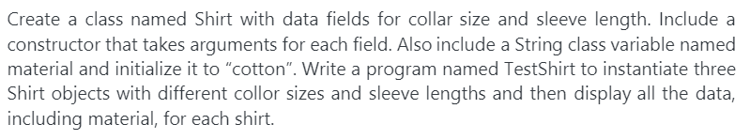

Also write a code to demonstrate by comparing two objects

2.

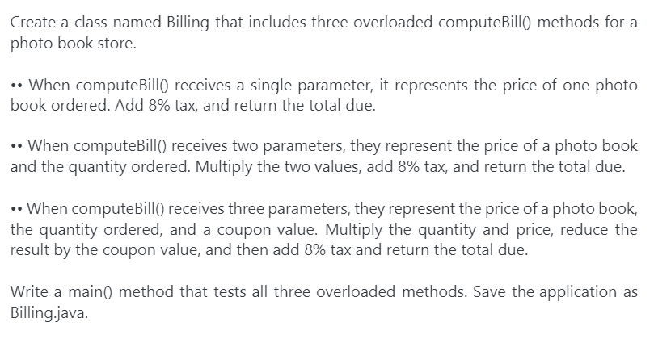

Also write a code to demonstrate by comparing two objects