**PSG COLLEGE OF TECHNOLOGY**

**DEPARTMENT OF COMPUTER APPLICATIONS**

**23MX26 - Java Programming Laboratory**

**Hands-on Worksheet 2**

1. Write a program called **PrintNumberInWord** which prints "ONE", "TWO",... , "NINE", "OTHER" if the int variable "number" is 1, 2,... , 9, or other, respectively. Use (a) a "nested-if" statement; (b) a "switch-case-default" statement.
2. Write a program called **PrintDayInWord** which prints “Sunday”, “Monday”, ... “Saturday” if the int variable "dayNumber" is 0, 1, ..., 6, respectively.  Otherwise, it shall print "Not a valid day". Use (a) a "nested-if" statement; (b) a "switch-case-default" statement.

Try dayNumber = 0, 1, 2, 3, 4, 5, 6, 7 and verify your results.

1. Write a program that takes three integer command-line arguments and prints equal if all three are equal, and not equal otherwise.
2. Write a program that that takes the wind speed (in miles per hour) as an integer command-line argument and prints whether it qualifies as a hurricane, and if so, whether it is a Category 1, 2, 3, 4, or 5 hurricane. Below is a table of the wind speeds according to the Saffir-Simpson scale.

|  |  |
| --- | --- |
| **Category** | **Wind Speed (mph)** |
| 1 | 74 - 95 |
| 2 | 96 - 110 |
| 3 | 111 - 130 |
| 4 | 131 - 155 |
| 5 | 1. and above |

1. **Gymnastics judging.** A gymnast's score is determined by a panel of 6 judges who each decide a score between 0.0 and 10.0. The final score is determined by discarding the high and low scores, and averaging the remaining 4. Write a program that takes 6 real command line inputs representing the 6 scores and prints their average, after throwing out the high and low scores.
2. **Quarterback rating.** To compare NFL quarterbacks, the NFL devised a the [quarterback rating](http://www.mathnotes.com/aw_quarterback.html) formula based on the quarterbacks number of completed passes (A), pass attempts (B), passing yards (C), touchdown passes (D), and interception (E) as follows:
   1. Completion ratio: W = 250/3 * ((A / B) - 0.3).
   2. Yards per pass: X = 25/6 * ((C / B) - 3).
   3. Touchdown ratio: Y = 1000/3 * (D / B)
   4. Interception ratio: Z = 1250/3 * (0.095 - (E / B))

The *quarterback rating* is computed by summing up the above four quantities, but rounding up or down each value so that it is at least 0 and at most 475/12. Write a program QuarterbackRating.java that takes five command line inputs A, B, C, D, and E, and prints the quarterback rating. Use your program to compute Steve Young's 1994 record-setting season (112.8) in which he completed 324 of 461 passes for 3,969 yards, and threw 35 touchdowns and 10 interceptions. As of 2014, the all-time single-season record is 122.5 by Aaron Rodgers in 2011.

1. **Decimal expansion of rational numbers.** Given two integers p and q, the decimal expansion of p/q has an infinitely repeating cycle. For example, 1/33 = 0.03030303.... We use the notation 0.(03) to denote that 03 repeats indefinitely. As another example, 8639/70000 = 0.1234(142857). Write a program DecimalExpansion.java that reads in two command line integers p and q and prints the decimal expansion of p/q using the above notation. *Hint*: use Floyd's rule.

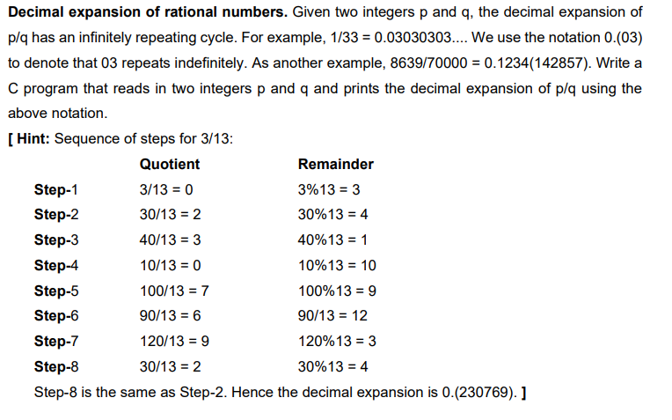

1. **Seasons.** Write a program that takes two command line integers M and D and prints the season corresponding to month M (1 = January, 12 = December) and day D in the northern hemisphere. Use the following table.

|  |  |  |
| --- | --- | --- |
| **SEASON** | **FROM** | **TO** |
| Spring | March 21 | June 20 |
| Summer | June 21 | September 22 |
| Fall | September 23 | December 21 |
| Winter | December 21 | March 20 |

1. **Zodiac signs.** Write a program that takes two command line integers M and D and prints the Zodiac sign corresponding to month M (1 = January, 12 = December) and day D. Use the following table

|  |  |  |
| --- | --- | --- |
| **SIGN** | **FROM** | **TO** |
| Capricorn | December 22 | January 19 |
| Aquarius | January 20 | February 17 |
| Pisces | February 18 | March 19 |
| Aries | March 20 | April 19 |
| Taurus | April 20 | May 20 |
| Gemini | May 21 | June 20 |
| Cancer | June 21 | July 22 |
| Leo | July 23 | August 22 |
| Virgo | August 23 | September 22 |
| Libra | September 23 | October 22 |
| Scorpio | October 23 | November 21 |
| Sagittarius | November 22 | December 21 |

1. **Projectile motion.** The following equation gives the trajectory of a ballistic missile as a function of the initial angle theta and windspeed: xxxx. Write a java program to print the (x, y) position of the missile at each time step t. Use trial and error to determine at what angle you should aim the missile if you hope to incinerate a target located 100 miles due east of your current location and at the same elevation. Assume the windspeed is 20 mph due east.