**PSG COLLEGE OF TECHNOLOGY**

**DEPARTMENT OF COMPUTER APPLICATIONS**

**23MX17- DATA STRUCTURES LABORATORY**

**MOCK LAB TEST-1- SET-A**

**Max. Marks: 15**

**Date: 25-09-2023 Duration: 2 hr**

|  |  |
| --- | --- |
| **Student Name:** | **Student Roll no:** |
| **Student Signature:** | **Faculty Signature:** |

|  |  |  |  |
| --- | --- | --- | --- |
| **Problem 1(10 marks)** | | **Problem 2 (5 marks)** | |
| **Logic (3 marks)** |  | **Logic (2 marks)** |  |
| **Coding (5 marks)** |  | **Coding (2 marks)** |  |
| **Output (2 marks)** |  | **Output (1 marks)** |  |

1. Write a program to read an n x n 2D matrix representing an image, rotate the image by **90** degrees (anti- clockwise). You have to rotate the image [**in-place**](https://en.wikipedia.org/wiki/In-place_algorithm), which means you have to modify the input 2D matrix directly. **DO NOT** allocate another 2D matrix and do the rotation. **Example:**

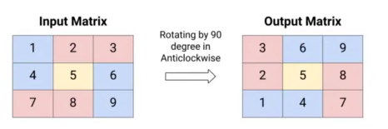

1. Write a program that reads email-id of a person in the form of a string and ensures that it belongs to domain @psgtech.ac.in. (Assume that no invalid characters are there in email id)