**PSG COLLEGE OF TECHNOLOGY**

**DEPARTMENT OF COMPUTER APPLICATIONS**

**I MCA**

**23MX16 DATA STRUCTURES LABORATORY**

**Problem Sheet -5**

**Date: 11-09-2023**

1. You are given an n x n 2D matrix representing an image, rotate the image by 90 degrees (clockwise). You have to rotate the image in-place, which means you have to modify the input 2D matrix directly. DO NOT allocate another 2D matrix and do the rotation.

Example 1:

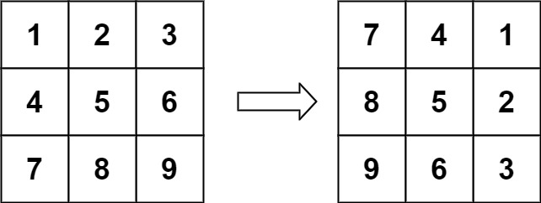

Input: matrix = [[1,2,3],[4,5,6],[7,8,9]]

Output: [[7,4,1],[8,5,2],[9,6,3]]

1. You are given an m x n integer matrix matrix with the following two properties:

* Each row is sorted in non-decreasing order.
* The first integer of each row is greater than the last integer of the previous row.

Given an integer target, return true if target is in matrix or false otherwise.

You must write a solution in O(log(m * n)) time complexity.

Example 1:

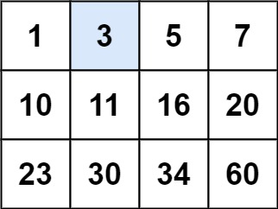

Input: matrix = [[1,3,5,7],[10,11,16,20],[23,30,34,60]], target = 3

Output: true

1. Given an m x n matrix, return all elements of the matrix in spiral order.

Example 1:

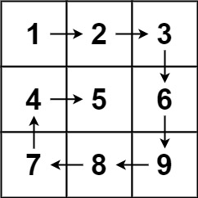

Input: matrix = [[1,2,3],[4,5,6],[7,8,9]]

Output: [1,2,3,6,9,8,7,4,5]

1. Given an expression string x. Examine whether the pairs and the orders of {,},(,),[,] are correct in exp.

For example, the function should return 'true' for exp = [()]{}{[()()]()} and 'false' for exp = [(]).

Note: The drive code prints "balanced" if function return true, otherwise it prints "not balanced".

Example 1:

Input:

{([])}

Output:

true

Explanation:

{ ( [ ] ) }. Same colored brackets can form

balanced pairs, with 0 number of

unbalanced bracket.