DATE: 18/01/2022

EXPERIMENT NO. 1

Q. Demonstrate the basic datatypes in C and implement arithmetic expressions.

PROGRAM STATEMENT:

a. Write a C program to display student information like Name, Roll no., Fees paid status, Gender, Address, Branch and Percentage of Previous Examination.

b. Write a C program to calculate area and circumference of the semicircle by entering radius.

c. Write a program to compute following formulas:

1. Force=Mass of an object\*acceleration

2. Speed=Distance/Time.

d. Write a C program to execute the expression for projectile motion:

s=ut+1/2at2; where s: Displacement, u: initial velocity, a: acceleration t: time

THEORY: For all the programs listed above, we have to use ‘scanf’ and ‘printf’ function for taking input and displaying output which are defined in the header file. The syntax is given as follows:

printf(“%format specifier”,var);

scanf(“%format specifier”,&var);

But in case of taking a string, don’t use &. Each datatype has its own specific format specifier. For eg; %d or %i for int, %f for float, %c for char, %s for string,etc.

PROGRAM a):

#include <stdio.h>

int main()

{

char name[30],fees[6],gen[8],adr[15],bran[15];

int roll;

float per;

printf("Enter the name of student: ");

gets(name);

printf("Address: ");

gets(adr);

printf("Branch: ");

gets(bran);

printf("Enter the roll no.: ");

scanf("%d",&roll);

printf("Feed paid status: ");

scanf("%s",fees);

printf("Gender: ");

scanf("%s",gen);

printf("Percentage of previous Examination: ");

scanf("%f",&per);

printf("\nStudent Information:");

printf("\nName of student: %s",name);

printf("\nRoll no.: %d",roll);

printf("\nFees paid status: %s",fees);

printf("\nGender: %s",gen);

printf("\nAddress: %s",adr);

printf("\nBranch: %s",bran);

printf("\nPercentage of Previous Examination: %f",per);

return 0;

}

OUTPUT a):

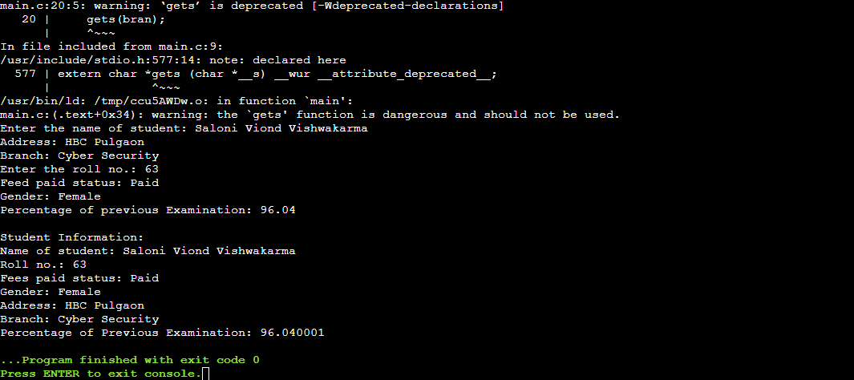

PROGRAM b):

#include<stdio.h>

int main()

{

float p=3.14;

float rad,A,C;

printf("Enter the value of radius: ");

scanf("%f",&rad);

A=p\*rad\*rad/2;

C=p\*rad + 2\*rad;

printf("Area is %f",A);

printf("\nCircumference is %f",C);

return 0;

}

OUTPUT b):

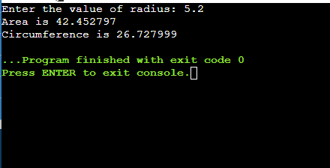

PROGRAM c):

#include <stdio.h>

int main()

{

float F,mass,acc,S,Dis,Time;

printf("Mass of the object= ");

scanf("%f",&mass);

printf("Acceleration of the object= ");

scanf("%f",&acc);

printf("Distance covered= ");

scanf("%f",&Dis);

printf("Time taken= ");

scanf("%f",&Time);

F=mass\*acc;

S=Dis/Time;

printf("Force= %f",F);

printf("\nSpeed= %f",S);

return 0;

}

OUTPUT c):

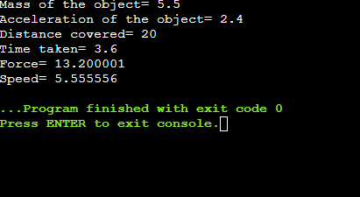

PROGRAM d):

#include <stdio.h>

int main()

{

float s,u,a,t;

printf("Initial velocity(u)= ");

scanf("%f",&u);

printf("Time taken(t)= ");

scanf("%f",&t);

printf("Acceleration(a)= ");

scanf("%f",&a);

s=u\*t+a\*t\*t/2;

printf("Displacement(s) = %f",s);

return 0;

}

OUTPUT d):

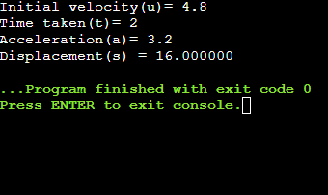

CONCLUSION:

We learnt about the various datatypes and use of scanf and printf function for different datatypes.