Date: 22/01/2022

Experiment no. 2

Q. To study and Demonstrate Decision Control Structures.

PROGRAM STATEMENT:

a. Write a C program to determine Body Mass Index BMI of the person (BMI=kg/m2) where kg is a person’s weight in kilograms and m2 is their height in meters squared and also determine health status by checking BMI.

|  |  |
| --- | --- |
| BMI | Health Status |
| >=25.0 | Overweight |
| >=18.5 and <=24.9 | Healthy |
| <18.5 | Underweight |

b. Write a C program to accept year (4-Digit>1900) and check whether it is a leap year or not.

c. Write a C program to check whether entered character is vowel or consonants or any other special symbols.

THEORY: For all the programs listed above, we have to use if-statement in which if the if expression evaluates to true, the block following the If statement or statements are executed.

SYNTAX: if (expression)

statement ;

PROGRAM a):

#include <stdio.h>

int main()

{

float w,h,BMI;

printf("Enter the weight of person in kg= ");

scanf("%f",&w);

printf("Enter the height of person in m= ");

scanf("%f",&h);

BMI=w/(h*h);

if(BMI>=25.0)

printf("The person is overweight");

if(BMI>=18.5 && BMI<=24.9)

printf("The person is healthy");

if(BMI<18.5)

printf("The person is underweight");

return 0;

}

OUTPUT a):

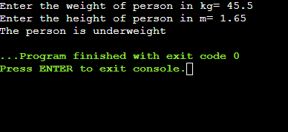

PROGRAM b):

#include <stdio.h>

int main()

{

int year;

printf("Enter the year(4-Digit>1900): ");

scanf("%d",&year);

if(year>1900 && year%4==0)

{

if(year%100==0)

{

if(year%400==0)

printf("Year is a leap year");

else

printf("Year is not a leap year");

}

else

printf("Year is a leap year");

}

else

printf("Year is not a leap year");

return 0;

}

OUTPUT b):

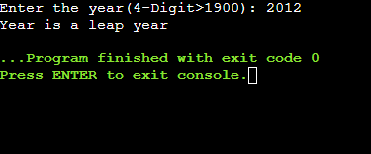

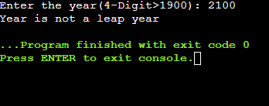

PROGRAM c):

#include <stdio.h>

int main()

{

char chr;

printf("Enter any character: ");

scanf("%c",&chr);

if((chr>=65 && chr<=90) || (chr>=97 && chr<=122))

{

if(chr=='A'||chr=='E'||chr=='I'||chr=='O'||chr=='U'||chr=='a'||chr=='e'||chr=='i'||chr=='o'||chr=='u')

printf("Entered character is a vowel");

else

printf("Entered character is a consonant");

}

else

printf("Entered character is a special symbol");

return 0;

}

OUTPUT c):

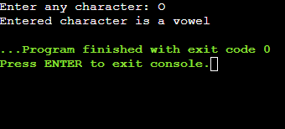

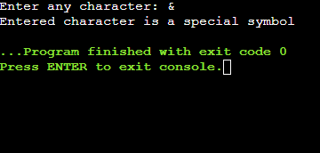

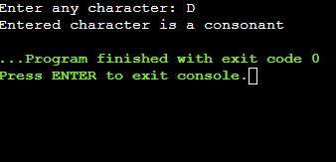

CONCLUSION:

We learnt about how to use if statement, if else statement, nested if else statements and Logical OR operator .We also learnt about the difference between if statement and if else statement.