Date: 02-04-2022

Experiment no. 7

Q. To study and demonstrate structures and pointers.

PROGRAM STATEMENTS:

a. Write a C program to define structure to store information of five employee. The employee record is comprised as employee id, employee name, employee designation, employee basic salary, HRA, TA, DA .Compute the gross salary of each employee and display the employee information who has highest gross salary.

b. Write a C program to create user defined function (by using pointer) to copy source string to target string.

Theory:

Structures: It is the collection of different datatypes under a single name. The variables are called members of structure. It is also called a user-defined datatype.

Syntax for defining a structure:

struct structure_name

{

data_type member_variable 1;

data_type member_variable 2;

data_type member_variable 3;

…….

data_type member_variable n;

};

struct structure_name structure_variable;

NOTE: The members of a structure do not occupy memory until they are associated with a structure variable.

Program a)

#include <stdio.h>

struct emp

{

int id;

char name[100];

char desig[100];

float sal;

float hra;

float da;

float ta;

};

int main()

{

int i,j;

float gross[5], hgross, temp;

struct emp a[5];

for(i=0,j=1;i<5;i++,j++)

{

printf("\nEnter Employee No. %d's\n Id-",j);

scanf("%d",&a[i].id);

printf("\nName-");

scanf("%s",a[i].name);

printf("\nDesignation-");

scanf("%s",&a[i].desig);

printf("\nSalary-");

scanf("%f",&a[i].sal);

printf("\nHRA-");

scanf("%f",&a[i].hra);

printf("\nTD-");

scanf("%f",&a[i].da);

printf("\nTA-");

scanf("%f",&a[i].ta);

}

printf("\n\n");

for(i=0;i<5;i++)

{

gross[i]=a[i].sal+a[i].hra+a[i].da+a[i].ta;

}

hgross=gross[i];

for(i=0;i<5;i++)

{

if(hgross<gross[i+1])

{

hgross<gross[i+1];

j=i+1;

}

}

printf("\n\n");

printf("Info of employee with highest gross salary is\n");

printf("Id-%d\nName-%s\nDesignation-%s\nSalary-%f\nHRA-%f\nTA-%f\nand Gross=%f",a[j].id,a[j].name,a[j].desig,

a[j].sal,a[j].hra,a[j].da,a[j].ta,hgross);

return 0;

}

OUTPUT:

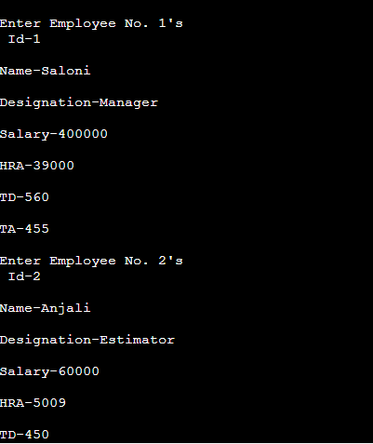

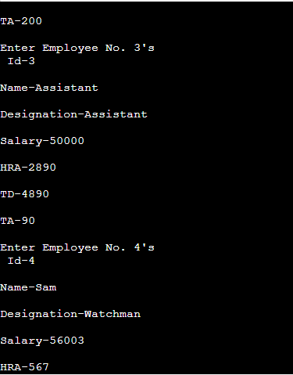

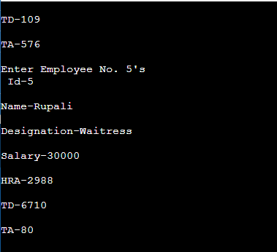

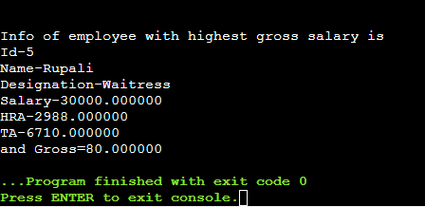

Program b)

#include <stdio.h>

void cp(char*,char*);

int main()

{

char a[100],b[100];

printf("Enter source string:\n");

scanf("%s",a);

cp(a,b);

printf("String copied is %s\n",b);

return 0;

}

void cp(char*a,char*b)

{

while(*a)

{

*b=*a;

a++;

b++;

}

*b='\0';

}

OUTPUT:

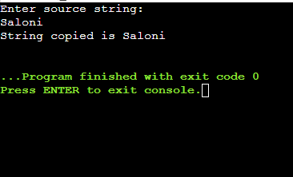

CONCLUSION: In this experiment, we learned about the structures and pointers.