PRACTICAL NO. 1

Roll no: C1-13

Name: Saloni Vinod Vishwakarma

HILL CIPHER CODE:

#include<stdio.h>

#include<string.h>

int main() {

unsigned int a[3][3] = { { 6, 24, 1 }, { 13, 16, 10 }, { 20, 17, 15 } };

unsigned int b[3][3] = { { 8, 5, 10 }, { 21, 8, 21 }, { 21, 12, 8 } };

int i, j;

unsigned int c[20], d[20];

char msg[20];

int determinant = 0, t = 0;

;

printf("Enter plain text\n ");

scanf("%s", msg);

for (i = 0; i < 3; i++) {

c[i] = msg[i] - 65;

printf("%d ", c[i]);

}

for (i = 0; i < 3; i++) {

t = 0;

for (j = 0; j < 3; j++) {

t = t + (a[i][j] \* c[j]);

}

d[i] = t % 26;

}

printf("\nEncrypted Cipher Text :");

for (i = 0; i < 3; i++)

printf(" %c", d[i] + 65);

for (i = 0; i < 3; i++) {

t = 0;

for (j = 0; j < 3; j++) {

t = t + (b[i][j] \* d[j]);

}

c[i] = t % 26;

}

printf("\nDecrypted Cipher Text :");

for (i = 0; i < 3; i++)

printf(" %c", c[i] + 65);

return 0;

}

OUTPUT:

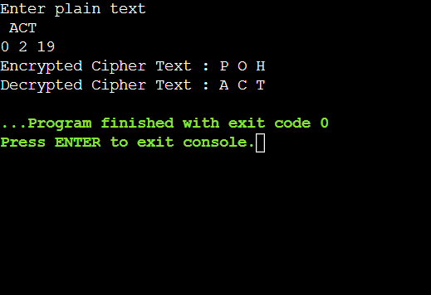

RAIL FENCE CIPHER CODE:

#include<stdio.h>

#include<string.h>

#include<stdlib.h>

void main()

{

int i,j,len,rails,count,code[100][100];

char str[100];

printf("Enter a secret message: ");

gets(str);

len=strlen(str);

printf("Enter number of rails: ");

scanf("%d",&rails);

for(i=0;i<rails;i++)

{

for(j=0;j<len;j++)

{

code[i][j]=0;

}

}

count=0;

j=0;

while(j<len)

{

if(count%2==0)

{

for(i=0;i<rails;i++)

{

code[i][j]=(int)str[j];

j++;

}

}

else

{

for(i=rails-3;i>0;i--)

{

code[i][j]=(int)str[i];

j++;

}

}

count++;

}

for(i=0;i<rails;i++)

{

for(j=0;j<len;j++)

{

if(code[i][j]!=0)

printf("%c",code[i][j]);

}

}

printf("\n");

}

OUTPUT:

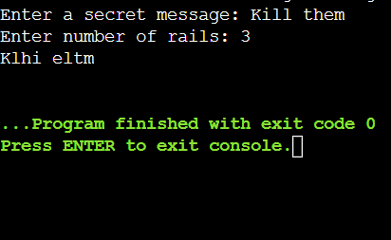

COLUMNAR TRANSPOSITION CODE:

#include<stdio.h>

int check(int x,int y)

{

int a,b,c;

if(x%y==0)

return 0;

a=x/y;

b=y\*(a+1);

c=b-x;

return c;

}

void main()

{

int l1,i,d,j;

printf("\nEnter the length of the key: ");

scanf("%d",&l1);

char a[l1];

int sequence[l1];

int c=1;

printf("\nEnter the key: ");

scanf("%s",&a);

for(char i='a';i<'z';i++)

for(int j=0;j<l1;j++)

if(a[j]==i)

{

sequence[j]=c;

c++;

}

int order[l1];

for(i=1;i<=l1;++i)

{

for(j=0;j<l1;++j)

{

if(sequence[j]==i)

order[i-1]=j;

}

}

printf("\nEnter the depth: ");

scanf("%d",&d);

int l2;

printf("\nEnter the length of the string without spaces: ");

scanf("%d",&l2);

int temp1=check(l2,l1);

int r=(l2+temp1)/l1;

char p[l2+temp1];

char p1[r][l1];

if(temp1>0)

printf("\nYou need to enter %d bogus characters. So,Enter total %d characters: ",temp1,(l2+temp1));

else

printf("\nEnter the string: ");

for(i=-1;i<(l2+temp1);++i)

{

scanf("%c",&p[i]);

}

int count=0;

while(d>0)

{

count=0;

for(i=0;i<r;++i)

{

for(j=0;j<l1;++j)

{

p1[i][j]=p[count];

count=count+1;

}

}

printf("\n\n");

for(i=0;i<r;++i)

{

for(j=0;j<l1;++j)

{

printf("%c",p1[i][j]);

}

printf("\n");

}

count=0;

for(i=0;i<l1;++i)

{

for(j=0;j<r;++j)

{

p[count]=p1[j][order[i]];

count=count+1;

}

}

for(i=0;i<(l2+temp1);++i)

printf("%c",p[i]);

d=d-1;

}

}

OUTPUT:

