PRACTICAL NO. 3

Name: Saloni Vinod Vishwakarma

Roll no: C1-13

Subject: Computer Network Lab

Aim: Java Socket Programming where a client sends a message and server receives and prints it.

Creating Client(Code and Output):

**package** Saloni;

**import** java.io.*;

**import** java.net.*;

**public** **class** MyClient{

**public** **static** **void** main(String[] args){

**try**{

Socket s=**new** Socket("localhost",6666);

DataOutputStream dout=**new** DataOutputStream(s.getOutputStream());

dout.writeUTF("hellosaloni");

dout.flush();

dout.close();

s.close();

}**catch**(Exception e){System.***out***.println(e);}

}

}

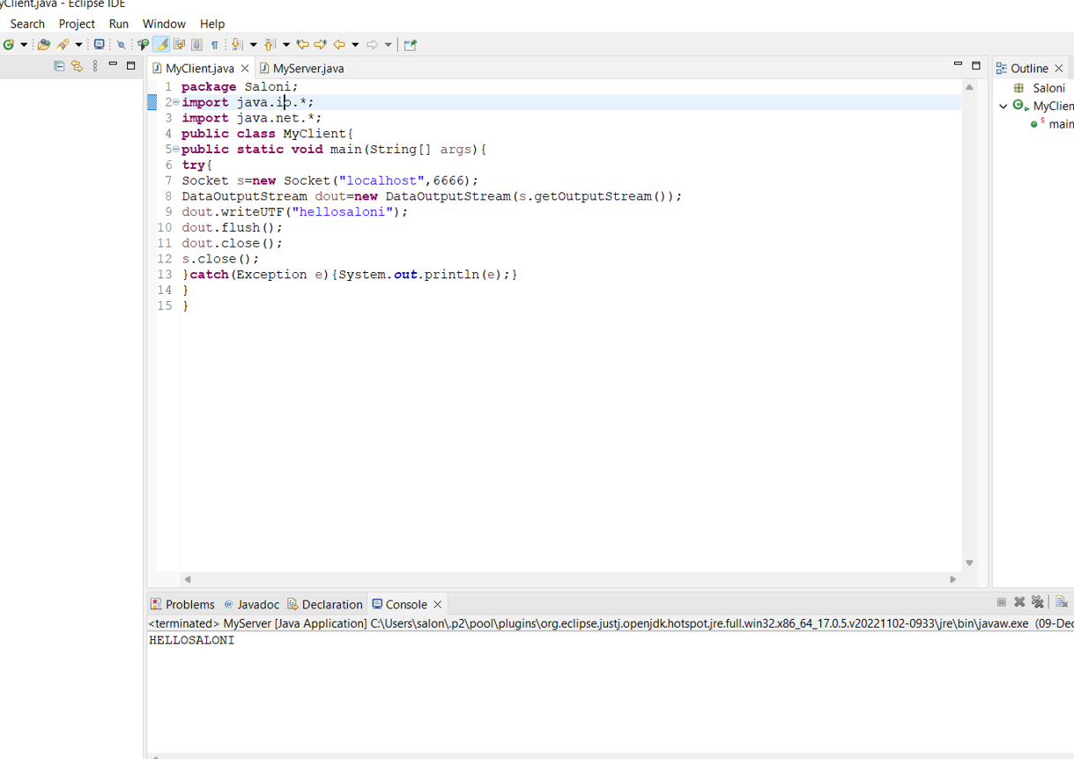

Creating Server(Code and Output):

**package** Saloni;

**import** java.io.*;

**import** java.net.*;

**public** **class** MyServer {

**public** **static** **void** main(String[] args){

**try**{

ServerSocket ss=**new** ServerSocket(6666);

Socket s=ss.accept();//establishes connection

DataInputStream dis=**new** DataInputStream(s.getInputStream());

String str=(String)dis.readUTF();

**for**(**int** i=0;i<str.length();i++)

{

**char** ch=str.charAt(i);

ch=(**char**)(ch-32);

System.***out***.print(ch);

}

ss.close();

}**catch**(Exception e){System.***out***.println(e);

}

}

}

