Practical no-5

Name: Saloni Vishwakarma

Batch: C1

Roll no: 13

Aim: Write a c program for bit stuffing and character stuffing.

Bit Stuffing:

#include<stdio.h>

#include<conio.h>

#include<string.h>

void main() {

int i, j,count=0,nl;

char str[100];

clrscr();

printf("enter the bit string: ");

gets(str);

for (i=0;i<strlen(str);i++) {

count=0;

//the following code search the six ones in given string

for (j=i;j<=(i+5);j++) {

if(str[j]=='1') {

count++;

}

}

//if there is six ones then folling code execute to bit stuffing after five ones

if(count==6) {

nl=strlen(str)+2;

for (;nl>=(i+5);nl--) {

str[nl]=str[nl-1];

}

str[i+5]='0';

i=i+7;

}

}

puts(str);

getch();

}

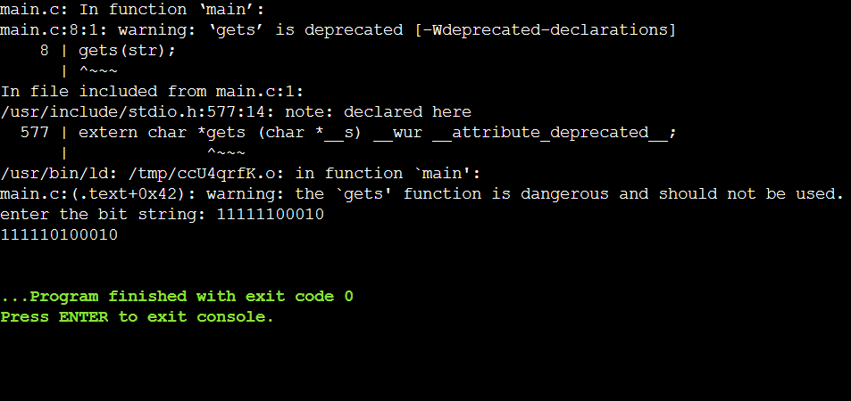

Character Stuffing:

#include<stdio.h>

int main()

{

int n,i,x=0;

printf("Enter the length of input: ");

scanf("%d",&n);

printf("\nFlag is: f");

printf("\nESC character is: e");

char a[n],b[100];

printf("\nEnter your string: ");

scanf("%s",a);

for(i=0;i<n;i++)

{

if(a[i]=='f' || a[i]=='e')

{

b[i+x]='e';

x++;

n++;

}

b[i+x]=a[i];

}

printf("Your payload is: %s",b);

return 0;

}

