PRACTICAL NO 6

Name: Saloni Vishwakarma

Batch: C1

Roll no: 13

Aim: Write a c program for error detection and correction in 7-bit hamming code and variable length hamming code.

7-bit hamming code:

**Code:**

#include <stdio.h>

int main() {

int data[10];

int datacheck[10],c,c1,c2,c3,i;

printf("Enter 4 bits of data one by one\n");

scanf("%d",&data[0]);

scanf("%d",&data[1]);

scanf("%d",&data[2]);

scanf("%d",&data[4]);

//Calculation of parity

data[6]=data[0]^data[2]^data[4];

data[5]=data[0]^data[1]^data[4];

data[3]=data[0]^data[1]^data[2];

printf("\nEncoded data is\n");

for(i=0;i<7;i++)

printf("%d",data[i]);

printf("\n\nEnter received data bits one by one\n");

for(i=0;i<7;i++)

scanf("%d",&datacheck[i]);

c1=datacheck[6]^datacheck[4]^datacheck[2]^datacheck[0];

c2=datacheck[5]^datacheck[4]^datacheck[1]^datacheck[0];

c3=datacheck[3]^datacheck[2]^datacheck[1]^datacheck[0];

c=c3*4+c2*2+c1 ;

if(c==0) {

printf("\nNo error while transmission of data\n");

}

else {

printf("\nFound error on position %d",c);

printf("\nData in : ");

for(i=0;i<7;i++)

printf("%d",data[i]);

printf("\nData out : ");

for(i=0;i<7;i++)

printf("%d",datacheck[i]);

printf("\nCorrect message is\n");

//if errorneous bit is 0 we complement it else vice versa

if(datacheck[7-c]==0)

datacheck[7-c]=1;

else

datacheck[7-c]=0;

for (i=0;i<7;i++) {

printf("%d",datacheck[i]);

}

}

}

**Output:**

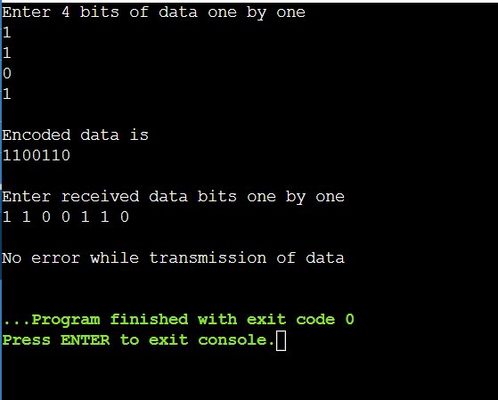

Variable length hamming code:

**Code:**

#include<stdio.h>

#include<stdlib.h>

#include<math.h>

void main()

{

int maxp=6;

int a[50],temp[70],temp2[70];

int t,i,j,k,nd,n,nh,sum=0,pos=0;

printf("Enter Length of Data String: ");

scanf("%d",&nd);

printf("Enter Data String: ");

for(i=0;i<nd;i++)

{

scanf("%d",&a[i]);

}

printf("-----------------------------------\n",nd);

for(i=0,j=0;i<nd;i++)

{

for(k=0;k<maxp;k++)

{

t=pow(2,k)-1;

if(j==t)

{

temp[j]=0;

j++;

}

}

temp[j]=a[i];

j++;

}

nh=j;

printf("Length of Hamming code: %d bits\n",nh);

n=nh-nd;

printf("Number of Parity Bits: %d \n",n);

int b[n];

int m=n-1;

for(k=0;k<n;k++)

{

t=pow(2,k)-1;

for(i=t;i<nh;)

{

for(j=0;j<=t;j++)

{

sum=sum+temp[i];

i++;

if(i>=nh)

break;

}

if(i>=nh)

break;

for(j=0;j<=t;j++)

{

i++;

if(i>=nh)

break;

}

if(i>=nh)

break;

}

temp[t]=sum%2;

sum=0;

printf("P%d: %d\n",t+1,temp[t]);

}

printf("\nHamming code: Sender side: ");

for(i=0;i<nh;i++)

{

printf("%d ",temp[i]);

}

printf("\nHamming code: Receiver side: ");

for(i=0;i<nh;i++)

{

scanf("%d",&temp2[i]);

}

sum=0;

for(k=0;k<n;k++)

{

t=pow(2,k)-1;

for(i=t;i<nh;)

{

for(j=0;j<=t;j++)

{

sum=sum+temp2[i];

i++;

if(i>=nh)

break;

}

if(i>=nh)

break;

for(j=0;j<=t;j++)

{

i++;

if(i>=nh)

break;

}

if(i>=nh)

break;

}

b[m]=sum%2;

sum=0;

printf("P%d: %d\n",t+1,b[m]);

m--;

}

for(m=0;m<n;m++)

{

pos=pos+b[n-m-1]*pow(2,m);

}

printf("Position of Error: %d\n",pos);

if(temp2[pos-1]==0)

temp2[pos-1]=1;

else

temp2[pos-1]=0;

printf("\nHamming code: Receiver side: Error Corrected: ");

for(i=0;i<nh;i++)

{

printf("%d ",temp2[i]);

}

printf("\n-----------------------------------\n",nd);

}

**Output:**

